Figure S1. Flowchart of participant selection for the analysis of incident cardiometabolic diseases in the ELSA, HRS, and SHARE cohorts.

Figure S2. Associations of dual sensory impairment with incident cardiometabolic disease, heart disease, diabetes, and stroke in the ELSA, HRS, and SHARE cohorts.

Figure S3. Forest plot of associations between cumulative average sensory impairment and incident cardiometabolic disease outcomes in the primary analysis.

Figure S4. Subgroup analyses of the association between cumulative average dual sensory impairment and incident cardiometabolic disease in the ELSA cohort.

Figure S5. Subgroup analyses of the association between cumulative average dual sensory impairment and incident cardiometabolic disease in the HRS cohort.

Figure S6. Subgroup analyses of the association between cumulative average dual sensory impairment and incident cardiometabolic disease in the SHARE cohort.

Figure S7. Forest plot of associations between cumulative average sensory impairment and incident cardiometabolic disease outcomes after excluding events occurring during the first 2 years of follow-up.

Figure S8. Random-effects meta-analysis of associations between cumulative average sensory impairment and incident cardiometabolic disease outcomes in sensitivity analyses.

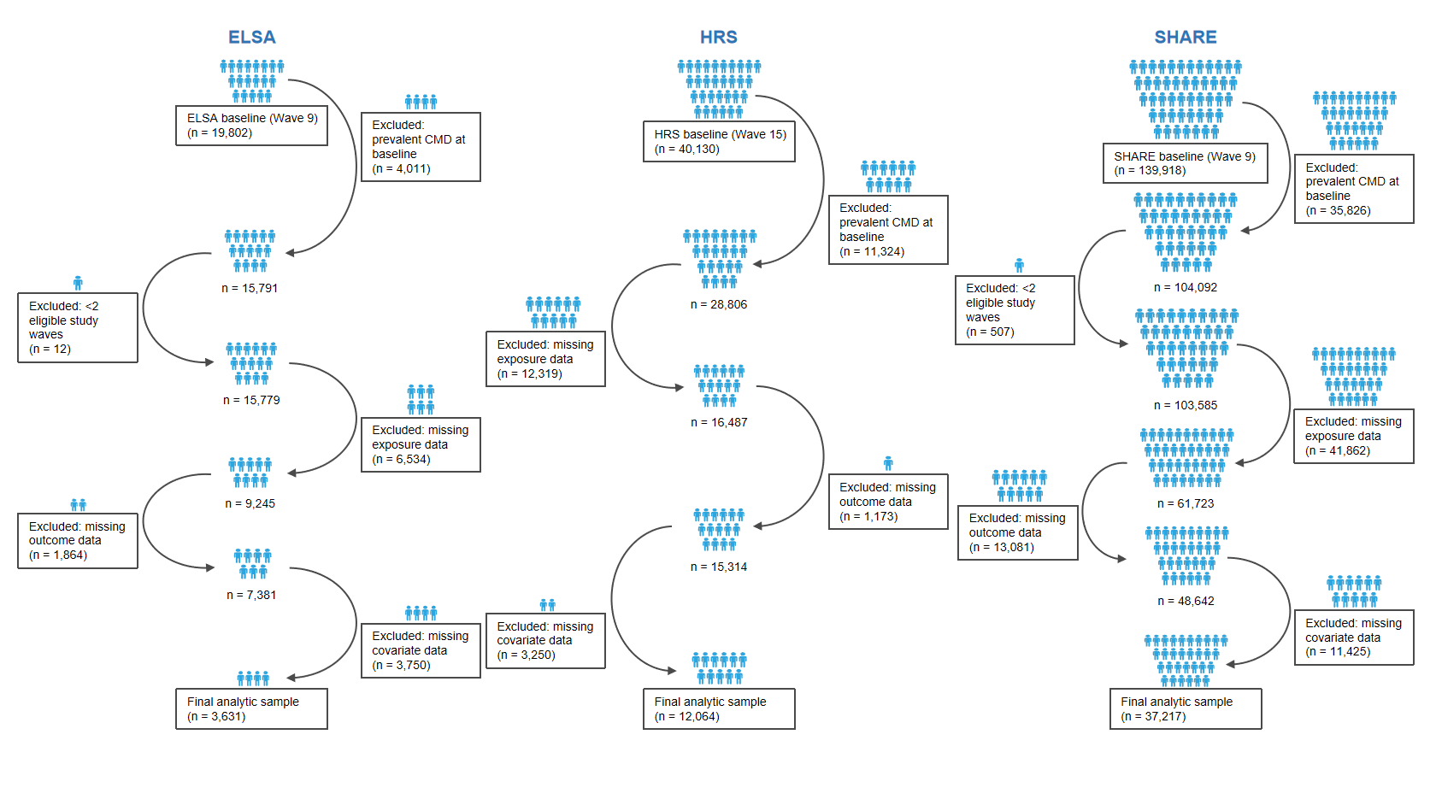
Figure S1. Flowchart of participant selection for the analysis of incident cardiometabolic diseases in the ELSA, HRS, and SHARE cohorts.
Note:CMD, cardiometabolic diseases; ELSA, English Longitudinal Study of Ageing; HRS, Health and Retirement Study; SHARE, Survey of Health, Ageing and Retirement in Europe. Participants with prevalent CMD at baseline were excluded to assess incident CMD during follow-up. Participants were required to contribute data at baseline and at least one eligible follow-up wave. No HRS participants were excluded because of fewer than two eligible study waves.

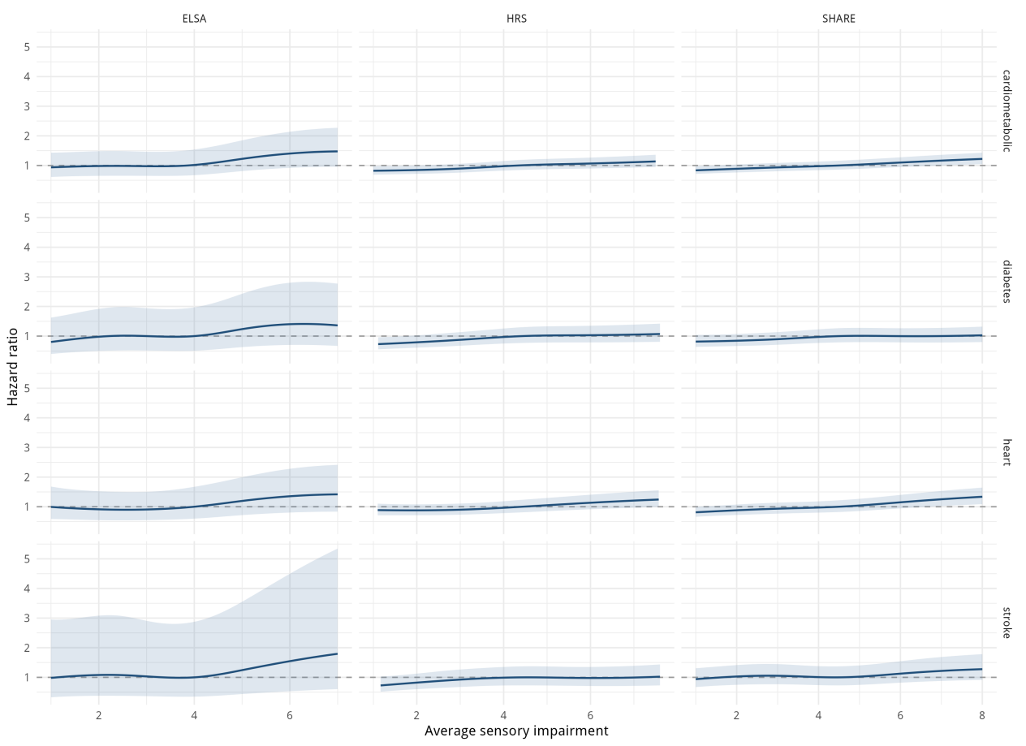
Figure S2. Associations of dual sensory impairment with incident cardiometabolic disease, heart disease, diabetes, and stroke in the ELSA, HRS, and SHARE cohorts.
Note:Hazard ratios (HRs) and 95% confidence intervals (CIs) were estimated using fully adjusted Cox proportional hazards models. Dual sensory impairment (DSI) was expressed as the cumulative average score per 1-standard deviation increase. Cardiometabolic disease (CMD) was defined as incident heart disease, diabetes, or stroke. Participants with the corresponding disease at baseline were excluded. The dashed line indicates an HR of 1.00.
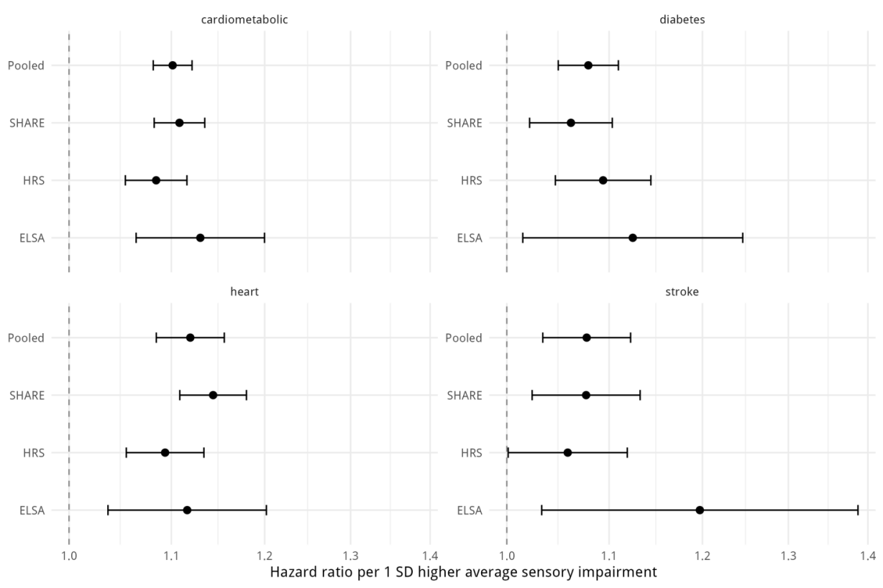
Figure S3. Forest plot of associations between cumulative average sensory impairment and incident cardiometabolic disease outcomes in the primary analysis.
Notes: Estimates are hazard ratios with 95% confidence intervals from fully adjusted Cox proportional hazards regression models. Associations are shown for cumulative average visual impairment, hearing impairment, and dual sensory impairment with incident cardiometabolic disease, heart disease, diabetes, and stroke. Sensory impairment measures were standardized within each cohort, and estimates are presented per 1-standard deviation increase. The vertical dashed line indicates a hazard ratio of 1.00. DSI, dual sensory impairment; CMD, cardiometabolic disease; HR, hazard ratio; CI, confidence interval.
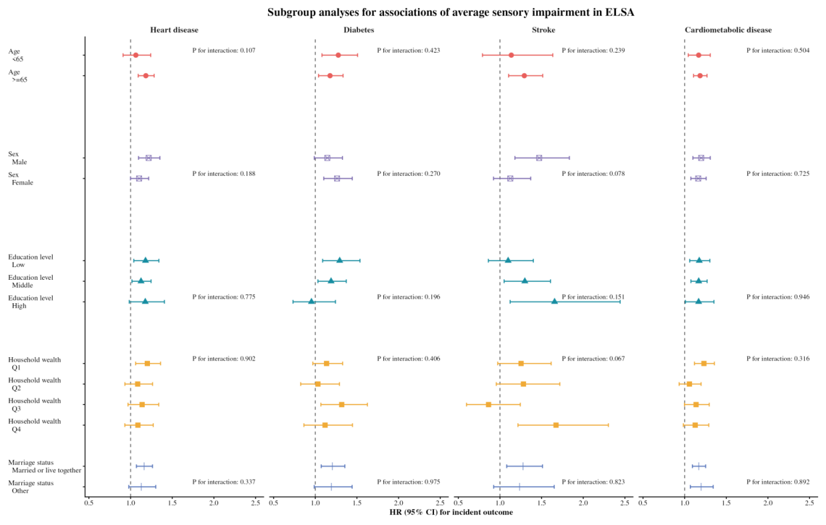
Figure S4. Subgroup analyses of the association between cumulative average dual sensory impairment and incident cardiometabolic disease in the ELSA cohort.
Notes: Hazard ratios and 95% confidence intervals were estimated using fully adjusted Cox proportional hazards regression models. Subgroup analyses were conducted by age group, sex, marital status, educational attainment, household wealth, smoking status, alcohol consumption, physical activity, and selected health conditions, where applicable. P values for interaction were calculated by including the cross-product term between dual sensory impairment and each subgroup variable in the model. DSI, dual sensory impairment; CMD, cardiometabolic disease; HR, hazard ratio; CI, confidence interval.
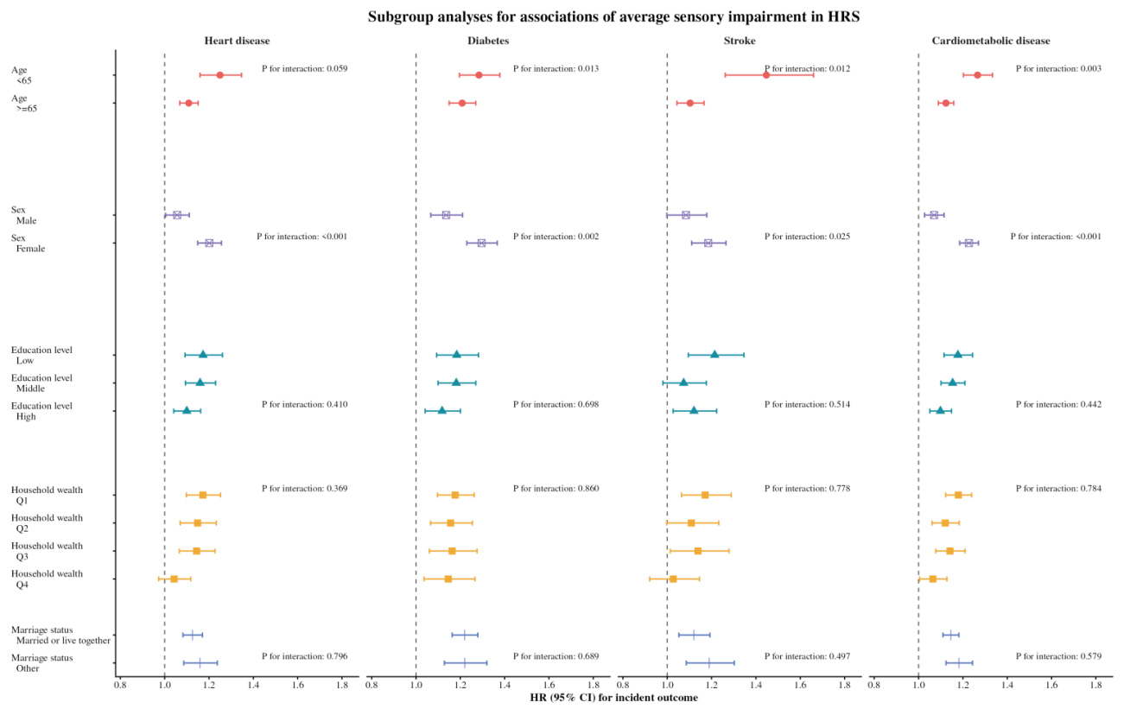
Figure S5. Subgroup analyses of the association between cumulative average dual sensory impairment and incident cardiometabolic disease in the HRS cohort.
Notes: Hazard ratios and 95% confidence intervals were estimated using fully adjusted Cox proportional hazards regression models. Subgroup analyses were conducted by age group, sex, marital status, educational attainment, household wealth, smoking status, alcohol consumption, physical activity, and selected health conditions, where applicable. P values for interaction were calculated by including the cross-product term between dual sensory impairment and each subgroup variable in the model. DSI, dual sensory impairment; CMD, cardiometabolic disease; HR, hazard ratio; CI, confidence interval.
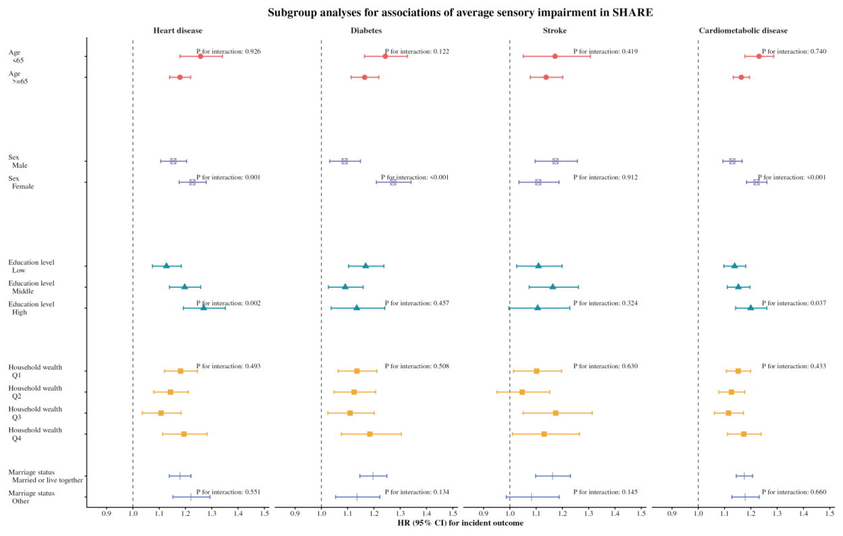
Figure S6. Subgroup analyses of the association between cumulative average dual sensory impairment and incident cardiometabolic disease in the SHARE cohort.
Notes: Hazard ratios and 95% confidence intervals were estimated using fully adjusted Cox proportional hazards regression models. Subgroup analyses were conducted by age group, sex, marital status, educational attainment, household wealth, smoking status, alcohol consumption, physical activity, and selected health conditions, where applicable. P values for interaction were calculated by including the cross-product term between dual sensory impairment and each subgroup variable in the model. DSI, dual sensory impairment; CMD, cardiometabolic disease; HR, hazard ratio; CI, confidence interval

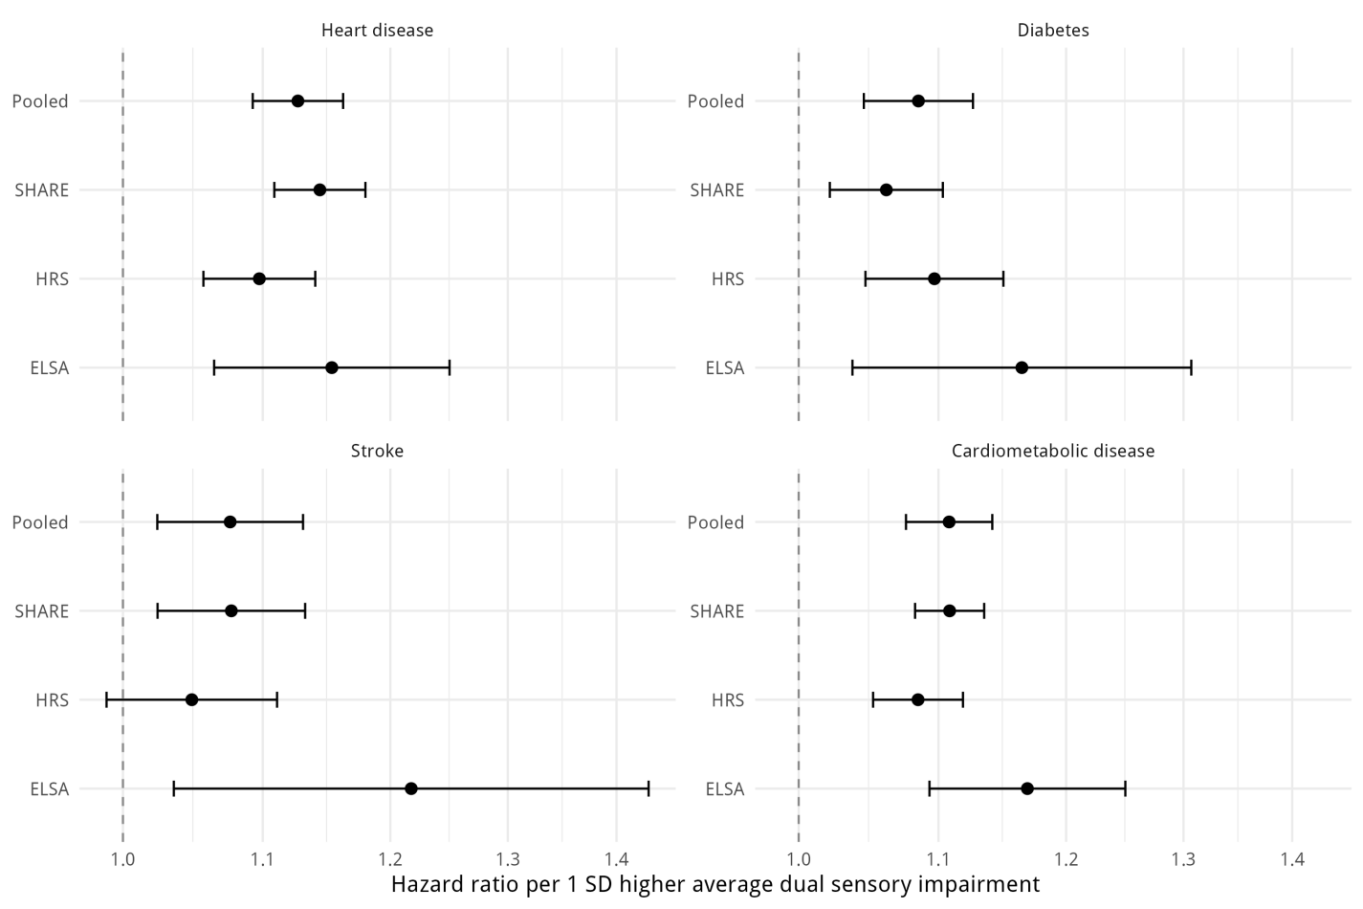
Figure S7. Forest plot of associations between cumulative average sensory impairment and incident cardiometabolic disease outcomes after excluding events occurring during the first 2 years of follow-up.
Notes: This sensitivity analysis excluded participants who developed the corresponding outcome within the first 2 years of follow-up to reduce the potential influence of undiagnosed or subclinical cardiometabolic disease at baseline and minimize reverse causation. Estimates are hazard ratios with 95% confidence intervals from fully adjusted Cox proportional hazards regression models. The vertical dashed line indicates a hazard ratio of 1.00. DSI, dual sensory impairment; CMD, cardiometabolic disease; HR, hazard ratio; CI, confidence interval.
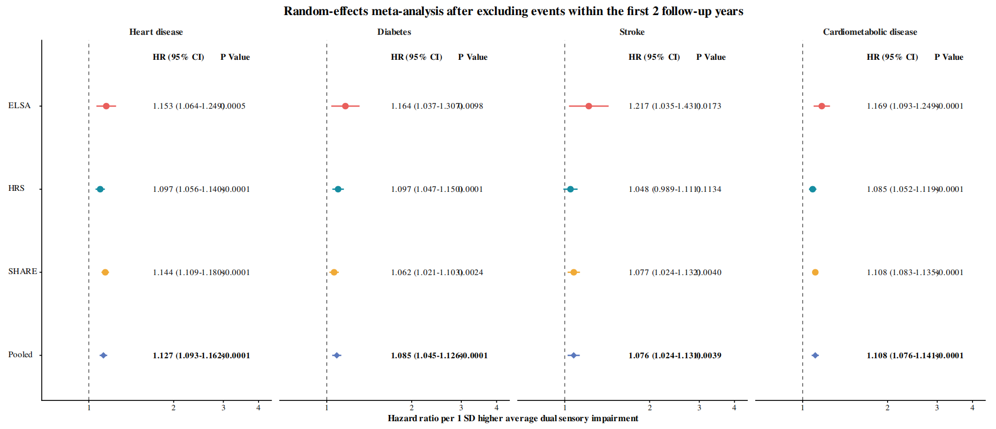
Figure S8. Random-effects meta-analysis of associations between cumulative average sensory impairment and incident cardiometabolic disease outcomes in sensitivity analyses.
Notes: Cohort-specific hazard ratios were pooled using random-effects meta-analysis. Sensitivity analyses excluded events occurring during the first 2 years of follow-up. Squares represent cohort-specific estimates, with square sizes proportional to the inverse variance of the estimates; horizontal lines indicate 95% confidence intervals; diamonds represent pooled estimates. DSI, dual sensory impairment; CMD, cardiometabolic disease; HR, hazard ratio; CI, confidence interval.

