Support Information
For
Silica Aerogel as an Active Residue Modifier in Intumescent Coatings: Balancing Thermal Insulation, Adhesion and Char Evolution

Experimental Section
Materials: Two commercial waterborne intumescent coatings, Brosteel Ultra 60 and SteelMaster 600WF White, were used as the coating matrices and are hereafter denoted as BS and SM, respectively. A commercial hydrophobic silica aerogel powder, Quartzene® Z1H1, supplied by Svenska Aerogel, was used as the thermal-insulating additive and is denoted as SA. 2-Propanol (Sigma-Aldrich, product No. 59300, 2.5 L) was used as the dispersion medium for the hydrophobic SA powder prior to its incorporation into the waterborne intumescent coatings. All materials were used as received without further purification.
Material characterizations: Fourier-transform infrared spectroscopy (FTIR) was performed using a PerkinElmer Spectrum Two spectrometer over the wavenumber range of 3500~500 cm⁻¹ to identify the characteristic functional groups of the silica aerogel and coating formulations. X-ray diffraction (XRD) patterns were recorded using a PANalytical Aeris diffractometer equipped with Cu Kα radiation over a 2θ range of 10~70° to examine the crystalline and amorphous phases present in the samples.
The surface and cross-sectional morphologies of the coatings before and after high-temperature exposure were examined using a ZEISS EVO LS15 scanning electron microscope. Elemental compositions and the spatial distributions of C, O, Si and P were analysed using an Oxford Instruments energy-dispersive X-ray spectroscopy (EDX) system coupled to the microscope. The elemental mass fractions obtained from the map-sum spectra were treated as semi-quantitative values corresponding to the selected analysis regions.
Thermogravimetric analysis (TGA) was conducted using a PerkinElmer TGA 4000 instrument. Samples were heated from 30 to 800°C at a heating rate of 10°C min⁻¹ under a nitrogen atmosphere with a gas flow rate of 20 mL min⁻¹.
Mechanical and thermal characterisation: The pull-off strength of the coatings was evaluated using a Mecmesin OmniTest 5.0 universal testing system equipped with an ELS-S 500 N load cell, following the general procedure described in ASTM D4541-22. Circular dollies with a diameter of 20 mm from a DeFelsko adhesion test kit were bonded to the coating surfaces using EP11HT grey two-component epoxy adhesive. Components A and B were mixed at a mass ratio of 1:1, and the bonded assemblies were cured at 60°C for 8 h before testing. The pull-off strength was calculated from the maximum tensile force divided by the bonded dolly area. The failure surfaces were visually examined after testing to identify adhesive, cohesive or mixed failure where applicable.
Thermal diffusivity was measured using an LFA 467 HyperFlash instrument. The specific heat capacity of the neat coating matrices and silica aerogel was measured using a PerkinElmer DSC 4000 under a nitrogen atmosphere over the temperature range of 30~50°C. The specific heat capacities of the composite coatings were subsequently estimated using a mass-weighted mixture rule. Thermal conductivity was calculated from the measured density and thermal diffusivity together with the estimated specific heat capacity according to ASTM E1461-13(2022): k=ραC_{p}.
The transient thermal-barrier behaviour of the coating–metal assemblies was evaluated using a FLIR T335 infrared camera. During thermal exposure, infrared thermograms were recorded at 5, 10, 20, 60, 90 and 120 s. The temperature at the central region of the monitored surface was extracted from each thermogram to compare the heat-transfer behaviour of coatings containing different SA loadings.
The high-temperature evolution of the coatings was investigated using a Nabertherm P330 furnace. The coated metal discs were heated in air from room temperature to 800°C at a heating rate of 10°C min⁻¹, maintained at 800°C for 20 min and then allowed to cool naturally to room temperature inside the furnace. The resulting residues were collected and examined by SEM and EDX to evaluate changes in coating thickness, char morphology and elemental distribution after high-temperature exposure.
Modelling: Two-dimensional steady-state finite element thermal simulations were performed in ANSYS Mechanical to investigate the influence of intumescent coating thickness on the thermal performance of two representative steel connection details, designated as Design 21683 and Design 21684. A parametric analysis was conducted by varying the coating thickness while maintaining identical geometry, material properties, and boundary conditions. The thermal performance of each configuration was evaluated using established thermal bridge performance indicators, including heat transfer rate, minimum internal surface temperature, temperature factor, and linear thermal transmittance (Ψ).
Steady-state thermal analyses were performed for both connection geometries under identical temperature differences, with convection boundary conditions applied according to the orientation of each design. The thermal boundary conditions applied to two designs is illustrated in Figure S1. The left boundary was exposed to an external temperature of −4 °C with a convective heat transfer coefficient of 25 W m⁻² K⁻¹, whereas the right boundary was exposed to an internal temperature of 21 °C with a convective heat transfer coefficient of 7.7 W m⁻² K⁻¹. The upper and lower boundaries were treated as adiabatic. Consequently, a temperature difference of 25 °C was maintained across both models.
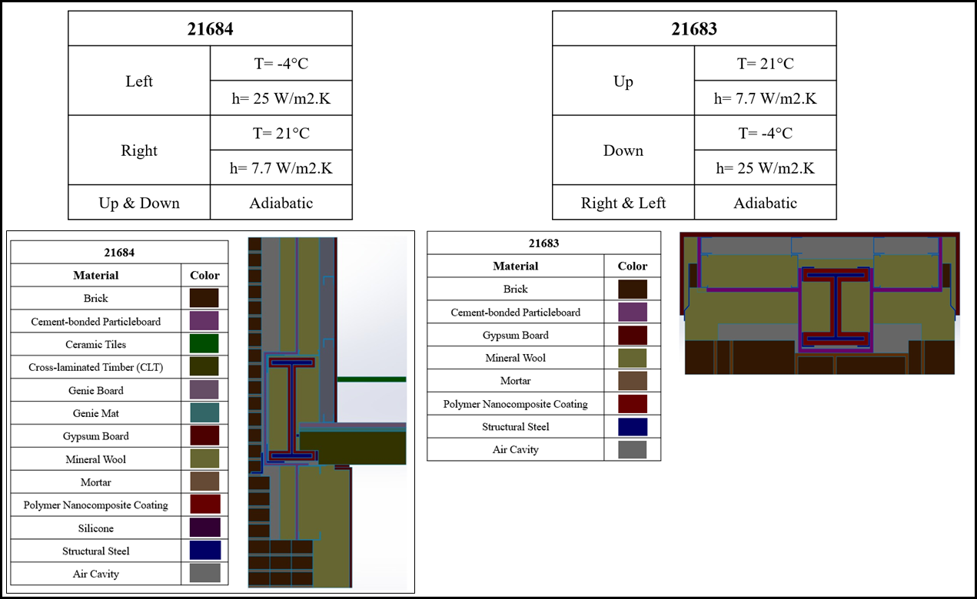
Figure S1- Geometrical Configurations, Boundary Conditions, and Material Assignments for Designs 21684 and 21683
The material properties assigned to the numerical models are summarized in Table S1 for Designs 21684 and 21683. The assemblies consisted of conventional construction materials, including masonry, insulation, timber, steel, internal air cavities, and finishing layers, with the thermal conductivity of each material assigned according to the design specifications. Structural steel exhibited the highest thermal conductivity (50 W m⁻¹ K⁻¹), making it the dominant heat transfer path among the structural materials, whereas mineral wool provided the lowest thermal conductivity (0.035 W m⁻¹ K⁻¹) and therefore acted as the primary thermal insulation layer. The intumescent coating was modelled with a thermal conductivity of 0.09 W m⁻¹ K⁻¹ to evaluate its influence on the thermal bridging behaviour. Air cavities were represented using equivalent effective thermal conductivities determined for each cavity, accounting for differences in cavity geometry and orientation.
Table S1. Thermal Conductivity of the Used Materials in the 21684 Model.
Material | Design 21684
Material | k (W m⁻¹ K⁻¹)
Brick | 0.770
Cement-bonded particleboard | 0.150
Ceramic tiles | 1.300
Cross-laminated timber (CLT) | 0.120
Genie Board | 0.300
Genie Mat | 0.133
Gypsum board | 0.250
Mineral wool | 0.035
Mortar | 0.940
Intumescent paint | 0.090
Silicone | 0.350
Structural steel | 50.0
Air cavity 1 | 0.305
Air cavity 2 | 0.380
Air cavity 3 | 0.657
Air cavity 4 | 0.271
Air cavity 5 | 0.423

A parametric study was conducted to investigate the effect of intumescent coating thickness on the thermal performance of the two connection details. The coating thickness was varied while all other modelling parameters, including the geometry, material properties, and thermal boundary conditions, were kept constant. Seven coating thicknesses were investigated: 0 mm (uncoated), 0.2 mm, 1 mm, 5 mm, 10 mm, 15 mm, and 20 mm. This approach ensured that any variation in the predicted thermal response could be attributed solely to the change in coating thickness, thereby providing a consistent basis for comparing the thermal bridging behaviour of Design 21684.
The thermal performance of each model was assessed using the performance indicators reported in accordance with thermal bridge analysis. These included the total heat transfer rate (Q), the minimum internal surface temperature (T_{s min}) , the one-dimensional thermal coupling coefficient (L_{1D}), the two-dimensional thermal coupling coefficient (L_{2D}), the linear thermal transmittance (Ψ), and the internal surface temperature factor (f_{RSI}). The total heat transfer rate quantifies the steady-state heat flow through the assembly, while T_{s min} and f_{RSI} were used to evaluate the risk of surface condensation. The additional heat transfer caused by the thermal bridge was quantified through the Ψ-value, which was determined from the difference between the two-dimensional and one-dimensional thermal coupling coefficients. These parameters were used to compare the thermal performance of the two connection designs and to assess the influence of intumescent coating thickness.
Figure S2 compares the predicted temperature distributions and total heat flux contours for the uncoated connection and the connection protected with a 20 mm intumescent coating for the 21684 design. The temperature contours (Figures S2(a) and S2(b)) show that the overall temperature field within the wall assembly changes only slightly after the application of the coating, indicating that the global thermal behaviour of the envelope remains largely unaffected. However, a closer examination of the steel connection reveals a smoother temperature gradient and a slight increase in the internal surface temperature adjacent to the thermal bridge. This behaviour is consistent with the increase in the calculated minimum surface temperature and fRSI presented in Table 2, confirming that the coating primarily influences the localized conductive heat transfer through the steel member.
The total heat flux contours (Figures S2(c) and S2(d)) provide further insight into the mechanism responsible for the improved thermal performance. In both cases, the highest heat flux is concentrated around the exposed steel connection, confirming that this region forms the dominant thermal bridge within the assembly. After applying the 20 mm intumescent coating, the magnitude of the localized heat flux concentration is visibly reduced while the heat flow path becomes more uniformly distributed around the steel section. This reduction in localized heat transfer agrees well with the numerical reductions in total heat transfer rate and linear thermal transmittance. The contour plots therefore demonstrate that the principal benefit of the intumescent coating under ambient service conditions is not a substantial modification of the overall wall temperature distribution, but rather the reduction of localized heat transfer through the steel connection, thereby mitigating the severity of the thermal bridge.
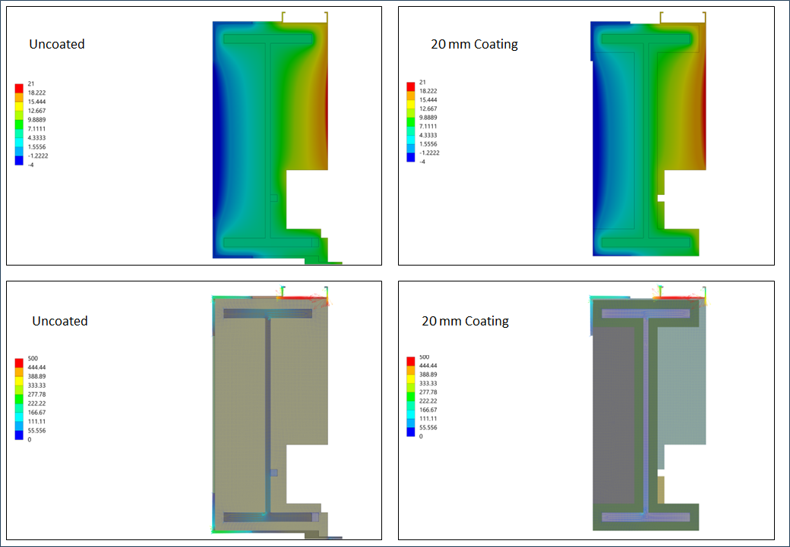
Figure S2- Comparison of the predicted temperature distributions and total heat flux contours for Design 21684 with and without a 20 mm intumescent coating.
Figure S3 compares the predicted temperature distributions and total heat flux contours for the uncoated connection and the connection protected with a 20 mm intumescent coating. As in Design 21684, the application of the coating has only a limited influence on the overall temperature field of the wall assembly, indicating that the global thermal behaviour remains largely unchanged. Nevertheless, the contours reveal a smoother temperature gradient around the steel connection together with a reduction in the localized heat flux concentration. These qualitative observations agree well with the numerical results and confirm that the principal effect of the coating is the mitigation of localized thermal bridging rather than a substantial modification of the overall thermal response of the wall.
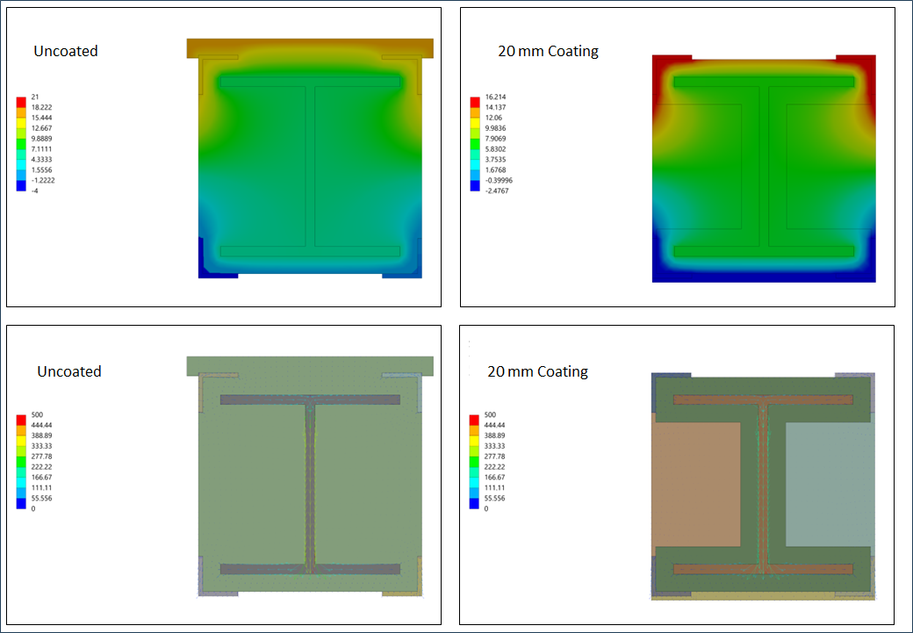
Figure S3- Comparison of the predicted temperature distributions and total heat flux contours for Design 21683 with and without a 20 mm intumescent coating.
Comparative Performance of the Two Structural Connection Designs:
Although both connection details exhibit similar trends with increasing intumescent coating thickness, their quantitative responses differ considerably because of their distinct thermal bridge characteristics. Design 21683 consistently produces a lower total heat transfer rate than Design 21684 throughout the investigated thickness range. However, this lower heat flow does not indicate superior thermal bridge performance.
A comparison of the linear thermal transmittance demonstrates that Design 21684 performs substantially better in mitigating localized thermal bridging. The Ψ-value of Design 21683 remains considerably higher for every coating thickness investigated, decreasing from 0.192 W/m·K to 0.158 W/m·K, whereas Design 21684 achieves a reduction from 0.061 W/m·K to only 0.027 W/m·K. Similarly, Design 21684 consistently exhibits higher minimum internal surface temperatures and larger temperature factors, indicating a lower risk of localized condensation and improved hygrothermal performance.
These differences arise from the distinct heat-flow mechanisms within the two connection geometries. In Design 21684, heat transfer is concentrated primarily through the exposed steel connection, allowing the low-conductivity intumescent coating to interrupt a significant proportion of the conductive heat path. In contrast, Design 21683 contains a more distributed conduction network, so increasing the thermal resistance around the steel member reduces only part of the overall thermal bridge. Consequently, although both designs benefit from thicker coatings, the reduction in Ψ-value is substantially greater for Design 21684.
From an engineering perspective, these results indicate that connection geometry has a greater influence on thermal bridge performance than coating thickness alone. Intumescent coatings provide measurable improvements under ambient service conditions and should therefore be regarded as an effective supplementary measure for reducing thermal bridging. However, achieving the greatest improvement requires optimizing the structural connection itself, with the coating serving to further enhance the thermal performance of an already well-designed detail.

