Figure S1
Network Structure with Communities Identified via Louvain Algorithm
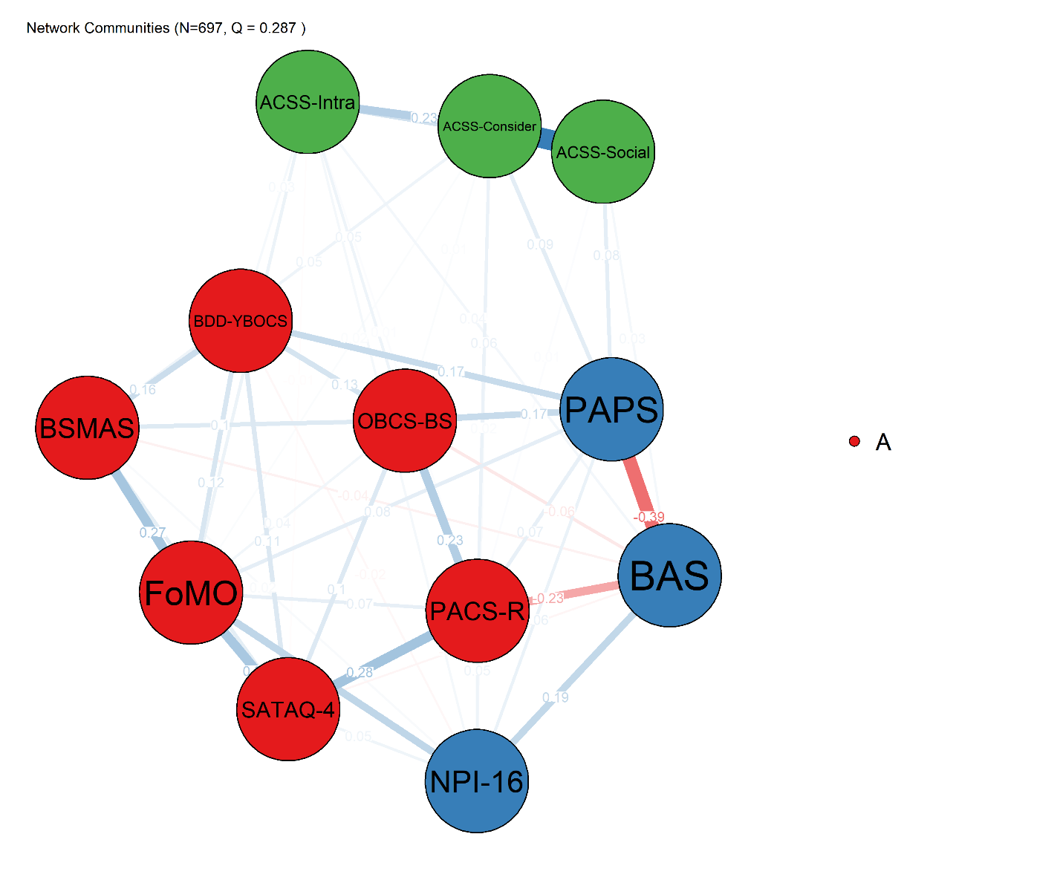
Note. Network visualization with communities identified via the Louvain algorithm. Nodes are color-coded by community membership: Red = Clinical/Social Community (BDD-YBOCS, OBCS-BS, BSMAS, FoMO, PACS-R, SATAQ-4); Blue = Perfectionism/Positive Community (PAPS, BAS, NPI-16); Green = ACSS/Future Surgery Community (ACSS_Intrapersonal, ACSS_Social, ACSS_Consider). Modularity Q = 0.287 indicates limited community differentiation. Blue edges = positive associations; red edges = negative associations.

Figure S2
Centrality Indices
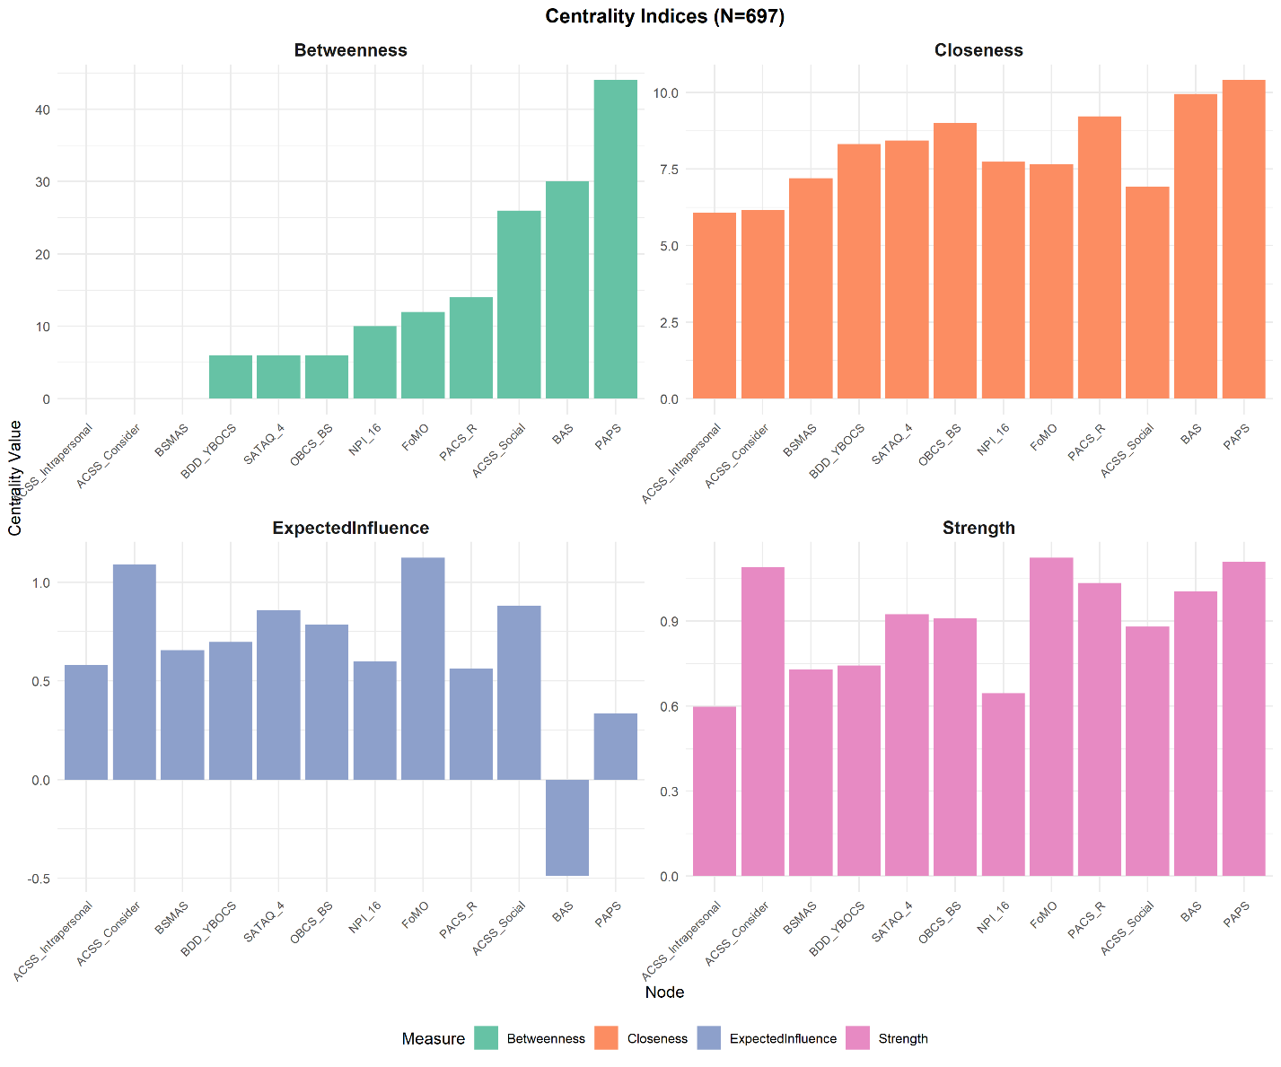
Note. Standardized centrality estimates for all 12 nodes. Panels display (A) Strength centrality, (B) Expected Influence, (C) Closeness centrality, and (D) Betweenness centrality. Higher values indicate greater centrality within the network. CS = correlation stability coefficient; EI = expected influence.

Figure S3
Bridge Centrality Indices
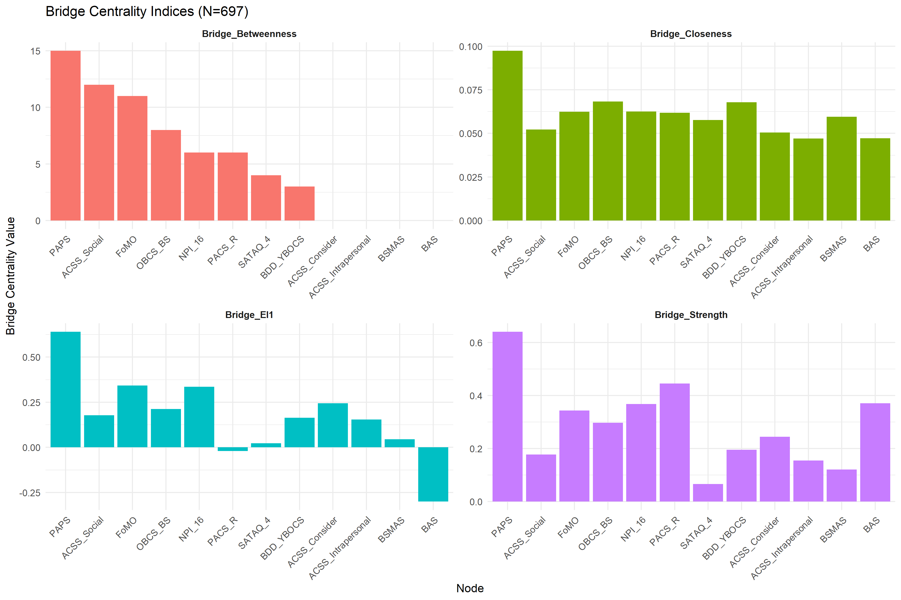
Note. Bridge centrality estimates for all 12 nodes. Panels display (A) Bridge Strength, (B) Bridge Betweenness, (C) Bridge Closeness, and (D) Bridge Expected Influence (1-step). Bridge centrality identifies nodes that connect different empirically derived communities. Higher values indicate greater bridging potential between communities.

Figure S4
Node Predictability (R²) of Each Node
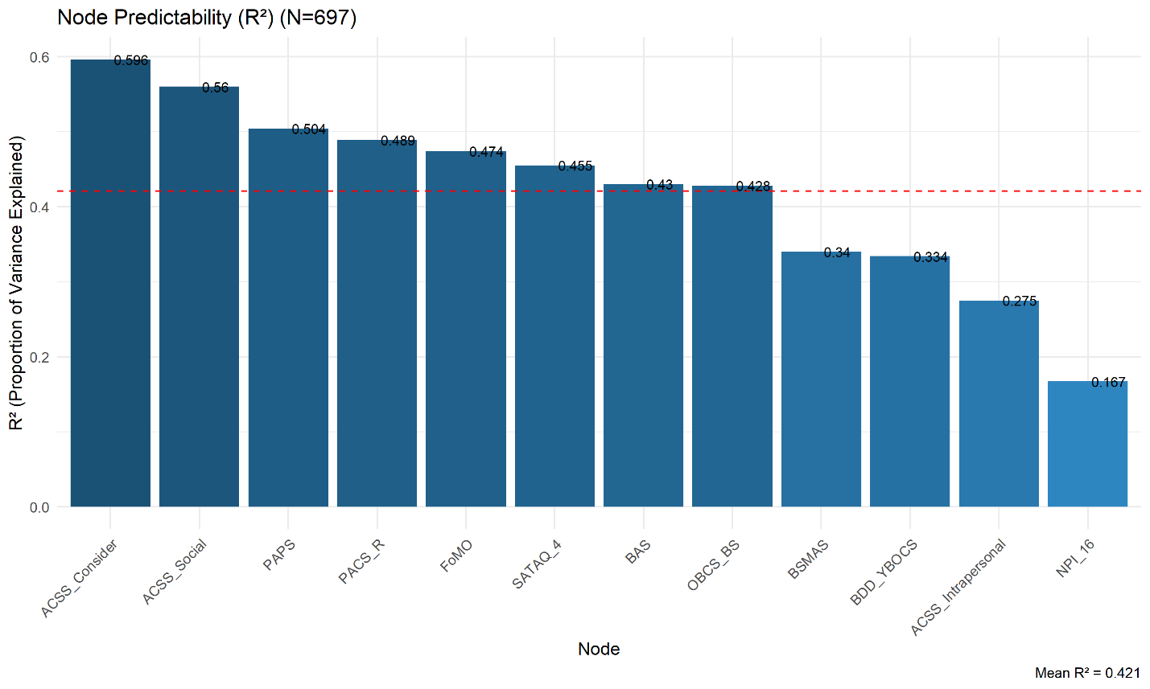
Note. Predictability values represent the proportion of variance in each node explained by its neighboring nodes in the network. Higher R² values indicate greater embeddedness within the network structure. ACSS = Attitudes Toward Cosmetic Surgery Scale; PAPS = Physical Appearance Perfectionism Scale; BAS = Body Appreciation Scale; FoMO = Fear of Missing Out Scale; PACS-R = Physical Appearance Comparison Scale; SATAQ-4 = Sociocultural Attitudes Toward Appearance Questionnaire; BSMAS = Social Media Addiction Scale; BDD-YBOCS = Body Dysmorphic Disorder Scale; NPI-16 = Narcissistic Personality Inventory; OBCS-BS = Body Shame Scale.

Figure S5
Subnetwork Connected to Future Surgery Intention
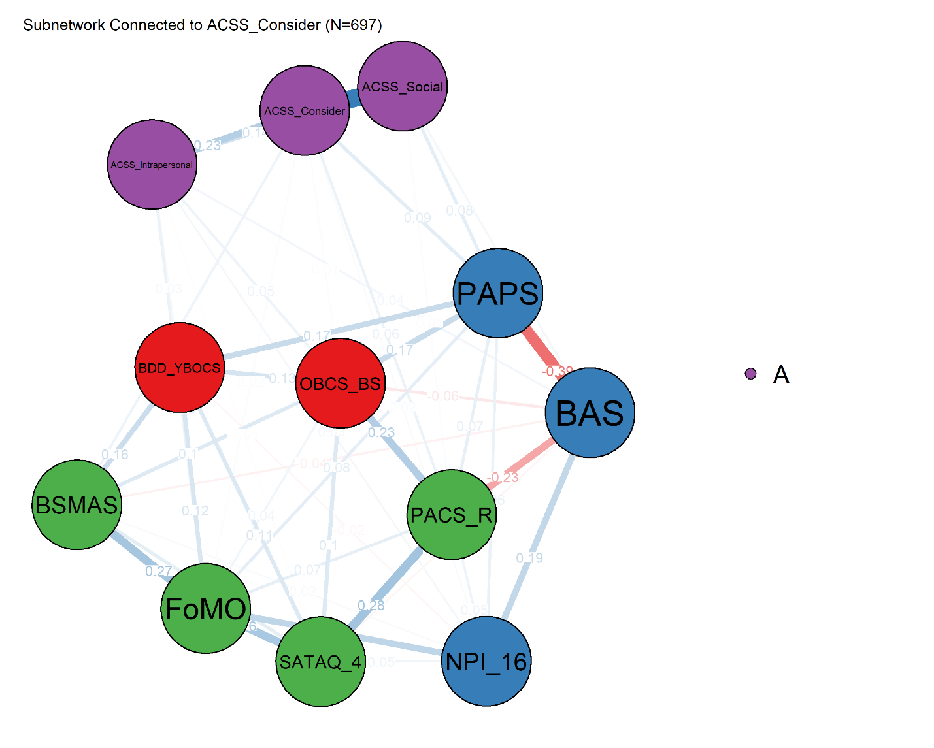
Note. Subnetwork visualization showing only nodes that have direct or indirect connections to ACSS-Consider. Nodes without any path to the outcome are excluded. This visualization clarifies the network pathways relevant to cosmetic surgery intention. Edge thickness represents distance (d = 1/|w|); shorter distances (thicker edges) indicate more direct routes.

Figure S6
Highlighted Edges to Future Surgery Intention
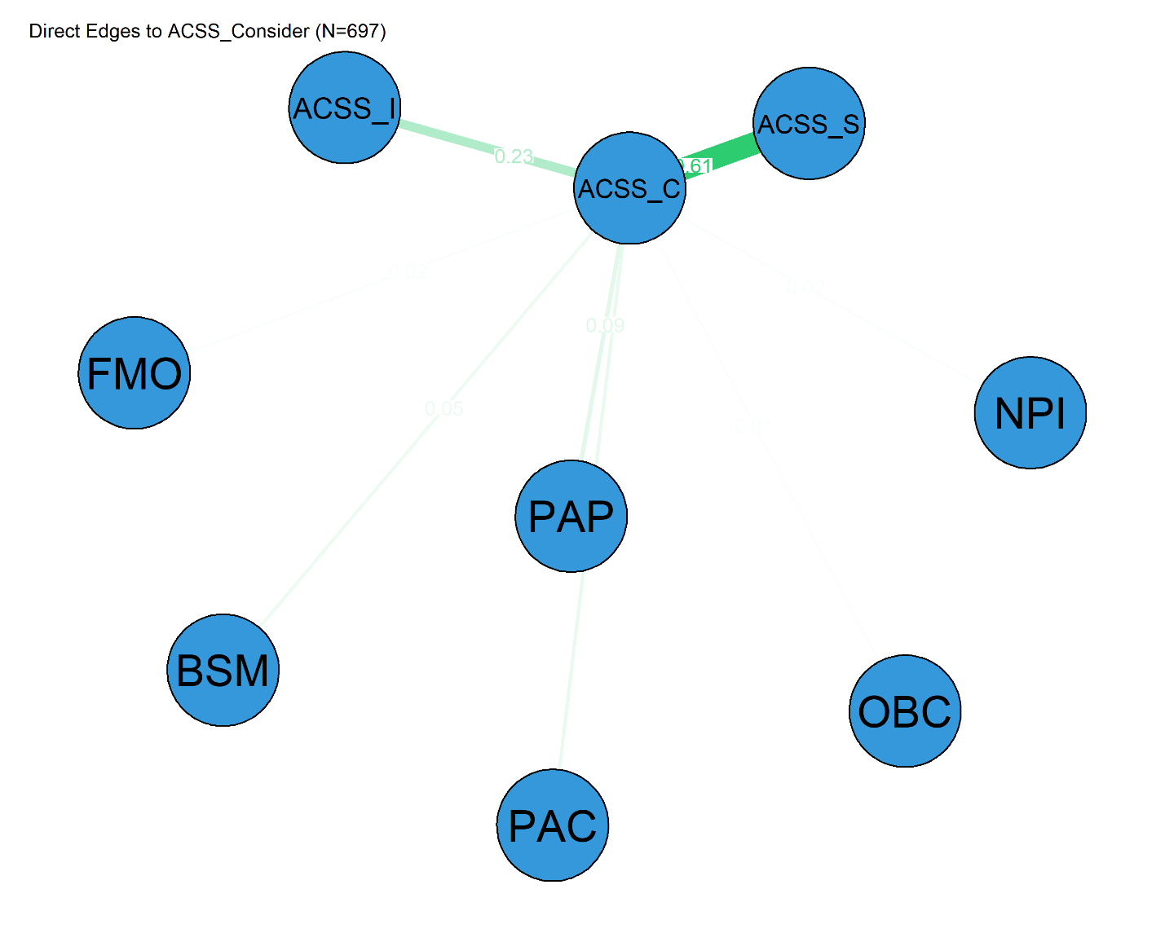
Note. Network visualization highlighting direct edges connecting each node to Future Surgery Intention (ACSS_Consider). Edge thickness represents weight magnitude. This visualization identifies direct associations with the outcome variable. Red edges indicate negative associations; green edges indicate positive associations.

Figure S7
Shortest Paths to Future Surgery Intention
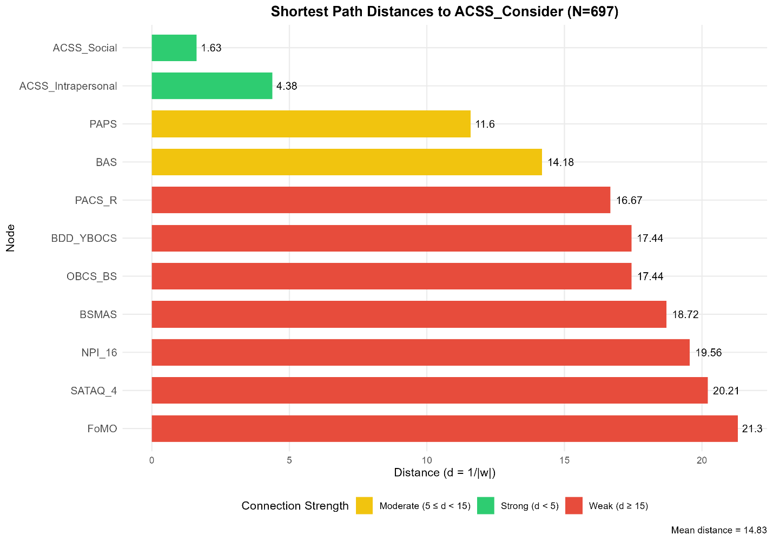
Note. Bar plot displaying the shortest path distances from each node to ACSS_Consider (Appearance Evaluation). Distances were calculated as d = 1/|w|, where w represents edge weights in the network. Shorter distances (bars on the left) indicate stronger topological connections to ACSS_Consider. Colors represent distance categories: Green = Strong connection (d < 5), Yellow = Moderate connection (5 ≤ d < 15), Red = Weak connection (d ≥ 15). FoMO (d = 21.303) showed the longest distance, followed by SATAQ_4 (d = 20.209), indicating weaker topological connections to future procedure intention. The mean shortest path distance was 14.83.

Figure S8
Network comparison test results across demographic, gender, and surgery subgroups.
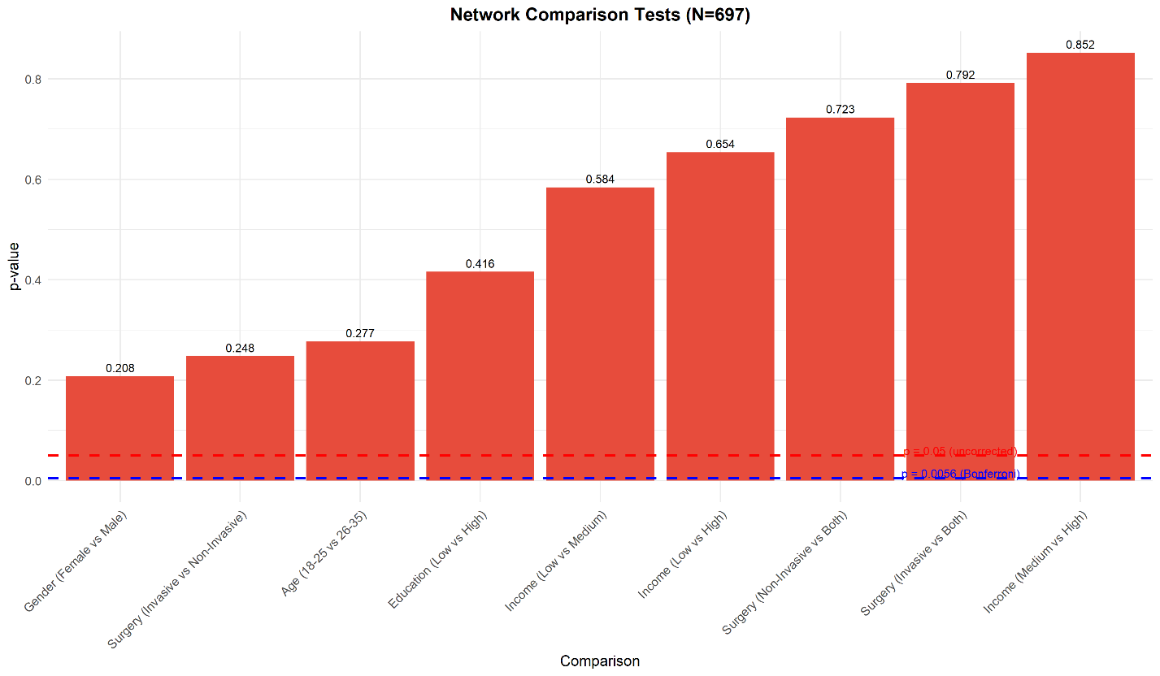
Note: Panel A displays the network structure invariance statistic (M) for each comparison; Panel B displays corresponding p-values. The dashed red line indicates the Bonferroni-corrected threshold (p = 0.0056). None of the comparisons reached statistical significance after correction. L-M = Low vs Medium income; L-H = Low vs High income; M-H = Medium vs High income; F-M = Female vs Male; I-N = Invasive Only vs Non-Invasive Only; I-B = Invasive Only vs Both; N-B = Non-Invasive Only vs Both.

Table S1
Demographic Characteristics of Participants (N = 697)
Characteristic | n | %
Gender
Female | 481 | 69.0
Male | 216 | 31.0
Education
Below diploma | 14 | 2.0
Diploma | 145 | 20.8
Associate degree | 59 | 8.5
Bachelor's degree | 292 | 41.9
Master's degree | 154 | 22.1
Doctorate | 33 | 4.7
Occupation
Student | 341 | 48.9
Full-time employed | 128 | 18.4
Part-time employed | 121 | 17.4
Unemployed | 107 | 15.4
Marital Status
Single without partner | 328 | 47.1
Single with partner | 175 | 25.1
Married | 178 | 25.5
Divorced | 16 | 2.3
Household Income
Below 15 million tomans | 92 | 13.2
15–30 million tomans | 174 | 25.0
30–50 million tomans | 212 | 30.4
50–100 million tomans | 147 | 21.1
Above 100 million tomans | 72 | 10.3
Cosmetic Surgery History
Ever undergone invasive surgery | 472 | 67.7
Ever undergone non-invasive procedures | 449 | 64.4
Surgery Group Classification
Invasive surgery only | 225 | 32.3
Non-invasive procedures only | 248 | 35.6
Both invasive and non-invasive | 224 | 32.1
Note. Age ranged from 18 to 55 years (M = 27.42, SD = 8.46). Income values are in Iranian tomans. Surgery group classification sums to 697. Percentages may not sum to 100% due to rounding.

Table S2
Reliability Coefficients and Sample Items for All Measures
Scale | Original α | Persian α | Sample Item(s)
PAPS | .83  (subscales .85, .80) | .90  (subscales .90, .89) | "I worry that my appearance is not good enough" (Worry About Imperfection); "I hope that I look attractive" (Hope for Perfection)
FoMO | .90 | .85 | "I fear that others have more rewarding experiences than I do"
ACSS | .89 | .94 | "I may have some form of cosmetic surgery in the future"
BAS | .94 | .87 | "I have a positive attitude towards my body"
BDD-YBOCS | .80 | .93 | "How much do your thoughts about body defect(s) interfere with your social or work functioning?"
OBCS-BS | .75 | .75 | "When I can't control my weight, I feel like something must be wrong with me"
NPI-16 | .80 | .79 | "I am an extraordinary person" vs. "I am much like  everybody else"
SATAQ-4 | _ | _ | "I feel pressure from my family to improve my appearance"
PACS-R | .97 | .97 | "When I'm at a party, I compare my body shape to the body shape of others"
BSMAS | .88 | .86 | "How often during the last year have you felt an urge to use social media more and more?"
Note. α = Cronbach’s alpha. Dashes indicate that the coefficient was not reported for the scale or subscales used. For SATAQ-4, only selected subscales were used in the present study; therefore, coefficients for the full scale are not reported. Full scale names are provided in the text.

Table S3
Reliability Coefficients (Cronbach's α and McDonald's ω) with 95% Bootstrap Confidence Intervals (N=697)
Scale | k | Cronbach's α | 95% CI | McDonald's ω | 95% CI
Physical Appearance Comparison Scale | 11 | 0.961 | [0.956, 0.966] | 0.962 | [0.958, 0.967]
Body Appreciation Scale | 13 | 0.931 | [0.922, 0.938] | 0.936 | [0.928, 0.944]
Fear of Missing Out Scale | 10 | 0.890 | [0.874, 0.903] | 0.892 | [0.876, 0.906]
Sociocultural Attitudes Toward Appearance Questionnaire | 11 | 0.888 | [0.870, 0.904] | 0.892 | [0.874, 0.908]
Body Dysmorphic Disorder Scale | 12 | 0.870 | [0.854, 0.884] | 0.881 | [0.864, 0.896]
Physical Appearance Perfectionism Scale | 12 | 0.862 | [0.846, 0.877] | 0.863 | [0.846, 0.879]
ACSS_Social | 5 | 0.821 | [0.794, 0.844] | 0.824 | [0.796, 0.848]
Social Media Addiction Scale | 6 | 0.809 | [0.782, 0.834] | 0.809 | [0.781, 0.834]
ACSS_Intrapersonal | 5 | 0.714 | [0.676, 0.747] | 0.738 | [0.702, 0.771]
Narcissistic Personality Inventory | 16 | 0.764 | [0.734, 0.792] | 0.722* | —
Body Shame Scale | 8 | 0.749 | [0.721, 0.777] | 0.761 | [0.732, 0.788]
ACSS_Consider | 5 | 0.759 | [0.727, 0.786] | 0.765 | [0.735, 0.792]
Note. For the dichotomously scored NPI-16, KR-20 = 0.722 is reported instead of McDonald's ω. k = number of items.

Table S4
Descriptive Statistics for All Study Scales (N = 697)
Scale | M | SD | Range | Skewness | Kurtosis
Body Dysmorphic Disorder Scale | 31.555 | 4.691 | 12–60 | 0.760 | 1.384
Body Shame Scale | 31.519 | 8.481 | 8–56 | -0.039 | -0.078
Physical Appearance Perfectionism Scale | 51.024 | 14.276 | 12–60 | -0.014 | -0.362
Body Appreciation Scale | 49.822 | 9.878 | 13–65 | -0.647 | 0.143
Narcissistic Personality Inventory | 5.828 | 3.013 | 0–16 | 0.498 | -0.267
Social Media Addiction Scale | 17.459 | 4.074 | 6–30 | 0.705 | 0.062
Fear of Missing Out Scale | 23.139 | 8.645 | 10–50 | 0.649 | -0.173
Physical Appearance Comparison Scale | 28.561 | 11.488 | 11–55 | 0.337 | -0.685
Sociocultural Attitudes Toward Appearance Questionnaire | 28.707 | 6.935 | 11–55 | 1.220 | 1.207
ACSS_Intrapersonal | 23.337 | 5.188 | 5–35 | -0.561 | 0.029
ACSS_Social | 25.082 | 6.692 | 5–35 | -0.605 | -0.059
ACSS_Consider | 23.022 | 6.785 | 5–35 | -0.275 | -0.457
Note. Range indicates theoretical minimum and maximum for each scale based on item response options. All skewness and kurtosis values were within acceptable ranges for approximate normality (|skewness| < 2, |kurtosis| < 7; Hair et al., 2019).

Table S5
Ten Strongest Edges in the Network (N=697)
Rank | Edge | Weight
1 | ACSS_Social – ACSS_Consider | 0.614
2 | PAPS – BAS | -0.387
3 | PACS_R – SATAQ_4 | 0.283
4 | BSMAS – FoMO | 0.273
5 | FoMO – SATAQ_4 | 0.263
6 | BAS – PACS_R | -0.235
7 | OBCS_BS – PACS_R | 0.233
8 | ACSS_Intrapersonal – ACSS_Consider | 0.228
9 | NPI_16 – FoMO | 0.197
10 | BAS – NPI_16 | 0.186
Note. Edge weights represent regularized partial correlation coefficients after graphical LASSO regularization. Positive weights indicate positive associations; negative weights indicate inverse associations. All edges are non-zero and stable (95% CI does not cross zero). ACSS = Attitudes Toward Cosmetic Surgery Scale; PAPS = Physical Appearance Perfectionism Scale; BAS = Body Appreciation Scale; PACS_R = Physical Appearance Comparison Scale; SATAQ_4 = Sociocultural Attitudes Toward Appearance Questionnaire; BSMAS = Social Media Addiction Scale; FoMO = Fear of Missing Out Scale; OBCS_BS = Body Shame Scale; NPI_16 = Narcissistic Personality Inventory.

Table S6
Community Membership (Louvain Algorithm) (N=697)
Node | Community
BDD_YBOCS | 1
OBCS_BS | 1
BSMAS | 1
FoMO | 1
PACS_R | 1
SATAQ_4 | 1
PAPS | 2
BAS | 2
NPI_16 | 2
ACSS_Intrapersonal | 3
ACSS_Social | 3
ACSS_Consider | 3
Note. Communities identified via Louvain algorithm with absolute edge weights. Modularity Q = 0.287.

Table S7
Correlation Stability Coefficients for Centrality and Bridge Centrality (N=697)
Index | CS Coefficient
Centrality
Strength | 0.750
Expected Influence | 0.750
Closeness | 0.439
Betweenness | 0.205
Bridge Centrality
Bridge Strength | 0.750
Bridge Expected Influence | 0.750
Bridge Closeness | 0.439
Bridge Betweenness | 0.000
Note. CS coefficients > 0.50 indicate good stability; > 0.25 indicate acceptable stability. Values below 0.25 indicate poor stability and should not be interpreted. Following Epskamp et al. (2018), betweenness centrality (CS = 0.205) and bridge betweenness (CS = 0.000) were excluded from interpretation.

Table S8
Shortest Path Details to ACSS_Consider (N=697)
Rank | Node | Path | Distance
1 | ACSS_Social | ACSS_Social → ACSS_Consider | 1.630
2 | ACSS_Intrapersonal | ACSS_Intrapersonal → ACSS_Consider | 4.383
3 | PAPS | PAPS → ACSS_Consider | 11.598
4 | BAS | BAS → PAPS → ACSS_Consider | 14.182
5 | PACS_R | PACS_R → ACSS_Consider | 16.672
6 | BDD_YBOCS | BDD_YBOCS → PAPS → ACSS_Consider | 17.436
7 | OBCS_BS | OBCS_BS → PAPS → ACSS_Consider | 17.441
8 | BSMAS | BSMAS → ACSS_Consider | 18.717
9 | NPI_16 | NPI_16 → BAS → PAPS → ACSS_Consider | 19.561
10 | SATAQ_4 | SATAQ_4 → PACS_R → ACSS_Consider | 20.209
11 | FoMO | FoMO → ACSS_Intrapersonal → ACSS_Consider | 21.303
Note. Distances represent the sum of inverse absolute edge weights (d = 1/|w|) along the shortest path from each node to ACSS_Consider. Shorter distances indicate stronger topological connections (i.e., stronger indirect associations). Edge signs along each path are reported separately in the text. Mean shortest path distance = 14.83.

Table S9
Network Comparison Test Results Across Subgroups (N=697)
Comparison | M | p-value | Global Strength Invariance | p-value
Demographic
Age: 18-25 vs 26-35 | 0.201 | 0.277 | 0.510 | 0.337
Education: Low vs High | 0.219 | 0.416 | 0.180 | 0.693
Income: Low vs Medium | 0.233 | 0.584 | 1.329 | 0.426
Income: Low vs High | 0.278 | 0.654 | 1.450 | 0.465
Income: Medium vs High | 0.221 | 0.852 | 0.120 | 0.881
Gender
Female vs Male | 0.193 | 0.208 | 0.017 | 0.970
Surgery History
Invasive Only vs Non-Invasive Only | 0.230 | 0.248 | 0.327 | 0.584
Invasive Only vs Both | 0.157 | 0.792 | 0.011 | 0.990
Non-Invasive Only vs Both | 0.167 | 0.723 | 0.316 | 0.396
Note. M = Network structure invariance test statistic; Global Strength Invariance = Difference in global strength between groups. Bonferroni-corrected alpha level = 0.0056 (0.05/9). None of the comparisons reached statistical significance after correction. All p-values are unadjusted.

