Sustainable synthesis of CuO-SnO₂ composite nanoparticles: In Vitro Biological and In Silico studies
Mullai vendhan Sivamani and Devikala Sundaramurthy*.
Department of Chemistry, College of Engineering and Technology, SRM Institute of Science and Technology, Kattankulathur-603 203, Tamil Nadu, India.
Corresponding author email: devikals@srmist.edu.in

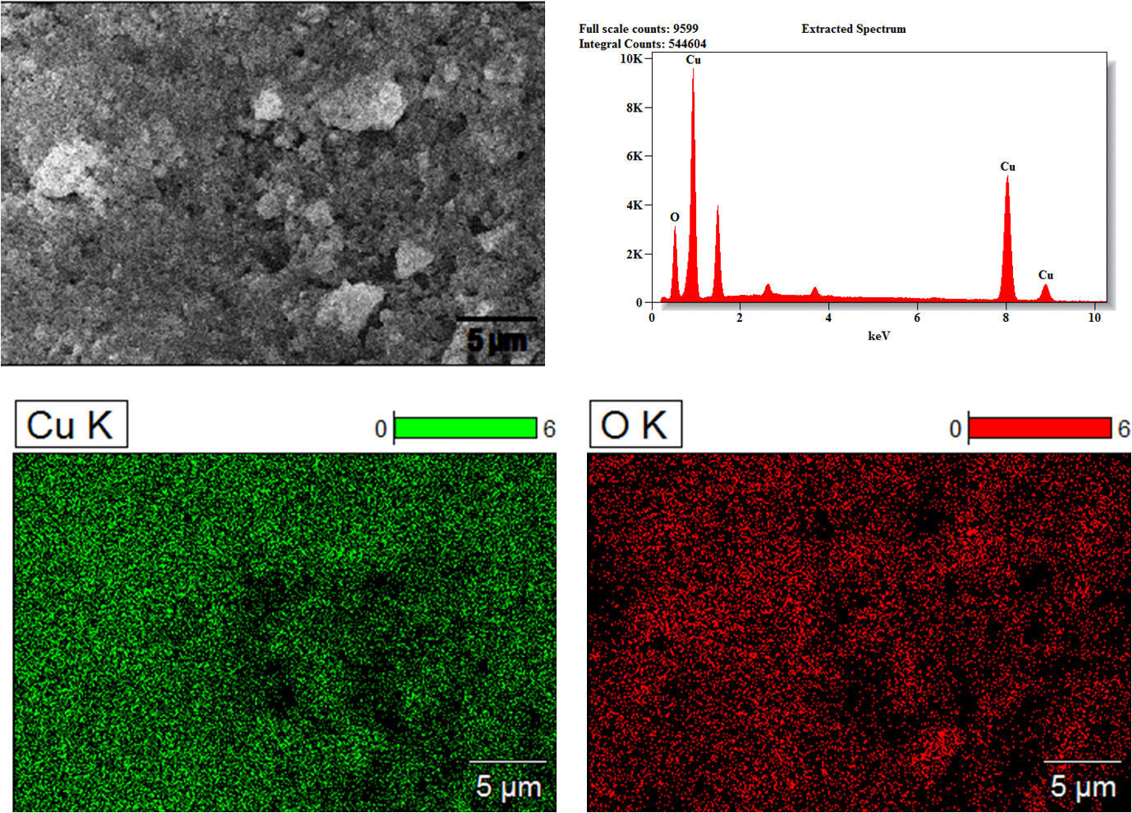
Fig. S1. CuO SEM EDX Elemental analysis
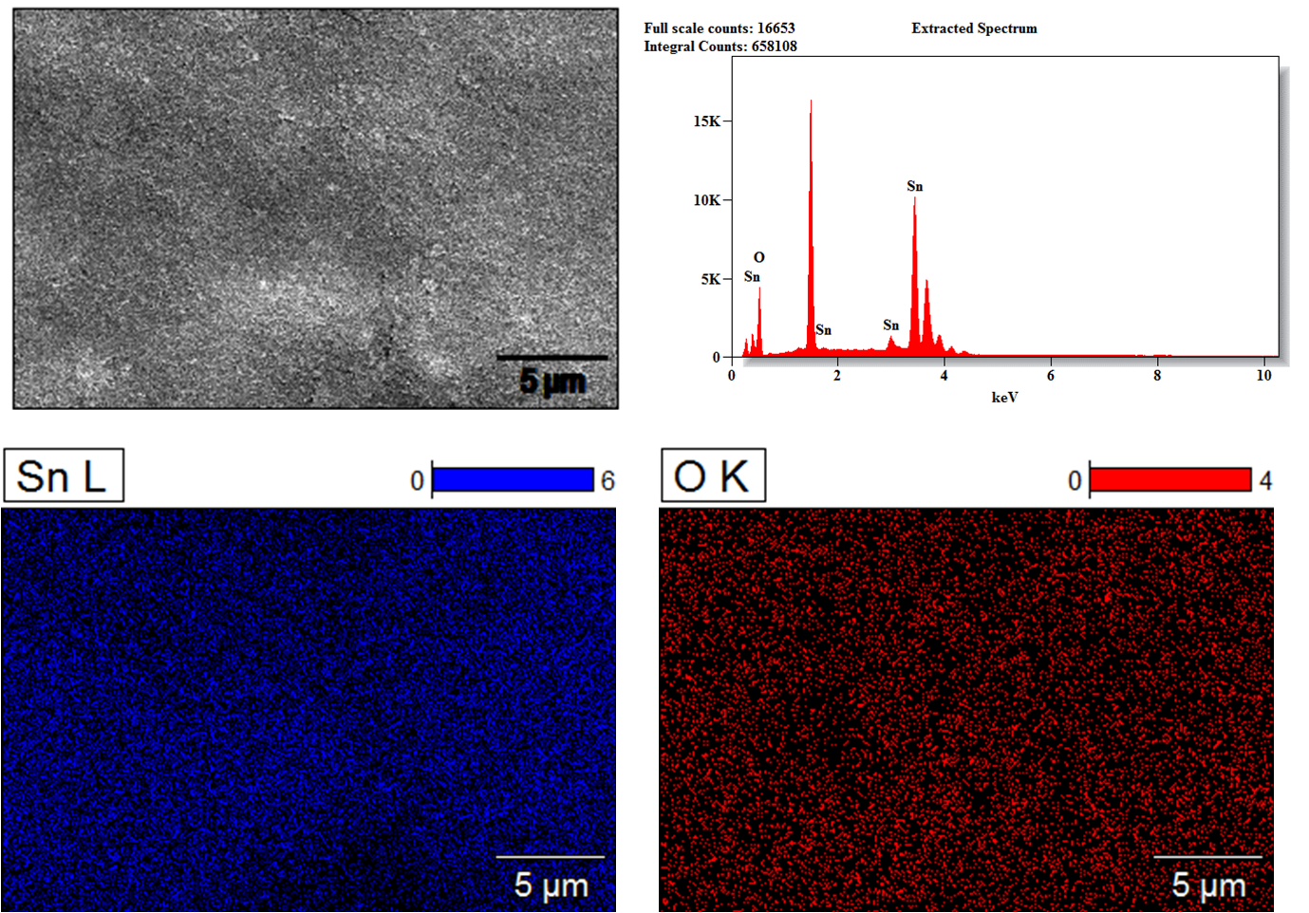
Fig. S2. SnO₂ SEM EDX Elemental analysis
Fig. S3. Two-way ANOVA of CuO-SnO₂ composite & Ascorbic acid
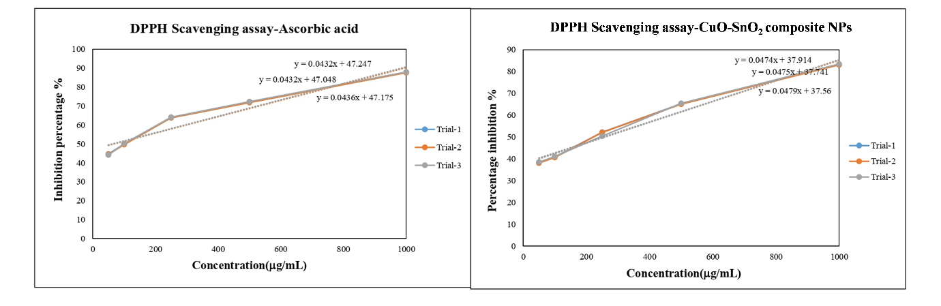
Fig. S4. DPPH inhibition Linear regression analysis of CuO-SnO₂ composite & Ascorbic acid
Fig. S5. One-Way ANOVA CuO-SnO₂ composite nanoparticles in % viability triplicates
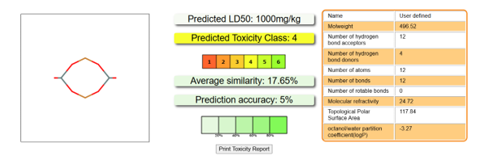
Fig. S6. PRO TOX-III results of CuO-SnO₂ composite nanoparticles

