Democracy, Far Right Populism and Climate Policy

Supporting Information

Table S1. Descriptive statistics | 2
Figure S1. Democracy scores over time 2007-2023 (demo index, Freedom house), EU countries | 3
Figure S2. Democracy scores over time 2007-2023 (dmo index scores, Freedom house), noEU countries | 4
Figure S3. Democracy scores over time 2007-2023 (V-dem data), EU countries | 5
Figure S4. Democracy scores over time 2007-2023 (V-dem data), nonEU countries | 6
Table S2. Climate Policy, Support for far-right populist parties and Democracy | 7
Figure S5. Exposure distribution by regime type | 8
Figure S6. Corruption distribution by regime type | 9

Table S1. Descriptive statistics
 | (1) | (2) | (3) | (4) | (5)
VARIABLES | N | mean | sd | min | max
year | 970 |  |  | 2,007 | 2,023
RR vote share | 958 | 10.47 | 14.50 | 0 | 64
Climate Policy | 964 | 9.716 | 4.232 | 0 | 20
RR vote share (lagged) | 897 | 9.475 | 13.61 | 0 | 64
EU years | 936 | 13.60 | 19.36 | 0 | 65
Democracy scores (prrating, source: FreedomHomuse) | 970 | 5.660 | 2.002 | 1 | 7
Democracy scores (clrating, source: FreedomHomuse) | 970 | 5.686 | 1.759 | 1 | 7
GDP | 970 | 41,601 | 23,722 | 4,380 | 138,678
GINI | 731 | 33.23 | 6.117 | 23.20 | 63.40
Vulnerability | 970 | 0.349 | 0.0492 | 0.251 | 0.529
Exposure | 970 | 0.403 | 0.0654 | 0.273 | 0.572
Capacity | 970 | 0.374 | 0.110 | 0.184 | 0.700
Sensitivity | 970 | 0.272 | 0.0621 | 0.142 | 0.476
Corruption | 970 | 0.290 | 0.282 | 0 | 0.930
Liberal Democracy Index | 970 | 0.596 | 0.278 | 0.0200 | 0.900
Participatory Democracy Index | 970 | 0.476 | 0.222 | 0.0200 | 0.810
Deliberative Democracy Index | 970 | 0.584 | 0.264 | 0.0200 | 0.880
Egalitarian Democracy Index | 970 | 0.581 | 0.252 | 0.0800 | 0.890
Party System Democracy Index | 192 | 0.713 | 0.293 | 0 | 1
Electoral Democracy Index | 970 | 0.684 | 0.269 | 0.0200 | 0.920
Neopatrimonial Rule Index | 970 | 0.269 | 0.290 | 0.01000 | 0.980
Exclusion by Social Group Index | 970 | 0.190 | 0.200 | 0.01000 | 0.790
Exclusion by Gender Index | 970 | 0.173 | 0.197 | 0.01000 | 0.920
country_num | 970 | 30.75 | 17.32 | 1 | 60
Notes. Summary statistics for all variables used in the analysis, pooling all available country-years (2007–2023; N up to 970 country-years across 60 countries). RR vote share is the un-lagged populist radical right vote share; RR vote share (lagged) is the one-year-lagged measure used in the regression models. Vulnerability, Exposure, Capacity, and Sensitivity are components of the ND-GAIN climate vulnerability index. Corruption is V-Dem's political corruption index (v2x_corr). The V-Dem democracy indices (Liberal, Participatory, Deliberative, Egalitarian, Party System, Electoral, Neopatrimonial Rule, Exclusion by Social Group, Exclusion by Gender) range from 0 to 1.
Figure S1. Democracy scores over time 2007-2023 (demo index, Freedom house), EU countries

Figure S2. Democracy scores over time 2007-2023 (demo index, Freedom house), nonEU countries
Note. Figs. S1 and S2 display democracy scores (Freedom House political-rights and civil-liberties average, 1–7 scale) for EU and non-EU countries, respectively, 2007–2023.
Figure S3. Democracy scores over time 2007-2023 (V-dem data), EU countries
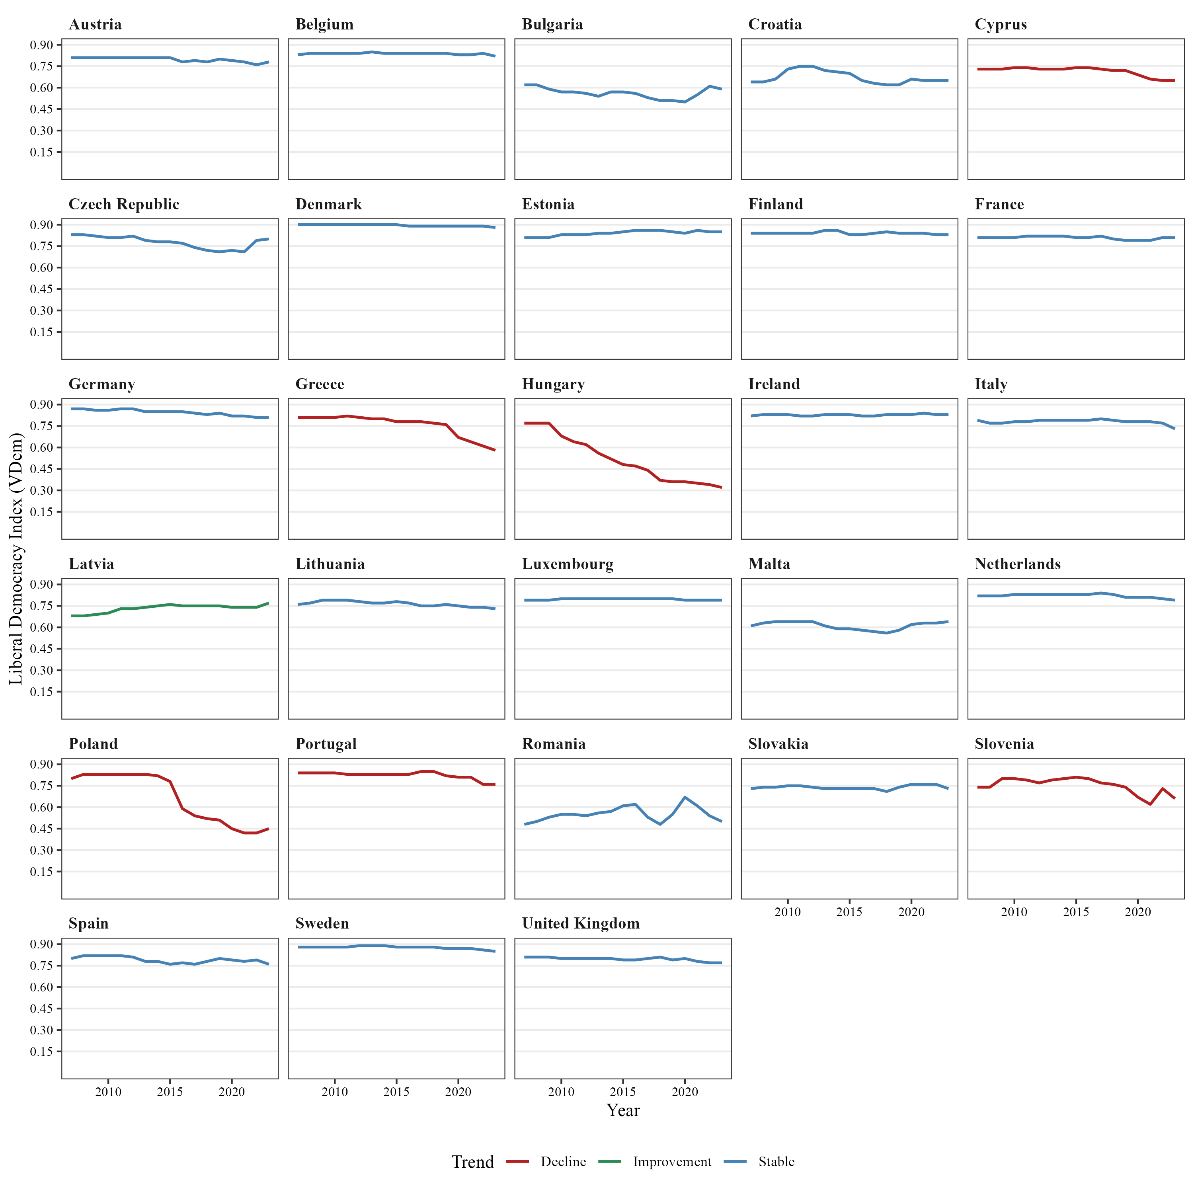

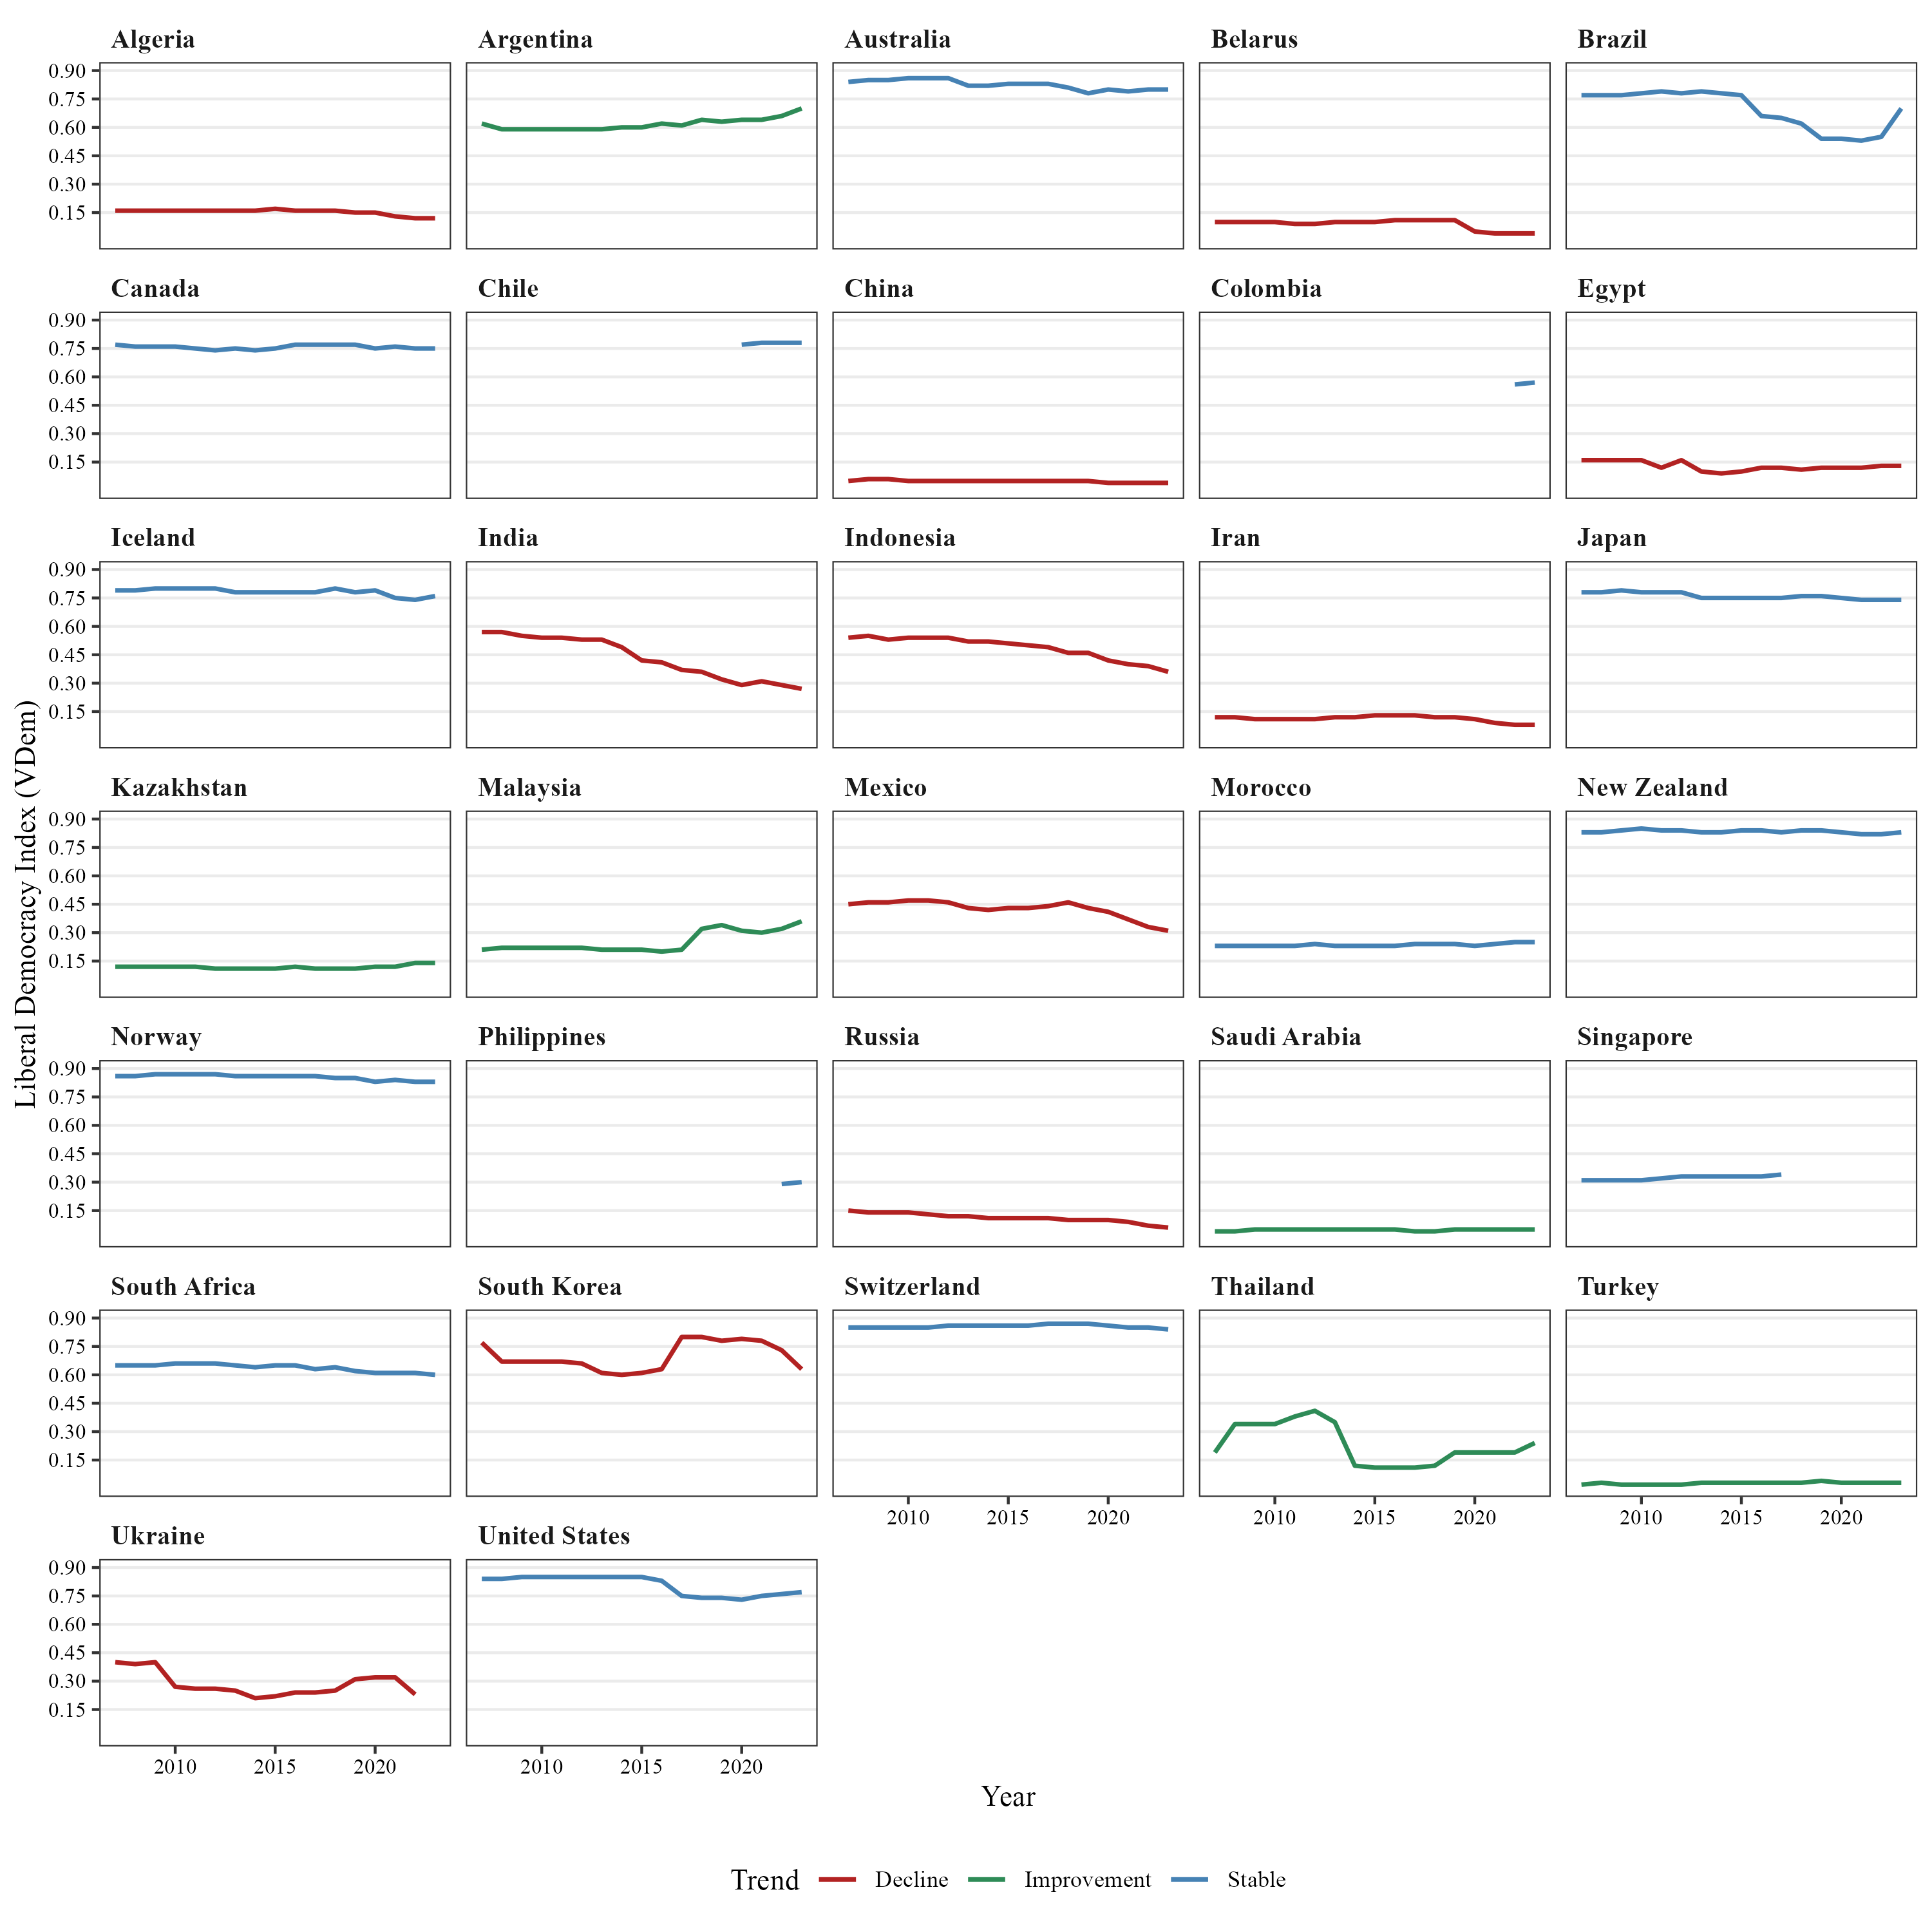
Figure S4. Democracy scores over time 2007-2023 (V-dem data), nonEU countries

Note. Figures S3 and S4 replicate Figs. S1 and S2 using an alternative measure of democracy: the V-Dem Liberal Democracy Index (0–1 scale) in place of the Freedom House political-rights score.

Table S2. Climate Policy, Support for far-right populist parties and Democracy
 | (1) | (2) | (3) | (5) | (6) | (7)
 | Civil Liberties index | Liberal democracy index | Deliberative democracy index | Participatory democracy index | Egalitarian democracy index | EU member state
PRRPs vote share | -0.22** | -0.14* | -0.14** | -0.18** | -0.17** | -0.07*
 | (0.08) | (0.06) | (0.05) | (0.06) | (0.06) | (0.03)
Democracy scores | -0.34 | 4.38 | 5.29* | 2.61 | 5.48 | -0.21
 | (0.56) | (3.37) | (2.48) | (4.30) | (3.91) | (1.55)
PRRPs x Democracy | 0.03** | 0.21** | 0.23** | 0.34*** | 0.29** | 0.12**
 | (0.01) | (0.08) | (0.07) | (0.10) | (0.09) | (0.04)
Gini | -0.03 | -0.13 | -0.15⁺ | -0.11 | -0.12 | -0.07
 | (0.08) | (0.09) | (0.08) | (0.08) | (0.08) | (0.08)
Vulnerability | 5.71 | 24.90 | 23.82 | 19.30 | 18.53 | -18.41
 | (51.42) | (51.61) | (51.31) | (51.46) | (51.43) | (52.17)
Exposure | 4.72 | -2.64 | 13.82 | -4.07 | 1.98 | 24.01
 | (33.85) | (33.67) | (32.82) | (33.69) | (32.98) | (32.50)
Capacity | 14.75 | 4.43 | 6.05 | 7.11 | 4.95 | 24.39
 | (19.31) | (19.62) | (19.45) | (19.52) | (19.51) | (19.43)
GDP | -0.00* | -0.00* | -0.00** | -0.00* | -0.00* | -0.00*
 | (0.00) | (0.00) | (0.00) | (0.00) | (0.00) | (0.00)
Corruption | -1.16 | 3.67 | 4.66 | 2.35 | 3.62 | -1.99
 | (3.08) | (3.61) | (3.48) | (3.52) | (3.51) | (3.09)
Country FEs | √ | √ | √ | √ | √ | √
Year FEs | √ | √ | √ | √ | √ | √
Constant | 7.64 | 5.84 | -1.81 | 8.71 | 4.86 | 3.97
 | (16.48) | (16.76) | (16.37) | (16.66) | (16.61) | (16.49)
Observations | 704 | 704 | 704 | 704 | 704 | 704
Adjusted R² | 0.552 | 0.553 | 0.557 | 0.553 | 0.556 | 0.548
Notes. Entries are OLS coefficients from country-year panel regressions predicting the Climate Policy Index. Each column replicates Table 1's Model 2 (interaction between PRRP vote share and democracy) using the democracy measure named in the column header in place of the combined Freedom House political-rights/civil-liberties score used in the main text. All models control for the Gini coefficient, climate vulnerability, exposure, adaptive capacity, GDP, and political corruption, and include country and year fixed effects. Standard errors in parentheses; + p<0.10, * p<0.05, ** p<0.01, *** p<0.001.

Figure S5. Exposure distribution by regime type
Note. Kernel density of the ND-GAIN climate-exposure measure among full democracies (Freedom House political-rights rating = 7) and hybrid regimes (rating 2–6), pooling country-years. Labeled points mark illustrative low- and high-exposure countries within each regime type.

Figure S6. Corruption distribution by regime type

Note. Kernel density of the V-Dem political corruption index (v2x_corr) among full democracies (Freedom House political-rights rating = 7) and hybrid regimes (rating 2–6), pooling country-years. Labeled points mark illustrative low- and high-corruption countries within each regime type.

