Supporting Information

Continuous-Flow Synthesis of 2-amino-4-(ethylsulfonyl) phenol via Integrated Oxidation and Nitration
Chaoyang Liu¹. Bo Li¹. Jie He¹. Zhiyuan Liu¹. Kun Hai¹. Shiqi Pu¹. Lihan Wang¹. Changhu Chu¹. Lei Ma¹
¹Engineering Research Centre of Pharmaceutical Process Chemistry, Ministry of Education; Shanghai Key Laboratory of New Drug Design; School of Pharmacy, East China University of Science and Technology, 130 Meilong Road, Shanghai 200237, China
E-mail:Changhu Chu chuch@ecust.edu.cn; Lei Ma malei@ecust.edu.cn

¹H and ¹³C NMR spectra of 1-Chloro-4-(ethylthio)benzene
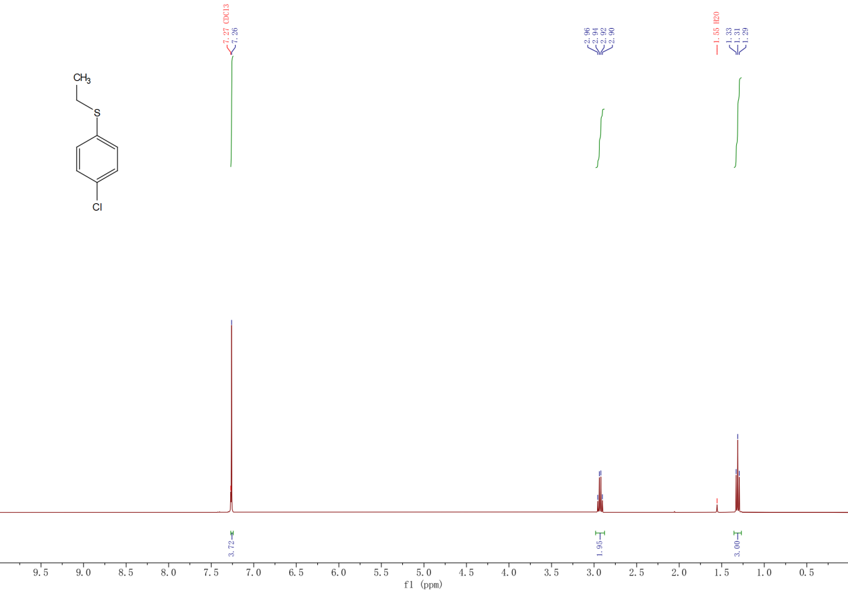

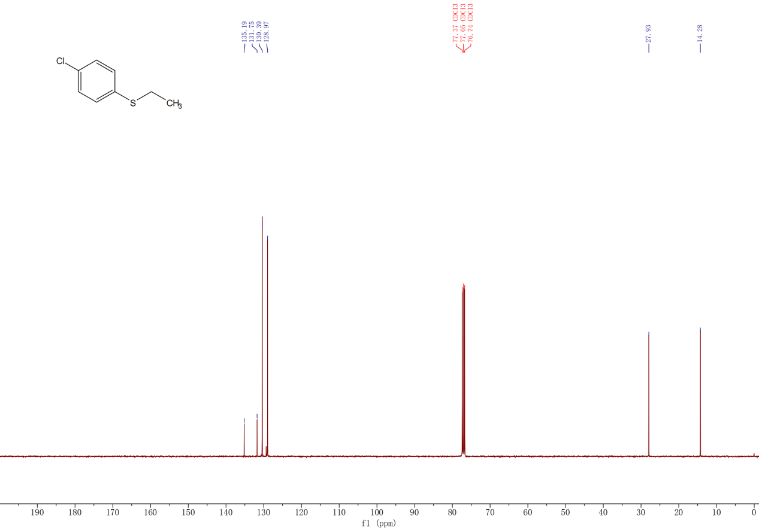

¹H, ¹³C NMR and MS spectra of 1-Chloro-4-(ethylsulfonyl)benzene
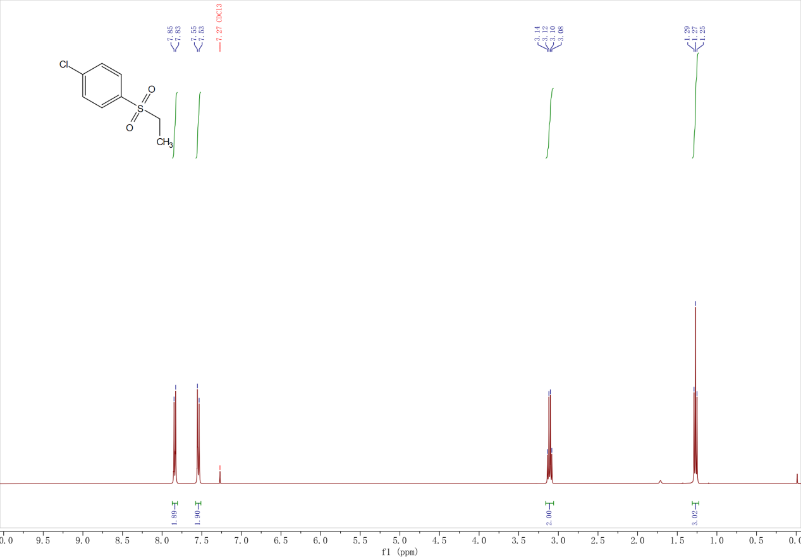

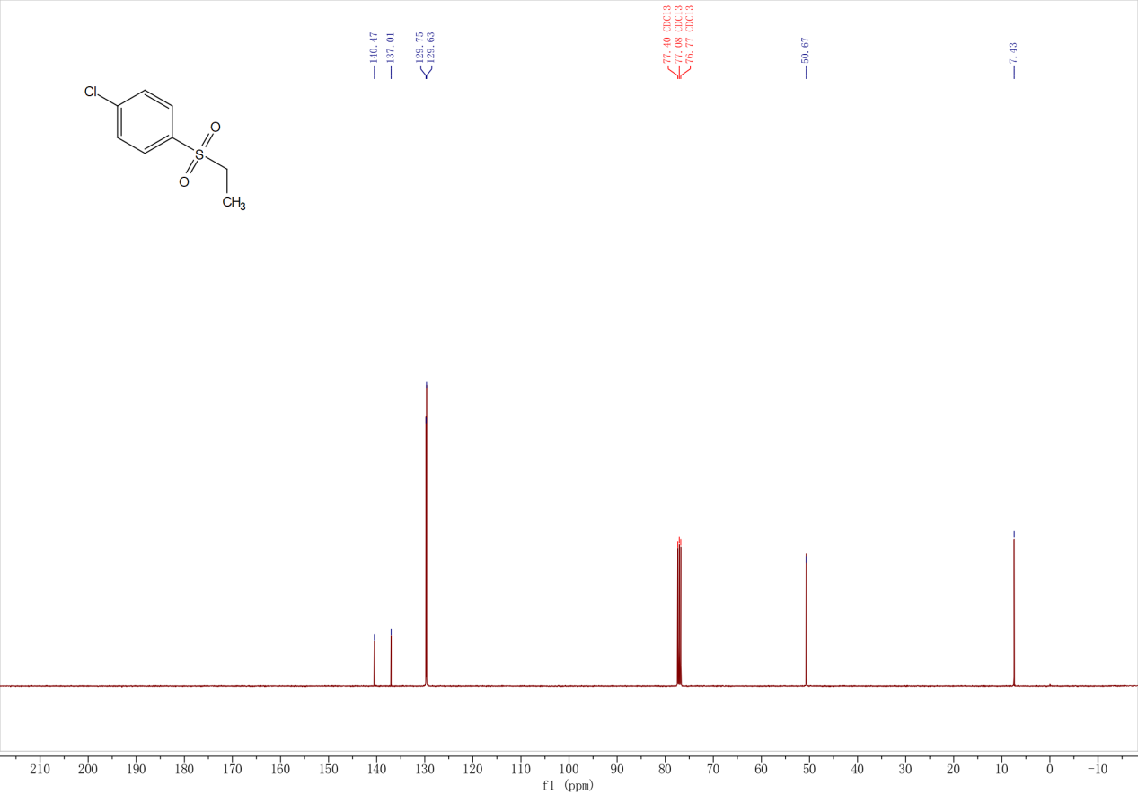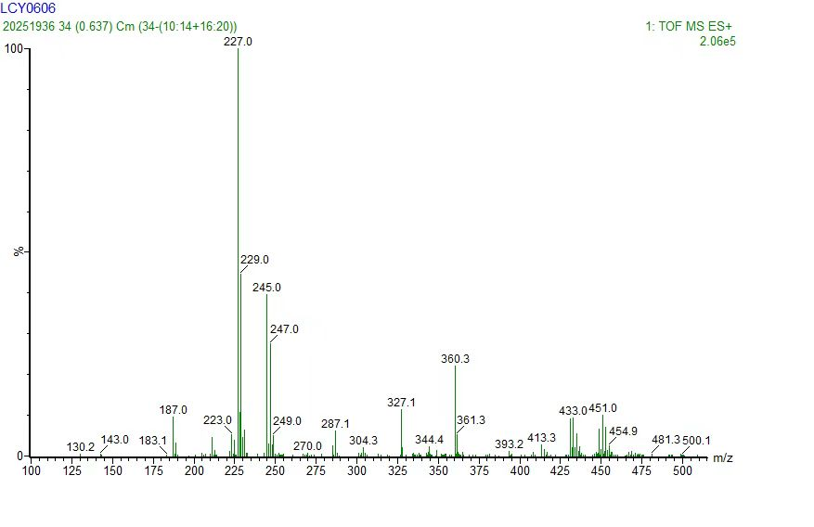

¹H and ¹³C NMR spectra of 1-chloro-4-(ethylsulfinyl)benzene
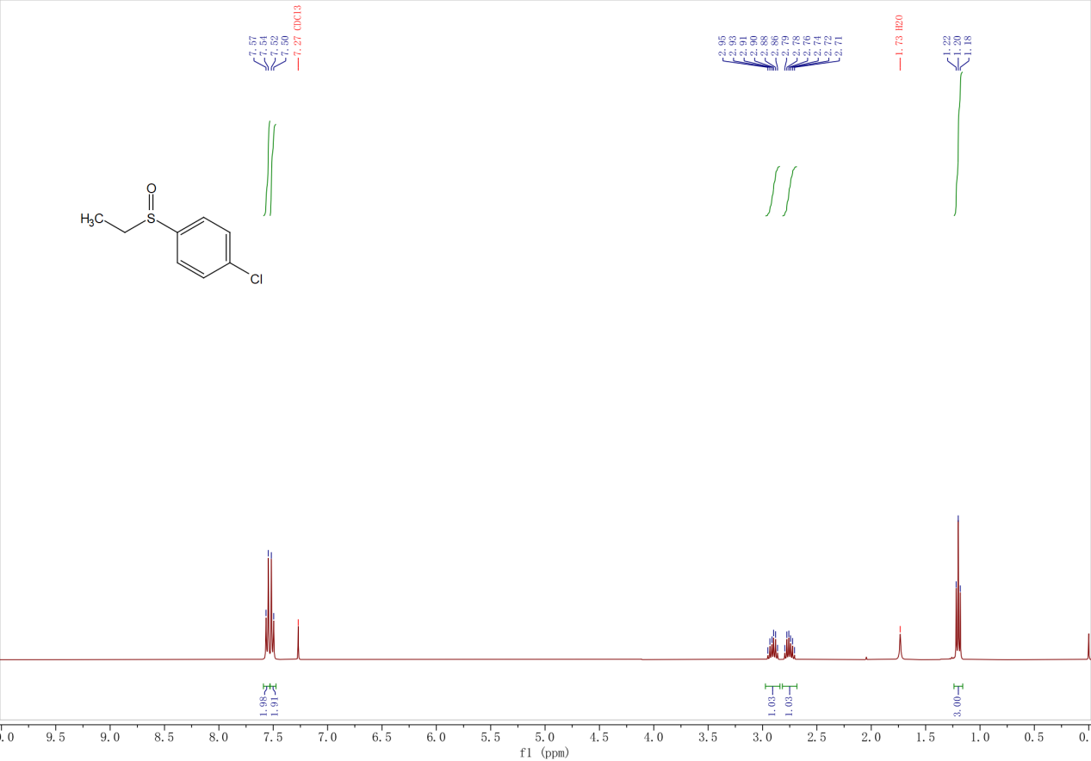

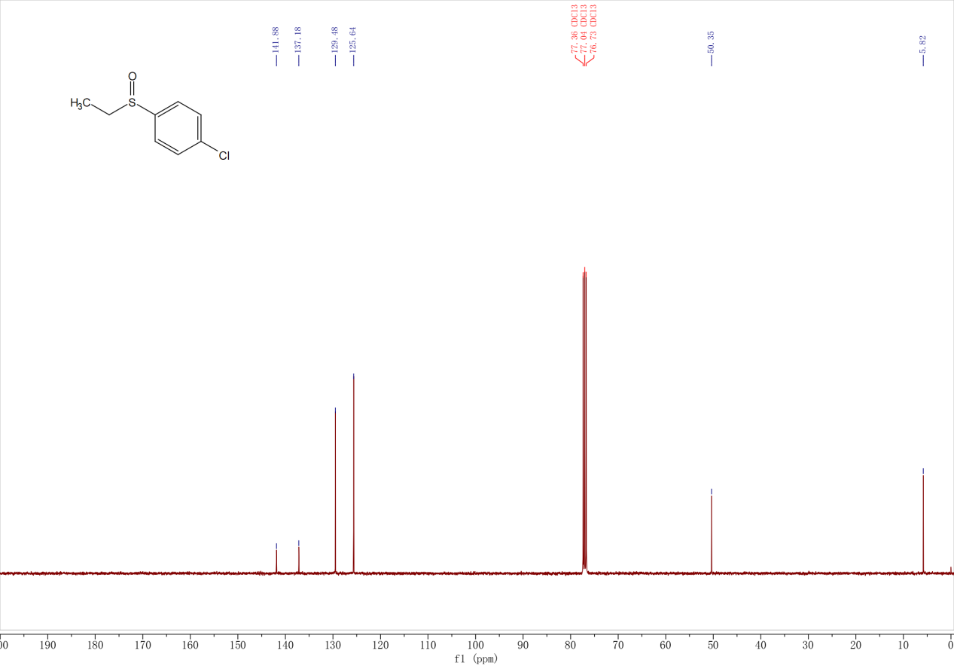

¹H and ¹³C NMR spectra of 1-Chloro-4-(ethylsulfonyl)-2-nitrobenzene
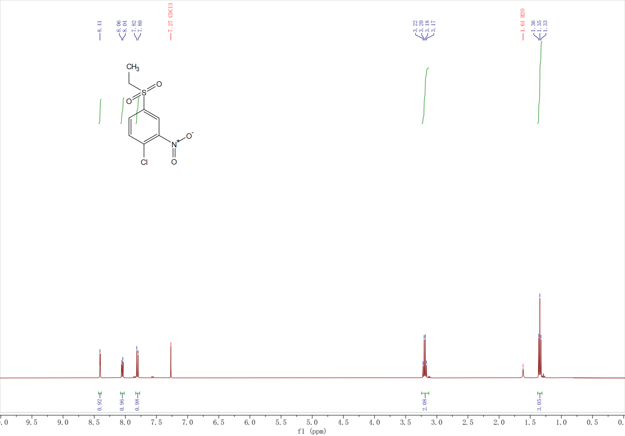

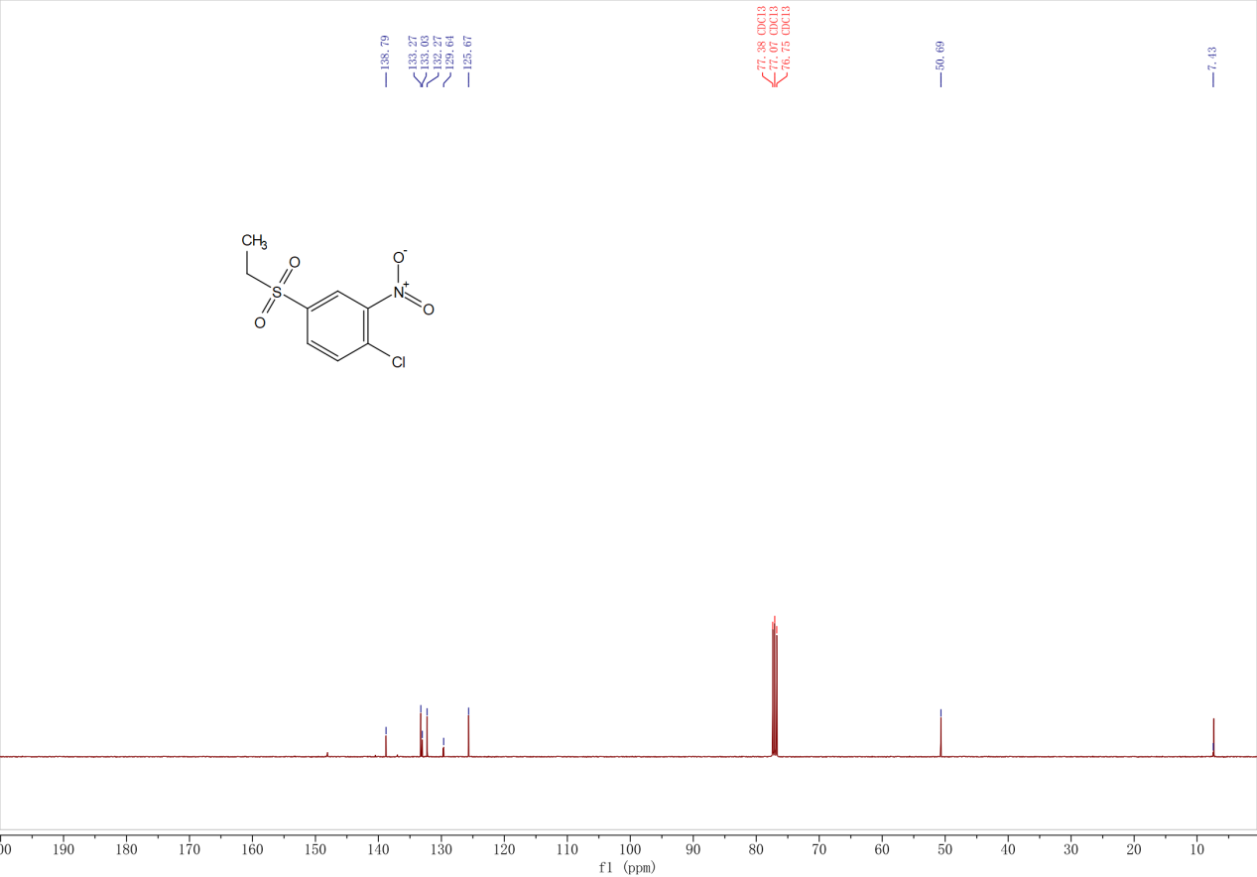

¹H and ¹³C NMR spectra of 4-(Ethylsulfonyl)-2-nitrophenol

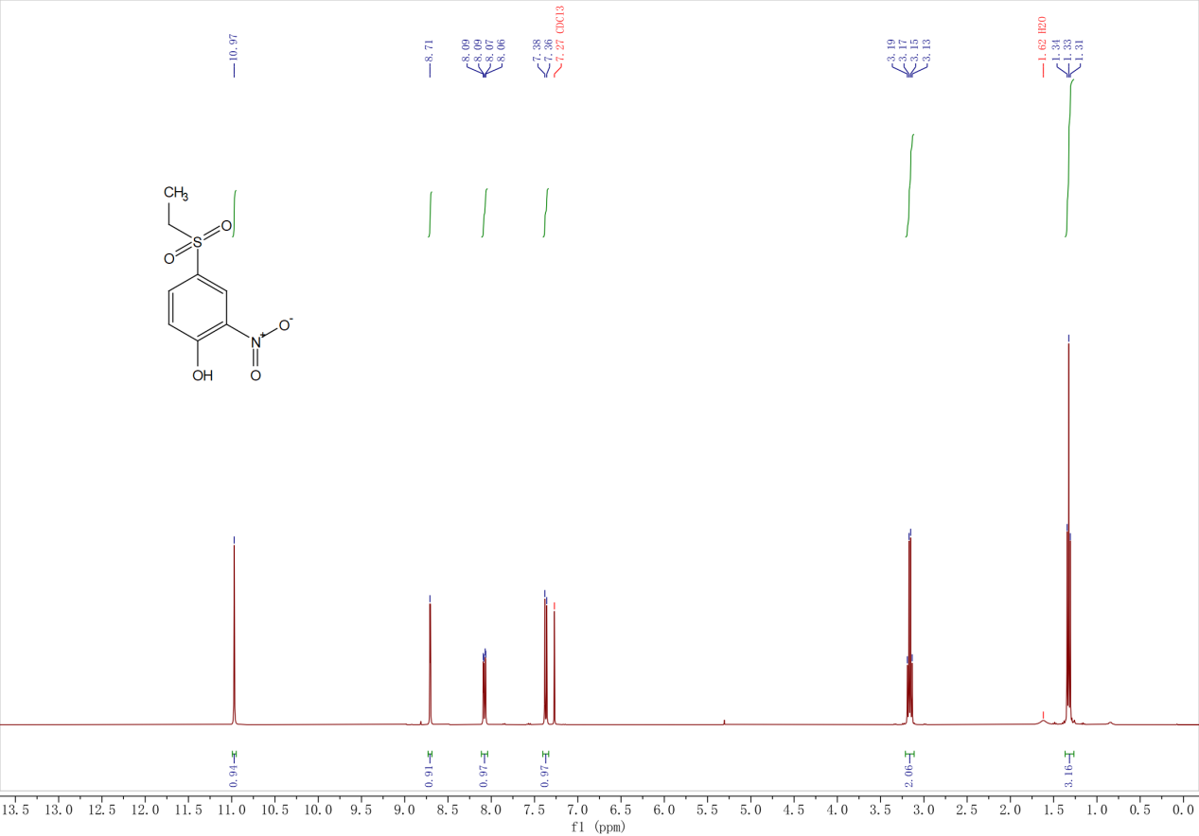

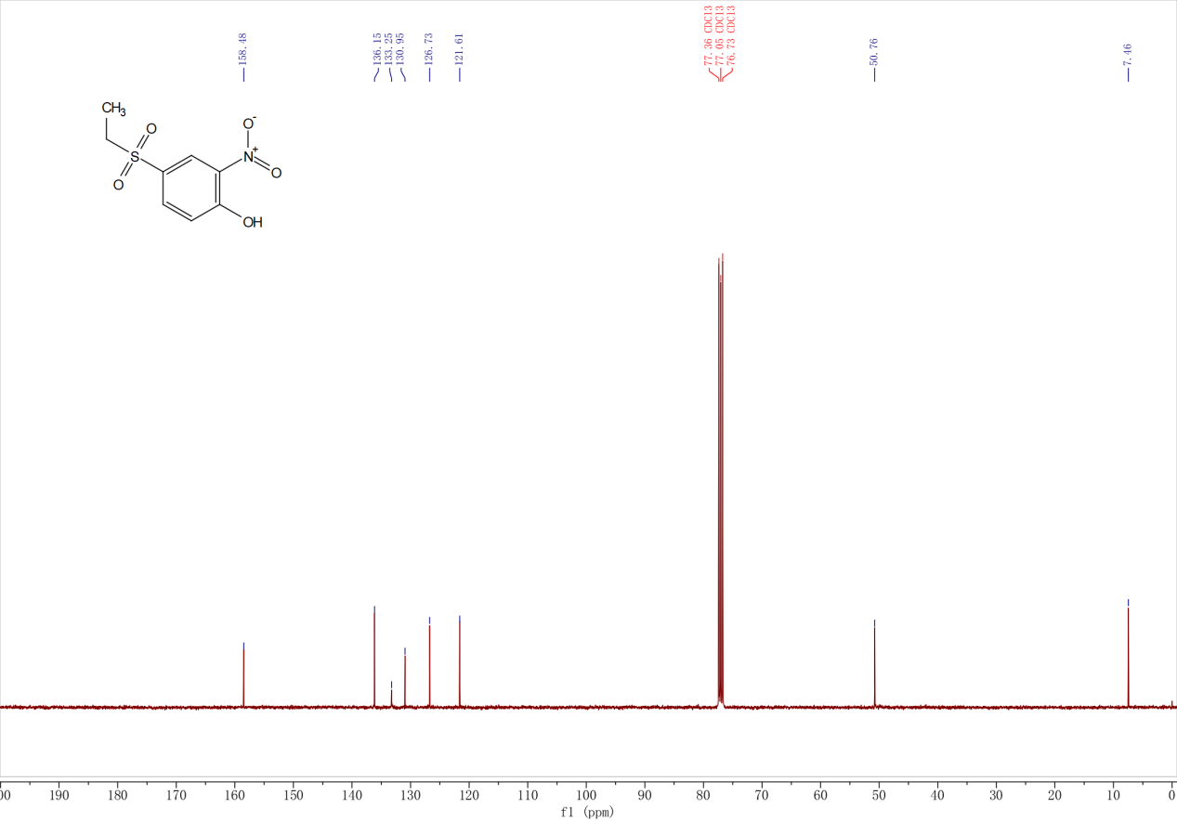

¹H, ¹³C NMR and MS spectra of 2-amino-4-(ethylsulfonyl)phenol

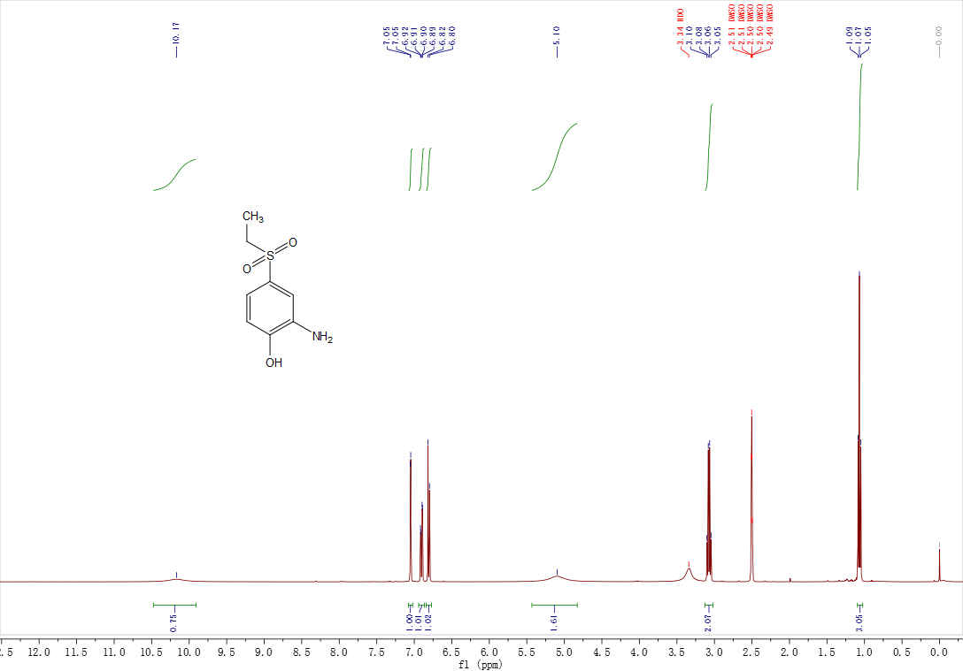

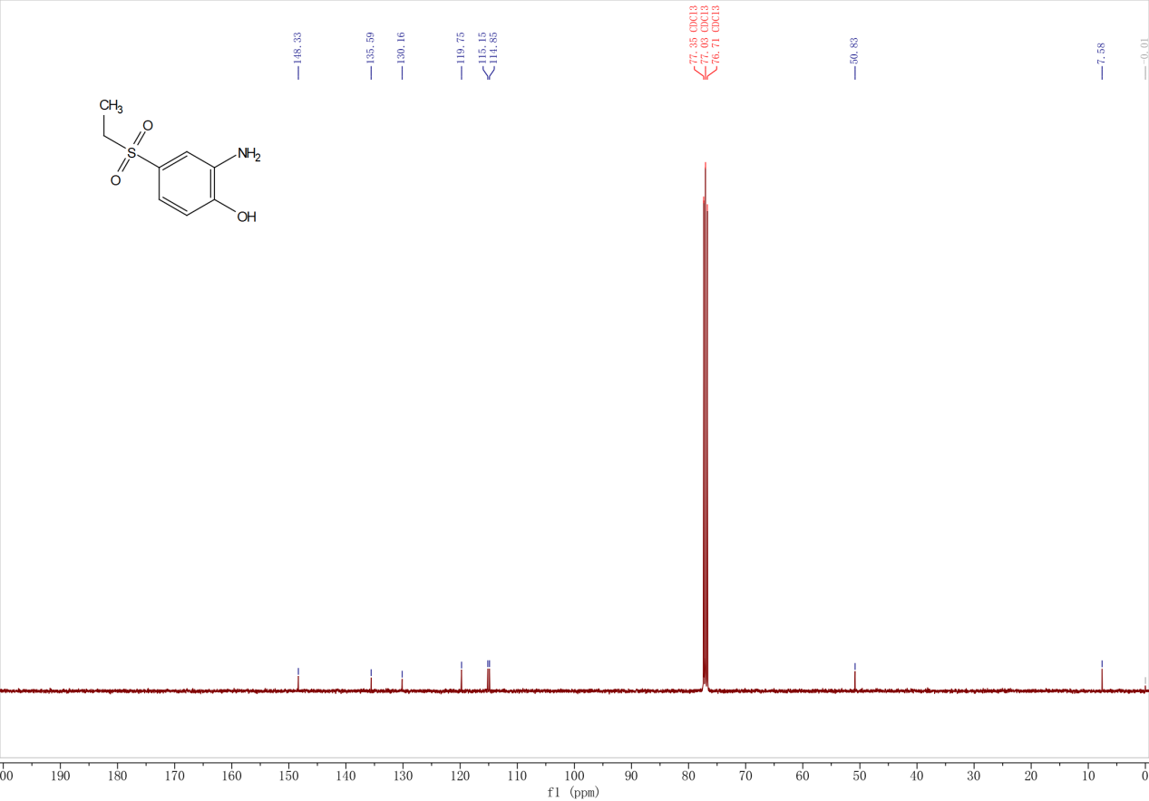
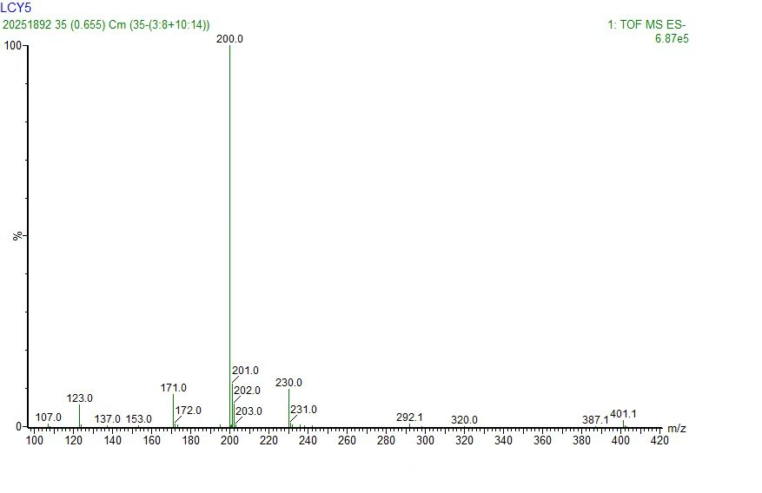

¹H, ¹³C NMR and MS spectra of Ezutromid

