Supplementary material

Supplementary Table 1 Subgroup analysis
 | OR, 95%CI | P value
Age
≥60 | 1.07(1.02,1.12) | 0.008
<60 | 1.03(0.99,1.07) | 0.088
Gender
Male | 1.04 (1.01, 1.08) | 0.04
Female | 1.054 (1.01, 1.1 ) | 0.01
BMI
≥30 | 1.24 (1.05, 1.45) | 0.01
<30 | 1.06 (1.03, 1.09) | <0.001
Hypertension
Yes | 1.19 (1.10, 1.27) | <0.001
No | 1.03 (1.00, 1.07) | 0.04

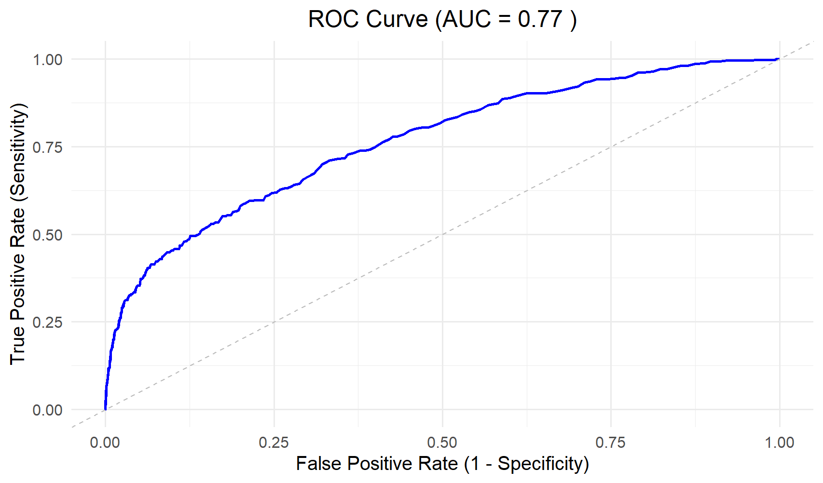
Supplementary Figures 1: The ROC curve of PHR in the training cohort

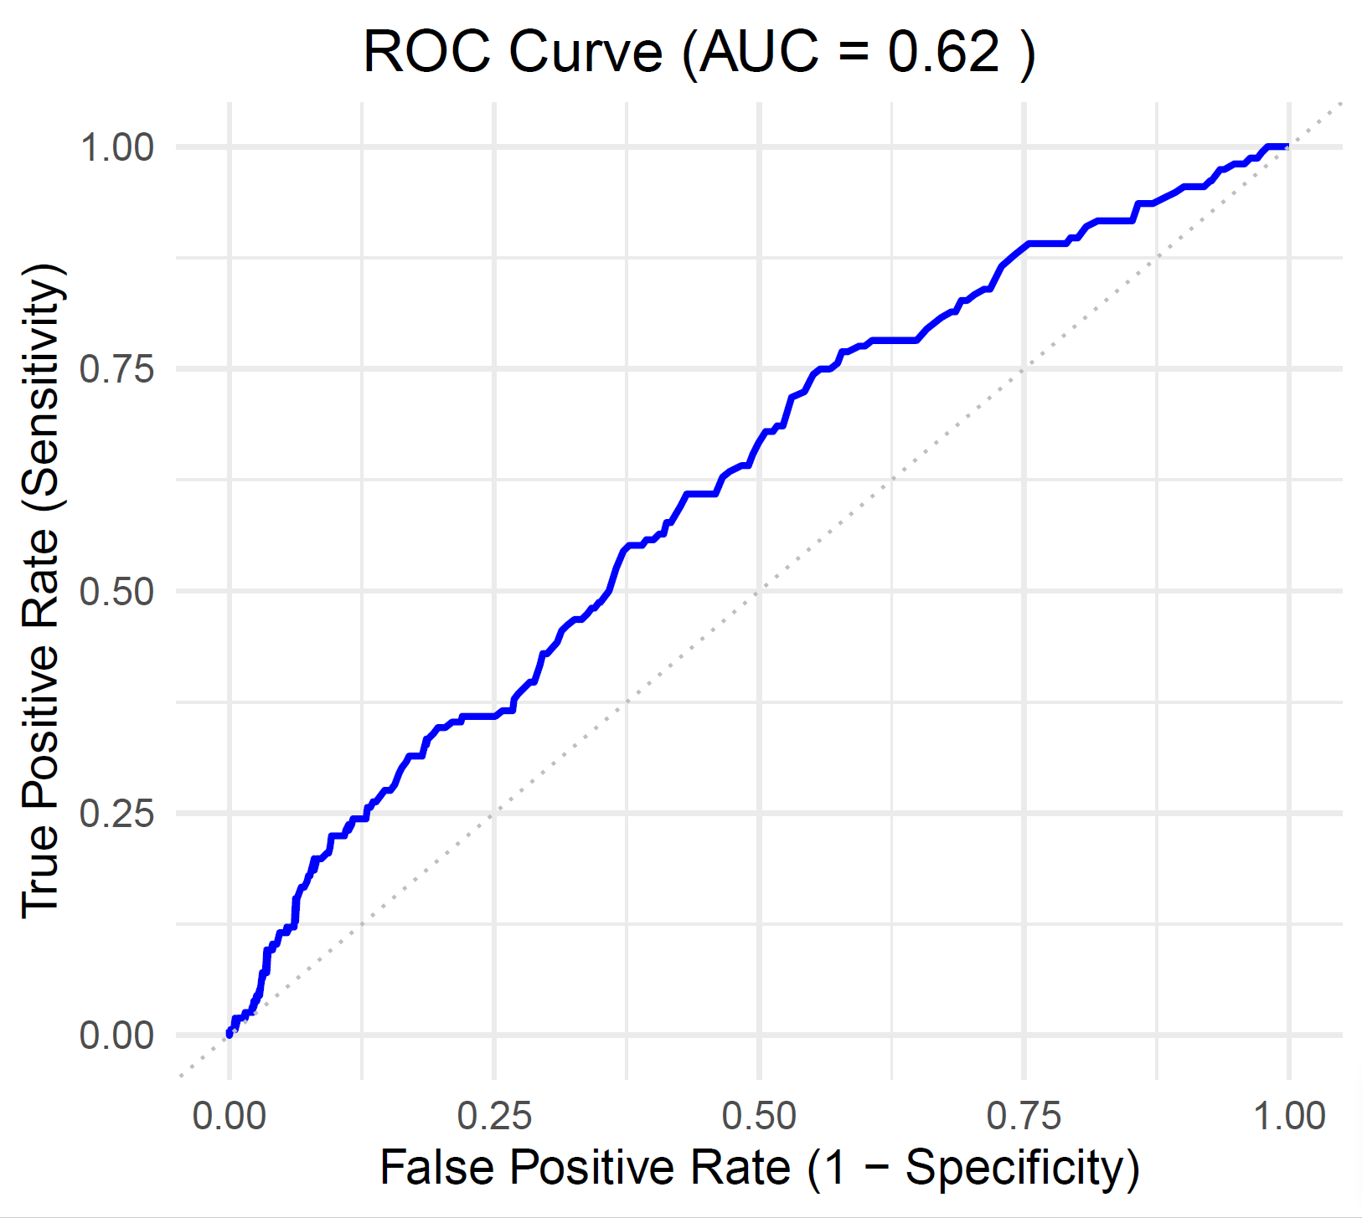
Supplementary Figures 2:The ROC curve of PHR in the testing cohort

