Supplementary Material

1. System Prompt
2.1 System prompt for single-choice question
您是一个资深的药师，请根据问题描述从给出的五个选项中选择一个最正确的答案，请直接回答该正确答案的编号A,B,C,D,或者E，也就是只需要回答正确答案编号的字母编号，不需要做任何解释。
2.1 System prompt for multiple-choice question
您是一个资深的药师，请根据问题描述从给出的五个选项中选择处正确的答案，每题至少有两个正确答案, 请直接回答该正确答案的编号A,B,C,D,或者E，也就是只需要回答正确答案编号的字母编号，不需要做任何解释。

2. Samples of questions
2.1 A sample of a text-based question
Question No 9.
Which antiviral drug competitively inhibits HIV-1 protease, thereby preventing the cleavage of precursor proteins and inhibiting viral maturation?
A. Delavirdine
B. Nevirapine
C. Stavudine
D. Zalcitabine
E. Saquinavir
Correct Answer: E

2.2 A sample of a question with an image in the stem
Question No 25.
Regarding the structure–activity relationship and metabolic characteristics of irbesartan (chemical structure shown below), which statement is incorrect?
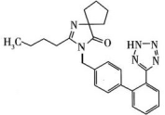
A. It lacks the hydroxymethyl group present in losartan, yet its receptor-binding affinity is 10 times that of losartan.
B. The ketone carbonyl group in its structure interacts with the receptor through hydrogen bonding or ion–dipole interactions.
C. It undergoes oxidative metabolism by CYP2C9 in vivo, and its metabolites are excreted in the bile and urine.
D. The tetrazole ring in its structure is basic and is essential for activity.
E. The spiro ring in its structure enhances hydrophobic binding to the receptor.
Correct Answer: D

2.3 A sample of a question with images in the answer options
Question No 40.
Which of the following is an arylacetic acid nonsteroidal anti-inflammatory drug (NSAID) that acts on cyclooxygenase?
A. Aspirin
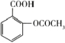

B. Indomethacin
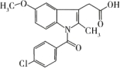

C. Celecoxib
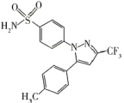

D. Ketoprofen
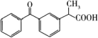

E. Meloxicam
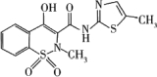
Correct Answer: B

3.Application Development of the Mock Examination System
2.1 System Architecture
The system uses a browser/server (B/S) architecture and consists of an Nginx reverse proxy, a web application (Python/Flask), and a database (MySQL 8.4).

2.2 System Development
The system was developed following a specification-driven approach, using the AI-powered development platform Trae (developed by ByteDance) and choosing DeepSeek-V4-Flash as its underlying model. The database was automatically constructed by AI from the provided data files. The web application was entirely developed by AI. Human engineers thoroughly reviewed the AI-generated code, tested the system, and were responsible for the system.
.
4. English-language Version
The English-language versions of the questions were first generated by Qwen3.8-Max, which automatically translated the Chinese questions into English. These versions were then reviewed and modified by the authors of this study.

