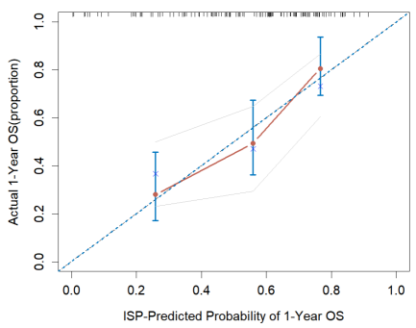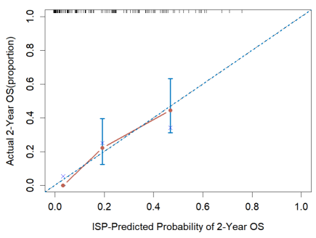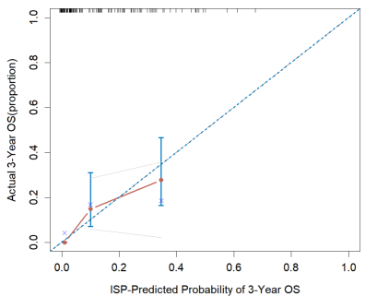
A B C
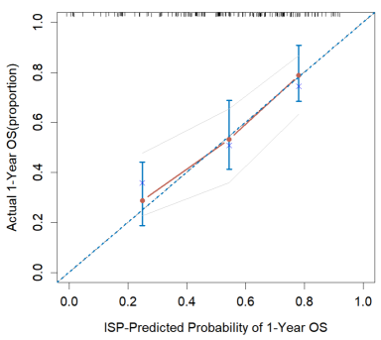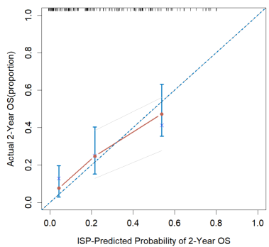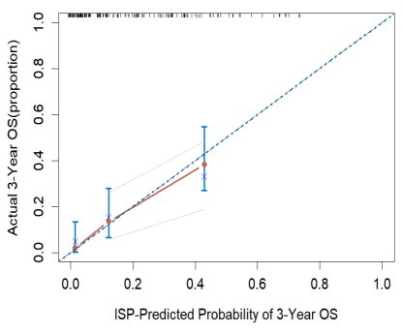
D E F
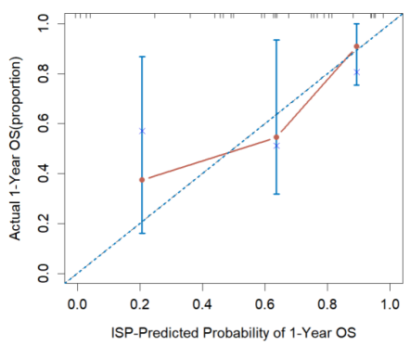
H
Supplementary FigS1 Calibration plots of 1–3-year for predicting the probability of overall survival of the prognostic model in the CGGA325 cohort(A-C),CGGA693(D-F) and GSE43378(H).
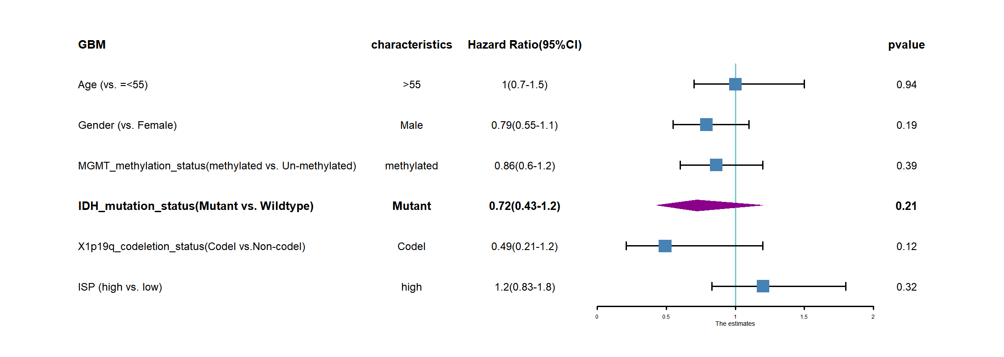
A
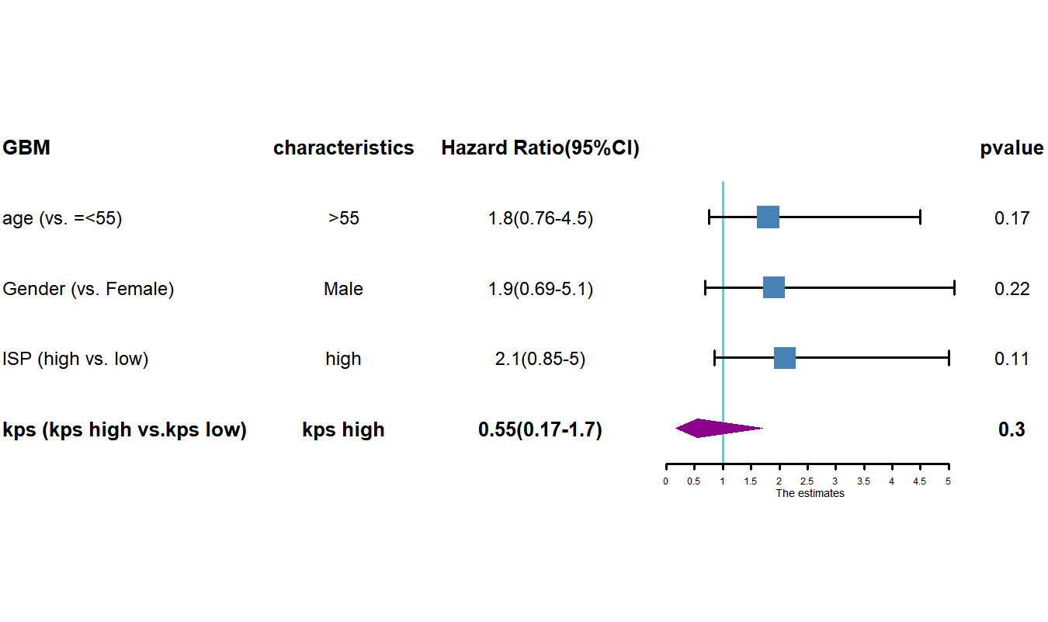
B
Supplementary FigS2 Multivariate Cox regression analysis and forest plot of the survival in CGGA693 (A) and GSE43378 (B).
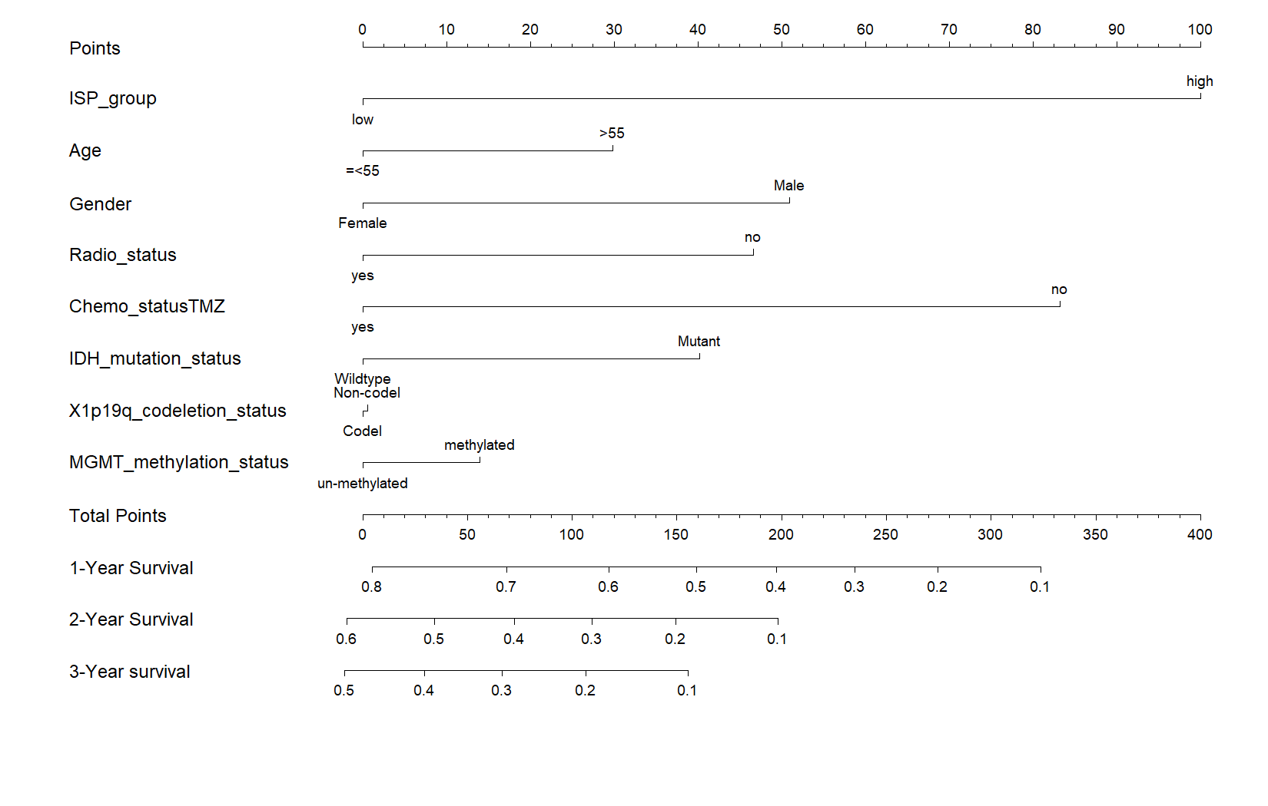
A
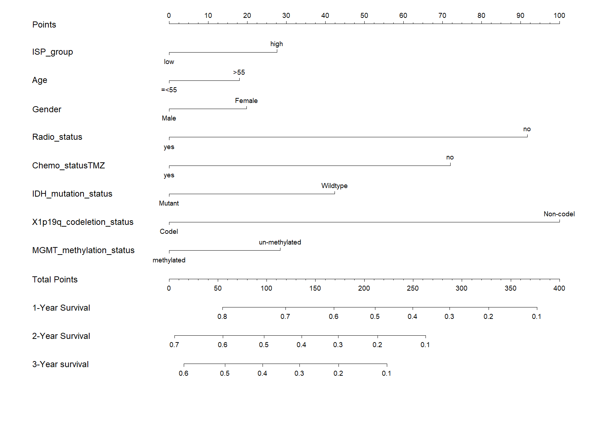
B
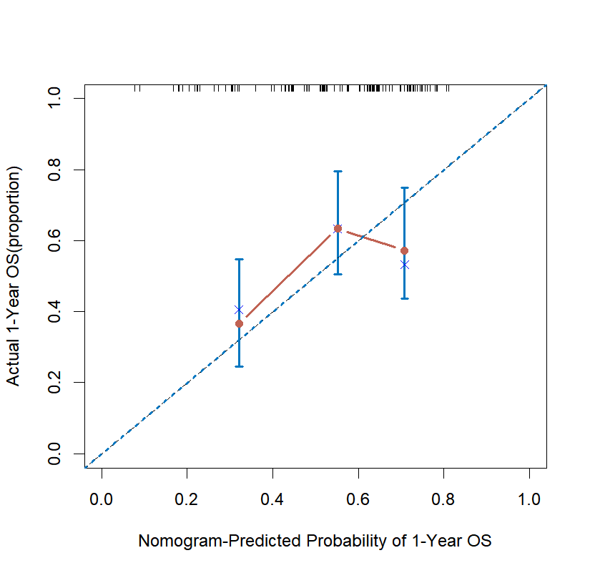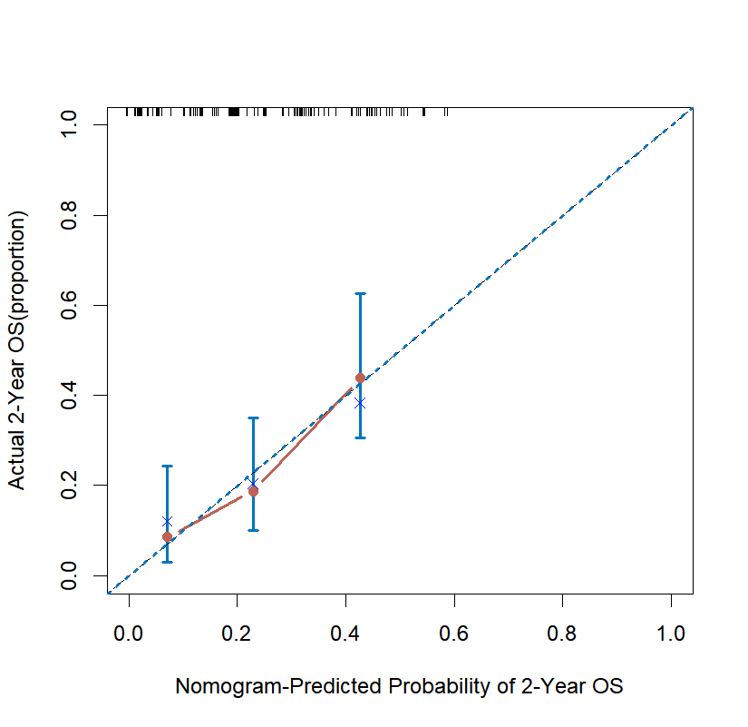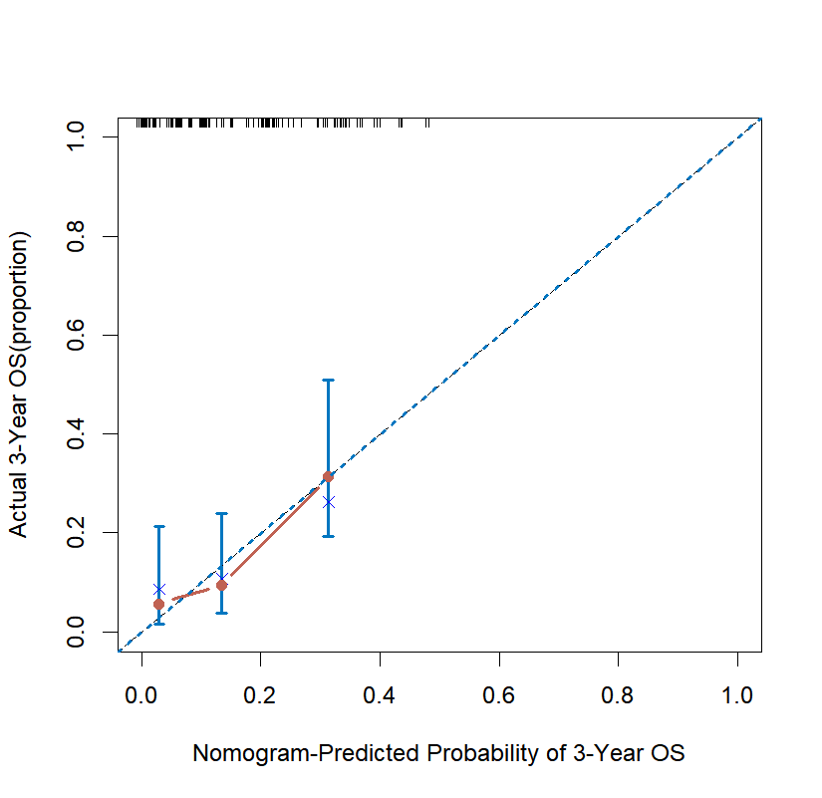
C D E
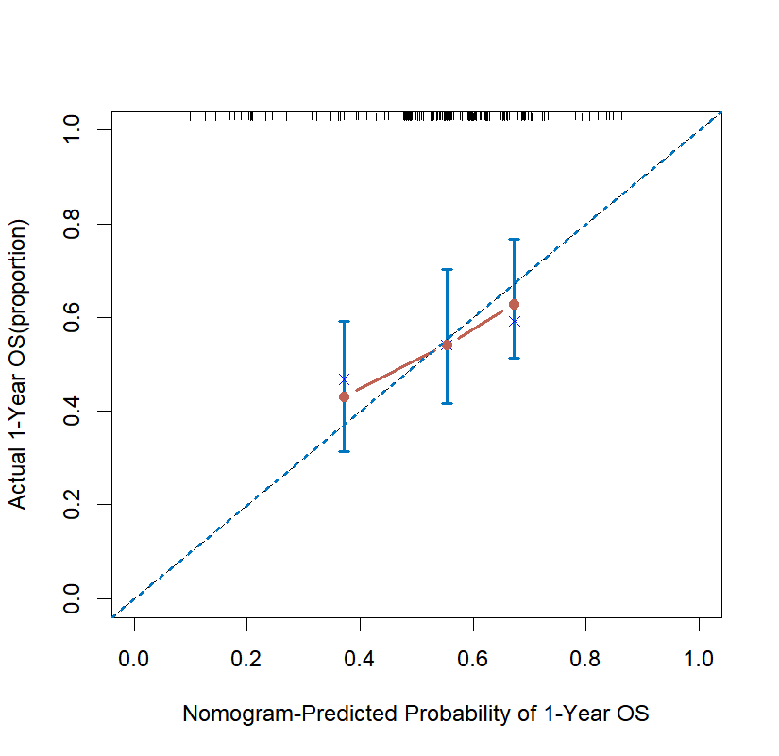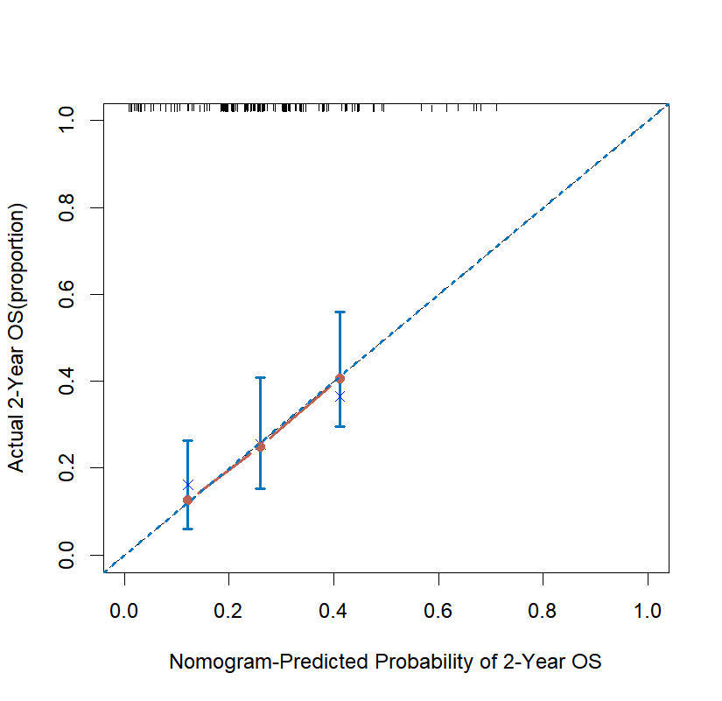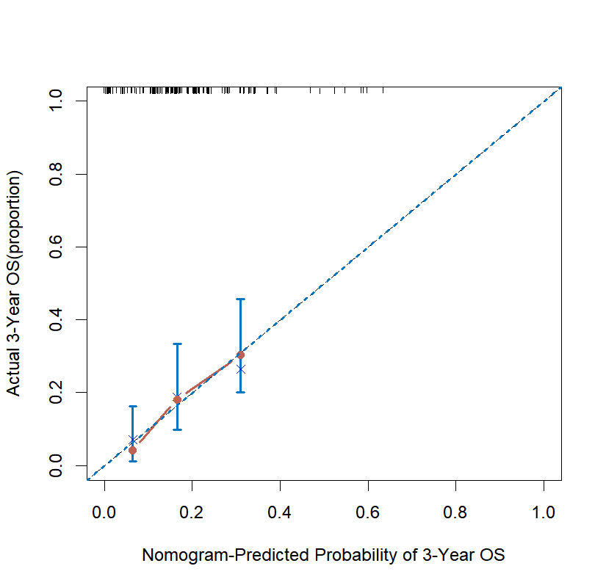
F G H
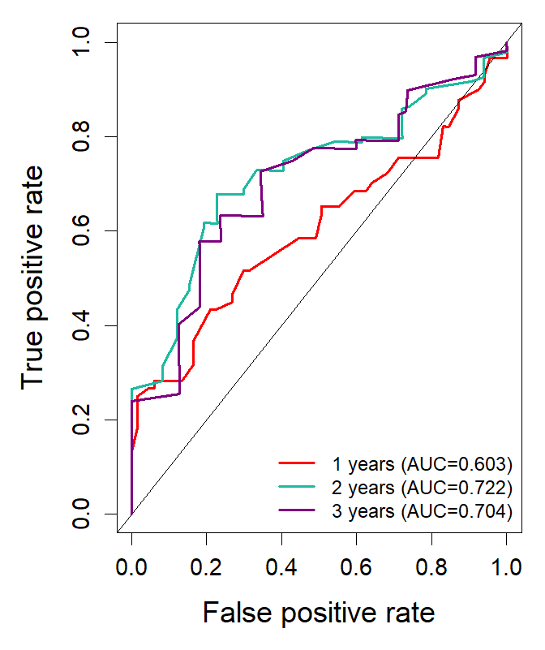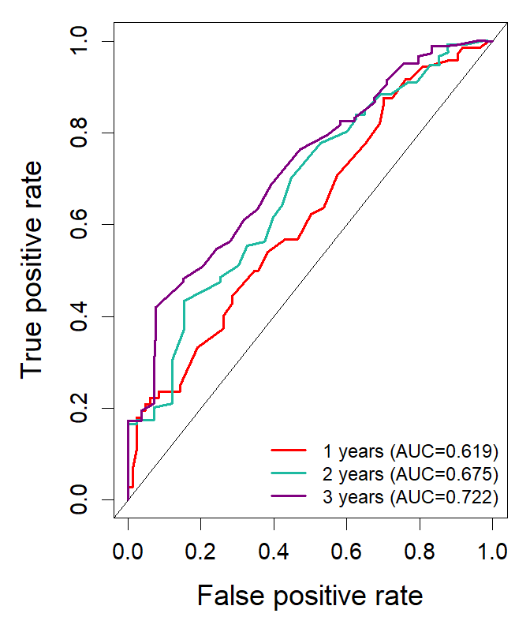
I J
Supplementary FigS3 Developed nomogram to predict the probability of survival in GBM patients. A and B, Nomogram built with clinicopathological factors incorporated estimating 1-, 2- and 3-year overall survival for GBM patients in CGGA325(A) and CGGA693(B). C-H,The calibration curves describing the consistency between predicted and observed overall survival at different time points in CGGA325(C-E) and CGGA693(F-H). D,ROC analysis for the nomogram in CGGA325(I) and CGGA693(J).

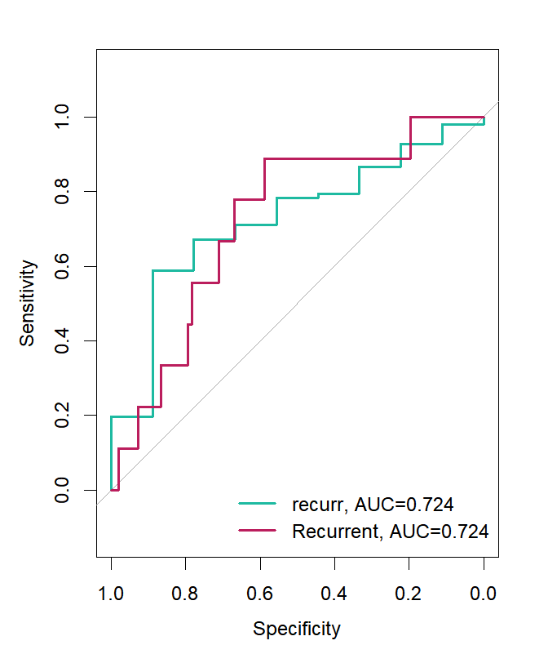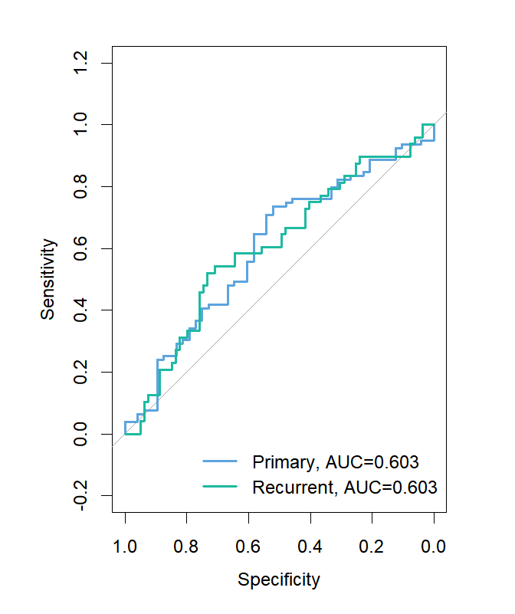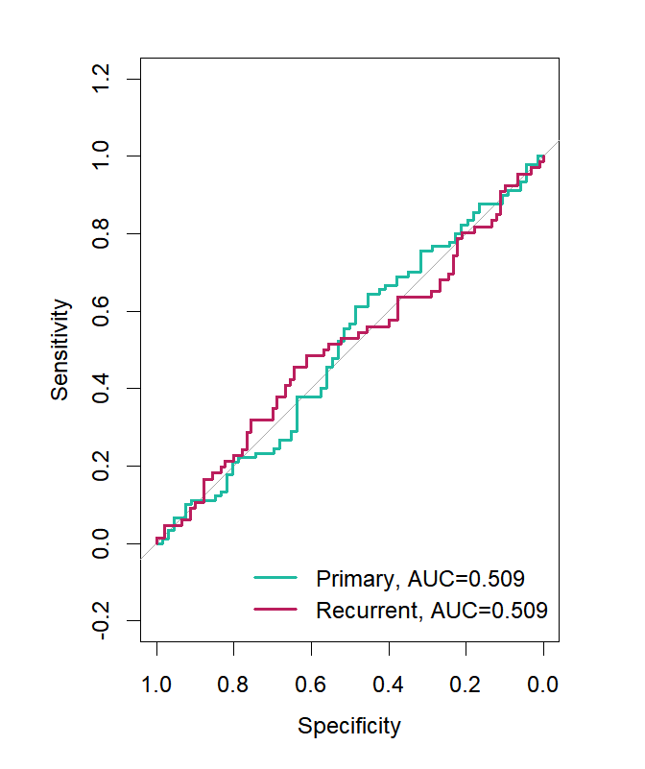
A B C
Supplementary FigS4 ROC curve analysis of the ISP score to distinguish between primary and recurrent GBM patients in the TCGA (A) and CGGA325 (B) cohorts

