Fig. 6a The interaction of MdMYB73 and MdWRKY31 was verified via yeast two-hybrid assays.
-T/-L
10 10⁻¹ 10⁻² 10⁻³

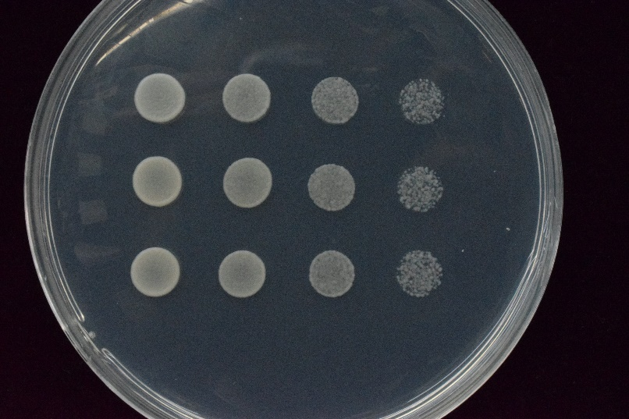
pGAD pGBD
MdWRKY31+MdMYB73
MdWRKY31+ pGBD
pGAD+MdMYB73

-T/-L/-H/-A
10 10⁻¹ 10⁻² 10⁻³

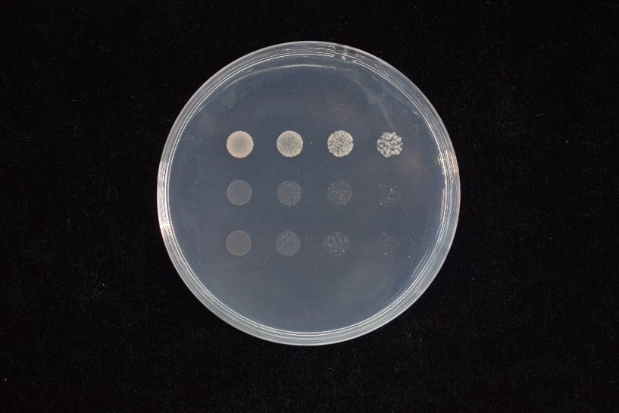
pGAD pGBD
MdWRKY31+MdMYB73
MdWRKY31+ pGBD
pGAD+MdMYB73

Fig. 6b In vitro pull-down assays were performed to verify the interaction between MdMYB73 and MdWRKY31. Pound sign represents GST protein. Asterisk represents MdMYB73-GST protein.
MdWRKY31-His
MdMYB73-GST
GST
Input Pull down
+ + + +
- + - +
+ - + -
WB: anti-His

Input Pull down
+ + + +
- + - +
+ - + -
#
*
MdWRKY31-His
MdMYB73-GST
GST

WB：anti-GST

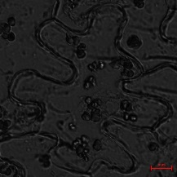
Fig. 6c MdMYB73 was confirmed to interact with MdWRKY31 in the bimolecular fluorescence complementary assay.
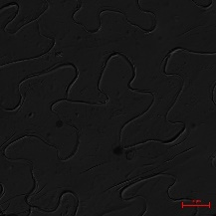
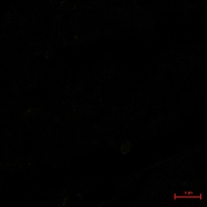
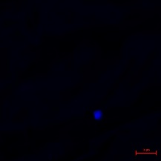
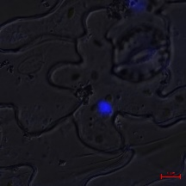
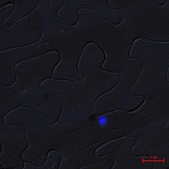
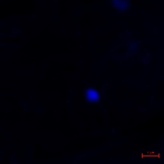
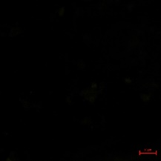
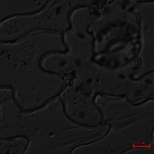
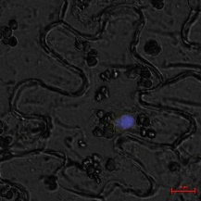
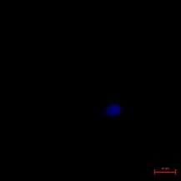
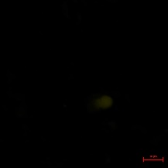
MdMYB73-YFP^{N}+
YFP^{C}
MdWRKY31-YFP^{C}+
YFP^{N}

MdWRKY31-YFP^{C}+
MdMYB73-YFP^{N}
Merge
DAPI
YFP
BF

