Title: Dual-Stressor Effects of Road Salt and Aquatic Herbicide on Freshwater Phytoplankton: Cyanobacterial Tolerance to Salinity

Ecotoxicology
Arif Ahmed^{a,b,c}, Averi Loriaª, Juliana Di Cosmoª and Matthew S. Schulerª
ª Department of Biology, Montclair State University, Montclair, NJ 07043, USA
^{b} School of Natural Resources, University of Missouri, Columbia, MO 65211, USA
^{c} Corresponding Author; email: ahmeda31@montclair.edu , phone: 973-925-3784

Table S1 Results of two-way analysis of variance (ANOVA) testing the main and interactive effects of ProcellaCOR and salt on abiotic parameters measured in Green Algae and Cyanobacteria experimental systems. Abiotic variables include dissolved oxygen (DO), temperature, pH, electrical conductivity (EC), total nitrogen (TN), total phosphorus (TP), and colored dissolved organic matter (CDOM). For each response variable, degrees of freedom (df), sum of squares (Sum Sq), mean square (Mean Sq), F values, and corresponding p values are reported for the main effects and their interaction. Significant effects (p < 0.05) are indicated by the reported p values in bold.

Taxa | Variable | Effect | df | Sum Sq | Mean Sq | F value | p value
Green Algae | DO | ProcellaCOR | 2 | 0.35 | 0.1773 | 0.174 | 0.84
 |  | Salt | 1 | 1.91 | 1.9086 | 1.876 | 0.174
 |  | ProcellaCOR × Salt | 2 | 0.07 | 0.0352 | 0.035 | 0.966
 |  | Residuals | 90 | 91.56 | 1.0173
 | Temperature | ProcellaCOR | 2 | 0.88 | 0.4392 | 0.552 | 0.578
 |  | Salt | 1 | 1.56 | 1.5607 | 1.962 | 0.165
 |  | ProcellaCOR × Salt | 2 | 1.84 | 0.9209 | 1.158 | 0.319
 |  | Residuals | 90 | 71.59 | 0.7955
 | pH | ProcellaCOR | 2 | 3.45 | 1.725 | 2.531 | 0.085
 |  | Salt | 1 | 19.78 | 19.781 | 29.024 | <0.001
 |  | ProcellaCOR × Salt | 2 | 0.58 | 0.288 | 0.423 | 0.656
 |  | Residuals | 90 | 61.34 | 0.682
 | EC | ProcellaCOR | 2 | 1.23 | 0.61 | 1.586 | 0.214
 |  | Salt | 1 | 38.62 | 38.62 | 99.842 | <0.001
 |  | ProcellaCOR × Salt | 2 | 0.23 | 0.11 | 0.296 | 0.745
 |  | Residuals | 58 | 22.44 | 0.39
 | TN | ProcellaCOR | 2 | 118.37 | 59.18 | 56.668 | <0.001
 |  | Salt | 1 | 63.35 | 63.35 | 60.652 | <0.001
 |  | ProcellaCOR × Salt | 2 | 1.4 | 0.7 | 0.671 | 0.52
 |  | Residuals | 26 | 27.15 | 1.04
 | TP | ProcellaCOR | 2 | 18.656 | 9.328 | 53.826 | <0.001
 |  | Salt | 1 | 6.761 | 6.761 | 39.012 | <0.001
 |  | ProcellaCOR × Salt | 2 | 0.822 | 0.411 | 2.372 | 0.113
 |  | Residuals | 26 | 4.506 | 0.173
 | CDOM | ProcellaCOR | 2 | 3.19 | 1.596 | 1.661 | 0.193
 |  | Salt | 1 | 5.78 | 5.784 | 6.019 | 0.015
 |  | ProcellaCOR × Salt | 2 | 1.75 | 0.877 | 0.912 | 0.404
 |  | Residuals | 154 | 147.97 | 0.961
Cyanobacteria | DO | ProcellaCOR | 2 | 1.54 | 0.7688 | 0.782 | 0.461
 |  | Salt | 1 | 1.44 | 1.4387 | 1.464 | 0.23
 |  | ProcellaCOR × Salt | 2 | 1.99 | 0.9957 | 1.013 | 0.367
 |  | Residuals | 90 | 88.46 | 0.9829
 | Temperature | ProcellaCOR | 2 | 3.94 | 1.9701 | 1.294 | 0.279
 |  | Salt | 1 | 0 | 0.0015 | 0.001 | 0.975
 |  | ProcellaCOR × Salt | 2 | 4.51 | 2.2572 | 1.483 | 0.233
 |  | Residuals | 90 | 137.01 | 1.5223
 | pH | ProcellaCOR | 2 | 3.11 | 1.5527 | 1.685 | 0.191
 |  | Salt | 1 | 2.82 | 2.8246 | 3.065 | 0.083
 |  | ProcellaCOR × Salt | 2 | 0.41 | 0.2045 | 0.222 | 0.802
 |  | Residuals | 90 | 82.94 | 0.9215
 | EC | ProcellaCOR | 2 | 1.45 | 0.73 | 1.853 | 0.166
 |  | Salt | 1 | 37.81 | 37.81 | 96.47 | <0.001
 |  | ProcellaCOR × Salt | 2 | 0.66 | 0.33 | 0.836 | 0.439
 |  | Residuals | 58 | 22.73 | 0.39
 | TN | ProcellaCOR | 2 | 154.8 | 77.4 | 85.022 | <0.001
 |  | Salt | 1 | 0.11 | 0.11 | 0.121 | 0.731
 |  | ProcellaCOR × Salt | 2 | 52.38 | 26.19 | 28.772 | <0.001
 |  | Residuals | 26 | 23.67 | 0.91
 | TP | ProcellaCOR | 2 | 21.654 | 10.827 | 33.876 | < 0.001
 |  | Salt | 1 | 0.202 | 0.202 | 0.632 | 0.434
 |  | ProcellaCOR × Salt | 2 | 0.462 | 0.231 | 0.722 | 0.495
 |  | Residuals | 26 | 8.31 | 0.32
 | CDOM | ProcellaCOR | 2 | 1.31 | 0.653 | 0.683 | 0.507
 |  | Salt | 1 | 3.56 | 3.559 | 3.722 | 0.056
 |  | ProcellaCOR × Salt | 2 | 6.63 | 3.315 | 3.468 | 0.034
 |  | Residuals | 154 | 147.23 | 0.956

Table S2 Adjusted p-values from Dunnett’s post hoc tests for abiotic parameters of Green Algae and Cyanobacteria under various treatments. Abiotic parameters include electrical conductivity (EC), dissolved oxygen (DO), temperature, pH, total nitrogen (TN), total phosphorus (TP), and colored dissolved organic matter (CDOM). Values represent the adjusted p-value for each treatment relative to the control. Significant effects (p < 0.05) are highlighted in bold.

Taxa | Treatment | EC | DO | Temp | pH | TN | TP | CDOM
Green Algae | ProcellaCOR low | 0.963 | 0.462 | 0.993 | 0.964 | 0.061 | 0.025 | 1
 | ProcellaCOR high | 0.867 | 0.755 | 0.767 | 1 | <0.001 | <0.001 | 0.974
 | Salt | <0.001 | 1 | 0.889 | 0.036 | 0.001 | <0.001 | 0.91
 | ProcellaCOR low + Salt | <0.001 | 0.986 | 1 | 0.011 | <0.001 | <0.001 | 0.185
 | ProcellaCOR high + Salt | 0.001 | 0.998 | 0.979 | 0.002 | <0.001 | <0.001 | 0.061
 | DMSO low | 0.984 | 0.93 | 0.889 | 1 | 0.999 | 1 | 0.931
 | DMSO high | 0.81 | 0.315 | 0.998 | 0.997 | 0.964 | 0.932 | 0.999
Cyanobacteria | ProcellaCOR low | 1 | 0.997 | 0.795 | 1 | <0.001 | 0.007 | 0.842
 | ProcellaCOR high | 0.977 | 0.663 | 1 | 0.836 | <0.001 | <0.001 | 0.948
 | Salt | <0.001 | 1 | 0.996 | 0.925 | 0.006 | 0.453 | 0.967
 | ProcellaCOR low + Salt | <0.001 | 0.997 | 0.645 | 0.376 | 0.532 | 0.007 | 0.852
 | ProcellaCOR high + Salt | <0.001 | 0.994 | 0.645 | 0.21 | <0.001 | <0.001 | 0.405
 | DMSO low | 0.873 | 1 | 0.99 | 0.942 | 0.099 | 0.961 | 0.998
 | DMSO high | 0.999 | 1 | 0.913 | 1 | 0.097 | 0.97 | 0.925

Table S3 Summary of linear mixed-effects model results for cell abundance in green algae and cyanobacteria. The table reports F-values and significance levels (p-values) for main effects and interactions based on ANOVA of the fitted models. Green algae showed significant effects of Day, Treatment, and their interaction, while cyanobacteria showed no significant treatment or interaction effects.

System | Effect | Df | F-value | p-value
Green Algae | Day | 1, 144 | 57.4 | <0.001
 | Treatment | 7, 144 | 8.13 | <0.001
 | Day × Treatment | 7, 144 | 3.51 | 0.0018
Cyanobacteria | Day | 1, 144 | 4.02 | 0.046
 | Treatment | 7, 144 | 0.59 | 0.76
 | Day × Treatment | 7, 144 | 1.16 | 0.33

Fig S1 Effects of ProcellaCOR and salt on total nitrogen (TN) concentrations
Boxplots show TN concentrations (mg L⁻¹) across treatments. Boxes represent the interquartile range (IQR), the horizontal line inside the box indicates the median, and whiskers represent the minimum and maximum values. Asterisks indicate statistically significant differences relative to the control (*p < 0.05, **p < 0.01, ***p < 0.001).

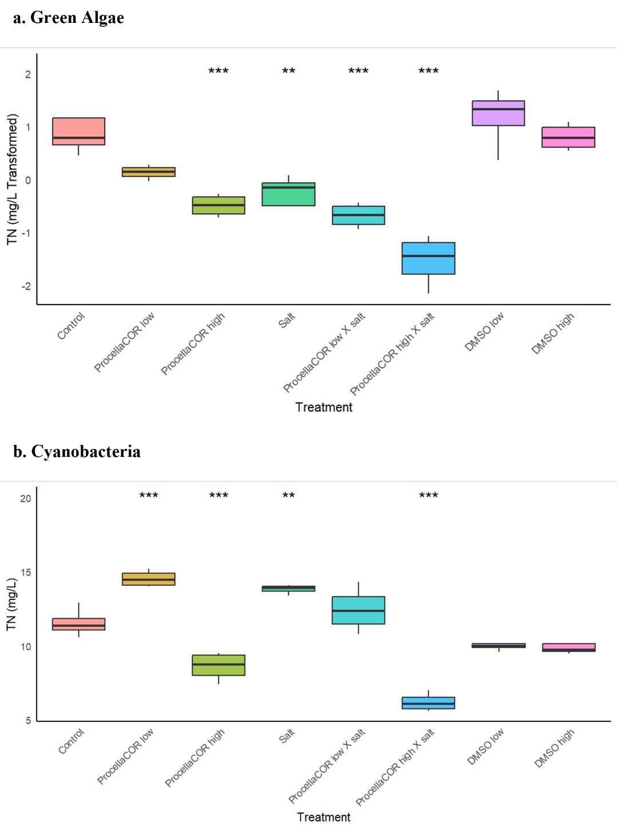

Fig S2 Effects of ProcellaCOR and salt on total phosphorus (TP) concentrations
Box plot showing total phosphorus (TP) levels (mg L⁻¹) across eight treatment groups, with TP values transformed and displayed on the y-axis and treatments labeled on the x-axis. Boxes represent the interquartile range (IQR), the horizontal line inside the box indicates the median, and whiskers represent the minimum and maximum values. Asterisks indicate statistically significant differences relative to the control (*p < 0.05, **p < 0.01, ***p < 0.001).

