Identifying Hidden Trends in Complex Data to Design Best Metal-Organic-Framework Catalysts for Oxygen Evolution Reaction
Liangliang Xu,^{1,2#} Jian Zhou,^{3#} Canhui Zhang,^{3,5#} Jiaqian Wang,^{1#} Jinpei Huang,² Zhong-Kang Han,¹* Huawei Huang,⁴ Ning Xu,¹ Heqing Jiang⁵, Minghua Huang,³* Zhengxiao Guo,^{2,6}* Sergey V. Levchenko,⁷ Xiaojuan Hu¹*

¹School of Materials Science and Engineering, Zhejiang University, Hangzhou, 310027, China
²Department of Chemistry, The University of Hong Kong, Hong Kong SAR, 999077, China
³School of Materials Science and Engineering, Ocean University of China, Qingdao, China
⁴China Yangtze Power Co., Ltd., Wuhan 430014, China
⁵Key Laboratory of Photoelectric Conversion and Utilization of Solar Energy, Qingdao New Energy Shandong Laboratory, Qingdao Institute of Bioenergy and Bioprocess Technology, Chinese Academy of Sciences, Qingdao, 266100, P. R. China
⁶Hong Kong Quantum AI Lab, AIR@InnoHK of Hong Kong Government, Hong Kong SAR, 999077, China
⁷Center for Energy Science and Technology, Skolkovo Institute of Science and Technology, Moscow 121205, Russia
#The authors contributed equally to this work.
*E-mail: hanzk@zju.edu.cn; huangminghua@ouc.edu.cn; zxguo@hku.hk; xiaojuanhu@zju.edu.cn

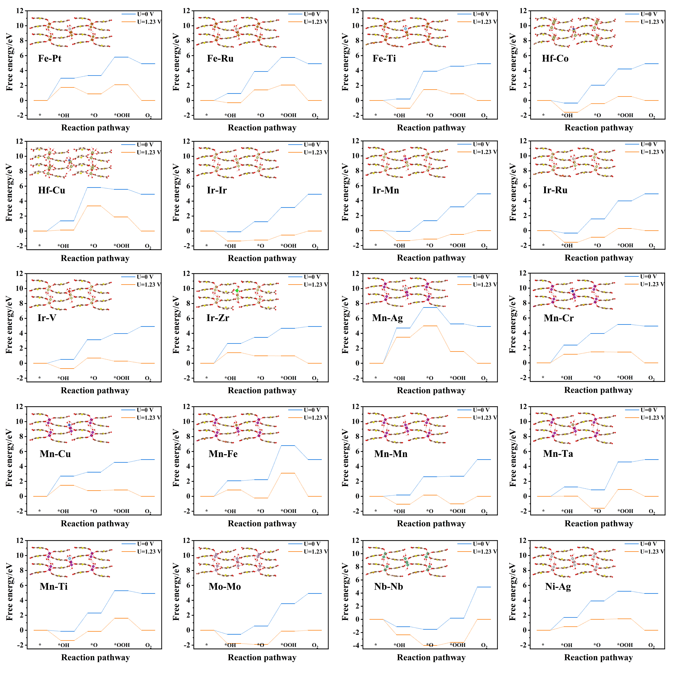
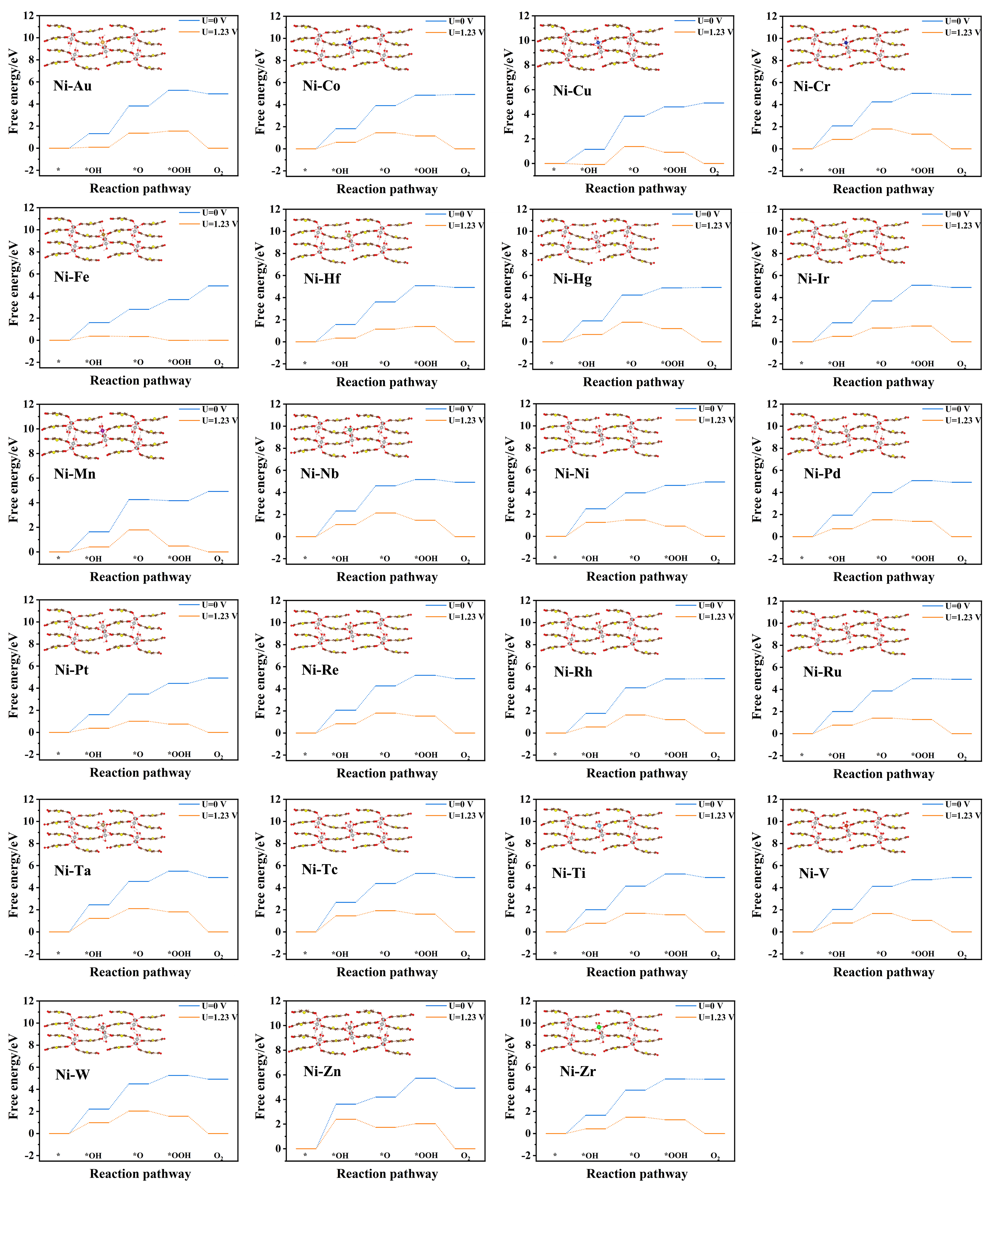
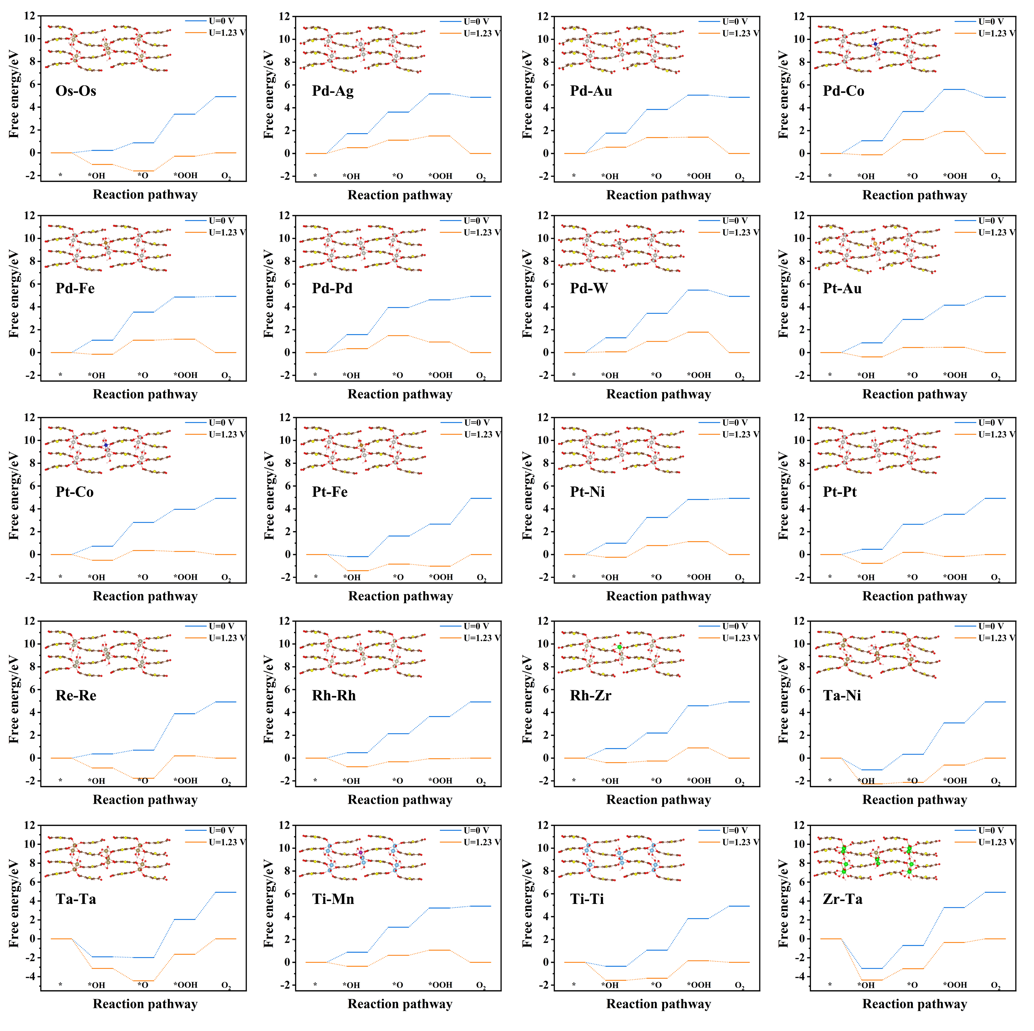
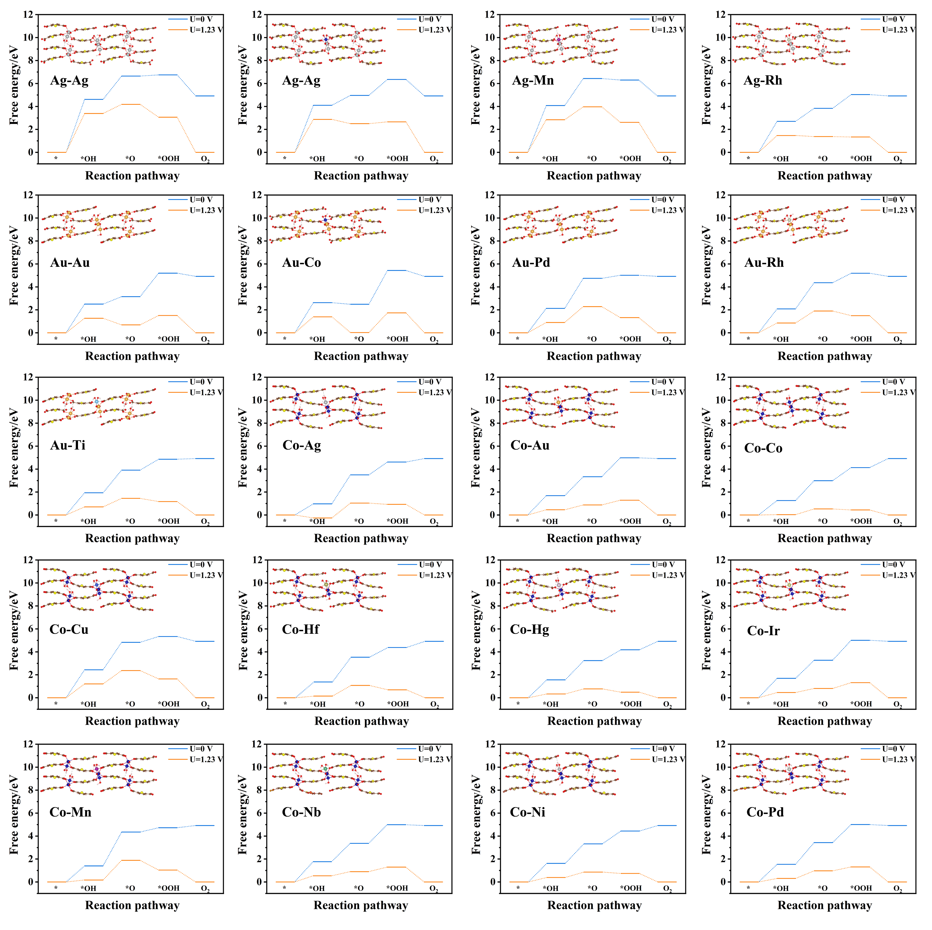
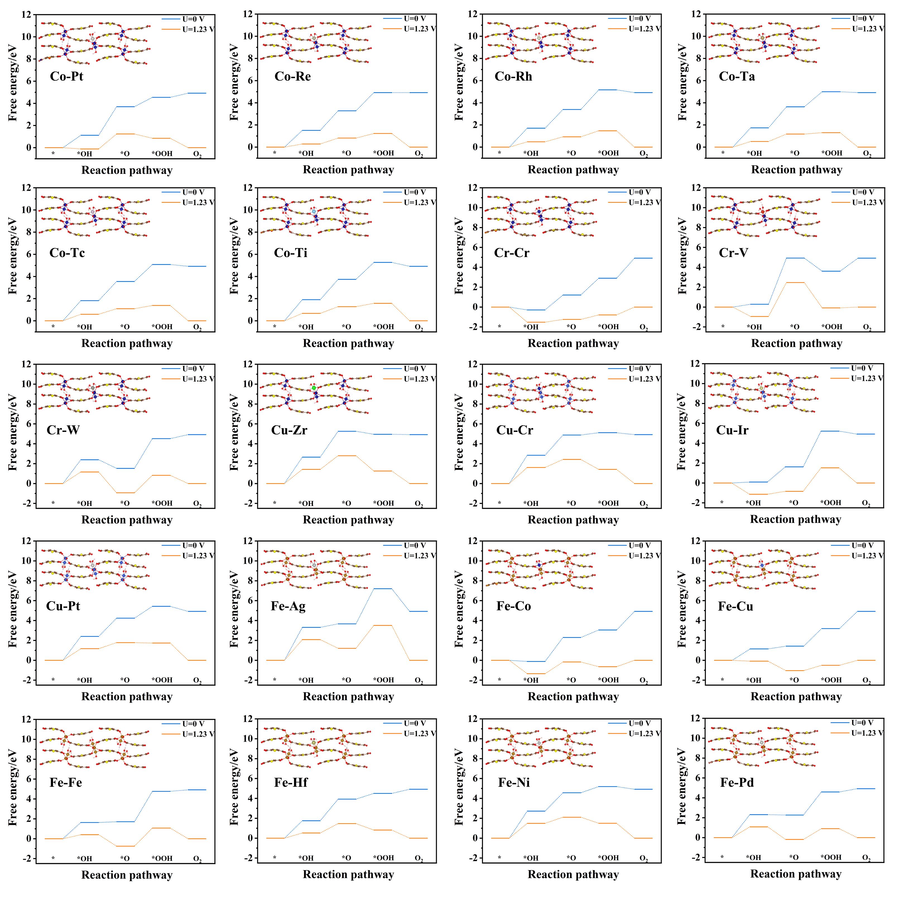
FIG. S1. 103-transition metal-doped MOF-TDC structural model and the corresponding free energy diagram.

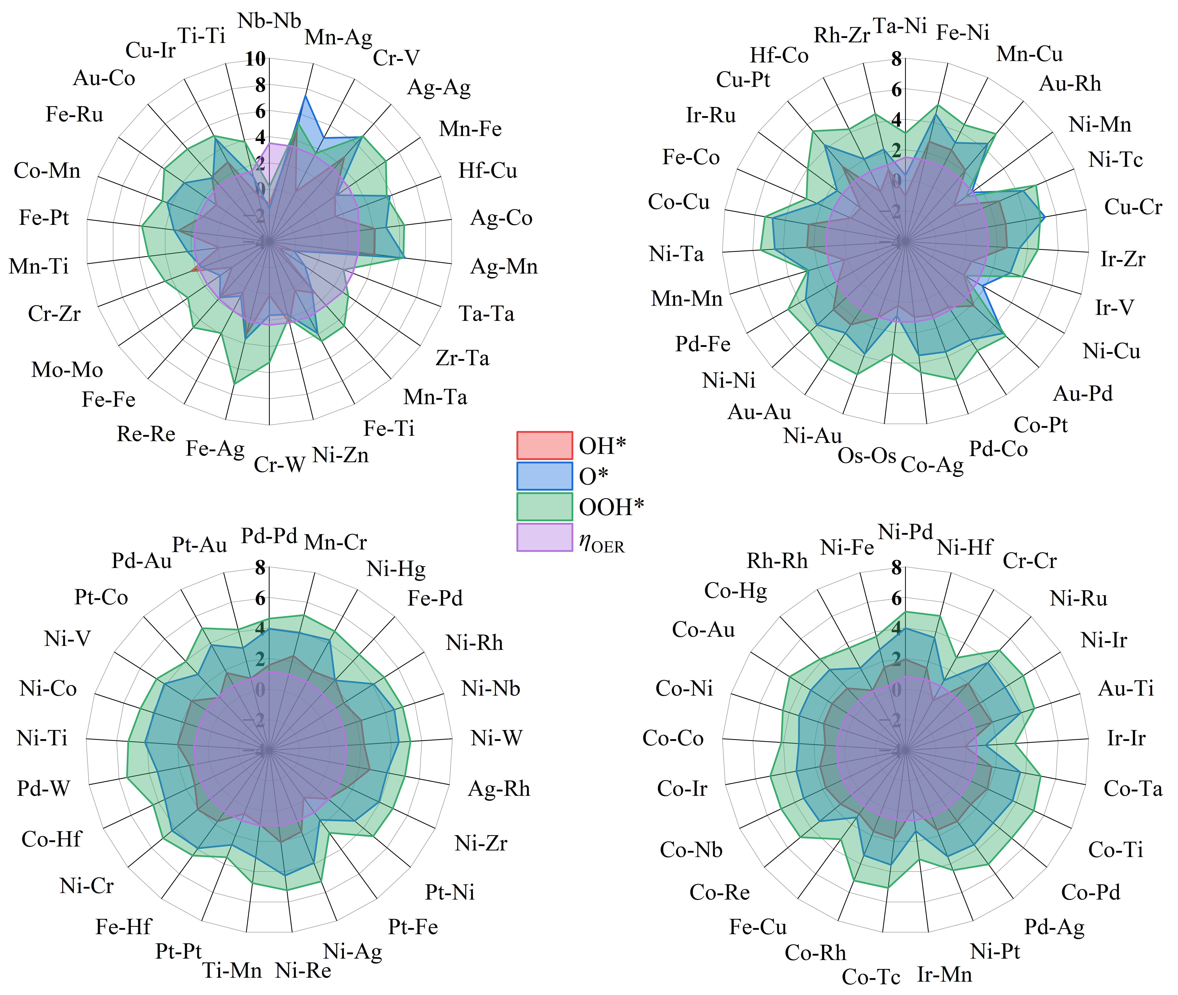
FIG. S2. The radar distribution of intermediate OH*, O*, OOH* and reaction overpotentials.

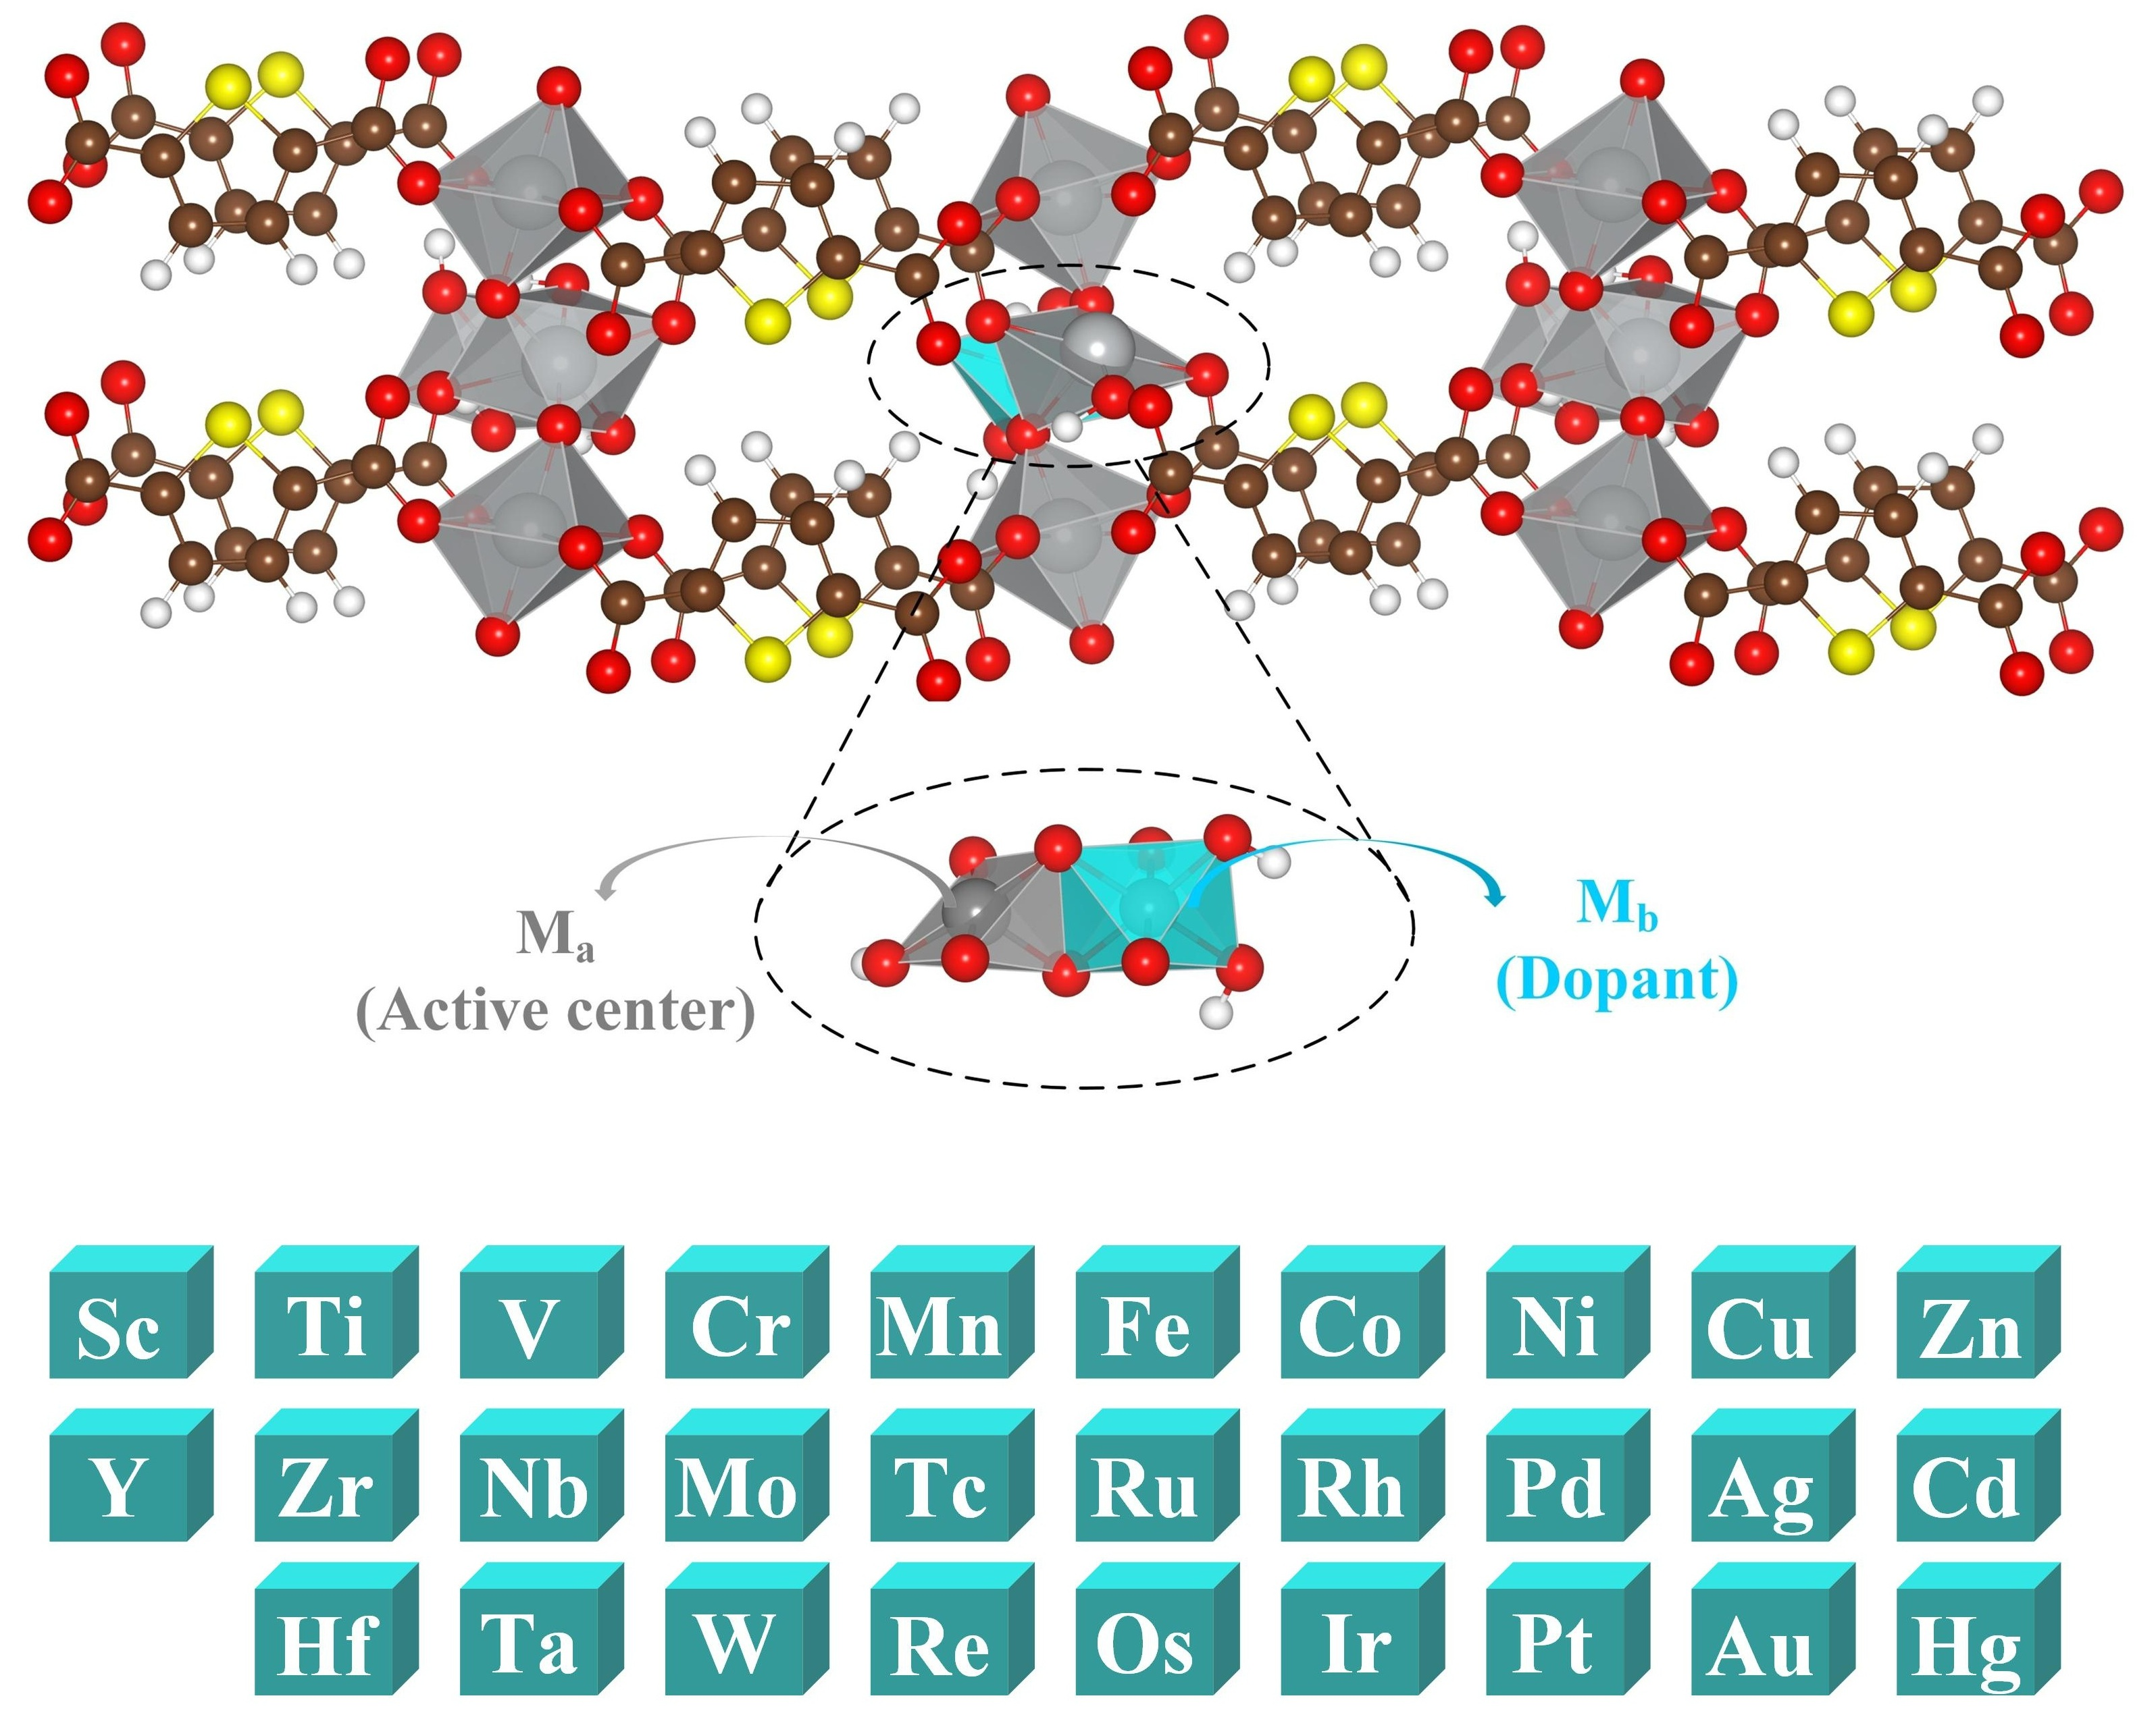
FIG. S3. Schematic diagram of the bulk structure. M_{a} with five coordination serves as the active center, while M_{b} with six coordination serves as the doping center.

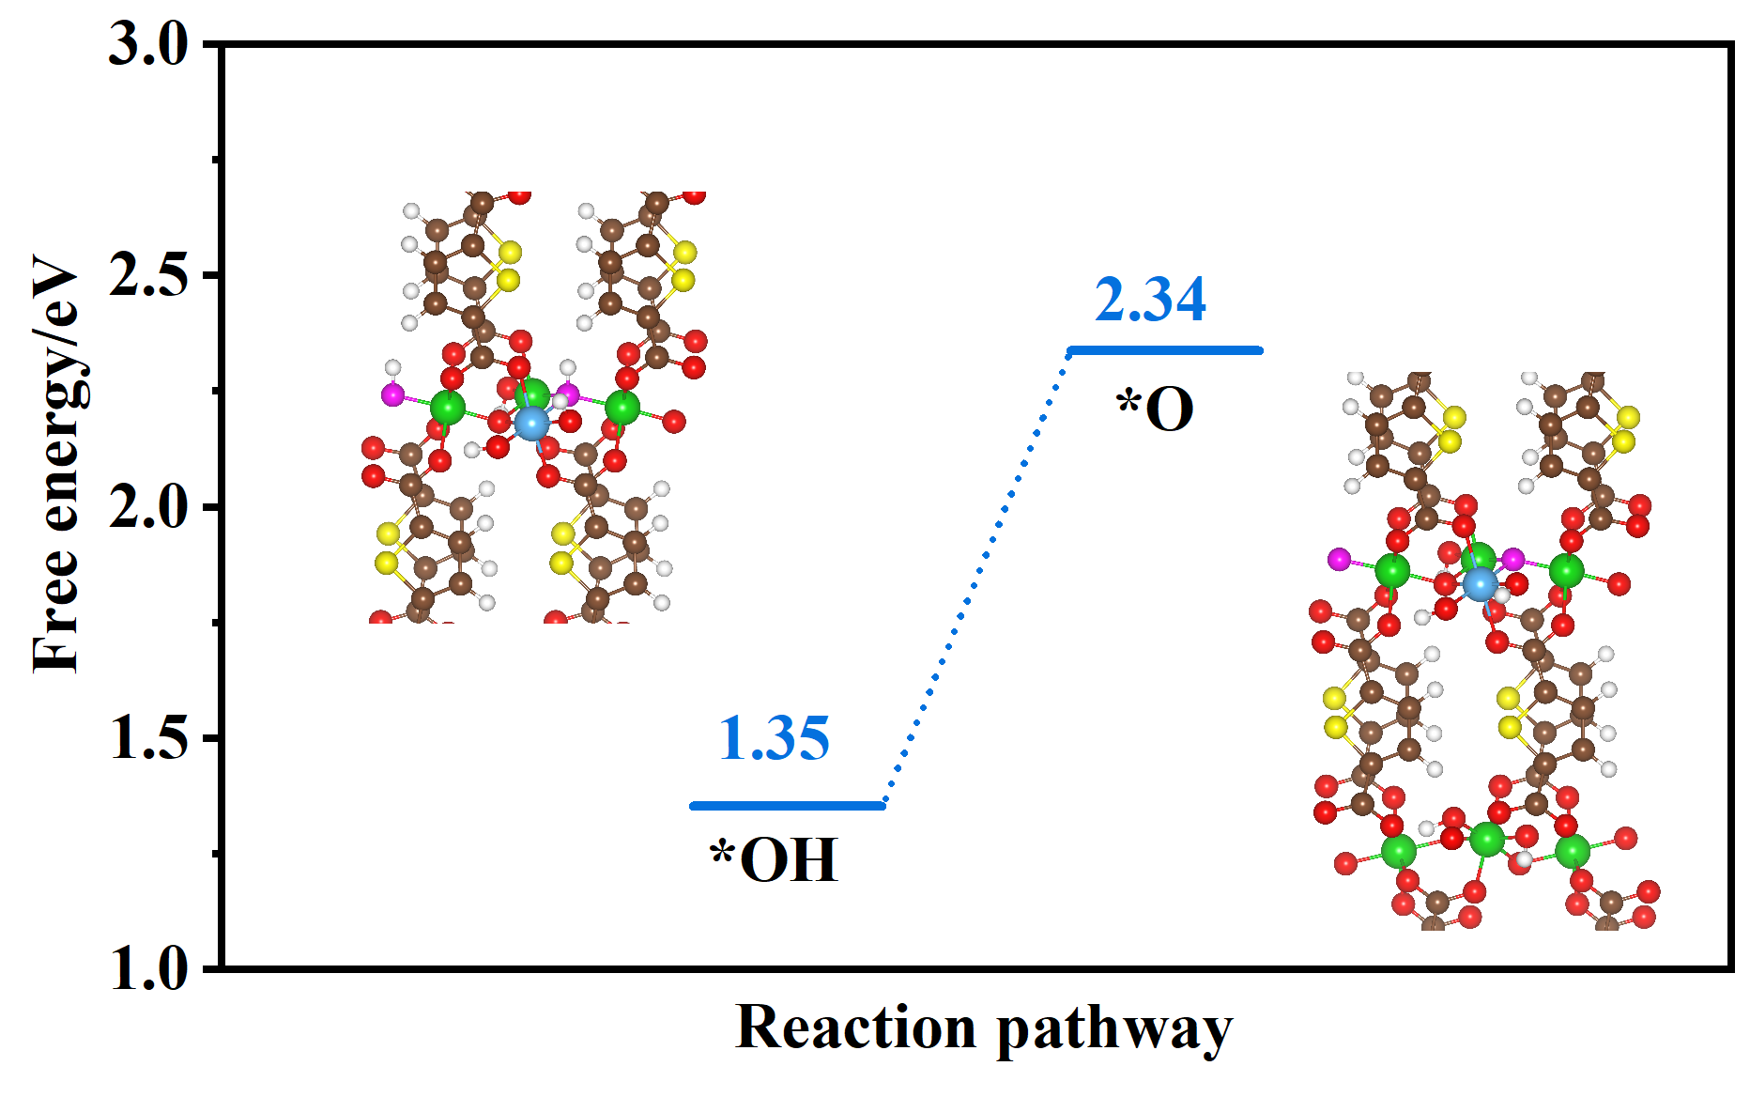
FIG. S4. The adsorption free energy at the hollow oxygen site.

FIG. S5. Formation energy of 103 systems by DFT calculations.

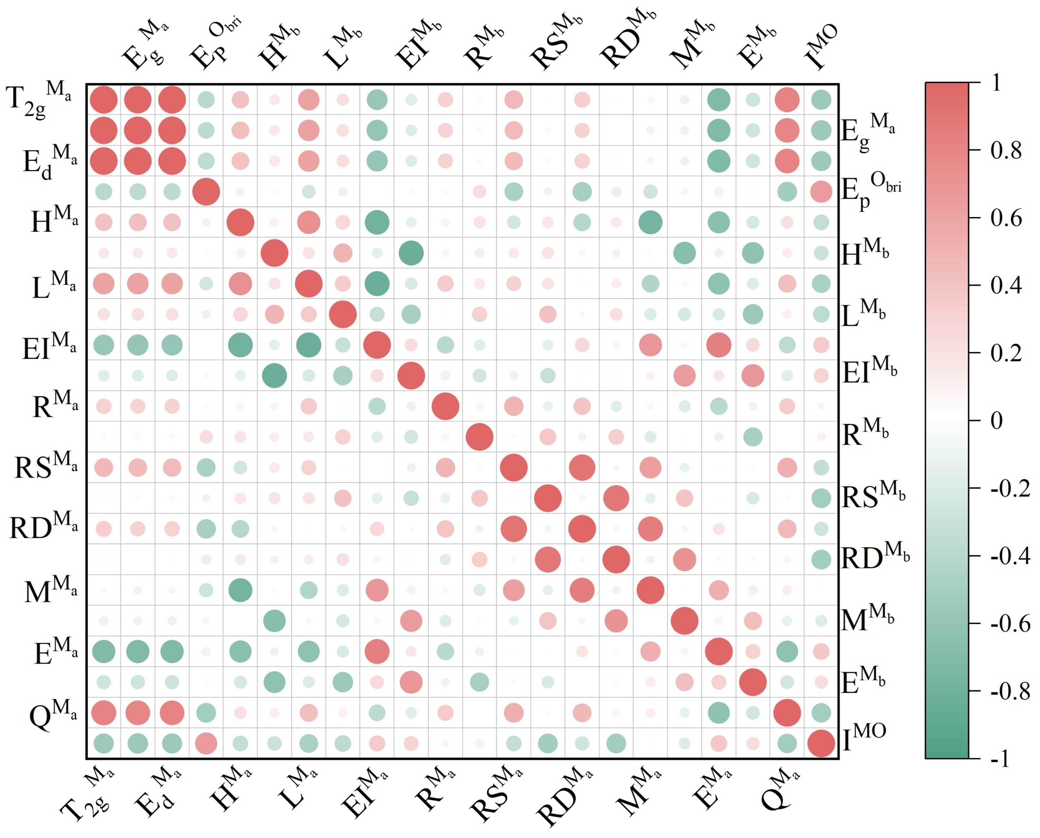
FIG. S6. The correlation between each individual feature.

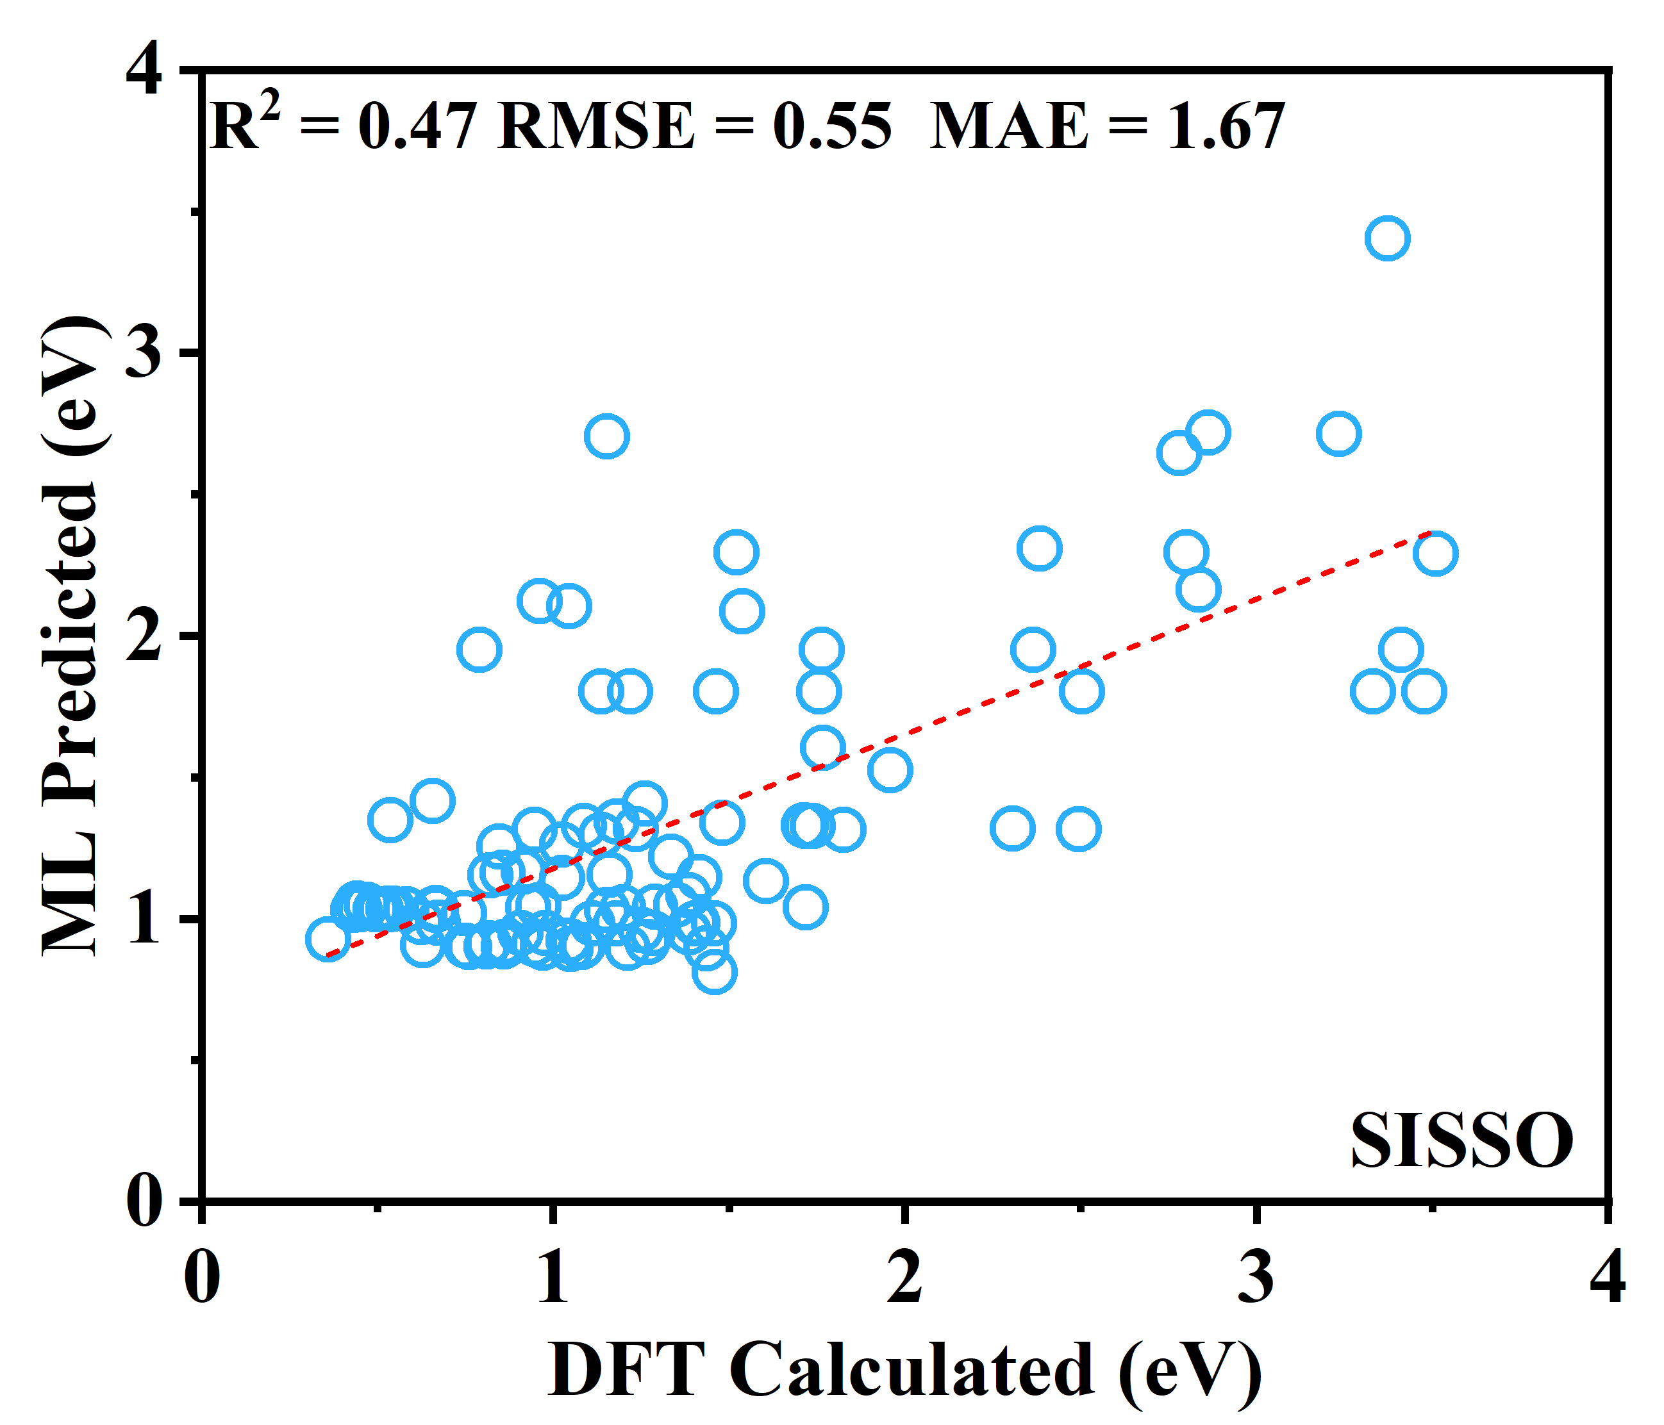
FIG. S7. The SISSO-trained machine learning model.

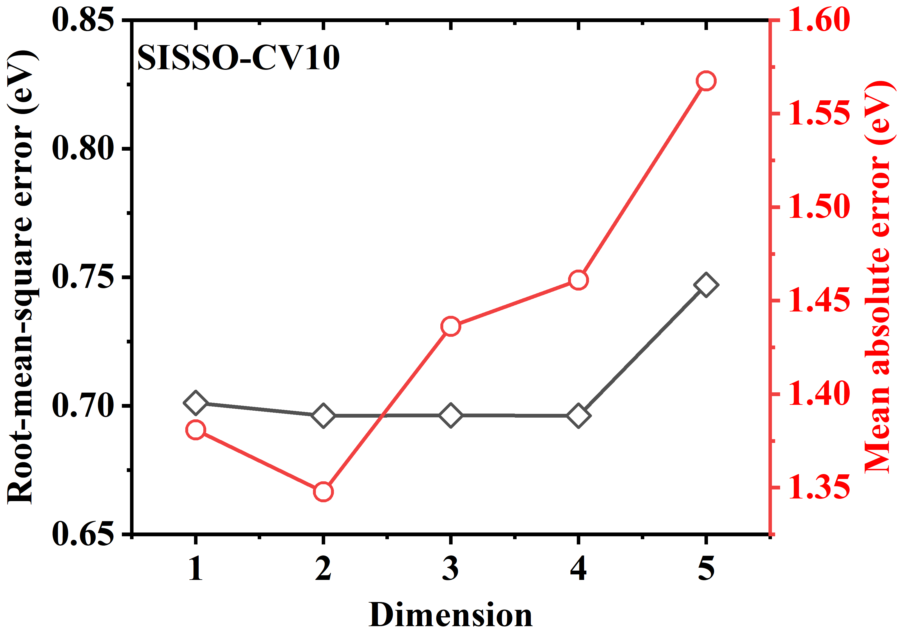
FIG. S8. RMSE and MAE of the 10-fold cross-validation by SISSO.

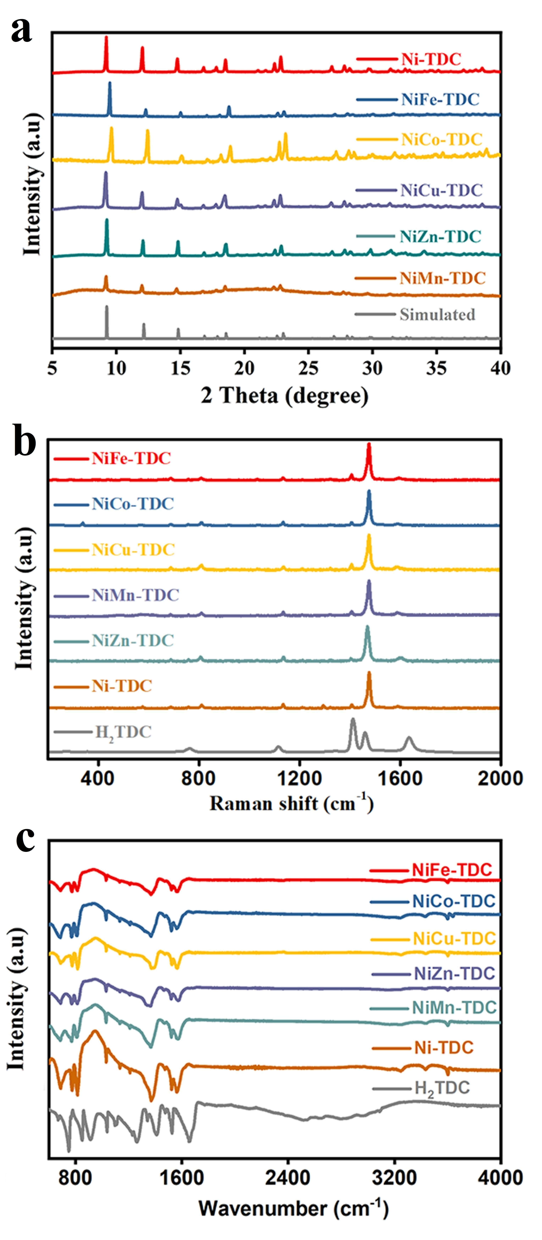
FIG. S9. (a) XRD patterns, (b) Raman, and (c) FT-IR spectra of Ni-M-TDC (M=Fe, Co, Cu, Mn and Zn).

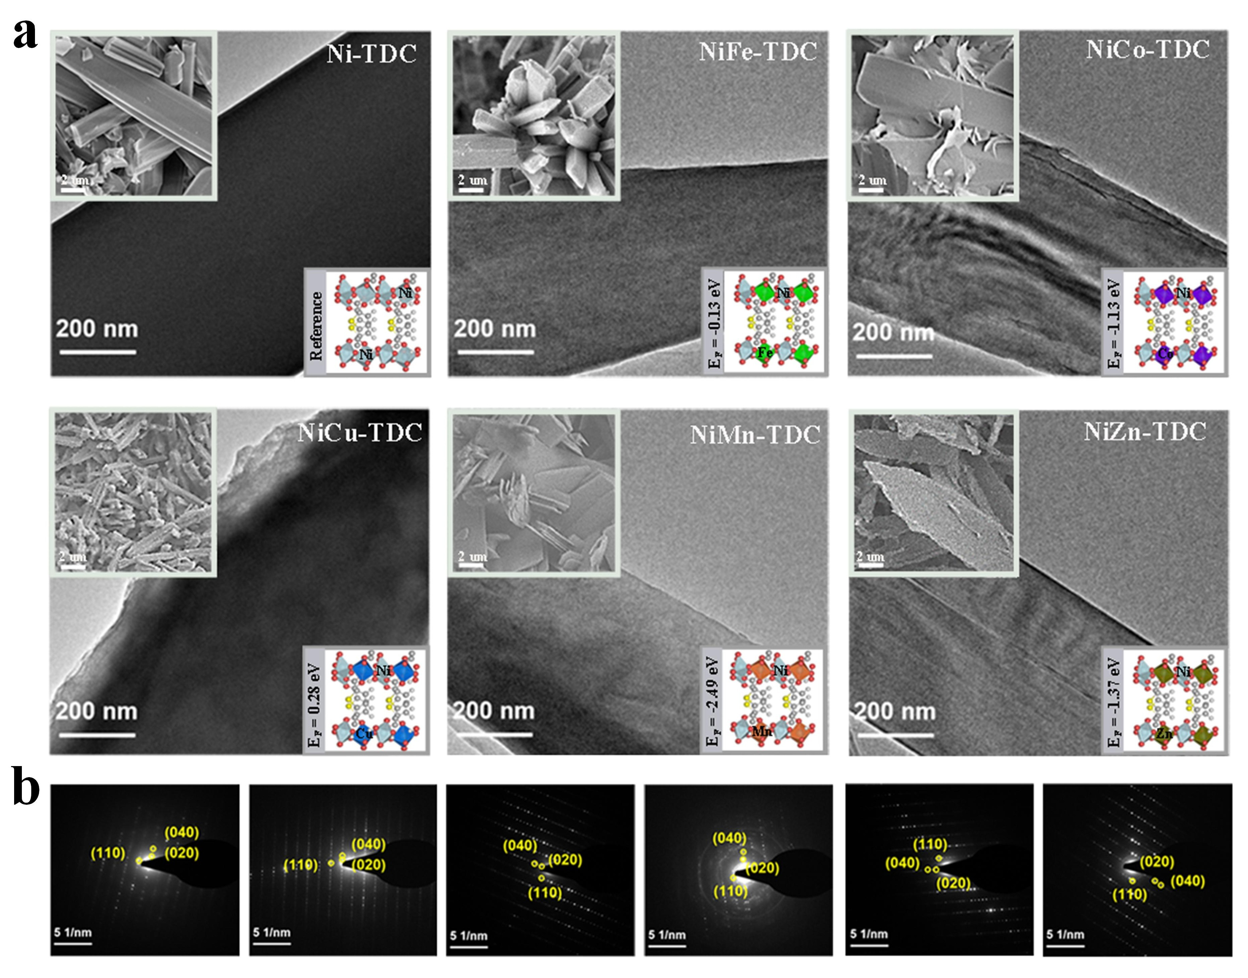
FIG. S10. Typical SEM and TEM inmages of (a) Ni-TDC, NiFe-TDC, NiCo-TDC, NiCu-TDC, NiMn-TDC, and NiZn-TDC. Inset represent the calculated formation energy of Ni-M-TDC. (b) The SAED images of Ni-M-TDC.

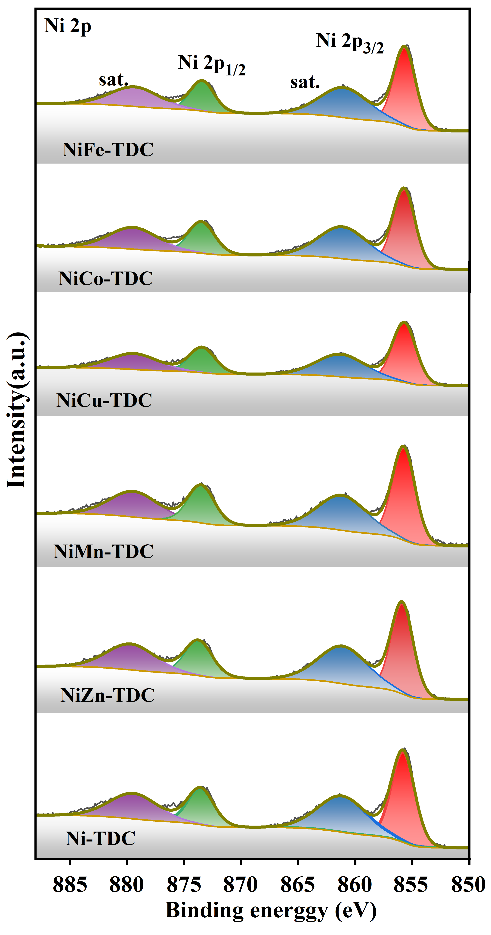
FIG. S11. High-resolution Ni 2p XPS spectra of Ni-TDC, NiZn-TDC, NiMn-TDC, NiCu-TDC, NiCo-TDC, and NiFe-TDC.

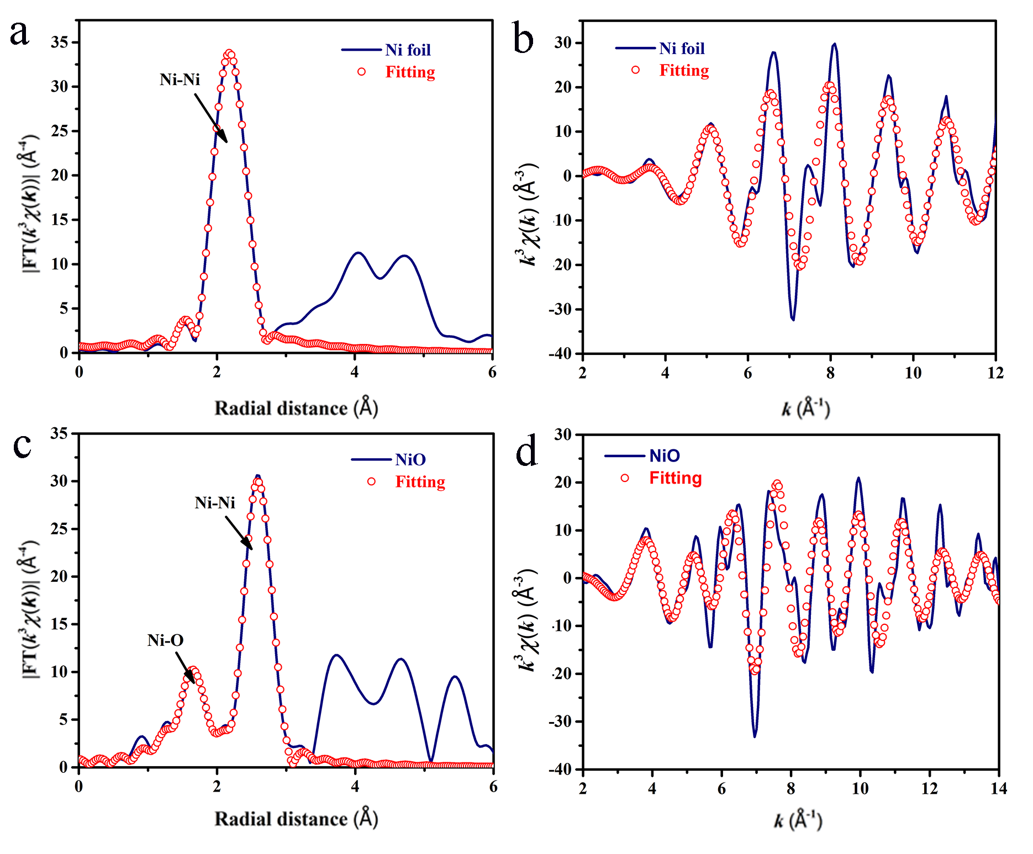
FIG. S12. The k³-weighted EXAFS fitting curves at R space (a and c) or k space (b and d) for Ni foil and NiO.

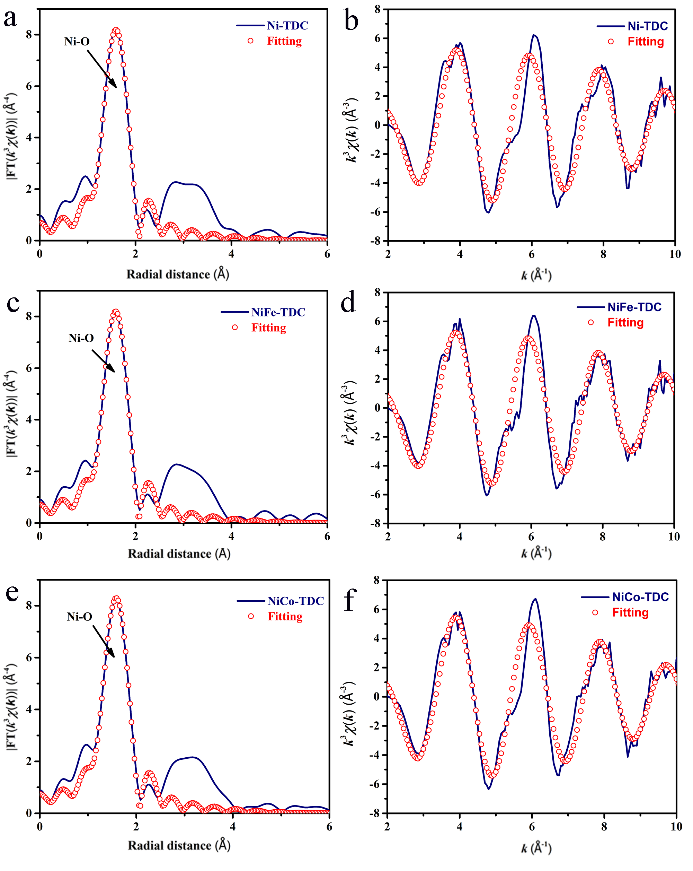
FIG. S13. The k³-weighted EXAFS fitting curves at R space (a,c and e) or k space (b,d and f) for Ni-TDC, NiFe-TDC, and NiCo-TDC.

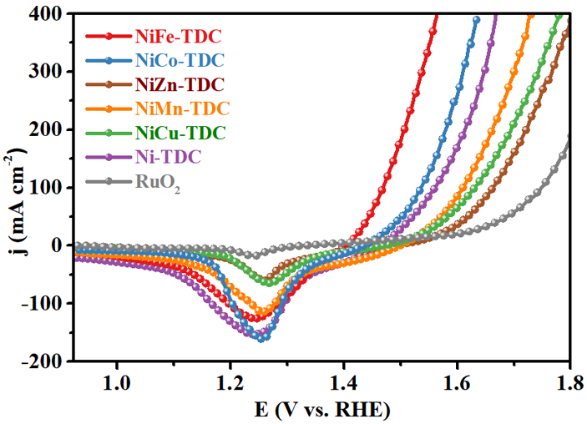
FIG. S14. LSV curves of Ni-TDC, NiZn-TDC, NiMn-TDC, NiCu-TDC, NiCo-TDC, NiFe-TDC and RuO₂.

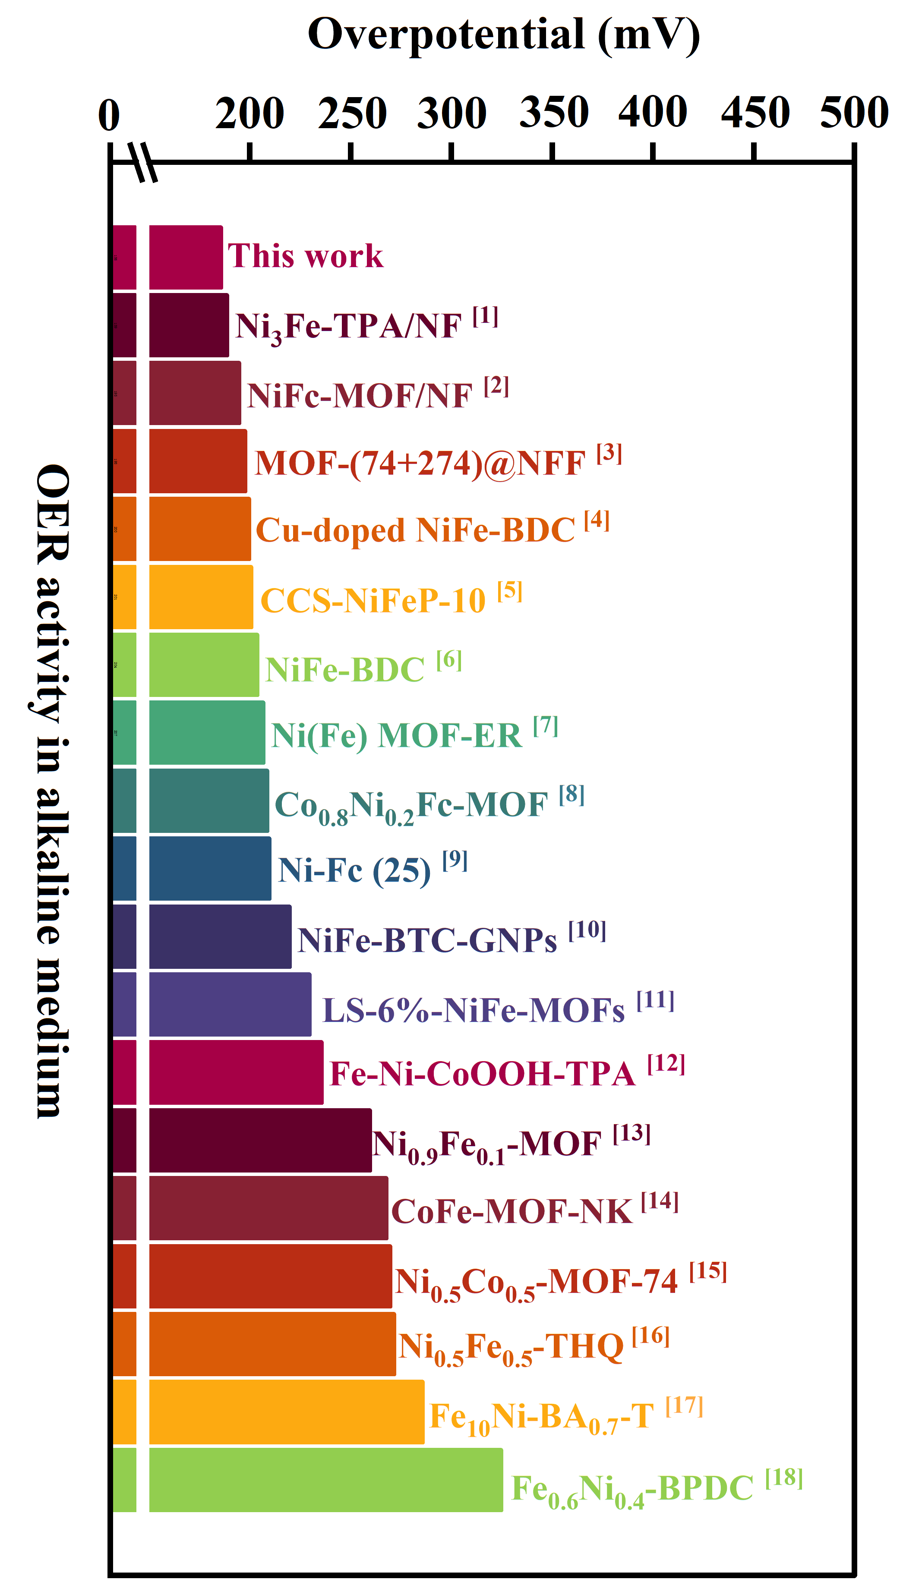
FIG. S15. OER catalytic activity of various MOF-based OER catalysts.

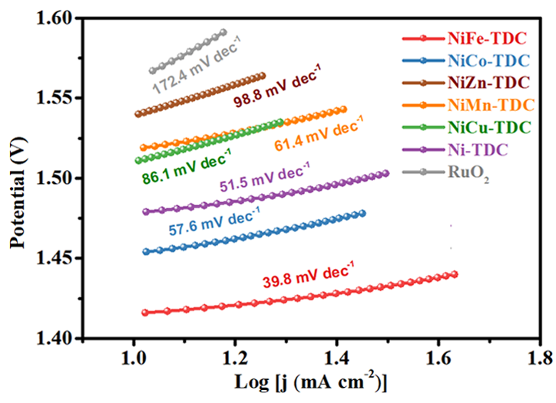
FIG. S16. Tafel slope of Ni-M-TDC (M=Fe, Co, Cu, Mn and Zn), and RuO₂.

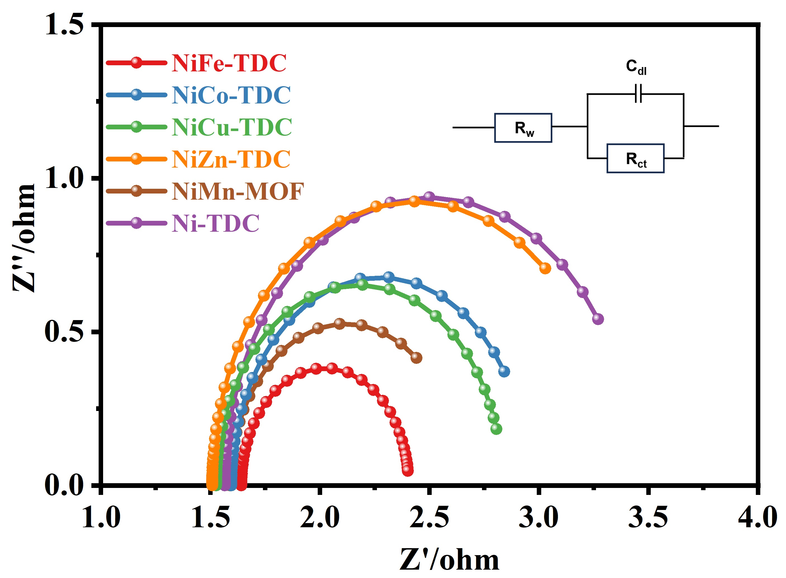
FIG. S17. The calculated Nyquist plots of Ni-M-TDC (M=Fe, Co, Cu, Mn, and Zn).

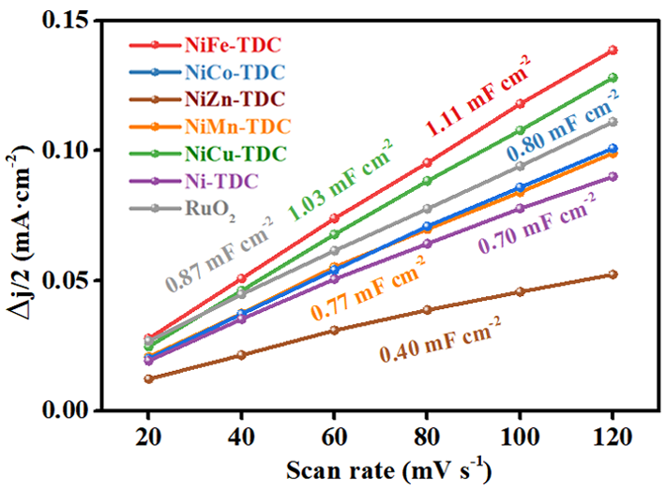
FIG. S18. Calculted C_{dl} of Ni-M-TDC (M=Fe, Co, Cu, Mn and Zn).

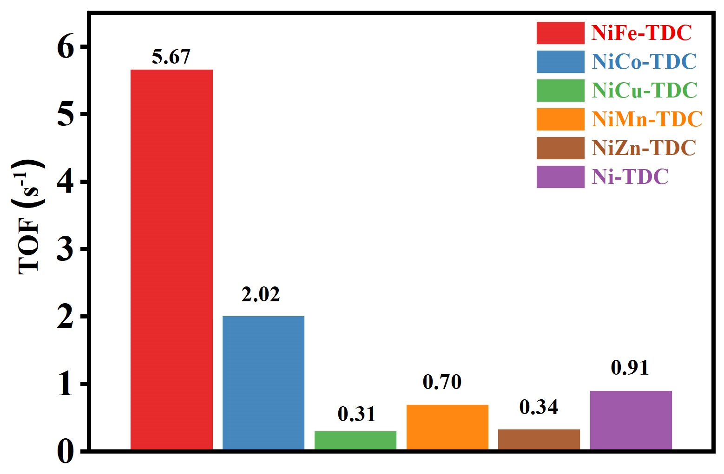
FIG. S19. The calculated TOF of Ni-M-TDC (M=Fe, Co, Cu, Mn, and Zn).

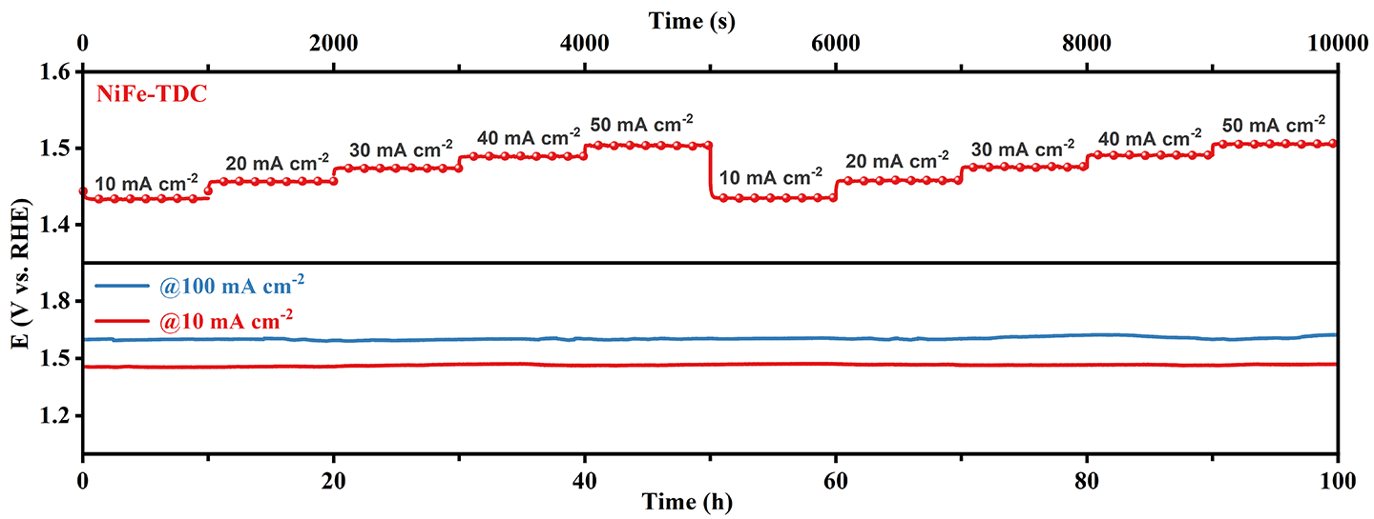
FIG. S20. Multi-current process from 10 to 50 mA cm⁻² and chronoamperometric (V-t) curves at 10 and 100 mA cm⁻² of NiFe-TDC.

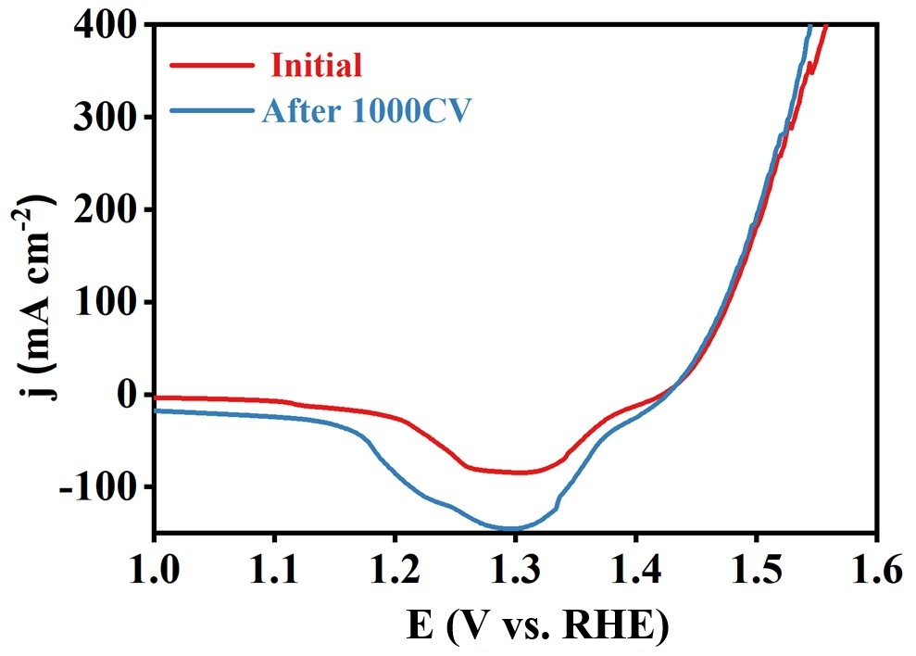
FIG. S21. The tested LSV curves of NiFe-TDC before and after 1000 cycles.

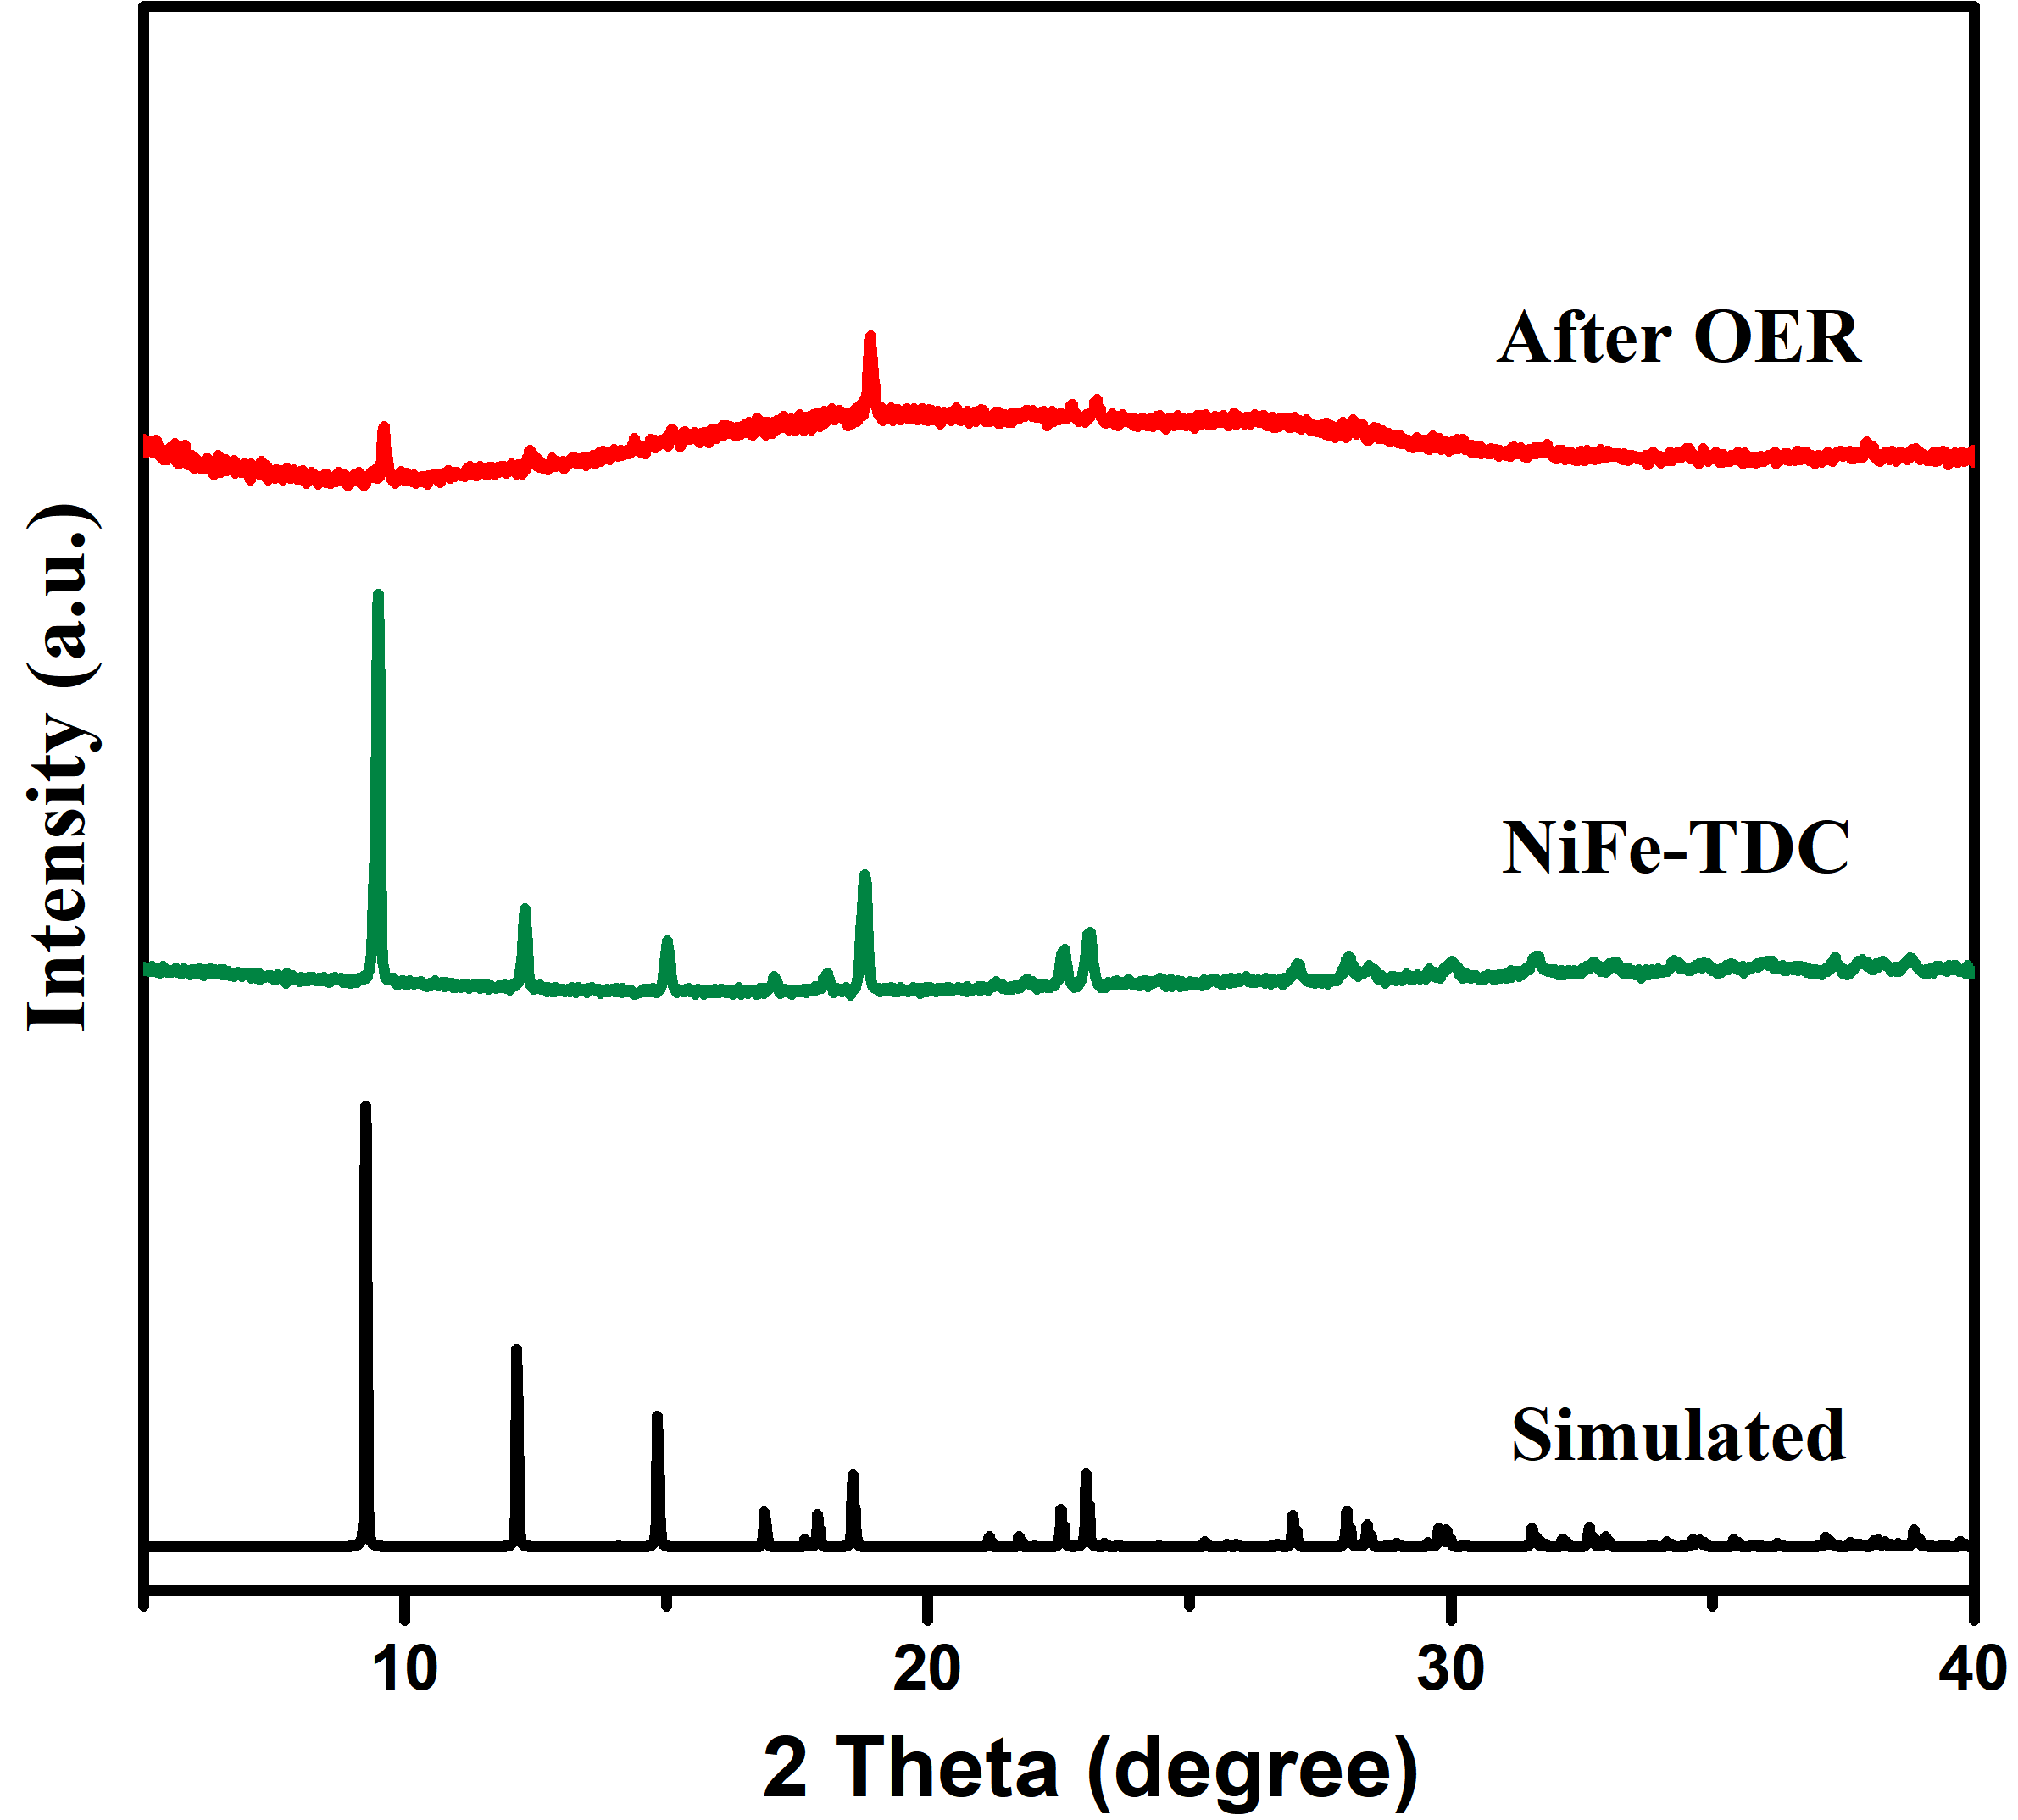
FIG. S22. The XRD patterns of the simulated MOF structure, NiFe-TDC and NiFe-TDC after OER.

FIG. S23. Free energy diagrams of (a) NiCuOOH, NiMnOON, NiZnOOH, as well as (b) NiOOH, NiCoOOH, and NiFeOOH.

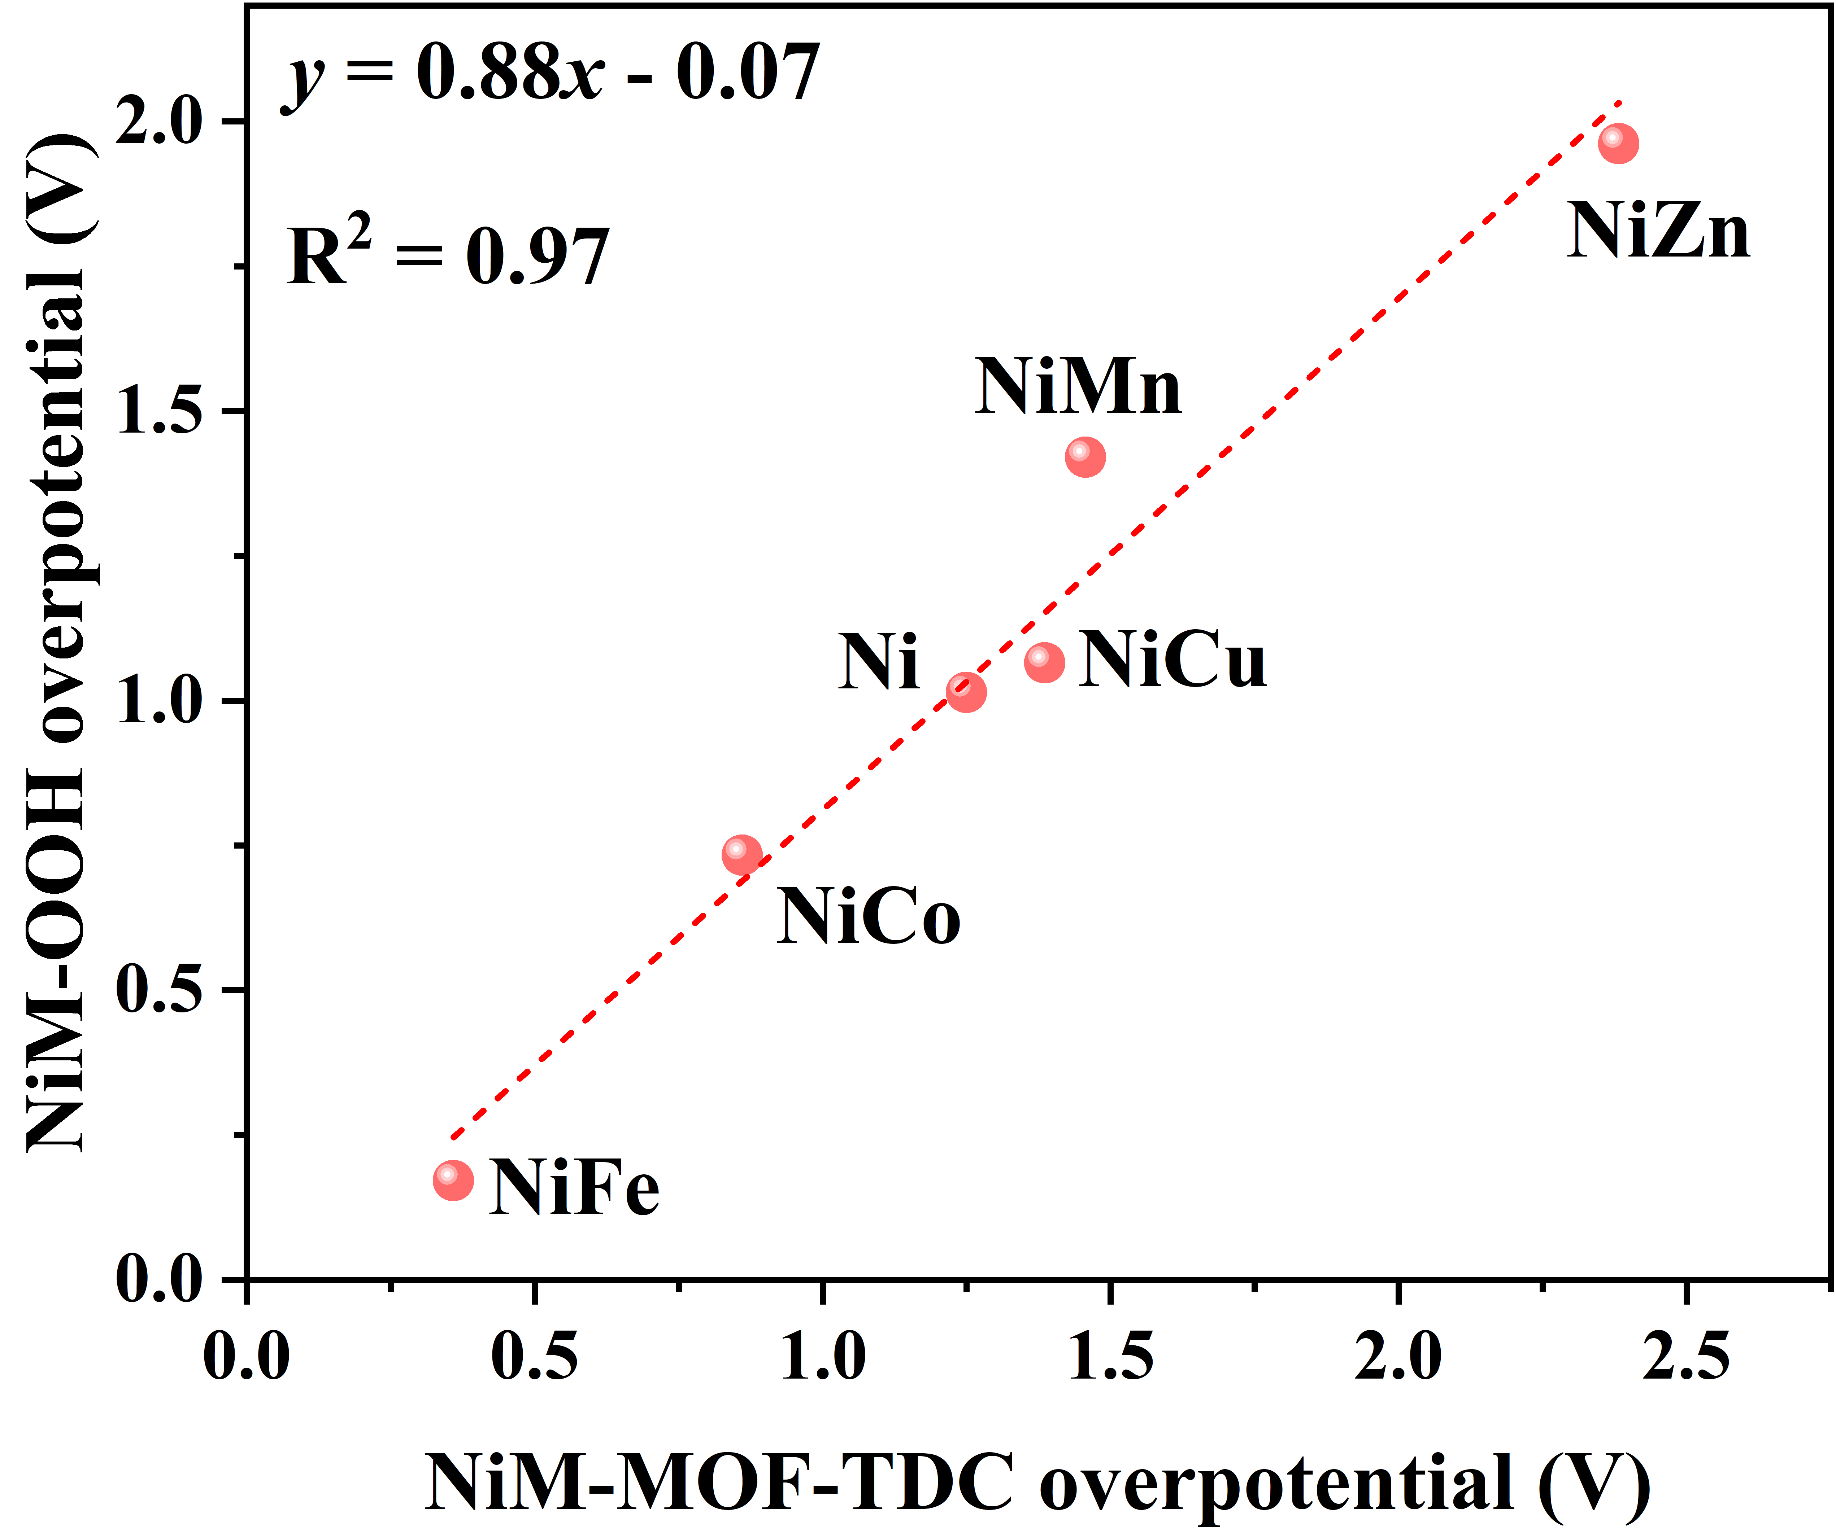
FIG. S24. Correlation of overpotential of NiM-MOF-TDC and NiM-OOH (M=Ni, Cu, Mn, Zn, Co, Fe).

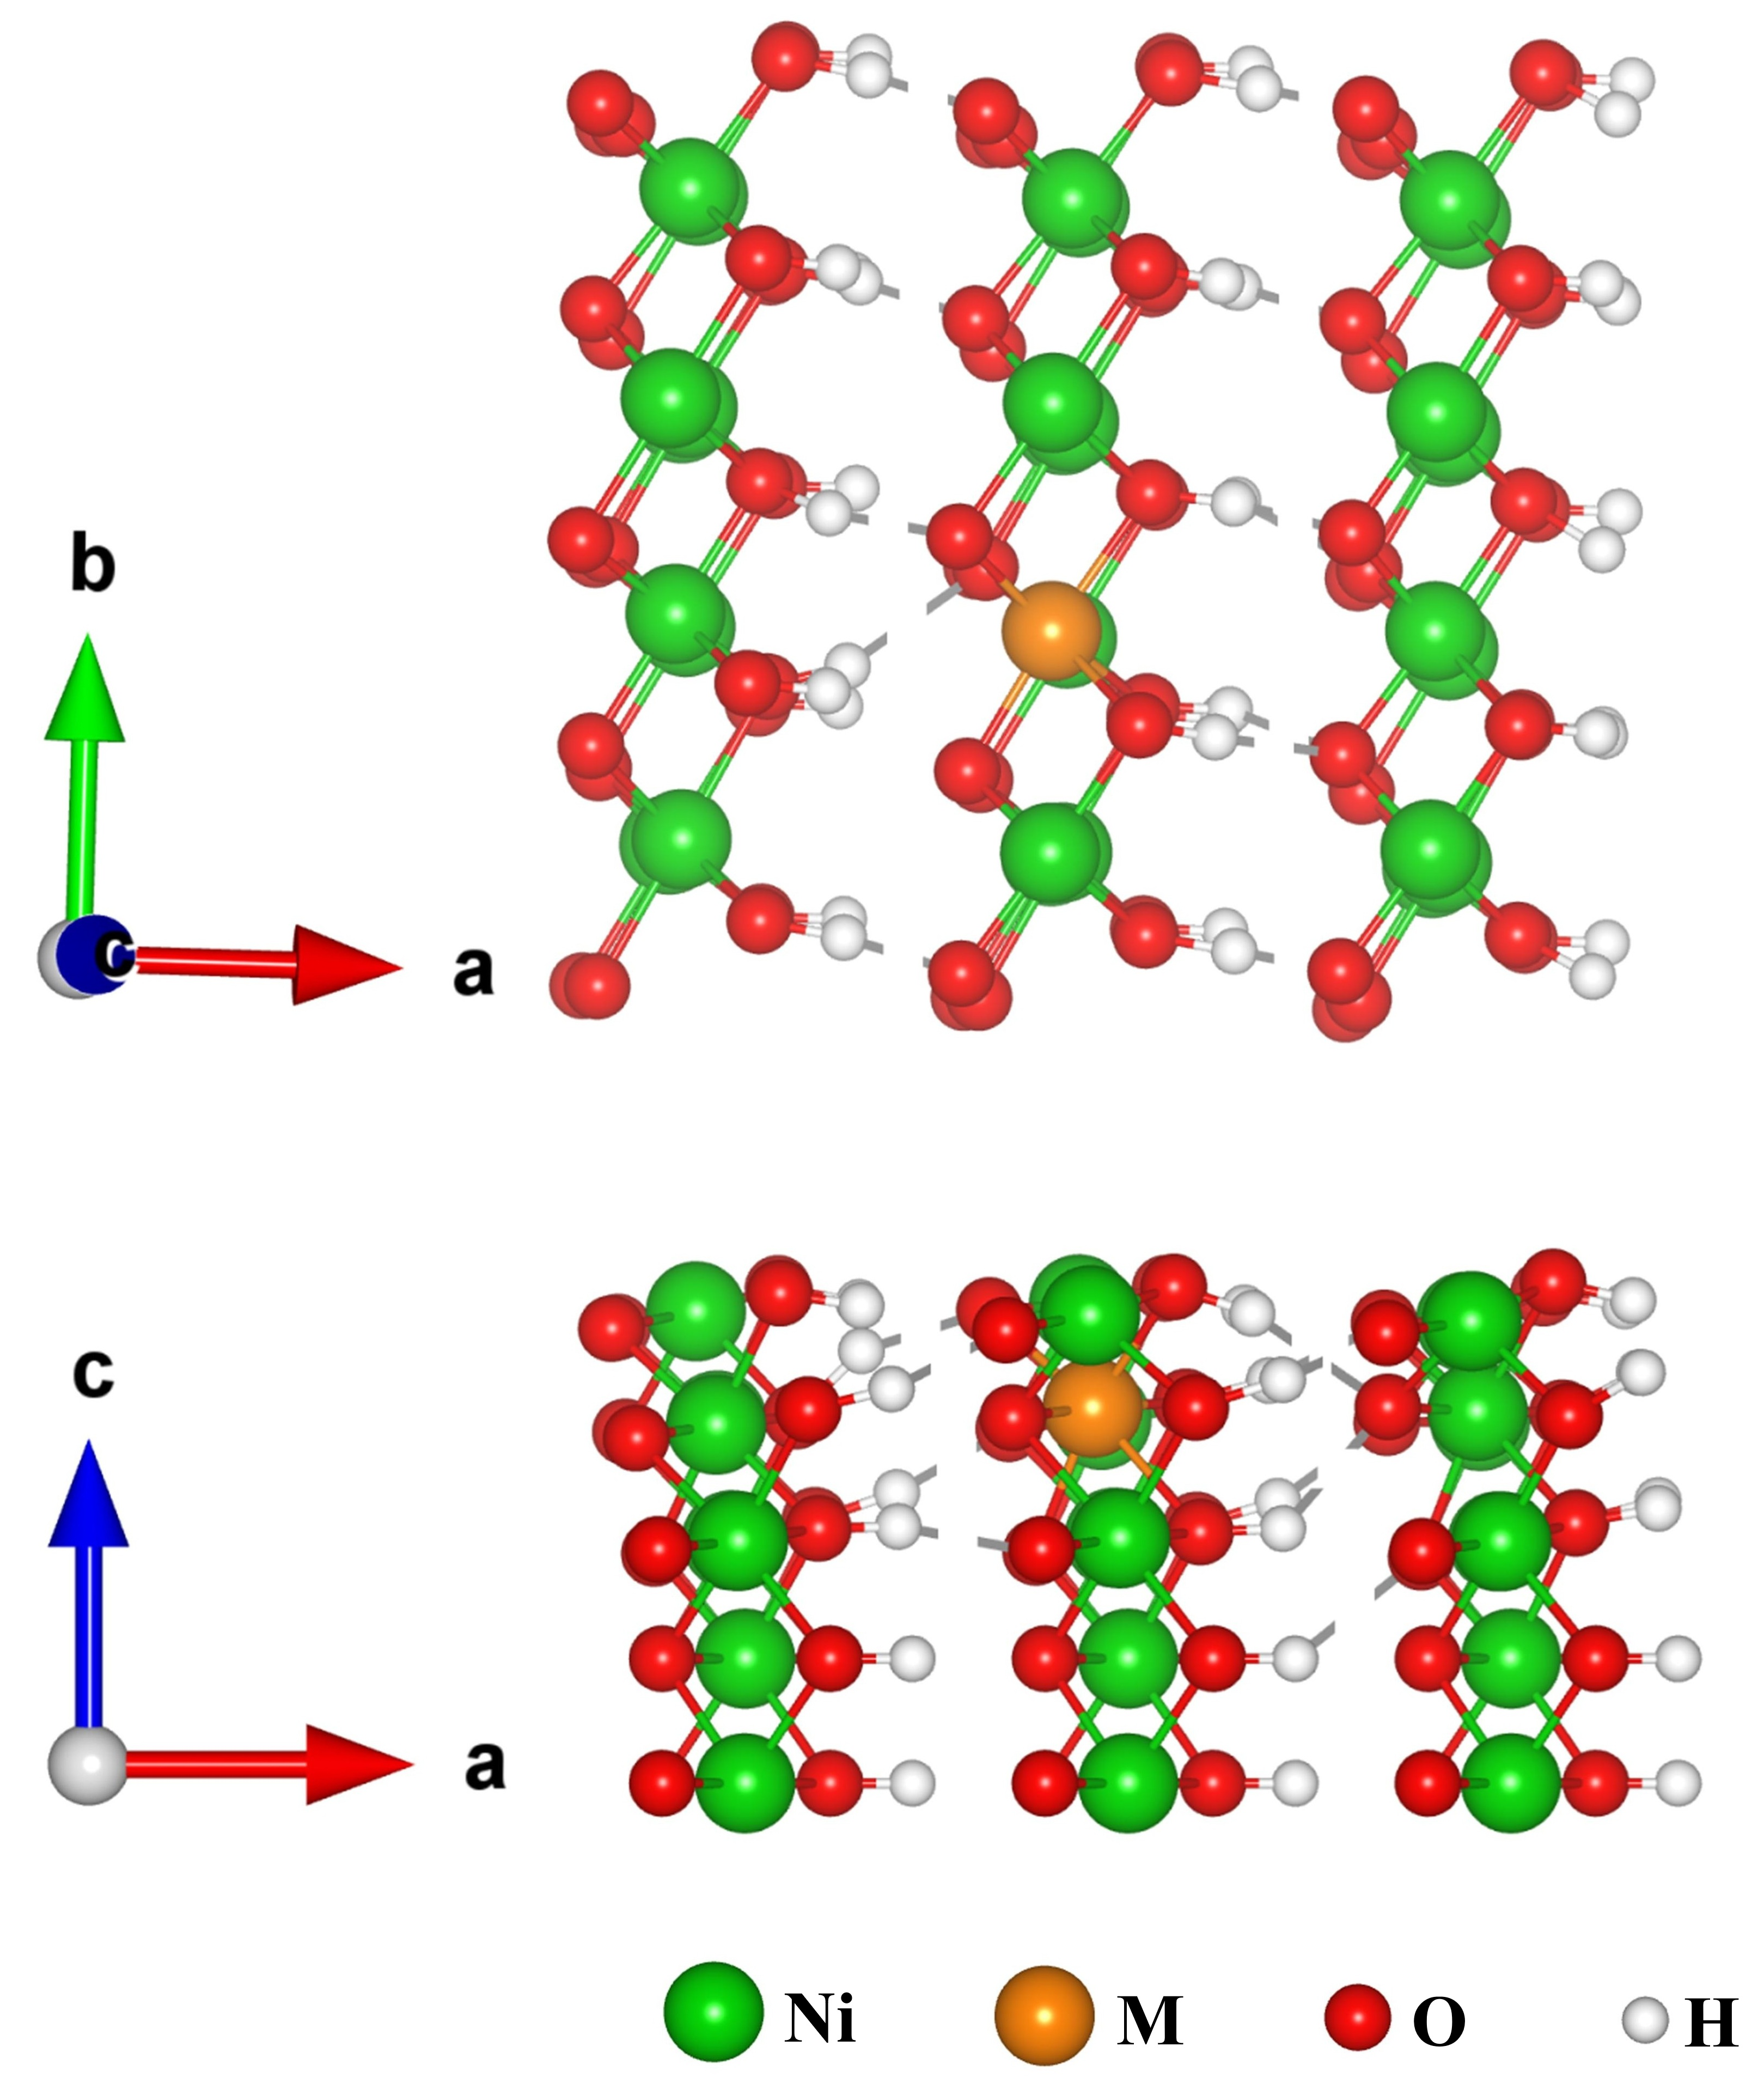
FIG. S25. Top and side views of the NiMOOH structure.

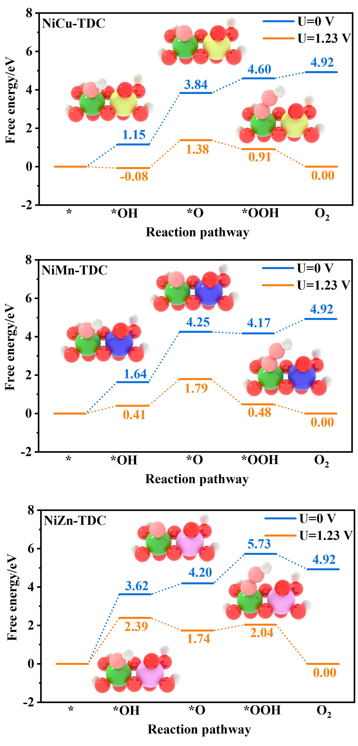
FIG. S26. Free energy diagrams of NiCu-TDC, NiMn-TDC, and NiZn-TDC. Inset are the corresponding adsorption models.

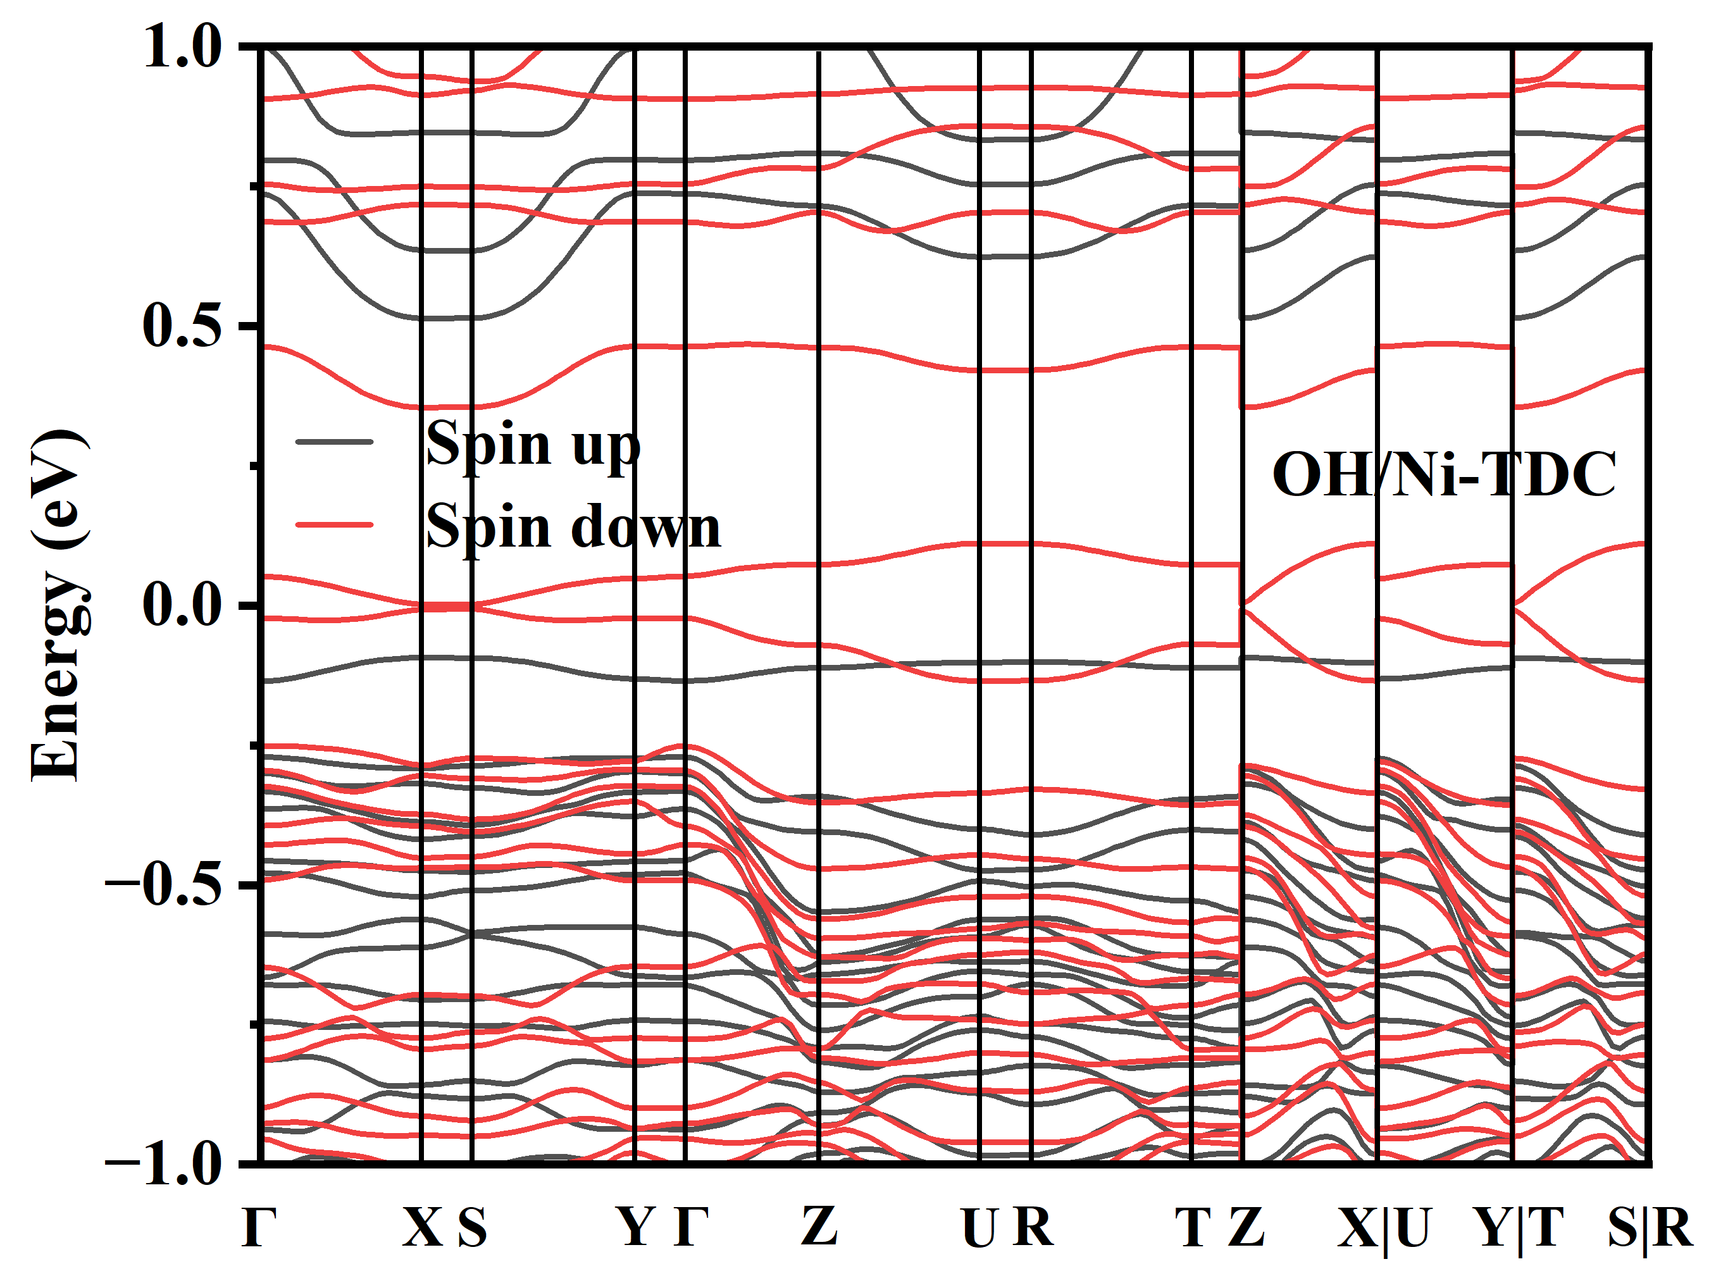
FIG. S27. The band structure of intermediates OH* adsorbed on Ni-TDC.
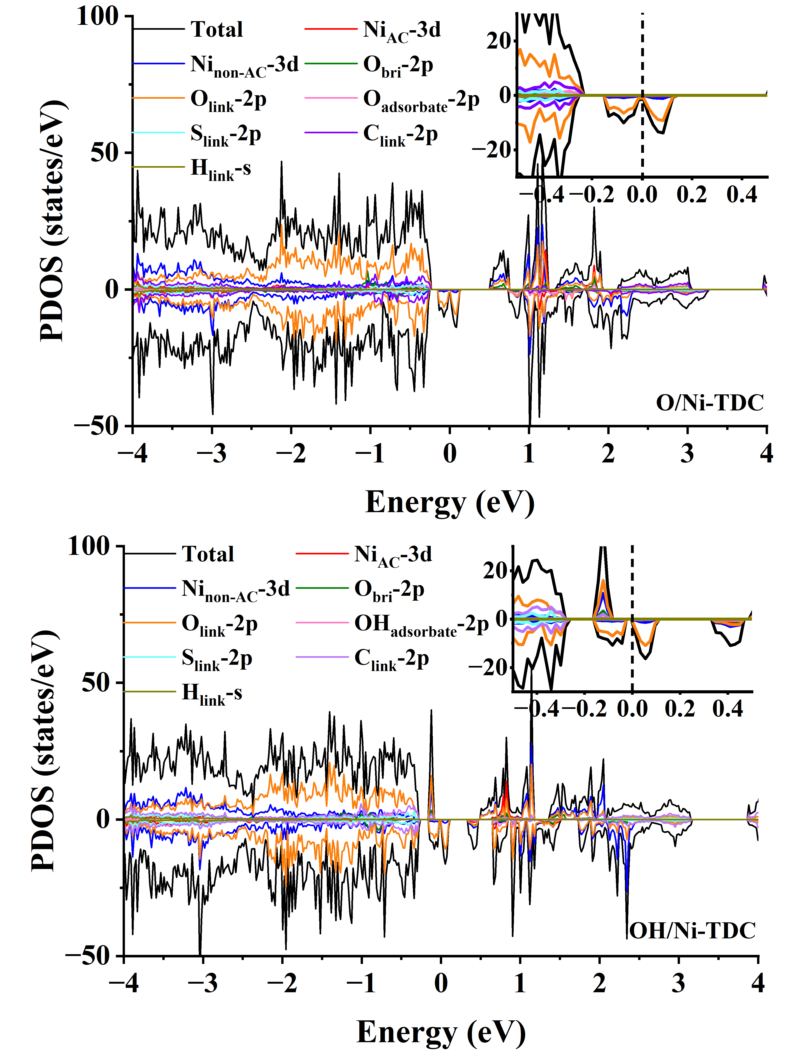
FIG. S28. The projected density of states of the adsorbed O* and adsorbed OH* on Ni-TDC. Total represents the total density of states, AC stands for the active center, non-AC denotes other metals excluding the active center, O_{bri} refers to the bridging oxygen, and the inset shows a magnified view near the Fermi level.

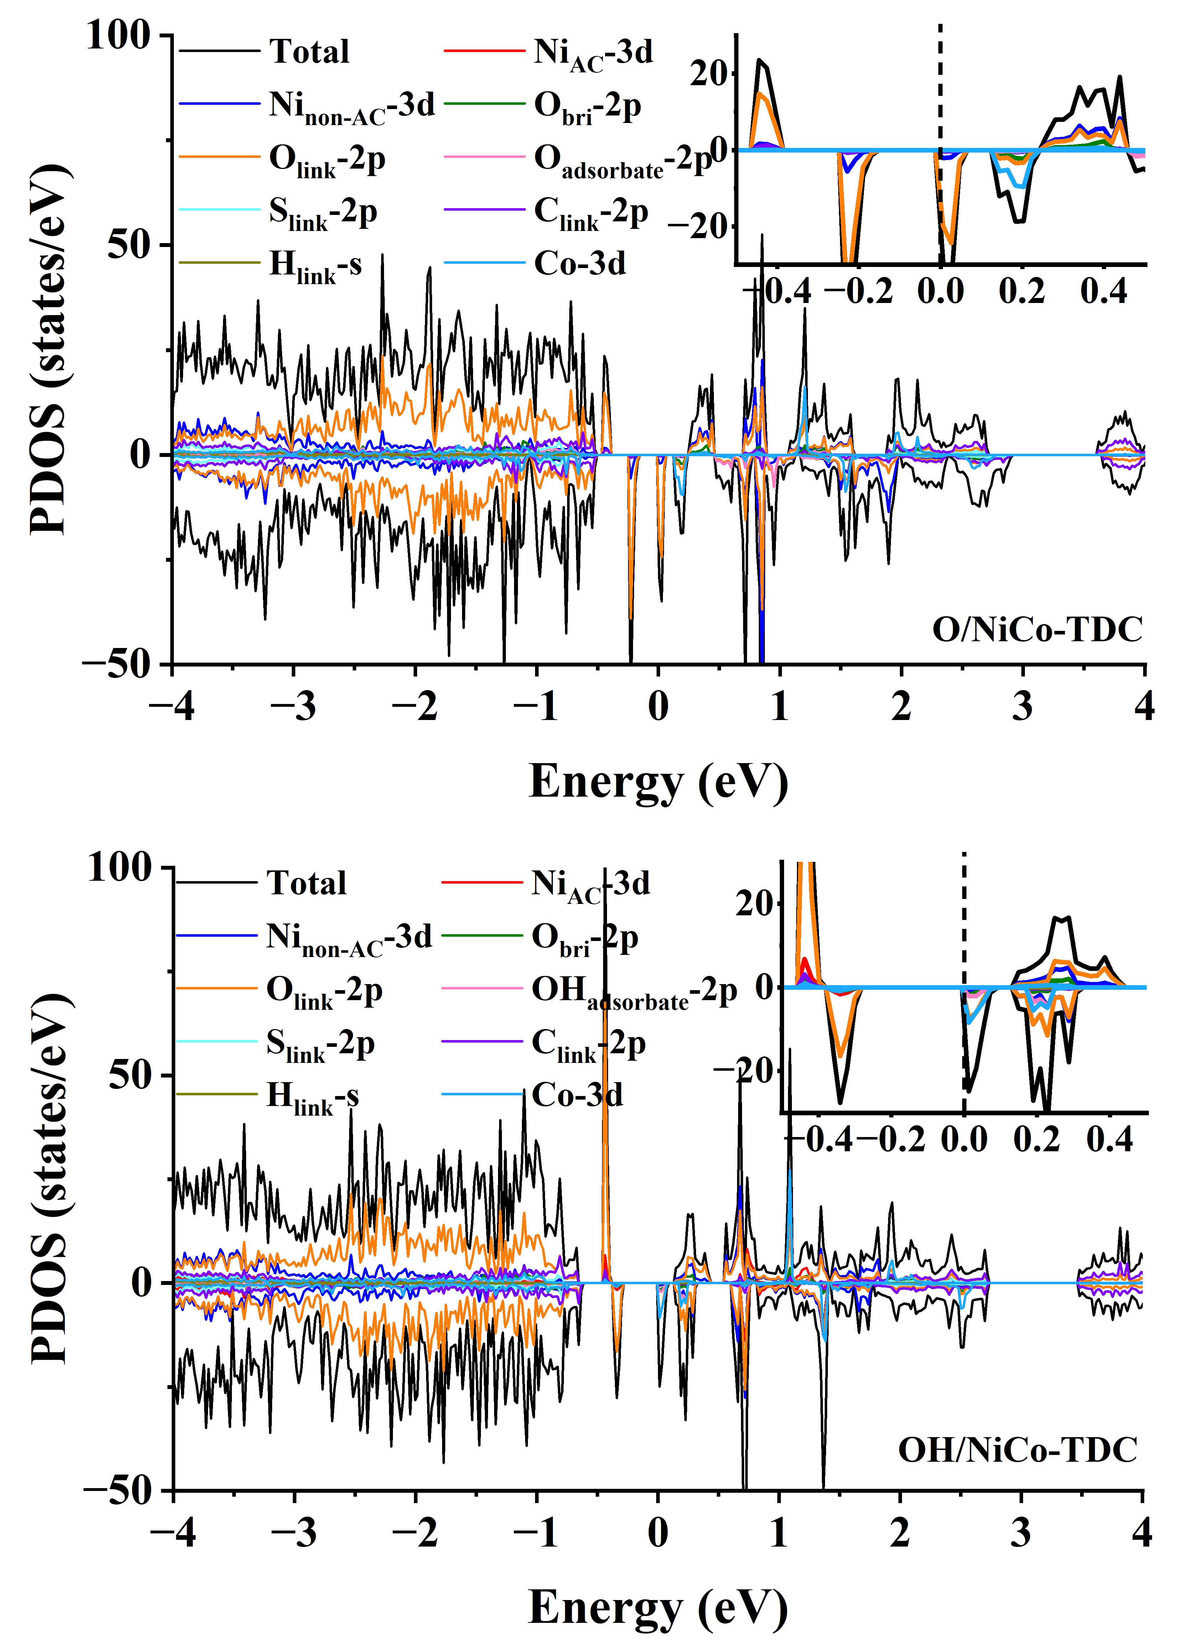
FIG. S29. The projected density of states of the adsorbed O* and adsorbed OH* on NiCo-TDC. Total represents the total density of states, AC stands for the active center, non-AC denotes other metals excluding the active center, O_{bri} refers to the bridging oxygen, and the inset shows a magnified view near the Fermi level.

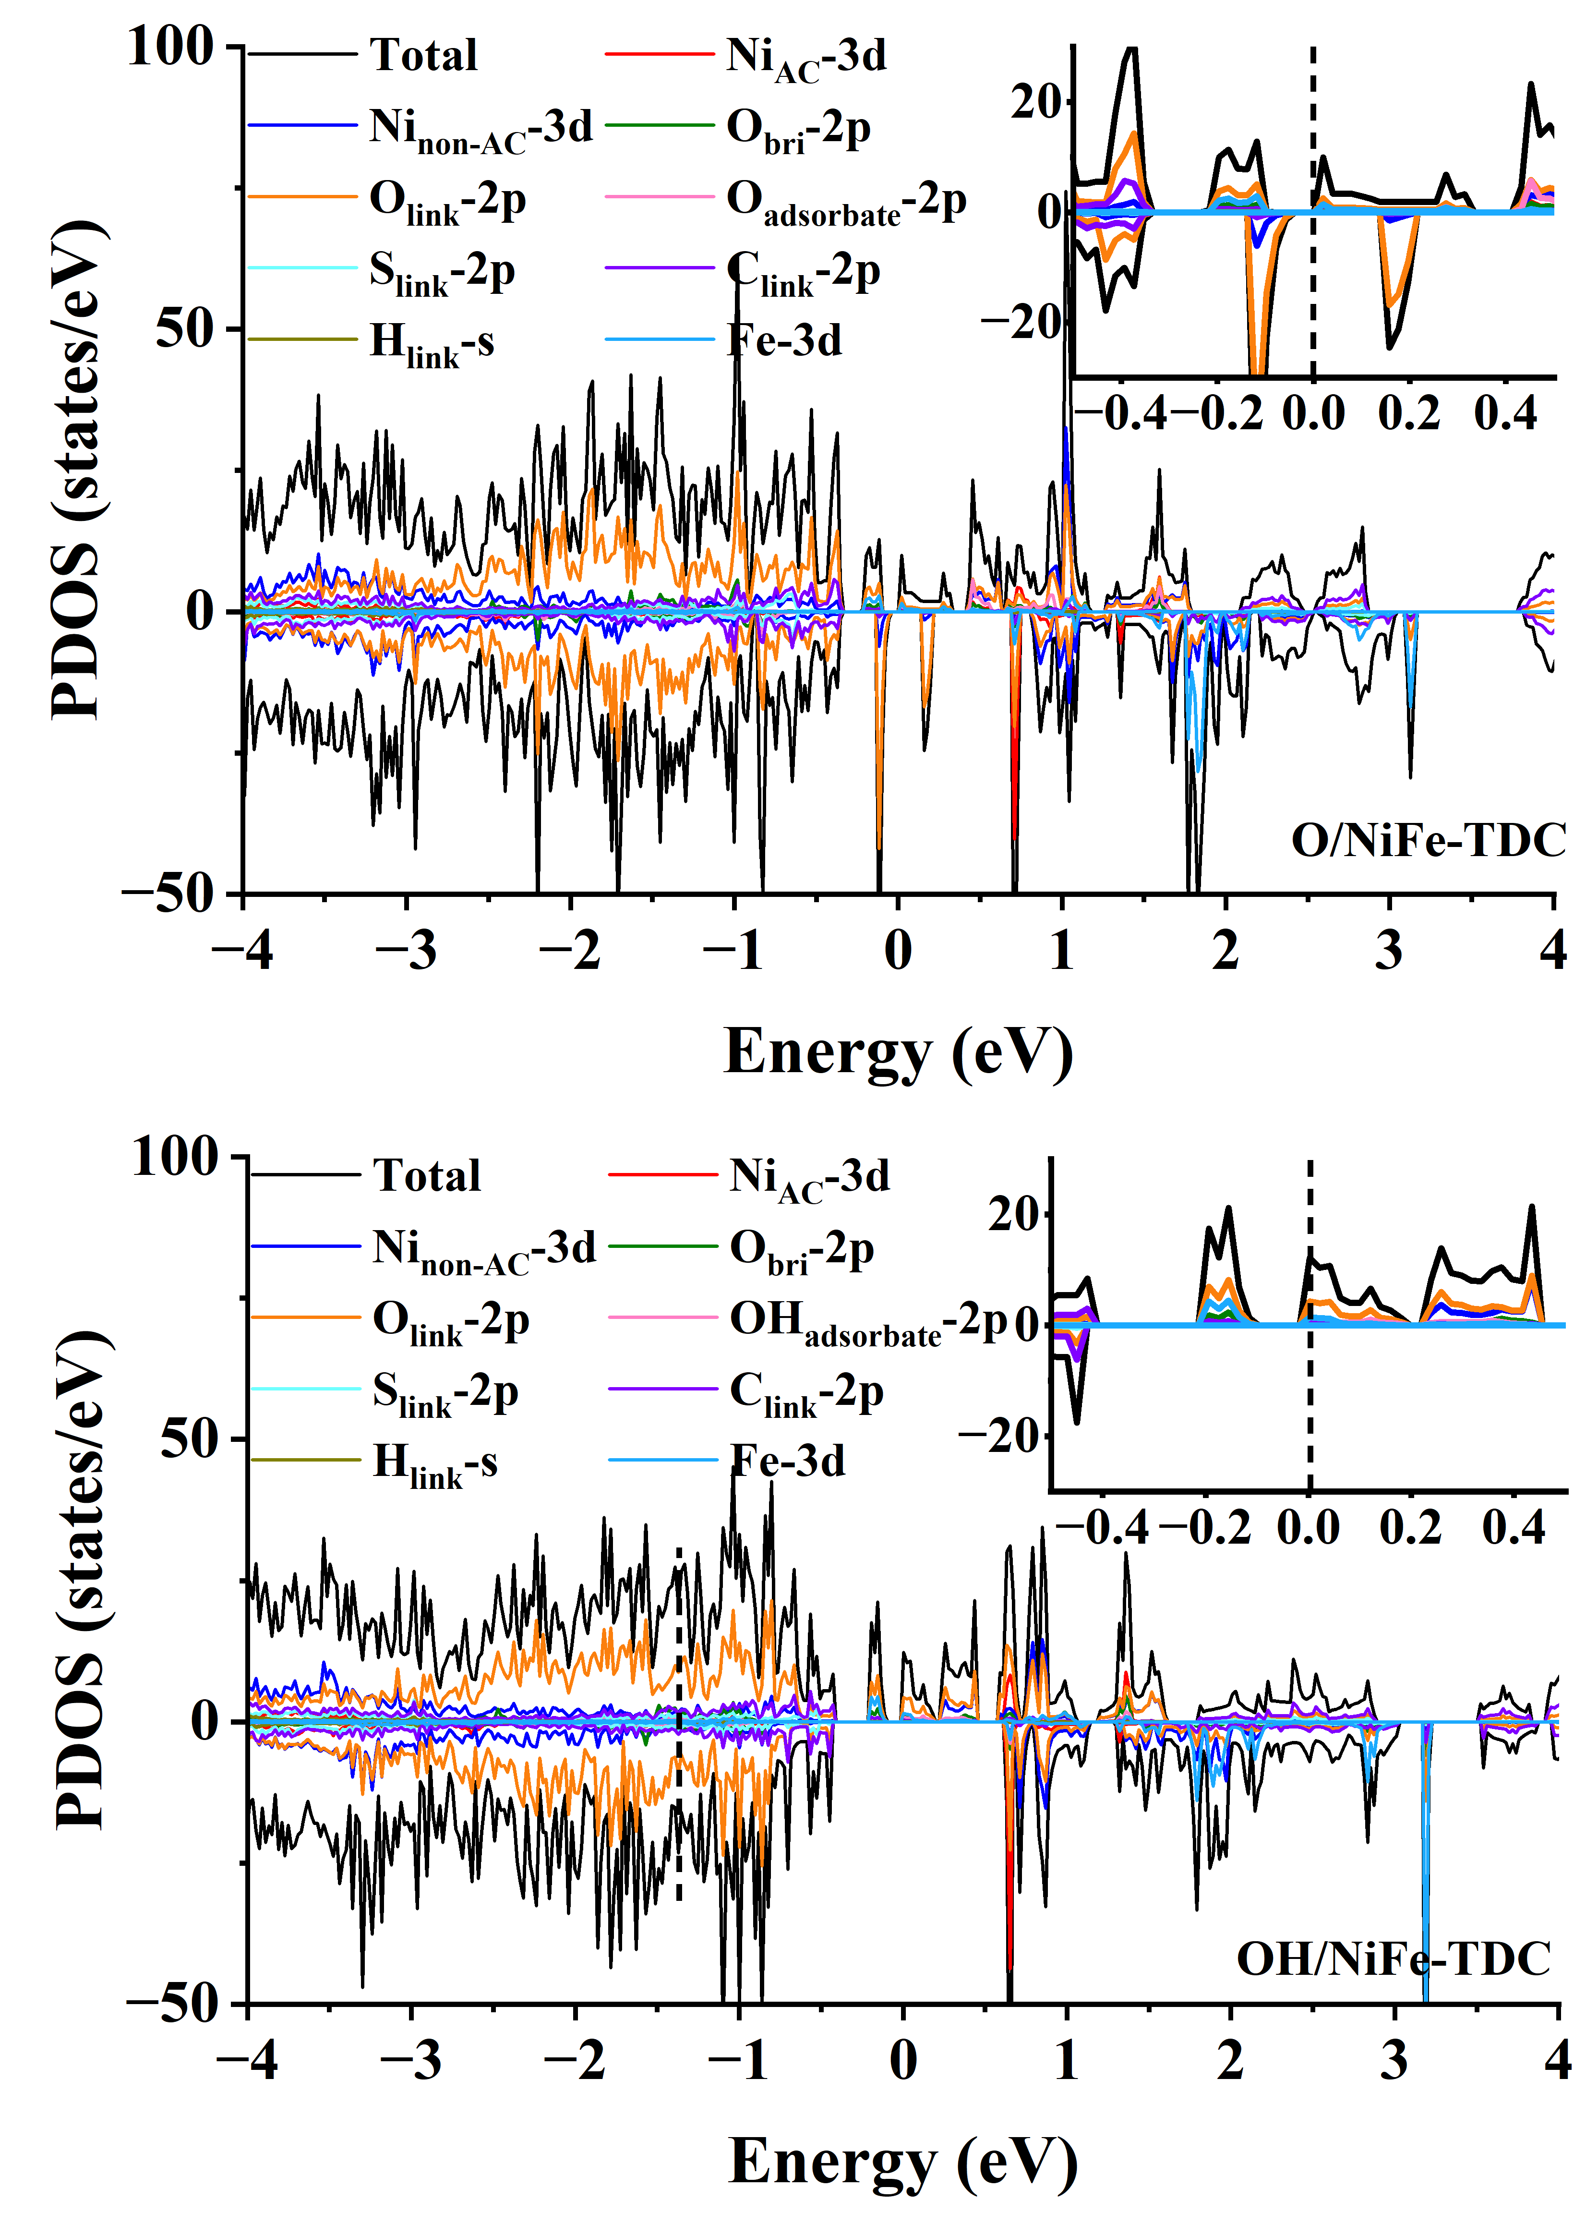
FIG. S30. The projected density of states of the adsorbed O* and adsorbed OH* on NiFe-TDC. Total represents the total density of states, AC stands for the active center, non-AC denotes other metals excluding the active center, O_{bri} refers to the bridging oxygen, and the inset shows a magnified view near the Fermi level.

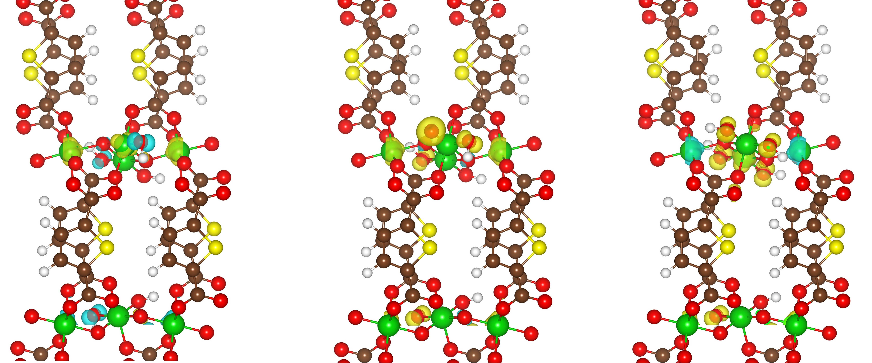
FIG. S31. The spin density of the substrates, adsorbed O*, and adsorbed OH* on Ni-TDC. Isosurface value of 0.02 e Å⁻³.

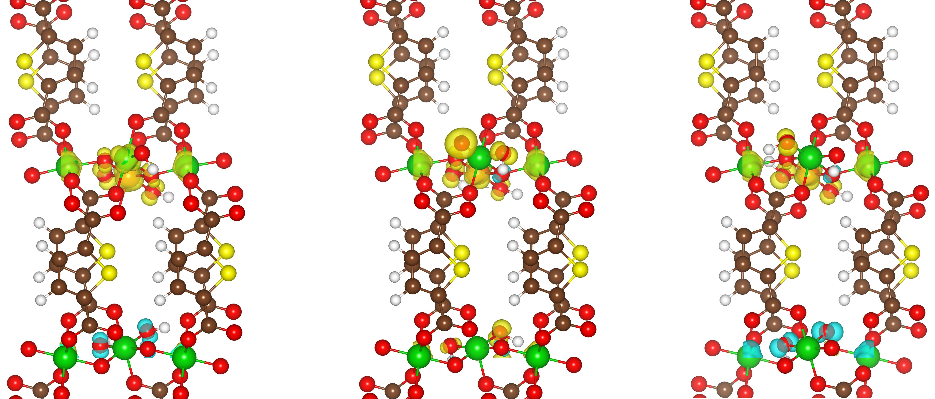
FIG. S32. The spin density of the substrates, adsorbed O*, and adsorbed OH* on NiCo-TDC. Isosurface value of 0.02 e Å⁻³.

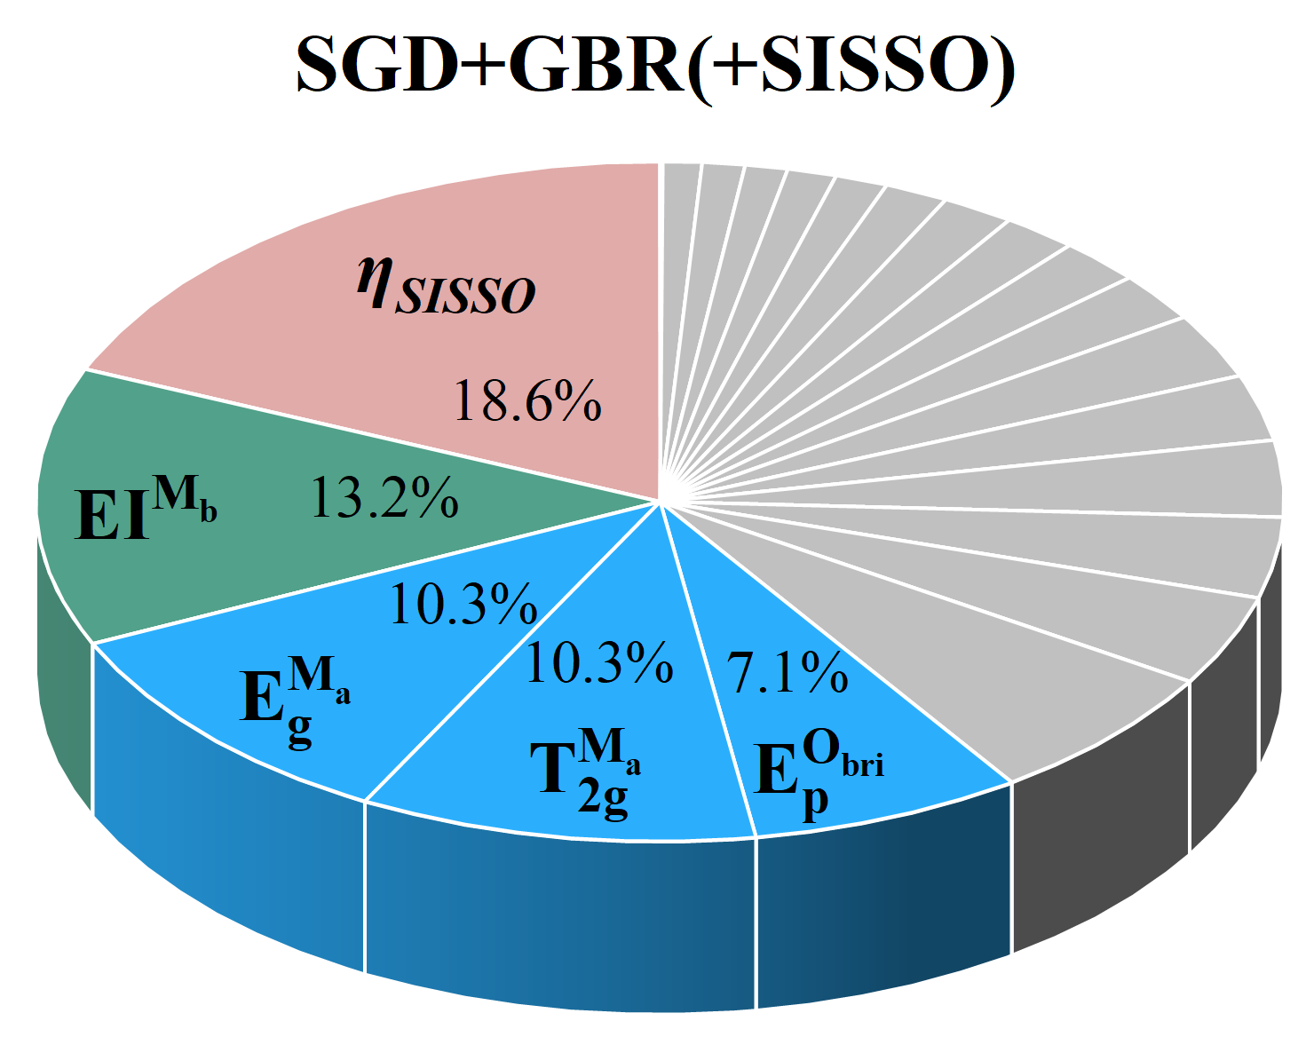
FIG. S33. Main feature importance of SGD+GBR(+SISSO).

Table S1. The initial features defined for machine learning.
Category | Feature | Notation
Bulk | E_{g}-band center of active center (M_{a}) (eV) | $${E_{g}}^{M_{a}}$$
Bulk | T_{2g}-band center of active center (M_{a}) (eV) | $${T_{2g}}^{M_{a}}$$
Bulk | d-band center of active center (M_{a}) (eV) | $$E_{d}^{M_{a}}$$
Bulk | p-band center of bridging oxygen (eV) | $$E_{p}^{O_{bri}}$$
Bulk | Bader charge of active center (M_{a}) (|e|) | $$Q^{M_{a}}$$
Bulk | Average integrated crystal orbital Hamilton population of active center (M_{a}), dopant (M_{b}), and bridging oxygen (O_{bri}). | $$I^{MO}$$
Atomic | Highest occupied orbital of active center (M_{a}) (eV) | $$H^{M_{a}}$$
Atomic | Highest occupied orbital of dopant (M_{b}) (eV) | $$H^{M_{b}}$$
Atomic | Lowest occupied orbital of active center (M_{a}) (eV) | $$L^{M_{a}}$$
Atomic | Lowest occupied orbital of dopant (M_{b}) (eV) | $$L^{M_{b}}$$
Atomic | First ionization energy of active center (M_{a}) (eV) | $${EI}^{M_{a}}$$
Atomic | First ionization energy of dopant (M_{b}) (eV) | $${EI}^{M_{b}}$$
Atomic | Atomic radius of active center (M_{a}) (Å) | $$R^{M_{a}}$$
Atomic | Atomic radius of dopant (M_{b}) (Å) | $$R^{M_{b}}$$
Atomic | Radius of s-orbital of active center (M_{a}) (Å) | $${RS}^{M_{a}}$$
Atomic | Radius of s-orbital of dopant (M_{b}) (Å) | $${RS}^{M_{b}}$$
Atomic | Radius of d-orbital of active center (M_{a}) (Å) | $${RD}^{M_{a}}$$
Atomic | Radius of d-orbital of dopant (M_{b}) (Å) | $${RD}^{M_{b}}$$
Atomic | Relative atomic mass of active center (M_{a}) | $$M^{M_{a}}$$
Atomic | Relative atomic mass of dopant (M_{b}) | $$M^{M_{b}}$$
Atomic | Pauling Electronegativity of active center (M_{a}) | $$E^{M_{a}}$$
Atomic | Pauling Electronegativity of dopant (M_{b}) | $$E^{M_{b}}$$

Table S2. EXAFS data fitting results of Samples.
Sample | Path | CNª | R(Å)^{b} | σ² (Å²)^{c} | ΔE₀(eV)^{d} | R factor
Ni K-edge (Ѕ₀²=0.818)
Ni foil | Ni-Ni | 12.0* | 2.489±0.002 | 0.0064 | 6.8±0.5 | 0.0016
NiO | Ni-O | 6.0±0.9 | 2.078±0.006 | 0.0048 | -3.1±0.7 | 0.0050
NiO | Ni-Ni | 12.9±0.9 | 2.950±0.003 | 0.0060 | -3.1±0.7 | 0.0050
S1 | Ni-O | 6.3±0.3 | 2.060±0.010 | 0.0063 | 1.5±1.7 | 0.0044
S2 | Ni-O | 5.9±0.3 | 2.056±0.008 | 0.0066 | 1.0±1.4 | 0.0032
S3 | Ni-O | 5.8±0.3 | 2.056±0.010 | 0.0073 | 0.9±1.7 | 0.0047
ªCN, coordination number; ^{b}R, the distance between absorber and backscatter atoms; ^{c}σ², the Debye Waller factor value; ^{d}ΔE₀, inner potential correction to account for the difference in the inner potential between the sample and the reference compound; R factor indicates the goodness of the fit. S0² was fixed to 0.818, according to the experimental EXAFS fit of Ni foil by fixing CN as the known crystallographic value. * This value was fixed during EXAFS fitting, based on the known structure of Ni. Fitting conditions: k range：3.0 - 10.0; R range: 1.0-2.0; fitting space: R space; k-weight = 3. A reasonable range of EXAFS fitting parameters: 0.800 < Ѕ₀² < 1.000; CN > 0; σ² > 0 Å²; |ΔE₀| < 15 eV; R factor < 0.02.

Table S3. The experimental overpotential of MOF-TDC.
 | MOF-TDC overpotential (V)
NiFe- | 0.186
NiCo | 0.247
Ni | 0.249
NiCu | 0.281
NiMn | 0.289
NiZn | 0.310

Table S4. Spin-resolved integration of PDOS of Ni-TDC substrate, O* absorbed on Ni-TDC, and OH* absorbed on Ni-TDC. (Ni_{AC} is active center, Ni_{dope} is dopant).
 |  | Ni-TDC |  | O/Ni-TDC |  | OH/Ni-TDC
 |  | Spin up | Spin down | Spin up | Spin down | Spin up | Spin down
Ni_{AC} | Above E_{F} | 0.79 | -1.43 | 1.22 | -1.07 | 1.26 | -1.16
Ni_{AC} | Below E_{F} | 4.63 | -4.09 | 4.31 | -4.55 | 4.31 | -4.39
Ni_{dope} | Above E_{F} | 1.09 | -1.20 | 1.11 | -1.16 | 0.57 | -1.92
Ni_{dope} | Below E_{F} | 4.31 | -4.29 | 4.31 | -4.32 | 4.85 | -3.96

Table S5. Spin-resolved integration of PDOS of NiCo-TDC substrate, O* absorbed on NiCo-TDC, and OH* absorbed on NiCo-TDC. (Ni_{AC} is active center, Co is dopant).
 |  | NiCo-TDC |  | O/NiCo-TDC |  | OH/NiCo-TDC
 |  | Spin up | Spin down | Spin up | Spin down | Spin up | Spin down
Ni_{AC} | Above E_{F} | 0.76 | -1.54 | 1.23 | -1.07 | 1.07 | -1.25
Ni_{AC} | Below E_{F} | 4.78 | -3.94 | 4.36 | -4.38 | 4.46 | -4.36
Co | Above E_{F} | 1.27 | -2.51 | 1.41 | -2.04 | 1.49 | -2.12
Co | Below E_{F} | 4.39 | -3.38 | 4.24 | -3.50 | 4.19 | -3.46

Table S6. Spin-resolved integration of PDOS of NiFe-TDC substrate, O* absorbed on NiFe-TDC, and OH* absorbed on NiFe-TDC. (Ni_{AC} is active center, Fe is dopant).
 |  | NiFe-TDC |  | O/NiFe-TDC |  | OH/NiFe-TDC
 |  | Spin up | Spin down | Spin up | Spin down | Spin up | Spin down
Ni_{AC} | Above E_{F} | 1.29 | -0.92 | 1.10 | -1.86 | 1.10 | -1.68
Ni_{AC} | Below E_{F} | 4.15 | -4.63 | 4.36 | -4.39 | 4.38 | -4.42
Fe | Above E_{F} | 0.50 | -4.80 | 0.52 | -5.04 | 0.52 | -4.67
Fe | Below E_{F} | 5.03 | -1.29 | 4.92 | -1.29 | 4.99 | -1.36

Table S7. The feature importance with GBR+SGD(+SISSO), respectively.
Features | GBR+SGD(+SISSO)
$$η_{SISSO}$$ | 0.186323
$${EI}^{M_{b}}$$ | 0.132368
$${E_{g}}^{M_{a}}$$ | 0.102979
$${T_{2g}}^{M_{a}}$$ | 0.102905
$$E_{p}^{O_{bri}}$$ | 0.070738
$$E^{M_{a}}$$ | 0.065893
$$L^{M_{a}}$$ | 0.042889
$$Q^{M_{a}}$$ | 0.038584
$$E_{d}^{M_{a}}$$ | 0.036181
$$H^{M_{a}}$$ | 0.031455
$$E^{M_{b}}$$ | 0.03089
$$L^{M_{b}}$$ | 0.023108
$$H^{M_{b}}$$ | 0.021678
$$R^{M_{b}}$$ | 0.019419
$${RD}^{M_{a}}$$ | 0.018828
$${RS}^{M_{b}}$$ | 0.016525
$$I^{MO}$$ | 0.013617
$${RS}^{M_{a}}$$ | 0.01278
$$M^{M_{b}}$$ | 0.01104
$${RD}^{M_{b}}$$ | 0.010931
$${EI}^{M_{a}}$$ | 0.01008
$$M^{M_{a}}$$ | 0.00079

