Supplementary Information

Recovering atmospheric dynamics from atmospheric composition snapshots using machine learning
Sudhanshu Pandey^{1*}
¹ Jet Propulsion Laboratory, California Institute of Technology, Pasadena, CA, USA
*Correspondence to: sudhanshu.pandey@jpl.nasa.gov

Supplementary overview
The supplementary analyses support the main results along four lines. First, they test whether the recovered dynamical information is available from satellite-like column observations alone, and whether even a single long-lived tracer column carries information about surface and free-tropospheric winds and PBLH (Supplementary Figs. S3 and S4). Second, they test whether the target- and altitude-dependent tracer partition identified in GEOS-CF replicates in an independently produced composition system (Supplementary Fig. S5). Third, they test alternative explanations for the recovered skill (Supplementary Figs. S6–S8). The TEMPO configurations probe sensitivity to trace-gas products, cloud information and weather-correlated sampling. The humidity comparison tests whether composition acts as a generic meteorological proxy, while the WRF-Chem experiment tests whether skill depends on source identity or absolute emission magnitude rather than flow-dependent plume geometry. Fourth, they examine how the recoverable information changes between spatially resolved imaging and sparse in-situ sampling (Supplementary Fig. S9). Supplementary Methods 4.1–4.8 specify the protocols, and Supplementary Tables S1 and S2 collect the experiment designs and selected summary statistics. Acronyms and dataset abbreviations follow their definitions in the main text.

1. Supplementary context and analytical framework

1.1 Composition imaging complements direct dynamical observations
Supplementary Fig. S1 places the study in its observational context by comparing the sampling geometry of direct wind observations with that of satellite composition imaging. Radiosondes provide accurate full-profile winds at fixed stations, scatterometers measure ocean-surface winds along swaths, and atmospheric motion vectors provide wind estimates wherever trackable cloud or humidity features exist. Geostationary composition imagers such as TEMPO, GEMS and Sentinel-4 scan continental domains at hourly cadence in daylight, and polar-orbiting composition sensors — ultraviolet–visible spectrometers and thermal-infrared sounders — provide near-global coverage at daily to multi-day revisit. The comparison concerns observing geometry and nominal sampling only, not retrieval accuracy or information content, and usable composition coverage is further limited by clouds and retrieval-quality filtering.
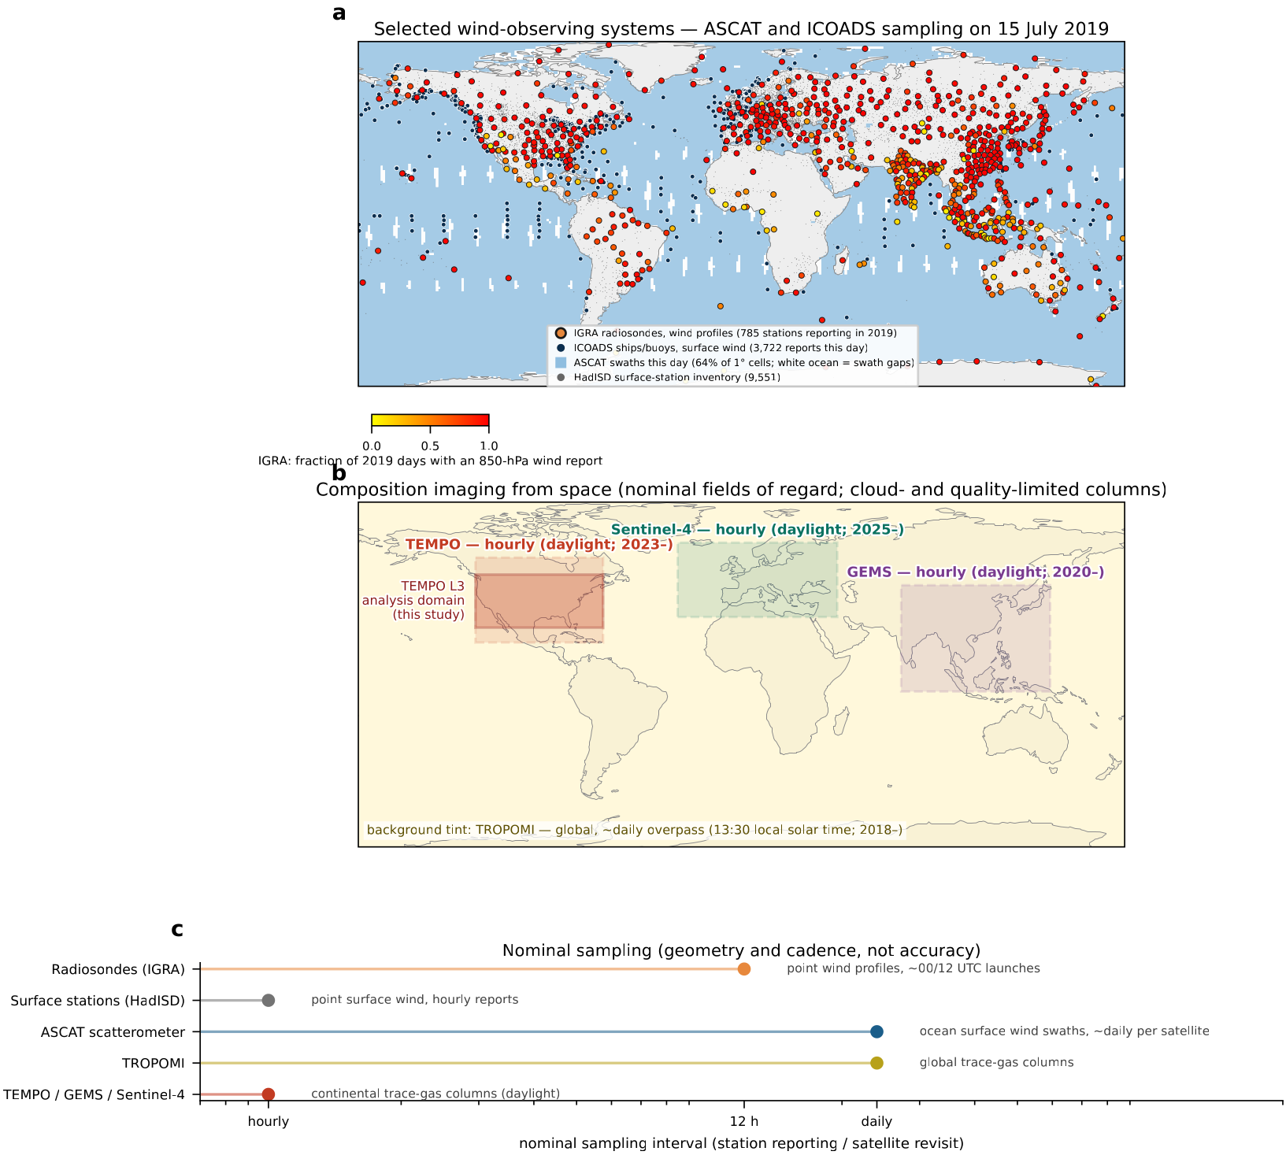
Supplementary Fig. S1 | Observing geometry and nominal sampling of direct wind observations and composition imaging. (a) Direct wind observations on one representative day (15 July 2019). Dots mark IGRA radiosonde stations that reported an 850-hPa wind in 2019, coloured by annual reporting frequency; blue shading marks that day’s ASCAT ocean-surface wind swaths; dark-blue points are ICOADS ship and buoy reports and grey points are HadISD surface stations (locations from the Aardvark Weather compilation). (b) Approximate geostationary fields of regard of TEMPO, GEMS and Sentinel-4 (dashed) and the TEMPO Level-3 domain used in this study (solid; Fig. 5); the background tint denotes near-global daily coverage from polar-orbiting composition sensors, shown for TROPOMI. (c) Nominal revisit interval of each system, annotated by the quantity measured.

1.2 Shared neural-network architecture
Every gridded image-to-field experiment uses the same four-level convolutional encoder–decoder (U-Net; Supplementary Fig. S2), so that differences in recovered skill reflect the composition inputs rather than architectural choices. Only the input and output channels change between experiments, as specified per experiment in the main Methods; no configuration receives wind, PBLH, temperature, humidity or meteorological-imagery input unless explicitly stated for a comparison experiment.
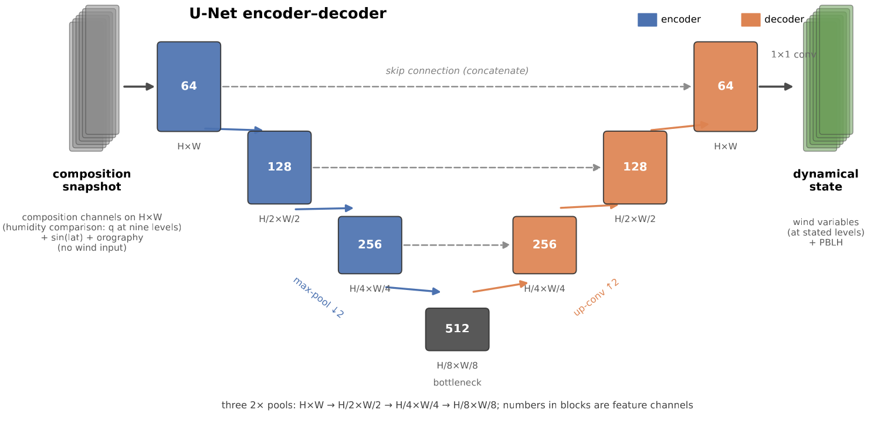
Supplementary Fig. S2 | Network architecture. Four-level convolutional encoder–decoder U-Net (base width 64), shown for a representative columns-only configuration on an H × W input grid. The numbers 64, 128, 256 and 512 denote feature-channel counts. Three 2× max-pooling operations reduce the horizontal dimensions from H × W to H/8 × W/8 at the bottleneck; the decoder mirrors this sequence with transposed convolutions and skip connections. A final 1×1 convolution maps the decoded features to the experiment-specific wind and PBLH targets. The separate humidity comparison supplies specific humidity at nine pressure levels as input; neither humidity nor temperature is an output in that experiment.

2. Supplementary Results

2.1 Column-only inputs retain free-tropospheric wind information
The primary GEOS-CF configuration receives trace-gas columns and near-surface concentrations of the same gases, whereas a satellite spectrometer observes columns alone. To separate the information available to satellite-like column observations from that supplied by near-surface concentrations, an otherwise identical model is retrained on trace-gas columns only and scored on the same temporally blocked August, October and December 2020 evaluation archive (Supplementary Methods 4.7).
The 500-hPa wind-component scores are unchanged between the two input classes, whereas removing the near-surface inputs lowers PBLH skill from a pooled ACC of 0.72 to 0.57, with a smaller decrease of about 0.10 for the surface-wind components (Supplementary Fig. S3; complete component scores in Supplementary Table S2).
This separation indicates that satellite-observable column structure carries the free-tropospheric wind signal, while near-surface concentrations strengthen the boundary-layer signal. It bounds what a column-observing instrument alone can be expected to provide and motivates the near-surface and in-situ analyses below.
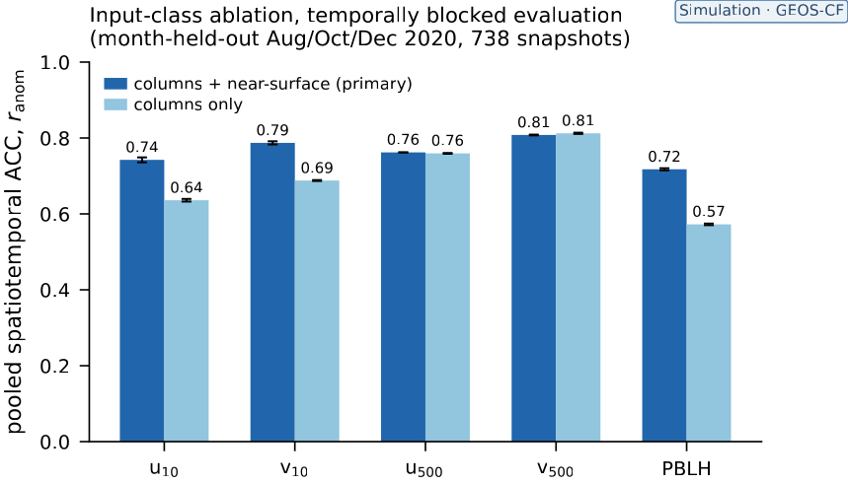
Supplementary Fig. S3 | Trace-gas columns alone retain free-tropospheric wind skill under temporal generalisation. Pooled spatiotemporal ACC on the month-held-out August, October and December 2020 GEOS-CF evaluation archive (738 snapshots) for the primary configuration, supplied with trace-gas columns and near-surface concentrations (dark), and an otherwise identical model retrained on trace-gas columns alone (light). Bars are means across three independently initialised training realisations, and whiskers show ±1 standard deviation across those three seeds. Bars show the wind components and PBLH. The 500-hPa components are unchanged between the configurations, whereas the surface components and PBLH decrease when the near-surface inputs are removed (component values in Supplementary Table S2).

2.2 A single tropospheric CO₂ column carries information about winds and PBLH
CO₂ is the longest-lived tracer considered in this study, is central to satellite greenhouse-gas observing systems, and is available here only in the CAMS reanalysis. An exploratory single-tracer experiment therefore tests whether a pressure-weighted tropospheric CO₂ column, with no other composition input, carries recoverable information about winds and PBLH (Supplementary Methods 4.2).
Evaluated on 80 held-out July 2019 snapshots, the CO₂-only network reaches pooled ACCs of 0.61, 0.71 and 0.77 for surface wind speed, 500-hPa wind speed and PBLH, respectively. A 24-h same-time-of-day persistence baseline, available for 77 valid pairs, yields ACCs of 0.32, 0.46 and 0.70 (Supplementary Fig. S4); per-pixel medians are given in Supplementary Table S2.
Because the anomaly definition uses a single held-out month, these scores quantify within-July, CAMS-only information content and are not directly comparable with the temporally blocked GEOS-CF results or the matched-species winner-map scores.
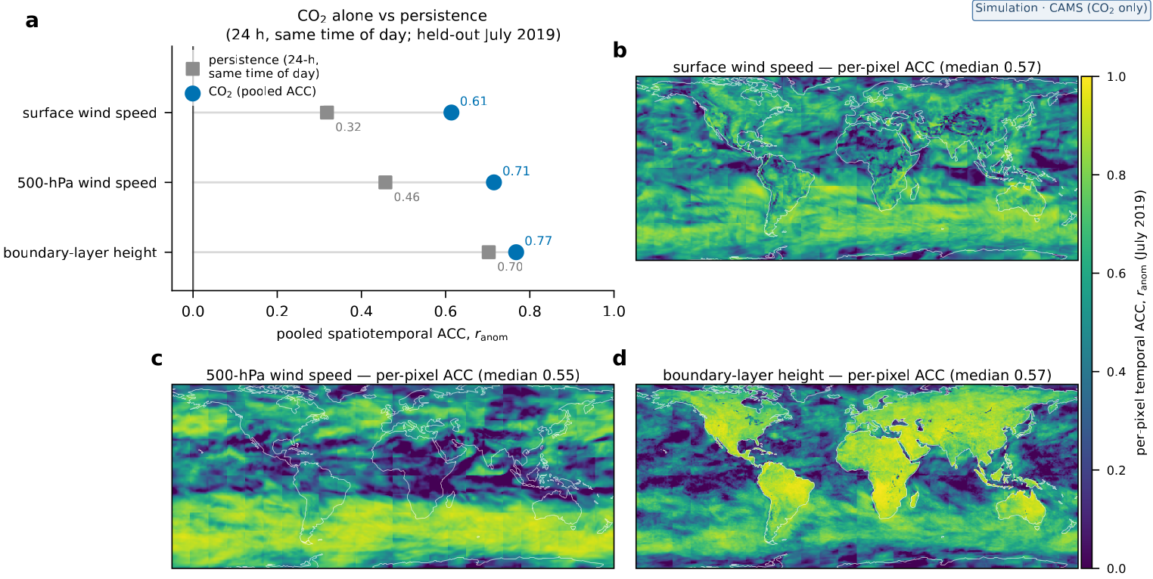
Supplementary Fig. S4 | CO₂-only information content for winds and boundary-layer height in CAMS. An exploratory CAMS analysis uses a pressure-weighted tropospheric CO₂ column as the sole composition input, evaluated on 80 held-out July 2019 snapshots. (a) Pooled spatiotemporal anomaly correlation coefficient (ACC), after removal of the July-mean field from prediction and truth, for surface wind speed, 500-hPa wind speed and PBLH, with a 24-h same-time-of-day persistence forecast for comparison. The persistence field is drawn from the full three-hourly target archive one day before each evaluation time (77 valid pairs) and uses the same July-mean anomaly reference. Per-pixel temporal ACC for (b) surface wind speed, (c) 500-hPa wind speed and (d) PBLH. The Plate Carrée maps cover |latitude| ≤ 75° and use a common 0–1 colour scale; negative correlations are shown at the lower bound. Panel (a) pools cells and times, whereas panels (b–d) correlate each pixel through time (area-weighted medians in Supplementary Table S2).

2.3 The altitude-dependent tracer partition replicates across composition systems
The winner-map partition of Fig. 4 could in principle be specific to GEOS-CF’s chemistry and transport. The probe is therefore repeated on the independently produced CAMS reanalysis with matched pressure-weighted tropospheric columns, using the six gases common to both systems, and — because CAMS additionally carries CO₂ — with CO₂ included as a seventh, CAMS-only candidate scored under the identical protocol (Supplementary Methods 4.3).
The principal features of the matched six-gas partition reproduce: O₃ leads at 500 hPa in both systems; NO₂ contributes little of the area aloft in either system but has a closely replicating PBLH share (26% in CAMS versus 30% in GEOS-CF); and HCHO leads the surface-wind area in both (Supplementary Table S2). The leading PBLH gas differs between systems (O₃ in CAMS, HCHO in GEOS-CF, with NO₂ second in both). In the displayed seven-candidate CAMS analysis, adding CO₂ changes the surface result: CO₂ has the largest winner share (25%; HCHO 23%). CO₂ and O₃ each lead about 25% of the PBLH area, with O₃ narrowly larger, whereas CO₂ leads only about 5% aloft (Supplementary Fig. S5). This pattern is consistent with the boundary-layer-dilution and synoptic-transport signal identified in the CO₂-only single-tracer experiment. Matched column definitions are necessary for this comparison: recomputing the GEOS-CF O₃ input as a matched tropospheric column raised the single-species 500-hPa zonal-wind skill from 0.69 to 0.83, removing an apparent cross-system disagreement that was a column-definition effect rather than a physical signal. The complete winner shares are given in Supplementary Table S2.
The replication indicates that the partition reflects the composition fields themselves rather than a single model’s configuration, while the differing PBLH leader bounds the strength of that claim: the altitude-dependent structure reproduces, not the identical map.
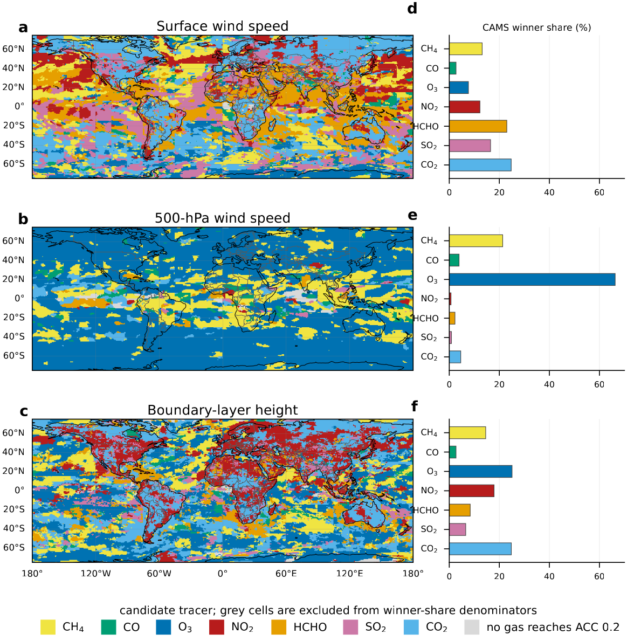
Supplementary Fig. S5 | The altitude-dependent tracer partition replicates in the CAMS simulation, and CO₂ carries boundary-layer information. (a–c) CAMS per-pixel winner maps — the gas whose single-species network best predicts (a) surface wind speed, (b) 500-hPa wind speed and (c) PBLH, by per-pixel temporal ACC (per-month climatology removed; trained on 2019, scored on the 2020 holdout). The candidate set comprises the six gases common to both systems plus CO₂, available only in CAMS and scored under the identical protocol (Supplementary Methods 4.3); grey marks cells where no gas reaches ACC 0.2. (d–f) Corresponding cosine-latitude-weighted winner shares for the three targets. Grey cells are excluded from each share denominator, so the seven displayed candidate shares sum to 100% for each target. These panels show the seven-candidate CAMS analysis; the separately recomputed matched six-gas comparison with GEOS-CF (Fig. 4d–f) is reported in Supplementary Results 2.3 and Supplementary Table S2 and is not plotted here.

2.4 TEMPO configurations probe sensitivity to retrieval and sampling information
The observational TEMPO result could in principle ride on non-composition pathways: the ultraviolet aerosol index and the two O₂–O₂ cloud channels carry aerosol and cloud information, and the availability pattern of valid retrievals is itself weather-correlated. Three configurations retrained on the identical interspersed split test sensitivity to these inputs: a gas-products-plus-context configuration that withholds all three non-gas by-product channels, a no-cloud configuration and a mask-only model that receives no TEMPO measurement values (Supplementary Methods 4.8).
The gas-products-plus-context configuration retains most of the primary configuration’s skill — for PBLH a pooled ACC of 0.66 versus 0.77, with day-block 95% confidence intervals of 0.34–0.40, 0.34–0.39 and 0.62–0.68 across the three targets — whereas the mask-only control retains 0.38 for PBLH and less than 0.2 for the wind components. Removing only the cloud channels reduces the unrounded pooled ACC by 0.05, 0.04 and 0.07 for u₁₀, v₁₀ and PBLH, respectively (all configurations in Supplementary Fig. S6 and Supplementary Table S2).
Substantial predictive skill therefore remains when the aerosol-index and cloud channels are withheld, while the lower no-cloud and mask-only scores show that cloud information and weather-correlated sampling also contain predictive information. The difference is largest for PBLH, the most diurnally and climatologically structured target. Because the inputs are correlated and the networks are nonlinear, these configurations do not uniquely partition the association among pathways. A residual pathway through the model a priori used by the TEMPO retrievals cannot be excluded (main Methods).
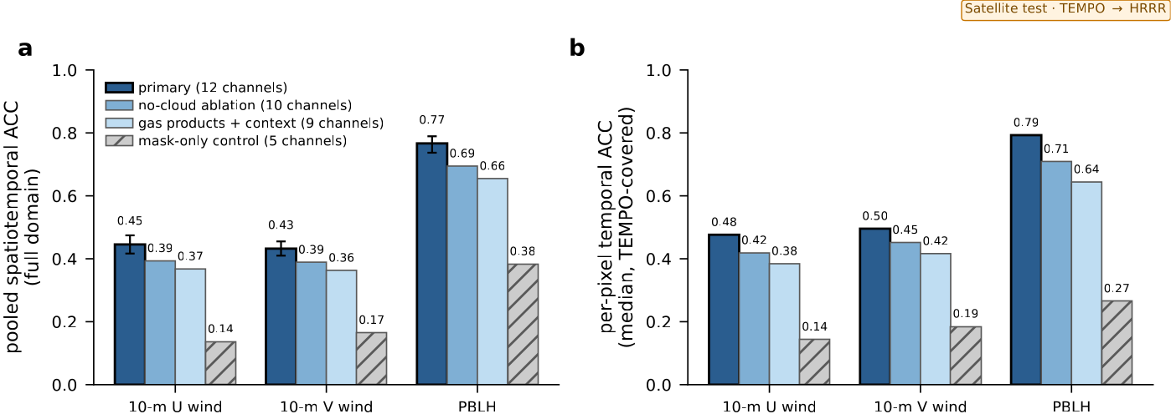
Supplementary Fig. S6 | TEMPO configurations probe sensitivity to retrieval and sampling information on the interspersed split. All four configurations are evaluated on the same interspersed temporal split: the twelve-channel primary (black outline), the no-cloud configuration (the primary minus the two O₂–O₂ cloud channels), the gas-products-plus-context configuration (the four gas products plus the validity mask and static fields; no aerosol-index or cloud channels) and the mask-only control (validity mask and static fields only — no TEMPO measurement values). (a) Pooled spatiotemporal ACC for u₁₀, v₁₀ and PBLH; whiskers give the day-block bootstrap 95% confidence interval on the primary configuration. The gas-products-plus-context intervals are 0.34–0.40, 0.34–0.39 and 0.62–0.68, respectively. (b) Corresponding median per-pixel temporal ACC (as in Fig. 5b–d). These nonlinear configurations test sensitivity to input groups but do not uniquely separate correlated pathways. Score values are given in Supplementary Table S2.

2.5 Trace gases and water vapour provide complementary dynamical information
Water vapour is itself meteorologically informative, so the trace-gas skill could in principle reflect composition acting as a proxy for humidity structure. The same architecture is therefore trained with a nine-level specific-humidity profile as input and compared per pixel with the trace-gas model, which receives satellite-like columns and 1000-hPa near-surface trace-gas concentrations only — a deliberate vertical handicap on composition (Supplementary Methods 4.4).
The comparison is target-dependent (Supplementary Fig. S7). The water-vapour model predicts near-surface wind better over 81% of the land area, and 500-hPa wind at 96% of pixels — where it is advantaged by construction, because it receives the 500-hPa humidity level directly. The trace-gas model predicts PBLH better over 78% of the land area (median per-pixel ACC 0.81 versus 0.73); over ocean, water vapour leads for PBLH. Complete lead shares are given in Supplementary Table S2.
The two input classes therefore carry complementary rather than interchangeable information, which argues against humidity acting as a generic proxy for the trace-gas skill and is consistent with a boundary-layer dilution signal carried by the gases themselves. The asymmetric vertical inputs mean the wind comparisons should not be read as a like-for-like ranking.
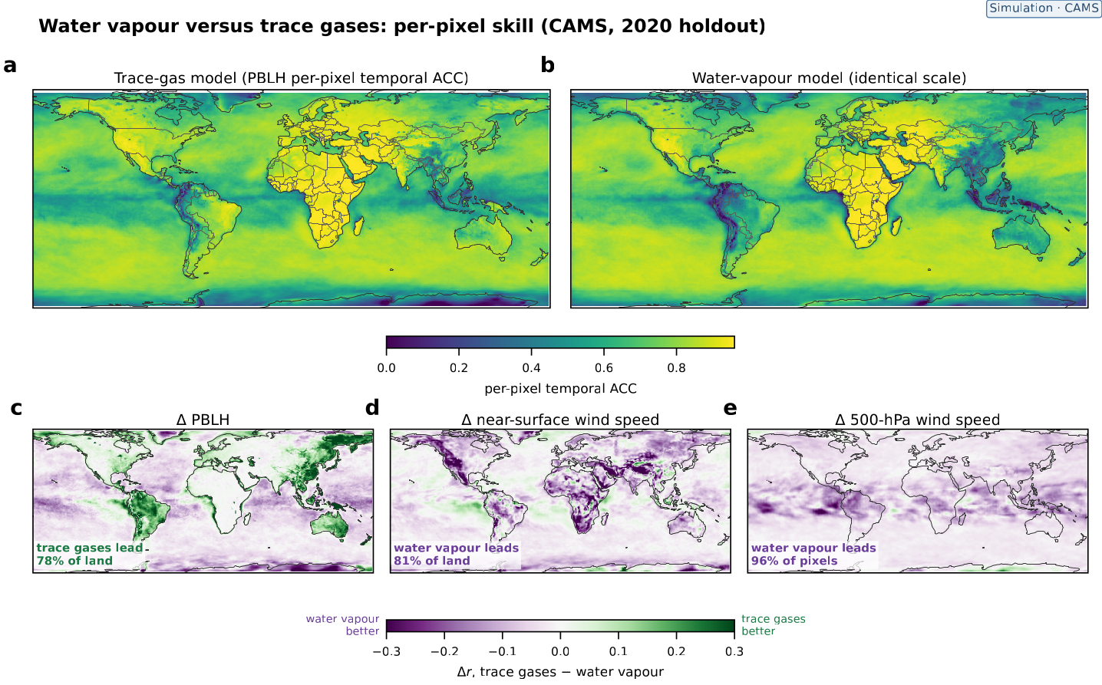
Supplementary Fig. S7 | Per-pixel skill of the trace-gas and water-vapour models on the CAMS 2020 holdout. (a, b) Per-pixel temporal ACC of predicted versus true PBLH (per-pixel per-month means removed) for the trace-gas and water-vapour models on a shared scale. (c–e) Per-pixel temporal ACC differences, Δr = r(trace gases) − r(water vapour), on a shared symmetric scale, for (c) PBLH, (d) near-surface wind speed and (e) 500-hPa wind speed. The water-vapour model receives a vertical humidity profile including the 500-hPa level, whereas the trace-gas model receives columns and near-surface fields only. Land/ocean lead shares are cosine-latitude-weighted and reported in Supplementary Results 2.5 and Supplementary Table S2.

2.6 Passive-tracer geometry generalises across source locations and emission strengths
A network trained on plumes could learn source identity or absolute emission magnitude rather than flow-dependent plume geometry. A WRF-Chem passive-tracer control tests these alternatives with plumes at held-out source locations, plume-concentration scaling far beyond the training range, shuffled-plume floors and a fixed-magnitude counterfactual network (Supplementary Methods 4.5).
The scaling test multiplies both plume-concentration input levels by a common factor before the fixed log transform and normalisation. Because the tracer has no chemistry and its transport is linear in the prescribed constant source strength, this operation represents the concentration field obtained by multiplying the source emission rate by the same factor; separate WRF-Chem simulations are therefore not required for each scale factor.
Skill at the 15 held-out source locations is comparable to that at the 35 training sources and far above the shuffled-plume floors, and patch-mean series at a held-out source track the truth at temporal correlations of 0.96 for PBLH and 0.84 for wind speed (Supplementary Table S2). Under test-time plume-concentration scaling from 0.01× to 1000× — equivalent here to emission-rate scaling and one to two orders of magnitude beyond the 0.1–10× training augmentation — the magnitude-augmented network is essentially unchanged, whereas an otherwise identical network trained at fixed magnitude degrades at weak source strength.
These results support sensitivity to plume geometry rather than memorisation of source identity or absolute magnitude, and show that the magnitude robustness is learned rather than imposed by preprocessing. Each reported condition is the mean over 400 evaluation scenes from one stored evaluation realisation, with no sampling-uncertainty estimate attached.
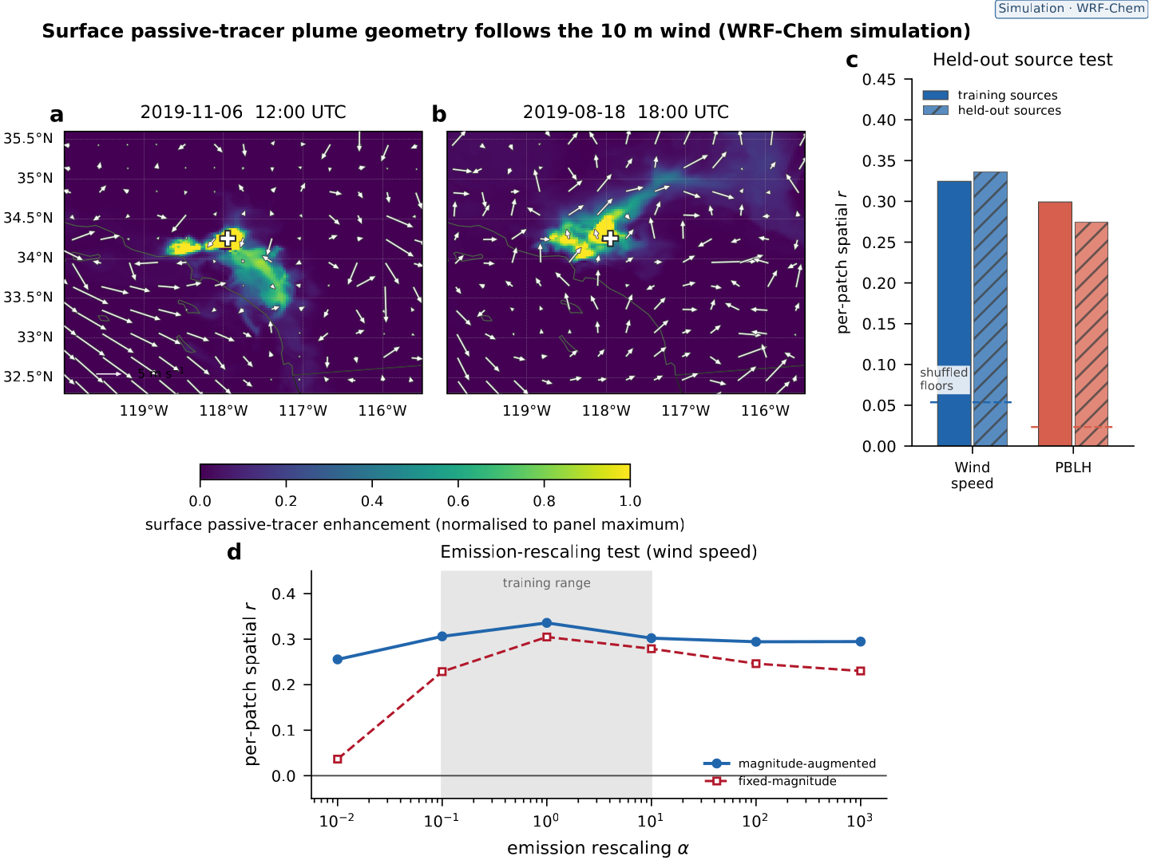
Supplementary Fig. S8 | WRF-Chem passive-tracer control: wind information generalises across source locations and emission magnitudes. (a, b) Two passive-tracer snapshots at the same point source (white cross) under contrasting flow; arrows show the 10-m wind field, with length proportional to wind speed (reference arrow in a). Each map is normalised to its own plume maximum, so colours are not an absolute concentration comparison between panels. (c) Per-patch spatial correlation, computed over each 96 × 96-cell plume-centred field, for wind speed and PBLH at the 35 training-source and 15 held-out-source locations, with shuffled-plume floors (dashed). (d) Test-time plume-concentration scaling (wind speed, per-patch spatial correlation): both input levels are multiplied by factors from 0.01 to 1000, equivalent to scaling the source emission rate by the same factors and extending beyond the 0.1–10 range used for training augmentation (shaded). The magnitude-augmented network was trained with random scaling over that shaded range; it is compared with an otherwise identical network trained at fixed magnitude. Bars and curves are means over 400 evaluation scenes from one stored evaluation realisation (Supplementary Methods 4.5).

2.7 Wind recovery from in-situ concentrations depends on spatial sampling
The imaging experiments read spatially organised composition fields; an exploratory virtual-station emulation asks whether the same information is accessible from sparse in-situ concentration measurements. At single CAMS grid cells, near-surface concentrations of the seven study tracers predict the same-site 10-m wind components and PBLH under the strictest climatology removal in this paper and validation-clean shallow models (Supplementary Methods 4.6).
A single instantaneous seven-gas sample reaches a station-mean temporal ACC of 0.54 for PBLH but only 0.28 and 0.32 for the wind components; a 3×3-cell neighbourhood raises the wind scores by 0.12 and 0.20 with little change for PBLH (Supplementary Fig. S9). Adding the station’s own 24-h concentration record changes station-mean skill by at most 0.05 on every target (Supplementary Table S2), indicating that the recovered information is carried by the instantaneous sample rather than by short temporal history. In station-count experiments, wind skill rises with the number of stations and meets or exceeds the separately fitted dense-grid reference by roughly 32 stations, whereas additional stations provide no consistent PBLH gain (station-level values in Supplementary Table S2).
The PBLH signal is therefore local — consistent with dilution — whereas the wind signal resides in spatial gradients that a single point cannot resolve, which is why spatially resolving observations are especially valuable for winds. These are information-content bounds under the simulation’s perfect co-location and species coverage, not observational station retrievals.
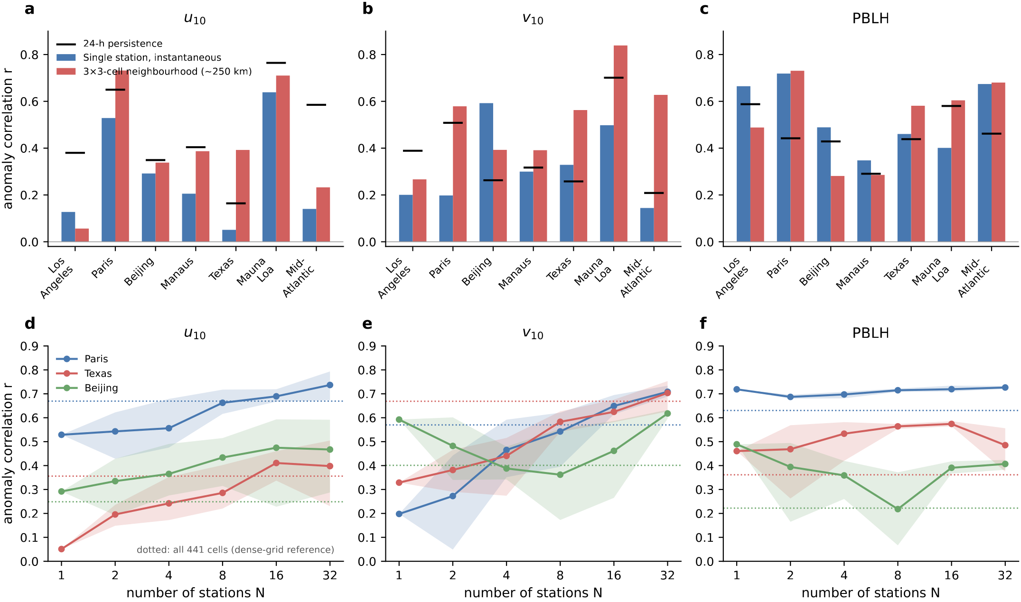
Supplementary Fig. S9 | Virtual in-situ stations recover boundary-layer height locally, whereas wind recovery improves with spatial sampling. Virtual stations are 0.75° CAMS reanalysis grid-cell samples at the nominal locations of seven sites; they are not measurements from operational stations. Near-surface (1000-hPa) concentrations of the seven study tracers predict the same-site targets after removal of the training-period month-by-hour climatology (trained on 2019, evaluated on 2020). Panels (a, d) show u₁₀, (b, e) v₁₀ and (c, f) PBLH. (a–c) Temporal ACC at seven sites spanning polluted-urban to remote regimes for a single instantaneous seven-gas sample (blue) and an instantaneous 3 × 3-cell neighbourhood centred on that site (red); black ticks show the Pearson correlation between the target anomaly at t and the anomaly at t − 24 h, computed from 2,920 matched 2020 pairs per site and target after the same training-year month-by-hour climatology removal. The station-mean persistence ACCs are 0.47, 0.38 and 0.46 for u₁₀, v₁₀ and PBLH, respectively. (d–f) Station-count ladder at Paris, Texas and Beijing: curves are means and shading is the minimum-to-maximum range across five random placements of N distinct grid cells within ±7.5° of the target. Dotted lines show a separately fitted 441-cell dense-grid reference, not an upper bound. The experiment assumes perfect co-location and complete seven-species coverage (Supplementary Methods 4.6); station-mean values are given in Supplementary Results 2.7 and Supplementary Table S2.

3. Supplementary Discussion

3.1 Synthesis of the control experiments
The supplementary experiments address, in turn, the observability, generality and interpretation of the composition-to-dynamics mapping. The column-only ablation (Supplementary Fig. S3) shows that the free-tropospheric wind signal survives the restriction to satellite-observable columns, while the PBLH signal weakens without near-surface concentrations; the CO₂-only single-tracer experiment (Supplementary Fig. S4) shows that even a single long-lived tracer column carries recoverable information at all three target levels. The winner-map replication (Supplementary Fig. S5) transfers the target- and altitude-dependent partition of Fig. 4 to an independently produced composition system: the leading gas aloft, the prominence of short-lived species near the surface and the collapse of NO₂ aloft all reproduce, although the leading PBLH gas differs between systems. Together, Supplementary Figs. S3–S5 indicate that satellite-like composition columns contain dynamical information whose vertical partition is physically organised — by lifetime, source distribution and production pathway — and partly reproducible across systems.
The TEMPO configurations (Supplementary Fig. S6) address the observational experiment: the gas-products-plus-context configuration retains substantial skill, removing the cloud channels reduces skill, and withholding all measurement values retains substantially less skill. The clock baseline of 0.68 relative to the primary PBLH ACC of 0.77 also shows that scan timing contains substantial predictive information for PBLH. These comparisons probe correlated pathways rather than uniquely partitioning them, and retrieval-related pathways remain (main Methods). The humidity comparison (Supplementary Fig. S7) shows that trace gases and water vapour carry different, target-dependent information rather than composition acting as a generic meteorological proxy: water vapour is the stronger wind predictor, composition the stronger PBLH predictor over land. The passive-tracer control (Supplementary Fig. S8) supports a role for flow-dependent plume morphology rather than source memorisation, and the virtual-station analysis (Supplementary Fig. S9) explains why spatial imaging matters most for winds — the wind signal resides in spatial gradients that a point measurement cannot resolve — whereas local concentrations already carry boundary-layer dilution information.

3.2 Interpretive limits and implications for observing systems
Three considerations qualify these conclusions. First, the humidity comparison is asymmetric in vertical information — the water-vapour model receives a resolved profile while the composition model receives columns and near-surface fields — so its wind results should not be read as a like-for-like ranking of the two input classes. Second, the TEMPO configurations probe, but do not uniquely separate, scan-timing, retrieval and sampling pathways: the retrievals employ model a priori profiles, and scan hour and cloud information both contribute measurably to the scores. Third, the WRF-Chem tracers and the virtual stations are idealised — passive tracers without chemistry, and stations with perfect co-location and species coverage — so the corresponding scores are upper bounds on what real point measurements would provide, and the plume-control means carry no sampling-uncertainty estimate. Within these limits, the supplementary evidence supports the main conclusion: composition observing systems — imaging spectrometers foremost for winds, and near-surface measurements for PBLH — hold recoverable dynamical information beyond their intended composition products.

4. Supplementary Methods
The datasets, network architecture, training procedure and the protocols of the main-figure experiments are specified in the main Methods; the sections below specify the supplementary analyses and extended evaluation statistics, stating only departures from the main protocols.

4.1 CAMS datasets and preprocessing
The Copernicus Atmosphere Monitoring Service (CAMS) global reanalysis (EAC4, with EGG4 CO₂) is used at 0.75° resolution as the second, independent composition system. The tracer-partition replication trains on 2019 and tests on 2020, whereas the CO₂-only single-tracer experiment uses the blocked within-2019 split specified in Supplementary Methods 4.2. Composition inputs are pressure-weighted tropospheric-column mixing ratios (nine pressure levels, 1000–200 hPa, TROPOMI-like averaging-kernel- and Δp-weighted vertical mean, kg kg⁻¹) for CH₄, CO, O₃, NO₂, HCHO, SO₂ and CO₂, plus total aerosol optical depth as a single-level field, with near-surface (1000 hPa) fields where stated; PBLH truth is taken from ERA5. For the CO₂-only and winner-map models, composition-input normalisation statistics are computed over January–September 2019 and therefore include January validation inputs and July inputs excluded from training; the within-2019 CO₂ experiment uses July as its test month. The 2020 winner-map holdout contributes to neither normalisation nor target references. These input statistics use no wind or PBLH targets, and the target-anomaly references exclude January and July. Existing checkpoints are tied to this source-archive scaling; a strictly training-only normalisation experiment would require retraining and is not reported here. The humidity comparison is the train-only exception specified in Supplementary Methods 4.4. The winner-map models (Supplementary Methods 4.3) train on a three-hourly archive subsampled to every third snapshot, with January 2019 held out for validation and July 2019 excluded (810 training snapshots); the water-vapour (Supplementary Methods 4.4) and virtual-station (Supplementary Methods 4.6) analyses use their own samplings, given in those sections.

4.2 CO₂-only single-tracer experiment
The exploratory CO₂ experiment was restricted to CAMS because GEOS-CF does not carry CO₂. The pressure-weighted tropospheric CO₂ column defined above was the sole composition input to the single-species dynamics models, which predicted surface wind speed, 500-hPa wind speed and PBLH; wind speed is the magnitude of the predicted zonal and meridional components, matching the main-text wind-speed targets. The split was blocked by month within 2019: all months except January and July were used for training, January 2019 for validation and July 2019 for testing; the entire month was excluded from training and validation, and the test uses 80 snapshots at 9-hourly cadence. Predictions and targets were expressed as anomalies by removing their respective July-mean fields. Pooled spatiotemporal ACC was calculated over the test cells and times, whereas per-pixel temporal ACC was calculated separately for each grid-cell time series and summarised by its area-weighted median. The 24-h persistence baseline uses the corresponding target field one day earlier from the full three-hourly target archive at the network’s evaluation times (77 valid pairs). The forecast and verifying fields therefore have the same UTC hour and are scored with the same July-mean anomaly definition.

4.3 CAMS tracer-partition replication
The winner-map probe of the main Methods (Fig. 4) is repeated on CAMS. Each of the six gases common to both systems (CH₄, CO, O₃, NO₂, HCHO, SO₂) is trained as a single-species pressure-weighted-column model and scored by per-pixel temporal ACC (per-month climatology removed) on the 2020 holdout; the per-pixel argmax gives the CAMS winner map (Supplementary Fig. S5a–c), with the corresponding cosine-latitude-weighted winner shares in Supplementary Fig. S5d–f, using the same ACC 0.2 masking threshold and share denominator as the main probe. For the cross-system comparison the shares are recomputed over the six-gas set and compared with the GEOS-CF shares (Fig. 4d–f). Matched column definitions are required: the GEOS-CF O₃ input is recomputed as a pressure-weighted tropospheric column over the same 1000–200 hPa band as CAMS, and the single-species O₃ model is retrained on the matched column before the winner maps are computed (sensitivity value in Supplementary Results 2.3). Because CAMS also carries CO₂ (absent from GEOS-CF), the CAMS winner maps and shares additionally include CO₂ as a seventh candidate, scored under the identical protocol as the other six gases — a single pressure-weighted tropospheric column with no near-surface channel, the same U-Net architecture and 60-epoch training, and the same per-month-deseasonalised per-pixel ACC metric — so CO₂ receives no representational or scoring advantage. CO₂ and aerosol optical depth are excluded from the six-gas cross-system comparison because GEOS-CF carries neither.

4.4 Water-vapour comparison
The identical U-Net architecture is trained with specific humidity as input over the 2020 CAMS holdout: the humidity model receives a nine-level vertical profile (1000–200 hPa), whereas the trace-gas model receives each of six gases as a pressure-weighted tropospheric column plus its 1000-hPa near-surface concentration. The humidity run predicts the zonal and meridional wind components at all nine levels and PBLH; Supplementary Fig. S7 evaluates derived wind speed at the near-surface and 500-hPa levels together with PBLH. The twice-daily 2019 archive contains 730 snapshots: the first 657 chronologically sorted snapshots (1 January–25 November 2019) are used for training and the final 73 (25 November–31 December 2019) for validation. Input normalisation uses the first 60 training snapshots only (1–30 January 2019), after removal of each channel’s instantaneous zonal mean; target statistics use a seed-0 sample of 120 training snapshots. One model realisation was trained for 80 epochs with 20 random patches per snapshot and batch size 16; the minimum-validation-loss checkpoint occurred at epoch 75. The per-pixel analysis evaluates the stored checkpoint on all 732 twice-daily 2020 holdout snapshots by global sliding inference, removes per-pixel per-month means, maps and differences the per-pixel temporal ACC, and splits lead shares by the Natural Earth 110-m land polygons with cosine-latitude area weighting (lead shares in Supplementary Results 2.5 and Supplementary Table S2).

4.5 WRF-Chem passive-tracer experiment
The tracer transport is simulated with WRF-Chem v4.1¹ on a single 200 × 200 domain at 3-km horizontal spacing (Lambert conformal projection, 32 vertical levels) covering the Los Angeles basin and surrounding Southern California. The available archive contains 396 daily files spanning 1 January 2019–29 February 2020, each with twelve two-hourly outputs. Initial and boundary conditions are taken from ERA5²; the physics configuration uses WSM6 microphysics, the YSU boundary-layer scheme and RRTMG radiation. Entire ISO weeks are assigned with random seed 42 to 43 training, nine validation and nine test weeks (283, 59 and 54 files). Training uses all 283 training files; seed-7 subsamples of 20 validation and 40 test files are used for checkpoint selection and evaluation. The test weeks are 2019 weeks 2, 3, 9, 14, 15, 34, 37 and 44 and 2020 week 8.
Fifty synthetic point sources emit at the same constant rate and are advected as independent passive mixing-ratio tracers without chemistry. Source coordinates are defined as the maxima of the time-mean surface tracer fields on 15 July 2019. Random seed 0 assigns 35 source IDs to training; the held-out one-based IDs are 1–35.
Each training sample selects one time and training source and extracts both tracer levels and the corresponding targets on a 96 × 96-cell patch whose centre is independently jittered by up to 20 cells in each horizontal direction. Both tracer input levels are multiplied by a common factor α before the signed-log transform and fixed training-set normalisation. In this linear, no-chemistry setup, tracer concentration is directly proportional to the prescribed source strength, so multiplying the plume field by α is equivalent to multiplying the source emission rate by α. The magnitude-augmented model draws α log-uniformly from 0.1 to 10 during training; the counterfactual model uses α = 1. Both models train for 100 epochs and retain the minimum-validation-loss checkpoint, at epoch 88 for the augmented model and epoch 74 for the fixed-magnitude model. Normalisation samples use seed 3, 20 training files, every fourth time and every fifth training-source ID. Per-scene standardisation is not used because it would remove the concentration-magnitude information relevant to boundary-layer dilution.
Evaluation uses the 15 held-out source locations and α ∈ {0.01, 0.1, 1, 10, 100, 1000}. The noise control adds zero-mean Gaussian noise before the signed-log transform, with each channel’s standard deviation set to 0.1, 0.3, 0.5, 1 or 2 times that channel’s spatial standard deviation; three draws are evaluated per noise level. The shuffled-plume floor replaces the input by a separately sampled test file, time, held-out source and patch while retaining the original target field and patch. Each condition averages per-patch spatial correlations over 400 scenes from one stored evaluation realisation; patch-mean series at a held-out source are scored as temporal correlations over the test weeks.

4.6 Virtual-station experiment
Virtual stations are emulated in the CAMS archive at nominal sites spanning polluted-urban, continental, tropical-forest, remote-marine and high-altitude regimes: Los Angeles (34.05° N, 118.25° W), Paris (48.85° N, 2.35° E), Beijing (39.90° N, 116.40° E), Manaus (3.10° S, 60.00° W), Texas (31.00° N, 100.00° W), Mauna Loa (19.50° N, 155.60° W) and the mid-Atlantic (40.00° N, 40.00° W). Each nominal coordinate is represented by its nearest 0.75° CAMS grid cell. The 3-hourly 1000-hPa concentrations of the seven CAMS tracers predict the same-site 10-m wind components and PBLH (train 2019, test 2020). A per-(month, hour-of-day) training climatology is removed from inputs and targets, so neither the seasonal nor the diurnal cycle contributes to the score. The instantaneous single-cell input contains seven features; the 3 × 3 comparison concatenates the simultaneous seven-gas values from the centred nine-cell neighbourhood (63 features), and the 24-h-history comparison concatenates the central-cell values at t, t − 3 h, …, t − 24 h (nine times × seven gases = 63 features). Models are ridge regression and a two-layer, 64-unit-per-layer perceptron, scored as the per-site temporal ACC. Model selection is validation-clean: the model class is chosen per site and target on a November–December 2019 validation split, with the perceptron judged and reported as the mean of three random seeds (0, 1 and 2; the ridge fit is deterministic); the selected class is refit on the full training year and the 2020 test year is scored once, so no test-set information enters model or seed selection. The 24-h persistence baseline uses the target anomaly at t − 24 h as the prediction for t, discards the first eight three-hourly timestamps of 2020 and computes one Pearson correlation over 2,920 matched pairs per site and target using the same training-year month-by-hour anomaly reference. The station-mean persistence ACCs are 0.47, 0.38 and 0.46 for u₁₀, v₁₀ and PBLH, respectively. Station-count ladders use N ∈ {1, 2, 4, 8, 16, 32}: station 1 is co-located with the target and the other stations are sampled without replacement from the remaining cells in the 21 × 21-cell (±7.5°) box using NumPy random seed 0, reset separately for Paris, Texas and Beijing. Five placement draws are evaluated for each N > 1, and a separate model using all 441 cells provides the dense-grid reference.

4.7 Extended evaluation statistics and the development holdout
GEOS-CF blocked archive. Amplitude errors, biases and prediction:truth variance ratios on the temporally blocked archive are given in Supplementary Table S2. Blocked skill declines from August to December, consistent with increasing seasonal distance from the trained months (Supplementary Table S2). On the development holdout the corresponding scores are higher; these within-record values estimate the information content of composition inside the trained period rather than temporal generalisation (Supplementary Table S2). The input-class ablation retrains the same configuration on columns alone under an identical protocol and is rescored, unchanged, on the temporally blocked archive with the primary configuration’s protocol (Supplementary Fig. S3; component scores in Supplementary Table S2).

4.8 TEMPO chronological stress test and independence controls
The chronological tail stress test is a separate training experiment, not a rescore of the interspersed model. It sorts the same 14,286 scans by acquisition time and assigns the first 10,002 scans (2 August 2023–26 July 2025) to training, the next 2,142 (26 July 2025–6 January 2026) to validation and the final 2,142 (6 January–21 May 2026) to testing; this partition is fixed for the reported seed-0 training realisation. The twelve input channels, network architecture, optimisation and 60-epoch budget otherwise match the primary TEMPO configuration. Input-normalisation statistics and the static per-cell anomaly reference are recomputed from the chronological training segment, and checkpoint selection uses only the chronological validation segment. The reported pooled ACCs of 0.23, 0.32 and 0.40 use the best validation-loss checkpoint at epoch 39. The score difference from the interspersed experiment therefore combines temporal distance with a smaller and temporally different training record; the complete TEMPO record also spans the V03–V04 product reprocessing.
Three neural-network configurations probe sensitivity to composition and non-composition inputs on the primary configuration’s interspersed split, with the same model capacity and 60-epoch schedule. The gas-products-plus-context configuration retrains on the four trace-gas products plus the validity mask and static fields, withholding the ultraviolet aerosol index and both O₂–O₂ cloud channels. The no-cloud configuration retrains without the two O₂–O₂ cloud channels only. The mask-only control receives the validity-mask pattern, static fields and coordinate channels but none of the TEMPO measurement values. The primary, no-cloud, mask-only and gas-products-plus-context results use their validation-loss-selected checkpoints at epochs 34, 31, 31 and 39, respectively. Day-block bootstrap intervals for the gas-products-plus-context pooled ACC are 0.34–0.40, 0.34–0.39 and 0.62–0.68 for u₁₀, v₁₀ and PBLH. Two additional comparisons are not trained networks. The clock baseline uses an hour-resolved climatology — the per-pixel, per-scan-hour mean training-split anomaly, where scan-hour is the UTC hour of the paired HRRR analysis (equivalently, the TEMPO scan-start time rounded to the nearest hour) — as the prediction. Scan-hour-conditioned scoring subtracts that hour-resolved climatology from both prediction and truth before scoring. These nonlinear configurations and comparisons test whether predictive information is retained after specific inputs or scan-hour structure are removed; they do not uniquely partition correlated pathways. The three retrained configurations are reported in Supplementary Fig. S6; the clock baseline and scan-hour-conditioned scores appear in Fig. 5a.

5. Supplementary Tables
Supplementary Table S1 | Datasets, inputs and evaluation protocols. One row per experiment; full protocols in the main Methods and Supplementary Methods 4.1–4.8.
Experiment | Composition inputs | Targets | Training and evaluation | Metric
GEOS-CF primary (Figs. 1–3) | CH₄, CO, O₃, NO₂ columns + near-surface | 10-m and 500-hPa winds; PBLH | 70/15/15 split of the 495-snapshot 2020 archive; evaluated on month-held-out Aug/Oct/Dec 2020 (738 snapshots) | snapshot spatial correlation; pooled + per-pixel ACC
GEOS-CF column-only (Fig. S3) | trace-gas columns only | as primary | identical protocol; evaluated on the same blocked archive | pooled ACC
CAMS CO₂-only (Fig. S4) | CO₂ tropospheric column | surface and 500-hPa wind speed; PBLH | 2019 excluding Jan (validation) and Jul; evaluated on Jul 2019 (80 snapshots) | pooled + per-pixel ACC
CAMS winner maps (Fig. S5) | one gas per model (6 common gases + CO₂) | surface and 500-hPa wind speed; PBLH | trained on 2019 (810 snapshots); evaluated on the 2020 holdout | per-pixel ACC (argmax)
TEMPO primary (Figs. 5, S6) | 4 trace-gas products + 4 retrieval by-products + 4 static fields | HRRR u₁₀, v₁₀, PBLH | interspersed split with 11,798 training scans; tested in Jul 2024, Feb 2025 and Oct 2025 (1,227 scans) | pooled + per-pixel ACC
TEMPO chronological-tail stress test | as TEMPO primary | as TEMPO primary | chronological 70/15/15 split with 10,002 training, 2,142 validation and 2,142 Jan–May 2026 test scans | pooled ACC
TEMPO no-cloud (Fig. S6) | primary minus two O₂–O₂ cloud channels | as TEMPO primary | identical interspersed split | pooled + per-pixel ACC
TEMPO gas-products-plus-context (Fig. S6) | 4 trace-gas products + validity mask + 4 static fields | as TEMPO primary | identical interspersed split | pooled + per-pixel ACC
TEMPO mask-only (Fig. S6) | validity mask + static fields only | as TEMPO primary | identical interspersed split | pooled + per-pixel ACC
CAMS humidity comparison (Fig. S7) | 9-level specific humidity vs 6 gases (columns + near-surface) | near-surface and 500-hPa wind speed; PBLH | trained on 2019; evaluated on the 2020 holdout (732 snapshots) | per-pixel ACC
WRF-Chem passive tracer (Fig. S8) | single-plume patches (tracer only) | 10-m wind speed; PBLH | trained on 35 sources; evaluated on 15 held-out sources | per-patch spatial correlation; held-source patch-mean temporal correlation
CAMS virtual stations (Fig. S9) | 1000-hPa concentrations of 7 tracers (single cell, 24-h history, 3 × 3 neighbourhood, N ≤ 32; 441-cell reference) | same-site u₁₀, v₁₀, PBLH | trained on 2019; evaluated on 2020 | per-site temporal ACC
Supplementary Table S2 | Extended performance and selected control statistics. Selected score sets for the supplementary experiments; protocols in Supplementary Methods 4.1–4.8. u₁₀/v₁₀ denote 10-m wind components, u₅₀₀/v₅₀₀ 500-hPa wind components and WS wind speed. CAMS CO₂-only values are ordered as surface WS/500-hPa WS/PBLH; TEMPO and virtual-station values are ordered as u₁₀/v₁₀/PBLH unless targets are named individually.
Experiment | Quantity | Values
GEOS-CF blocked, primary | pooled component ACC (3-seed range) | u₁₀ 0.73–0.75; v₁₀ 0.78–0.79; u₅₀₀ 0.76; v₅₀₀ 0.81; PBLH 0.71–0.72
GEOS-CF blocked, column-only | pooled component ACC | u₁₀ 0.63–0.64; v₁₀ 0.69; u₅₀₀ 0.76; v₅₀₀ 0.81; PBLH 0.57
GEOS-CF blocked (Fig. S3, plotted) | pooled component ACC, primary compared with column-only | u₁₀: 0.74 primary, 0.64 column-only; v₁₀: 0.79, 0.69; u₅₀₀: 0.76, 0.76; v₅₀₀: 0.81, 0.81; PBLH: 0.72, 0.57
GEOS-CF blocked, primary | RMSE (physical units) | u₁₀ 2.82, v₁₀ 2.63, u₅₀₀ 6.26, v₅₀₀ 5.14 m s⁻¹; PBLH 321 m
GEOS-CF blocked, primary | bias | winds ≤ 0.31 m s⁻¹; PBLH −1.1 m
GEOS-CF blocked, primary | prediction:truth variance ratio | 0.85 / 0.74 / 0.82 / 0.73 / 0.73 (u₁₀/v₁₀/u₅₀₀/v₅₀₀/PBLH)
GEOS-CF blocked, primary | seasonal decline, 500-hPa zonal-wind pooled ACC | 0.80 in August and 0.72 in December
GEOS-CF development holdout | within-record pooled ACC | 500-hPa WS 0.84; meridional component 0.88; per-pixel medians 0.74–0.83
GEOS-CF development holdout | column-only ablation, pooled ACC | surface winds: 0.87 primary and 0.77–0.79 column-only; PBLH: 0.81 primary and 0.61–0.63 column-only
CAMS CO₂-only (July 2019) | pooled ACC, network (80 snapshots) | surface WS 0.61; 500-hPa WS 0.71; PBLH 0.77
CAMS CO₂-only | pooled ACC, 24-h same-time-of-day persistence (77 valid pairs) | surface WS 0.32; 500-hPa WS 0.46; PBLH 0.70
CAMS CO₂-only | per-pixel temporal-ACC medians | 0.57 / 0.55 / 0.57
Winner shares, matched six gases (CAMS vs GEOS-CF) | O₃ share, 500-hPa wind | 68% vs 48%
Winner shares, matched six gases | NO₂ share, 500-hPa wind | ≈1% in both
Winner shares, matched six gases | NO₂ share, PBLH | 26% vs 30%
Winner shares, matched six gases | HCHO share, surface wind | 30% vs 46%
CAMS seven-candidate shares | CO₂ share and leading comparison | surface wind: CO₂ 25%, HCHO 23%; 500 hPa: CO₂ 5%, O₃ 66%; PBLH: CO₂ 25%, O₃ 25% (O₃ narrowly larger)
GEOS-CF O₃ column-definition sensitivity | single-species 500-hPa zonal-wind ACC | 0.69 with the stratosphere-inclusive column and 0.83 with the matched tropospheric column
TEMPO interspersed, primary | pooled ACC (day-block bootstrap 95% CI) | 0.45 (0.42–0.47) / 0.43 (0.41–0.46) / 0.77 (0.74–0.79)
TEMPO chronological-tail stress test | pooled ACC; change from interspersed primary | 0.23 / 0.32 / 0.40; −0.22 / −0.11 / −0.37
TEMPO interspersed, no-cloud | pooled ACC | 0.39 / 0.39 / 0.69
TEMPO interspersed, gas-products-plus-context | pooled ACC (day-block bootstrap 95% CI) | 0.37 (0.34–0.40) / 0.36 (0.34–0.39) / 0.66 (0.62–0.68)
TEMPO interspersed, mask-only | pooled ACC | 0.14 / 0.17 / 0.38
TEMPO interspersed | clock baseline ACC | 0.21 / 0.17 / 0.68
TEMPO interspersed, primary | scan-hour-conditioned pooled ACC | 0.41 / 0.41 / 0.57
TEMPO interspersed | per-pixel temporal-ACC medians | primary 0.48/0.50/0.79; no-cloud 0.42/0.45/0.71; gas-products-plus-context 0.38/0.42/0.64; mask-only 0.14/0.19/0.27
CAMS humidity comparison | PBLH lead shares | trace gases 78% of land (median 0.81 vs 0.73); water vapour 84% of ocean (0.79 vs 0.75)
CAMS humidity comparison | near-surface wind lead shares | water vapour 81% of land / 75% global / 73% of ocean
CAMS humidity comparison | 500-hPa wind lead share | water vapour 96% of pixels
WRF-Chem plume control | patch-mean temporal correlation, held-out source | PBLH 0.96; wind speed 0.84
Virtual stations | single-station mean temporal ACC (7 sites) | 0.28 / 0.32 / 0.54 (u₁₀/v₁₀/PBLH)
Virtual stations | 24-h target-anomaly persistence, station-mean ACC (2,920 matched pairs per site) | 0.47 / 0.38 / 0.46
Virtual stations | 3×3-neighbourhood change | +0.12 / +0.20 / −0.02
Virtual stations | adding own 24-h concentration record | ≤ 0.05 change on every target
Virtual stations | station-count ladder | wind skill meets or exceeds the separate dense-grid reference by N ≈ 32

Supplementary References
1. Grell, G. A. et al. Fully coupled "online" chemistry within the WRF model. Atmospheric Environment 39, 6957–6975 (2005).
2. Hersbach, H. et al. The ERA5 global reanalysis. Quarterly Journal of the Royal Meteorological Society 146, 1999–2049 (2020).

