Table 1. Infectivity of oT4 and ahT4 against E. coli cells contacted with oEc-oT4 lysate. E. coli populations were isolated from oEc lawns spotted and incubated for one hour with 1% and 10% of the <20 nm oEc-oT4 lysate. Susceptibility of each E. coli specimen was examined by the plaque formation with spots of oT4 and ahT4. oEc was susceptible to oT4 infection, while the E. coli populations in the spots were genetically modified to be resistant to oT4 except for the case of 1% lysate 2. In this case, in spot population was resistant to oT4 after four hours.
+ : plaque formation, - : no plaque.

Spot | 1%  lys1 |  | 1%  lys2 | 10% lys1 |  | 10% lys2
oT4 | - | + |  | - | -
ahT4 | + | + |  | - | +

Table 2. A successive change of the abundances (PFU) of oT4 and ahT4 in a suspension of hEc inoculated with oT4, fg1 and fg7 in NB. The abundances of oT4 were constant at the initial several hours. After this period, hEc became susceptible to oT4 which started to increase their abundance. Synchronous to that, ahT4 was produced and increased their abundance. Contrarily, oT4 decreased its abundance after attended its maximum abundance at 8h.

T (h) | oT4 | ahT4
0 | 100 | 0
2 | 96 | 0
4 | 94 | 0
6 | 729 | 44
8 | 1533 | 488
10 | 663 | 600
12 | 0 | 613

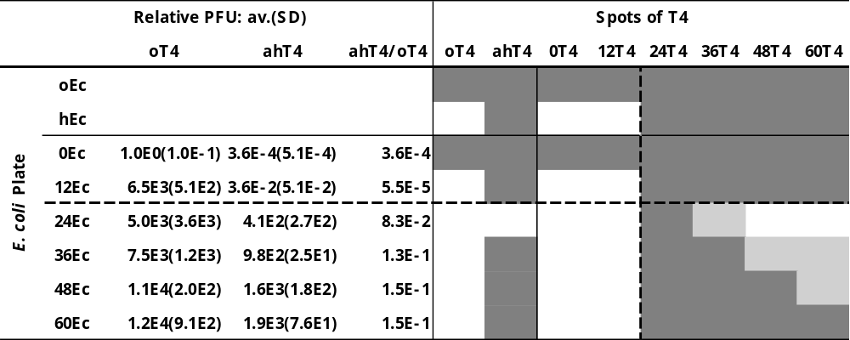Table 3. The cross spots of T4 suspensions and the lawns of E. coli appeared in the time series specimens. Each row of the table shows the pattern of the infection sensitivity of E. coli to T4, and the columns of the table show the patterns of the infection ability of T4 to E. coli. The infection pattern can be divided into three sections; controls and time series specimens, and the latter is divided into pre-24h and post-24h specimens which are corresponded with before the genetic alteration of T4 and after that. The PFU values of oT4 increased rapidly after the inoculation, while the rapid increase of ahT4 appeared after 24h incubation.
numbers: hours of incubations, oEc: the original E. coli, hEc: the halo-type E. coli, oT4: the original T4, ahT4: the anti-halo type T4, ++: confluent plaque, · ·: partial infection, : no infection, PFU values: n = 3, nEm = n*10^{m}.

