SUPPLEMENTAL MATERIALS

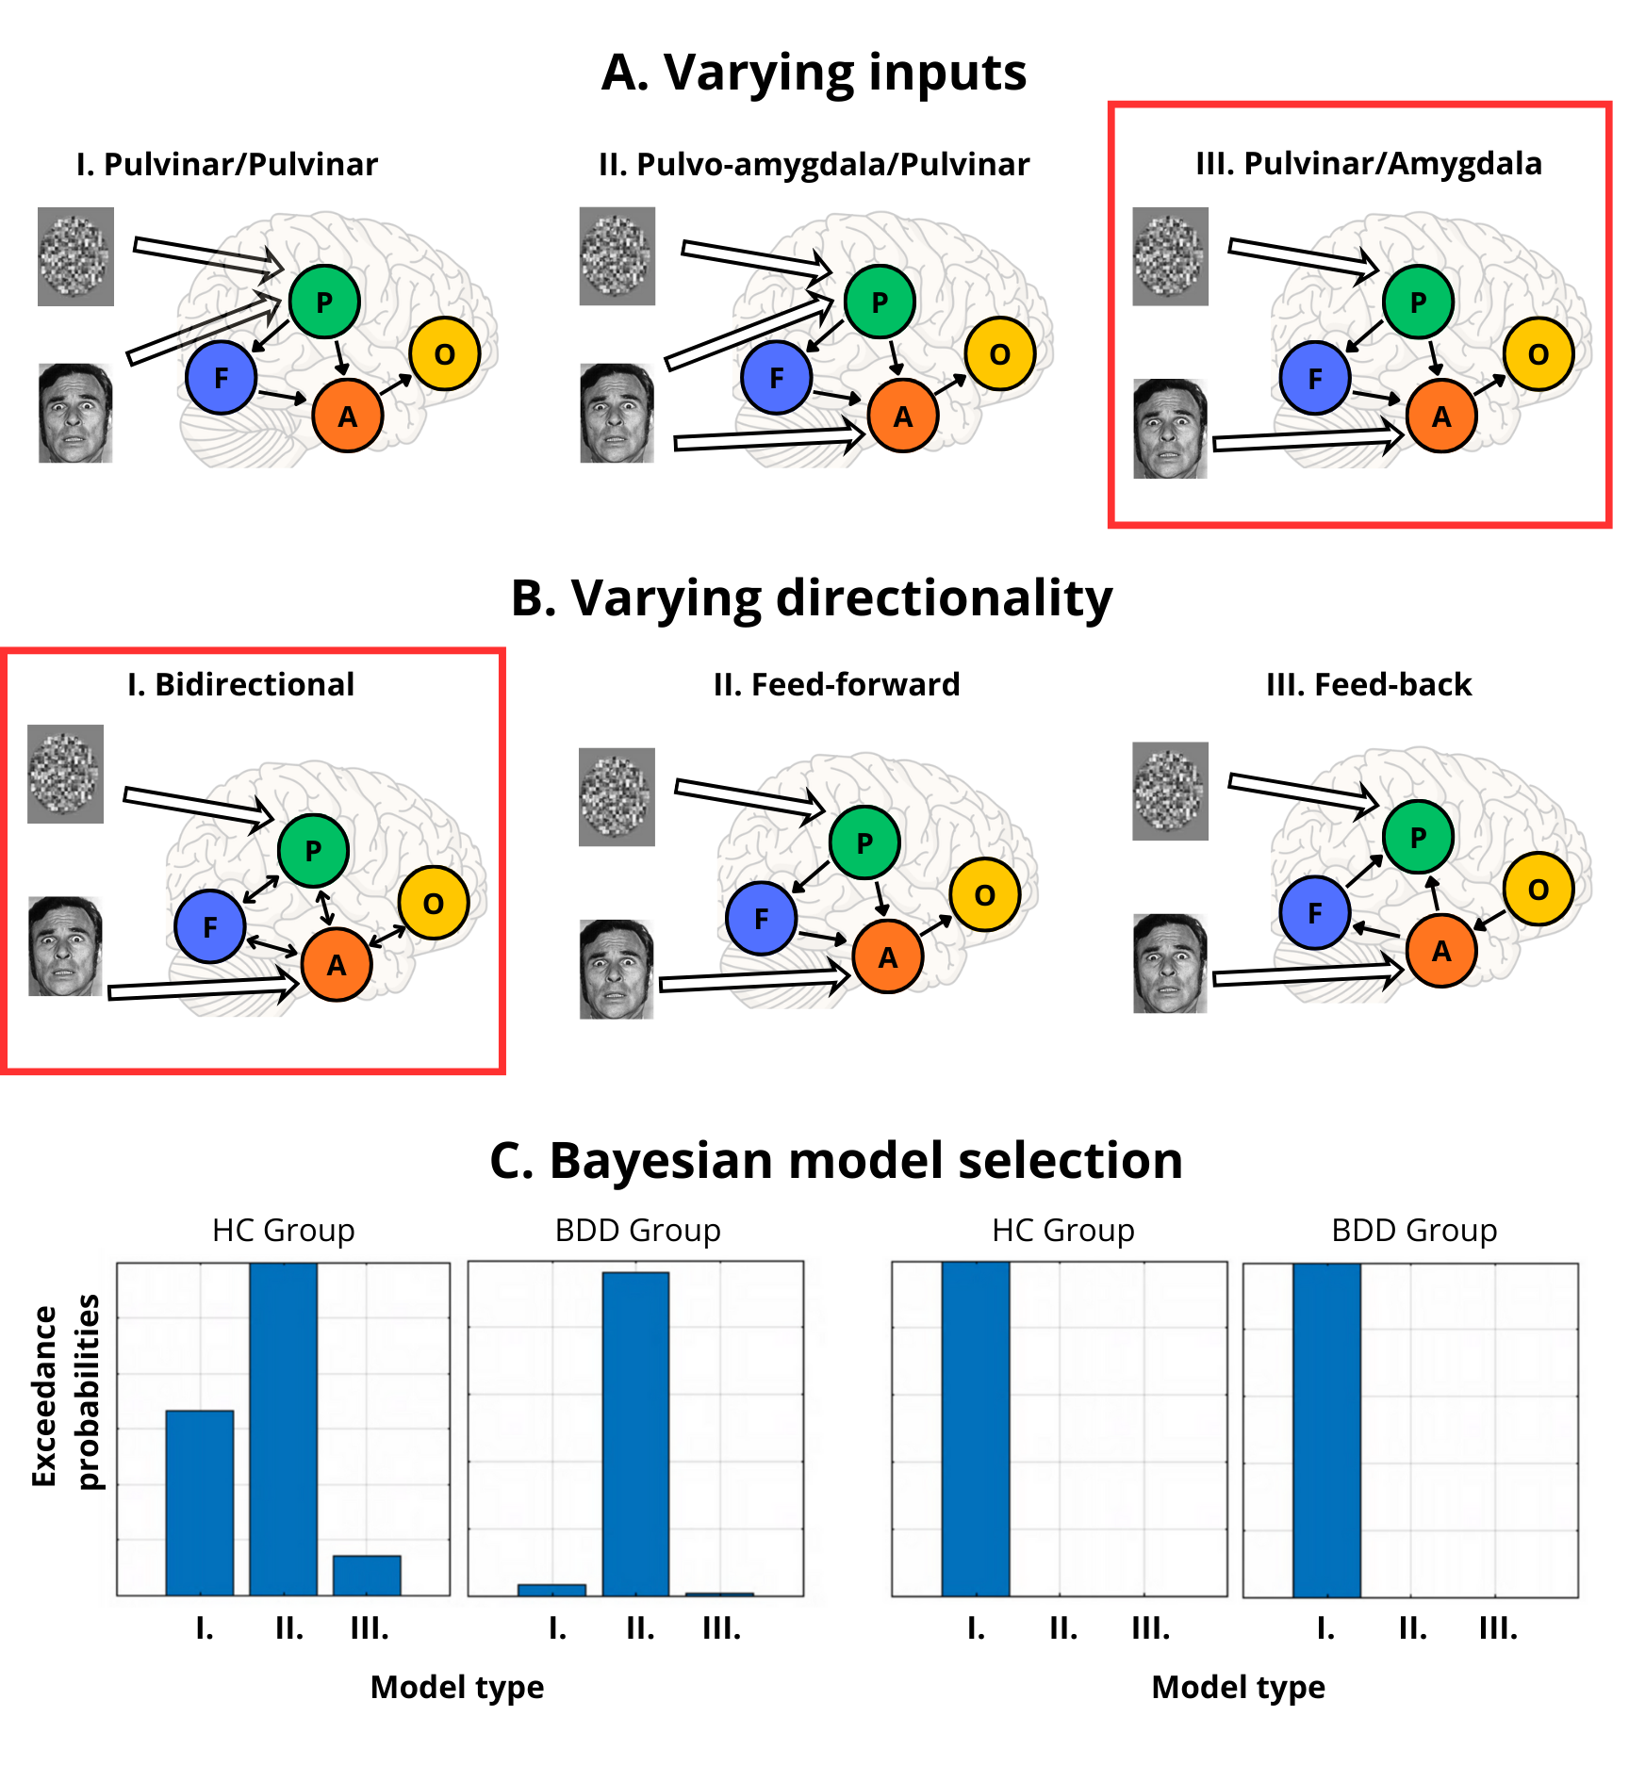
Supplementary Figure 1. Depiction of the Bayesian model selection process for models including a priori regions of bilateral pulvinar (P), amygdala (A), FFA (F), and mOFC (O) specifically testing A) models of varying stimulus input region and B) models of varying directionality and their C) corresponding exceedance probabilities calculated separately for each group. We verified that both groups were fit by a model that allowed for stimulus input region to vary based on stimulus type, with fearful faces driving activity in both the bilateral pulvinar and amygdala and scrambled faces driving activity in just the bilateral pulvinar. We took that model structure to test optimal directionality between regions and verified bidirectional connections between all regions as the model with best fit for both groups. FFA = fusiform face area; mOFC = medial orbitofrontal cortex

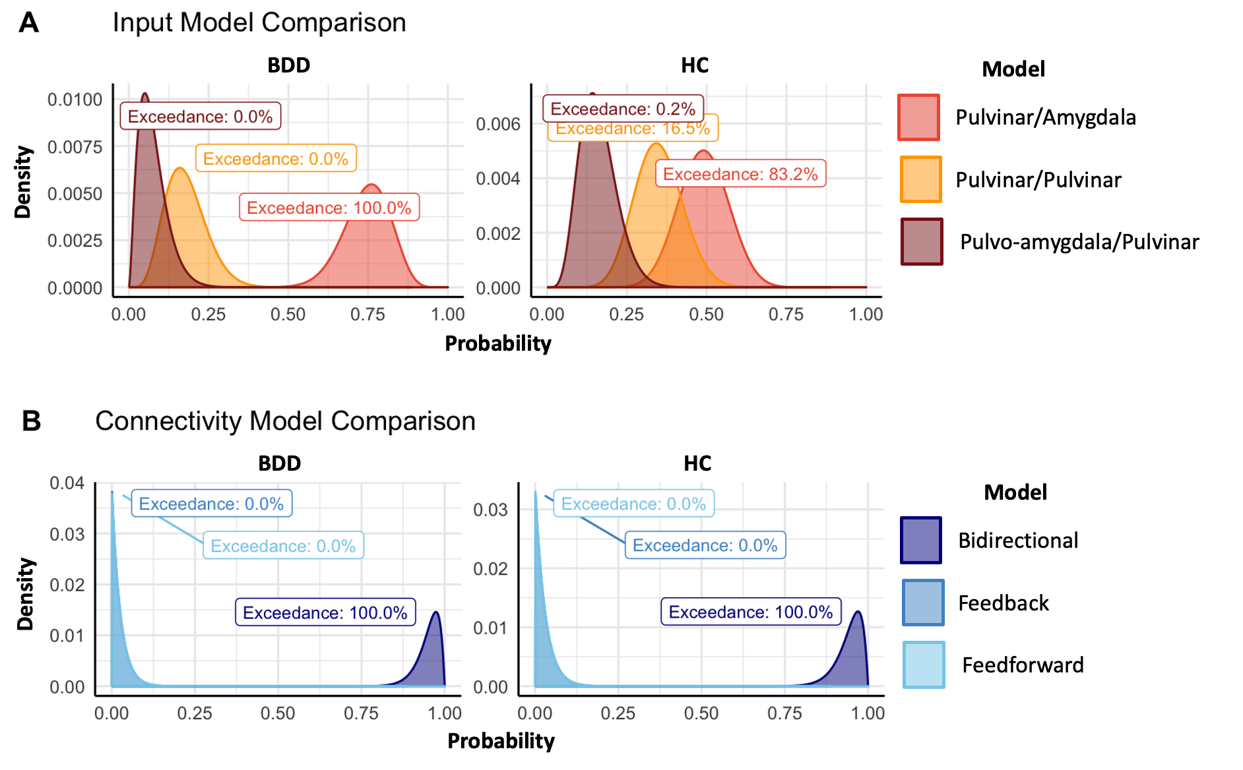
Supplementary Figure 2. Depiction of the exceedance probabilities for A) models of varying stimulus input region and B) models of varying directionality in both individuals with BDD (right) and healthy controls (left). The bell curves depicted in the figure represent the estimated densities of the probabilities that a given model would fit an individual in our sample; the areas of all distributions sum up to one. Distributions that are farther to the right imply that the associated model has a greater probability of accurate fit. Exceedance probabilities can be seen for each distribution on the figure. The pulvinar/amygdala inputs with bidirectional connectivities between each connected node yielded the highest exceedance probabilities in both healthy control and BDD groups.

Connectivity | BDD (n=32)  Mean (SEM) | HC (n=37)  Mean (SEM) | Beta  (SE) | Pp
Left Amygdala – Left Amygdala | -0.070 (0.019) | -0.061 (0.015) | 0.01 (0.06) | 0.17
Left Amygdala – Left FFA | 0.103 (0.051) | 0.164 (0.033) | -0.06 (0.04) | 0.81
Left Amygdala – Left mOFC | 0.241 (0.042) | 0.111 (0.040) | 0.09 (0.04) | 0.96
Left Amygdala – Left Pulvinar | 0.037 (0.039) | 0.003 (0.029) | 0.03 (0.05) | 0.42
Right Amygdala – Right Amygdala | -0.035 (0.019) | -0.061 (0.013) | 0.02 (0.06) | 0.32
Right Amygdala – Right FFA | 0.157 (0.048) | 0.200 (0.040) | -0.04 (0.04) | 0.65
Right Amygdala – Right mOFC | 0.106 (0.049) | 0.087 (0.043) | 0.01 (0.04) | 0.27
Right Amygdala – Right Pulvinar | -0.033 (0.031) | 0.050 (0.026) | -0.11 (0.05) | 0.98
Left FFA – Left Amygdala | -0.113 (0.041) | -0.016 (0.034) | -0.03 (0.04) | 0.56
Left FFA – Left FFA | -0.193 (0.020) | -0.145 (0.018) | 0.12 (0.06) | 0.96
Left FFA – Left Pulvinar | -0.024 (0.037) | -0.003 (0.038) | -0.02 (0.04) | 0.33
Right FFA – Right Amygdala | -0.044 (0.033) | -0.029 (0.030) | -0.02 (0.05) | 0.30
Right FFA – Right FFA | -0.157 (0.020) | -0.159 (0.015) | -0.004 (0.06) | 0.05
Right FFA – Right Pulvinar | 0.019 (0.037) | 0.013 (0.032) | 0.01 (0.05) | 0.26
Left mOFC – Left Amygdala | 0.080 (0.031) | 0.044 (0.016) | 0.06 (0.05) | 0.75
Left mOFC – Left mOFC | -0.066 (0.014) | -0.058 (0.016) | 0.06 (0.06) | 0.70
Right mOFC – Right Amygdala | 0.022 (0.023) | 0.047 (0.023) | -0.04 (0.05) | 0.53
Right mOFC – Right mOFC | -0.061 (0.011) | -0.070 (0.016) | 0.04 (0.06) | 0.52
Left Pulvinar – Left Amygdala | 0.040 (0.031) | 0.071 (0.034) | -0.03 (0.04) | 0.48
Left Pulvinar – Left FFA | 0.227 (0.054) | 0.161 (0.054) | 0.05 (0.04) | 0.78
Left Pulvinar – Left Pulvinar | -0.018 (0.018) | -0.053 (0.012) | -0.07 (0.05) | 0.81
Right Pulvinar – Right Amygdala | 0.028 (0.031) | 0.099 (0.032) | -0.05 (0.05) | 0.75
Right Pulvinar – Right FFA | 0.224 (0.047) | 0.192 (0.042) | 0.03 (0.04) | 0.50
Right Pulvinar – Right Pulvinar | -0.033 (0.017) | -0.039 (0.009) | -0.01 (0.05) | 0.10

Supplementary Table 1. Effective connectivity estimates between-group differences. Contains statistics (beta and standard error (SE), Posterior probabilities (Pp)) from group comparison using Parametric Empirical Bayes looking at connectivity differences between participants with BDD and healthy controls for each effective connectivity estimate (24 total). Connectivities with Pp > 0.95 indicate strong evidence for differences between individuals with BDD and healthy controls.

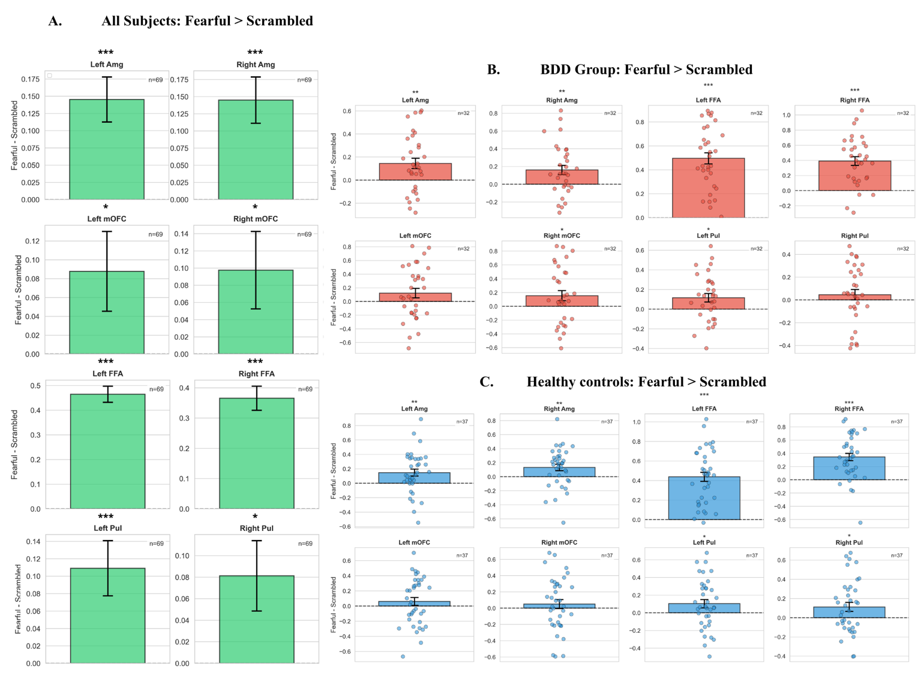
Supplementary Figure 3. Second-level GLM estimates of all ROIs used in the effective connectivity analysis A) across all subjects and within B) the BDD group and C) healthy controls. Of note, across all subjects and across all ROIs, participants showed greater fMRI BOLD responses to fearful compared to scrambled stimuli, indicating significant activity in the regions used within the DCM (* uncorrected p < 0.05; ** uncorrected p < 0.01, ** uncorrected p < 0.001).

Connectivity | All subjects (n=69)  Mean (SE) | BDD (n=32)  Mean (SE) | HC (n=37)  Mean (SE) | t-stat (p)
Left Amygdala | 0.15 (0.03) | 0.15 (0.05) | 0.14 (0.04) | 4.45 (<0.001)
Right Amygdala | 0.14 (0.03) | 0.13 (0.05) | 0.16 (0.05) | 4.30 (<0.001)
Left FFA | 0.46 (0.03) | 0.44 (0.05) | 0.50 (0.05) | 14.26 (<0.001)
Right FFA | 0.37 (0.04) | 0.34 (0.06) | 0.39 (0.06) | 9.21 (<0.001)
Left mOFC | 0.09 (0.04) | 0.06 (0.05) | 0.12 (0.07) | 2.07 (0.04)
Right mOFC | 0.10 (0.05) | 0.05 (0.05) | 0.15 (0.07) | 2.16 (0.03)
Left Pulvinar | 0.11 (0.03) | 0.10 (0.05) | 0.12 (0.04) | 3.45 (<0.001)
Right Pulvinar | 0.08 (0.03) | 0.11 (0.05) | 0.05 (0.05) | 2.49 (0.02)

Supplementary Table 2. Second-level GLM beta estimates of ROIs used in the effective connectivity analysis shown for all subjects as well as within-each group (BDD and HC). Means and standard error (SE) are provided for all subjects combined as well as within-each group. We performed univariate t-tests across all subjects (combined across BDD and HC groups) to confirm non-zero activation across all ROIs; test statistics and p-values are reported. Of note, all p-values are uncorrected.

