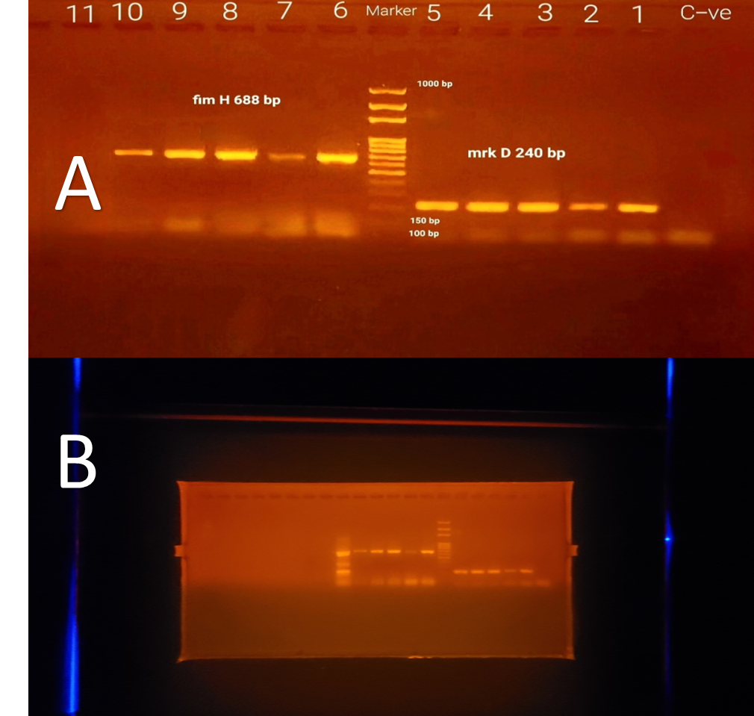

Fig. 2: A) Agarose gel electrophoresis for the PCR amplified products of Klebsiella pneumoniae fimH and mrkD genes. Lane marker: DNA molecular size marker (1000 bp). Lane C-ve: negative control. Lanes 1, 2, 3, 4 and 5: represent positive mrkD gene (240 bp) and lanes 6, 7, 8, 9 and 10: represent positive fimH gene (688 bp). Lane 11: represents negative sample. B) full-length original unprocessed version gel with clearly marked edges.

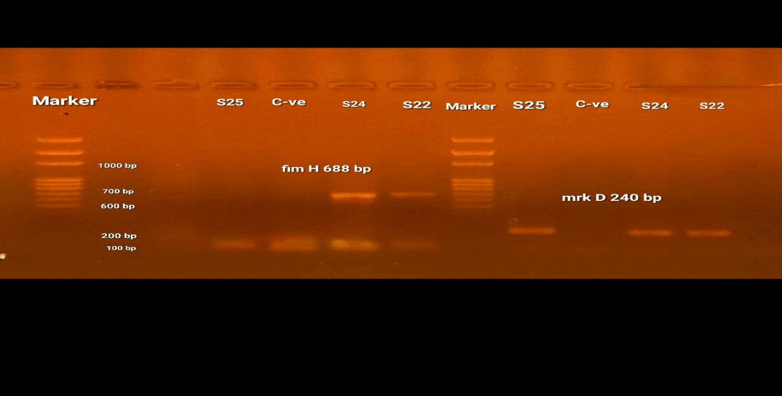

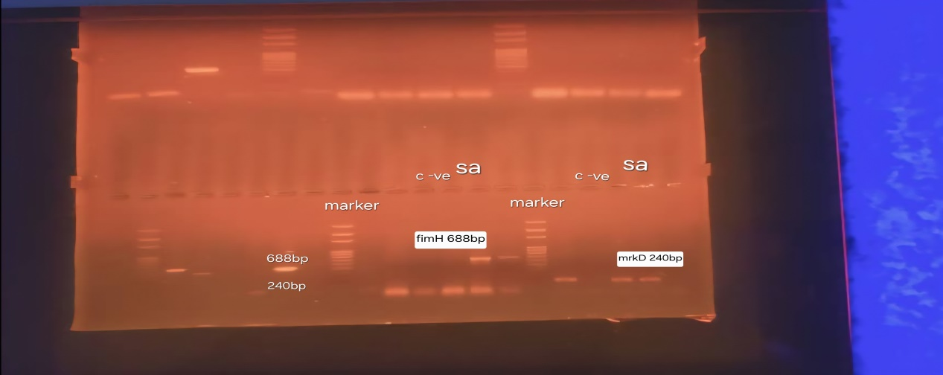

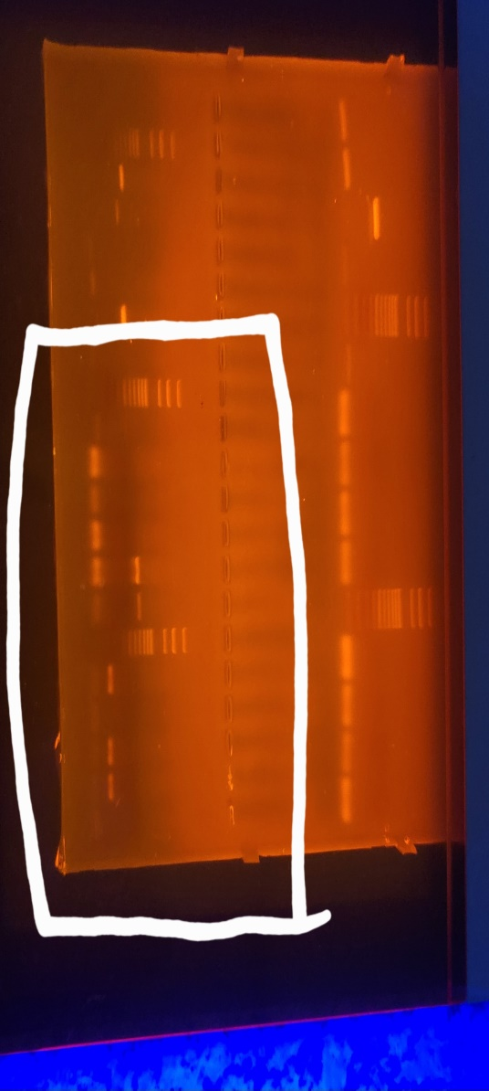

Note: The three above images are for the processed and labeled version of the gel in Fig. 2(B).

