Additional file 1: Supplementary material
Machine learning prediction of clinical trajectories after N-terminal pro-B-type natriuretic peptide exceeds 35,000 pg/mL: a retrospective development and external validation study

Supplementary Methods

S1. Data extraction and index construction
MIMIC-IV is a deidentified, longitudinal electronic-health-record database containing hospital and intensive-care data from Beth Israel Deaconess Medical Center in Boston, Massachusetts. Version 3.1 was stored locally and queried in a read-only manner. The NT-proBNP laboratory item was identified as item ID 50963, for which the recorded unit was pg/mL. The MIMIC dates are deidentified and shifted within patients; therefore, calendar dates were not interpreted clinically. Patient identifiers were used only to preserve grouped resampling and to prevent the same individual from contributing to both training and validation partitions.
The external cohort was assembled from 14 local-hospital workbooks containing laboratory and encounter data. The observed index dates extended from 18 September 2021 to 31 October 2024. Patient and encounter identifiers were pseudonymised in all derived files. Laboratory labels and units were mapped to the common MIMIC variables before external evaluation. Local hospital source data were accessed in read-only form throughout the analysis.
The locked analytical population comprised adult inpatient admissions with at least one NT-proBNP result reported above 35,000 pg/mL. For each qualifying admission, the index time was the timestamp of the first over-range result. MIMIC contained 1,532 qualifying over-range laboratory rows linked to 605 admissions in 573 patients. The local source contained 907 qualifying over-range rows linked to 496 encounters in 449 patients. Each encounter contributed one index observation.
Results reported with a greater-than sign were treated as right-censored above 35,000 pg/mL. They were not recoded to an exact concentration of 35,000 pg/mL, and a percentage decline from the index value was not calculated because its denominator was unknown. Numerical values greater than 35,000 in MIMIC were eligible under the same threshold rule but were not used as continuous predictors, maintaining a common prediction problem across sites.
An acceptable confirmation would include prespecified ICD-based acute-heart-failure codes with exclusion of isolated right-sided conditions, or a clinically adjudicated combination of symptoms, signs, imaging and treatment. In a clinical setting, no diagnostic criterion was inferred from NT-proBNP alone because severe kidney dysfunction, sepsis and other critical illnesses can also produce extreme concentrations.
Primary and secondary outcomes
The final locked primary endpoint was an investigator-defined composite improvement event. An event occurred at the earliest of (i) the first post-index NT-proBNP result at or below 35,000 pg/mL or (ii) alive hospital discharge. Alive discharge counted as an event irrespective of remeasurement status. Thus, a patient with no repeat NT-proBNP who survived to discharge was classified as having the event, and a patient whose repeated measurements remained above 35,000 pg/mL but who survived to discharge was also classified as having the event. Hospital death without a preceding laboratory-confirmed return to the reportable range was a non-event. When both components occurred, event time was the earlier timestamp. Local discharge time was available only to the day, and same-day discharge was stored as day 0.
This definition was chosen to reflect the investigators’ intended clinical trajectory: either objective biochemical re-entry into the measurable range or sufficient clinical improvement to leave hospital alive. It is not equivalent to “NT-proBNP decline”, because most events were alive discharges without documented biochemical recovery. We therefore prespecified component analyses for (i) laboratory-confirmed recovery among patients with at least one remeasurement and (ii) alive hospital discharge among all admissions. Routine or home discharge was considered a sensitivity outcome because discharge-location coding differed between databases. Hospital death and previously explored 28-day death/readmission outcomes were supplementary prognostic outcomes and were not used as the primary endpoint in the present manuscript.
Candidate predictors and measurement window
Prediction occurred at the index over-range result. Candidate laboratory measurements were extracted from the preceding 48 h, using the most recent numeric result at or before the prediction time. Variables available in at least 20% of admissions in both cohorts were eligible for the common model. All 27 prespecified variables were retained in the primary model: age; sex; albumin; alanine aminotransferase; aspartate aminotransferase; bicarbonate; total bilirubin; total calcium; chloride; creatinine; glucose; haemoglobin; international normalised ratio; lactate; lymphocyte percentage; mean corpuscular volume; neutrophil percentage; partial pressure of carbon dioxide; pH; platelet count; partial pressure of oxygen; potassium; red cell distribution width; sodium; troponin T; urea nitrogen; and white blood cell count.
The selection reflects multiple physiological domains relevant to advanced heart failure and critical illness: myocardial injury, kidney function, hepatic congestion or hypoperfusion, acid-base status, tissue perfusion, inflammation, haematological reserve and electrolyte balance. Variables were not removed on the basis of univariable AUC or external performance. C-reactive protein, magnesium and phosphate were excluded from the locked 27-variable set because coverage did not reach 20% in both datasets. No post-index measurement, treatment, length of stay or discharge information was used as a predictor.
Units were harmonised before model fitting. Local creatinine in µmol/L was divided by 88.4 to obtain mg/dL. Local albumin and haemoglobin in g/L were divided by 10 to obtain g/dL. Local total bilirubin in µmol/L was divided by 17.104 to obtain mg/dL. MIMIC blood urea nitrogen in mg/dL was multiplied by 0.357 to obtain mmol/L; glucose by 0.05551 to obtain mmol/L; total calcium by 0.2495 to obtain mmol/L; magnesium by 0.4114 to obtain mmol/L; and phosphate by 0.3229 to obtain mmol/L. Distributional audits were performed after conversion, and implausible mappings were reviewed against the originating test labels.
Coverage varied substantially by predictor and site. Core chemistry and haematology variables were nearly complete in MIMIC, whereas several local variables had approximately 80–84% coverage. Albumin, liver enzymes, bilirubin, lactate and blood-gas variables were selectively measured in both settings. Because missingness can carry information about clinician assessment and disease severity, each fold-specific preprocessing object combined median imputation with a missingness indicator for variables with missing observations. All medians and indicators were learned from the training partition only. Robust centring and scaling were additionally applied within training folds for penalised logistic regression and radial-basis-function support vector machines. No imputation parameter was estimated using validation data.

S2. Model development and validation details
The prespecified primary algorithm was histogram gradient boosting. The originally locked implementation used scikit-learn’s HistGradientBoostingClassifier and was the basis for the main composite and component analyses. To reproduce the entire comparison in R, we fitted a constrained LightGBM histogram model with 63 bins as a native-R analogue because R has no implementation that is numerically identical to scikit-learn’s estimator. We report this distinction explicitly and do not present the R analogue as a bit-for-bit replication.
Eight additional full-feature algorithms were compared in R: XGBoost, standard LightGBM, CatBoost, random forest, extremely randomised trees, conventional gradient boosting, a radial-basis-function support vector machine and ridge-penalised logistic regression. These models span boosting, bagged trees, kernel classification and linear shrinkage. All used the same 27 source predictors and the same outer resampling assignments. SHAP was used for model explanation and not for feature selection or tuning.
Hyperparameter grids were intentionally small to limit overfitting. The R histogram analogue compared learning rates of 0.05 and 0.07, 7 or 9 leaves and minimum leaf sizes of 20 or 25. LightGBM, XGBoost, random forest, CatBoost, gradient boosting, extra trees, ridge logistic regression and RBF-SVM each compared two prespecified configurations. Boosted models used 200 iterations; random forest and extra trees used 300 trees. The complete grids, seeds and saved preprocessing objects are available in the reproducible analysis script.
Internal validation used two repeats of five-fold patient-grouped stratified outer cross-validation. Admissions from the same MIMIC patient were kept in the same fold. Within each outer training set, hyperparameters were selected using three-fold patient-grouped inner cross-validation. Every MIMIC admission therefore received two out-of-fold predictions for each algorithm, which were averaged for overall internal metrics. The local cohort was evaluated only after the final configuration had been selected in MIMIC and fitted to the complete development cohort, consistent with guidance to separate model development from evaluation. This nested structure reduces optimism from reusing tuning folds and addresses a key risk-of-bias domain.
The scikit-learn primary model was locked during the original analysis. The R analysis retained the endpoint, admissions and 27 predictors unchanged and served as an algorithmic reproduction and robustness analysis. Apparent superiority in the local cohort was not used to relabel the primary model. An AUC of 0.75 was specified as a performance target, not as a licence for iterative external-cohort tuning.
Discrimination was quantified with the receiver-operating-characteristic (ROC) AUC and precision-recall AUC. Overall accuracy was summarised with the Brier score. Calibration was assessed using the mean predicted risk, observed event rate, calibration intercept, calibration slope and smoothed calibration plots. Clinical utility was explored with decision-curve analysis and net benefit across plausible probability thresholds. Because the composite event was common, precision-recall curves were interpreted against the cohort-specific event prevalence rather than against a universal baseline.
Uncertainty for AUC was estimated with 5,000 patient-cluster bootstrap replicates, preserving within-patient correlation. Model differences were evaluated with paired cluster-bootstrap distributions because every algorithm generated predictions for the same admissions. Eight comparisons with the primary R analogue were corrected using the Benjamini-Hochberg false-discovery-rate procedure. The AUC implementation and serialised prediction files were independently recomputed, with a numerical tolerance of 5 × 10⁻⁵ for nearly tied random-forest probabilities. Classical nonparametric AUC comparison is well established, but the clustered paired bootstrap was preferred for the repeated-admission structure.
No statistical significance tests were used to compare baseline characteristics between the development and external cohorts. Such tests would mainly reflect sample size and would not quantify clinically relevant transportability. Instead, differences in distributions, missingness, event prevalence, calibration and performance were described directly.
Global feature importance for tree models was estimated using mean absolute SHAP values. Contributions from a variable’s observed value and its missingness indicator were aggregated back to the prespecified source predictor. Importance was calculated separately in MIMIC out-of-fold predictions and in the external cohort. Because feature attribution describes the fitted prediction function rather than causal effects, SHAP rank was interpreted as model reliance and not as evidence that changing a laboratory value would change the outcome. This distinction is particularly important in clinical applications, where post hoc explanations can appear plausible even when a model relies on unstable or site-specific patterns.
Sensitivity analyses included the nine-algorithm comparison, component-specific validation and assessment of the remeasurement process. The component analyses asked whether the composite model discriminated laboratory-confirmed recovery among remeasured patients and alive discharge among all patients. The remeasurement-process analysis assessed whether predicted risk was associated with receiving another NT-proBNP measurement. These analyses were required to evaluate the observation-process dependence introduced by the composite endpoint.
The R reproduction used R version 4.4.1 with LightGBM, XGBoost, CatBoost, ranger, gbm, glmnet, kernlab, PRROC, fastshap and shapviz. A fixed seed of 20260802 was used. Model objects, outer-fold assignments, predictions, bootstrap summaries, SHAP values, session information and independent validation reports were retained. The MIMIC source remained unmodified, and the local source was accessed read-only.
MIMIC-IV is distributed under a data-use agreement with deidentification and institutional approvals described by its custodians.

Supplementary Results

S3. Extended cohort construction and endpoint composition
The MIMIC laboratory table contained 98,206 NT-proBNP rows from 41,238 patients. Of these, 1,532 rows were numerically above 35,000 pg/mL. After linkage to admissions and selection of the first qualifying result, 605 admissions from 573 patients formed the development cohort. Ninety-three admissions (15.4%) had at least one subsequent NT-proBNP measurement, 21 had at least three total measurements and five had at least four. Forty-five of the 93 remeasured admissions (48.4%) subsequently recorded a result at or below 35,000 pg/mL.
The local laboratory sources contained 25,372 deduplicated BNP-family rows, of which 15,889 were NT-proBNP measurements from 5,164 patients and 6,623 encounters. Nine hundred and seven rows qualified as over range: 901 were explicitly recorded as greater than 35,000, six contained a numeric value above 35,000 and three exact values of 35,000 did not qualify. The index cohort comprised 496 encounters from 449 patients. Remeasurement was more frequent than in MIMIC, occurring in 262 encounters (52.8%). Of these, 150 (57.3%) returned to the reportable range, with a median observed recovery time of 70.1 h. The predominance of text-reported “>35,000” values in the local cohort confirmed that the index concentration could not be analysed as a continuous variable.
Patients were older in both cohorts, with a median age of 72 years (interquartile range [IQR] 61–82) in MIMIC and 74 years (65–84) locally. Men accounted for 323 of 605 development admissions (53.4%) and 291 of 496 external-validation encounters (58.7%). Kidney dysfunction was prominent: median creatinine was 2.60 mg/dL (IQR 1.70–3.93) in MIMIC and 2.91 mg/dL (1.80–5.04) locally, while median urea nitrogen was 17.14 mmol/L (11.42–24.99) and 16.79 mmol/L (11.16–22.91), respectively. These distributions support the need to interpret over-range NT-proBNP jointly with renal function rather than as an isolated marker.
Other measurements indicated multisystem illness. Median haemoglobin was 9.5 g/dL in MIMIC and 9.2 g/dL locally. Median red cell distribution width was 16.3% and 15.2%, median troponin T was 0.170 ng/mL and 0.177 ng/mL, and median lactate among measured patients was 1.8 mmol/L and 1.9 mmol/L, respectively. Aspartate aminotransferase and alanine aminotransferase were right-skewed in both cohorts, with occasional values in the thousands, consistent with heterogeneous hepatic injury or hypoperfusion. Sodium was modestly higher locally (median 140 mmol/L versus 138 mmol/L), while bicarbonate was lower (21.6 versus 23.0 mmol/L). The complete distribution and missingness profile of all 27 predictors is reported in Table 1.
Measurement density differed by site. Albumin coverage was 49.3% in MIMIC and 46.8% locally. Lactate was available in 40.3% and 57.1%, and blood-gas variables in approximately 36% and 57%, respectively. Core blood counts were available in approximately 99% of MIMIC admissions but 83% of local encounters. These patterns argue against interpreting missingness as random and justify learning missingness indicators within the development data. They also represent a realistic transportability challenge because the model had to operate under different laboratory-ordering practices.
The primary composite improvement event occurred in 479 of 605 MIMIC admissions (79.2%). This total included 434 alive discharges without documented laboratory recovery, 35 admissions with both laboratory-confirmed recovery and alive discharge, and 10 laboratory-recovery events without alive discharge. The remaining 126 admissions had no observed improvement event. Overall, 469 patients (77.5%) left hospital alive and 136 died in hospital. Among the 93 remeasured admissions, 45 (48.4%) achieved laboratory-confirmed recovery; their median time to the first value at or below 35,000 pg/mL was 112.2 h.
In the external cohort, 436 of 496 encounters (87.9%) met the primary endpoint. These comprised 286 alive discharges without documented recovery, 127 encounters with both components and 23 recovery events without alive discharge. Sixty encounters had no observed improvement event. Four hundred and thirteen patients (83.3%) left hospital alive and 83 died in hospital. The external event prevalence was therefore 8.7 percentage points higher than in MIMIC. The balance between components also differed: laboratory-confirmed recovery contributed to 34.4% of external events but only 9.4% of development events. This difference largely reflected the threefold higher remeasurement rate locally.
The endpoint consequently represented a union of a biological process and a clinical-disposition process. It avoided classifying every unmeasured survivor as a non-recovery, which would have made the outcome depend even more strongly on laboratory-ordering practice. At the same time, counting alive discharge as improvement meant that the event could occur without evidence that NT-proBNP had fallen. Component-specific performance was therefore essential to interpretation.

S4. Nine-algorithm comparison and observation-process analyses
The originally locked histogram gradient-boosting model achieved an internally validated ROC AUC of 0.756 (95% patient-cluster bootstrap interval 0.710–0.800) and a precision-recall AUC of 0.919 in MIMIC. Its external ROC AUC was 0.813 (0.753–0.861), precision-recall AUC was 0.967 and Brier score was 0.096. The external calibration intercept was 0.692 and slope was 1.286, indicating that recalibration of the baseline risk would be appropriate before clinical deployment despite preserved ranking performance. The prespecified AUC target of 0.75 was reached in both the internal and external analyses.
The native-R constrained histogram-boosting analogue yielded an internal ROC AUC of 0.741 (0.695–0.787), precision-recall AUC of 0.915 and Brier score of 0.148. Its calibration intercept was 0.244 and slope 0.674. In the local cohort, the corresponding ROC AUC was 0.808 (0.745–0.863), precision-recall AUC 0.963 and Brier score 0.099, with a calibration intercept of 0.795 and slope of 0.899. The near-identical external discrimination of the original and R-native implementations supports algorithmic robustness, but the lower R internal AUC and different calibration demonstrate why the analogue cannot be described as an exact replication.
The higher precision-recall AUC in the external cohort must be interpreted in the context of its higher event prevalence. Mean predicted risk from the R analogue was 0.810 internally versus an observed rate of 0.792, and 0.806 externally versus an observed rate of 0.879. The positive external calibration intercept therefore reflected systematic underestimation of the higher local event rate. This is a transportability issue rather than a contradiction of the ROC AUC, which measures ranking and is comparatively insensitive to prevalence.
Internal discrimination was similar across the tree-ensemble methods. CatBoost produced the highest internal R AUC at 0.748 (0.701–0.795), followed by conventional gradient boosting at 0.747 (0.700–0.794). Extra trees and the R histogram analogue both achieved approximately 0.741, XGBoost 0.738, random forest 0.736 and standard LightGBM 0.735. Penalised logistic regression and RBF-SVM were lower at 0.709 and 0.708. No R implementation exceeded an internal AUC of 0.75. This result was retained rather than optimised away, because continued optimisation against internal fluctuations or external performance would undermine the locked-validation design.
External AUCs were generally higher. Conventional gradient boosting achieved 0.818 (0.759–0.870), CatBoost 0.817 (0.754–0.870), extra trees 0.813 (0.745–0.871), XGBoost 0.812 (0.756–0.862), the R histogram analogue 0.808 (0.745–0.863), standard LightGBM 0.797, random forest 0.794 and penalised logistic regression 0.790. RBF-SVM achieved 0.729 (0.662–0.794). After paired cluster-bootstrap testing and false-discovery-rate correction, only RBF-SVM was significantly worse than the primary R analogue in the external cohort (q=0.045). None of the differences among the tree ensembles survived correction.
The best Brier score did not coincide with the best AUC. In external validation, penalised logistic regression had a Brier score of 0.093, CatBoost 0.095, gradient boosting 0.096, LightGBM and XGBoost 0.097, and the R analogue 0.099. The logistic model nevertheless had a calibration intercept of 1.07 and slope of 0.67, showing that a low average squared error under high event prevalence does not by itself establish well-calibrated individual probabilities. CatBoost had an external intercept of 0.49 and slope of 1.24; conventional gradient boosting had 0.57 and 1.22. These findings favour model-specific recalibration and prospective assessment rather than selecting a model solely on a small AUC difference.
Decision-curve analysis showed that several tree ensembles provided positive net benefit over a range of thresholds, but the high prevalence of the composite event made the treat-all strategy competitive at low thresholds. Because no clinical intervention was prespecified for a positive model result, these curves are exploratory. They demonstrate that potential utility depends on the decision threshold and action attached to the prediction; they do not prove improved patient outcomes.
The primary R analogue relied on a consistent cross-system set of predictors. In MIMIC, the ten leading aggregated SHAP features were age (10.6% of total mean absolute importance), troponin T (10.1%), aspartate aminotransferase (9.9%), red cell distribution width (8.8%), lactate (5.4%), mean corpuscular volume (5.3%), creatinine (5.0%), white blood cell count (5.0%), platelet count (4.8%) and potassium (4.4%). In the local cohort, the leading features were troponin T (12.1%), age (10.2%), aspartate aminotransferase (8.7%), red cell distribution width (7.7%), lactate (6.6%), platelet count (5.7%), creatinine (4.6%), mean corpuscular volume (4.6%), white blood cell count (4.4%) and sodium (3.8%).
The overlap in the leading predictors suggests that the model captured broad domains of myocardial injury, age-related vulnerability, hepatic or systemic hypoperfusion, renal dysfunction and haematological stress. This pattern is clinically coherent with prior work on kidney function and blood urea nitrogen. Studies in acute and older heart-failure cohorts show that prognosis is not captured by a single peptide concentration. Comparative work has also examined BNP, NT-proBNP and their ratio. However, coherence does not confer causality. SHAP values describe changes in model output conditional on the fitted feature distribution; they cannot determine whether a predictor is a mediator, marker, confounder or consequence of treatment.
The prespecified model discriminated the overall composite but did not discriminate laboratory-confirmed recovery among remeasured admissions. In MIMIC, the component analysis included 93 admissions with 45 recovery events and yielded an AUC of 0.440 and precision-recall AUC of 0.435. In the external cohort, 262 remeasured encounters included 150 recoveries, with an AUC of 0.491 and precision-recall AUC of 0.585. These estimates were close to or below chance and do not support use of the current model to predict biochemical crossing of the 35,000 pg/mL threshold.
By contrast, alive discharge was predicted with an AUC of 0.760 in MIMIC and 0.798 locally. The remeasurement-process AUC was 0.452 and 0.453, suggesting that the main model did not simply predict whether clinicians would order another NT-proBNP test. Nevertheless, most composite events were alive-discharge events. The observed overall AUC should therefore be described as prediction of the composite “NT-proBNP recovery or alive discharge” trajectory and, in practical terms, primarily as short-term clinical prognosis or survival to discharge. It must not be reported as an AUC for NT-proBNP decline alone.

Supplementary Tables
Supplementary Table S1. Baseline characteristics and missingness of the 27 prespecified predictors
Predictor | Unit | MIMIC development (n=605) | Local external validation (n=496)
Age | years | 72.00 [61.00–82.00]; missing 0 (0.0%) | 74.00 [65.00–84.00]; missing 0 (0.0%)
Male sex | n (%) | 323 (53.4%) | 291 (58.7%)
Albumin | g/dL | 3.200 [2.800–3.700]; missing 307 (50.7%) | 3.275 [2.970–3.690]; missing 264 (53.2%)
Alanine aminotransferase | U/L | 23.00 [13.00–49.25]; missing 217 (35.9%) | 17.00 [10.00–37.00]; missing 273 (55.0%)
Aspartate aminotransferase | U/L | 32.00 [20.25–72.75]; missing 207 (34.2%) | 27.50 [17.00–58.00]; missing 226 (45.6%)
Bicarbonate | mmol/L | 23.00 [19.00–26.00]; missing 1 (0.2%) | 21.60 [18.80–24.90]; missing 96 (19.4%)
Total bilirubin | mg/dL | 0.600 [0.300–1.100]; missing 200 (33.1%) | 0.690 [0.433–1.193]; missing 271 (54.6%)
Total calcium | mmol/L | 2.146 [2.021–2.270]; missing 68 (11.2%) | 2.120 [2.000–2.270]; missing 321 (64.7%)
Chloride | mmol/L | 100.0 [95.00–105.0]; missing 1 (0.2%) | 102.4 [98.90–107.7]; missing 78 (15.7%)
Creatinine | mg/dL | 2.600 [1.700–3.925]; missing 1 (0.2%) | 2.907 [1.799–5.040]; missing 92 (18.5%)
Glucose | mmol/L | 7.105 [5.607–9.159]; missing 2 (0.3%) | 7.520 [5.965–10.38]; missing 89 (17.9%)
Haemoglobin | g/dL | 9.500 [8.400–10.90]; missing 8 (1.3%) | 9.200 [7.600–11.00]; missing 83 (16.7%)
International normalised ratio | ratio | 1.400 [1.200–1.900]; missing 136 (22.5%) | 1.180 [1.070–1.375]; missing 205 (41.3%)
Lactate | mmol/L | 1.800 [1.300–2.825]; missing 361 (59.7%) | 1.900 [1.200–3.100]; missing 213 (42.9%)
Lymphocytes | % | 10.10 [5.775–16.00]; missing 205 (33.9%) | 9.900 [6.200–15.30]; missing 83 (16.7%)
Mean corpuscular volume | fL | 93.00 [89.00–98.00]; missing 8 (1.3%) | 90.00 [84.90–93.70]; missing 83 (16.7%)
Neutrophils | % | 79.80 [71.60–86.05]; missing 205 (33.9%) | 80.50 [72.50–87.30]; missing 83 (16.7%)
Partial pressure of carbon dioxide | mmHg | 40.00 [33.00–44.25]; missing 389 (64.3%) | 33.20 [28.30–40.00]; missing 213 (42.9%)
pH | unitless | 7.370 [7.310–7.430]; missing 386 (63.8%) | 7.406 [7.357–7.447]; missing 213 (42.9%)
Platelet count | 10^9/L | 199.0 [137.0–260.0]; missing 9 (1.5%) | 187.0 [127.0–252.0]; missing 83 (16.7%)
Partial pressure of oxygen | mmHg | 76.00 [50.00–116.2]; missing 389 (64.3%) | 99.20 [78.70–136.0]; missing 213 (42.9%)
Potassium | mmol/L | 4.400 [3.900–5.000]; missing 3 (0.5%) | 4.240 [3.862–4.780]; missing 78 (15.7%)
Red cell distribution width | % | 16.30 [14.95–18.20]; missing 10 (1.7%) | 15.20 [14.00–17.10]; missing 83 (16.7%)
Sodium | mmol/L | 138.0 [134.0–141.0]; missing 1 (0.2%) | 140.0 [136.0–143.0]; missing 78 (15.7%)
Troponin T | ng/mL | 0.170 [0.070–0.460]; missing 196 (32.4%) | 0.177 [0.089–0.599]; missing 47 (9.5%)
Urea nitrogen | mmol/L | 17.14 [11.42–24.99]; missing 1 (0.2%) | 16.79 [11.16–22.91]; missing 92 (18.5%)
White blood cell count | 10^9/L | 9.200 [6.400–13.20]; missing 8 (1.3%) | 8.530 [6.600–11.74]; missing 83 (16.7%)
Continuous variables are median [interquartile range]; missing values are n (%).
Supplementary Table S2. Internal performance of nine full-feature R models
Model | Internal ROC AUC (95% CI) | Internal PR AUC | Internal Brier | Internal calibration intercept/slope
CatBoost | 0.748 (0.701–0.795) | 0.913 | 0.141 | -0.13 / 1.03
Gradient boosting | 0.747 (0.700–0.794) | 0.909 | 0.142 | 0.04 / 0.96
Histogram gradient boosting (R analogue; primary) | 0.741 (0.695–0.787) | 0.915 | 0.148 | 0.24 / 0.67
Extra trees | 0.741 (0.693–0.789) | 0.903 | 0.144 | 0.13 / 0.96
XGBoost | 0.738 (0.692–0.784) | 0.914 | 0.145 | 0.04 / 0.92
Random forest | 0.736 (0.687–0.786) | 0.902 | 0.144 | 0.24 / 0.84
LightGBM | 0.735 (0.688–0.781) | 0.910 | 0.149 | 0.18 / 0.73
Penalised logistic | 0.709 (0.658–0.758) | 0.897 | 0.151 | 0.31 / 0.73
RBF SVM | 0.708 (0.658–0.758) | 0.890 | 0.153 | -0.24 / 1.19
Internal estimates use repeated patient-grouped nested cross-validation.
Supplementary Table S3. External performance of nine full-feature R models
Model | External ROC AUC (95% CI) | External PR AUC | External Brier | External calibration intercept/slope | External FDR q vs primary
CatBoost | 0.817 (0.754–0.870) | 0.966 | 0.095 | 0.49 / 1.24 | 0.772
Gradient boosting | 0.818 (0.759–0.870) | 0.967 | 0.096 | 0.57 / 1.22 | 0.772
Histogram gradient boosting (R analogue; primary) | 0.808 (0.745–0.863) | 0.963 | 0.099 | 0.80 / 0.90 | reference
Extra trees | 0.813 (0.745–0.871) | 0.959 | 0.103 | 0.65 / 1.45 | 0.795
XGBoost | 0.812 (0.756–0.862) | 0.968 | 0.097 | 0.49 / 1.21 | 0.795
Random forest | 0.794 (0.724–0.855) | 0.954 | 0.105 | 0.79 / 1.13 | 0.772
LightGBM | 0.797 (0.735–0.854) | 0.963 | 0.097 | 0.58 / 1.06 | 0.772
Penalised logistic | 0.790 (0.717–0.854) | 0.956 | 0.093 | 1.07 / 0.67 | 0.772
RBF SVM | 0.729 (0.662–0.794) | 0.947 | 0.111 | 0.47 / 1.33 | 0.045
False-discovery-rate q values compare each model with the R histogram analogue.
Supplementary Table S4. Primary endpoint composition
Cohort | All admissions, n | Primary events, n (%) | Remeasured, n (%) | Laboratory-confirmed recovery among remeasured, n (%) | Alive discharge, n (%)
MIMIC development | 605 | 479 (79.2%) | 93 (15.4%) | 45 (48.4%) | 469 (77.5%)
Local external validation | 496 | 436 (87.9%) | 262 (52.8%) | 150 (57.3%) | 413 (83.3%)
Laboratory-confirmed recovery is evaluated among remeasured admissions.
Supplementary Table S5. Component-specific validation
Cohort | Primary-model AUC for composite | Primary-model AUC for laboratory recovery | Primary-model AUC for alive discharge
MIMIC development | 0.756 | 0.440 | 0.760
Local external validation | 0.813 | 0.491 | 0.798
AUCs refer to the originally locked Python histogram gradient-boosting model.
Supplementary Table S6. Leading SHAP features for the primary R histogram analogue
Cohort | Rank | Predictor | Mean absolute SHAP | Relative importance
Local external | 1 | Troponin T | 0.458 | 12.1%
Local external | 2 | Age | 0.384 | 10.2%
Local external | 3 | AST | 0.329 | 8.7%
Local external | 4 | RDW | 0.292 | 7.7%
Local external | 5 | Lactate | 0.250 | 6.6%
Local external | 6 | Platelets | 0.217 | 5.7%
Local external | 7 | Creatinine | 0.175 | 4.6%
Local external | 8 | MCV | 0.175 | 4.6%
Local external | 9 | White blood cells | 0.166 | 4.4%
Local external | 10 | Sodium | 0.144 | 3.8%
MIMIC internal | 1 | Age | 0.398 | 10.6%
MIMIC internal | 2 | Troponin T | 0.381 | 10.1%
MIMIC internal | 3 | AST | 0.372 | 9.9%
MIMIC internal | 4 | RDW | 0.331 | 8.8%
MIMIC internal | 5 | Lactate | 0.205 | 5.4%
MIMIC internal | 6 | MCV | 0.197 | 5.3%
MIMIC internal | 7 | Creatinine | 0.189 | 5.0%
MIMIC internal | 8 | White blood cells | 0.187 | 5.0%
MIMIC internal | 9 | Platelets | 0.179 | 4.8%
MIMIC internal | 10 | Potassium | 0.165 | 4.4%
Observed-value and missingness-indicator contributions are aggregated by source predictor.

Supplementary Figure Legends
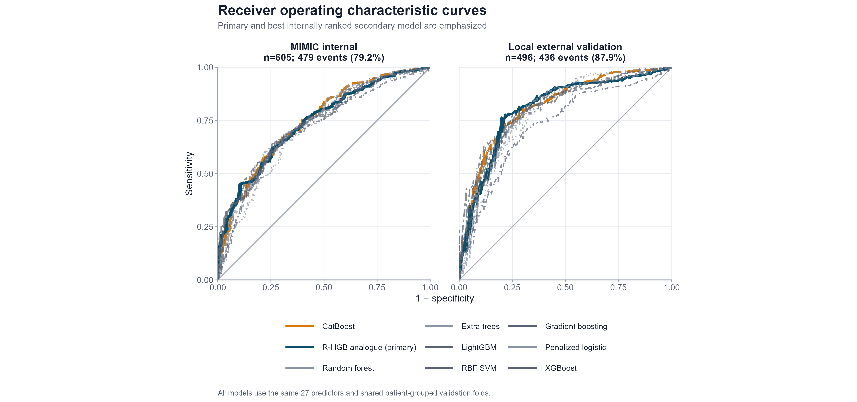
Supplementary Figure S1. Receiver-operating-characteristic curves.
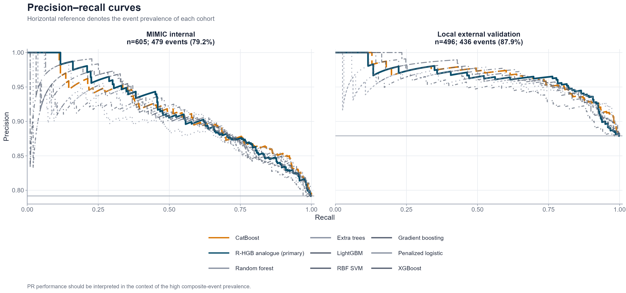
Supplementary Figure S2. Precision-recall curves.
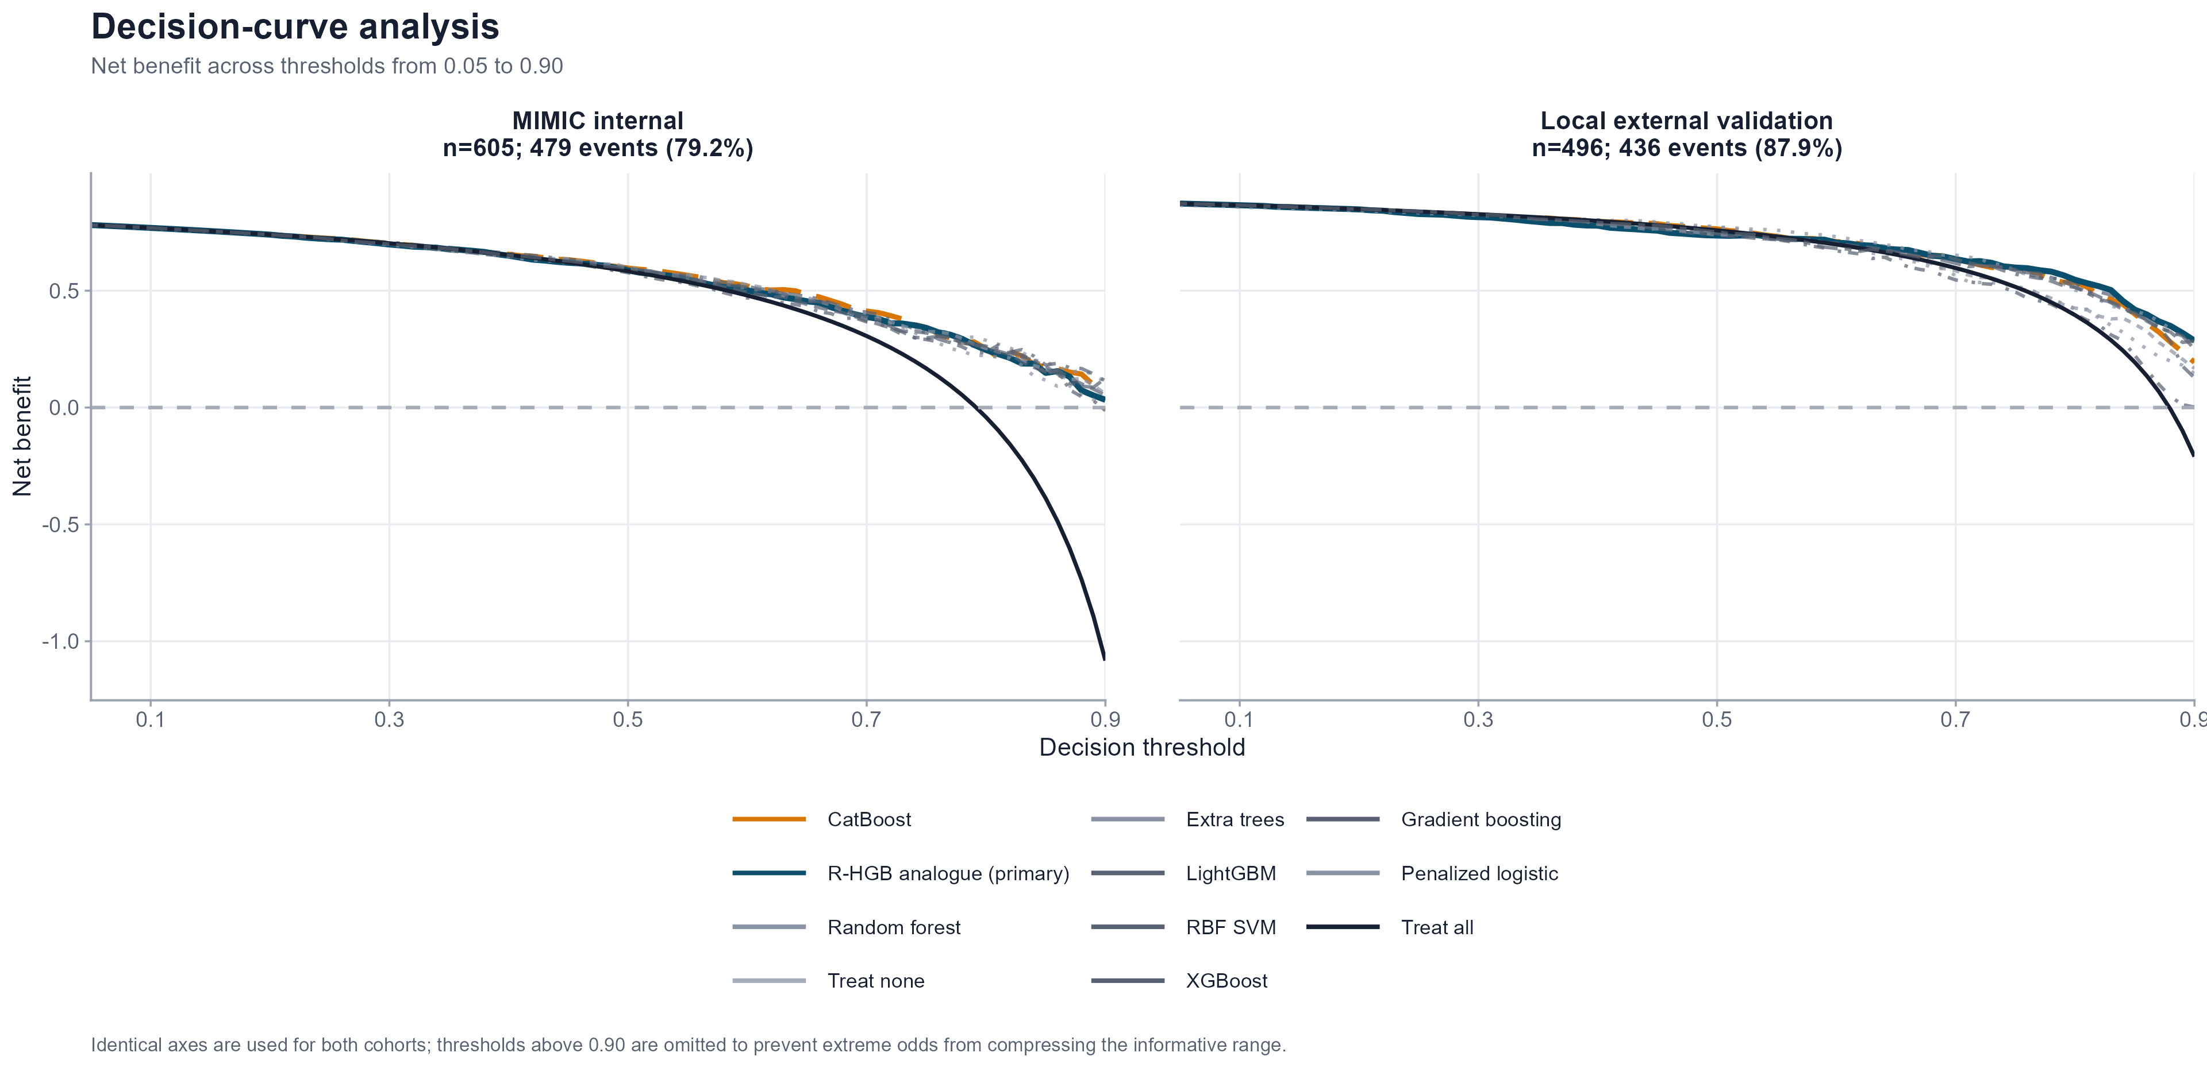
Supplementary Figure S3. Decision-curve analysis.
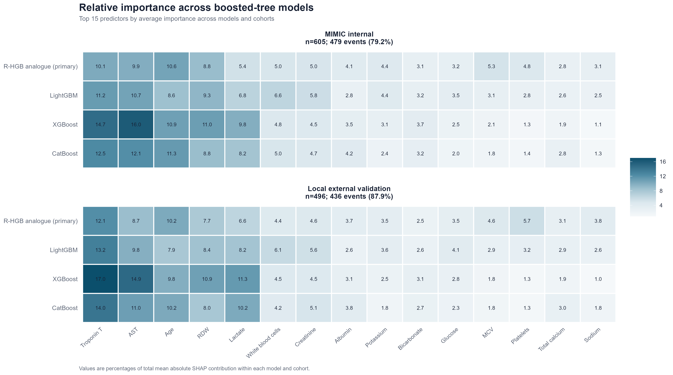
Supplementary Figure S4. Cross-model SHAP heatmap.

