Additional file 1
Supplementary tables and figures
Blood cadmium and mortality among U.S. stroke survivors: a survey-weighted NHANES-linked cohort study of competing risks and renal pathways

Table S1. Fine–Gray competing-risk regression for cardiovascular mortality by blood cadmium group.
Model | Subdistribution HR (95% CI)  BCd ≥0.36 vs <0.36 μg/L | P value
Crude | 1.51 (1.08–2.13) | 0.017
Model 1 | 1.50 (1.06–2.12) | 0.021
Model 2 | 1.48 (1.04–2.11) | 0.028
Model 3 | 1.50 (1.05–2.14) | 0.024
Model 4 | 1.44 (1.01–2.06) | 0.045
Note. Fine–Gray subdistribution hazard models were conducted without NHANES survey weights and treated non-CVD death as the competing event, using a three-level mortality status variable (0 = alive/censored, 1 = CVD death, 2 = non-CVD death). Model 1 adjusted for sex, age, and race/ethnicity. Model 2 additionally adjusted for education, marital status, poverty-to-income ratio, total energy intake, alcohol use, serum cotinine, and physical activity. Model 3 additionally adjusted for continuous BMI, hyperlipidemia, diabetes, cancer, heart failure, coronary heart disease, and hypertension. Model 4 additionally adjusted for eGFR. BCd <0.36 μg/L served as the reference group. sHR, subdistribution hazard ratio; CI, confidence interval; BCd, blood cadmium; CVD, cardiovascular disease; BMI, body mass index; eGFR, estimated glomerular filtration rate.
Table S2. Exploratory renal mediation analyses of blood cadmium and mortality.
Mediator | Outcome | ACME, mo  (95% CI) | P | ADE, mo  (95% CI) | P | Total effect, mo  (95% CI) | P | Proportion mediated  (95% CI) | P
eGFR | All-cause mortality | −8.68 (−35.26, −3.24) | <0.001 | −74.05 (−258.06, −41.78) | <0.001 | −82.73 (−292.84, −49.70) | <0.001 | 0.105 (0.041, 0.224) | <0.001
eGFR | CVD mortality | −17.47 (−61.55, −2.68) | NA | −120.19 (−361.04, −10.62) | NA | −137.67 (−402.05, −34.79) | NA | 0.127 (0.012, 0.585) | NA
CKD | All-cause mortality | −5.87 (−23.01, −1.72) | 0.002 | −76.92 (−250.18, −44.98) | <0.001 | −82.79 (−267.55, −50.25) | <0.001 | 0.071 (0.021, 0.158) | 0.002
CKD | CVD mortality | −17.58 (−55.57, −4.94) | NA | −119.31 (−358.01, −18.81) | NA | −136.89 (−393.87, −36.50) | NA | 0.128 (0.030, 0.482) | NA
UACR | All-cause mortality | −3.13 (−14.29, 0.07) | 0.058 | −84.80 (−280.02, −51.41) | <0.001 | −87.93 (−288.62, −54.02) | <0.001 | 0.036 (−0.001, 0.096) | 0.058
UACR | CVD mortality | −3.68 (−16.53, 1.97) | NA | −142.89 (−422.83, −40.37) | NA | −146.57 (−428.48, −44.42) | NA | 0.025 (−0.014, 0.130) | NA
Note. Exploratory mediation analyses were adjusted for the Model 3 covariate set. Effects are expressed on the predicted survival-time scale (months); negative values indicate shorter predicted survival through the corresponding pathway. The primary Cox analyses (Table 2) report associations on the hazard scale (HR), whereas mediation effects are reported as differences in predicted survival time from the Weibull accelerated failure time outcome model; the two scales address complementary questions. Proportion mediated = ACME/total effect. Ninety-five percent CIs were obtained using 5,000 nonparametric bootstrap resamples. For CVD mortality, bootstrap P values could not be reliably computed because some resampled models failed to converge and are therefore reported as NA; these mediation estimates should be interpreted as exploratory. ACME, average causal mediation effect; ADE, average direct effect; CI, confidence interval; CVD, cardiovascular disease; eGFR, estimated glomerular filtration rate; CKD, chronic kidney disease; UACR, urine albumin-to-creatinine ratio.
Table S3. Unweighted Cox regression of blood cadmium and mortality.
Model | ln(BCd), all-cause  HR (95% CI) | P value | ln(BCd), CVD  HR (95% CI) | P value | BCd ≥0.36 μg/L, all-cause  HR (95% CI) | P value | BCd ≥0.36 μg/L, CVD  HR (95% CI) | P value
Crude | 1.20 (1.07–1.35) | 0.002 | 1.13 (0.93–1.38) | 0.212 | 1.70 (1.38–2.10) | <0.001 | 1.66 (1.18–2.34) | 0.004
Model 1 | 1.56 (1.36–1.79) | <0.001 | 1.46 (1.17–1.83) | 0.001 | 1.75 (1.42–2.16) | <0.001 | 1.72 (1.22–2.43) | 0.002
Model 2 | 1.50 (1.30–1.74) | <0.001 | 1.41 (1.10–1.79) | 0.006 | 1.65 (1.33–2.05) | <0.001 | 1.67 (1.17–2.37) | 0.004
Model 3 | 1.51 (1.30–1.75) | <0.001 | 1.41 (1.11–1.80) | 0.006 | 1.66 (1.34–2.06) | <0.001 | 1.72 (1.21–2.45) | 0.003
Model 4 | 1.44 (1.24–1.67) | <0.001 | 1.34 (1.05–1.71) | 0.021 | 1.57 (1.27–1.96) | <0.001 | 1.61 (1.13–2.31) | 0.009
Note. Hazard ratios were estimated using standard Cox proportional hazards models without NHANES survey weights. Model 1 adjusted for sex, age, and race/ethnicity. Model 2 additionally adjusted for education, marital status, poverty-to-income ratio (PIR), total energy intake, alcohol use, serum cotinine, and physical activity. Model 3 additionally adjusted for continuous body mass index (BMI), hyperlipidemia, diabetes, cancer, heart failure, coronary heart disease, and hypertension. Model 4 additionally adjusted for estimated glomerular filtration rate (eGFR). For categorical exposure analyses, BCd <0.36 μg/L served as the reference group. BCd, blood cadmium; HR, hazard ratio; CI, confidence interval; CVD, cardiovascular disease.
Table S4. Survey-weighted Cox regression among participants with preserved eGFR.
Model | ln(BCd), all-cause  HR (95% CI) | P value | ln(BCd), CVD  HR (95% CI) | P value | BCd ≥0.36 μg/L, all-cause  HR (95% CI) | P value | BCd ≥0.36 μg/L, CVD  HR (95% CI) | P value
Crude | 1.22 (1.03–1.46) | 0.022 | 1.07 (0.86–1.32) | 0.563 | 1.86 (1.36–2.55) | <0.001 | 1.46 (0.87–2.46) | 0.15
Model 1 | 1.85 (1.53–2.22) | <0.001 | 1.53 (1.16–2.00) | 0.002 | 1.93 (1.44–2.59) | <0.001 | 1.54 (0.92–2.58) | 0.103
Model 2 | 1.64 (1.34–2.01) | <0.001 | 1.35 (1.03–1.77) | 0.029 | 1.66 (1.21–2.26) | 0.002 | 1.36 (0.79–2.34) | 0.274
Model 3 | 1.61 (1.31–1.99) | <0.001 | 1.31 (0.97–1.78) | 0.079 | 1.65 (1.18–2.30) | 0.003 | 1.34 (0.75–2.40) | 0.323
Model 4 | 1.61 (1.30–2.01) | <0.001 | 1.30 (0.96–1.76) | 0.093 | 1.64 (1.17–2.32) | 0.005 | 1.32 (0.74–2.36) | 0.344
Note. Survey-weighted Cox proportional hazards models were restricted to participants with eGFR ≥60 mL/min/1.73 m² and incorporated the NHANES complex survey design using the combined 7-cycle MEC examination weight for 2005–2018. Model 1 adjusted for sex, age, and race/ethnicity. Model 2 additionally adjusted for education, marital status, poverty-to-income ratio (PIR), total energy intake, alcohol use, serum cotinine, and physical activity. Model 3 additionally adjusted for continuous body mass index (BMI), hyperlipidemia, diabetes, cancer, heart failure, coronary heart disease, and hypertension. Model 4 additionally adjusted for estimated glomerular filtration rate (eGFR). For categorical exposure analyses, BCd <0.36 μg/L served as the reference group. BCd, blood cadmium; HR, hazard ratio; CI, confidence interval; CVD, cardiovascular disease.
Table S5. Blood cadmium and cardiovascular mortality in NHANES 2005–2014.
Model | ln(BCd)  HR (95% CI) | P value | BCd ≥0.36 vs <0.36 μg/L  HR (95% CI) | P value
Crude | 1.08 (0.89–1.31) | 0.455 | 1.66 (1.13–2.46) | 0.011
Model 1 | 1.43 (1.16–1.75) | <0.001 | 1.57 (1.10–2.23) | 0.012
Model 2 | 1.31 (1.06–1.62) | 0.012 | 1.50 (1.04–2.18) | 0.030
Model 3 | 1.30 (1.02–1.66) | 0.036 | 1.55 (1.03–2.34) | 0.036
Model 4 | 1.26 (0.98–1.62) | 0.075 | 1.50 (1.00–2.27) | 0.051
Note. This cause-specific mortality sensitivity analysis was restricted to NHANES 2005–2014, when deaths from diseases of the heart and cerebrovascular diseases could both be separately identified in the public-use linked mortality data. Survey-weighted Cox models incorporated the NHANES complex survey design using the combined five-cycle MEC examination weight (WTMEC2YR/5). Model 1 adjusted for sex, age, and race/ethnicity. Model 2 additionally adjusted for education, marital status, poverty-to-income ratio (PIR), total energy intake, alcohol use, serum cotinine, and physical activity. Model 3 additionally adjusted for continuous body mass index (BMI), hyperlipidemia, diabetes, cancer, heart failure, coronary heart disease, and hypertension. Model 4 additionally adjusted for estimated glomerular filtration rate (eGFR). For categorical exposure analyses, BCd <0.36 μg/L served as the reference group. BCd, blood cadmium; HR, hazard ratio; CI, confidence interval; CVD, cardiovascular disease.
Table S6. Fine–Gray sensitivity analysis for cardiovascular mortality in NHANES 2005–2014.
Model | Subdistribution HR (95% CI)  BCd ≥0.36 vs <0.36 μg/L | P value
Crude | 1.44 (1.02–2.05) | 0.040
Model 1 | 1.40 (0.98–1.99) | 0.062
Model 2 | 1.40 (0.98–2.01) | 0.068
Model 3 | 1.43 (1.00–2.07) | 0.052
Model 4 | 1.38 (0.96–1.99) | 0.083
Note. This sensitivity analysis was restricted to NHANES 2005–2014, when deaths from diseases of the heart and cerebrovascular diseases could both be separately identified in the public-use linked mortality data. Fine–Gray subdistribution hazard models were conducted without NHANES survey weights, with non-CVD death treated as the competing event. Model 1 adjusted for sex, age, and race/ethnicity. Model 2 additionally adjusted for education, marital status, poverty-to-income ratio, total energy intake, alcohol use, serum cotinine, and physical activity. Model 3 additionally adjusted for continuous BMI, hyperlipidemia, diabetes, cancer, heart failure, coronary heart disease, and hypertension. Model 4 additionally adjusted for eGFR. BCd <0.36 μg/L served as the reference group. sHR, subdistribution hazard ratio; CI, confidence interval; BCd, blood cadmium; CVD, cardiovascular disease; BMI, body mass index; eGFR, estimated glomerular filtration rate.

Figure S1. Cumulative incidence of cardiovascular mortality by blood cadmium group.
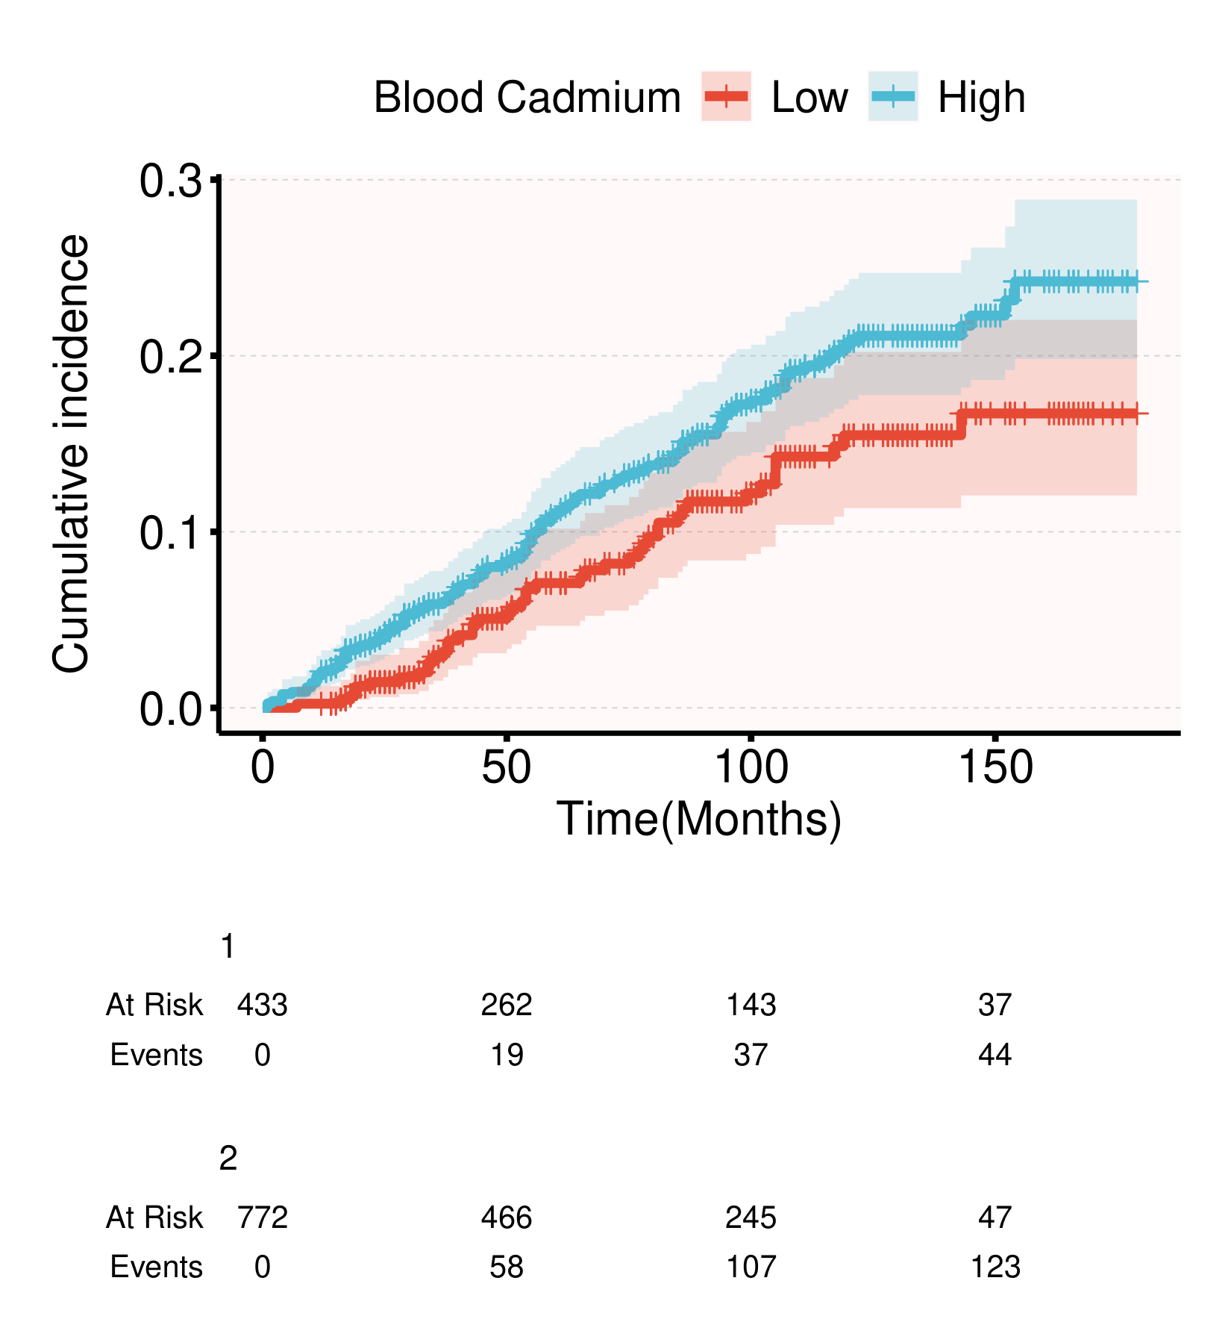
Cumulative incidence functions for cardiovascular disease (CVD) mortality were estimated for BCd <0.36 μg/L and BCd ≥0.36 μg/L using the Aalen–Johansen estimator, with non-CVD death treated as the competing event. Gray’s test yielded P = 0.019 for CVD death and P < 0.001 for the competing event. Numbers at risk and cumulative CVD event counts are shown below the plot. In the risk table, strata 1 and 2 correspond to the low- and high-BCd groups, respectively.
Figure S2. Cumulative incidence of cardiovascular mortality in NHANES 2005–2014.
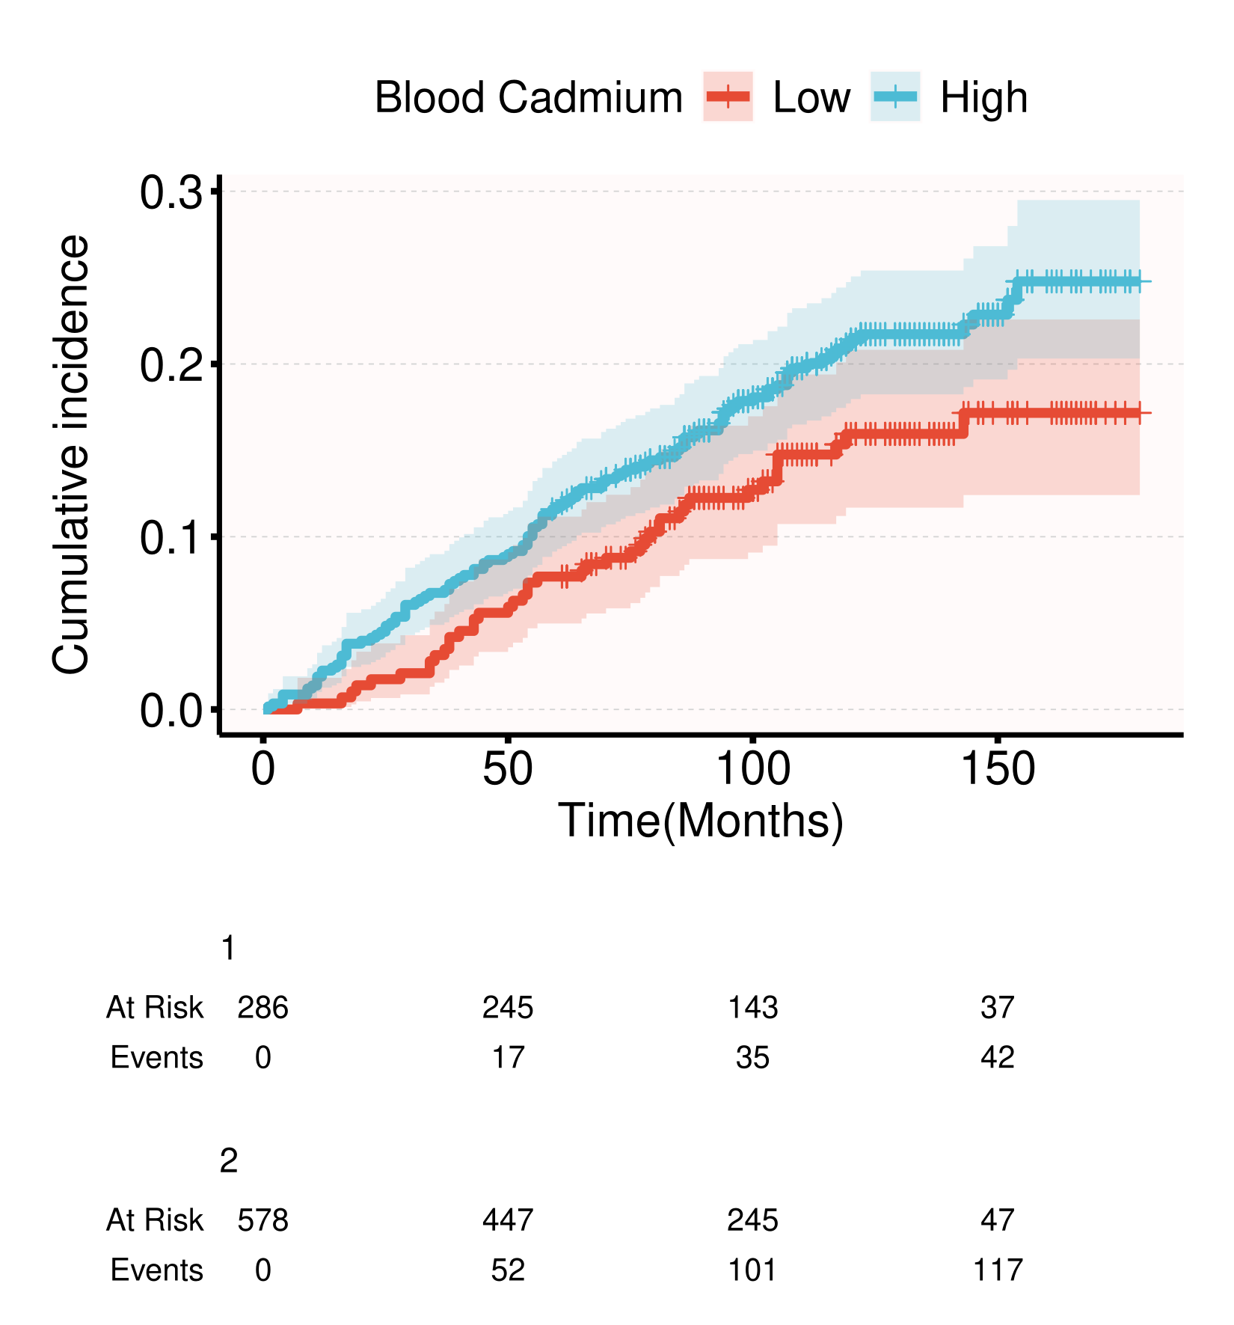
Cumulative incidence functions for cardiovascular disease (CVD) mortality were estimated after restriction to NHANES 2005–2014, with non-CVD death treated as the competing event. BCd <0.36 μg/L and BCd ≥0.36 μg/L defined the exposure groups. Numbers at risk and cumulative CVD event counts are shown below the plot. This analysis evaluated the potential influence of cause-specific mortality classification limitations in the 2015–2018 public-use linked mortality files. In the risk table, strata 1 and 2 correspond to the low- and high-BCd groups, respectively.

