Supplementary Figure 1. Heatmap of edge weights for the cross-sectional network in the first trimester
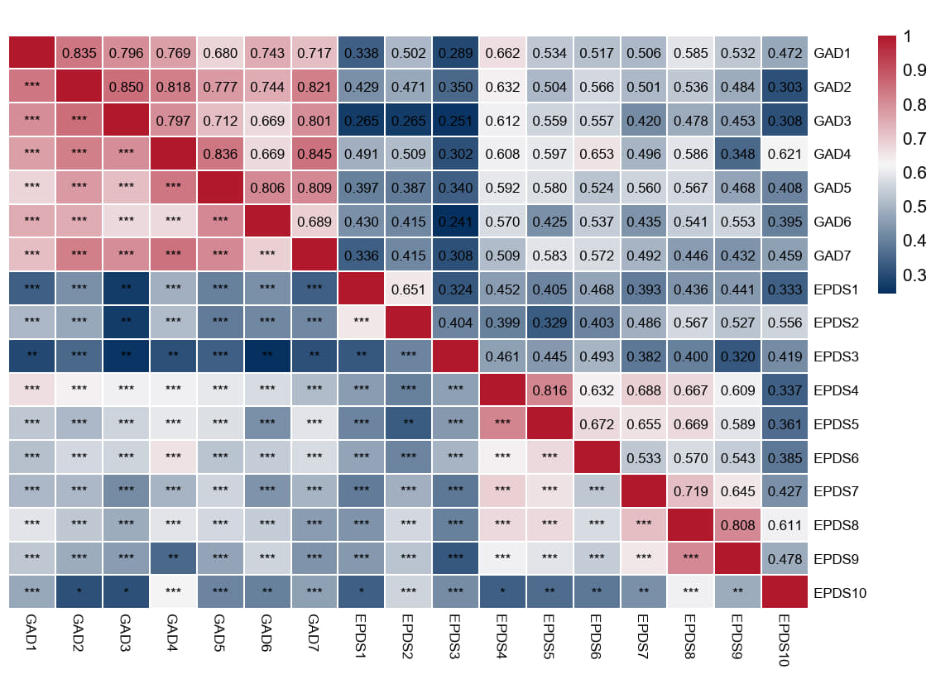
Supplementary Table 1. Centrality values of the cross-sectional network in the first trimester
Node | Betweenness | Closeness | Strength | ExpectedInfluence
GAD 1 | 0.928 | 0.568 | 0.385 | 0.414
GAD 2 | 0.058 | 0.556 | 1.037 | 1.073
GAD 3 | -0.811 | -0.158 | 0.225 | 0.251
GAD 4 | 2.916 | 1.545 | 1.620 | 1.465
GAD 5 | 0.058 | 0.580 | -0.082 | -0.060
GAD 6 | -0.439 | 0.297 | 0.144 | 0.169
GAD 7 | -0.936 | 0.234 | 0.308 | 0.335
EPDS 1 | -0.936 | -2.248 | -1.458 | -1.452
EPDS 2 | -0.439 | -1.659 | -0.587 | -0.571
EPDS 3 | -1.060 | -1.449 | -1.645 | -1.642
EPDS 4 | 0.680 | 0.893 | 1.144 | 1.181
EPDS 5 | -0.190 | 0.606 | 0.370 | 0.398
EPDS 6 | 0.680 | 0.768 | 0.085 | 0.109
EPDS 7 | -0.563 | -0.025 | -0.175 | -0.154
EPDS 8 | 0.680 | 0.048 | 1.082 | 1.119
EPDS 9 | -0.936 | -0.855 | -0.471 | -0.652
EPDS 10 | 0.307 | 0.300 | -1.982 | -1.982

Supplementary Figure 2. Accuracy plot of the cross-sectional network in the first trimester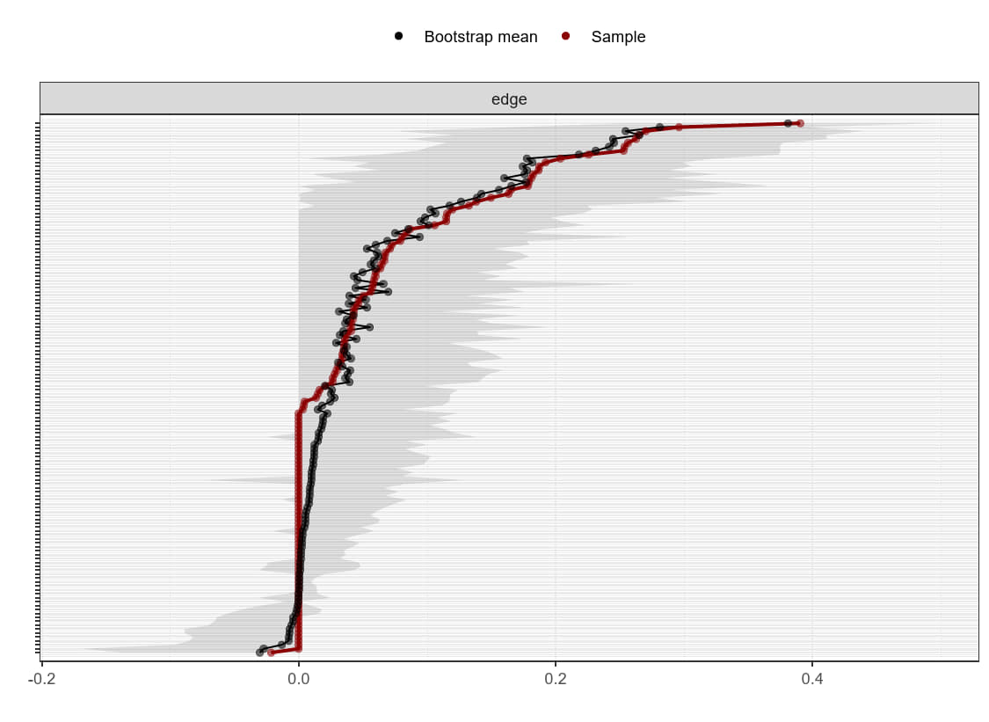
Supplementary Figure 3. Bridge strength of the cross-sectional network in the first trimester
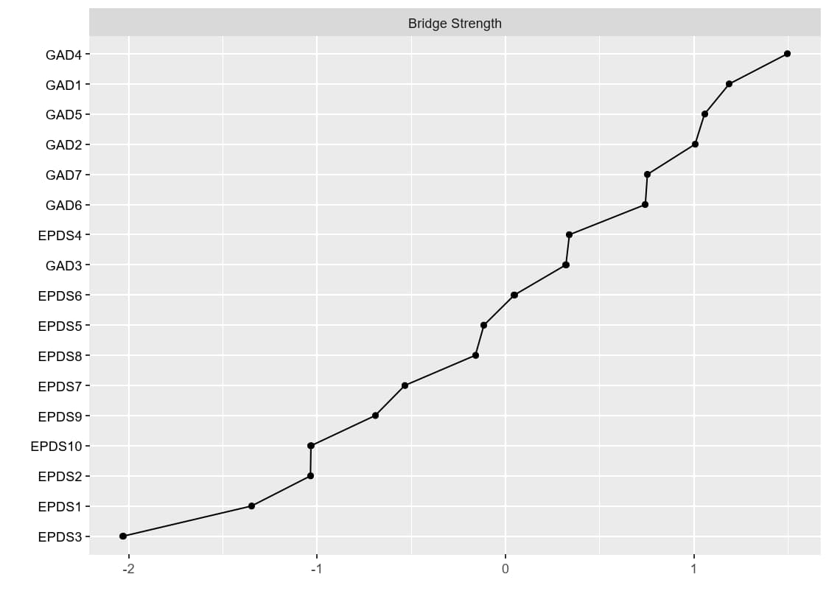
Supplementary Table 2. Bridge strength values (Z-score) of the cross-sectional network in the first trimester
Node | Z_Score | Node | Z_Score
GAD1 | 1.188 | EPDS3 | -2.030
GAD2 | 1.006 | EPDS4 | 0.339
GAD3 | 0.321 | EPDS5 | -0.115
GAD4 | 1.496 | EPDS6 | 0.047
GAD5 | 1.056 | EPDS7 | -0.535
GAD6 | 0.742 | EPDS8 | -0.160
GAD7 | 0.753 | EPDS9 | -0.692
EPDS1 | -1.349 | EPDS10 | -1.033
EPDS2 | -1.035
Supplementary Figure 4. Heatmap of edge weights for the cross-sectional network in the second trimester
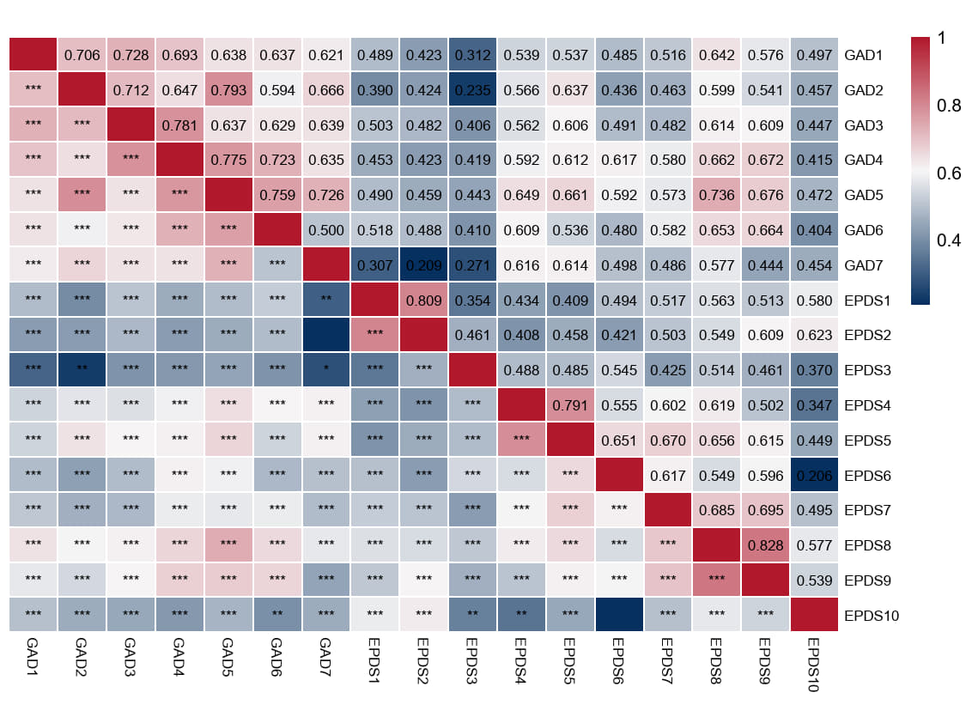
Supplementary Table 3. Centrality values of the cross-sectional network in the second trimester
Node | Betweenness | Closeness | Strength | ExpectedInfluence
GAD 1 | -0.172 | 0.294 | 0.072 | 0.072
GAD 2 | 0.153 | 0.270 | 0.274 | 0.274
GAD 3 | -0.982 | -0.053 | 0.455 | 0.455
GAD 4 | 0.153 | 0.299 | 0.777 | 0.777
GAD 5 | 1.287 | 0.741 | 0.859 | 0.859
GAD 6 | -0.334 | 1.065 | 0.284 | 0.284
GAD 7 | -1.306 | -1.139 | -1.452 | -1.452
EPDS 1 | -0.982 | -1.581 | -0.111 | -0.111
EPDS 2 | -0.010 | -1.546 | -0.075 | -0.075
EPDS 3 | -0.334 | -0.144 | -1.728 | -1.728
EPDS 4 | -0.496 | -0.005 | 0.312 | 0.312
EPDS 5 | 0.639 | 0.617 | 1.012 | 1.012
EPDS 6 | 0.639 | 0.634 | -0.105 | -0.105
EPDS 7 | -0.010 | 0.322 | 0.087 | 0.087
EPDS 8 | 2.746 | 1.297 | 1.415 | 1.415
EPDS 9 | 0.315 | 1.000 | 0.355 | 0.355
EPDS 10 | -1.306 | -2.071 | -2.430 | -2.430

Supplementary Figure 5. Accuracy plot of the cross-sectional network in the second trimester
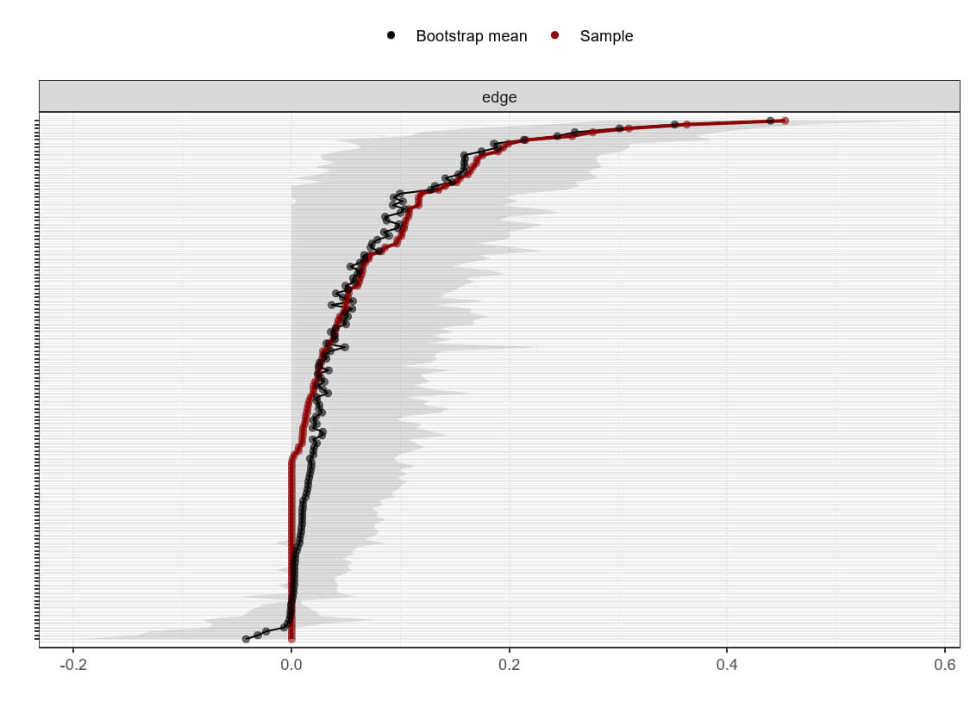
Supplementary Figure 6. Bridge strength of the cross-sectional network in the second trimester
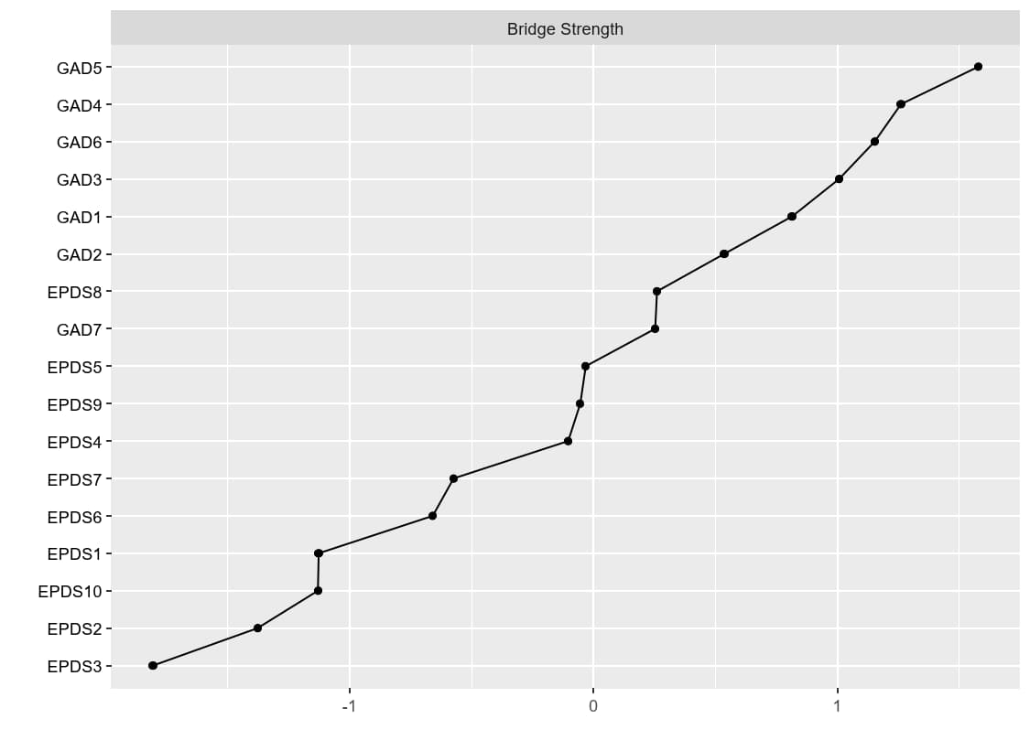
Supplementary Table 4. Bridge strength values (Z-score) of the cross-sectional network in the second trimester
Node | Z_Score | Node | Z_Score
GAD1 | 0.814 | EPDS 3 | -1.807
GAD2 | 0.536 | EPDS 4 | -0.104
GAD3 | 1.007 | EPDS 5 | -0.032
GAD4 | 1.261 | EPDS 6 | -0.659
GAD5 | 1.578 | EPDS 7 | -0.574
GAD6 | 1.153 | EPDS 8 | 0.261
GAD7 | 0.253 | EPDS 9 | -0.054
EPDS1 | -1.127 | EPDS 10 | -1.130
EPDS2 | -1.378
Supplementary Figure 7. Supplementary Figure 3. Heatmap of edge weights for the cross-sectional network in the third trimester
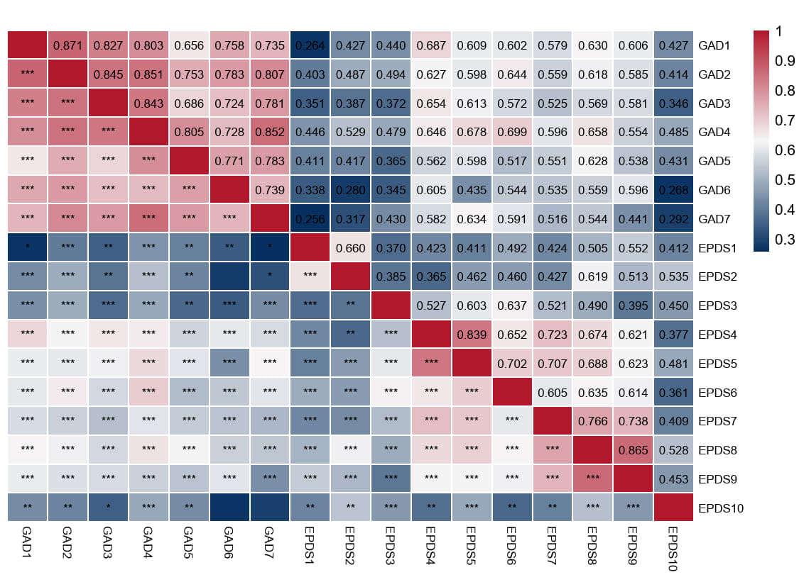
Supplementary Table 5. Centrality values of the cross-sectional network in the third trimester
Node | Betweenness | Closeness | Strength | ExpectedInfluence
GAD 1 | 1.471 | 0.578 | 0.361 | 0.361
GAD 2 | 0.623 | 1.081 | 1.183 | 1.183
GAD 3 | -1.213 | 0.059 | 0.314 | 0.314
GAD 4 | 2.459 | 1.195 | 1.325 | 1.325
GAD 5 | -0.789 | -0.351 | -0.601 | -0.601
GAD 6 | 0.623 | -0.080 | -0.107 | -0.107
GAD 7 | -1.213 | -0.635 | 0.073 | 0.073
EPDS 1 | -0.507 | -0.950 | -1.290 | -1.290
EPDS 2 | -0.083 | -0.623 | -1.201 | -1.201
EPDS 3 | -0.648 | -0.426 | -1.025 | -1.025
EPDS 4 | 0.906 | 1.399 | 0.547 | 0.547
EPDS 5 | 0.058 | 0.833 | 0.846 | 0.846
EPDS 6 | 0.058 | 0.758 | 0.288 | 0.288
EPDS 7 | -0.083 | 0.097 | 0.004 | 0.004
EPDS 8 | -0.648 | -0.125 | 1.240 | 1.240
EPDS 9 | 0.199 | -0.017 | 0.350 | 0.350
EPDS 10 | -1.213 | -2.794 | -2.308 | -2.308

Supplementary Figure 8. Accuracy plot of the cross-sectional network in the third trimester
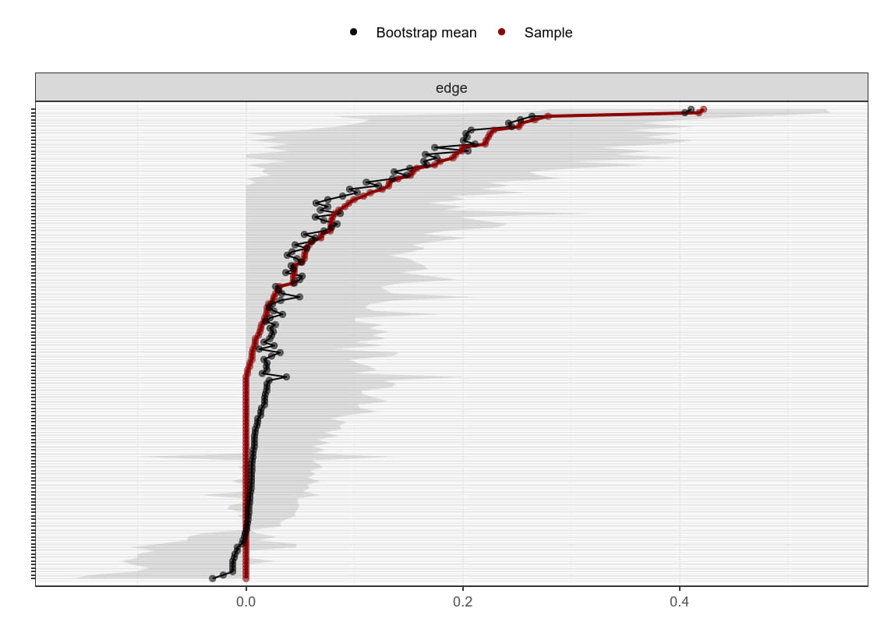
Supplementary Figure 9. Bridge strength of the cross-sectional network in the third trimester
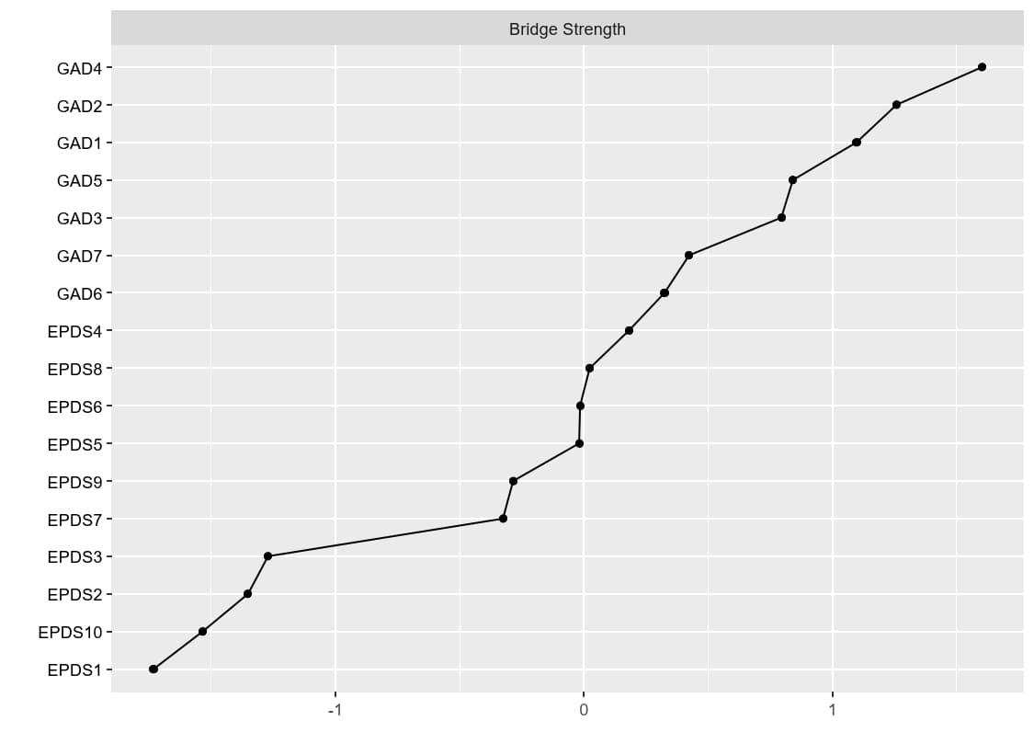
Supplementary Table 6. Bridge strength values (Z-score) of the cross-sectional network in the third trimester
Node | Z_Score | Node | Z_Score
GAD1 | 1.097 | EPDS 3 | -1.272
GAD2 | 1.258 | EPDS 4 | 0.181
GAD3 | 0.794 | EPDS 5 | -0.020
GAD4 | 1.602 | EPDS 6 | -0.016
GAD5 | 0.840 | EPDS 7 | -0.326
GAD6 | 0.324 | EPDS 8 | 0.023
GAD7 | 0.423 | EPDS 9 | -0.286
EPDS1 | -1.733 | EPDS 10 | -1.535
EPDS2 | -1.352

Supplementary Figure 10. Stability plot of autoregressive coefficients for the cross-lagged network (T1→T2)
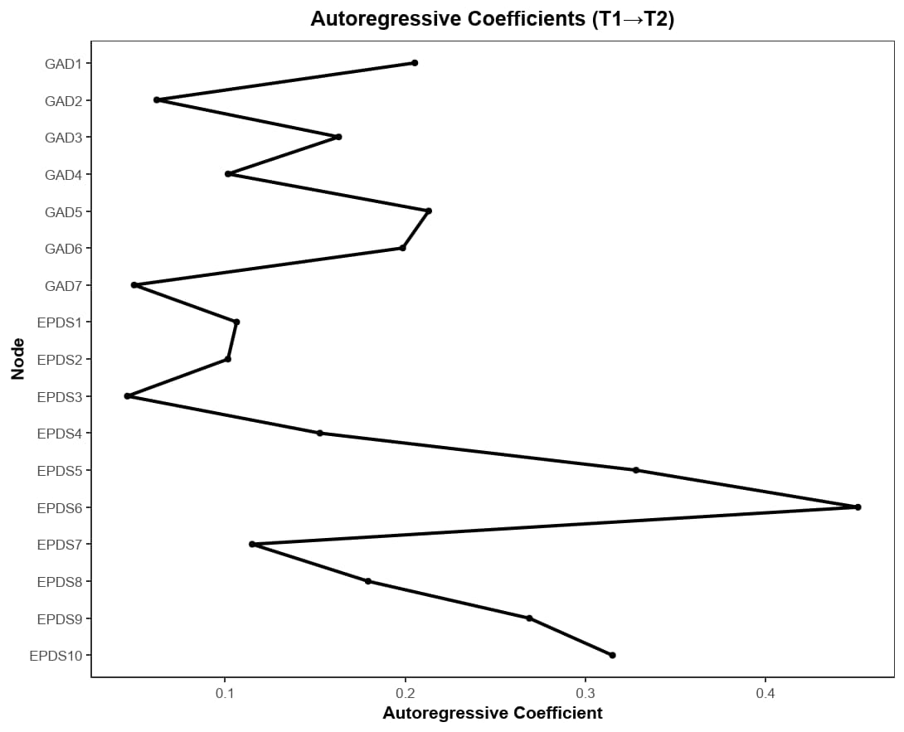
Supplementary Table 7. Stability coefficients of autoregressive coefficients for the cross-lagged network(T1→T2)
Note | Autoregressive Coefficients | Note | Autoregressive Coefficients
GAD1 | 0.205 | EPDS3 | 0.046
GAD2 | 0.062 | EPDS4 | 0.153
GAD3 | 0.163 | EPDS5 | 0.328
GAD4 | 0.102 | EPDS6 | 0.451
GAD5 | 0.213 | EPDS7 | 0.115
GAD6 | 0.199 | EPDS8 | 0.179
GAD7 | 0.050 | EPDS9 | 0.269
EPDS1 | 0.106 | EPDS10 | 0.315
EPDS2 | 0.102

Supplementary Table 8. Statistical results of the top 10 absolute edge weights in the cross-lagged network (T1→T2)

Edge | Original
EPDS10→EPDS6 | -0.349
GAD5→GAD2 | 0.190
EPDS6→EPDS7 | 0.179
GAD5→GAD1 | 0.165
EPDS8→GAD1 | 0.146
GAD5→EPDS2 | 0.139
GAD6→GAD4 | 0.136
EPDS1→GAD1 | 0.135
EPDS5→EPDS4 | 0.128
EPDS9→EPDS5 | 0.122

Supplementary Table 9. Centrality values of the cross-lagged network (T1→T2)
Note | Out-EI | In-EI | Note | Out-EI | In-EI
GAD1 | -0.315 | 0.556 | EPDS3 | -0.913 | 0.174
GAD2 | 0.739 | 1.230 | EPDS4 | 0.045 | 1.120
GAD3 | -0.782 | 0.576 | EPDS5 | 0.654 | -0.052
GAD4 | -0.959 | 0.848 | EPDS6 | 0.882 | -2.873
GAD5 | 1.810 | 0.001 | EPDS7 | 0.587 | 0.340
GAD6 | 0.054 | 0.488 | EPDS8 | 1.508 | -0.874
GAD7 | -0.573 | 0.238 | EPDS9 | 0.302 | -0.418
EPDS1 | -0.298 | 0.421 | EPDS10 | -2.270 | -1.381
EPDS2 | -0.471 | -0.394

Supplementary Figure 11. Stability plot of autoregressive coefficients for the cross-lagged network (T2→T3)
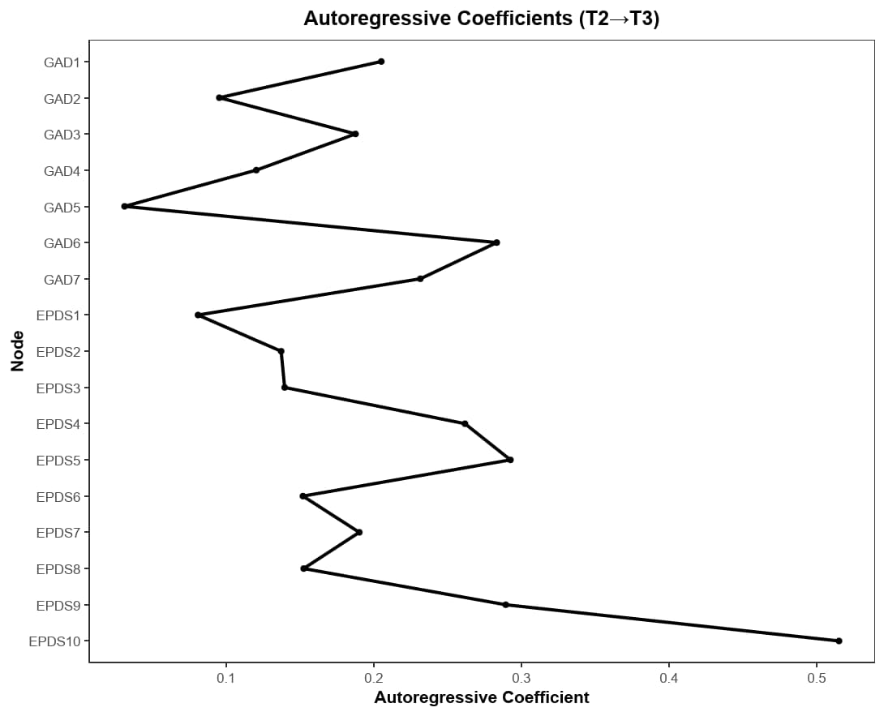
Supplementary Table 10. Stability coefficients of autoregressive coefficients for the cross-lagged network(T2→T3)

Note | Autoregressive Coefficients | Note | Autoregressive Coefficients
GAD1 | 0.205 | EPDS3 | 0.140
GAD2 | 0.096 | EPDS4 | 0.262
GAD3 | 0.188 | EPDS5 | 0.293
GAD4 | 0.121 | EPDS6 | 0.152
GAD5 | 0.031 | EPDS7 | 0.190
GAD6 | 0.283 | EPDS8 | 0.153
GAD7 | 0.232 | EPDS9 | 0.289
EPDS1 | 0.081 | EPDS10 | 0.515
EPDS2 | 0.137

Supplementary Table 11. Statistical results of the top 10 absolute edge weights in the cross-lagged network (T2→T3)

Edge | Original
GAD7→GAD4 | 0.248
EPDS5→EPDS6 | 0.246
GAD7→EPDS5 | 0.224
EPDS5→EPDS8 | 0.197
EPDS4→EPDS5 | 0.197
GAD7→EPDS7 | 0.177
EPDS2→GAD5 | 0.176
GAD7→GAD3 | 0.174
EPDS10→GAD4 | 0.169
GAD2→GAD7 | 0.162

Supplementary Table 12. Centrality values of the cross-lagged network (T2→T3)

Note | Out-EI | In-EI | Note | Out-EI | In-EI
GAD1 | -0.012 | -0.084 | EPDS3 | -0.441 | -0.580
GAD2 | 0.579 | 1.659 | EPDS4 | 1.255 | 0.360
GAD3 | -0.709 | 0.302 | EPDS5 | 1.383 | 0.032
GAD4 | 0.234 | 1.359 | EPDS6 | -1.765 | 0.355
GAD5 | -0.950 | 0.618 | EPDS7 | -0.866 | 0.995
GAD6 | -0.327 | -0.389 | EPDS8 | -1.290 | 0.816
GAD7 | 2.092 | -0.183 | EPDS9 | -0.066 | -0.616
EPDS1 | -0.013 | -1.176 | EPDS10 | 0.677 | -2.331
EPDS2 | 0.218 | -1.137
Supplementary Figure 12. Stability plot of autoregressive coefficients for the cross-lagged network (T1→T3)
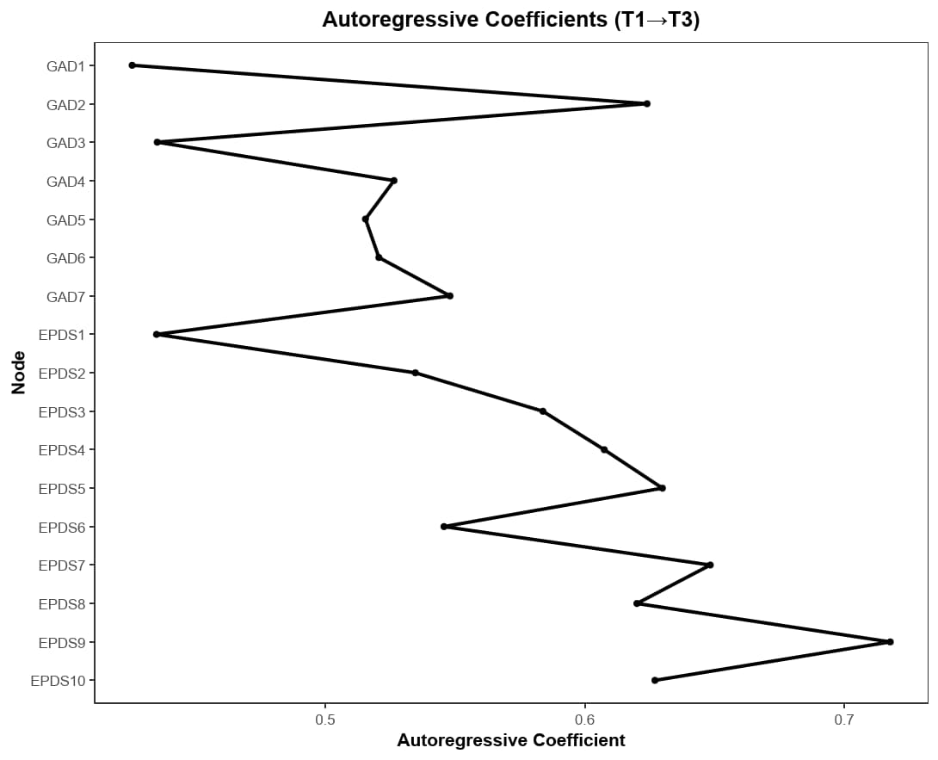
Supplementary Table 13. Stability coefficients of autoregressive coefficients for the cross-lagged network(T1→T3)
Note | Autoregressive Coefficients | Note | Autoregressive Coefficients
GAD1 | 0.426 | EPDS3 | 0.584
GAD2 | 0.624 | EPDS4 | 0.608
GAD3 | 0.435 | EPDS5 | 0.630
GAD4 | 0.527 | EPDS6 | 0.546
GAD5 | 0.516 | EPDS7 | 0.648
GAD6 | 0.521 | EPDS8 | 0.620
GAD7 | 0.548 | EPDS9 | 0.718
EPDS1 | 0.435 | EPDS10 | 0.627
EPDS2 | 0.535

Supplementary Table 14. Statistical results of the top 10 absolute edge weights in the cross-lagged network (T1→T3)
Edge | Original
EPDS5→EPDS4 | 0.125
EPDS5→EPDS6 | 0.111
EPDS3→EPDS5 | 0.083
EPDS9→EPDS8 | 0.082
EPDS4→GAD1 | 0.079
EPDS2→GAD7 | -0.078
EPDS3→EPDS8 | 0.075
EPDS5→GAD7 | 0.074
EPDS4→GAD3 | 0.068
EPDS5→EPDS7 | 0.061

Supplementary Table 15. Centrality values of the cross-lagged network (T1→T3)

Note | Out-EI | In-EI | Note | Out-EI | In-EI
GAD1 | -0.641 | 1.392 | EPDS3 | 1.816 | 0.504
GAD2 | -0.381 | -0.749 | EPDS4 | 1.192 | 1.083
GAD3 | -0.641 | -0.414 | EPDS5 | 2.633 | 1.366
GAD4 | -0.641 | -0.740 | EPDS6 | -0.403 | 0.571
GAD5 | -0.633 | -0.951 | EPDS7 | -0.222 | 1.495
GAD6 | -0.520 | -0.581 | EPDS8 | -0.451 | 0.699
GAD7 | -0.370 | -0.697 | EPDS9 | 0.781 | 0.622
EPDS1 | -0.033 | -1.209 | EPDS10 | -0.623 | -1.209
EPDS2 | -0.864 | -1.183

