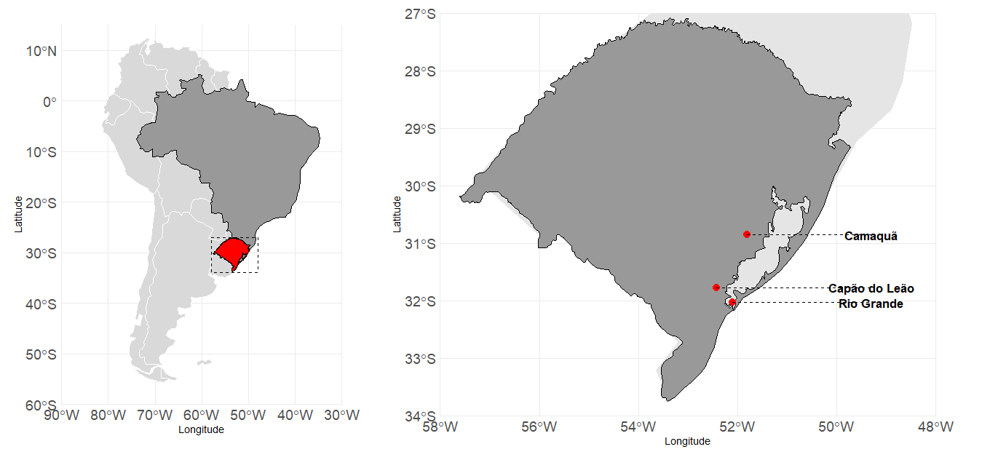
Figure 1. Location of experiments with silicate minerals as potassium sources in irrigated rice in southern Brazil.

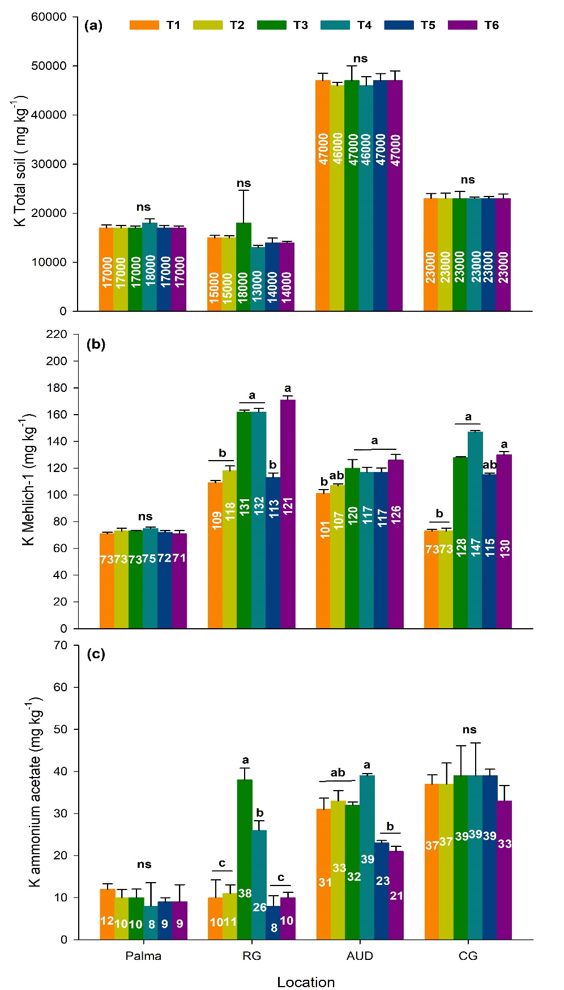
Figure 2. Total K content (a), Mehlich-1-extractable K (b), and ammonium acetate-extractable K (c) in the soil under irrigated rice cultivation with different potassium fertilizer sources in the 2023/2024 growing season. Treatments: T1 - no potassium fertilization; T2 - potassium chloride; T3 - phonolite; T4 - syenite; T5 - nepheline syenite; T6 - mica schist. Locations: L1: Capão do Leão/RS; L2: Rio Grande/RS; L3 and L4: Camaquã/RS. Different letters within the same location indicate significant differences according to Tukey’s test (p < 0.05). ns (not significant).
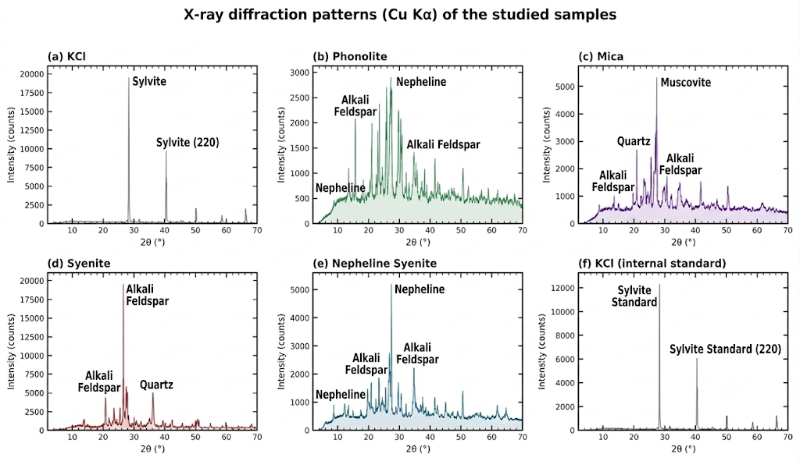

Figure 3. Mineralogical composition of the samples determined by X-ray diffraction (XRD) for phonolite (a), mica (b), syenite (c), and nepheline syenite (d), used as alternative potassium fertilizer sources in irrigated rice production fields during the 2023/2024 growing season.

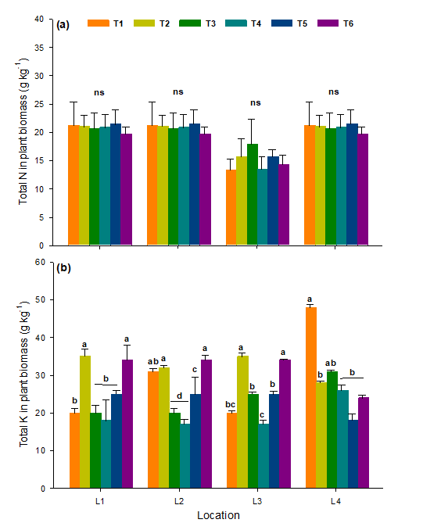Figure 4. N (a) and K (b) contents in the biomass of irrigated rice plants grown under different potassium fertilizer sources in the 2023/2024 growing season. Treatments: T1 - no potassium fertilization; T2 - potassium chloride; T3 - phonolite; T4 - syenite; T5 - nepheline syenite; T6 - mica schist. Locations: L1: Capão do Leão/RS; L2: Rio Grande/RS; L3 and L4: Camaquã/RS. Different letters within the same location indicate significant differences according to Tukey’s test (p < 0.05). ns (not significant).

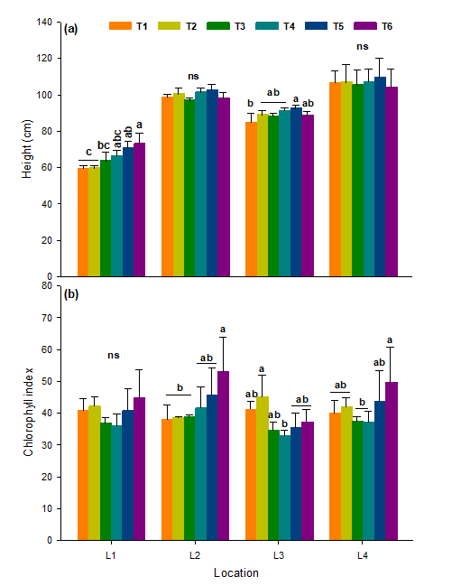
Figure 5. Plant height (a) and chlorophyll index (b) in irrigated rice plants grown under different potassium fertilizer sources in the 2023/2024 growing season. Treatments: T1 - no potassium fertilization; T2 - potassium chloride; T3 - phonolite; T4 - syenite; T5 - nepheline syenite; T6 - mica schist. Locations: L1: Capão do Leão/RS; L2: Rio Grande/RS; L3 and L4: Camaquã/RS. Different letters within the same location indicate significant differences according to Tukey’s test (p < 0.05). ns (not significant).

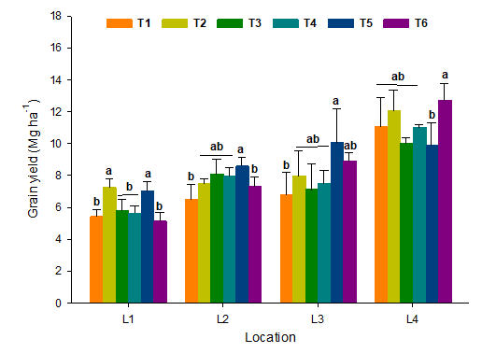
Figure 6. Grain yield of irrigated rice grown under different potassium fertilizer sources in the 2023/2024 growing season. Treatments: T1 - no potassium fertilization; T2 - potassium chloride; T3 - phonolite; T4 - syenite; T5 - nepheline syenite; T6 - mica schist. Locations: L1: Capão do Leão/RS; L2: Rio Grande/RS; L3 and L4: Camaquã/RS. Different letters within the same location indicate significant differences according to Tukey’s test (p < 0.05). ns (not significant).

Table 1. Chemical characteristics of the study sites before the beginning of the experiments, 2023/24 growing season.
Location | Layer | Clay | OM | pH | P | K | Ca | Al | Mg | CEC pH 7.0 | V
Location | (m) | .......%...... |  | (1:1) | ....mg dm⁻³.... |  | .........cmol_{c} dm⁻³......... |  |  | CEC pH 7.0 | (%)
L1 | 0-0.2 | 23 | 1.66 | 6.1 | 13.3 | 44.0 | 4.3 | 0.0 | 2.1 | 8.3 | 80
L2 | 0-0.2 | 23 | 1.10 | 6.5 | 30.5 | 91.0 | 5.3 | 0.0 | 2.8 | 10.1 | 85
L3 | 0-0.2 | 20 | 0.97 | 6.8 | 30.5 | 74.0 | 4.3 | 0.0 | 2.4 | 8.3 | 85
L4 | 0-0.2 | 19 | 1.66 | 6.2 | 121.2 | 123.0 | 5.5 | 0.0 | 2.5 | 10.2 | 83
Organic matter (OM), phosphorus (P), potassium (K), calcium (Ca), aluminum (Al), magnesium (Mg), cation exchange capacity at pH 7.0 (CEC), and base saturation (V).

Table 2. Description of treatments with different agrominerals used in an irrigated rice experiment.
Treatments | Total de K content (%) | Application rates of the sources (kg ha⁻¹)
Treatments | Total de K content (%) | Palma³ | AUD³ | Capão Grande⁴ | Rio Grande⁴
T1 - No potassium fertilization | - | - | - | - | -
T2 - Potassium chloride¹ | 49.8 | 221 | 221 | 221 | 221
T3 - Phonolite² | 8.8 | 3,750 | 3,750 | 3,750 | 3,750
T4 - Syenite² | 8.1 | 4,075 | 4,075 | 4,075 | 4,075
T5 - Nepheline syenite² | 8.3 | 3,976 | 3,976 | 3,976 | 3,976
T6 - Mica schist² | 13.0 | 2,539 | 2,539 | 2,539 | 2,539
¹Readily available potassium (100% water-soluble)
²Slow-release potassium (<1% water-soluble)

Table 3. Cumulative grain yield, K inputs and outputs, and K balance in the 0-20 cm soil layer in rice production systems under different potassium fertilizer sources during the 2023/2024 growing season.
Variable | T1 | T2 | T3 | T4 | T5 | T6
Location 1: Capão do Leão
Rice grain yield (Mg ha⁻¹) | 5.4 | 7.2 | 5.8 | 5.6 | 7.0 | 5.1
K exported by grains (kg ha⁻¹) | 14 | 18 | 15 | 14 | 18 | 13
Total K input via fertilizer (kg ha⁻¹) | - | 55 | 54 | 53 | 53 | 53
K balance in the system (kg ha⁻¹) | - | 37 | 40 | 39 | 35 | 40
Initial Mehlich-1 K, 0-20 cm (mg kg⁻¹) | 44 | 44 | 44 | 44 | 44 | 44
Final Mehlich-1 K, 0-20 cm (mg kg⁻¹) | 71 | 73 | 73 | 75 | 72 | 71
Soil exchangeable K (exch-M) balance (mg kg⁻¹) | 27 | 29 | 29 | 31 | 28 | 27
Location 2: Rio Grande
Rice grain yield (Mg ha⁻¹) | 6.5 | 7.5 | 8.1 | 8.0 | 8.6 | 7.3
K exported by grains (kg ha⁻¹) | 16 | 19 | 20 | 20 | 21 | 18
Total K input via fertilizer (kg ha⁻¹) | - | 55 | 54 | 53 | 53 | 53
K balance in the system (kg ha⁻¹) | - | 36 | 34 | 33 | 31 | 34
Initial Mehlich-1 K, 0-20 cm (mg kg⁻¹) | 91 | 91 | 91 | 91 | 91 | 91
Final Mehlich-1 K, 0-20 cm (mg kg⁻¹) | 109 | 118 | 162 | 162 | 113 | 171
Soil exchangeable K (exch-M) balance (mg kg⁻¹) | 18 | 27 | 71 | 71 | 22 | 80
Location 3: AUD
Rice grain yield (Mg ha⁻¹) | 6.8 | 8.0 | 7.1 | 7.5 | 10.1 | 8.9
K exported by grains (kg ha⁻¹) | 17 | 20 | 18 | 19 | 25 | 22
Total K input via fertilizer (kg ha⁻¹) | - | 50 | 50 | 50 | 50 | 50
K balance in the system (kg ha⁻¹) | - | 30 | 33 | 32 | 25 | 28
Initial Mehlich-1 K, 0-20 cm (mg kg⁻¹) | 74 | 74 | 74 | 74 | 74 | 74
Final Mehlich-1 K, 0-20 cm (mg kg⁻¹) | 101 | 107 | 120 | 117 | 117 | 126
Soil exchangeable K (exch-M) balance (mg kg⁻¹) | 27 | 33 | 46 | 43 | 43 | 52
Location 4: Capão Grande
Rice grain yield (Mg ha⁻¹) | 11.1 | 12.1 | 10.0 | 11.0 | 9.9 | 12.7
K exported by grains (kg ha⁻¹) | 28 | 30 | 25 | 28 | 25 | 32
Total K input via fertilizer (kg ha⁻¹) | - | 50 | 50 | 50 | 50 | 50
K balance in the system (kg ha⁻¹) | - | 20 | 25 | 23 | 26 | 19
Initial Mehlich-1 K, 0-20 cm (mg kg⁻¹) | 123 | 123 | 123 | 123 | 123 | 123
Final Mehlich-1 K, 0-20 cm (mg kg⁻¹) | 73 | 73 | 128 | 147 | 115 | 130
Soil exchangeable K (exch-M) balance (mg kg⁻¹) | -50 | -50 | 5 | 24 | -8 | 7
Treatments: T1 - without potassium fertilization; T2 - potassium chloride; T3 - phonolite; T4 - syenite; T5 - nepheline syenite; T6 - mica schist.

