Supplementary Material
for
A Physics-Guided Transfer Learning Framework for Cloud, Dust and Clear-Sky Detection over Bright Surfaces in Passive Satellite Remote Sensing
Sichen Wangª, Tianhe Wang^{a,*}, Yingzi Jiaoª, Wenge Hanª, Jingtao Liª, Xi Mu^{b}, Jingyi Tangª, Fan Yang^{c}, Chenglong Zhou^{c}, Bakhriddin E. Nishonov^{d}, Mansur O. Amonov^{e}
a. The Key Laboratory for Semi-Arid Climate Change of the Ministry of Education, College of Atmospheric Sciences, Lanzhou University, Lanzhou 730000, China
b. University of Science and Technology of China, Hefei 230026, China
c. The Institute of Desert Meteorology, China Meteorological Administration, Urumqi 830002, China
d. The Hydrometeorological Research Institute, Tashkent 100052, Uzbekistan
e. Central Asian University of Environmental and Climate Change Studies (Green University), Tashkent 100052, Uzbekistan
f. The Tashkent Institute of Irrigation & Agricultural Mechanization Engineers, National Research University,
Tashkent 100000, Uzbekistan
* Corresponding author. E-mail address: wangth@lzu.edu.cn

Supplementary Methods

S1. Evaluation metrics
All evaluations were performed on the withheld MODIS–CALIPSO test samples, with CALIPSO VFM used as the reference. Daytime and nighttime samples were evaluated independently. Conventional one-versus-rest counts were used for each class, and the standard classification metrics were calculated as
$$\text{Accuracy=}\frac{{\text{N}}_{\text{correct}}}{\text{N}}$$
$$\text{P}\text{=}\frac{\text{TP}}{\text{TP}\text{+}\text{FP}}\text{,} \text{R}\text{=}\frac{\text{TP}}{\text{TP}\text{+}\text{FN}}$$
$$\text{F}\text{1}\text{=}\frac{\text{2}\text{PR}}{\text{P}\text{+}\text{R}}\text{=}\frac{\text{2}\text{TP}}{\text{2}\text{TP}\text{+}\text{FP}\text{+}\text{FN}}$$
Macro-F1 and weighted-F1 were calculated as
$$\text{F}{\text{1}}_{\text{macro}}\text{=}\frac{\text{F}{\text{1}}_{\text{clear}}\text{+}\text{F}{\text{1}}_{\text{cloud}}\text{+}\text{F}{\text{1}}_{\text{dust}}}{\text{3}}$$
$$\text{F}{\text{1}}_{\text{weighted}}\text{=}\frac{{\text{N}}_{\text{clear}}\text{F}{\text{1}}_{\text{clear}}\text{+}{\text{N}}_{\text{cloud}}\text{F}{\text{1}}_{\text{cloud}}\text{+}{\text{N}}_{\text{dust}}\text{F}{\text{1}}_{\text{dust}}}{{\text{N}}_{\text{clear}}\text{+}{\text{N}}_{\text{cloud}}\text{+}{\text{N}}_{\text{dust}}}$$
where ${\text{N}}_{\text{clear}}$, ${\text{N}}_{\text{cloud}}$, and ${\text{N}}_{\text{dust}}$ are the numbers of reference samples in the three classes. The confusion matrices were normalized by reference class, so the diagonal elements represent class recall. For the binary dust comparisons, dust aerosol was treated as the positive class, while clear sky and cloud were combined as the negative class.

S1.1. ROC-AUC
ROC curves were generated from the predicted class probabilities by varying the decision threshold. The true-positive rate and false-positive rate were calculated as
$$\text{TPR}\text{=}\frac{\text{TP}}{\text{TP}\text{+}\text{FN}}\text{,} \text{FPR}\text{=}\frac{\text{FP}}{\text{FP}\text{+}\text{TN}}\text{.}$$
The AUC was calculated as
$$\text{AUC}\text{=}\int_{\text{0}}^{\text{1}}{\text{T}}\text{PR} \text{d}\left(\text{FPR}\right)\text{.}$$
For the three-class problem, ROC-AUC was calculated separately for clear sky, cloud, and dust aerosol using a one-versus-rest formulation.

S2. Cloud-mask evaluation against MYD35
MYD35 assigns values of 0 for confident cloudy, 1 for probably cloudy, 2 for probably clear, and 3 for confident clear. Under the strict scheme, only values 0 and 3 were retained. Under the relaxed scheme, values 0 and 1 were grouped as cloud, and values 2 and 3 were grouped as clear. CALIPSO VFM was used as the reference, and the transparent-cloud cases denoted C0/C4 were excluded.
For the binary cloud-mask comparison, cloud was treated as the positive class, while clear sky and dust aerosol were treated as non-cloud. The false cloud count was calculated as
$$\text{F}{\text{P}}_{\text{cloud}}\text{=}\text{F}{\text{P}}_{\text{clear}}\text{+}\text{F}{\text{P}}_{\text{dust}}\text{,}$$
where $\text{F}{\text{P}}_{\text{clear}}$ and $\text{F}{\text{P}}_{\text{dust}}$ are the numbers of CALIPSO clear-sky and dust samples incorrectly flagged as cloud, respectively. Cloud recall and cloud F1 score were calculated as
$${\text{R}}_{\text{cloud}}\text{=}\frac{\text{T}{\text{P}}_{\text{cloud}}}{\text{T}{\text{P}}_{\text{cloud}}\text{+}\text{F}{\text{N}}_{\text{cloud}}}\text{,}$$
$$\text{F}{\text{1}}_{\text{cloud}}\text{=}\frac{\text{2}\text{T}{\text{P}}_{\text{cloud}}}{\text{2}\text{T}{\text{P}}_{\text{cloud}}\text{+}\text{F}{\text{P}}_{\text{cloud}}\text{+}\text{F}{\text{N}}_{\text{cloud}}}\text{.}$$
The cloud-to-clear omission rate, clear-to-cloud false-alarm rate, and dust-to-cloud misclassification rate were defined as
$${\text{R}}_{\text{cloud→clear}}\text{=}\frac{\text{F}{\text{N}}_{\text{cloud}}}{\text{T}{\text{P}}_{\text{cloud}}\text{+}\text{F}{\text{N}}_{\text{cloud}}}\text{,}$$
$${\text{R}}_{\text{clear→cloud}}\text{=}\frac{\text{F}{\text{P}}_{\text{clear}}}{\text{T}{\text{P}}_{\text{clear}}\text{+}\text{F}{\text{P}}_{\text{clear}}}\text{,}$$
$${\text{R}}_{\text{dust→cloud}}\text{=}\frac{\text{F}{\text{P}}_{\text{dust}}}{\text{T}{\text{P}}_{\text{dust}}\text{+}\text{F}{\text{P}}_{\text{dust}}}\text{.}$$
All rates were reported as percentages. Relative improvements in higher-is-better metrics were calculated as
$$\text{Δ}{\text{M}}_{\text{relative}}\text{=}\frac{{\text{M}}_{\text{proposed}}\text{−}{\text{M}}_{\text{MYD35}}}{{\text{M}}_{\text{MYD35}}}\text{×}\text{100}\text{\%.}$$

Supplementary Figures
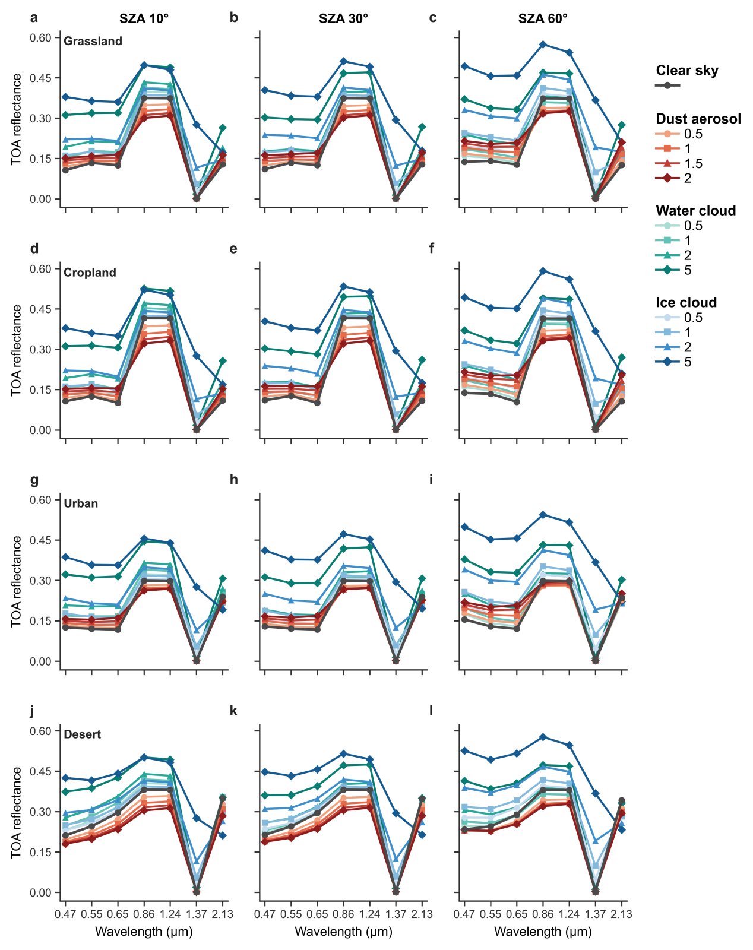
Fig. S1. Simulated MODIS TOA reflectance spectra for clear sky, dust aerosol, water cloud, and ice cloud. Rows represent grassland, cropland, urban, and desert surfaces, and columns represent SZA values of 10°, 30°, and 60°, with VZA fixed at 40° and RAA at 90°. Dust AOD values are 0.5, 1.0, 1.5, and 2.0, while cloud optical depths are 0.5, 1.0, 2.0, and 5.0.

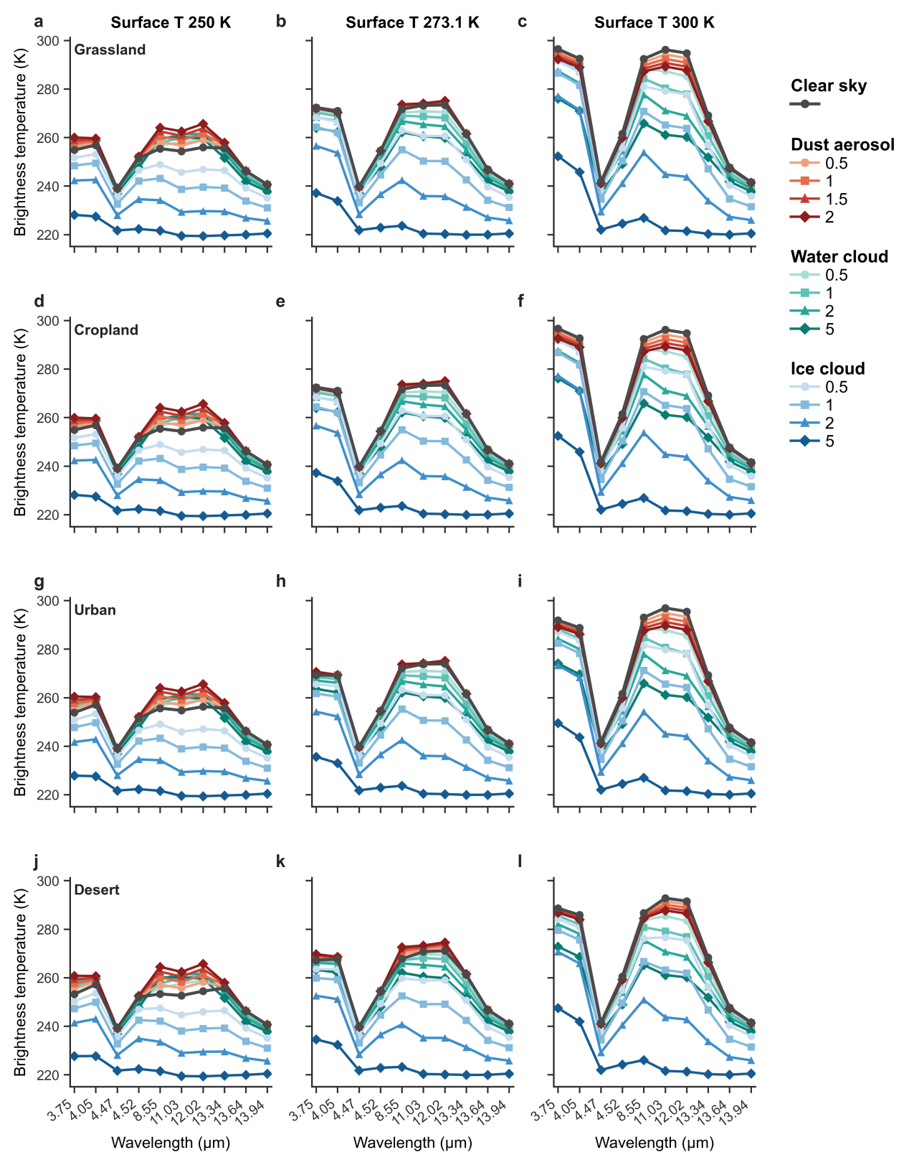
Fig. S2. Simulated MODIS TOA brightness-temperature spectra for clear sky, dust aerosol, water cloud, and ice cloud. Rows represent grassland, cropland, urban, and desert surfaces, and columns represent surface temperatures of 250, 273.1, and 300 K, with VZA fixed at 40°. Dust AOD values are 0.5, 1.0, 1.5, and 2.0, while cloud optical depths are 0.5, 1.0, 2.0, and 5.0.

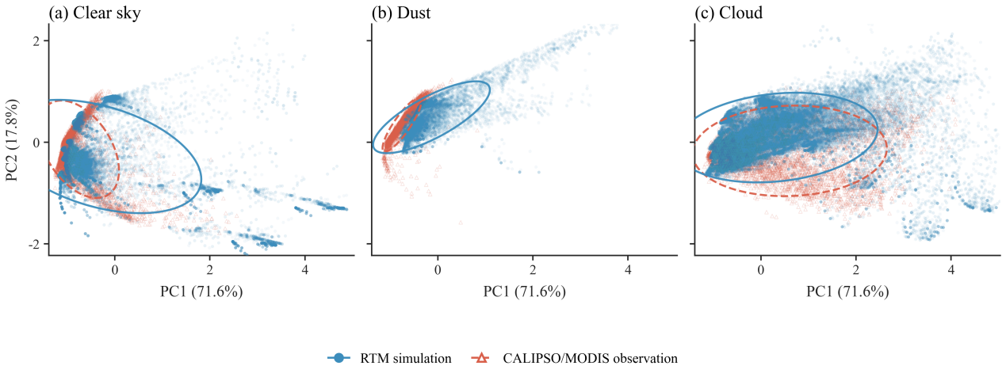
Fig. S3. PCA visualization of the encoded features of RTM simulations and MODIS-CALIPSO collocations for (a) clear sky, (b) dust, and (c) cloud. Features were extracted from the encoding module of the final fine-tuned SDE-Net. The features from both domains were combined to fit a single PCA transformation and projected using the same transformation. PC1 and PC2 explain 71.6% and 17.8% of the total feature variance, respectively. Blue circles and solid ellipses represent RTM simulations, whereas orange circles represent MODIS observations labeled using collocated CALIPSO VFM.

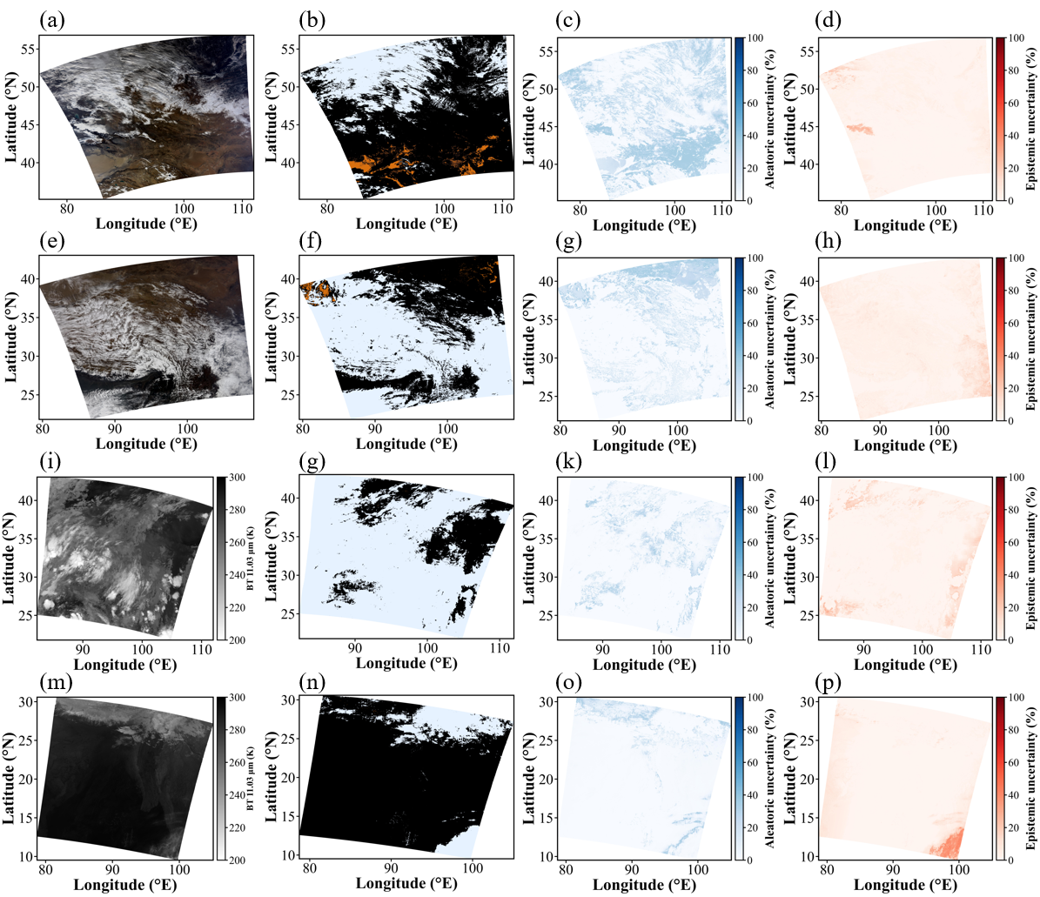
Fig. S4. Spatial distributions of SDENet classification results and predictive uncertainties. From top to bottom, the rows correspond to 14 November 2017, 8 March 2017, 24 July 2017, and 21 February 2017, respectively. From left to right, the columns show the MODIS observations (true-colour RGB imagery for daytime scenes and 11.03μm brightness temperature for nighttime scenes), SDENet classification results, aleatoric uncertainty, and epistemic uncertainty. In the classification maps, clear sky, cloud, and dust are displayed in black, white, and orange, respectively. Both uncertainty components are expressed on a scale of 0–100%, with darker colours indicating higher uncertainty.

