Supplemental Information

Extracting Observables: Amplitude, Resonant frequency and sub-resonant displacement
Hilbert-transform and lock-in–based methods are widely used to extract amplitude and phase in dynamic AFM. These techniques assume narrowband, approximately stationary oscillations over time windows that are typically at least a few periods. In the present case, oscillations are impulsively excited, rapidly decaying, and often span only a few cycles, violating these assumptions and leading to bias or ill-defined phase and frequency estimates.
In this case, we adopted a simple peak/trough finding routine to estimate both the tip amplitude and frequency. Local peak and trough values of the displacement ${disp}_{±}(i)$, where the subscript $±$ designates a peak or trough, are found with prominence‑based criteria and optionally refined by a quadratic fit over three samples. The ‘instantaneous’ amplitude $A_{i}$ is estimated by $A_{i}≈{disp}_{+}(i)-{disp}_{-}(i)$, where ${disp}_{+}(i)$ and ${disp}_{-}(i)$ the $i^{th}$ local maxima and minima, respectively. The instantaneous frequency is estimated by $f_{i}≈1/{\left(t_{i+1}-t_{i}\right)}$, with timestamps $t_{i}$ assigned to the ith segment. An example is shown in Figure S2 below.
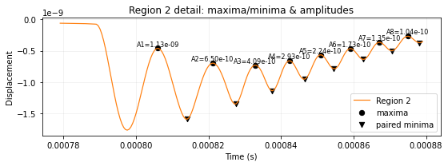
Figure S1 Example Cycle-resolved amplitude extraction in Region 2. The time-domain cantilever displacement trace for Region 2, showing the identification of successive local maxima (circles) and their paired minima (triangles) used to compute the peak-to-next-valley amplitudes $A_{n}$. The annotated values ($A_{1},A_{2},…$) indicate the extracted amplitudes for consecutive oscillation cycles, illustrating the decay and subsequent modulation of the cantilever response during the interaction. The timestamp for the amplitude and frequency estimates is attached to the peak amplitude values. This automated analysis underlies the quantitative amplitude metrics reported in the main text.

In the case of high-Q oscillations, this approach yields amplitude and frequency estimates that agree with conventional narrowband (Hilbert-transform or lock-in) techniques, while remaining well defined for the impulsively excited, rapidly decaying oscillations analyzed here, for which those techniques break down.
We explored a number of ways of further filtering the resulting estimates. In the analysis reported in the main text, the returned oscillation frequency was restricted to the band f_{free}/N < f_{n} < Nf_{free}, with the bandwidth factor N typically chosen to be 2–3; estimates outside this band were returned as NaN (see Equations 1 and 2 of the main text). This gating excludes low-frequency drift as well as higher-mode and noise-dominated contributions.
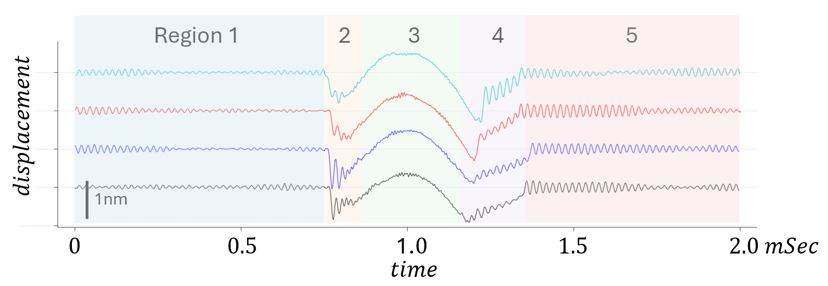Figure S2. Thermal fluctuations before and after interaction, and enhanced oscillations following snap-off. Time-domain cantilever displacement traces segmented into five automatically detected regimes. Region 1 (left) corresponds to the free cantilever prior to interaction, where the motion is dominated by small, stationary thermal fluctuations about equilibrium. Region 5 (right) represents the post-interaction state after detachment (“snap-off”), where the cantilever again oscillates freely but with larger amplitudes, reflecting the sudden release of stored elastic energy during snap-off, which impulsively excites the cantilever and produces enhanced ringing compared to the pre-interaction thermal motion in Region 1. This contrast highlights the transition from equilibrium Brownian fluctuations to a non-equilibrium, energy-injected response following detachment.
Peak to peak amplitudes
For a lightly damped cantilever dominated by thermal motion near a single resonance, the displacement can be modeled as a narrowband Gaussian process, represented in the time domain by a sinusoid with slowly varying random envelope, $x(t)=A(t)cos⁡(ω_{0}t+ϕ)$. The peak-to-next-valley metric defined in Equation 1 of the main text reduces to $A_{n}≃2A$ for a sinusoid. For a narrowband Gaussian process, the in-phase and quadrature components are independent zero-mean Gaussians with equal variance, implying a Rayleigh distribution for the envelope $A=\sqrt{X^{2}+Y^{2}}$ and hence $⟨A⟩=σ\sqrt{π/2}$. The RMS displacement is $x_{rms}=\sqrt{⟨x^{2}⟩}=\sqrt{⟨A^{2}⟩/2}=σ$, giving $⟨A⟩=\sqrt{π/2} x_{rms}$ and therefore $⟨A_{n}⟩≃2⟨A⟩=\sqrt{2π} x_{rms}≈2.506 x_{rms}$. Using equi-partition for a single mode, $x_{rms}=\sqrt{k_{B}T/k}$; for $T=300$K and $k=4.05$ N/m this yields $x_{rms}=0.0455$nm and thus $\left\langle A_{n}\right\rangle ≈2.506×0.0455\text{ = 0.1}14 nm$. This “mean peak-to-valley” thermal amplitude is a convenient cycle-resolved measure for comparison with peak-finding algorithms, but it should be interpreted as a statistical average of a fluctuating envelope.

Stiffness estimations
Brownian Amplitude approach In the high-$Q$ limit, where the cantilever motion is dominated by a narrowband, quasi-sinusoidal thermal response near its fundamental resonance, the tip–sample interaction stiffness can be expressed in terms of averaged peak-to-peak amplitudes measured in the free and interacting states. Using the sinusoidal relationship between peak-to-peak and RMS amplitude, the effective stiffness in each state is written as
$$k≈\frac{8k_{B}T}{⟨A_{pp}⟩^{2}},$$
which leads to the expression for the interaction tip-sample stiffness $k_{ts}$ (N/m),
$$k_{ts}=\frac{8k_{B}T}{⟨A_{pp,int}⟩^{2}}-\frac{8k_{B}T}{⟨A_{pp,free}⟩^{2}}.$$
Here, $k_{B}$is the Boltzmann constant, $T$is the absolute temperature (K), $⟨A_{pp,int}⟩$is the averaged peak-to-peak displacement amplitude during interaction, and $⟨A_{pp,free}⟩$is the corresponding amplitude for the free cantilever. This formulation assumes that the measurement bandwidth fully captures the first resonance and that the motion is effectively single-mode and sinusoidal, conditions typically satisfied for $Q≳50$.
Using peak-to-peak amplitude instead of the more conventional RMS amplitude is experimentally convenient, but it is inherently a secondary statistic. The RMS displacement is directly tied to thermal energy through equipartition, whereas peak-to-peak amplitude depends on waveform shape and sampling. In the high-$Q$ regime, where the motion is nearly sinusoidal, the conversion $x_{rms}=A_{pp}/(2\sqrt{2})$is well-defined, making $⟨A_{pp}⟩$a reliable proxy. However, when the signal becomes more “noisy” (e.g., deviates from a single-frequency sinusoid due to broadband contributions, mode coupling, or detector noise), this relationship breaks down. In such cases, a more appropriate conversion is
$$x_{rms}≈\frac{⟨A_{pp}⟩}{N_{eff}},$$
where $N_{eff}$depends on the statistical properties of the signal (typically $N_{eff}∼5\text{–}6$for Gaussian-like noise). The stiffness expression is then corrected to
$$k≈\frac{k_{B}T}{{\left(⟨A_{pp}⟩/N_{eff}\right)}^{2}},$$
which smoothly connects the sinusoidal and noise-dominated limits.
This distinction becomes especially important for stiff tip–sample interactions, where the oscillation amplitude is strongly suppressed. As $⟨A_{pp,int}⟩$approaches the displacement sensor noise floor, the measured peak-to-peak amplitude increasingly reflects detector noise rather than true cantilever motion. In this regime, the apparent amplitude is artificially inflated, leading to an underestimate of $k_{eff}$and thus an underestimate of the true interaction stiffness. Simultaneously, the waveform loses its sinusoidal character, further invalidating the $8k_{B}T/A_{pp}^{2}$scaling. Practically, this results in a systematic flattening or even saturation of the inferred $k_{ts}$at high stiffness.
Additionally, the quadratic dependence of stiffness on amplitude amplifies systematic errors. In particular, overestimating $⟨A_{pp,free}⟩$leads to an underestimate of the free cantilever stiffness $k_{c}=8k_{B}T/⟨A_{pp,free}⟩^{2}$, which biases $k_{ts}$upward. Conversely, overestimating the interacting amplitude (e.g., due to noise floor contamination) biases $k_{ts}$downward. Because these effects enter through squared amplitudes, even modest measurement errors can produce large stiffness errors.
For these reasons, while peak-to-peak amplitude provides a convenient and intuitive measure in the high-$Q$, high-SNR regime, care must be taken when the signal becomes noise-dominated. In such cases, PSD-based integration or RMS estimation within a well-defined bandwidth is generally more reliable, and explicit correction for detector noise may be required to obtain accurate tip–sample stiffness values.

SHO Frequency shift stiffness estimations
In the single-mode simple harmonic oscillator (SHO) approximation, the tip–sample interaction acts as a spring k_{ts} in parallel with the cantilever stiffness k_{c}, so that the contact resonance frequency satisfies f_{res}/f₀ = (1 + k_{ts}/k_{c})^{1/2}. Inverting this relation yields the closed-form estimate of Equation 3 of the main text, k_{ts,SHO} ≈ k_{c}[(f_{res}/f₀)² − 1], which permits rapid stiffness estimation directly from the measured frequency shift. Because the SHO model lumps the distributed mass and higher modes of the cantilever into a single effective mode, it becomes increasingly inaccurate when the interaction stiffness is large; as quantified below, it agrees with the Euler–Bernoulli solution to within approximately 10% only for k_{z} < 5k_{c}. This motivates the beam-based treatment described next.

Euler-Bernoulli stiffness estimations
Assuming harmonic motion, the spatial solution consists of a combination of trigonometric and hyperbolic functions, and the resonance frequencies are determined by applying appropriate boundary conditions.
At the clamped base ($x=0$), the displacement and slope vanish. At the free end ($x=L$), the tip–sample interaction is incorporated through a force balance that includes both stiffness and damping contributions:
$$EI\frac{d^{3}z}{dx^{3}}∣_{x=L}=-k_{z}z(L)-iωg_{z}z(L),$$
where $k_{z}$is the contact stiffness and $g_{z}$is a viscous damping term. This boundary condition effectively introduces a complex stiffness $k_{z}^{*}=k_{z}+iωg_{z}$, allowing both conservative and dissipative interactions to be modeled. Additional effects such as tip mass loading and distributed inertia are naturally included within this framework.

We developed a relationship between resonance frequency and stiffness in the Euler–Bernoulli model. Using this, the stiffness was determined through a numerical calibration and inversion procedure. A calibration curve $f_{res}(k_{z})$was generated by solving the cantilever dynamics over a broad range of trial stiffness values spanning multiple orders of magnitude. For each value of $k_{z}$, the cantilever response was simulated under harmonic excitation, and the resonance frequency was identified as the first physically meaningful peak in the amplitude–frequency response. This procedure yields a monotonic but generally nonlinear mapping between stiffness and resonance frequency (Figure S3).
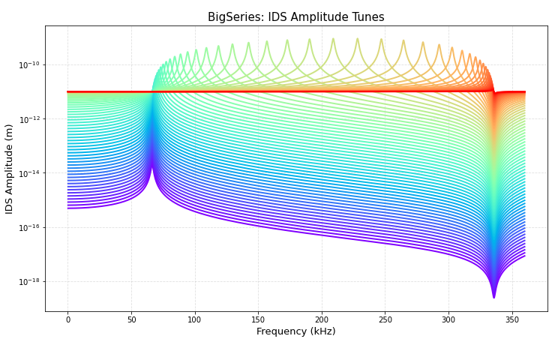
Figure S3. Fimulated amplitude–frequency responses (“tunes”) over the range of trial stiffness values.

For each value of kz/kstatic, the peak is located as discussed above to generate a resonance frequency versus stiffness master curve (Figure S4).

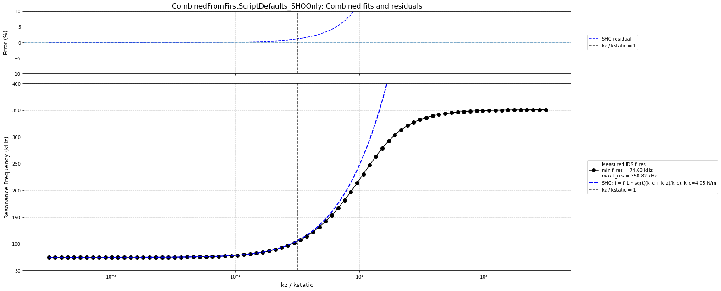
Figure S4. Resonance frequency versus stiffness master curve.

The tip-sample stiffness can be readily estimated from this curve via a number of methods discussed below. For the work here, we simply numerically invert the curve.
The SHO model does not reproduce the full distributed beam dynamics but for gentle tip-surface interactions ($k_{z}<5k_{c}$), it agrees to within approximately 10% with the Euler–Bernoulli solution. For a model prediction $f_{model}(k_{z})$and numerical resonance value $f_{res}(k_{z})$, the residual was defined as
$$ε(k_{z})=100 \frac{f_{model}(k_{z})-f_{res}(k_{z})}{f_{res}(k_{z})}.$$
The residual for the SHO approximation is plotted in Figure S5 (dashed blue line). We implemented an inverse interpolation function to determine the contact stiffness corresponding to a desired resonance frequency.

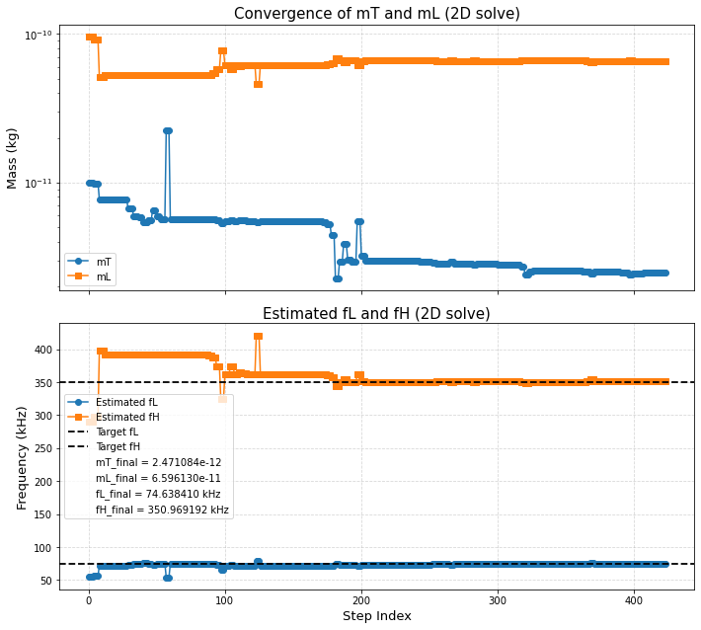
Figure S5. Residual ε(kz) of the SHO approximation relative to the Euler–Bernoulli solution (dashed blue line) versus step index.

The experimentally measured frequency $f(t)$was then mapped onto this calibration curve using interpolation to obtain the corresponding stiffness:
$$k_{ts}(t)=f_{res}^{-1}(f(t)).$$
This numerical inversion approach avoids reliance on simplifying assumptions and remains valid across the full stiffness range, including regimes where the SHO approximation breaks down. In particular, the Euler–Bernoulli model correctly predicts the saturation of the resonance frequency at a finite upper limit $f_{H}$as the contact stiffness becomes large, reflecting the physical constraints imposed by the cantilever geometry.
- Sub-resonant, displacement based stiffness estimates
In addition to the dynamic frequency-based methods described above, the tip–sample stiffness can be independently estimated using the conventional force–distance (displacement–load) approach, which is widely employed in quasi-static AFM nanomechanical measurements. In this framework, the interaction stiffness is obtained directly from the slope of the force–indentation response derived from the measured low-frequency displacement signal.
The primary observable is the low-frequency cantilever displacement $d(t)$, together with the piezo (or sensor) displacement $z(t)$. A baseline correction is first applied to the displacement signal using a linear fit to the non-contact regions, yielding the corrected displacement $d_{corr}=d-d_{baseline}$. The interaction force is then computed via Hooke’s law,
$$F(t)=k_{c} d_{corr}(t),$$
where $k_{c}$is the calibrated cantilever spring constant. The indentation depth is defined as
$$δ(t)=z_{corr}(t)-d_{corr}(t),$$
where $z_{corr}(t)=z(t)-z(t_{2})$is referenced to the contact point (identified at time $t_{2}$). This definition ensures that $δ>0$corresponds to tip–sample compression.
Importantly, this displacement–load formulation can, in principle, be evaluated at all points along the force curve, providing a time-resolved estimate of the interaction force and indentation throughout approach, contact, and retraction. However, model-based stiffness extraction using contact mechanics is restricted to the contact regime (Region 3), where the assumptions of continuous tip–sample contact are valid.
Within this contact region, only data above a small indentation threshold (typically a few percent of the maximum indentation) are used in the fitting procedure to avoid noise-dominated points near initial contact.
Three contact-mechanics models are used to extract stiffness from the $F(δ)$relationship in Region 3. In the simplest “punch” (flat punch) model, the force is assumed to vary linearly with indentation,
$$F=S_{p} δ,$$
where $S_{p}$is the slope obtained from a least-squares fit. The corresponding effective modulus is $E_{p}=(πS_{p})/(2a)$, where $a$is the punch radius. In this case, the tip–sample stiffness is directly given by the slope $k_{ts}=S_{p}$, providing a local linear approximation to the interaction.
For more realistic contact geometries, nonlinear models are employed. In the Hertz model for a spherical tip of radius $R$, the force scales as
$$F=\frac{4}{3}E^{*}\sqrt{R} δ^{3/2},$$
where $E^{*}$is the reduced modulus. The stiffness is then obtained by differentiating the force with respect to indentation,
$$k_{ts}=\frac{dF}{dδ}=2E^{*}\sqrt{Rδ}.$$
Because the stiffness depends explicitly on indentation, it must be evaluated at a representative depth. In the present implementation, this is taken either as the maximum indentation $δ_{max}$or the median indentation within the contact region, controlled by the HertzRegion parameter.
Adhesive interactions are incorporated using the Derjaguin–Muller–Toporov (DMT) model, in which the force is offset by an adhesion term $F_{adh}$,
$$F=\frac{4}{3}E^{*}\sqrt{R} δ^{3/2}-F_{adh}.$$
The adhesion force is either computed directly from the retraction branch (e.g., from the minimum force or pull-off displacement) or assigned a constant fallback value when the measurement is unreliable. The effective modulus is then extracted by fitting $F+F_{adh}$versus $δ^{3/2}$, and the stiffness is again evaluated as
$$k_{ts}=2E^{*}\sqrt{Rδ}$$
To capture hysteresis and viscoelastic effects, the force–indentation data are further separated into approach and retract branches by identifying the point of maximum indentation. Independent fits are performed on each branch, yielding distinct stiffness estimates that reflect loading and unloading behavior.
Overall, this displacement–load method provides a direct, model-based estimate of the tip–sample stiffness rooted in contact mechanics. Since the force and indentation can be computed continuously along the full force curve using the low-frequency displacement $d(t)$, the method additionally provides an independent, quasi-static reference against which the resonance-frequency-based stiffness estimates are compared in Figure 6 of the main text.

Equipartition Validity Test
The use of Brownian motion as an effective drive requires that the measured near-resonance fluctuations are thermally populated and therefore satisfy equipartition. Within a given interaction regime, the cantilever can be approximated as a harmonic mode with an effective vertical stiffness $k_{z}$, obtained either from a single-mode SHO model or from an Euler–Bernoulli beam calculation evaluated at the measured instantaneous resonance frequency.
To assess whether the measured near-resonance fluctuations are consistent with thermally driven Brownian motion, we compare the measured peak-to-peak residual amplitude with the amplitude expected from equipartition. The extracted residual amplitude $A_{pp,meas}$, Eq. (1) is treated as a local peak-to-peak amplitude of an approximately sinusoidal near-resonance fluctuation. The effective vertical stiffness is estimated from the smoothed dynamic stiffness and the static cantilever stiffness as
$$k_{z}(t)=k_{ts,smooth}(t)+k_{c}.$$
In this assumption, $k_{ts,smooth}(t)$ is deduced from the local resonant frequency, using either a SHO or Euler Bernoulli model.

Assuming the fluctuation is thermally populated and can be approximated as a harmonic mode, equipartition gives
$$\frac{1}{2}k_{z}⟨z^{2}⟩=\frac{1}{2}k_{B}T,$$
so that the thermal mean-square displacement is
$${⟨z^{2}⟩}_{th}=\frac{k_{B}T}{k_{z}}.$$
The corresponding thermal RMS amplitude is
$$z_{rms,th}=\sqrt{\frac{k_{B}T}{k_{z}}}.$$
Because the measured amplitude is peak-to-peak, the thermal expectation is converted to peak-to-peak form using the sinusoidal relation
$$A_{pp}=2\sqrt{2} z_{rms}.$$
Therefore,
$$A_{pp,th}(t)=2\sqrt{2}\sqrt{\frac{k_{B}T}{k_{z}(t)}}.$$
The Brownian amplitude consistency ratio is then defined as
$$R_{A}(t)=\frac{A_{pp,meas}(t)}{A_{pp,th}(t)}.$$
Equipartition corresponds to
$$R_{A}≈1.$$
In practice, because the amplitude is estimated locally from peak-to-next-valley fluctuations rather than from a long-time ensemble average, individual values are expected to scatter about unity. We therefore classify the response as Brownian-consistent when
$$0.5≤R_{A}≤2.0.$$
Values outside this range are treated as inconsistent with a purely thermal amplitude. Values substantially above the band indicate excess motion relative to equipartition, suggesting additional non-thermal excitation, impulsive tip–sample dynamics, snap-in or snap-out events, or release of stored mechanical energy. Values substantially below the band indicate that the measured motion is smaller than expected, which may reflect bandwidth limitation, filtering, amplitude-calibration error, or an overestimate of $k_{z}$.
The corresponding energy-based equipartition ratio is
$$η_{eq}=\frac{{\left(A_{pp,meas}/2\sqrt{2}\right)}^{2}}{k_{B}T/k_{z}}.$$
Since
$$R_{A}=\frac{A_{pp,meas}}{2\sqrt{2}\sqrt{k_{B}T/k_{z}}},$$
the energy ratio is simply
$$η_{eq}=R_{A}^{2}.$$
Thus, the accepted amplitude range
$$0.5≤R_{A}≤2.0$$
corresponds to an energy-ratio range of approximately
$$0.25≤η_{eq}≤4.$$
This criterion is therefore intentionally a practical amplitude-level consistency check rather than a strict point-by-point test of equipartition. It assumes an approximately harmonic near-resonance response, a meaningful instantaneous stiffness estimate, adequate displacement calibration and bandwidth, and no significant external drive during the analyzed interval.
Because the amplitude is estimated from local peak-to-peak fluctuations, individual values of $R_{A}$are expected to scatter substantially about unity. We therefore interpret equipartition statistically rather than point-by-point. Brownian-consistent motion is identified when the regime-averaged amplitude ratio remains of order unity, typically within a factor of about two of the thermal expectation. Persistent deviations by factors of several, or energy ratios $R_{A}^{2}$substantially larger than unity, indicate additional non-thermal excitation, non-equilibrium tip–sample dynamics, or an inaccurate estimate of the effective stiffness $k_{z}$.
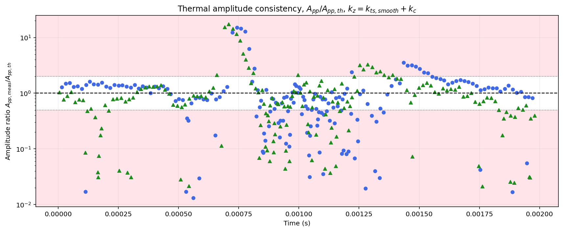
Figure S6. Thermal-amplitude consistency during the force-curve cycle. The plot shows the measured peak-to-peak residual amplitude normalized by the Brownian thermal expectation,
$$R_{A}=\frac{A_{pp,meas}}{A_{pp,th}},$$
where
$$A_{pp,th}=2\sqrt{2}\sqrt{\frac{k_{B}T}{k_{z}}},k_{z}=k_{ts,smooth}+k_{c}.$$
Blue circles and green triangles represent the two analyzed force-curve cases. The dashed horizontal line marks $R_{A}=1$, where the measured amplitude equals the equipartition prediction. The dotted lines mark the practical Brownian-consistency bounds, $0.5≤R_{A}≤2$. The white band denotes amplitudes consistent with thermally driven motion within this criterion, while the light pink regions indicate amplitudes that are smaller or larger than expected for purely Brownian fluctuations. Persistent excursions above the upper bound suggest excess non-thermal excitation or impulsive tip–sample dynamics, whereas values below the lower bound indicate under-measured motion, filtering/bandwidth limitations, or an overestimate of the effective stiffness.

Simulation details
Condition | Forces | Damping | Physical regime
$$d > d_{in}$$  $$and ż < 0$$ | $$F_{ts} = F_{vdW}= \frac{-RH}{6d^{2}}$$ | $$b_{free}$$ | R1: Approach, no meniscus (“dry”) vdW unclamped.
$$ϵ < d ≤ d_{in}$$ | $$F_{ts} = F_{vdW} + F_{CAP}$$  $$F_{CAP} = -2πRγcos(θ)\left(1 - \frac{d}{d_{K}}\right)$$  $$F_{vdW} = \frac{-RH}{6d^{2}}$$ | $$b_{free} + b_{water}$$ | R2: Approach, vdW interaction, no mechanical contact.
$$d < ϵ$$ | $$F_{ts} = F_{DMT} + \left(1 + α_{contact}\right)F_{vdW} + F_{CAP}$$  $$F_{vdW} = \frac{-RH}{6{a_{0}}^{2}}$$  $$F_{CAP} = -2πRγcos(θ)\left(1 - \frac{a_{0}}{d_{K}}\right)$$  $$F_{DMT} = \frac{4}{3}ER^{\frac{1}{2}}δ^{\frac{3}{2}}$$ | $$b_{free} + b_{water}$$  $$b_{free} + b_{water}$$  $$+ b_{rep}$$ | R3: Mechanical contact plus capillary and clamped vdW with hysteretic retraction for vdW.
$$ϵ< d ≤ d_{out}$$  $$and ż > 0$$ | $$F_{ts} = F_{vdW} + F_{CAP}$$  $$F_{CAP} = -2πRγcos(θ)\left(1 - \frac{d}{d_{K}}\right)$$  $$F_{vdW} = \frac{-RH}{6d^{2}}$$ | $$b_{free} + b_{water}$$ | R4: Retract, meniscus force and vdW.
$$d > d_{out}$$  $$and ż > 0$$ | $$F_{ts} = F_{vdW}= \frac{-RH}{6d^{2}}$$ | $$b_{free}$$ | R5: Retract, no meniscus (“dry”) vdW.

Modeling details
The instantaneous tip-sample separation was defined as
$$d(t)=z_{surf}(t)+x(t),$$
where $z_{surf}$is the imposed surface position and $x(t)$is the cantilever deflection. Mechanical contact was defined by
$$d≤ϵ,$$
where $ϵ$is the contact offset. The meniscus force was applied only outside mechanical contact. On approach, the R2 meniscus was active for
$$ϵ<d≤ϵ+d_{water,in},$$
while on retract, the R4 meniscus was active for
$$ϵ<d≤ϵ+d_{water,out}.$$
For the analysis described here, both R2 and R4 used a linear softening capillary model. The model uses the separation beyond the contact offset,
$$s=max⁡(0,d-ϵ),$$
as the independent coordinate for the capillary force. At small separation, the capillary force is held at a constant maximum attractive value. This force plateau extends from contact to
$$s=d_{lin}.$$
The plateau force is calculated from the zero-separation value of the parent softening-meniscus expression:
$$F_{plateau}=-F_{cap0}{\left[1+\exp\left(\frac{s_{rup}}{Δ}\right)\right]}^{-1}≈-1.8 nN.$$
Here $F_{cap0}$sets the nominal capillary force scale, $s_{rup}$is the rupture-length parameter inherited from the parent softening expression, and $Δ$is the corresponding smoothing width. In the current linear_softening implementation, these parameters are used to determine the plateau force; the subsequent force decay is then imposed as an explicitly linear softening branch.
The capillary force law is piecewise. For the constant-force shelf,
$$0≤s≤d_{lin},$$
the force is
$$F_{cap}(s)=F_{plateau}.$$
For larger separations, the force softens linearly from the plateau value to a small residual adhesive force immediately before snap-out:
$$d_{lin}<s<s_{snap}.$$
Within both R2 and R4 the capillary force is computed with the linear_softening model, expressed as a function of the meniscus elongation s, e.g. the separation beyond the repulsive contact point. The force is piecewise in s and has three branches: a constant adhesive shelf, a linear softening branch, and an abrupt rupture to zero:

$$F_{cap}(s)=F_{plateau}+\frac{s-d_{lin}}{s_{snap}-d_{lin}}\left(F_{snap} − F_{plateau}\right).$$
For separations at or beyond snap-out, the meniscus is removed and the capillary force is set to zero:
$$F_{cap}(s)=0,s≥s_{snap}.$$
Thus, the model intentionally includes a discontinuous snap-out event: the force reaches a small negative value $F_{snap}$, called z_snap in the script, and then jumps directly to zero. In the current implementation, the snap-out distance is tied to the retract-side water length,
$$d_{snap}=ϵ+d_{water,out},$$
and
$$s_{snap}=d_{snap}-ϵ=d_{water,out}.$$
This choice makes the apparent retract-side meniscus rupture distance directly controlled by $d_{water,out}$. The approach-side meniscus cutoff is controlled separately by $d_{water,in}$, while the retract-side persistence of the liquid bridge is controlled by $d_{water,out}$.

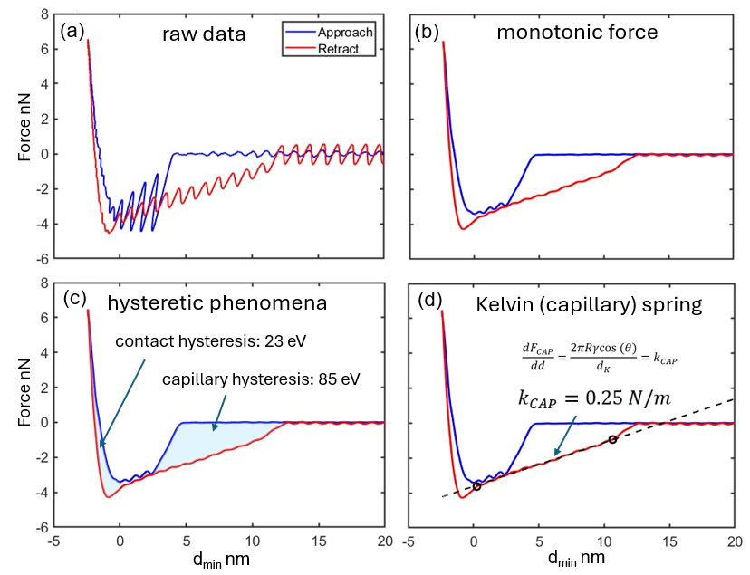
Figure 6. The force is decomposed and presented in terms of a) raw data and the b) monotonic force component where the transient have been partially removed through the smoothening function lowess in Matlab (It uses local linear regression and it is computationally heavy but removes artificial step-discontinuities across boundaries), and several examples of quantification per pixel as c) dissipative hysteretic mechanisms in the capillary (R2-R4) and contact (R3) regions, and d) the effective spring constant of the capillary force (~0.25 N/m) recovered from R4.

Figure 6 shows a single FFC on a point on the PS sample. The force curves in Figure 6 show the full tip trajectory - approach and retraction. Because these forces do not reply on transforms based on mathematical even or odd functions such as the force reconstruction typical of AC methods (see discussion below)^{S1–S3}, the approach and retraction paths in Figure 6c are the “true” paths of the monotonic force component. Focusing on regions (R2 and R4), in the following we will explore several models and hypotheses related to the hysteretic forces in the attractive region.. Figure 6a shows the unfiltered displacement versus indentation δ. Figure 6b shows the low-pass filtered displacement. Capillarity, or hysteresis, involves the onset and break-off distances, here symbolizing the distance for bridge formation (don) and rupture (doff), which are in general, not equal. The vertical dashed lines in Figure 6b indicate don and doff. Figure 6c shows how we can estimate hysteretic energy losses for the contact and capillary formation and rupture portions for the curve. Note that as opposed to the average power or energy dissipated per cycle typically recovered from AC modes^{S1–S3}, energy dissipation can be quantified (~103 eV) for each physical mechanism (23 and 85 eV for contact hysteresis and capillary hysteresis respectively) directly from the FFCs.

The approach outlined above, based on a simple Hooke’s law, should be contrasted with the methodologies employed in AC AFM modes to recover force since these typically recover the “conservative”^{S4} or monotonic force in terms of the even part,^{S1,S5} this being the average of the approach and retract paths. Simulations show that standard AC models for force reconstruction produce the approach path only under these conditions, meaning that the retraction path is missing completely.^{S5}
In summary, the recovering of the full tip trajectory during both tip approach and retraction opens the door to investigating the physics of capillarity directly from the shape of force profiles - as discussed below.

Parameters for the Simulations shown in Figure 2
------------------------------------------------------------------------------
Cases
------------------------------------------------------------------------------
CASE1 name Soft
CASE1 E_modulus 0.1 GPa
CASE1 Qrep 10
CASE1 FMax 10 nN
CASE1 IndentDepth = FMax/k_ts 5 nm (k_ts=2)

CASE2 name Stiff
CASE2 E_modulus 3 GPa
CASE2 Qrep 10
CASE2 FMax 1 nN
CASE2 IndentDepth = FMax/k_ts 0.5 nm (k_ts=2)

------------------------------------------------------------------------------
Dynamics mode / thermal forcing
------------------------------------------------------------------------------
ADD_BROWNIAN False
TEMP_K 300 K
RNG_SEED 0

------------------------------------------------------------------------------
Signal processing / analysis
------------------------------------------------------------------------------
Y_OFFSET (plot only) 0 m
RESIDUAL_LP_CUTOFF 20 kHz
RESIDUAL_LP_ORDER 4
ALIGN_T_CENTER 1 ms
ALIGN_HALF_WIDTH 0.2 ms
PEAK prominence 1.000e-12 m
PEAK distance (samples) 3
FREQ_MIN_HZ gate 50 kHz
FREQ_MAX_HZ gate 200 kHz
FREQ_SMOOTH_W (only if Brownian) 21

------------------------------------------------------------------------------
Cantilever + drive
------------------------------------------------------------------------------
k (cantilever) 2 N/m
f0 = omega_0 / (2π) 65 kHz (omega_0=4.084e+05 rad/s)
Q (free) 120
Qwater 30
Qrep_default 10
E_modulus_default 1 GPa
F_d (drive force amplitude) 0 N
driveFreq 500 Hz (omega_d=3.142e+03 rad/s)

------------------------------------------------------------------------------
Time discretization / numerics
------------------------------------------------------------------------------
ttotal 2 ms
NumTimeChunks 2000
step_size (per chunk) 1 µs
NUM_POINTS_PER_SEGMENT 2000
F_NEW (downsample target) 2 MHz

------------------------------------------------------------------------------
Surface interaction parameters
------------------------------------------------------------------------------
k_ts 2
Hamaker 2.000e-19 J
R (tip radius) 20 nm
dwaterin 2 nm
dwaterout 8 nm
epsilon 0.31 nm
FFMAmp (surface oscillation amplitude) 8 nm

------------------------------------------------------------------------------
Capillary model (softening + smooth rupture)
------------------------------------------------------------------------------
USE_SOFTENING_MENISCUS True
Fcap0 2 nN (defined as 0.1*R)
cap_lambda 5 nm
cap_s_rup 10 nm
cap_delta 6 nm

------------------------------------------------------------------------------
Initial conditions / constants / plotting
------------------------------------------------------------------------------
x0 3.000e-11 m
v0 0 m/s
kB 1.381e-23 J/K

Supplemental References
S1. Sader, J. E., Uchihashi, T., Higgins, M. J., Farrell, A., Nakayama, Y. & Jarvis, S. P. Quantitative force measurements using frequency modulation atomic force microscopy—theoretical foundations. Nanotechnology 16, S94–S101 (2005).
S2. Zitzler, L., Herminghaus, S. & Mugele, F. Capillary forces in tapping mode atomic force microscopy. Phys. Rev. B 66, 155436 (2002).
S3. Sahagún, E., García-Mochales, P., Sacha, G. M. & Sáenz, J. J. Energy dissipation due to capillary interactions: hydrophobicity maps in force microscopy. Phys. Rev. Lett. 98, 176106 (2007).
S4. Giessibl, F. J. Forces and frequency shifts in atomic-resolution dynamic-force microscopy. Phys. Rev. B 56, 16010–16015 (1997).
S5. Santos, S. Phase contrast and operation regimes in multifrequency atomic force microscopy. Appl. Phys. Lett. 104, 143109 (2014).

