Appendix
Tabell A1. Indicators of family-immigration policies (IMPIC).
Eligibility criteria | Indicator | Range | Description
 | Residence requirements (AvgS_a01) | 0 - No  0.5 - Yes, less or equal 12 months  0.6 – Yes. 13–24 months  0.7 – Yes, 25–48 months  0.8 – Yes, 49–60 months  0.9 – Yes, more than 60 months or permanent residence  1 – No family reunification policy | For the years 1980–2018, did the sponsor (if s/he was a TCN) need to have resided in the country for a specific amount of time before his/her family members could immigrate?
 | Family members (AvgS_a02) | 0 – Yes, 6 or more kinds of members  0.1 – Yes, 5 kinds of members  0.2 - Yes, 4 kinds of members  0.3 - Yes, 3 kinds of members  0.4 - Yes, 2 kinds of members  0.5 - Yes, 1 kind of members  1 – No family reunification policy | For the years 1980–2018, which family members were allowed to immigrate according to the regulations governing family reunification? Please also consider family members who are allowed to immigrate under certain conditions only.
 | Age limits (AvgS_a03) | 0 – No  0.5 – Yes, less or equal 17 years  0.6 – Yes, 18 years  0.7 – Yes, 19–20 years  0.8 – Yes, 21–23 years  0.9 – Yes, more or equal 24 years  1 – No family reunification policy | For the years 1980–2018, was there a minimum age for sponsored spouses in order to be admitted to the country?

Table A1 (continuation).
Qualifying conditions | Indicator | Range | Description
 | Financial requirements (AvgS_a04) | 0 – No  0.5 – Yes, no reliance on social welfare  0.6 – Yes, equal social assistance or sufficient income  0.7 – Yes, equal to minimum wage or bigger social assistance  0.8 – Yes, bigger minimum wage or specific funds  0.9 – Yes, specific financial funds and amount specified  1 – No family reunification policy | For the years 1980–2018, were sponsors required to prove the ability to financially support themselves and their family? If yes, please specify how.
 | Accommodation requirements (AvgS_a05) | 0 – No  0.5 – Yes  1 - NA | For the years 1980–2018, were sponsors required to show proof of adequate accommodation for them and their family?
 | Language skills (AvgS_a06) | 0 – No  0.5 – Yes, required but not specified  0.6 – Yes, required but not tested  0.7 – Yes, required and tested after arrival  0.8 – Yes, required and tested before arrival  0.9 – Yes, required and tested before and after arrival  1 – No family reunification policy | For the years 1980–2018, were minimum language skills required from the sponsored spouses?
 | Application fees (AvgS_a07) | 0 – No  0.5 – Yes, 1–100  0.6 – 101–300  0.7 – 300–600  0.8 – 601–999  0.9 – Yes, equal or bigger 1000  1 – No family reunification policy | For the years 1980–2018, did the application for a residence permit for a sponsored spouse (without other family members) cost a certain fee (excluding costs for language and integration courses)?
Source: Berger et al., 2024.
Note: Application fees in constant USD (PPP).

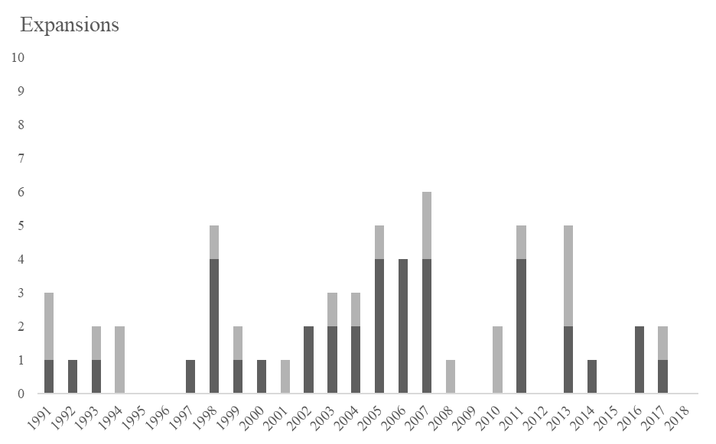
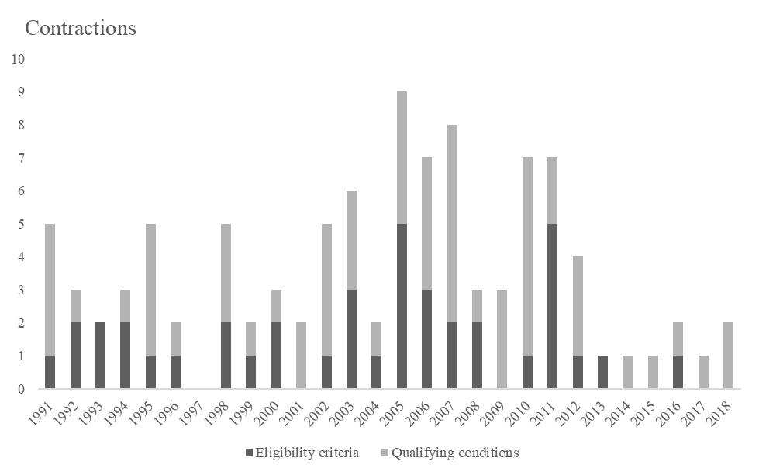
Countries included: Austria (1992–2018), Belgium, the Czech Republic (1992–2018), Denmark, Estonia (1991–2018), Finland, France, Germany, Hungary, Italy, Luxembourg, the Netherlands, Norway, Poland (2001–2018), Portugal (1998–2018), Slovakia, Spain (1996–2018), Sweden, Switzerland, and the United Kingdom.

Figure A1. Number of expansions and contractions in family-immigration policies, 1990–2018.

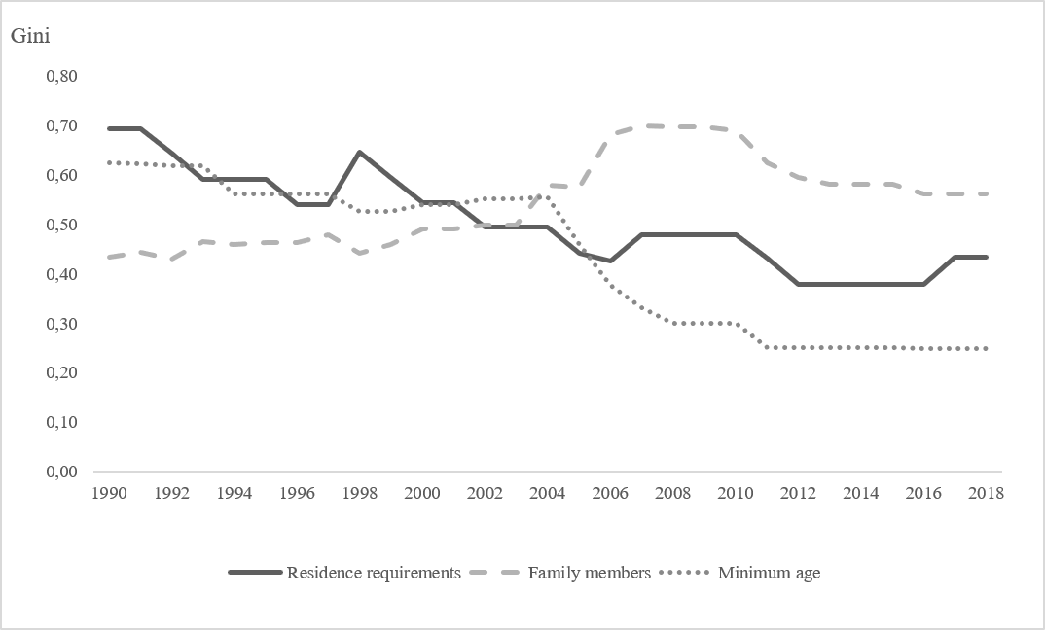
Notes: The Gini coefficient varies between 0 and 1, where higher values indicate greater variation in policy restrictiveness. 17 countries are included: Austria (1992–2018), Belgium, the Czech Republic (1992–2018), Denmark, Estonia (1991–2018), Finland, France, Germany, Hungary, Italy, Luxembourg, the Netherlands, Norway, Slovakia, Sweden, Switzerland, and the United Kingdom. The values of Austria and the Czech Republic in 1992 are used in the Gini estimations in 1990 and 1991. The value of Estonia in 1991 is used in the 1990 estimation. Poland, Portugal and Spain are excluded because their time series begin after 1990.
Figure A2 Dispersion of eligibility criteria for family immigration, 1990–2018.

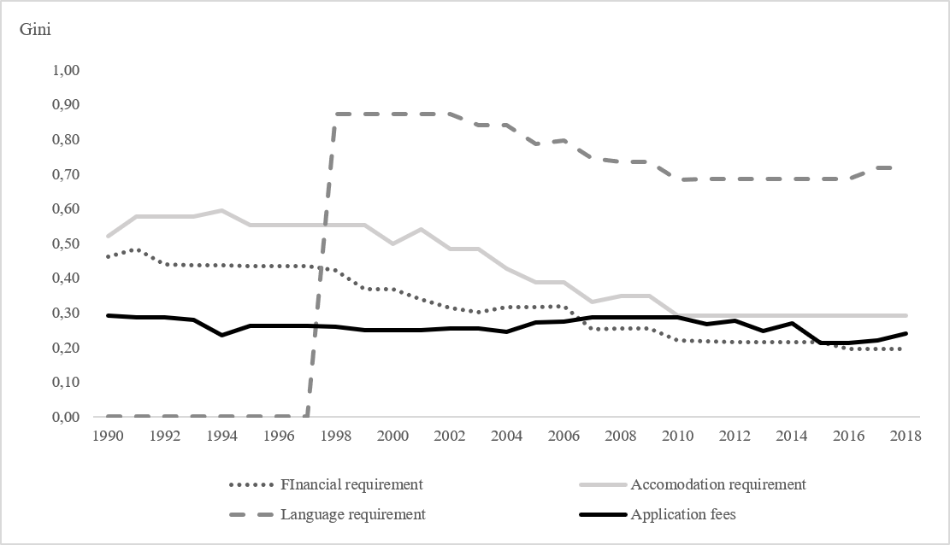
Notes: The Gini coefficient varies between 0 and 1, where higher values indicate greater variation in policy restrictiveness. 17 countries are included: Austria (1992–2018), Belgium, the Czech Republic (1992–2018), Denmark, Estonia (1991–2018), Finland, France, Germany, Hungary, Italy, Luxembourg, the Netherlands, Norway, Slovakia, Sweden, Switzerland, and the United Kingdom. The values of Austria and the Czech Republic in 1992 are used in the Gini estimations in 1990 and 1991. The value of Estonia in 1991 is used in the 1990 estimation. Poland, Portugal and Spain are excluded because their time series begin after 1990.
Figure A3 Dispersion of qualifying conditions for family immigration, 1990–2018.

