Supplementary Information
Systematic evidence mapping shows artificial intelligence dependence claims outnumber corresponding assessments in health professions education
Hao Wu, Yixuan Guo and Feifei Na

Supplementary Table S1 Information sources and search documentation
Database | Platform or index | Search date | Records | Retained export
PubMed | PubMed (National Library of Medicine) | 11 May 2026 | 1,348 | pubmed-Artificial-set.nbib
Embase | Embase.com (Elsevier) | 12 May 2026 | 1,631 | Five RIS files: 400 + 400 + 400 + 400 + 31
Web of Science Core Collection | Clarivate; Science Citation Index Expanded (SCI-EXPANDED) and Social Sciences Citation Index (SSCI); platform codes WOS.SCI and WOS.SSCI | 12 May 2026 | 4,426 | Five RIS files: 1,000 + 1,000 + 1,000 + 1,000 + 426
Scopus | Scopus (Elsevier) | 12 May 2026 | 6,986 | One RIS file
Total | Four databases | 11–12 May 2026 | 14,391 | Retained exports reconciled to the screening denominator

The four searches returned 14,391 records. After 3,666 duplicates were removed in EndNote, 10,725 records entered title and abstract screening. Complete verbatim strategies for each database, including all field tags and syntax, are supplied once in Supplementary Data 1, worksheet 03 Search Strategies; retained export filenames, timestamps, counts and SHA-256 hashes are supplied in worksheet 04 Search Exports. Native platform session-history screenshots and the native EndNote duplicate-action log were not retained.

Supplementary Note S1 Screening and coding audit
H.W. and Y.G. independently screened the original 10,725 records and assessed 485 reports in the original full-text review, with F.N. adjudicating disagreements. All 1,263 records originally marked Unclear by both reviewers were later reassessed under the final rules; 41 records advanced to full-text review, of which 32 reports were eligible and nine were excluded. A subsequent blinded random audit of 250 agreed-exclude records advanced 14 records to full-text review, of which two reports were eligible. These retrospective corrections were completed before the final analytical dataset was locked on 13 August 2026 and are reported separately from the original agreement estimates.
Stage | Units | Agreements | Agreement | Cohen's kappa | Adjudication or note
Title and abstract | 10,725 | 8,600 | 80.2% | 0.538 | Original dual screening
Original full-text review | 485 | 420 | 86.6% | 0.727 | F.N. adjudicated disagreements
Double-Unclear correction | 1,263 records | Not pooled | Reported separately | Not applicable | 41 records advanced to full-text review; 32 reports eligible
Agreed-exclude robustness audit | 250 records | Not pooled | Reported separately | Not applicable | 14 records advanced to full-text review; two reports eligible
Strict interpretive claim | 191 candidate units | 105/151 binary pairs | 69.5% among binary pairs | Initial kappa 0.078 | Gwet's AC1 0.564; 40 initial Y.G. Unclear; F.N. independently assessed all 191 units; 11 evidence-meeting decisions

Y.G. independently coded the final T1a corpus while blinded to H.W.'s row-level decisions for six phenomenon claims, criteria-concordant assessments, temporal structure and AI availability; F.N. adjudicated discrepancies and Unclear ratings. Across non-Unclear pairs, agreement was 87.0% for broad claims (Cohen's kappa 0.516; Gwet's AC1 0.823) and 95.0% for criteria-concordant assessments (kappa 0.241; AC1 0.946). The initial H.W.-Y.G. strict interpretive-claim comparison included 151 binary pairs (105/151 agreement, 69.5%; Cohen's kappa 0.078; Gwet's AC1 0.564), with 40 initial Y.G. Unclear ratings recorded separately. F.N. subsequently assessed all 191 candidate report–phenomenon units independently; 11 units underwent an evidence-based three-reviewer meeting. The final sensitivity analysis contained 20 claim-positive reports and 32 positive units. Scripts supported text extraction, table assembly and arithmetic checks but did not make eligibility or coding decisions.
AI exposure and use verification. An AI-exposure phase was recorded when a report assigned participants to an AI-supported activity or described AI use during a task or training period. This did not imply verified uptake by every participant. Platform logs, interaction records, use frequency and exposure duration were inconsistently reported, so actual AI use and adherence were not treated as eligibility or alignment criteria. Temporal structure therefore represents the scheduled or reported design, whereas AI availability during assessment was coded separately.

Supplementary Note S2 Protocol amendments and deviations
The review was registered in PROSPERO on 8 May 2026 before the four final database searches. The registration stated that searching had not started or been completed; pilot work had been completed. The following amendments were made after registration, during preliminary synthesis and methodological reassessment, and before the final submission dataset was frozen. They were intended to improve interpretability and were not selected according to the direction or statistical significance of study findings.

Registered or initial plan | Final approach | Reason
Broad evidence scope | Four mutually exclusive tiers; main quantitative analysis restricted to 150 T1a reports | A common denominator across empirical, technical, secondary and conceptual publications was not interpretable
Broad dependence domains | Six operational phenomena coded separately for claims and targeted assessments | To require same-phenomenon alignment; exploratory and not a validated taxonomy
No M0–M5 scheme | Assessment specificity, temporal structure and AI availability separated | To distinguish source and timing of measurement from confirmed AI-off testing
Broad appraisal using multiple planned tools | Targeted appraisal of 13 reports using selected design-matched domains; no mixed numerical score | To avoid combining non-equivalent tools and publication types
No explicit version or family sensitivity | Version chains, study families and three sensitivity analyses added | To reduce double counting and test stability of the descriptive pattern

Supplementary Figures

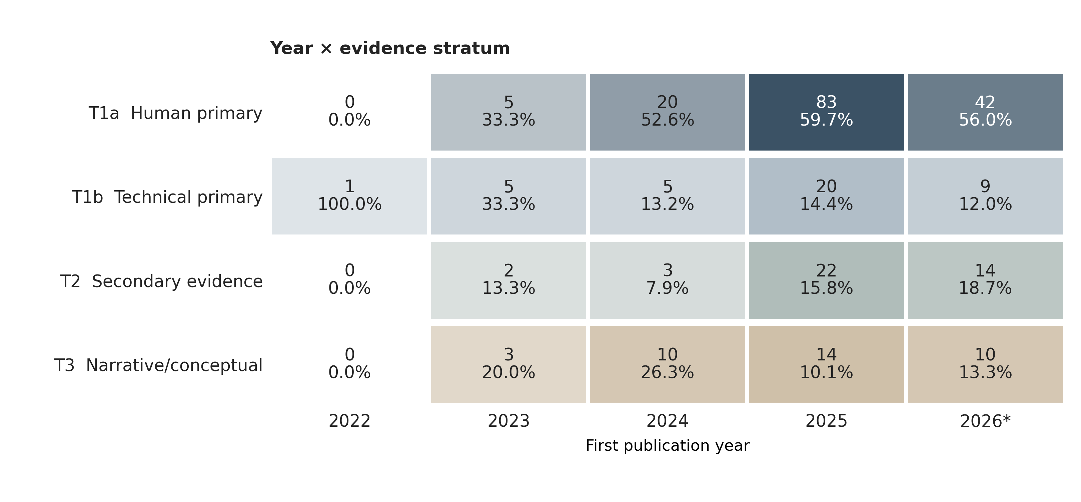
Supplementary Figure S1. Distribution of included reports by first publication year and evidence tier. Each cell gives the report count and its share of all reports first made public in that year. The 2026 column includes only reports eligible by 12 May 2026. The figure describes the corpus and not the incidence of AI dependence.

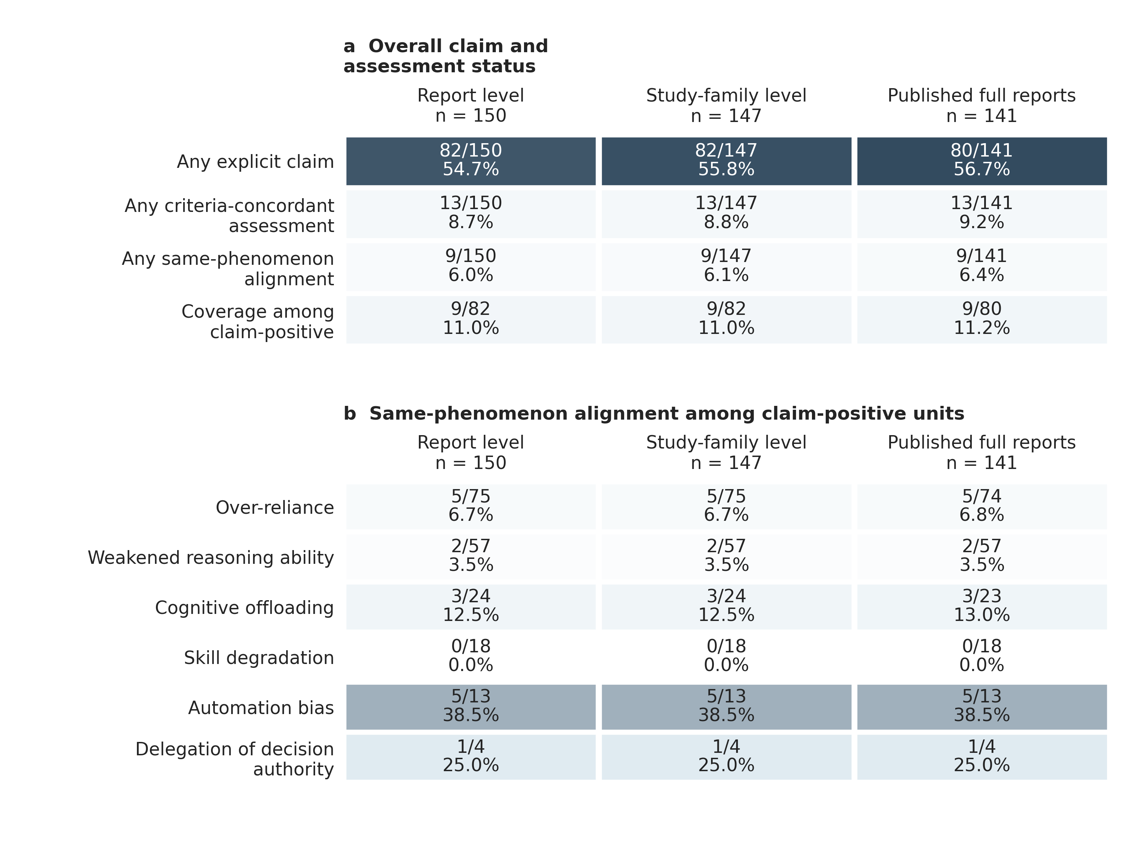
Supplementary Figure S2. Sensitivity analyses by report, study family and publication status. Criteria-concordant claim/assessment/alignment counts were 82/13/9 at report level, 82/13/9 across 147 T1a families and 80/13/9 among 141 complete peer-reviewed T1a reports. The broader assessment definition identified 25 reports and 19 alignments. Family-level alignment still required the claim and assessment to occur in the same report.

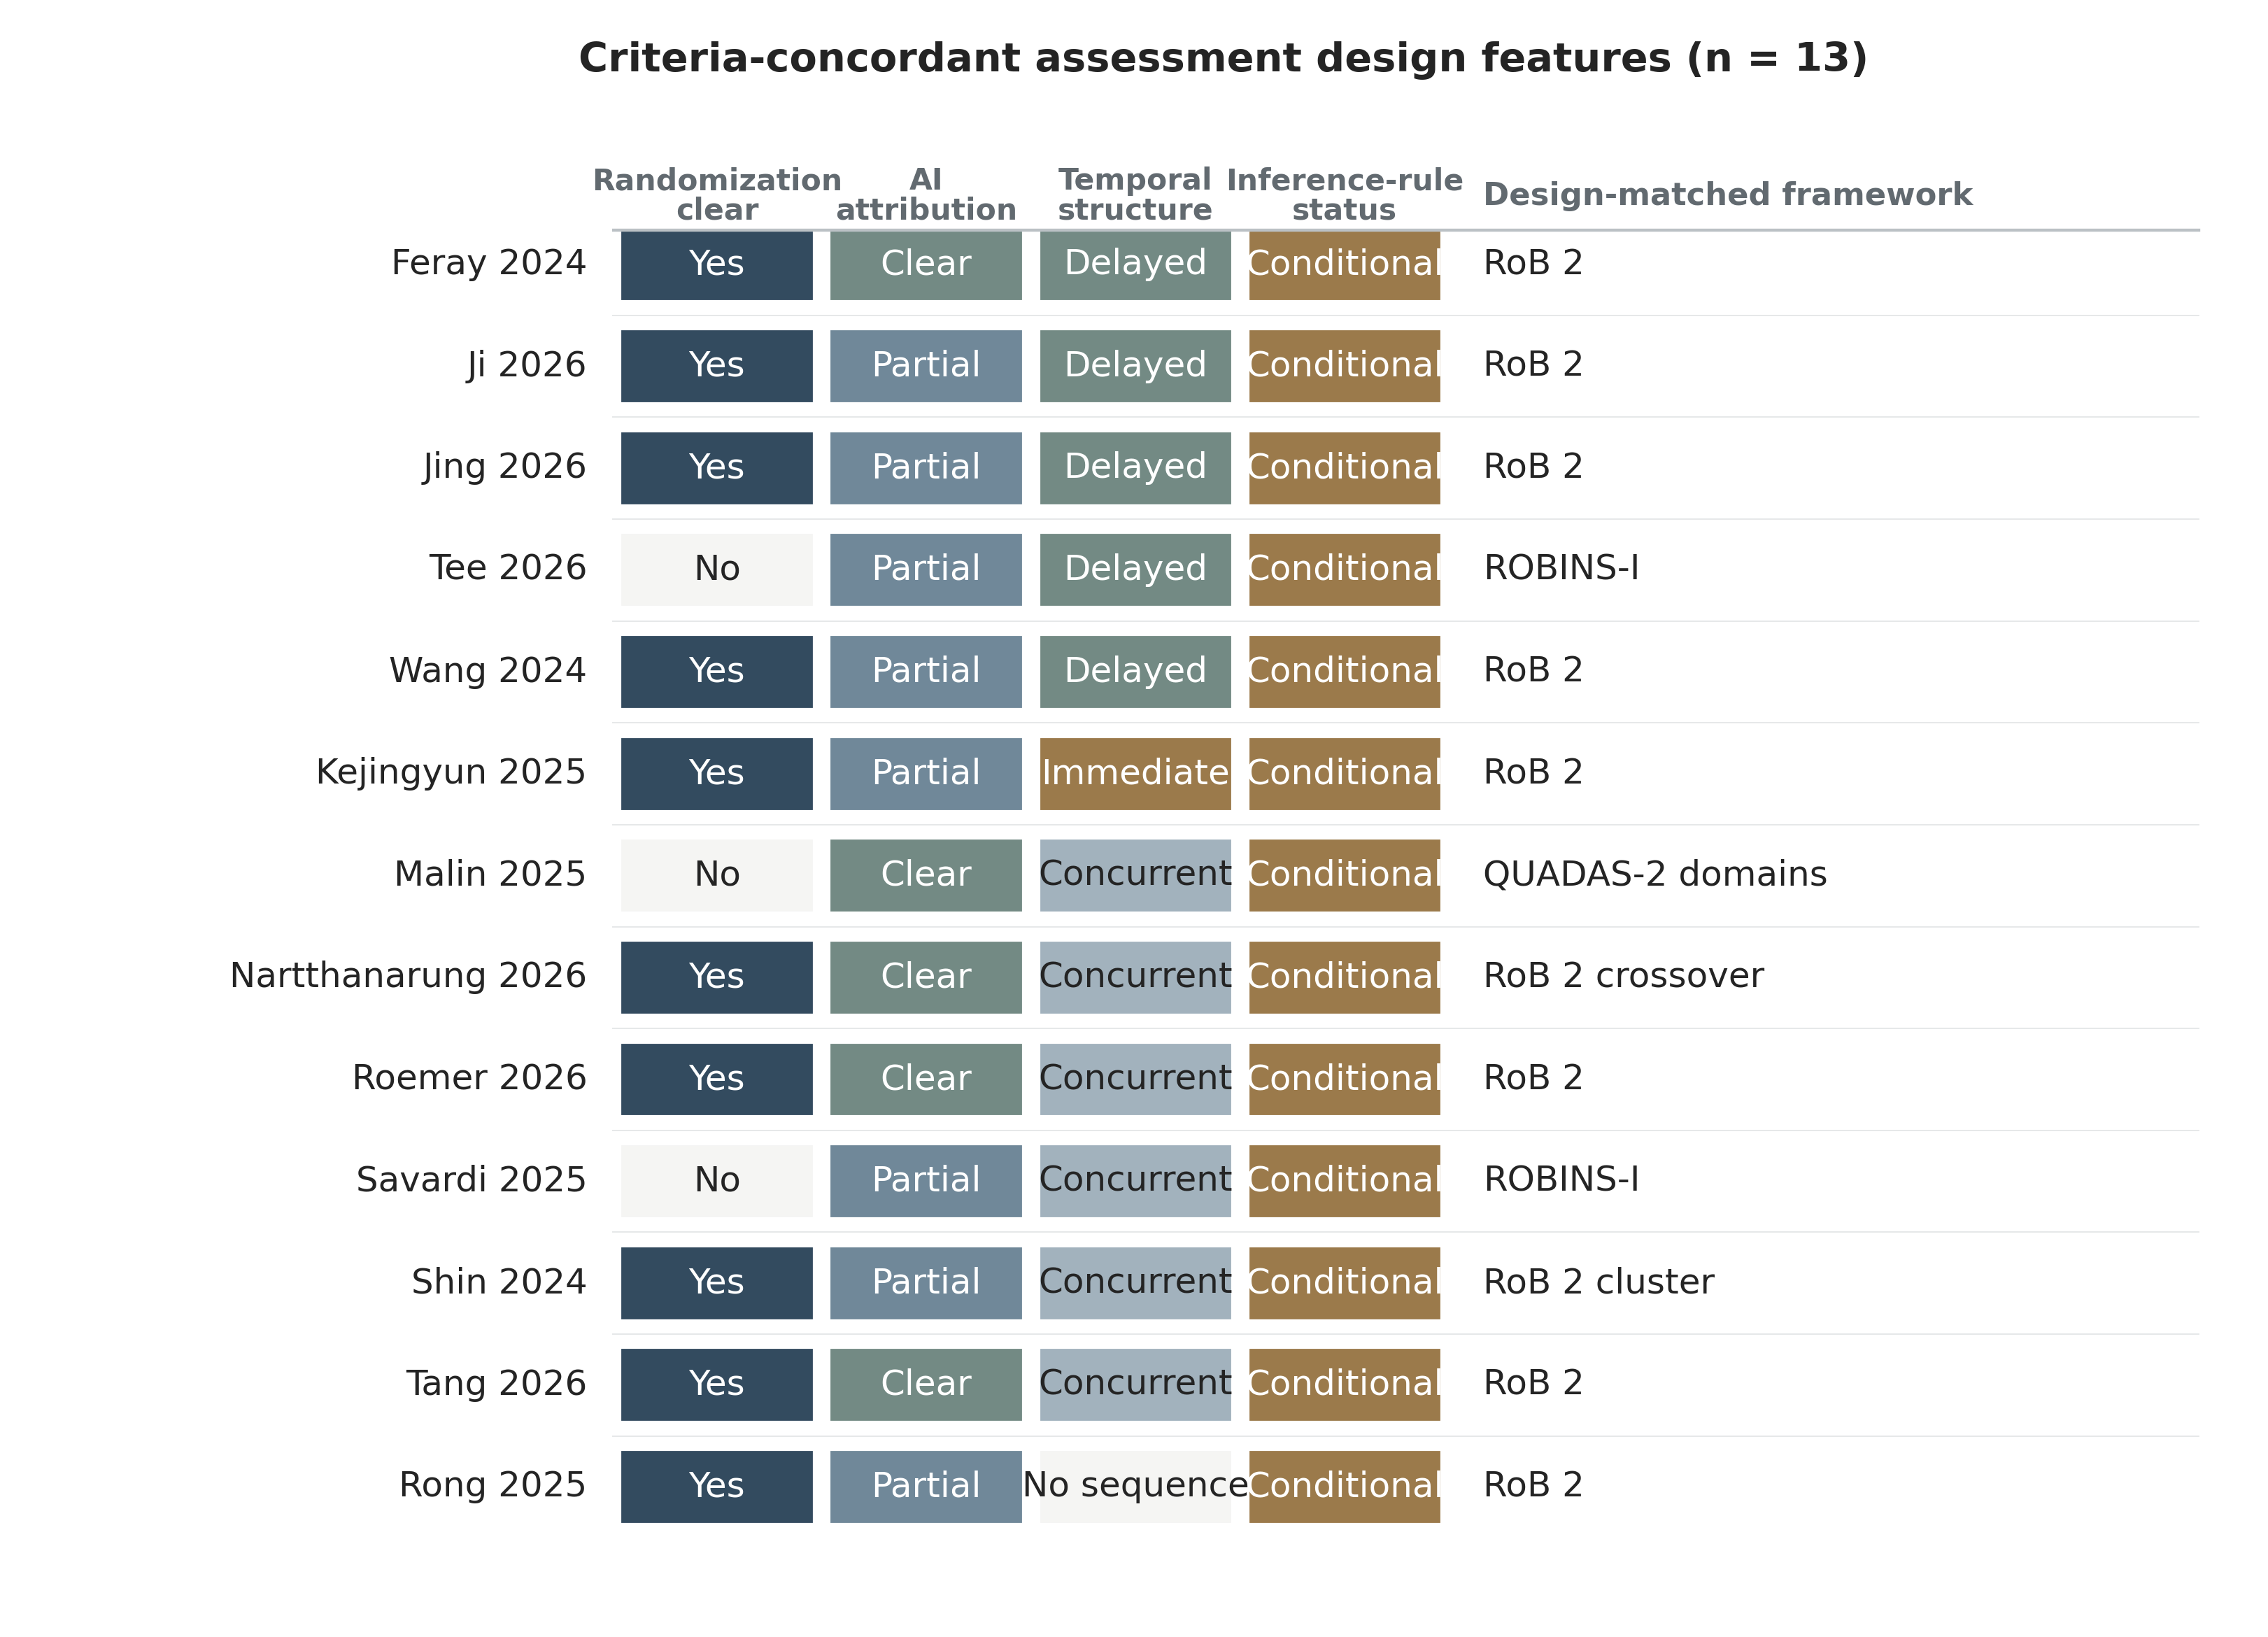
Supplementary Figure S3. Design features of the 13 reports with at least one criteria-concordant assessment. Randomisation, separability of the artificial-intelligence contribution, temporal structure, inference-rule status and the design-specific appraisal framework are shown separately; no common hierarchy or quality score was created.

Supplementary Data 1
Supplementary Data 1 contains PRISMA accounting, search documentation, 268 included reports, mappings for 263 study families, coding of 150 T1a reports, criteria-concordant, broad-assessment and strict-claim sensitivity analyses, targeted appraisal of 13 criteria-concordant reports using selected design-matched domains, protocol amendments and review-audit summaries. Full screening lineage and signed adjudication workbooks are retained internally and are available on reasonable request.

