Synthesis and Application of a Thiadiazole-Based Schiff Base pH Fluorescent Probe
Yuting Liu ª*, Jiale He ª, Dawei Yin ^{b}, Liangyan QiaoJiale He ª, Qian Yu ª, Shuaiqi Wang ª
Yuting Liu,lyt@sust.edu.cn, Key Laboratory of Chemical Additives for China National Light Industry, College of Chemistry and Chemical Engineering, Shaanxi University of Science＆Technology, Xi`an 710021, China
Jiale He, 250811075@sust.edu.cn, Key Laboratory of Chemical Additives for China National Light Industry, College of Chemistry and Chemical Engineering, Shaanxi University of Science＆Technology, Xi`an 710021, China
Dawei Yin,yindawei@sust.edu.cn, .Institute of Frontier Science and Technology transfer, Shaanxi University of Science＆technology, Xi`an 710021, China.
Liangyan Qiao, 250811076@sust.edu.cn, Key Laboratory of Chemical Additives for China National Light Industry, College of Chemistry and Chemical Engineering, Shaanxi University of Science＆Technology, Xi`an 710021, China
Qian Yu, 250811028@sust.edu.cn, Key Laboratory of Chemical Additives for China National Light Industry, College of Chemistry and Chemical Engineering, Shaanxi University of Science＆Technology, Xi`an 710021, China
Shuaiqi Wang, 250811061@sust.edu.cn , Key Laboratory of Chemical Additives for China National Light Industry, College of Chemistry and Chemical Engineering, Shaanxi University of Science＆Technology, Xi`an 710021, China

Synthesis and Application of a Thiadiazole-Based Schiff Base pH Fluorescent Probe
contents
Figure S1. 1
Figure S2. 1
Figure S3. 2
Figure S4. 3
Figure S5. 3
Figure S6. 3

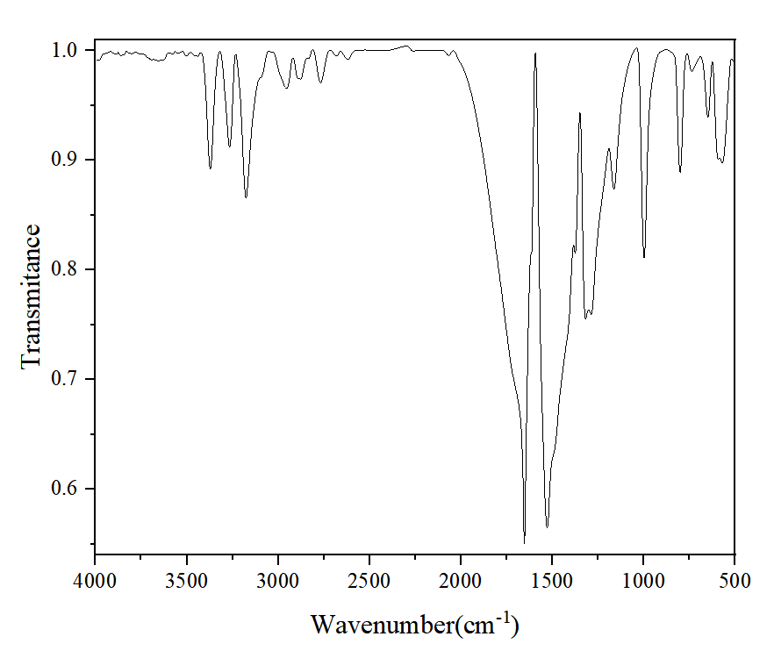
Figure S1.FT-IR spectra of 5-phenyl-1,3,4-thiadiazol-2-amine.
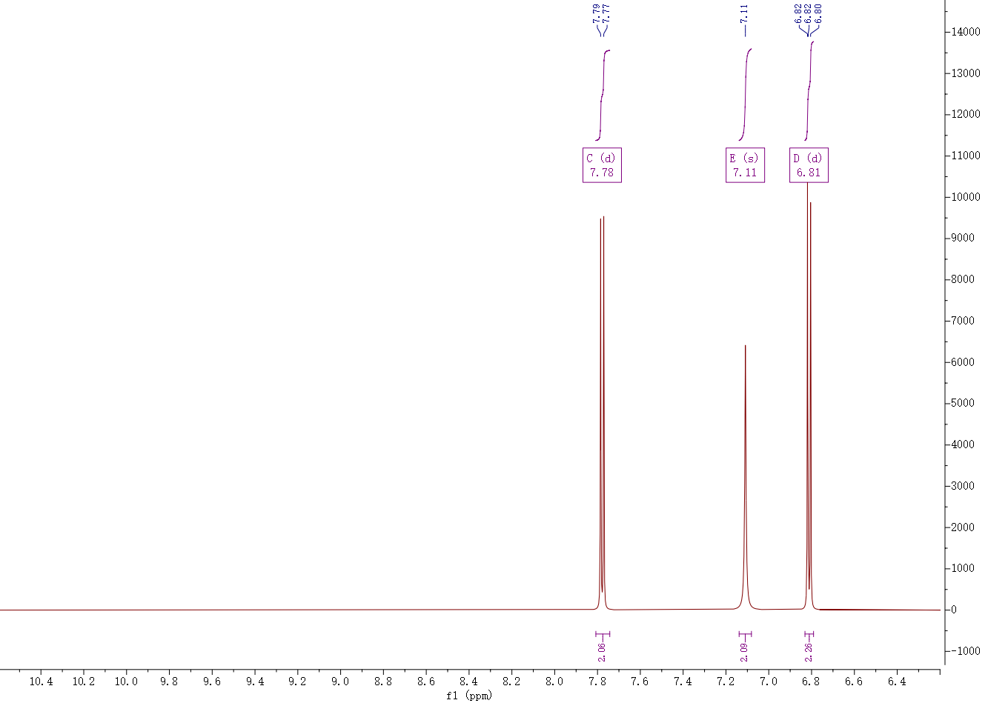
Figure S2.¹H NMR spectra of 5-phenyl-1,3,4-thiadiazol-2-amine.

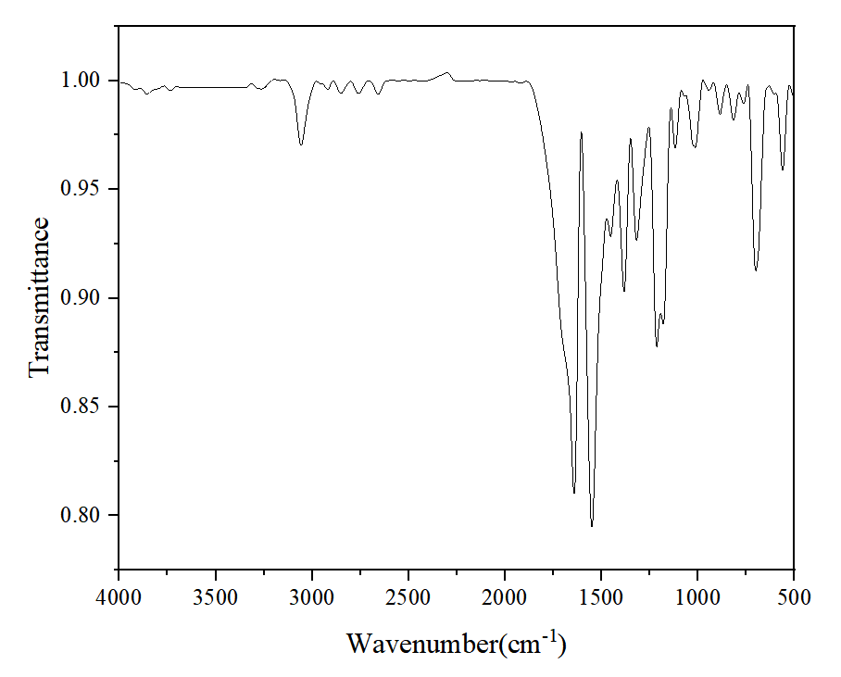
Figure S3. FT-IR spectra of (E)-1-phenyl-N-(5-phenyl-1,3,4-thiadiazol-2-yl)methanimine.

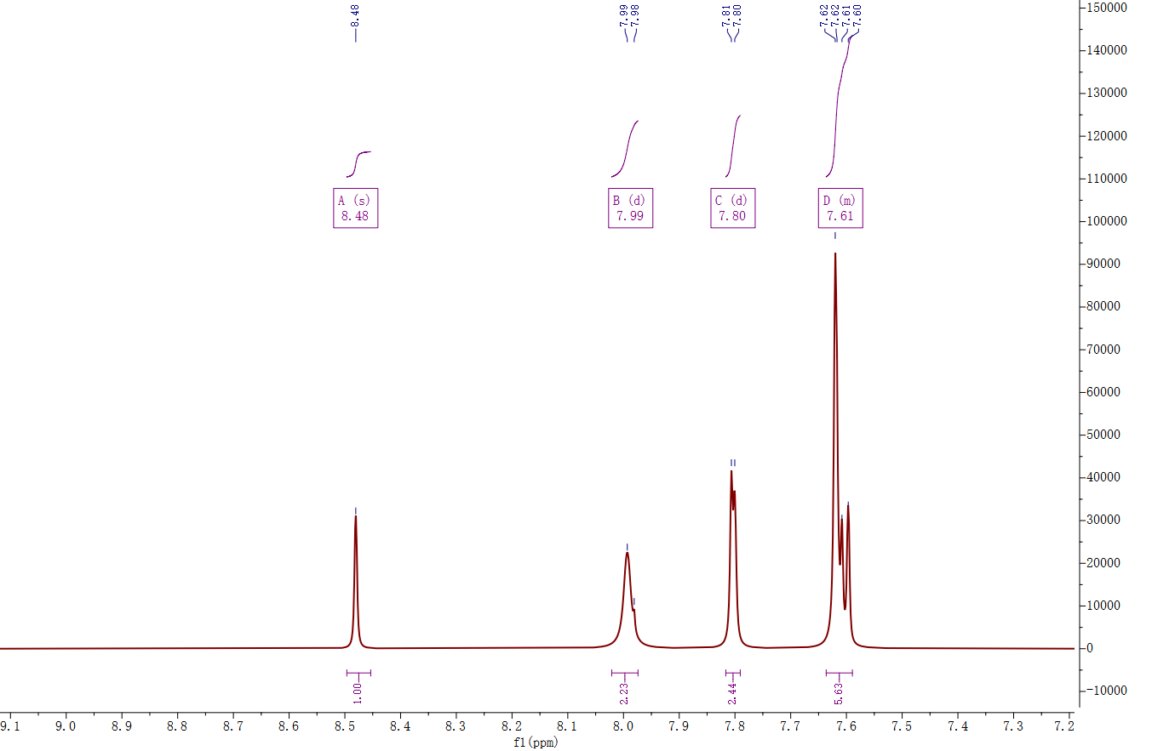
Figure S4.¹H NMR spectra of (E)-1-phenyl-N-(5-phenyl-1,3,4-thiadiazol-2-yl)methanimine.
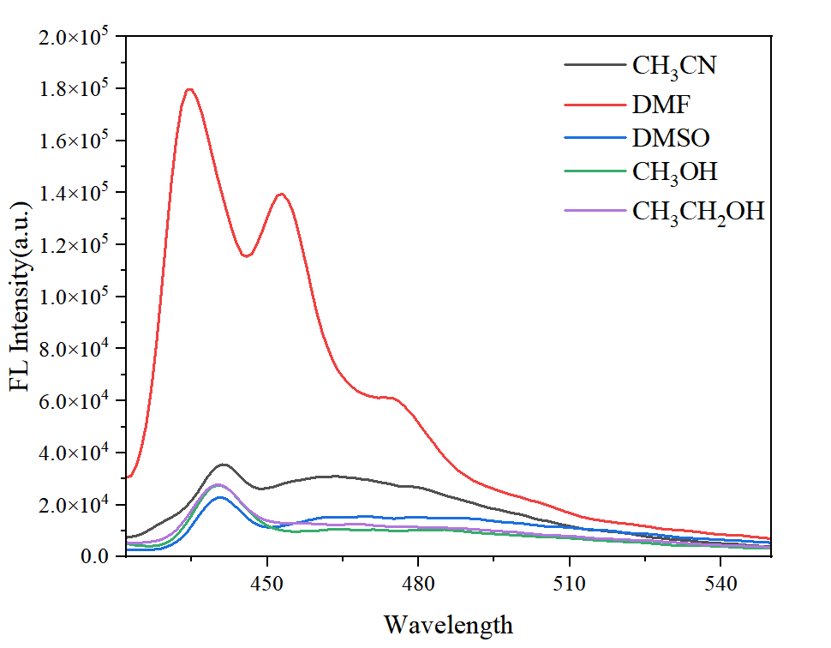
Figure S5. Fluorescence spectra of probe TDP in various pure solvents
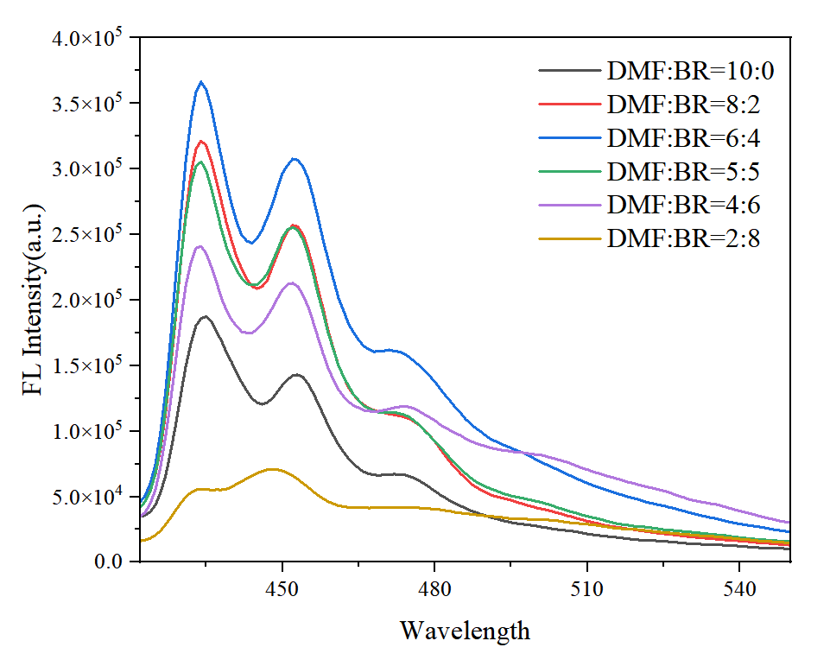
Figure S6. Fluorescence spectra of probe TDP at different DMF/BR ratios

