Supplementary Data
Mouse models of activity-based anorexia and binge-eating disorder show distinct patterns of intestinal barrier dysfunction and immune dysregulation
Petra Prochazkova¹*, Helena Knotkova¹, Janet Luthar^{1,2}, Radka Roubalova¹, Michal Kraus^{1,2}, Toghrul Naghiyev^{1,3}, Enrico Patrono¹, Helena Tlaskalova-Hogenova¹, Hana Papezova⁴
¹Institute of Microbiology of the Czech Academy of Sciences, Videnska 1083, Prague 4, Czech Republic
²First Faculty of Medicine, Charles University, Katerinska 32, Prague 2, Czech Republic
³Faculty of Science, Department of Cellular Biology, Charles University, Vinicna 7, Prague 2, Czech Republic
⁴Department of Psychiatry, First Faculty of Medicine, Charles University and General University Hospital in Prague, Ke Karlovu 11, Prague 2, Czech Republic
*Corresponding author: Petra Prochazkova, Institute of Microbiology of the CAS, Videnska 1083, Prague 4, 14220, Czech Republic; e-mail: petra.prochazkova@mbu.cas.cz; Tel.: +420-2-4106-2367

Fig. S1. Evaluation and screening of reference genes in the colon and hypothalamus using RefFinder. Geometric means of ranking values are shown. For the analysis, a pooled cDNA sample containing equal amounts of cDNA from all experimental groups was used to evaluate and identify the most stable reference genes (1).

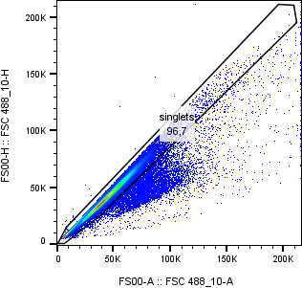
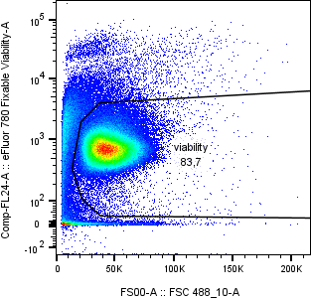
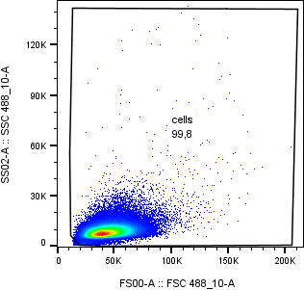
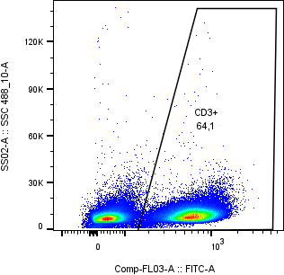
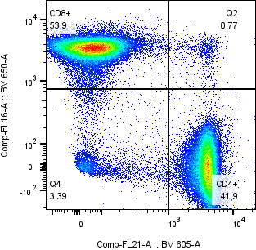
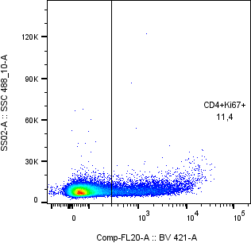
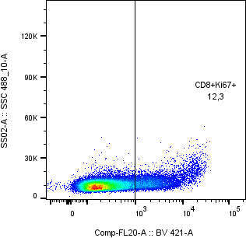
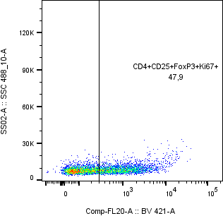
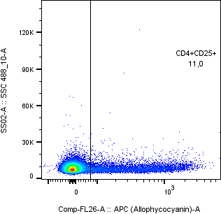
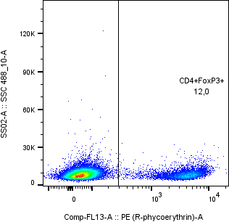
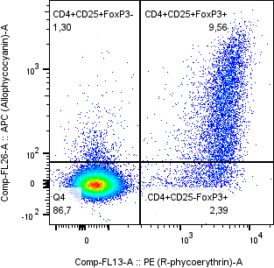
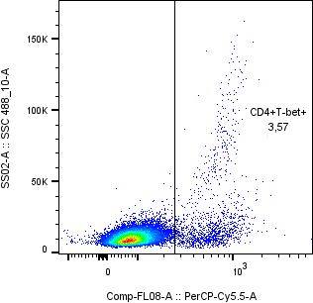
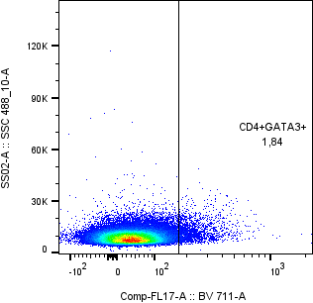
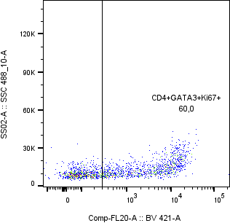
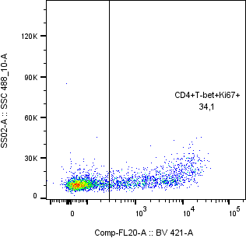
Fig. S2. Representative flow cytometry gating strategy for T-cell subsets using spleen cells of control BALB/c mice. Sequential gating was performed on singlets, viable cells, lymphocytes, and CD3⁺ T cells, followed by discrimination of CD4⁺ and CD8⁺ subsets. Transcription factor expression within defined T-cell populations was quantified within each population.

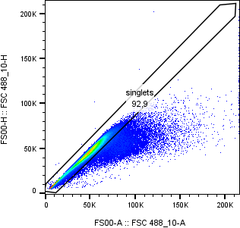
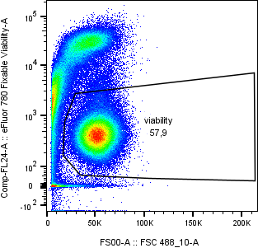
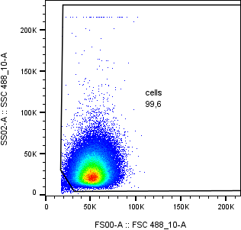
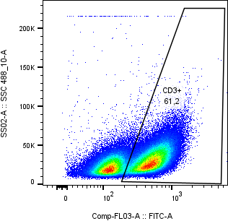
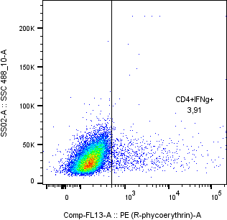
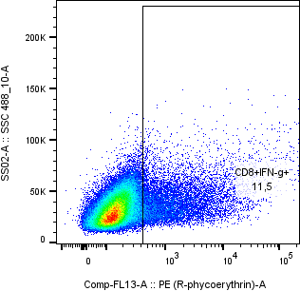
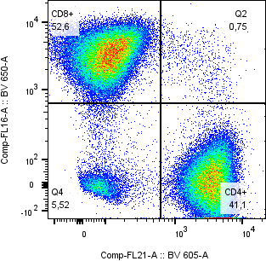
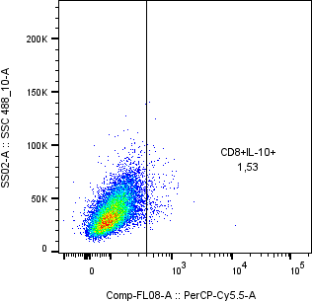
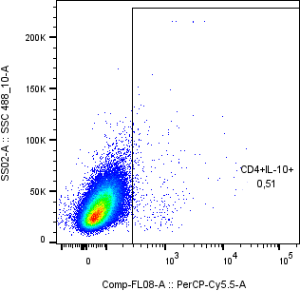
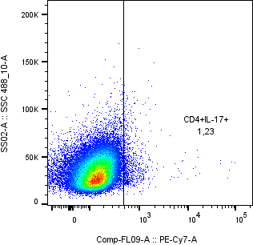
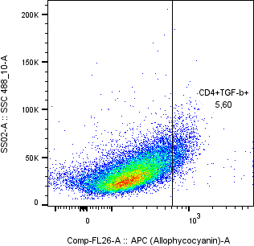
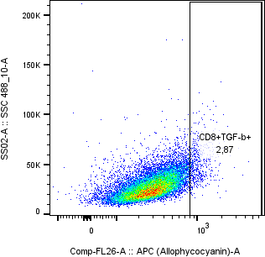
Fig. S3. Representative flow cytometry gating strategy for cytokine production by T-cell subsets using spleen cells of control BALB/c mice. Sequential gating was performed on singlets, viable cells, lymphocytes, and CD3⁺ T cells, followed by discrimination of CD4⁺ and CD8⁺ subsets. Transcription factor expression within defined T-cell populations was quantified within each population.

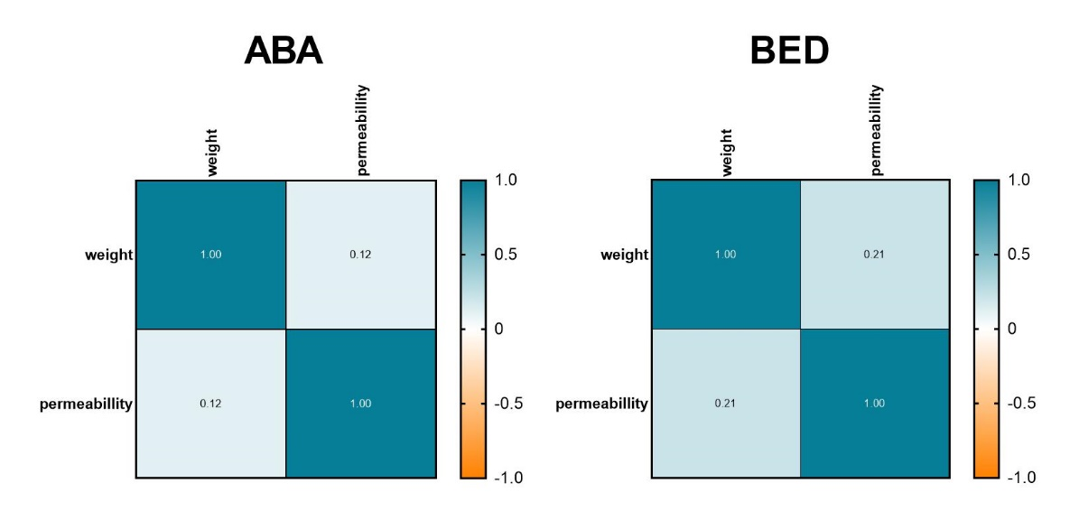
Fig. S4. Correlation between body weight and intestinal permeability (serum FITC-dextran levels) in ABA (female Balb/c) and BED (male C57Bl/6) mice. Spearman correlation analysis between mouse body weight and serum FITC-dextran levels in activity-based anorexia (ABA) and binge-eating disorder (BED) models. Mice received a weight-adjusted oral dose of FITC-dextran (500 µg/g body weight), and blood samples were collected 3 hours post-administration. Spearman correlation coefficients (R values) are shown for each group. n = 10 mice/group.

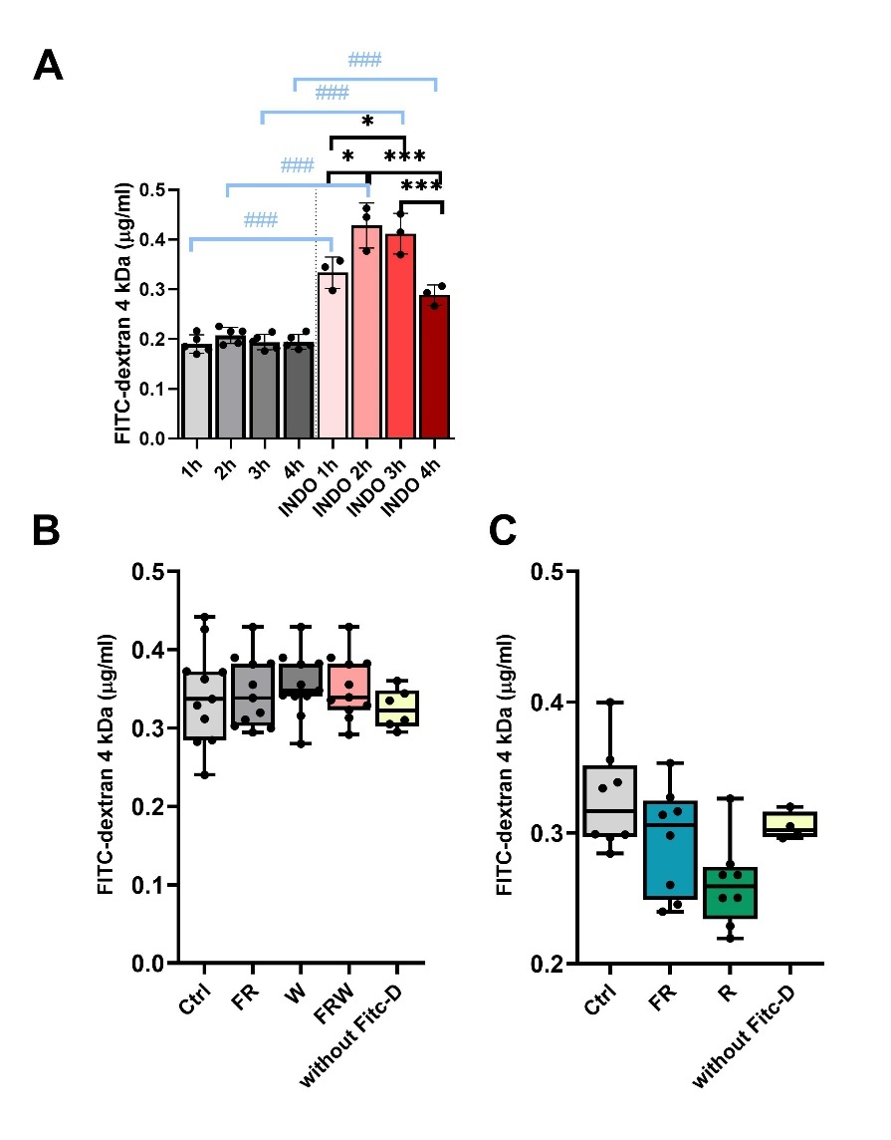
Fig. S5. Preliminary assessment of BBB permeability was measured in brain homogenates of female BALB/c mice following oral gavage of 4 kDa FITC-dextran. Mice received FITC-dextran, and fluorescence was measured in homogenates at 1, 2, 3, and 4 hours post-gavage. Indomethacin-treated mice served as positive controls for increased BBB permeability. (A) Time-dependent FITC-dextran translocation; (B) comparison of brain homogenate levels of translocated FITC-dextran in Balb/C mice in the ABA model; (C) comparison of brain homogenate levels of translocated FITC-dextran in male C57Bl/6 mice in the BED model. Data were analyzed using one-way ANOVA with Tukey’s post hoc test. Black lines connect bars compared within the same experimental group. Blue lines connect bars comparing indomethacin-treated mice with their vehicle-treated counterparts. Asterisks and hash signs indicate statistical significance: * p < 0.05, ** p < 0.01, ***### p < 0.001, ****#### p < 0.0001. Values represent the mean ± SD or span the complete range from minimum to maximum. Sample sizes: assessment of optimal brain collection time, n = 5 and 3 with INDO per interval; measurement of BBB: ABA = 11 mice/group, mice without FITC-dextran: n = 6; BED = 8 mice/group, mice without FITC-dextran: n = 4. INDO – indomethacin; FR – food restriction; FRW – food restriction with running wheel; R – restrained; W – running wheel.

Immunohistology - methodology
After sacrifice, colons were excised, embedded in O.C.T. compound (Avantor, USA), frozen on dry ice, and stored at −80 °C. Tissue sections (8 µm) were prepared using a cryostat (CM1950, Leica, Germany). For immunostaining, sections were fixed in 4% paraformaldehyde for 5 min, washed, and subjected to antigen retrieval in 0.01 M citrate buffer (pH 8.5) at 80 °C for 15 min. Sections were blocked with 5% FBS in TBS containing 0.3% Triton X-100 for 1 h at room temperature, followed by overnight incubation at 4 °C with primary antibodies (anti-ZO-1; 1:500, and anti-claudin-1; 1:50, Thermo Fisher Scientific, USA). Sections were incubated with Alexa Fluor 594-conjugated chicken anti-rabbit secondary antibody (1:500 or 1:100, respectively; Thermo Fisher Scientific, USA) for 3 h at room temperature (Table S3). Images were acquired using a confocal microscope (STELLARIS, Leica, Germany) with a 40× glycerol-immersion objective. Z-stacks were processed in Fiji (ImageJ) (2) by maximum-intensity projection and background subtraction. Regions of interest (ROIs), corresponding to colonic crypts, were manually selected. For each animal, five representative crypts were analyzed, and mean and median fluorescence intensities were calculated per crypt and subsequently averaged to obtain a single value per mouse.
Fig. S6. Fluorescence intensity of claudin-1 in the colon of ABA mice. Representative images showing immunofluorescence staining of claudin-1 and median fluorescence intensity. Data were analyzed using the non-parametric Kruskal-Wallis test. Values are presented as a range (min–max). ABA groups (n = 5mice/group): Ctrl – control; FR – food restriction; FRW – food restriction with running wheel; W – running wheel.
Fig. S7. Fluorescence intensity of tight junction protein-1 (TJP-1) in the colon of ABA mice. Representative images showing immunofluorescence staining of TJP-1 and median fluorescence intensity. Data were analyzed using the non-parametric Kruskal-Wallis test. Values are presented as a range (min–max). ABA groups (n = 5 mice/group): Ctrl – control; FR – food restriction; FRW – food restriction with running wheel; TJP-1; W – running wheel.
Fig. S8. Fluorescence intensity of tight junction protein-1 (TJP-1) in the colon of BED mice. Representative images showing immunofluorescence staining of TJP-1 and median fluorescence intensity. Data were analyzed using the non-parametric Kruskal-Wallis test. Values are presented as a range (min–max). BED groups: Ctrl (n = 4 mice) and FR/R (n = 7/8 mice). Ctrl – control; FR – food restriction; R – restraint; TJP-1 – tight junction protein-1.
Fig. S9. Fluorescence intensity of claudin-1 in the colon of BED mice. Representative images showing immunofluorescence staining of claudin-1 and median fluorescence intensity. Data were analyzed using the non-parametric Kruskal-Wallis test. Values are presented as a range (min–max). BED groups: Ctrl (n = 4 mice) and FR/R (n = 7/8 mice). Ctrl – control; FR – food restriction; R – restraint.

Table S1. Primers used in this study.
Name | Sequence (5´–3´) | Target | Size
ACTB_F | TTGCTGACAGGATGCAGAAG | Actb - Actin beta | 85 bp
ACTB_R | GTACTTGCGCTCAGGAGGAG | Actb - Actin beta | 85 bp
GAPDH_F | CGTCCCGTAGACAAAATGGT | Gapdh - Glyceraldehyde 3-phosphate dehydrogenase | 110 bp
GAPDH_R | TTGATGGCAACAATCTCCAC | Gapdh - Glyceraldehyde 3-phosphate dehydrogenase | 110 bp
Occludin_F | GATCATGGCACTGTTCTTCTC | Ocln - Occludin | 103 bp
Occludin_R | CACACCTGGATAAATCCAGC | Ocln - Occludin | 103 bp
JAM-A_F | CACCTACTCTGGCTTCTCCTCT | Jama - Junctional adhesion molecule A | 131 bp
JAM-A_R | TGCCACTGGATGAGAAGGTGAC | Jama - Junctional adhesion molecule A | 131 bp
TJP-1_F | GTTGGTACGGTGCCCTGAAAGA | Tjp1 - Tight junction protein-1 | 132 bp
TJP-1_R | GCTGACAGGTAGGACAGACGAT | Tjp1 - Tight junction protein-1 | 132 bp
TJP-2_F | GCCTGCAAGAAGGAGACCAGAT | Tjp2 - Tight junction protein-2 | 127 bp
TJP-2_R | CTCGGCTCTGAGCCAAAATGGT | Tjp2 - Tight junction protein-2 | 127 bp
TJP-3_F | TGCCATTTCGGAACCTGACTCG | Tjp3 - Tight junction protein-3 | 151 bp
TJP-3_R | GTGCGGATGTAGAAGGAGTCAC | Tjp3 - Tight junction protein-3 | 151 bp
Mucin-2_F | TCCTGACCAAGAGCGAACAC | Muc2 - Mucin-2 | 101 bp
Mucin-2_R | ACAGCACGACAGTCTTCAGG | Muc2 - Mucin-2 | 101 bp
Claudin-1_F | GGACTGTGGATGTCCTGCGTTT | Cldn1 - Claudin-1 | 116 bp
Claudin-1_R | GCCAATTACCATCAAGGCTCGG | Cldn1 - Claudin-1 | 116 bp
Claudin-2_F | AGGACTTCCTGCTGACATCCAG | Cldn2 - Claudin-2 | 119 bp
Claudin-2_R | AATCCTGGCAGAACACGGTGCA | Cldn2 - Claudin-2 | 119 bp
Claudin-3_F | TCATCGTGGTGTCCATCCTGCT | Cldn3 - Claudin-3 | 141 bp
Claudin-3_R | AGAGCCGCCAACAGGAAAAGCA | Cldn3 - Claudin-3 | 141 bp
Claudin-4_F | CGAGCCCTTATGGTCATCAGCA | Cldn4 - Claudin-4 | 149 bp
Claudin-4_R | ATGCTTGCCACGATGAACACGG | Cldn4 - Claudin-4 | 149 bp
Claudin-5_F | TAACCTGAAAGGGCAGCTGGAGAAAC | Cldn5 - Claudin-5 | 118 bp
Claudin 5_R | AGGTCCAGGCTAAGTCCTTTGGTTCAGTAG | Cldn5 - Claudin-5 | 118 bp
Claudin-7_F | CTGCCTTGGTAGCATGTTCCTG | Cldn7 - Claudin-7 | 91 bp
Claudin-7_R | CCAGCCGATAAAGATGGCAGGT | Cldn7 - Claudin-7 | 91 bp
Claudin-8_F | GTGGAGAGTGTCTGCCTTCATC | Cldn8 - Claudin-8 | 133 bp
Claudin-8_R | TAAGAGCCAGCAGGGAGTCGTA | Cldn8 - Claudin-8 | 133 bp
Claudin-12_F | GGACTCTGCTTCCTAACTGGAG | Cldn12 - Claudin-12 | 125 bp
Claudin-12_R | TCAGGCAGTCACTGCTTCCATC | Cldn12 - Claudin-12 | 125 bp

Table S2. List of antibodies used for flow cytometry analyses.

Epitope – Fluorochrome | Clone | Manufacturer | Cat#
CD3ε (purified) | 145-2C11 | Thermo Fisher Scientific | 14-0031-86
CD28 (purified) | 37.51 | BioLegend | 102121
CD16/32 (purified) | 93 | Thermo Fisher Scientific | 14-0161-82
Fixable Viability Dye eFluor 780 |  | Thermo Fisher Scientific | 65-0865-14
CD3ε – FITC | 145-2C11 | BioLegend | 100306
CD4 – Brilliant violet 605 | GK1.5 | BioLegend | 100451
CD8 – Brilliant violet 650 | 53-6.7 | BioLegend | 100742
CD25 – APC | PC61.5 | Thermo Fisher Scientific | 17-0251-82
Foxp3 – PE | FJK-16s | Thermo Fisher Scientific | 12-5773-82
Ki-67 – BV421 | 16A8 | BioLegend | 65411
T-bet – PerCPCy5.5 | 4B10 | BioLegend | 644806
GATA3 – BV711 | L50-823 | BD Horizon | 565449
IFN-γ – PE | XMG1.2 | Thermo Fisher Scientific | 12-7311-81
IL-17A – PE-Cy7 | eBio1787 | Thermo Fisher Scientific | 25-7177-80
IL10 – PerCP–Cy5.5 | JeS5-16E3 | BioLegend | 505027
TGF-β1 – APC | TW7-16B4 | BioLegend | 141405

Table S3. List of antibodies used for immunohistochemistry.

Antibody | Dilution | Manufacturer | Cat#
anti-ZO-1 (TJP-1) | 1:500 | Thermo Fisher Scientific | 21773-1-AP
anti-claudin-1 | 1:50 | Thermo Fisher Scientific | 71-7800
Alexa Fluor 594-conjugated chicken anti-rabbit secondary antibody | 1:500/1:100 | Thermo Fisher Scientific | A-21442

References:
1. Xie F, Xiao P, Chen D, Xu L, Zhang B. miRDeepFinder: a miRNA analysis tool for deep sequencing of plant small RNAs. Plant Mol Biol. 2012.
2. Schindelin J, Arganda-Carreras I, Frise E, Kaynig V, Longair M, Pietzsch T, et al. Fiji: an open-source platform for biological-image analysis. Nat Methods. 2012;9(7):676-82.

