Extended data
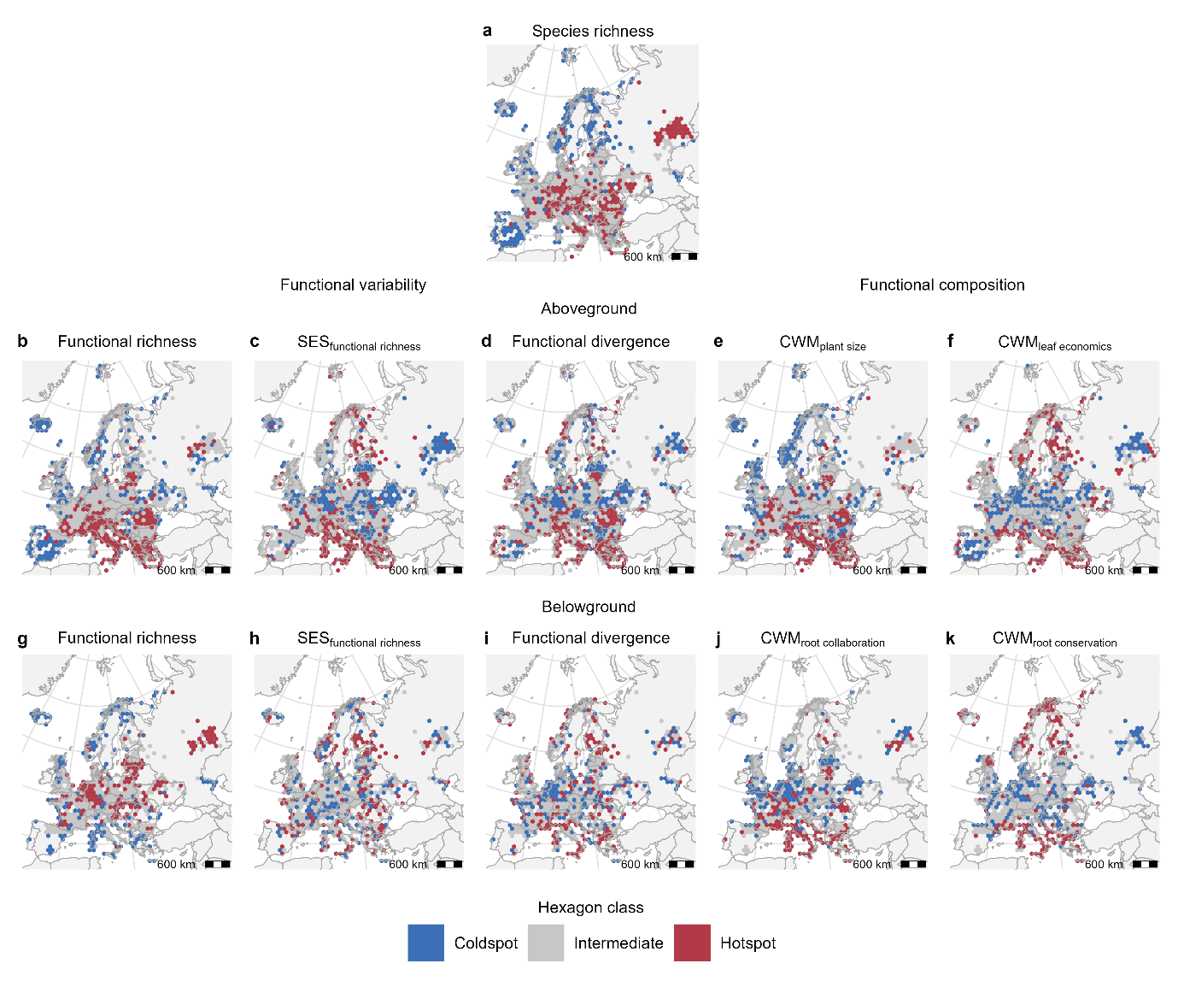
Extended Data Fig. 1 | Hotspots and coldspots of above- and belowground functional structure across Europe. Panels show species richness (a), functional variability (b-d, g-i), and functional composition (e-f, j-k) in above- (b-f) and belowground (g-k) plant compartments. Hotspots (>75%) are shown in red, intermediate values (25-75%) in grey, and coldspots (<25%) in blue, based on median values per hexagon. Species richness was log-transformed, and all variables were centered and scaled prior to classification. SES_{fr}: standardized effect size of functional richness, CWMs: community-weighted means. Sample sizes were n = 29,223 (species richness), n = 29,105 (aboveground), and n = 8,875 (belowground).
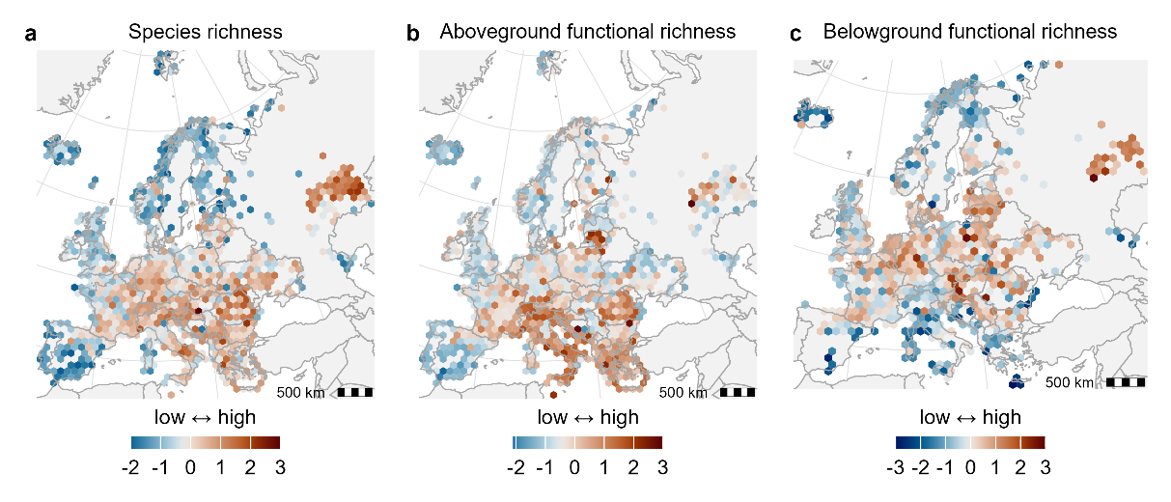
Extended Data Fig. 2 | Spatial patterns of species richness (a) and above- (b) and belowground (c) raw functional richness across Europe. Colors show the hexagonal medians of standardized values (z-scores) and are centered on the median to show relative spatial differences within variables. Species richness was log-transformed, and all variables were centered and scaled prior to mapping. Sample sizes were n = 29,223 (species richness), n = 29,105 (aboveground), and n = 8,875 (belowground).
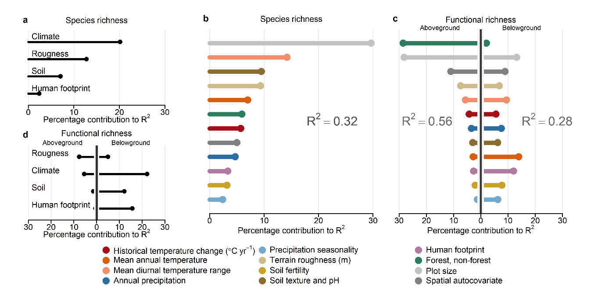
Extended Data Fig. 3 | Relative contributions of environmental drivers to species richness (a-b) and raw functional richness (c-d) across Europe. Black lines indicate contributions of major driver categories (a, d), whereas colored lines represent contributions of individual predictors (b, c), expressed as a percentage of explained variance (R²). Predictors are ordered by decreasing contribution to the species richness (a-b) and the aboveground plant compartment (c-d).
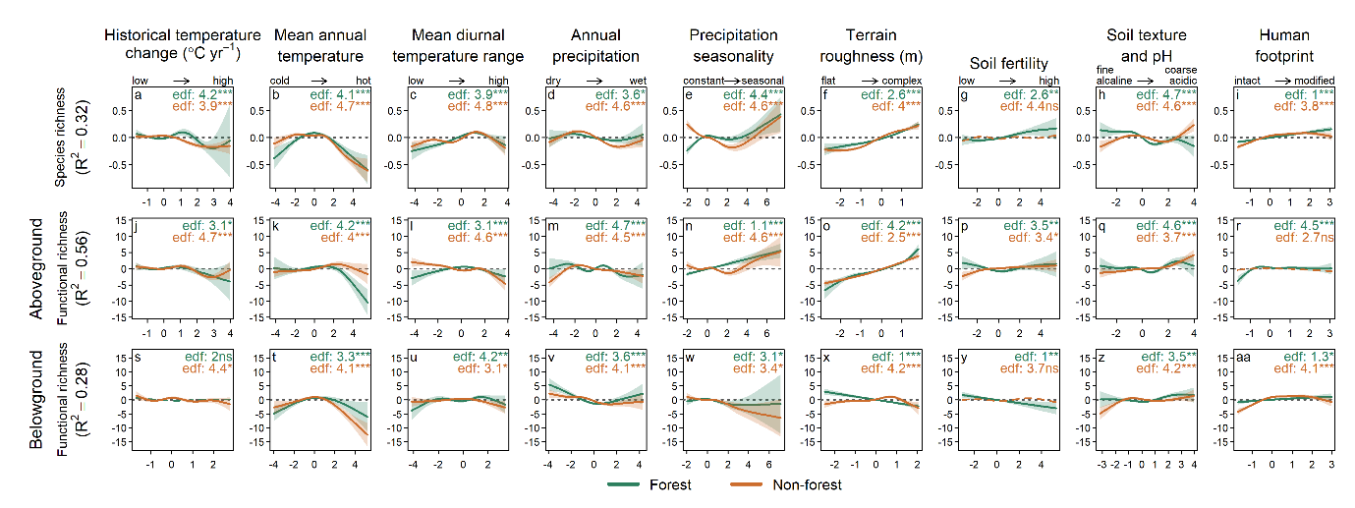
Extended Data Fig. 4 | Environmental effects on species richness and above- and belowground raw functional richness across Europe. Panels show partial dependence plots from generalized additive models (GAMs) for species richness and raw functional richness in above- and belowground compartments. Solid lines represent fitted smooths, shaded areas indicate 95% confidence intervals, and dashed lines denote non-significant effects. Colors indicate vegetation type (forest, green; non-forest, orange). R² values show the total explained variance of each model. Effective degrees of freedom (edf) and significance levels are reported within panels (***p < 0.001, **p < 0.01, *p < 0.05; ns, not significant).

