Supplementary information for the paper:
Congruent functional patterns conceal contrasting environmental drivers of aboveground and belowground community assembly across Europe

Blanca Luz Caleño-Ruiz¹, Enrico Tordoni^{2†}, and Carlos P. Carmona^{1,3†}

¹Institute of Ecology and Earth Sciences, University of Tartu, Tartu, Estonia.
²Department of Biological, Geological, and Environmental Sciences, Alma Mater Studiorum University of Bologna, Bologna, Italy.
³Misión Biológica de Galicia, Consejo Superior de Investigaciones Científicas CSIC, Pontevedra, Spain.

Corresponding author: blanca.caleno@gmail.com, blanca.luz.caleno.ruiz@ut.ee
†Carlos P. Carmona and Enrico Tordoni share senior co-authorship.

Supplementary figures
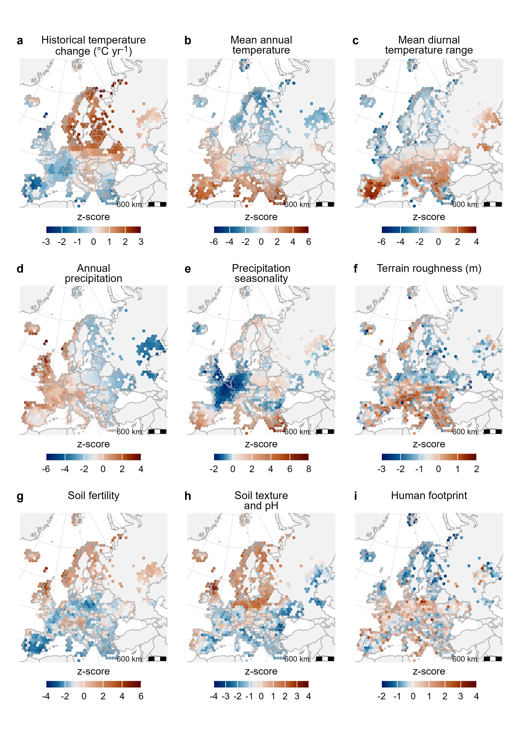
Supplementary Fig. 1 | Spatial patterns of environmental drivers across Europe. Panels show climatic variables (a-e), terrain roughness (f), soil properties (g-h), and human footprint (i). Colors show the hexagonal medians of standardized values (z-scores) and are centered on the median to show relative spatial differences within variables. Total sample size was n = 32,596 plots.
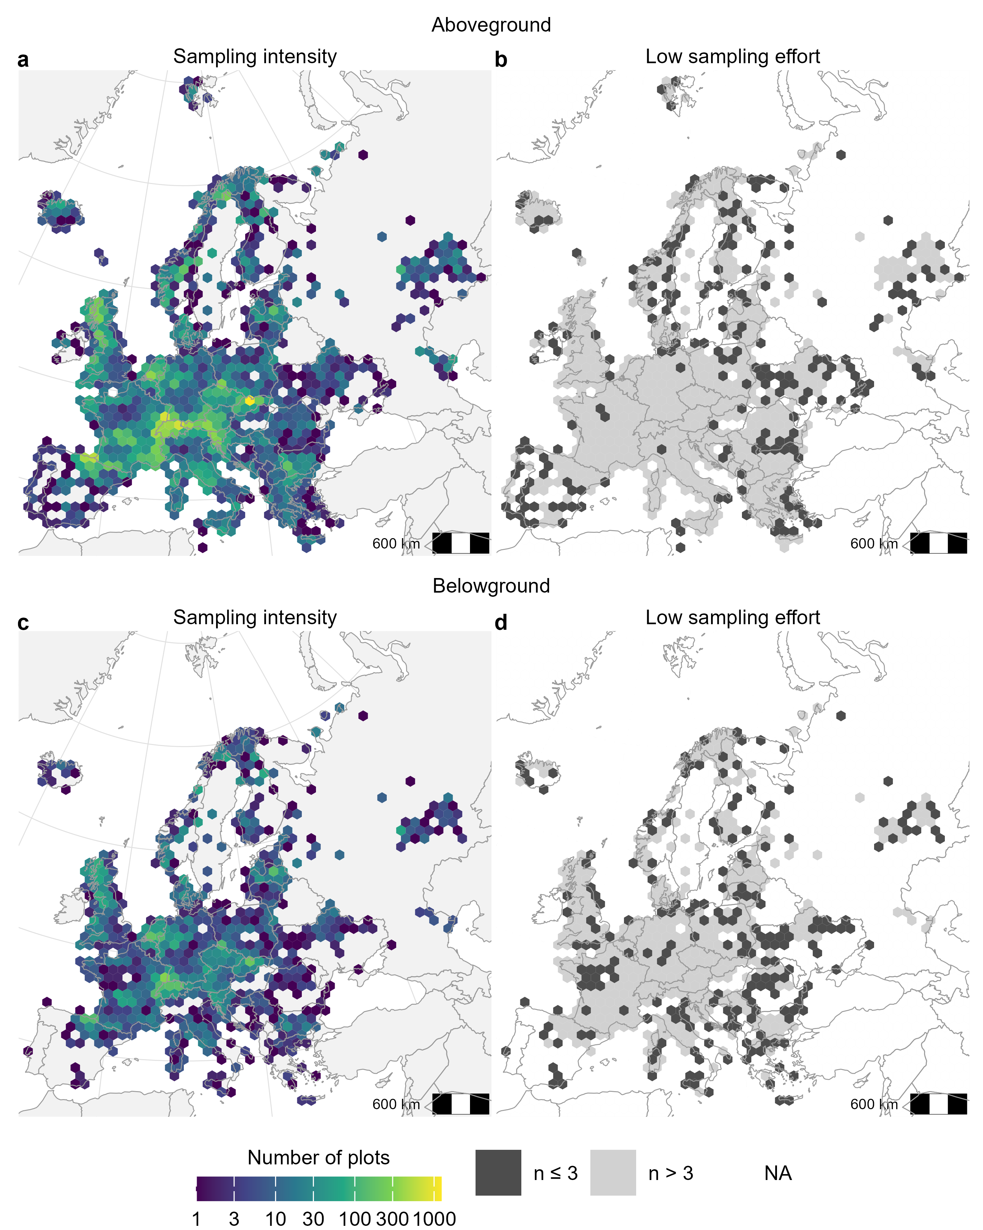
Supplementary Fig. 2 | Spatial distribution of sampling effort across Europe for above- (a, b) and belowground datasets (c, d). Sampling intensity was quantified as the number of vegetation plots per 100-km hexagonal grid cell (a, c) and displayed using a logarithmic (log10) color scale. Sampling effort was classified as low for hexagons containing three or fewer plots (b, d). Both datasets show broadly similar geographic coverage but heterogeneous sampling intensity across Europe. The aboveground dataset comprises 29,105 plots, and the belowground dataset 8,875 plots.
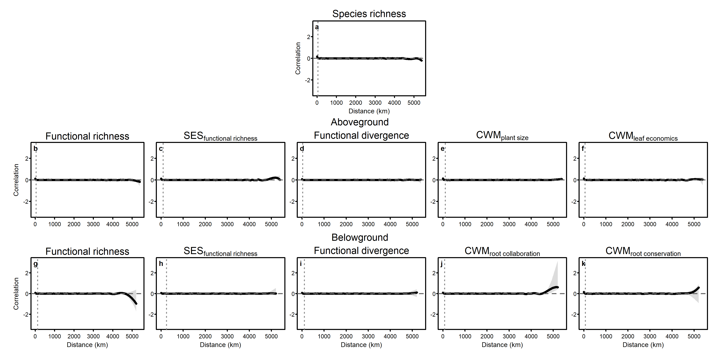
Supplementary Fig. 3 | Spline correlograms of residuals from generalized additive models (GAMs) for species richness (a) and plant functional structure in above- (b-f) and belowground compartments (g-k). Solid lines show fitted spatial correlation, shaded areas indicate bootstrap confidence envelopes, the horizontal dashed line denotes zero correlation, and the vertical dashed line marks the distance at which correlation approaches zero. The consistently weak correlations across spatial distances indicate that residual spatial autocorrelation was effectively controlled in the models.

Supplementary tables

Supplementary Table 1 | Relative contributions of environmental drivers to variation in species richness and above- and belowground functional structure across Europe. Contributions, expressed as percentages of explained variance (R²), were derived from hierarchical partitioning of generalized additive models (GAMs). SES_{fr}: standardized effect size of functional richness, CWMs: community-weighted means. Cell shading indicates the magnitude of the contribution; the five strongest predictors per response are highlighted in red, with the remaining predictors in blue. Vegetation type is shown in bold where its contribution is high.
 |  | Aboveground
Predictor/model | Species richness | Raw functional richness | SES_{fr} | Functional divergence | CWM_{plant size} | CWM_{leaf economics}
Variance explained (R²) | 0.32 | 0.56 | 0.34 | 0.37 | 0.66 | 0.21
Historical temperature change (°C yr⁻¹) | 5.71 | 4.27 | 5.81 | 5.43 | 4.37 | 3.4
Mean annual temperature | 7 | 2.79 | 7.83 | 5.85 | 9.96 | 17.75
Mean diurnal temperature range | 14.22 | 5.61 | 3.9 | 4.69 | 3.42 | 12.21
Annual precipitation | 4.71 | 3.42 | 5.09 | 3.87 | 3.27 | 8.08
Precipitation seasonality | 2.39 | 1.22 | 6.13 | 2.69 | 3.34 | 12.17
Terrain roughness (m) | 9.35 | 7.39 | 5.29 | 5.16 | 4.01 | 3.95
Soil fertility | 3.17 | 2.06 | 2.86 | 2.66 | 6.01 | 6.54
Soil texture and pH | 9.51 | 2.94 | 3.15 | 2.74 | 5.41 | 4.58
Human footprint | 3.33 | 2.63 | 3.64 | 3.77 | 4.16 | 7.54
Vegetation type | 5.93 | 28.53 | 36.64 | 44.14 | 34.15 | 5.67
Plot size (m²) | 29.66 | 28.14 | 9.82 | 15.72 | 17.85 | 2.13
Spatial autocovariate | 5.02 | 11 | 9.85 | 3.29 | 4.07 | 15.98
 |  | Belowground
Predictor/model |  | Raw functional richness | SES_{fr} | Functional divergence | CWM_{root collaboration} | CWM_{root conservation}
Variance explained (R²) |  | 0.28 | 0.05 | 0.1 | 0.59 | 0.38
Historical temperature change (°C yr⁻¹) |  | 5.6 | 9.98 | 3.46 | 5.04 | 4.97
Mean annual temperature |  | 13.94 | 12.25 | 9.78 | 7.69 | 14.23
Mean diurnal temperature range |  | 9.45 | 10.89 | 9.52 | 3.23 | 12.72
Annual precipitation |  | 7.56 | 8.17 | 7.27 | 3 | 4.51
Precipitation seasonality |  | 6.28 | 10.14 | 6.06 | 7.19 | 11.37
Terrain roughness (m) |  | 6.82 | 9.83 | 12.54 | 4.77 | 3.61
Soil fertility |  | 7.8 | 6.05 | 4.93 | 3.46 | 11.21
Soil texture and pH |  | 6.21 | 11.04 | 6.75 | 2.57 | 10.19
Human footprint |  | 12.09 | 4.54 | 5.8 | 2.06 | 13.03
Vegetation type |  | 2.06 | 0 | 25.52 | 39.54 | 4.15
Plot size (m²) |  | 13.23 | -0.15 | 1.99 | 13.49 | 1.18
Spatial autocovariate |  | 8.95 | 17.25 | 6.4 | 7.94 | 8.83
Supplementary Table 2 | Parametric coefficients from generalized additive models (GAMs) for species richness and above- and belowground functional structure. Coefficients correspond to linear terms included in the models. Significance levels are indicated as follows: ***p < 0.001, **p < 0.01, *p < 0.05; ns, not significant.
Species richness
Model | Parametric coefficient | Estimate | Standard error | p-value | Significance
Species richness  (R² =0.32) | Intercept | 2.973 | 0.008 | 0.000 | ***
Species richness  (R² =0.32) | Vegetation type | 0.037 | 0.010 | 0.000 | ***
Species richness  (R² =0.32) | Plot size (m²) | 0.227 | 0.005 | 0.000 | ***
Plant functional structure
Aboveground |  |  |  |  |  | Belowground
Model | Parametric coefficient | Estimate | Standard error | p-value | Significance | Model | Parametric coefficient | Estimate | Standard error | p-value | Significance
Raw functional richness  (R² =0.56) | Intercept | 42.971 | 0.132 | 0.000 | *** | Raw functional richness  (R² =0.28) | Intercept | 26.172 | 0.166 | 0.000 | ***
Raw functional richness  (R² =0.56) | Vegetation type | -7.829 | 0.165 | 0.000 | *** | Raw functional richness  (R² =0.28) | Vegetation type | 1.941 | 0.215 | 0.000 | ***
Raw functional richness  (R² =0.56) | Plot size (m²) | 4.386 | 0.086 | 0.000 | *** | Raw functional richness  (R² =0.28) | Plot size | 1.846 | 0.117 | 0.000 | ***
SES_{fr}  (R² =0.34) | Intercept | -0.465 | 0.019 | 0.000 | *** | SES_{fr}  (R² =0.05) | Intercept | -0.761 | 0.025 | 0.000 | ***
SES_{fr}  (R² =0.34) | Vegetation type | -1.097 | 0.024 | 0.000 | *** | SES_{fr}  (R² =0.05) | Vegetation type | -0.020 | 0.032 | 0.538 | ns
SES_{fr}  (R² =0.34) | Plot size (m²) | 0.126 | 0.012 | 0.000 | *** | SES_{fr}  (R² =0.05) | Plot size | -0.003 | 0.017 | 0.848 | ns
Functional divergence  (R² =0.37) | Intercept | 0.586 | 0.002 | 0.000 | *** | Functional divergence  (R² =0.1) | Intercept | 0.516 | 0.003 | 0.000 | ***
Functional divergence  (R² =0.37) | Vegetation type | -0.123 | 0.002 | 0.000 | *** | Functional divergence  (R² =0.1) | Vegetation type | -0.046 | 0.003 | 0.000 | ***
Functional divergence  (R² =0.37) | Plot size (m²) | 0.018 | 0.001 | 0.000 | *** | Functional divergence  (R² =0.1) | Plot size | -0.009 | 0.002 | 0.000 | ***
CWM_{plant size}  (R² =0.66) | Intercept | 0.801 | 0.011 | 0.000 | *** | CWM_{root collaboration}  (R² =0.59) | Intercept | -0.700 | 0.018 | 0.000 | ***
CWM_{plant size}  (R² =0.66) | Vegetation type | -1.136 | 0.014 | 0.000 | *** | CWM_{root collaboration}  (R² =0.59) | Vegetation type | 0.992 | 0.022 | 0.000 | ***
CWM_{plant size}  (R² =0.66) | Plot size (m²) | 0.237 | 0.007 | 0.000 | *** | CWM_{root collaboration}  (R² =0.59) | Plot size | -0.146 | 0.012 | 0.000 | ***
CWM_{leaf economics}  (R² =0.21) | Intercept | 0.683 | 0.016 | 0.000 | *** | CWM_{root conservation}  (R² =0.38) | Intercept | 0.872 | 0.014 | 0.000 | ***
CWM_{leaf economics}  (R² =0.21) | Vegetation type | -0.190 | 0.020 | 0.000 | *** | CWM_{root conservation}  (R² =0.38) | Vegetation type | -0.152 | 0.018 | 0.000 | ***
CWM_{leaf economics}  (R² =0.21) | Plot size (m²) | 0.091 | 0.010 | 0.000 | *** | CWM_{root conservation}  (R² =0.38) | Plot size | 0.021 | 0.010 | 0.036 | *

Supplementary Table 3 | Significance and estimated degrees of freedom (edf) of smooth terms from generalized additive models (GAMs) for species richness and above- and belowground functional structure. Estimated degrees of freedom (edf) describe the complexity of each smooth term, and approximate significance is reported. Significance levels are indicated as follows: ***p < 0.001, **p < 0.01, *p < 0.05; ns, not significant.
 | Estimated degrees of freedom (edf)
Model | Species richness  R² = 0.32
Predictor | Forest |  | Non-forest
Historical temperature change (°C yr⁻¹) | 4.22 | *** | 3.91 | ***
Mean annual temperature | 4.1 | *** | 4.71 | ***
Mean diurnal temperature range | 3.89 | *** | 4.75 | ***
Annual precipitation | 3.59 | * | 4.58 | ***
Precipitation seasonality | 4.38 | *** | 4.56 | ***
Terrain roughness (m) | 2.61 | *** | 4.03 | ***
Soil fertility | 2.62 | ** | 4.43 | ns
Soil texture and pH | 4.67 | *** | 4.57 | ***
Human footprint | 1.02 | *** | 3.82 | ***
Residuals autocovariate | 2.22 | *** | 4.78 | ***
Plant compartment | Aboveground
Model | Raw functional richness  R² =0.56 |  |  |  | SES_{fr}  R² =0.34 |  |  |  | Functional divergence  R² =0.37 |  |  |  | CWM_{plant size}  R² =0.66 |  |  |  |  | CWM_{leaf economics}  R² =0.21
Predictor | Forest |  | Non-forest |  | Forest |  | Non-forest |  | Forest |  | Non-forest |  | Forest |  | Non-forest |  |  | Forest |  | Non-forest
Historical temperature change (°C yr⁻¹) | 3.13 | * | 4.67 | *** | 4.7 | *** | 4.72 | *** | 3.52 | *** | 4.2 | ** | 2.93 | ** | 3.88 | * | 3.39 |  | * | 3.12 | **
Mean annual temperature | 4.22 | *** | 3.99 | *** | 3.9 | *** | 4.77 | *** | 4.85 | *** | 4.2 | *** | 4.86 | *** | 4.69 | *** | 4.67 |  | *** | 4.69 | ***
Mean diurnal temperature range | 3.09 | *** | 4.61 | *** | 2 | *** | 4.26 | *** | 3.77 | *** | 4.3 | *** | 4.45 | *** | 3.92 | *** | 4.04 |  | * | 4.9 | ***
Annual precipitation | 4.73 | *** | 4.49 | *** | 4.5 | *** | 4.59 | *** | 4.69 | *** | 4.3 | *** | 2.67 | *** | 3.4 | *** | 4.32 |  | *** | 4.88 | ***
Precipitation seasonality | 1.05 | *** | 4.59 | *** | 4.3 | *** | 1 | *** | 3.26 | ** | 1 | *** | 4.21 | *** | 4.75 | *** | 4.29 |  | *** | 4.46 | ***
Terrain roughness (m) | 4.17 | *** | 2.54 | *** | 3.5 | ** | 4.23 | *** | 2.7 | *** | 3.1 | ** | 4.4 | *** | 4.53 | *** | 4.38 |  | *** | 3.8 | ***
Soil fertility | 3.48 | ** | 3.43 | * | 2.5 | ns | 2.99 | *** | 1.3 | ns | 1 | *** | 4.81 | *** | 3.04 | ns | 4.66 |  | *** | 3.13 | ***
Soil texture and pH | 4.63 | *** | 3.74 | *** | 2.4 | *** | 4.52 | *** | 2.75 | ns | 4.5 | *** | 1 | *** | 4.46 | *** | 3.52 |  | *** | 4.28 | ***
Human footprint | 4.48 | *** | 2.69 | ns | 4.6 | *** | 4.35 | *** | 4.73 | *** | 2.2 | *** | 2.69 | *** | 2.64 | ns | 4.57 |  | *** | 1.41 | ***
Residuals autocovariate | 4.85 | *** | 4.87 | *** | 4.2 | *** | 4.91 | *** | 4.2 | ** | 4.4 | *** | 4.53 | *** | 4.62 | *** | 4.35 |  | *** | 4.93 | ***
Plant compartment | Belowground
Model | Raw functional richness  R² =0.28 |  |  |  | SES_{fr}  R² =0.05 |  |  |  | Functional divergence  R² =0.1 |  |  |  | CWM_{root collaboration}  R² =0.59 |  |  |  |  | CWM_{root conservation}  R² =0.38
Predictor | Forest |  | Non-forest |  | Forest |  | Non-forest |  | Forest |  | Non-forest |  | Forest |  | Non-forest |  |  | Forest |  | Non-forest
Historical temperature change (°C yr⁻¹) | 2.01 | ns | 4.45 | * | 4.3 | *** | 3.23 | * | 1.06 | ns | 1 | ns | 2.5 | *** | 4.83 | *** | 1 |  | * | 4.77 | ***
Mean annual temperature | 3.33 | *** | 4.1 | *** | 4.3 | *** | 3.48 | ** | 1 | *** | 4.3 | *** | 4.27 | *** | 4.61 | *** | 3.91 |  | *** | 4.65 | ***
Mean diurnal temperature range | 4.19 | ** | 3.1 | * | 4.2 | *** | 2.91 | ns | 1 | ns | 1 | ** | 2.4 | *** | 4.71 | *** | 2.08 |  | *** | 4.73 | ***
Annual precipitation | 3.6 | *** | 4.1 | *** | 3.5 | ns | 3.15 | ** | 1.82 | *** | 3.7 | * | 4.04 | *** | 2.62 | ** | 3.42 |  | ** | 3.76 | ***
Precipitation seasonality | 3.09 | * | 3.38 | * | 4.6 | *** | 3.57 | * | 1.01 | ns | 2.3 | *** | 2.57 | ns | 4.79 | *** | 3.87 |  | *** | 4.7 | ***
Terrain roughness (m) | 1 | *** | 4.23 | *** | 1 | *** | 1.93 | ns | 1.23 | *** | 2.2 | ns | 2.13 | *** | 2.04 | ns | 2.66 |  | *** | 3.71 | ***
Soil fertility | 1 | ** | 3.7 | ns | 1 | ns | 2.18 | ** | 1.01 | * | 2.4 | ns | 4.59 | *** | 1 | ns | 1 |  | * | 4.13 | ***
Soil texture and pH | 3.52 | ** | 4.2 | *** | 2.9 | ** | 3.95 | ** | 2.96 | ns | 3.1 | *** | 3.49 | * | 1.03 | *** | 3.49 |  | ** | 3.95 | ***
Human footprint | 1.31 | * | 4.08 | *** | 1.2 | * | 3.19 | * | 2.34 | ** | 3.2 | ** | 2.52 | *** | 3.97 | *** | 1 |  | *** | 4.11 | ***
Residuals autocovariate | 1 | ns | 3.86 | *** | 3.8 | *** | 3.19 | *** | 1.97 | ns | 3.9 | ** | 4.14 | *** | 3.64 | *** | 1 |  | *** | 3.78 | ***

Supplementary Table 4 | Summary statistics, species coverage of plant functional traits, and plots used in this study. Aboveground traits include plant height (ph, m), specific stem density (ssd, mg mm⁻³), leaf area (la, mm²), specific leaf area (sla, mm² mg⁻¹), leaf nitrogen (ln, mg g⁻¹), and seed dry mass (sm, mg). Belowground traits include specific root length (SRL, m g⁻¹), mean root diameter (D, mm), root tissue density (RTD, g cm⁻³), and root nitrogen concentration (N, mg g⁻¹).
Plant compartment | Trait | Mean | SD | Minimum | Maximum | Species with information | Species without information | Missingness (%) | Total species in sPlotOpen | Species with trait information | Species with complete information | Imputed species | Total species analyzed | Total plots from sPlotOpen | Plots included in maps | Plots included in models
Aboveground | ph | 1.232 | 4.238 | 0.01 | 71.88 | 4318 | 857 | 16.56 | 5175 | 5142 | 1074 | 1907 | 2981 | 38934 | 29105 | 18834
Aboveground | la | 2361.3 | 8575.47 | 0.195 | 155928 | 2818 | 2357 | 45.55
Aboveground | ln | 23.593 | 8.556 | 2.566 | 57.467 | 1540 | 3635 | 70.24
Aboveground | sla | 21.572 | 13.794 | 0.508 | 224 | 2936 | 2239 | 43.27
Aboveground | sm | 28.171 | 364.67 | 0 | 11476 | 4429 | 746 | 14.42
Aboveground | ssd | 0.268 | 0.142 | 0.094 | 1 | 2287 | 2888 | 55.81
Belowground | SRL | 117.427 | 137.714 | 0.791 | 1407.8 | 620 | 4555 | 88.02 | 5175 | 694 | 196 | 416 | 612 | 38934 | 8875 | 5947
Belowground | D | 0.338 | 0.237 | 0.03 | 3.1 | 628 | 4547 | 87.86
Belowground | RTD | 0.294 | 0.176 | 0.022 | 0.955 | 564 | 4611 | 89.1
Belowground | N | 13.263 | 6.576 | 1.37 | 38 | 277 | 4898 | 94.65

Supplementary Table 5 | Eigenvectors (loadings) from principal component analysis (PCA) and rotated components describing above- and belowground trait variation. PCA loadings correspond to eigenvectors of the covariance matrix and indicate the contribution of each trait to the principal components. Variance explained by the original components was derived from PCA eigenvalues. For the rotated solution, the variance associated with each axis was obtained by rotating the covariance matrix of the retained components, preserving the total variance of the retained subspace under orthogonal rotation. PC, principal component. Aboveground traits include plant height (ph, m), specific stem density (ssd, mg mm⁻³), leaf area (la, mm²), specific leaf area (sla, mm² mg⁻¹), leaf nitrogen (ln, mg g⁻¹), and seed dry mass (sm, mg). Belowground traits include specific root length (SRL, m g⁻¹), mean root diameter (D, mm), root tissue density (RTD, g cm⁻³), and root nitrogen concentration (N, mg g⁻¹).
Aboveground |  |  |  |  |  |  | Belowground
Unrotated
 | PCA loadings (eigenvectors) |  |  |  |  |  |  | PCA loadings (eigenvectors)
Trait | PC1 | PC2 | PC3 | PC4 | PC5 | PC6 | Trait | PC1 | PC2 | PC3 | PC4
ph | 0.496 | 0.348 |  | 0.212 | 0.354 | 0.679 | SRL | 0.663 | 0.201 | 0.133 | 0.709
la |  | 0.601 | 0.685 | -0.276 |  | -0.303 | D | -0.479 | -0.592 | 0.341 | 0.551
ln | -0.325 | 0.457 | -0.569 | -0.484 | 0.357 |  | RTD | -0.491 | 0.465 | -0.592 | 0.438
sla | -0.429 | 0.35 |  | 0.791 | 0.167 | -0.197 | N | 0.3 | -0.627 | -0.718
sm | 0.388 | 0.416 | -0.414 | 0.112 | -0.686 | -0.147
ssd | 0.558 | -0.118 | -0.179 |  | 0.499 | -0.622
 | Importance of components |  |  |  |  |  |  | Importance of components
Standard deviation | 1.4920 | 1.3087 | 0.8025 | 0.7500 | 0.7177 | 0.5780 |  | 1.3714 | 1.0913 | 0.8319 | 0.4646
Eigenvalues (standard deviation²) | 2.2261 | 1.7127 | 0.6440 | 0.5625 | 0.5150 | 0.3341 |  | 1.8807 | 1.1909 | 0.6921 | 0.2159
Proportion of variance | 0.3714 | 0.2857 | 0.1074 | 0.0938 | 0.0859 | 0.0557 |  | 0.4726 | 0.2993 | 0.1739 | 0.0543
Cumulative proportion | 0.3714 | 0.6571 | 0.7645 | 0.8583 | 0.9443 | 1.0000 |  | 0.4726 | 0.7718 | 0.9457 | 1.0000
Rotated
ph | 0.132 | 0.591 |  |  |  |  | SRL | 0.657 | -0.219
la | -0.367 | 0.478 |  |  |  |  | D | -0.733 | -0.207
ln | -0.548 | 0.118 |  |  |  |  | RTD | -0.133 | 0.663
sla | -0.553 | -0.031 |  |  |  |  | N | -0.117 | -0.685
sm | 0.006 | 0.569
ssd | 0.492 | 0.289
Variance associated with the rotated axis | 0.3324 | 0.3247 |  |  |  |  |  | 0.415 | 0.357
Supplementary Table 6 | Eigenvectors (loadings) from principal component analysis (PCA) and rotated components describing contemporary climate and soil properties. PCA loadings correspond to eigenvectors of the covariance matrix and indicate the contribution of each variable to the principal components. Variance explained by the original components was derived from PCA eigenvalues. For the rotated solution, the variance associated with each axis was obtained by rotating the covariance matrix of the retained components, preserving the total variance of the retained subspace under orthogonal rotation. PC, principal component; RC, rotated component. Variable names follow the conventions of the CHELSA-bioclim and SoilGrids datasets.
Contemporary climatic variables (CHELSA-bioclim)
 |  | Unrotated PCA loadings (eigenvectors) |  |  |  |  |  |  |  | Rotated PC loadings
Name (unit) | Short name | PC1 | PC2 | PC3 | PC4 | PC5 | PC6 | PC7 | PC8 | RC1 | RC2 | RC3 | RC4
Mean annual near-surface air temperature (°C) | bio1 | 0.471 | 0.358 |  | 0.233 |  | 0.588 | 0.488 |  | 0.622 | 0.103 | -0.002 | 0.090
Mean diurnal near-surface air temperature range (°C) | bio2 | 0.263 | -0.599 | -0.243 | -0.149 | 0.198 | 0.143 |  | 0.656 | -0.100 | -0.706 | 0.015 | 0.019
Isothermality (°C) | bio3 | 0.281 | -0.149 | -0.613 |  | 0.401 | -0.112 |  | -0.587 | 0.123 | -0.478 | -0.454 | 0.176
Temperature seasonality (°C) | bio4 |  | -0.594 | 0.393 |  | -0.11 | 0.511 |  | -0.459 | -0.301 | -0.301 | 0.567 | -0.081
Annual precipitation (kg m⁻² year⁻¹) | bio12 | -0.235 | 0.123 | -0.523 | -0.439 | -0.558 | 0.39 |  |  | -0.265 | -0.061 | -0.658 | -0.171
Precipitation seasonality (kg m⁻²) | bio15 | 0.133 | 0.184 | 0.354 | -0.847 | 0.31 |  |  |  | 0.040 | 0.018 | -0.044 | -0.944
Mean monthly near-surface relative humidity (%) | hurs_mean | -0.5 | 0.216 | -0.104 |  | 0.588 | 0.444 | -0.365 |  | -0.314 | 0.396 | -0.191 | 0.150
Mean monthly potential evapotranspiration (kg m⁻² month⁻¹) | pet_penman_mean | 0.553 | 0.206 |  |  | -0.164 | 0.105 | -0.783 |  | 0.572 | -0.103 | -0.005 | -0.106
Importance of components
Standard deviation |  | 1.6418 | 1.3564 | 1.3291 | 0.9333 | 0.6610 | 0.4885 | 0.3656 | 0.1327
Eigenvalues |  | 2.6957 | 1.8397 | 1.7665 | 0.8711 | 0.4369 | 0.2386 | 0.1337 | 0.0176
Proportion of variance |  | 0.3370 | 0.2300 | 0.2208 | 0.1089 | 0.0546 | 0.0298 | 0.0167 | 0.0022
Cumulative proportion |  | 0.3370 | 0.5669 | 0.7878 | 0.8967 | 0.9513 | 0.9811 | 0.9978 | 1.0000
Variance associated with the rotated axis |  |  |  |  |  |  |  |  |  | 0.303 | 0.2497 | 0.2111 | 0.1329
Description: The first four principal components explained 89.7% of total climatic variation (33.7%, 23%, 22.1%, and 10.9%, respectively). Following varimax rotation, the axes showed improved interpretability and were assigned descriptive names based on their dominant loadings. The first rotated axis, primarily associated with bio1 and potential evapotranspiration, was interpreted as mean annual temperature. The second rotated axis, primarily associated with bio2 and bio3, was interpreted as the mean diurnal temperature range. The third rotated axis, strongly associated with bio12 and bio4, was interpreted as annual precipitation. The fourth rotated axis, dominated by bio15, was interpreted as precipitation seasonality. These rotated axes were used as synthetic predictors that captured the major dimensions of contemporary climate in subsequent analyses.
Soil properties (SoilGrids)
 |  | Unrotated PCA loadings (eigenvectors) |  |  |  |  | Rotated PC loadings
Name (unit) | Short name | PC1 | PC2 | PC3 | PC4 | PC5 | RC1 | RC2
Bulk density (g/cm³) | bdod | 0.488 | 0.174 | 0.320 | 0.603 | 0.515 | 0.503 | -0.125
Cation exchange capacity at pH 7 (cmol(c)/kg) | cec | -0.424 | -0.587 | 0.396 | -0.160 | 0.542 | -0.677 | -0.256
Total nitrogen content (%) | nitrogen | -0.496 | -0.116 | 0.193 | 0.711 | -0.444 | -0.478 | 0.177
Soil pH in H₂O | phh2o | 0.450 | -0.275 | 0.659 | -0.216 | -0.491 | 0.224 | -0.477
Sand content (%) | sand | -0.365 | 0.732 | 0.519 | -0.240 |  | 0.100 | 0.812
Importance of components
Standard deviation |  | 1.8140 | 0.8772 | 0.7037 | 0.4890 | 0.4533
Eigenvalues |  | 3.2905 | 0.7696 | 0.4952 | 0.2391 | 0.2055
Proportion of variance |  | 0.6581 | 0.1539 | 0.0990 | 0.0478 | 0.0411
Cumulative proportion |  | 0.6581 | 0.8120 | 0.9111 | 0.9589 | 1.0000
Variance associated with the rotated axis |  |  |  |  |  |  | 0.5044 | 0.3076
Description: The first two principal components explained 81.2% of total soil variation (65.8% and 15.4%, respectively). After rotation, the first rotated axis, primarily associated with cec, bdod, and soil nitrogen, was interpreted as a soil fertility gradient that integrates nutrient availability and soil density, ranging from nutrient-rich, low-density soils (high cec and nitrogen, low bdod) to nutrient-poor, compact soils. The second rotated axis, mainly associated with sand content and soil pH, was interpreted as a soil texture-pH gradient, ranging from fine-textured, alkaline soils to coarse-textured, acidic soils. These rotated axes were used as synthetic soil predictors in subsequent analyses.

Supplementary Table 7 | Residual spatial autocorrelation of generalized additive models (GAMs) for species richness and above- and belowground functional structure, quantified using Moran’s I. Low values (|Moran’s I| < 0.01) indicate negligible residual spatial structure after accounting for environmental predictors and the residual autocovariate (rac). SES_{fr}: standardized effect size of functional richness; CWM: community-weighted mean.
Plant compartment | Plant functional structure metric | Moran I | Z value | p-value
Species richness | Species richness | 0.0055 | 14.96 | <0.001
Aboveground | Raw functional richness | 0.0055 | 14.77 | <0.001
Aboveground | SES_{fr} | 0.0058 | 15.52 | <0.001
Aboveground | Functional divergence | 0.0009 | 2.44 | 0.007
Aboveground | CWM_{plant size} | 0.0049 | 13.32 | <0.001
Aboveground | CWM_{leaf economics} | 0.0062 | 16.67 | <0.001
Belowground | Raw functional richness | 0.0074 | 8.09 | <0.001
Belowground | SES_{fr} | -0.0006 | -0.48 | 0.683
Belowground | Functional divergence | -0.0015 | -1.42 | 0.922
Belowground | CWM_{root collaboration} | 0.0028 | 3.16 | <0.001
Belowground | CWM_{root conservation} | 0.0039 | 4.33 | <0.001

