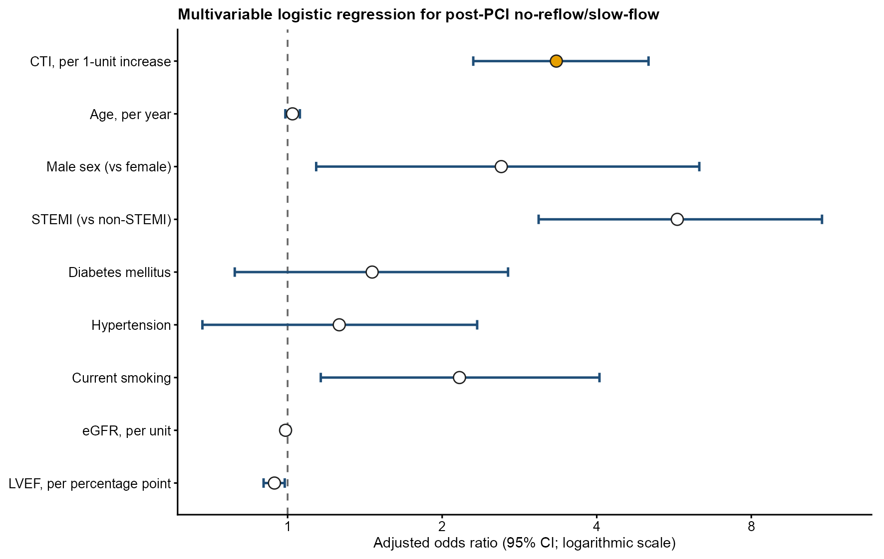
Supplementary Figure S1. Primary multivariable regression estimates. Points show adjusted odds ratios and horizontal lines show 95% confidence intervals from the primary logistic regression model.

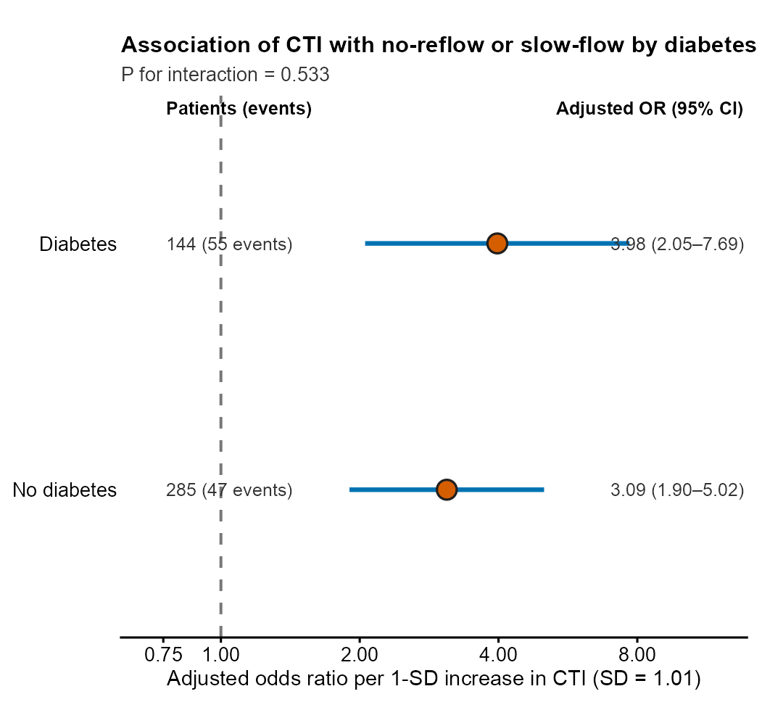
Supplementary Figure S2. CTI association according to diabetes status. Estimates are adjusted odds ratios per 1-SD increase in CTI from a single full-cohort model containing the CTI-by-diabetes interaction and adjusted for age, sex, STEMI, hypertension, current smoking, eGFR, and LVEF. The primary interaction P value used a 1-degree-of-freedom likelihood-ratio test. The cohort included 285 patients without diabetes (47 events) and 144 with diabetes (55 events). Effect modification is assessed by the interaction test.

