Supporting information

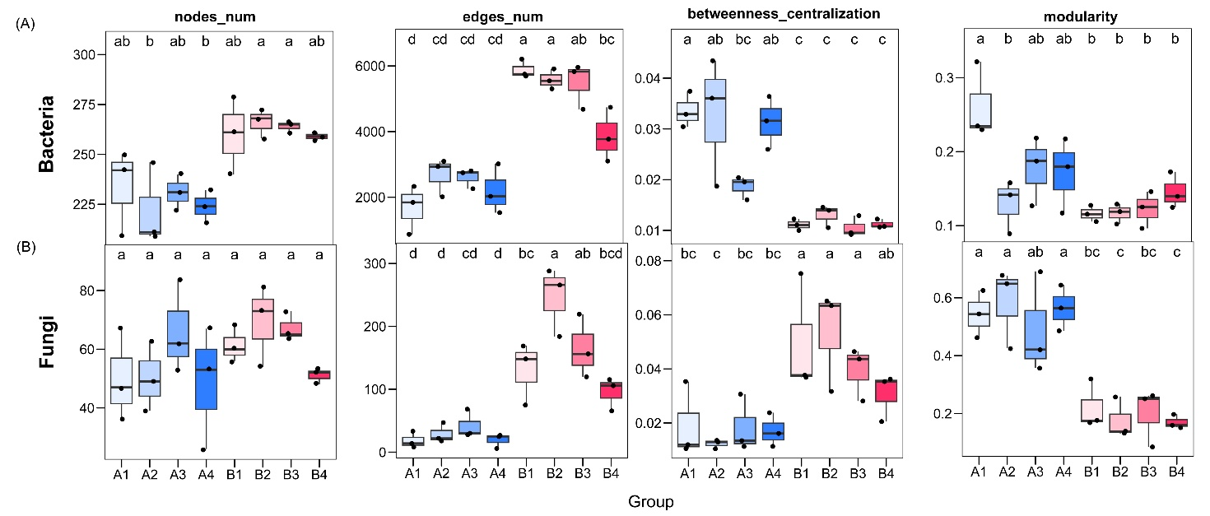
Supplementary Figure 1. Topological properties of rhizosphere bacterial (A) and fungal (B) sub-networks across habitats and foxtail millet cultivars. nodes_num, number of nodes; edges_num, number of edges; betweenness_centralization, betweenness centralization; modularity, network modularity. Uppercase letters indicate overall differences between Group A (saline-alkali) and Group B (control) (ANOVA or Kruskal-Wallis test, p < 0.05). Lowercase letters indicate significant differences among individual treatment groups (Tukey's HSD or Dunn's post hoc test, p < 0.05); different letters denote significant differences. Blue shades represent the saline-alkali habitat (A1-A4) and red shades represent the control habitat (B1-B4). A1/B1: Xingu 1; A2/B2: Cangu 15; A3/B3: Xingu 2; A4/B4: Xingu 3.

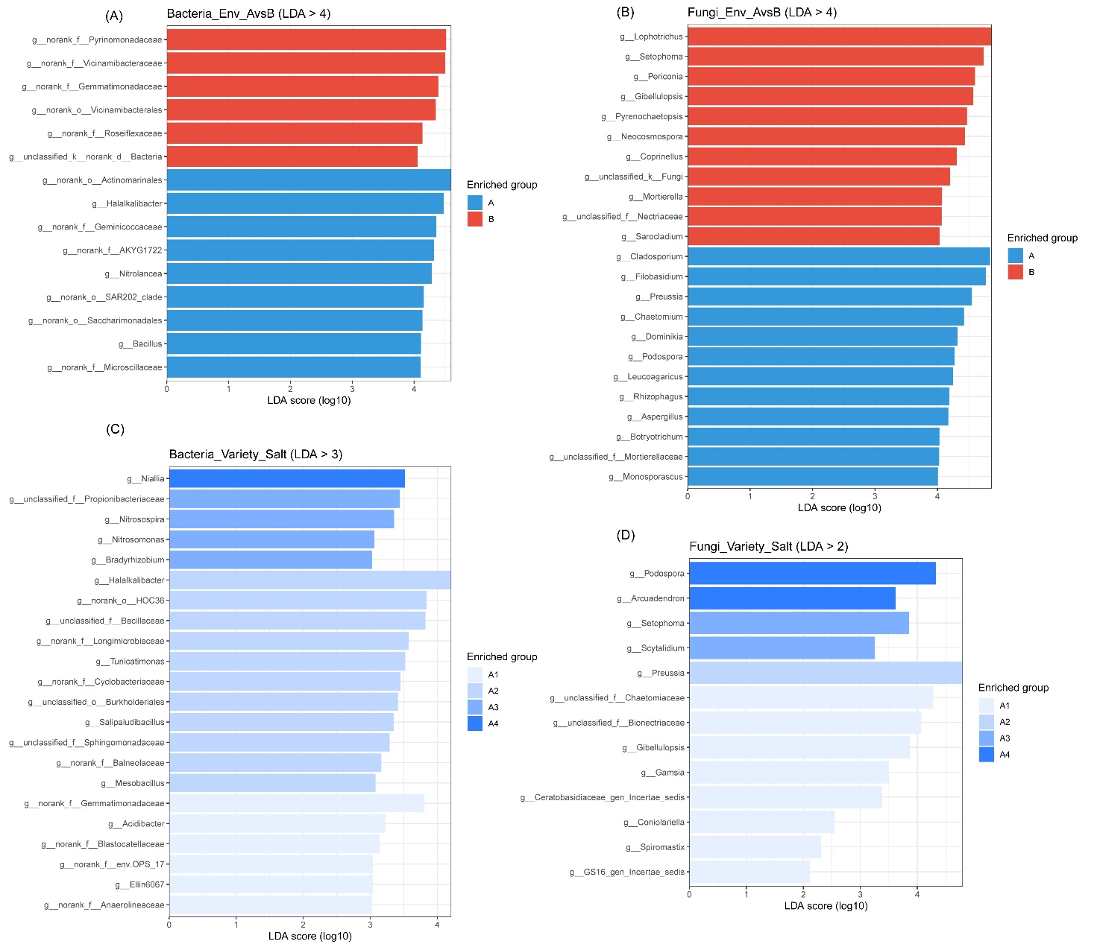

Supplementary Figure 2. LEfSe analysis reveals differential microbial taxa between treatment groups. (A, B) Bacterial and fungal genus-level taxa showing significant differences between the saline-alkali field (Group A) and control field (Group B) (LDA score (log10) > 4). Red bars indicate taxa enriched in the saline-alkali Group A; blue bars indicate taxa enriched in the control Group B. (C, D) Bacterial and fungal genus-level taxa showing significant differences among foxtail millet cultivars (A1-A4) within the saline-alkali field (LDA score (log10) > 3 for bacteria, > 2 for fungi). Different shades of blue indicate taxa enriched in different cultivars.

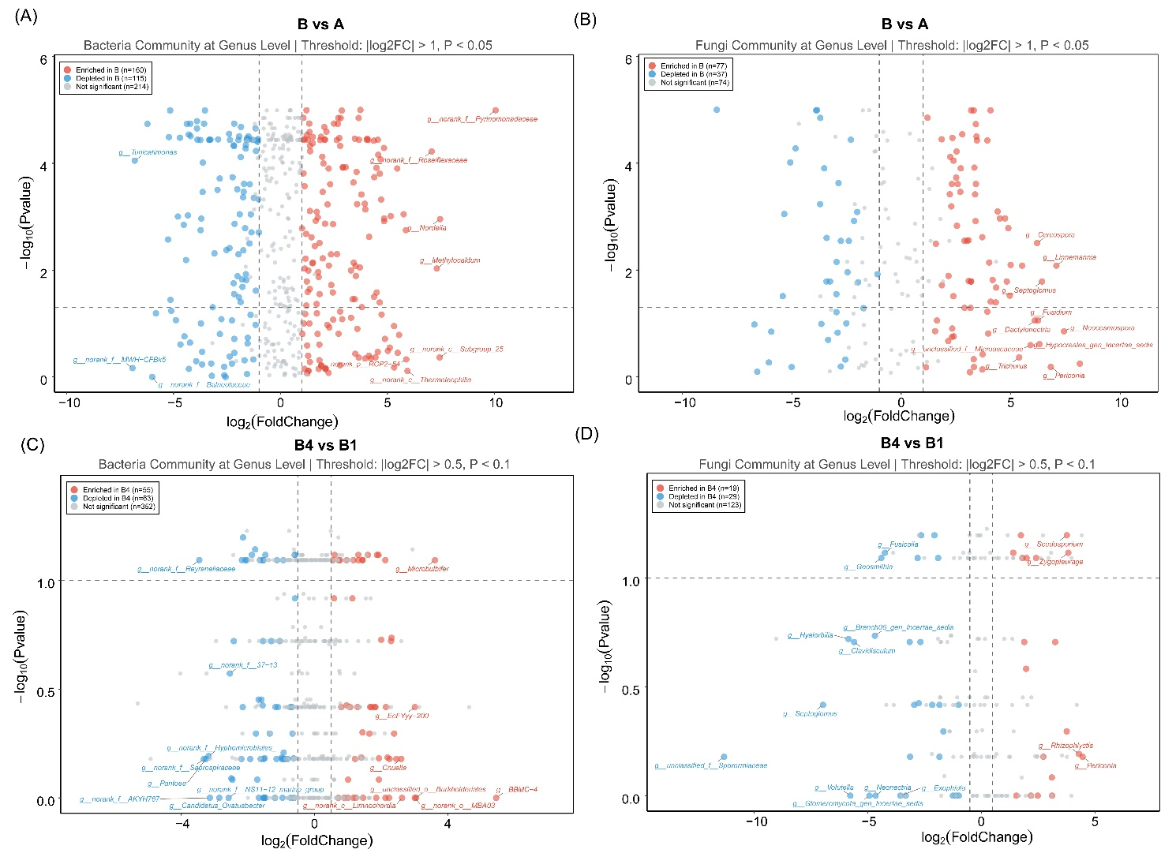

Supplementary Figure 3. Genus-level differential abundance analysis of rhizosphere microbial communities. Volcano plots show bacterial community differences between the control field (B) and saline-alkali field (A) (A), and between cultivar B4 and cultivar B1 within the control field (C), with corresponding fungal community differences shown in (B) and (D). The x-axis shows log2 (fold change) and the y-axis shows -log10 (p-value). Red points indicate significantly enriched genera (log2FC > 1, p < 0.05, or log2FC > 0.5, p < 0.1), blue points indicate significantly depleted genera, and grey points indicate non-significant genera.

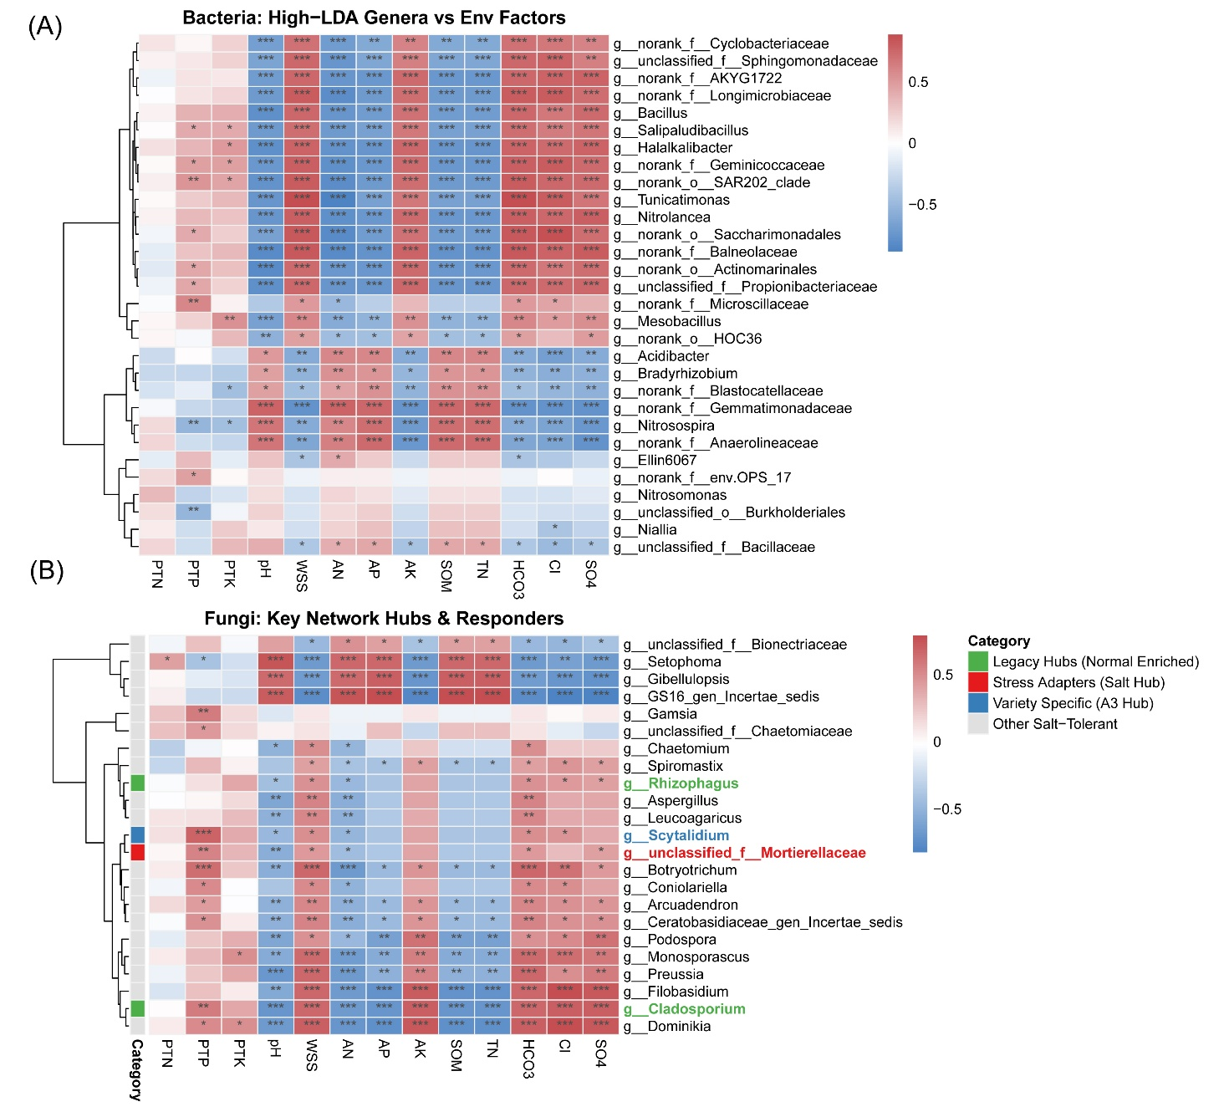

Supplementary Figure 4. Correlation heatmap of key bacterial and fungal genera with soil and plant environmental factors. Correlations between high-LDA-score bacterial genera (A) and key network/LEfSe-derived fungal genera (B) with environmental factors (PTN: plant total nitrogen; PTP: plant total phosphorus; PTK: plant total potassium; pH; WSS: soil water-soluble salts; AN: soil available/ammonium nitrogen; AP: soil available phosphorus; AK: soil available potassium; SOM: soil organic matter; TN: soil total nitrogen; HCO3: soil bicarbonate; Cl: soil chloride; SO4: soil sulfate). Red indicates positive correlation, blue indicates negative correlation, and color intensity indicates correlation strength (p < 0.05, p < 0.01, p < 0.001). In (B), fungal genera are annotated by functional category (Legacy Hubs/Normal Enriched, Stress Adapters/Salt Hub, Variety Specific/A3 Hub, Other Salt-Tolerant), shown by colored side bars.

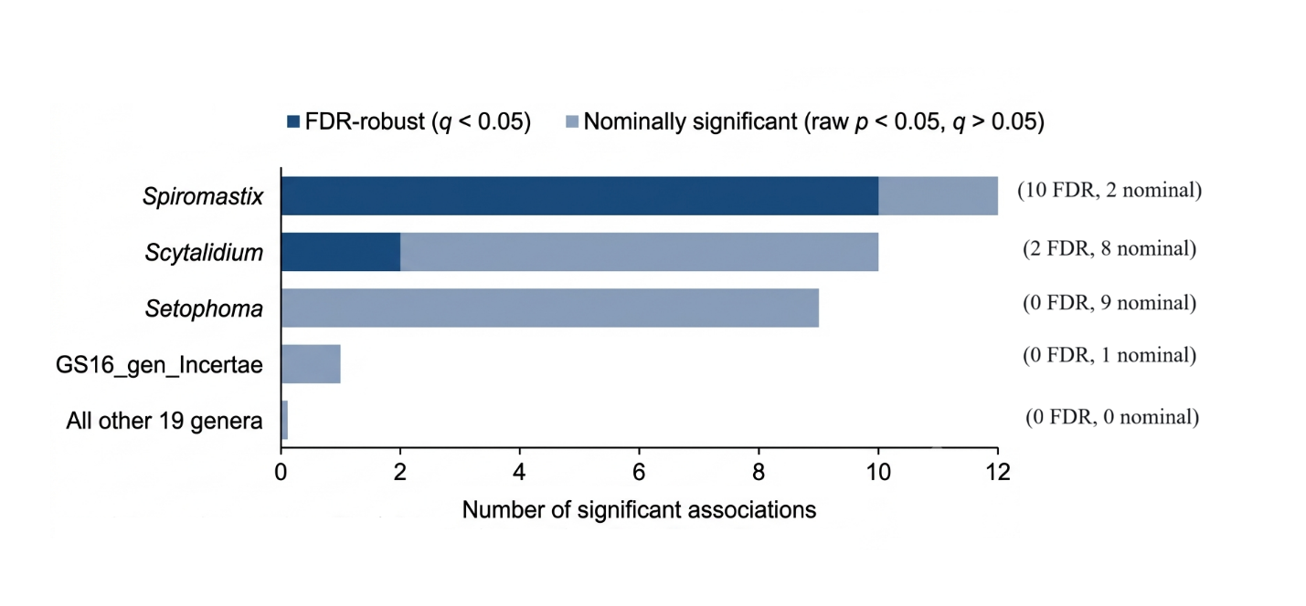
Supplementary Figure 5. Number of significant associations between key fungal genera and foxtail millet agronomic traits under saline-alkali stress. Red bars indicate FDR-robust associations (q < 0.05 after Benjamini-Hochberg correction); grey bars indicate nominally significant associations (raw p < 0.05, q > 0.05). Spiromastix showed 10 FDR-robust positive associations, Scytalidium showed 2 FDR-robust negative associations, Setophoma showed 9 nominally significant negative associations, and GS16_gen_Incertae_sedis showed 1 nominally significant positive association. All other 19 genera showed no significant associations (p > 0.05). Data based on 23 genera × 13 traits = 299 pairwise tests; n = 12 saline-alkali samples.

