Supplementary Information for Environmental Science and Pollution Research manuscript:
Plastics within contemporary cultural collections: opportunities to discuss sustainability and challenges in their preservation.
Panagiotis Morfis,¹ Simon R. Collinson*,¹ Louise Dennis,² James Bowen³ and Emma Dewberry³
*email simon.collinson@open.ac.uk telephone +44(0)1908332644
1 School of Life, Health & Chemical Sciences, The Open University, Milton Keynes, MK7 6AA, UK;
2 Museum of Design in Plastics (MoDiP), Arts University Bournemouth, Poole, UK;
3 School of Engineering & Innovation, The Open University, Milton Keynes, MK7 6AA, UK.

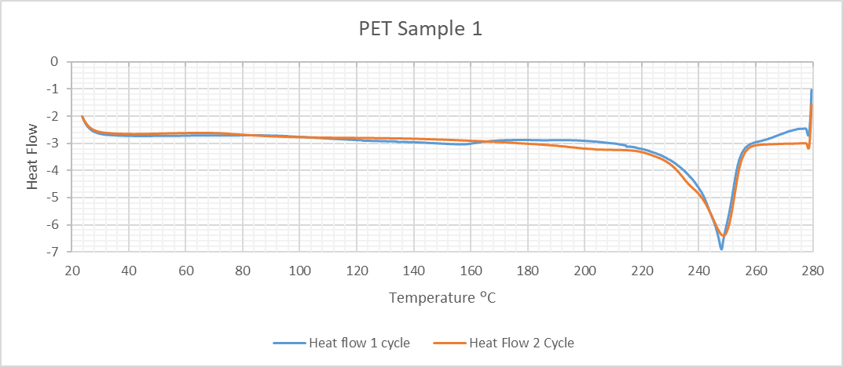

 | Glass transition temperature T_{g} (°C) | Melting Temperature T_{m} (°C) | Enthalpy of melting ΔH_{m} (J/g) | Crystallinity X_{c} (%)
1st Cycle | 79.77 | 248.45 | 42.63 | 30.5
2nd Cycle | 75.08 | 247.96 | 47.63 | 34.0
1st Cycle | 75.13 | 249.31 | 43.06 | 30.8
2nd Cycle | 74.04 | 248.36 | 42.02 | 30
Average 2nd cycle | 74.6 | 248.2 | 44.8 | 32

Fig. S1 Differential Scanning Calorimetry of PET soda water bottle and the thermal properties

Table S1 Raman data from everyday plastic items, spectra were recorded using a Cora100
Plastic item, recycling code if marked | Peaks (cm⁻¹) and assignment or comment | Reference for checking peaks
Clear PET bottle, 1, green PET bottle, 1, clear PET yoghurt pot | 1726 (carbonyl stretch), 1612, 1546, 1530 (aromatic C=C stretch), 1466 (CCH bending), 1290 (C(O)-O stretch), 1124, 1094 (combined C-H in plane bend and C-C stretch), 854 (C-C breathing), 790 (C-H out of plane bend), 626 (C-C-C in plane bend) | Umurhan et al. 2025
PLA cup & PLA Vegware™ pen | 1774 (carbonyl stretch), 1462 (CH₃ asymmetric bend), 1394 and 1376 (CCH and CH₃ symmetric bend), 1306 (CH bend), 1134 (CH₃ rock), 1052 (C-CH₃ stretch), 878 (C-COO stretch), 752 (C=O bend) | Marin et al. 2023
HDPE vitamin bottle, 2, soda water bottle lid, 2 and red milk lid, 2 | 1464, 1442, 1420 1298 (CH₂ twisting), 1128 (C-C bonds in trans conformation symmetric stretch), 1062 (C-C bonds in trans conformation asymmetric stretch) | Umurhan et al. 2025
PP soup container, 5 | 1462, 1442 (CH₂ bend and CH₃ asymmetric bend), 1362 (CH₂ wagging and CH₃ bending), 1330 (CH₂ twisting) 1222, 1156 (C-H bend, C-C stretching), 1042 (C-CH₃ stretch), 976 (C-C stretch) 840 (C-C stretching and CH₂ rocking) 810 (C-CH₃ stretch) | Umurhan et al. 2025
PP food container, marked with only a recycling triangle | 1460, 1438 (CH₂ bend and CH₃ asymmetric bend), 1360 (CH₂ wagging and CH₃ bending), 1332 (CH₂ twisting) 1222, 1152 (C-H bend, C-C stretching), 1038 (C-CH₃ stretch), 972 (C-C stretch) 842 (C-C stretching and CH₂ rocking) 808 (C-CH₃ stretch)which corresponds to the PP spectrum | Umurhan et al. 2025
Starch knife⁺ and starch lid⁺ | 1462, 1312 (CH₂ bend and CH bend), 1364, 1328 (CH₂ and C-OH bend), 1152 (C-H bend, C-C stretching), 844, 810 (C-O-C stretch), 532, 484, 460 (ring C-O-C and C-C-O bend) | Pooja et al. 2024
PS yoghurt pot, 5 clear pen and white pen | 1602 (aromatic C=C stretch), 1184 (CH in plane bend), 1030 (CH in plane deformation), 1002 (benzene ring stretching mode), 790 (CCC ring deformation mode), 618 (CCC ring deformation mode) | Umurhan et al. 2025
Clear PMMA sheet | 1730 (carbonyl stretch), 1456 (C-H bending), 992 (C-C stretch), 812 (COC symmetric stretch), 600 (CCO stretch) | Umurhan et al. 2025
Clear polycarbonate spectacles | 1604 (benzene ring stretch), 1238, 1180 (C-O-C stretching), 1112 (C-H in plane bending), 888 (O-C(O)-O stretch), 706, 734 (C-H out of plane bending), 832, 636, 580 (benzene ring vibrations) | Umurhan et al. 2025
White LDPE bag, 4 | 1450, 1420 1298 (CH₂ twisting), 1130 (C-C bonds in trans conformation symmetric stretch), 1080 (C-C bonds in trans conformation asymmetric stretch), 616 & 446 (TiO₂ pigment) | Luo et al. 2020; Umurhan et al. 2025
Oxobiodegradable tube⁺ | 1442, 1302, 1080, 860 which corresponds to the LDPE spectrum
White PVC | 1440 (CH₂ bending), 1188 (CH₂ twist), 698 (C-Cl asymmetric stretch in H₂C=CHCl), 636 (C-Cl stretch in Cl₂C=CHCl) | Umurhan et al. 2025
Black spoon | Damaged by beam even when set on lowest power.
Black PLA lid | Failed to show any clear peaks
⁺ did not match with the Cora 100 demo database and so matched with the literature

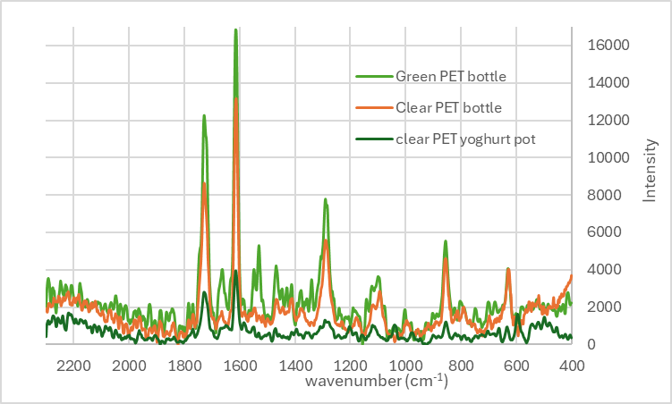
Fig. S2 Comparing Raman spectra of PET yoghurt pot, clear and green bottles (with 54%, 62% and 54% match to database)

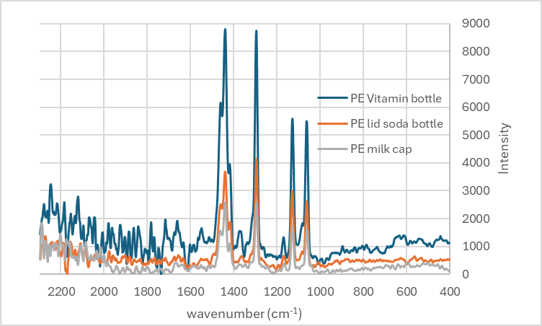

Fig. S3 Comparing Raman spectra of PE vitamin bottle, lid of a soda water bottle and milk cap (with 79%, 88% and 56% match to database)

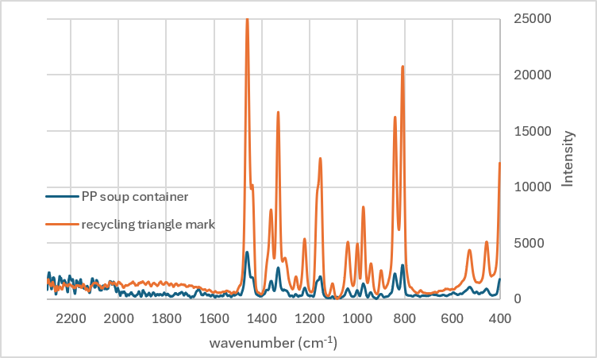
Fig. S4 Comparing Raman spectra of PP soup container and food container, marked with only a recycling triangle (with 74% match and no match to database)

Fig. S5 Comparing Raman spectra of oxobiodegradable tube and white LDPE bag (NB no match to demo database)

