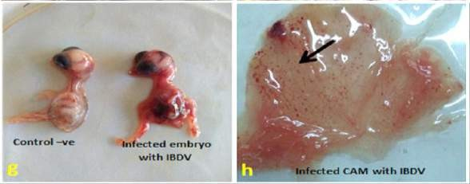
A
B
Plate,1 Lesions on Inculcated Chicken Embryos: Fig. a: Photomicrographs of +ve control embryo
and dwarfed dead embryo 2-5 days PI with IBDV showing edema and hemorrhages. Fig. b: Photomicrographs of CAM showing petechial hemorrhages (arrow).
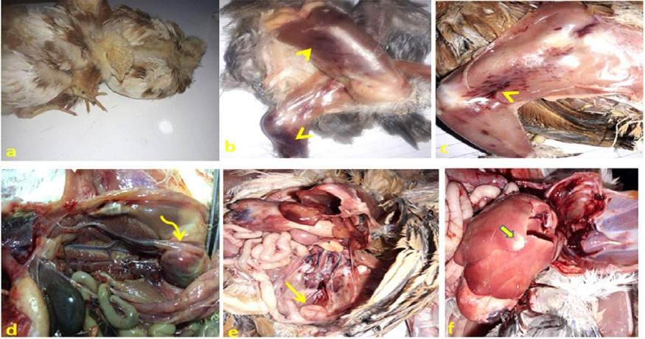
C
D
E
F
G
H
Plate 1. 3 week-old Balady Broiler Chickens Experimentally Infected with IBDV (gr.B):
Fig. c: Showing clinical signs of severe depression and prostration. Fig. d, e: Hemorrhages in thigh and breast muscles (arrow heads).
Fig. f: Showing swollen and hemorrhagic bursa (curved arrow) after 3 days of infection. Fig. g: Showing atrophied bursa (arrow) after 6 days of infection.
Fig. h: Photomicrographs of liver showing peripheral pale yellow infarct area (thick arrow).
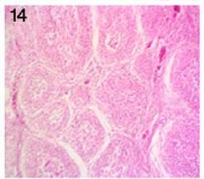
4
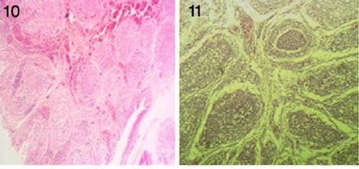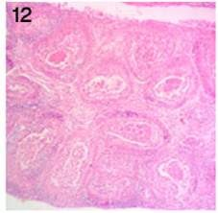
1
2
3
Plate. 2: Histopathological Lesions of Cloacal Bursa of Experimental Chicks groups:
Fig. 1: +ve control group (B) 3 days post infection the bursa showing cystic cavitation, necrosis of most bursal follicles, and hemorrhages between the follicles. H&E X100.
Fig. 2: +ve control group (B) 6 days post infection the bursa showing atrophied lymphoid populations and caseous necrosis of most lymphoid follicles center H&E X100.
Fig. 3: Infected and treated group (C) 3 days PI the bursa showing cystic cavitation and heterophil infiltration. H&E X100.
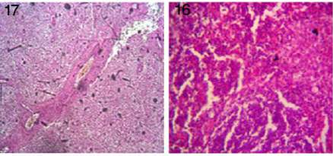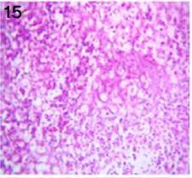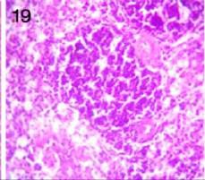Fig. 4: Infected and treated group (C) 6 days PI the bursa showing lymphocytic repopulation of the lymphoid follicles. H&E X100.
5
6
7
8

Plate.3: Histopathological Lesions of Spleen of Experimental Chicks groups:
Fig. 5: +ve control group (B) 3 days post infection the spleen showing necrosis of most lymphoid follicles. H&E X400.
Fig. 6: +ve control group (B) 6 days post infection the spleen showing edema and necrotic cells of the red pulp H&E X400.
Fig. 7: Infected and treated group (C) 3 days PI showing congestion of blood vessels H&E X100.
Fig. 8: Infected and treated group (C) 6 days PI showing repopulation of lymphocytes of the lymphoid follicles H&E X400.
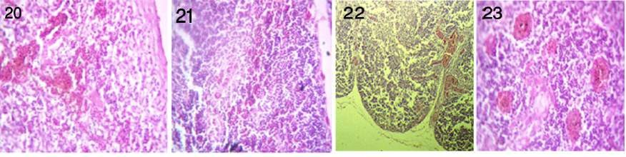
9
12
11
10
Plate.4: Histopathological Lesions of Thymus of Experimental Groups :
Fig. 9: +ve control group (B) 3 days post infection showing necrosis of most lymphoid lobules, marked congestion of blood vessels, and hemorrhages throughout the parenchyma. H&E X400.
Fig. 10: +ve control group (B) 6 days post infection showing reduction of lymphoid populations. H&E X400.
Fig. 11: Infected and treated group (C) 3 days PI showing moderate activity of cortical and medullary lymphoid contents of thymic nodules and dilated septal blood vessels. H&E X100.
Fig. 12: Infected and treated group (C) 6 days PI showing mild congestion of blood vessels, apparently normal cortical and medullary lymphoid population, and normal Hassall's corpuscles. H&E X400.

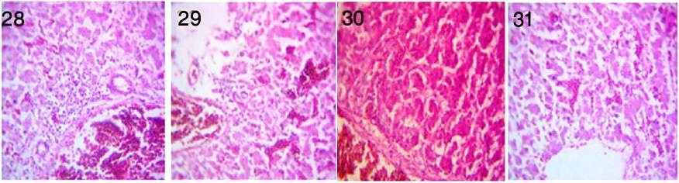
14
16
15
13
Plate.5: Histopathological Lesions of Liver of Experimental Chicks groups:
Fig. 13: +ve control group (B) 3 days post infection showing necrotic area admixed with inflammatory cells and congestion of hepatic blood vessels. H&E X400.
Fig. 14: +ve control group (B) 6 days post infection showing inflammatory cells within sinusoids and congestion of hepatic blood vessels and sinusoids. H&E X400.
Fig. 15: Infected and treated group (C) 3 days PI showing nearly normal hepatic acini and congestion of some hepatic blood vessels. H&E X400.
Fig. 16: Infected and treated group (C) 6 days PI showing apparently normal hepatic parenchyma and congestion hepatic sinusoids. H&E X400.

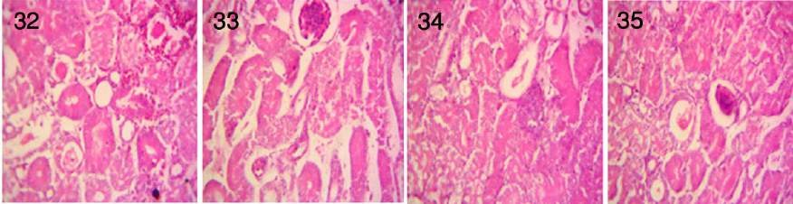
18
20
19
17
Plate.6: Histopathological Lesions of Kidney of Experimental Chicks groups:
Fig. 17: +ve control group (B) 3 days post infection showing focal hemorrhagic area and severe degeneration and necrosis of some renal tubules. H&E X400.
Fig. 18: +ve control group (B) 6 days post infections p showing degenerative changes of renal tubular epithelium. H&E X400.
Fig. 19: Infected and treated group (C) 3days PI showing regenerative attempts of renal tubular epithelium. H&E X400.
Fig. 20: Infected and treated group (C) 6 days PI showing apparently normal renal tubules. H&E X400.

