Supplementary File

Ruby Fatma^{1,2}, Ananya Dwivedi^{1,3}, Anamika Asthana¹, Pradeep Kumar^{1,4}, Ratna Katiyar^{1,2}, Suchi Srivastava^{1*}

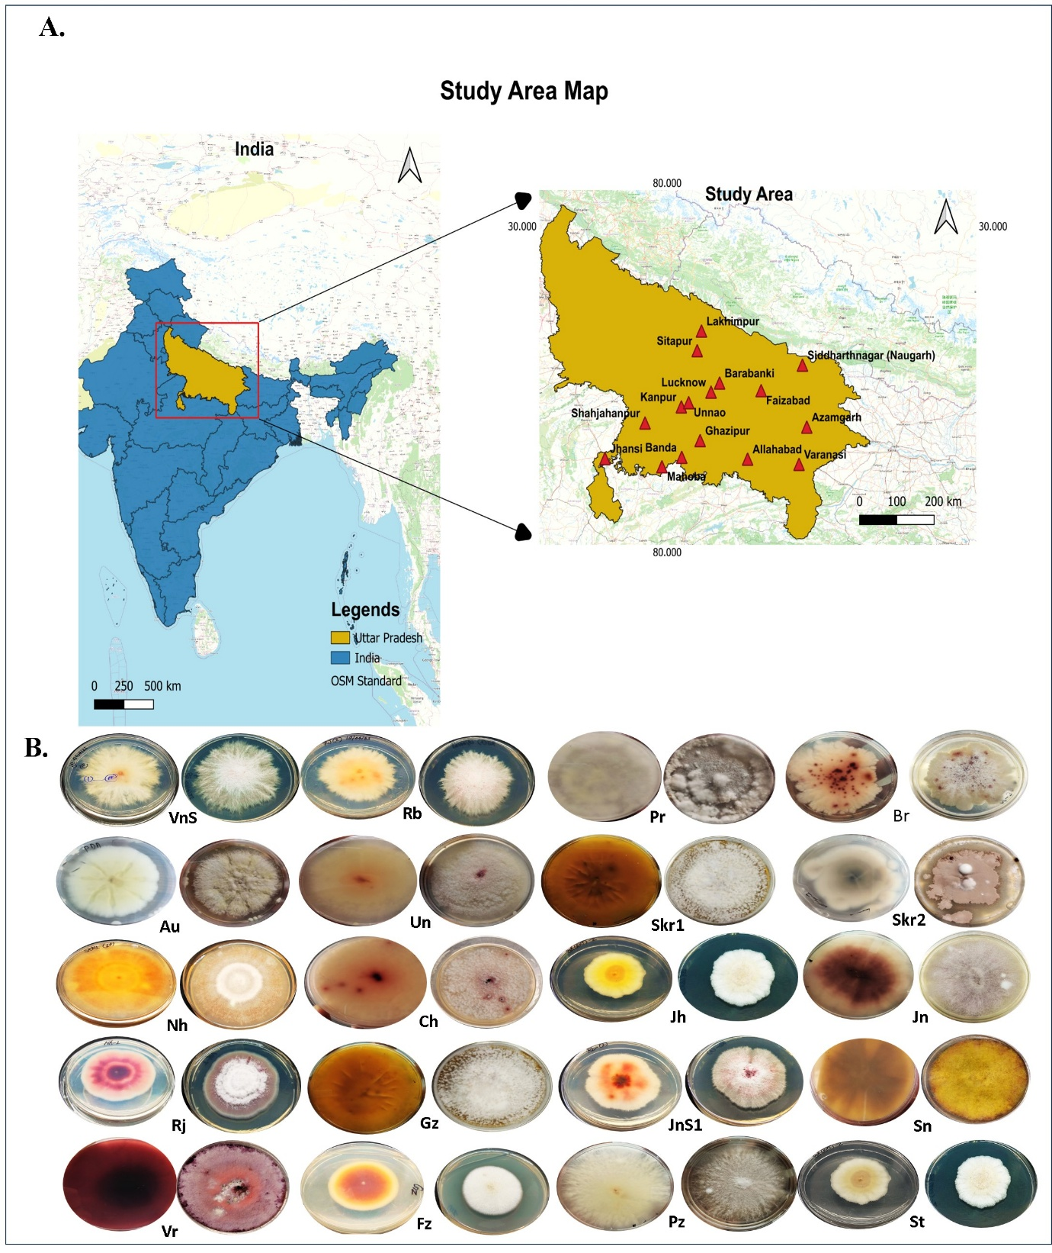
Fig. 1S. (A) Geographic locations of Fusarium isolates associated with pigeonpea Fusarium wilt, (B) Fungal morphology of highly virulent Fusarium strains.

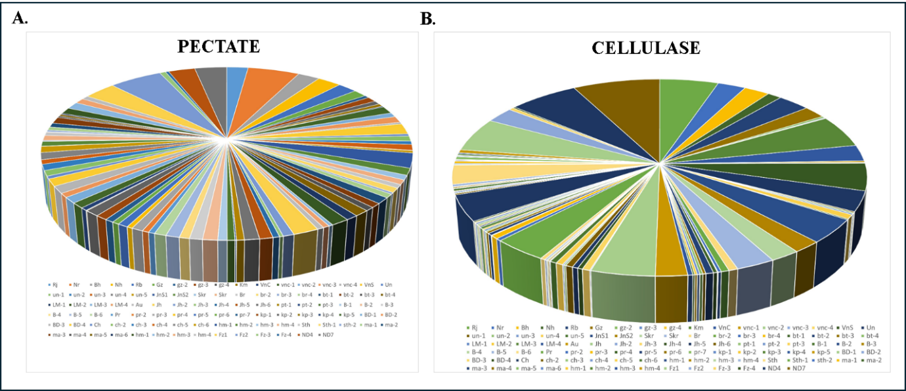

Fig. 2S. Characterization of cell wall degrading enzymes for 97 virulent Fusarium isolates in terms of (A) Pectate lyase activity (B) Cellulase activity.

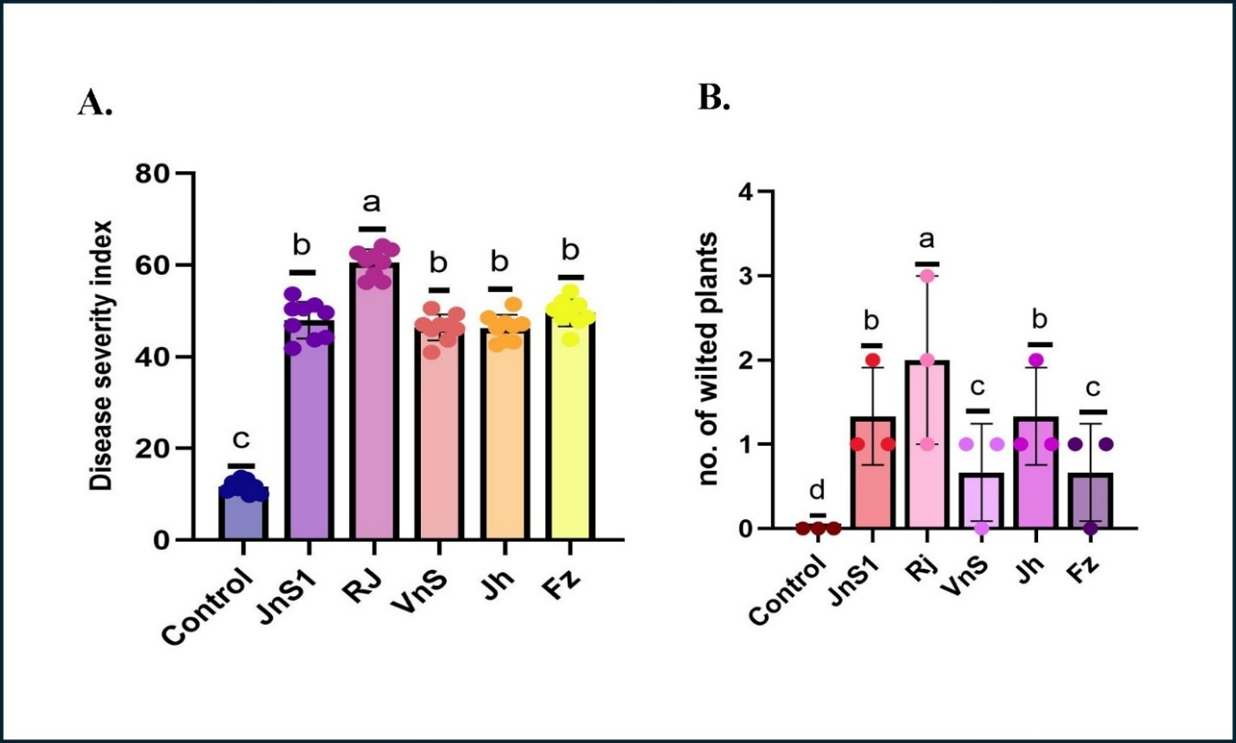
Fig. 3S. Impact of Fusarium infestation in pigeonpea plants (A) Disease severity index (B) No. of wilted plants

Table 1S. ITS & TEF α Accession Numbers of Fusarium isolates
Species | Designation | Host | State | Lattitude | Longitude | Accession numbers
 |  |  |  |  |  | ITS | TEF 1α
Fusarium oxysporum | JnS1 | Pigeonpea | Janua Uttar Pradesh | 27.5645°N | 80.6672°E | PX091664 | PX845595
Fusarium nygamai | Rj | Pigeonpea | Rajapur Uttar Pradesh | 27.5463°N | 80.9428°E | PX097965 | PX845596
Fusarium nygamai | VnS | Pigeonpea | Varanasi Uttar Pradesh | 23.3740°N | 83.0754°E | PX091229 | PX845597
Fusarium nygamai | Jh | Pigeonpea | Jhansi Uttar Pradesh | 25.4363°N | 78.5674°E | PX091240 | PX845598
Fusarium nygamai | Fz | Pigeonpea | Faizabad Uttar Pradesh | 26.7730°N | 82.1462°E | PX091242 | PX845599

Treatment/Parameters | Wilt Sensitive (BAHAR) |  |  |  | Wilt Resistant (IPAC-79)
Biochemical characterization | Cont. | RJ | ND | ND+RJ | Cont. | RJ | ND | ND+RJ
Total Chl (mg/g) | 3.99±0.02ª | 0.98±0.02^{d} | 2.65±0.05^{b} | 1.38±0.01^{c} | 3.59±0.02ª | 1.16±0.03^{d} | 1.80±0.17^{b} | 1.57±0.10^{c}
Proline (µM) | 18.85±7.64ª | 11.77±2.31^{b} | 7.42±0.93^{b} | 47.02±37.67^{b} | 56.32±13.97^{b} | 17.05±4.51ª | 50.65±1.48ª | 32.78±27.72ª
Physical parameters | Wilt Sensitive (BAHAR) |  |  |  | Wilt Resistant (IPAC-79)
Shoot length(cm) | 44.58±0.81ª | 26.41±0.31^{b} | 27.5±0.39^{b} | 26.16±0.20^{b} | 46.5±0.5ª | 26.91±0.22^{b} | 27.91±0.35^{b} | 26.91±0.25^{b}
Root length(cm) | 6.08±0.19ª | 3.75±0.21^{b} | 3.5±0.23^{b} | 3.83±0.24^{b} | 6.08±0.25ª | 4.5±0.35^{b} | 4±0.27^{b} | 3.5±0.15^{b}
No. of branches | 3.75±0.17ª | 2.5±0.15^{b} | 3.33±0.14ª | 2.58±0.14^{b} | 3.5±0.15ª | 2.5±0.15^{b} | 3±0.12^{ab} | 2.58±0.14^{b}
Dry biomass(g) | 8.66±0.18ª | 6.58±0.22^{b} | 6.33±0.30^{b} | 7.08±0.19^{b} | 7.5±0.33ª | 6.25±0.30^{b} | 6±0.32^{b} | 5.91±0.33^{b}

Table 2S. Influence of Fusarium infection (alone and complex) in pigeonpea plants under microplot condition. Mean & standard deviation values were calculated separately and represented using alphabets, showing differences across rows at p<0.05 Tuckey’s Test.

