Supplementary material

Supplementary Table S1. Reasons for bDMARD discontinuation
Reasons for discontinuation | Adalimumab  monotherapy  N = 102 | Adalimumab  combination  therapy  N = 146 | Secukinumab  monotherapy  N = 88 | Secukinumab combination therapy  N = 84
Inefficacy | 60 (59%) | 92 (63%) | 66 (75%) | 60 (71%)
Side effects | 31 (30%) | 36 (25%) | 15 (17%) | 15 (18%)
Censoring, N (%)
Crohn/Uveitis/Coliitis  Pregnancy | 0 (0%)  1 (1%) | 0 (%)  0 (0%) | 2 (2.3%)  0 (0%) | 4 (4.8%)  0 (%)
Death  Remission  Infection  Patient initiative  Lymphoma  Antibiotics  Unknown | 1 (1%)  4 (3.9%)  0 (%)  2 (2%)  0 (%)  1 (1%)  2 (2%) | 4 (2.7%)  10 (6.8%)  2 (1.4%)  2 (1.4%)  0 (%)  0 (%)  0 (%) | 1 (1.1%)  2 (2.3%)  0 (%)  2 (2.3%)  0 (%)  0 (%)  0 (%) | 2 (2.4%)  2 (2.4%)  0 (%)  0 (%)  1 (1.2%)  0 (%)  0 (%)

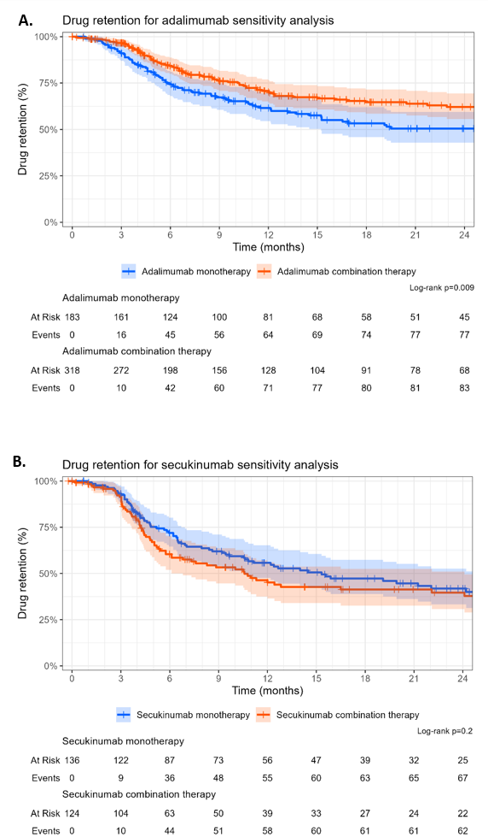

Supplementary Figure S1. Kaplan–Meier curves of drug retention for sensitivity analyses. Drug retention sensitivity analysis in patients treated with (A) adalimumab monotherapy versus combination therapy and (B) secukinumab monotherapy versus combination therapy. Kaplan–Meier curves illustrate drug retention for each treatment strategy, with shaded areas representing 95% confidence intervals. Numbers at risk and cumulative events are shown below the plots.
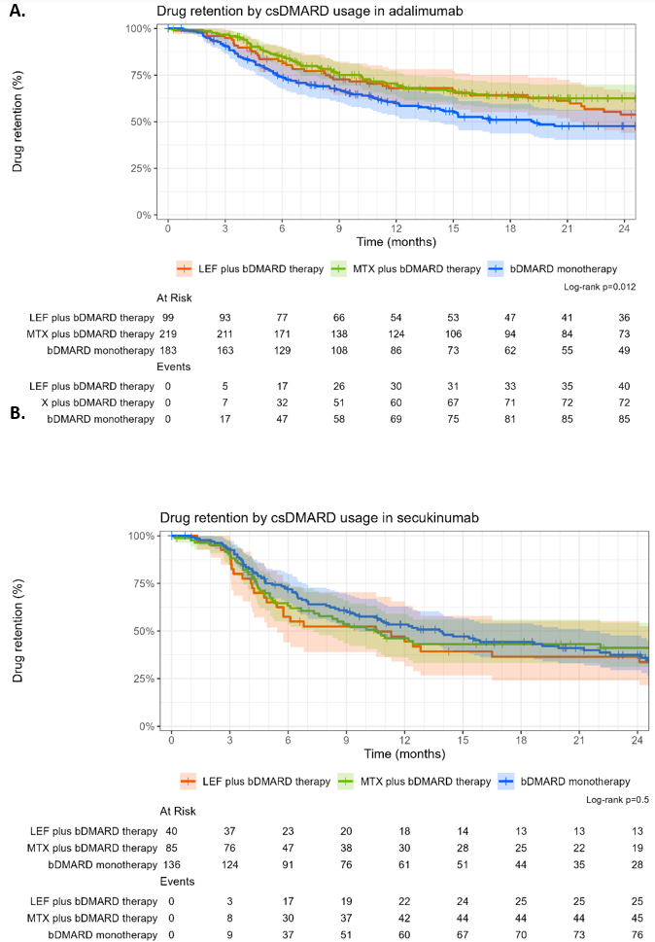

Supplementary Figure S2. Kaplan–Meier curves of drug retention for exploratory analyses. Drug retention exploratory analysis in patients treated with (A) adalimumab monotherapy versus methotrexate or leflunomide combination therapy and (B) secukinumab monotherapy versus methotrexate or leflunomide combination therapy. Kaplan–Meier curves illustrate drug retention for each treatment strategy, with shaded areas representing 95% confidence intervals. Numbers at risk and cumulative events are shown below the plots.

