Interview Questions

- For which purpose have you used ChatGPT?
- How do you perceive ChatGPT for your professional growth?
- In what ways can the use of ChatGPT be merged into your current teaching practice?
- As an ESL teacher, how does the arrival of ChatGPT influence your English teaching in terms of curriculum designing and other tasks relevant to your job?
- In your opinion, how could the use of ChatGPT help ESL students in their English learning?
- In your opinion, what are the challenges of integrating ChatGPT in English learning for ESL students?
- In your opinion, how does the use of ChatGPT help to enhance ESL students’ productive skills in terms of English writing?
- How do you think the use of ChatGPT influence the critical thinking and creativity of ESL students in English learning?
- What are the concerns or ethical issues that make you worry while using ChatGPT in English teaching and learning?
- What suggestions do you want to give to ESL teachers and students who use ChatGPT in their English teaching and learning respectively?
- What are the practical solutions to deal with the challenges related to the use of ChatGPT in English teaching and learning?
- How do you predict the role of ChatGPT in the future of English teaching and learning?

Appendix B

Consent Form
Introduction:
The objective of this study is to investigate the ESL teachers’ perspections about the use of ChatGPT in English teaching and learning. You are invited to participate in this research work voluntarily and you can withdraw at any time. Your participation will be greatly appreciated.
Procedure:
The semi-structured interviews will be taken for the study. Your name will only be mentioned in the study with your consent. The interview will be recorded so its transcription will be used in the research work for analysis. The interview might take 25-30 minutes.
Risks and Benefits:
Your contribution to this research work would be greatly appreciated and it’ll be beneficial not only for this study but for future researchers as well to proceed with the research on this topic by getting ideas from this study. However, no risks are involved.
Confidentiality:
The data collected in the form of interview will totally be confidential and only the researcher would have access to that. All the personal information will be secured, and it’ll not be revealed in the analysis or findings.
Contact Information:
If you have any questions or concerns about this study, please contact the researcher Syed Waqar Ali Shah, Masters of Science in English (Linguistics and Literature), COMSATS University Islamabad, Lahore Campus. Email: waqarrizvi412@gmail.com
Consent:
I confirm that I understand the details of this study and agree to participate. I give permission for my interview to be recorded for the purpose of the analysis. I certify that I am not prevented from leaving the study at any point without being subjected to any hindrances.

Signature: ____________ Date: _________________

Themes/Coding
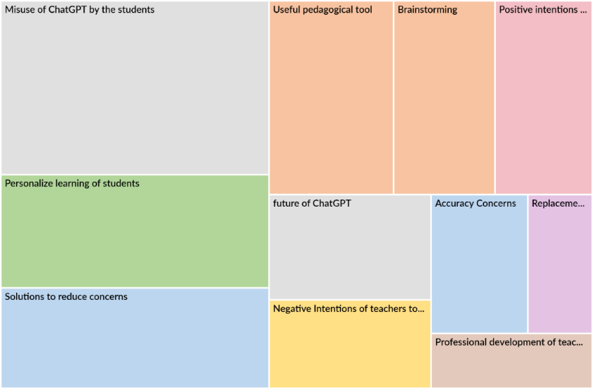

Benefits of using ChatGPT
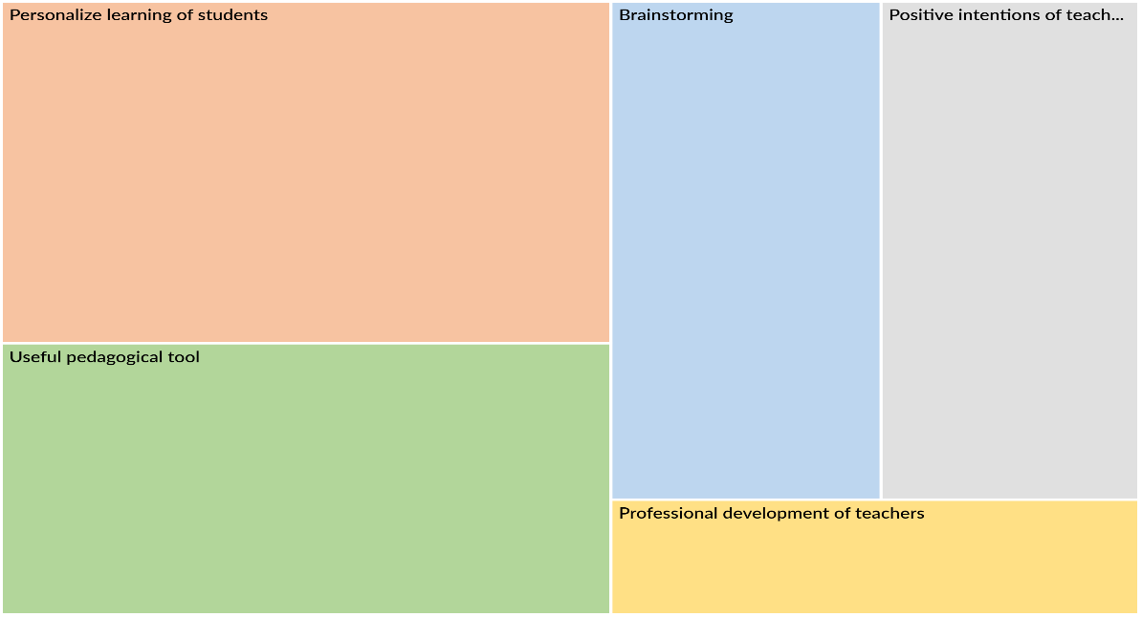
Challenges of using ChatGPT
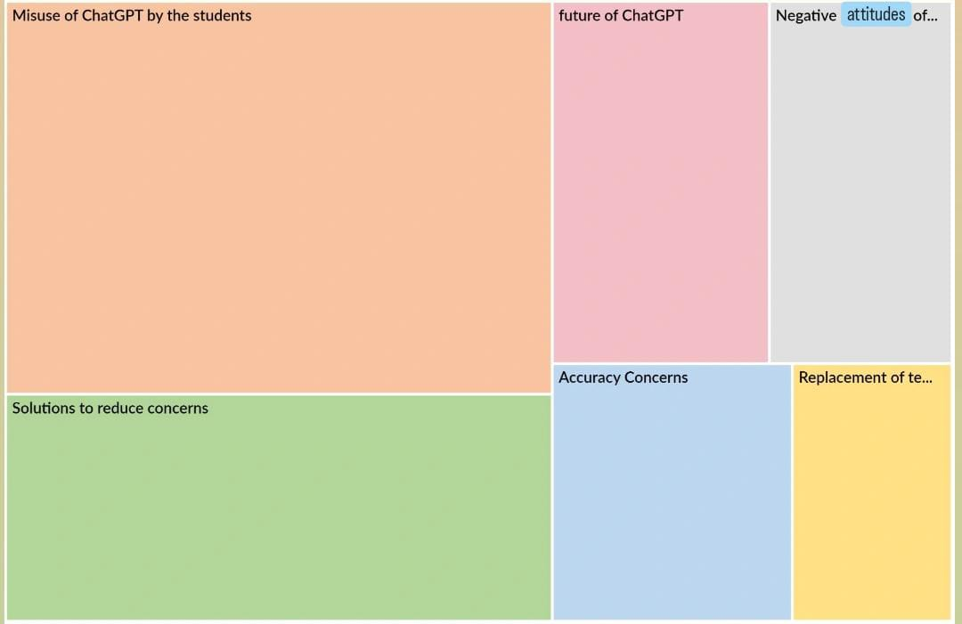

Participant Information
Profile of Interview Participants
Participant | Academic Position | Department | University Location
P1 | Lecturer | Humanities | Lahore
P2 | Lecturer | Management Sciences | Lahore
P3 | Assistant Professor | Computer Sciences | Lahore
P4 | Lecturer | Psychology | Lahore
P5 | Assistant Professor | Humanities | Lahore
P6 | Lecturer | Management Sciences | Lahore
P7 | Assistant Professor | Computer Sciences | Lahore
P8 | Lecturer | Psychology | Lahore
P9 | Assistant Professor | Humanities | Lahore
P10 | Lecturer | Management Sciences | Lahore
P11 | Assistant Professor | Computer Sciences | Lahore
P12 | Lecturer | Psychology | Lahore
P13 | Assistant Professor | Humanities | Lahore
P14 | Lecturer | Management Sciences | Lahore
P15 | Assistant Professor | Psychology | Lahore
Note: All participants were university lecturers or assistant professors based at universities in Lahore. Participant identifiers (P1–P15) are used to maintain confidentiality.

