Supporting Information
Dual-Mode Colorimetric Detection of Creatinine Using DTPA-Modified Silver Nanoparticles: Experimental Validation and Computational Analysis

Martina Asti Rahayu¹, Sonita Afrita Purba Siboro², Lala Adetia Marlina³, Muh Rizal B⁴, Nabilah Firyal Suhendra^{2*}

¹Chemical Analysis Study Program, Department of Mathematics and Natural Sciences, Faculty of Science and Technology, Universitas Jambi, Muaro Jambi 36361, Indonesia
²Research Center for Polymer Technology, National Research and Innovation Agency (BRIN), South Tangerang 15314, Indonesia
³Research Center for Computing, National Research and Innovation Agency (BRIN), Bandung 40135, Indonesia
⁴Department of Chemistry, Faculty of Science and Technology, Universitas Jambi, Jambi 36361, Indonesia.

*Corresponding author: nabilah.firyal.suhendra@brin.go.id

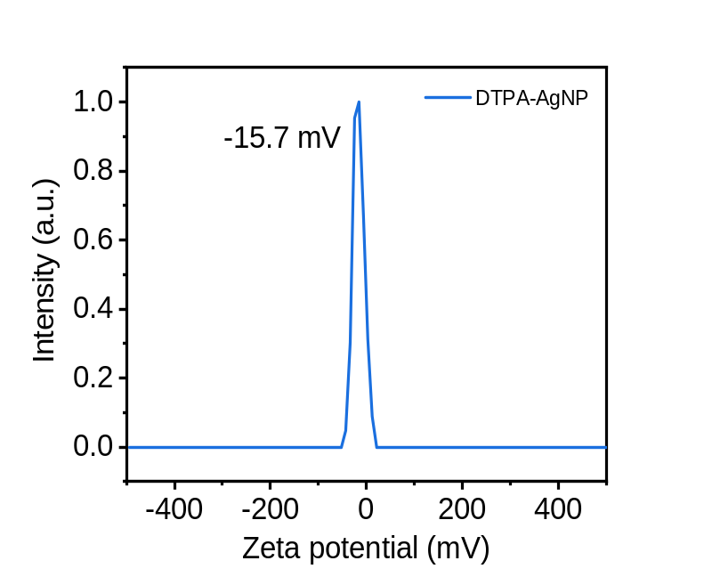

Fig S1. DLS measurement of AgNP-DTPA before and after creatinine addition (90 µM), demonstrating nanoparticle aggregation.

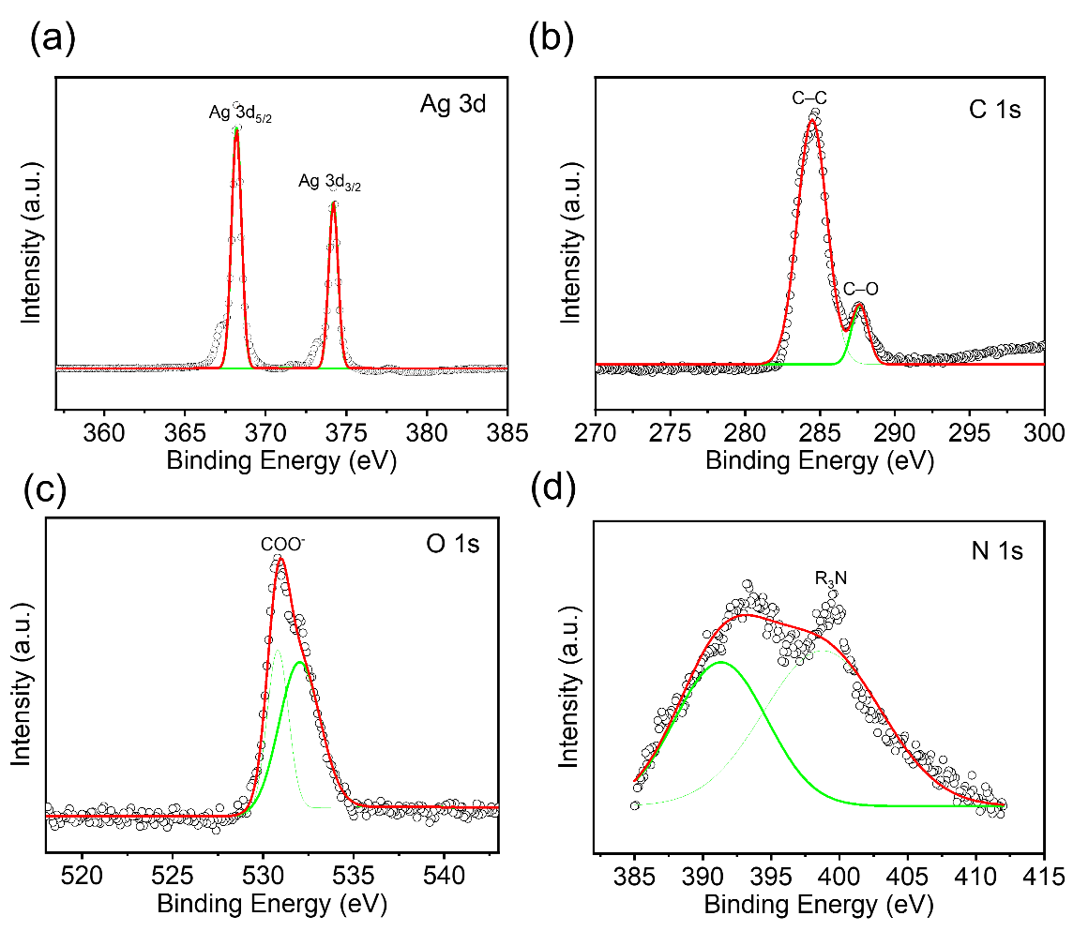
Fig S2. High-resolution XPS spectrum of (a) Ag 3d, (b) C 1s, (c) O 1s, and (d) N 1s in AgNP. The scattered and solid line showing experimental and fitted data, respectively.
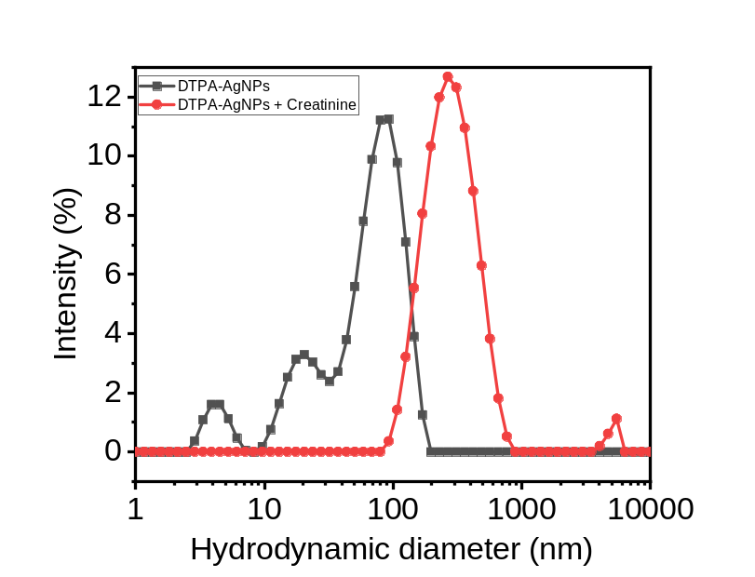

Fig S3. DLS measurement of AgNP-DTPA before and after creatinine addition (90 µM), demonstrating nanoparticle aggregation.

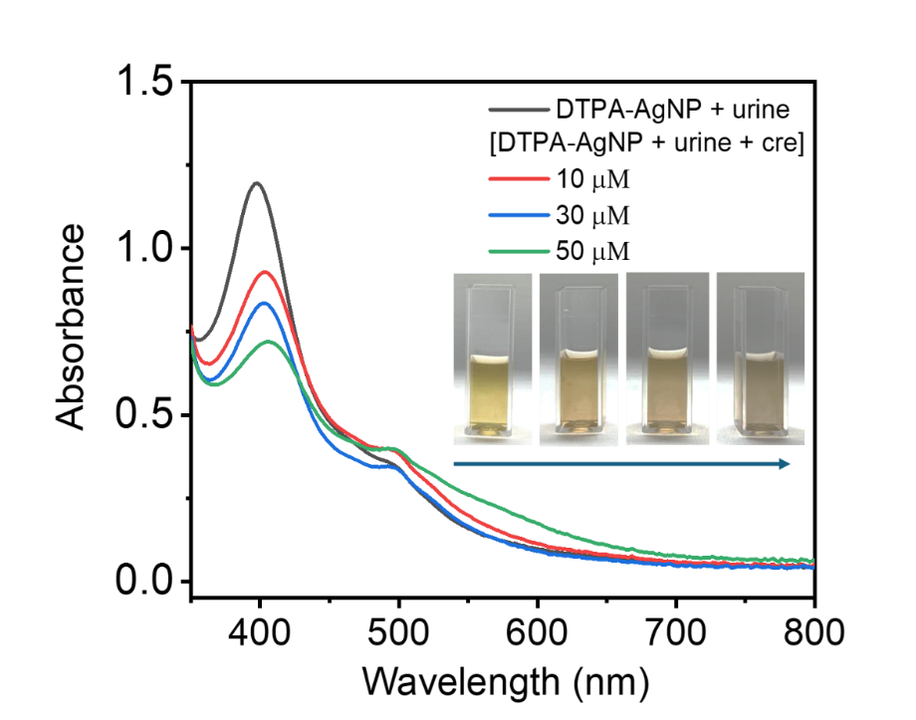
Fig S4. UV-Vis absorbance spectrum of the DTPA-AgNP with diluted urine and creatinine-spiked urine (10, 30, 50 µM) (inset: Photograph of unspiked and creatinine-spiked DTPA-AgNP solution)

Table S1. Topological descriptors obtained from QTAIM analysis of the DTPA-AgNP and DTPA-AgNP/creatinine complexes at the DFT/M06-2X/6-311G(d,p)/LanL2DZ level of theory. Listed parameters include the electron density ($ρ_{bcp}$), kinetic energy density ($G_{bcp}$) potential energy density ($V_{bcp})$total energy density ($H_{bcp}$), Laplacian of electron density (${∇^{2}}_{bcp})$ and the $-G_{bcp}/V_{bcp}$ ratio evaluated at the bond critical points. All values are expressed in atomic units or a.u.

Complexes | BCP | $$ρ_{bcp}$$ | $$G_{bcp}$$ | $$V_{bcp}$$ | $$H_{bcp}$$ | $${∇^{2}}_{bcp}$$ | $$-G_{bcp}/V_{bcp}$$
DTPA-AgNP | Ag⋯O | 0.0426 | 0.0558 | -0.0561 | -0.0003 | 0.2223 | 0.9947
DTPA-AgNP | Ag⋯O | 0.0352 | 0.0419 | -0.0414 | 0.0005 | 0.1698 | 1.0121
DTPA-AgNP | Ag⋯O | 0.0480 | 0.0635 | -0.0650 | -0.0015 | 0.2481 | 0.9769
DTPA-AgNP | Ag⋯O | 0.0384 | 0.0468 | -0.0468 | -0.0001 | 0.1869 | 1.0000
DTPA-AgNP | Ag⋯O | 0.0299 | 0.0281 | -0.0288 | -0.0007 | -0.0007 | 0.9757
DTPA-AgNP | Ag⋯O | 0.0162 | 0.0162 | -0.0132 | 0.0008 | 0.0590 | 1.2273
DTPA-AgNP | Ag⋯H | 0.0208 | 0.0164 | -0.0156 | 0.0008 | 0.0685 | 1.0513
DTPA-AgNP | Ag⋯H | 0.0145 | 0.0099 | -0.0093 | 0.0007 | 0.0428 | 1.0645
DTPA-AgNP/Cre | Ag⋯O | 0.0550 | 0.0775 | -0.0803 | -0.0028 | 0.0030 | 0.9651
DTPA-AgNP/Cre | Ag⋯C | 0.0062 | 0.0037 | -0.0033 | 0.0004 | 0.0163 | 1.1212
DTPA-AgNP/Cre | Ag⋯H | 0.0212 | 0.0171 | -0.0164 | 0.0008 | 0.0718 | 1.0427
DTPA-AgNP/Cre | Ag⋯H | 0.0084 | 0.0051 | -0.0048 | 0.0003 | 0.0215 | 1.0625
DTPA-AgNP/Cre | Ag⋯H | 0.0067 | 0.0035 | -0.0034 | -0.0001 | 0.0142 | 1.0294
DTPA-AgNP/Cre | Ag⋯O | 0.0489 | 0.0649 | -0.0665 | -0.0015 | 0.2538 | 0.9759
DTPA-AgNP/Cre | Ag⋯O | 0.0199 | 0.0182 | -0.0175 | -0.0008 | 0.0759 | 1.0400
DTPA-AgNP/Cre | Ag⋯O | 0.0348 | 0.0415 | -0.0409 | 0.0005 | 0.1681 | 1.0147
DTPA-AgNP/Cre | O⋯H | 0.0421 | 0.0390 | -0.0414 | -0.0025 | 0.1458 | 0.9420
DTPA-AgNP/Cre | O⋯H | 0.0130 | 0.0096 | -0.0084 | 0.0012 | 0.0434 | 1.1429
DTPA-AgNP/Cre | O⋯N | 0.0103 | 0.0067 | -0.0058 | 0.0009 | 0.0305 | 1.1552
DTPA-AgNP/Cre | O⋯H | 0.0123 | 0.0096 | -0.0081 | 0.0015 | 0.0444 | 1.1852

