Supplementary information

Large variation in soil phosphorus availability and tree nutritional strategies in humid temperate forests of carbonate rocks

Text content:
Description of effects of specific leaf area and mycorrhizal types on plant nutritional strategies
Tables S1–S3
Figures S1–S5

Description of effects of specific leaf area and mycorrhizal types on plant nutritional strategies

Methods
To compare the CCA axis-2 scores with established plant strategy frameworks, such as leaf economics spectrum and mycorrhizal association, we obtained specific leaf area (SLA) data from the TRY database (Kattge et al. 2011), and mycorrhizal association at genus level data from the FungalRoot database (Soudzilovskaia et al. 2020). Mean SLA values were calculated for each species. Mycorrhizal association types (arbuscular mycorrhiza, AM; ectomycorrhiza, EcM; ericoid mycorrhiza, ErM; uncertain) for all recorded woody species were assigned according to the genus-level recommendation list of Soudzilovskaia et al. (2020). The relative abundance of AM species was calculated for each of the 60 plots, weighted by their respective vegetation coverage.
Statistics
The relationships of the species CCA axis-2 scores with species mean SLA were analyzed using a linear model. The relationships of the CCA axis-2 scores with mycorrhizal association types were analyzed using a generalized linear model, with a logit link function and a binomial error distribution, modeling the probability of a species being AM-associated as a function of its CCA axis-2 score.
Because the CCA axis-2 scores ​​may covary with SLA and mycorrhizal association type, we constructed structural equation models to distinguish between the direct effects of CCA axis-2 values ​​on P nutritional strategies and the indirect effects mediated by changes in SLA and mycorrhizal association type. The full models are shown in Figure S3. Mycorrhizal association type was treated as a binary variable consisting of two levels: “AM (0)” and “EcM (1)”. Species classified as “ErM” or "uncertain" were excluded from these analyses due to their low occurrence and abundance. All continuous variables except for P resorption efficiency and CCA axis-2 scores were log-transformed to ensure normality. Structural equation modeling was performed with the sem function in “lavaan” package (Rosseel 2012) using Diagonal Weighted Least Squares (DWLS) estimation, as recommended for models containing continuous variables alongside ordinal or binary variables.
To examine the effects of SLA and mycorrhizal types on rhizosphere soil measurement, we built linear mixed models incorporating SLA and mycorrhizal association, respectively, as fixed effects of Equations 5 and 6 in the main manuscript.
Results
Specific Leaf Area values were obtained for 99 of the 165 species observed in the vegetation survey. The relationship between species CCA axis-2 scores and species mean of SLA was not significant (data not shown). The probability of being an AM-associated species was significantly higher at higher CCA axis-2 scores (p < 0.001) (data not shown).
In all structural equation models, soil P availability had significant direct effects on P nutritional strategies (Figure S3). The CCA axis-2 scores had significant direct effects on P repsorption efficiency and leaf Mn concentrations. Although the CCA axis-2 score negatively affected SLA across all models, SLA itself had no significant effect on P nutritional strategies. The CCA axis-2 score had indirect effect on leaf Mn mediated by mycorrhizal association type, however, the direct effects of the CCA axis-2 score and soil P availability were more dominant than the influence of mycorrhizal association type.
Specific leaf area and mycorrhizal types had no significant effect on rhizosphere effect (i.e. difference in pH or exchangeable Mn between bulk and rhizosphere soils) (data not shown).

Reference
Kattge J, Díaz S, Lavorel S, et al (2011) TRY – a global database of plant traits. Glob Change Biol 17:2905–2935. https://doi.org/10.1111/j.1365-2486.2011.02451.x
Rosseel Y (2012) lavaan: An R Package for Structural Equation Modeling. J Stat Softw 48:1–36. https://doi.org/10.18637/jss.v048.i02
Soudzilovskaia NA, Vaessen S, Barcelo M, et al (2020) FungalRoot: global online database of plant mycorrhizal associations. New Phytol 227:955–966. https://doi.org/10.1111/nph.16569

Table S1. Species scores of canonical correspondence analysis (CCA). Species are ordered along with CCA axis-2 scores.
Species | CCA1 | CCA2 | CCA3 | CCA4 | CCA5
Rhamnus japonica | -1.3 | 2.09 | 1.94 | -0.03 | 0.74
Ligustrum tschonoskii | -1.4 | 1.91 | 1.35 | -0.2 | 1.14
Syringa reticulata | -1.37 | 1.74 | 1.59 | 1.21 | -0.61
Quercus dentata | 1.25 | 1.71 | -0.98 | -1.16 | 2.52
Toxicodendron succedaneum | 1.25 | 1.71 | -0.98 | -1.16 | 2.52
Kalopanax septemlobus | 1.27 | 1.62 | -0.97 | -0.64 | 1.89
Euptelea polyandra | -0.71 | 1.62 | 0.32 | -3.64 | -4.22
Padus buergeriana | -0.63 | 1.6 | 0.69 | -3.37 | -6.26
Enkianthus cernuus | -1.34 | 1.57 | 1.82 | 2.62 | -2.37
Toxicodendron orientale | -0.41 | 1.56 | 0.08 | 0.22 | 0.85
Clerodendrum trichotomum | 1.27 | 1.54 | -0.6 | 0.5 | 0.43
Berberis thunbergii | -1.32 | 1.54 | 1.6 | 2.38 | -2.02
Clematis japonica | 1.29 | 1.54 | -0.97 | -0.12 | 1.27
Stachyurus praecox | 0.65 | 1.53 | -0.33 | -0.1 | -0.44
Cephalotaxus harringtonia | 1.31 | 1.45 | -0.86 | 0.56 | 0.43
Trachelospermum asiaticum | 1.32 | 1.45 | -1.08 | 0.16 | 0.98
Ilex chinensis | 1.32 | 1.45 | -1.08 | 0.16 | 0.98
Deutzia gracilis | 1.32 | 1.45 | -1.08 | 0.16 | 0.98
Platycarya strobilacea | 1.32 | 1.45 | -1.08 | 0.17 | 0.96
Nandina domestica | 1.33 | 1.44 | -1.08 | 0.23 | 0.88
Morus cathayana | 1.32 | 1.44 | -0.99 | 0.4 | 0.66
Picrasma quassioides | 1.31 | 1.44 | -0.86 | 0.63 | 0.34
Acer carpinifolium | -1.14 | 1.43 | -0.84 | -1.63 | 3.44
Abelia spathulata | 1.33 | 1.41 | -1.02 | 0.51 | 0.54
Amelanchier asiatica | 1.32 | 1.41 | -0.87 | 0.79 | 0.16
Celtis sinensis | 1.19 | 1.41 | -1.12 | 0.21 | 0.94
Staphylea bumalda | 1.32 | 1.41 | -0.87 | 0.79 | 0.16
Zanthoxylum piperitum | 1.32 | 1.4 | -0.88 | 0.79 | 0.17
Callicarpa japonica | 1.12 | 1.38 | -1.11 | -0.23 | 0.07
Hedera rhombea | 0.1 | 1.37 | -0.67 | 0.31 | 0.87
Philadelphus satsumi | -1.14 | 1.37 | -0.52 | -0.42 | 1.9
Aucuba japonica | 1.34 | 1.35 | -0.94 | 0.51 | 0.5
Juglans mandshurica | -1.16 | 1.35 | -0.1 | 0.46 | 0.75
Lindera glauca | 1.33 | 1.34 | -0.76 | 1.38 | -0.57
Daphne pseudo mezereum | -1.16 | 1.33 | 0.05 | 0.83 | 0.25
Viburnum sieboldii | -1.14 | 1.31 | -0.12 | 0.35 | 0.74
Kerria japonica | 1.38 | 1.31 | -1.34 | 0.51 | 0.63
Orixa japonica | -0.07 | 1.3 | -0.76 | -1.04 | -1.21
Cinnamomum yabunikkei | 1.36 | 1.27 | -0.83 | 1.65 | -0.88
Hydrangea petiolaris | -1.08 | 1.27 | -0.27 | -1.66 | 2.02
Akebia trifoliata | 1.36 | 1.26 | -0.92 | 1.54 | -0.72
Camellia japonica | 1.36 | 1.24 | -0.76 | 1.95 | -1.26
Acer pictum | -0.96 | 1.24 | 0.23 | -1.21 | -1.11
Cerasus apetala | 1.38 | 1.22 | -0.92 | 1.79 | -1.02
Euonymus sieboldianus | -1.13 | 1.22 | 0.08 | 1.24 | -0.28
Euonymus oxyphyllus | 1.17 | 1.21 | -0.68 | 0.9 | -0.02
Wisteria floribunda | 1.19 | 1.2 | -0.71 | -0.82 | 1.48
Acer maximowiczianum | 0.51 | 1.19 | -1.4 | -1.82 | -2.06
Lonicera gracilipes | 1.37 | 1.15 | -0.66 | 1.57 | -0.85
Helwingia japonica | 1.39 | 1.14 | -0.77 | 2.49 | -1.9
Akebia quinata | 0.21 | 1.11 | -1.3 | 0.7 | 0.58
Aesculus turbinata | -0.65 | 1.1 | 0.28 | -2.68 | -4.38
Fraxinus sieboldiana | 1.36 | 1.1 | -0.54 | 0.8 | 0.01
Fagus japonica | 1.06 | 1.09 | -0.64 | -0.72 | 0.02
Ligustrum japonicum | 1.35 | 1.09 | -0.49 | 0.29 | 0.6
Elaeagnus pungens | 1.38 | 1.08 | -0.6 | 1.75 | -1.08
Lindera obtusiloba | 1.41 | 1.05 | -0.73 | 3.11 | -2.65
Lindera praecox | -1.1 | 1.01 | -0.04 | -0.52 | 1.84
Ligustrum obtusifolium | -0.59 | 0.99 | -1.02 | 1.22 | 0.02
Actinidia arguta | -1.04 | 0.99 | -0.51 | -1.71 | 2.88
Torreya nucifera | -0.34 | 0.98 | -0.96 | -1.26 | -3.48
Hydrangea scandens | 1.43 | 0.95 | -0.56 | 4.02 | -3.78
Ficus sarmentosa | 1.43 | 0.95 | -0.56 | 4.02 | -3.78
Deutzia crenata | -0.36 | 0.89 | -1.22 | 0.23 | 1.2
Neolitsea sericea | 1.22 | 0.86 | -1.03 | 0.44 | 0.61
Morus australis | -0.85 | 0.85 | -1.63 | 0.66 | 0.91
Lindera erythrocarpa | -0.24 | 0.83 | -2.19 | -4.14 | -4.56
Zanthoxylum ailanthoides | -0.24 | 0.83 | -2.19 | -4.14 | -4.56
Cladrastis shikokiana | -0.24 | 0.83 | -2.19 | -4.14 | -4.56
Berchemia racemosa | -0.92 | 0.83 | -1.68 | 0.61 | 1
Elaeagnus multiflora | -0.92 | 0.83 | -1.68 | 0.61 | 1
Actinidia polygama | -0.92 | 0.83 | -1.68 | 0.61 | 1
Zelkova serrata | -0.47 | 0.78 | -1.75 | 0.66 | 0.1
Celastrus orbiculatus | -0.88 | 0.78 | -2.1 | 0.12 | 1.69
Acer palmatum | 1.1 | 0.72 | -1.36 | 0.78 | 0.32
Ilex crenata | 1.09 | 0.71 | -0.66 | 0.16 | 0.83
Viburnum erosum | 1.16 | 0.71 | 0.1 | 0.33 | 0.37
Euonymus alatus | -0.64 | 0.7 | 0.09 | 0.24 | 0.81
Carpinus cordata | -0.88 | 0.69 | -0.06 | -1.57 | 0.31
Cornus controversa | -0.16 | 0.67 | 0.12 | -1.46 | -1.03
Diospyros kaki | 1.42 | 0.66 | -0.18 | 0.79 | -0.13
Fraxinus apertisquamifera | -0.92 | 0.64 | -0.81 | 3.26 | -2.41
Elaeagnus yoshinoi | 1.37 | 0.61 | 0.38 | -0.66 | 1.41
Padus grayana | 1.16 | 0.61 | -0.75 | 1.18 | -1.22
Symplocos sawafutagi | -1.1 | 0.57 | 1.27 | 0.77 | -0.12
Pinus densiflora | 1.14 | 0.56 | 0.11 | 0.44 | 0.24
Quercus variabilis | 1.45 | 0.49 | -0.04 | 1.22 | -0.69
Abies firma | 0.98 | 0.42 | 0.1 | -1.57 | -0.17
Pertya scandens | 1.46 | 0.34 | 0.07 | 0.34 | 0.29
Osmanthus heterophyllus | 1.38 | 0.33 | 0.95 | -0.3 | 0.77
Cornus kousa | 0.12 | 0.28 | -0.41 | -0.11 | 0.09
Toxicodendron trichocarpum | 1.09 | 0.26 | 0.51 | 0.09 | 0.51
Hydrangea luteovenosa | 1.4 | 0.26 | 0.83 | -0.63 | 1.19
Acer crataegifolium | 1.44 | 0.26 | 0.6 | 0.59 | -0.17
Lindera umbellata | 0.95 | 0.2 | 0.68 | 0.14 | 0.42
Acer shirasawanum | -1.01 | 0.2 | 0.99 | 0.78 | -0.08
Fraxinus lanuginosa | -0.71 | 0.18 | 0.12 | -1.24 | -1.41
Daphniphyllum macropodum | 1.39 | 0.16 | 1.24 | -0.69 | 1.13
Quercus serrata | 1.11 | 0.13 | -0.01 | -0.56 | -0.52
Cerasus leveilleana | 1.41 | 0.1 | 1.09 | -1.08 | 1.63
Rhus javanica | -0.57 | 0.09 | -3.96 | 0.82 | 1.36
Ilex pedunculosa | 1.44 | 0.09 | 0.77 | 0.21 | 0.17
Cornus macrophylla | -0.57 | 0.07 | -3.89 | 0.8 | 1.36
Pourthiaea villosa | -0.67 | 0.05 | -0.07 | 0.61 | 0.39
Gamblea innovans | 1.43 | 0.04 | 1.02 | -0.4 | 0.84
Cerasus jamasakura | 0.64 | 0.03 | -1.3 | -1.2 | 0.63
Quercus glauca | 1.48 | -0.07 | 0.73 | -0.29 | 0.79
Viburnum dilatatum | -0.6 | -0.09 | -3.12 | 0.97 | 0.91
Hydrangea hydrangeoides | -0.92 | -0.18 | 0.89 | 0.64 | 0.07
Sorbus japonica | 1.45 | -0.19 | 1.36 | -1.04 | 1.47
Quercus crispula | -0.82 | -0.22 | 1.02 | -1.17 | 0.04
Smilax china | 0.51 | -0.31 | -1.38 | 0.48 | 0.71
Rhododendron reticulatum | 1.45 | -0.33 | 1.69 | -0.39 | 0.59
Maackia amurensis | 1.44 | -0.35 | 1.83 | -0.83 | 1.06
Skimmia japonica | 1.44 | -0.35 | 1.83 | -0.83 | 1.06
Vaccinium hirtum | 1.43 | -0.35 | 2.11 | -0.33 | 0.39
Vaccinium oldhamii | 1.43 | -0.35 | 2.11 | -0.33 | 0.39
Cryptomeria japonica | 1.51 | -0.35 | 1.17 | 0.09 | 0.18
Callicarpa mollis | 1.45 | -0.36 | 1.69 | -1.03 | 1.34
Magnolia obovata | 1.44 | -0.37 | 1.71 | -0.99 | 1.21
Chengiopanax sciadophylloides | 1.16 | -0.37 | 1 | -0.02 | 0.42
Quercus salicina | 1.53 | -0.54 | 0.88 | -1.3 | 1.74
Carpinus laxiflora | 1.26 | -0.55 | 1.05 | -0.56 | 0.6
Magnolia salicifolia | 0.29 | -0.56 | 1.59 | -1.06 | 1.61
Neoshirakia japonica | -0.28 | -0.59 | -0.92 | -3.44 | -2.15
Eurya japonica | 1.52 | -0.6 | 1.15 | -0.24 | 0.56
Rhododendron pentandrum | -0.98 | -0.6 | 2.57 | -0.11 | 0.4
Enkianthus campanulatus | -0.98 | -0.6 | 2.57 | -0.11 | 0.4
Sorbus commixta | -0.98 | -0.6 | 2.57 | -0.11 | 0.4
Phellodendron amurense | -0.95 | -0.62 | 2.16 | -0.72 | 1.24
Hydrangea hirta | -0.95 | -0.62 | 2.16 | -0.72 | 1.24
Fagus crenata | -0.97 | -0.62 | 2.48 | -0.16 | 0.48
Chamaecyparis obtusa | 1.54 | -0.62 | 1.41 | -0.01 | 0.19
Acer micranthum | -0.93 | -0.67 | 2.02 | -0.71 | 1.26
Hamamelis japonica | -0.92 | -0.69 | 1.95 | -0.7 | 1.28
Acer japonicum | -0.9 | -0.7 | 1.75 | -1.01 | 1.7
Vaccinium japonicum | 1.57 | -0.72 | 1.4 | 0.52 | -0.43
Acer distylum | -0.86 | -0.78 | 1.34 | -1.3 | 2.15
Viburnum wrightii | -0.86 | -0.78 | 1.34 | -1.3 | 2.15
Tilia japonica | -0.76 | -0.85 | 0.76 | 0.68 | -0.2
Styrax obassia | -0.83 | -0.89 | 1.41 | -0.52 | 1.21
Lyonia ovalifolia | 0.78 | -0.91 | 0.67 | 0.43 | 0.03
Carpinus tschonoskii | -0.41 | -0.94 | -1.13 | -1.44 | 0.15
Ilex macropoda | 1.26 | -1.03 | 0.54 | 0.58 | -0.76
Rhododendron kaempferi | 0.46 | -1.05 | 1.14 | 0.93 | -0.66
Viburnum furcatum | -0.73 | -1.09 | 0.75 | -0.55 | 1.42
Rhododendron macrosepalum | 0.57 | -1.12 | -0.43 | -1.46 | 2.63
Acer rufinerve | -0.67 | -1.14 | 0.31 | 0.63 | 0.09
Clethra barbinervis | 0.82 | -1.2 | 0.41 | 0.67 | -0.41
Acer amoenum | -0.06 | -1.2 | -1.7 | 0.67 | -0.23
Sorbus alnifolia | -0.65 | -1.32 | 0.62 | 0.61 | -0.06
Styrax japonicus | -0.46 | -1.34 | -0.5 | 0.3 | 0.36
Vitis flexuosa | 0.08 | -1.45 | -0.41 | -4.37 | -5.07
Alnus hirsuta | 0.09 | -1.48 | -0.45 | -4.3 | -5.14
Symplocos coreana | -0.61 | -1.51 | 0.66 | 1.72 | -1.27
Eubotryoides grayana | -0.59 | -1.57 | 0.65 | 2.02 | -1.63
Pieris japonica | 0.53 | -1.66 | -0.57 | 1.41 | -0.93
Lindera triloba | -0.47 | -1.68 | -0.69 | 0.21 | 0.65
Carpinus japonica | -0.46 | -1.7 | -0.7 | 0.47 | 0.27
Castanea crenata | -0.41 | -1.77 | -1.11 | -0.04 | 1.12
Stewartia pseudocamellia | 0.27 | -1.83 | -1.9 | -4.88 | -4.06
Acer sieboldianum | 0.04 | -1.85 | -1.54 | -2.59 | -2.94
Tilia miqueliana | -0.37 | -1.88 | -1.62 | -0.24 | 1.69
Hydrangea paniculata | -0.37 | -2.12 | -0.49 | 3.17 | -2.7
Quercus acuta | -0.07 | -2.63 | -3.03 | 1.51 | -0.02

Table S2. Sampling locations for green and senescent leaves. CCA2 means CCA axis-2 score of each species. Plots C1–8 represent plots on carbonate rocks, and S1–8 represent plots on silicate rocks. The numbers in each cell indicate the number of the sampled individual in each plot.
Species | CCA2 | Ibuki |  |  |  |  |  |  |  |  |  | Atetsu
Species | CCA2 | C1 | C2 | C3 | C4 | C5 | S1 | S2 | S3 | S4 | S5 | C6 | C7 | C8 | S6 | S7 | S8
Green leaves
Syringa reticulata | 1.29 |  |  |  |  | 3
Platycarya strobilacea | 1.08 |  |  |  |  |  |  |  |  |  |  |  |  | 3
Morus cathayana | 1.07 |  |  |  |  |  |  |  |  |  |  |  |  | 3
Viburnum sieboldii | 0.98 | 2 |  | 3 | 3
Euonymus sieboldianus | 0.90 | 3 | 3 | 3 | 3 | 3
Euonymus oxyphyllus | 0.90 |  |  |  |  |  |  |  |  |  |  |  |  | 3
Helwingia japonica | 0.85 |  |  |  |  |  |  |  |  |  |  |  |  | 3
Lindera praecox | 0.75 | 3
Zelkova serrata | 0.59 |  |  |  | 3 |  |  |  |  |  |  |  |  | 3
Carpinus cordata | 0.51 |  | 3
Quercus variabilis | 0.37 |  |  |  |  |  |  |  |  |  |  | 3 |  |  | 2
Acer shirasawanum | 0.15 | 3 | 3 |  | 3 |  |  | 2
Quercus serrata | 0.10 |  |  |  |  |  |  |  |  |  |  | 3 |  | 2 | 3 |  | 3
Ilex pedunculosa | 0.06 |  |  |  |  |  |  |  |  |  |  | 3 |  |  |  |  | 3
Quercus crispula | -0.17 |  |  | 3 | 3 | 3 |  | 3 | 3 |  | 3
Tilia japonica | -0.63 | 1 | 3 | 3 |  |  |  |  | 3
Acer rufinerve | -0.85 |  |  |  | 3 |  |  | 3
Clethra barbinervis | -0.89 |  |  |  |  |  |  | 3 |  |  | 3 |  |  |  | 3 |  | 3
Micromeles alnifolia | -0.98 |  | 3 |  |  |  |  | 3
Pieris japonica | -1.23 |  |  |  |  |  |  |  |  |  |  |  | 3 |  | 3
Lindera triloba | -1.25 |  |  |  |  |  |  | 3
Castanea crenata | -1.31 |  |  |  |  |  |  | 3 |  |  | 3
Senescent leaves
Syringa reticulata | 1.29 |  |  |  |  | 3
Platycarya strobilacea | 1.08 |  |  |  |  |  |  |  |  |  |  |  |  | 3
Viburnum sieboldii | 0.98 | 1 |  | 2 | 3
Acer pictum | 0.92 | 3
Euonymus sieboldianus | 0.90 | 3 | 1 | 2 | 3 | 3
Zelkova serrata | 0.59 |  |  |  | 3 |  |  |  |  |  |  |  |  | 3
Quercus variabilis | 0.37 |  |  |  |  |  |  |  |  |  |  | 3 |  |  | 2
Acer shirasawanum | 0.15 | 3 | 3 | 3 | 3 | 3 |  | 3
Quercus serrata | 0.10 |  |  |  |  |  |  |  |  |  |  | 3 |  | 3 | 3 |  | 3
Quercus crispula | -0.17 |  | 1 | 3 | 3 | 3 | 2 | 3 | 1 |  | 3
Tilia japonica | -0.63 | 1 | 1 |  |  |  |  |  | 2
Acer rufinerve | -0.85 |  |  |  | 3 |  |  | 3
Clethra barbinervis | -0.89 |  |  |  |  |  | 3 | 3 | 3 |  | 3 |  |  |  | 3 |  | 3
Micromeles alnifolia | -0.98 |  | 3 |  |  |  |  | 3
Pieris japonica | -1.23 |  |  |  |  |  |  |  |  |  |  |  | 3 |  | 3
Lindera triloba | -1.25 |  |  |  |  |  |  | 3
Castanea crenata | -1.31 |  |  |  |  |  |  | 3 |  |  | 2

Table S3. Total phosphorus stock in carbonate rock soils, and mass balance estimation for the thickness of carbonate rock required to supply the P stock. The thickness ratio are the quotient of the estimated carbonate rock thickness and the soil thickness (30 cm).
 | Upper 30cm  soil P stock (g m⁻²) | Rock thickness required for P supply (cm) | Thickness ratio  Rock : Soil
Ibuki | 439 | 6.2 | 0.207
Ibuki | 451 | 6.4 | 0.213
Ibuki | 471 | 6.7 | 0.222
Ibuki | 334 | 4.7 | 0.157
Ibuki | 11668 | 165 | 5.499
Atetsu | 52 | 0.7 | 0.024
Atetsu | 100 | 1.4 | 0.047
Atetsu | 74 | 1.1 | 0.035

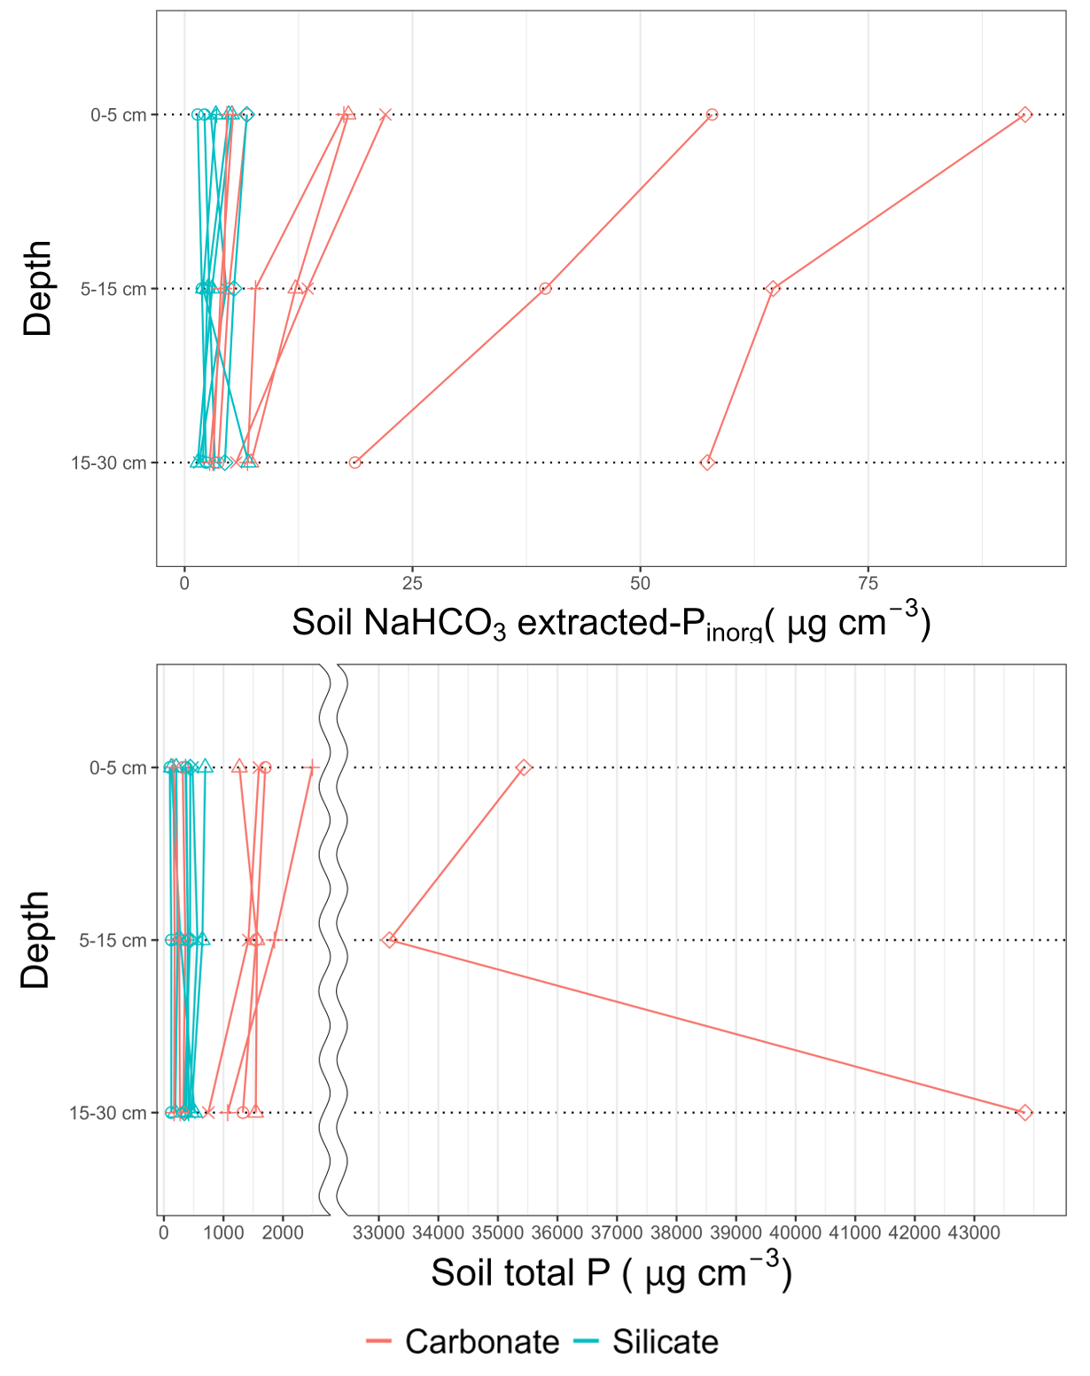
Figure S1. Vertical distribution of NaHCO₃-extracted inorganic P and total P. Phosphorus concentrations are shown on a volumetric basis in order to take account for the reduction in bulk density caused by the inclusion of organic matter. The same points indicate the soil profiles collected from the same plot.
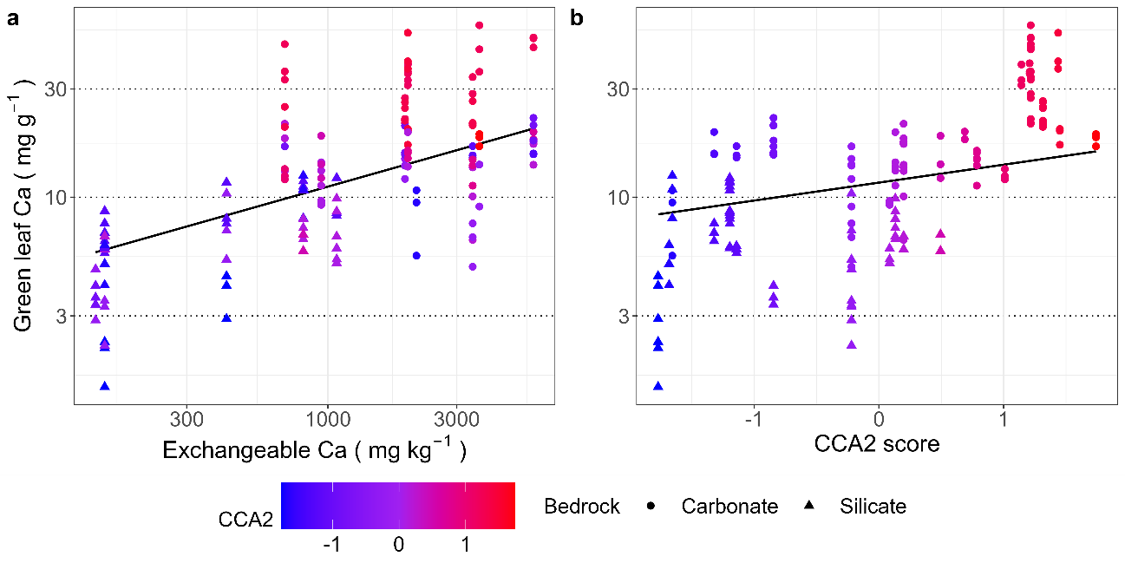Figure S2. Leaf calcium concentration in relation to soil exchangeable calcium concentration (Exchangeable Ca) and an index of species habitat associations related to carbonate rocks (the score of the CCA axis-2; Figure 1). Each point represents an individual tree. Leaf calcium concentration and soil exchangeable calcium concentration were log-transformed. The black lines indicate a prediction from linear mixed-effects models, with all other covariates fixed at their mean values. See Table 4 for the result of mixed-effect linear models.

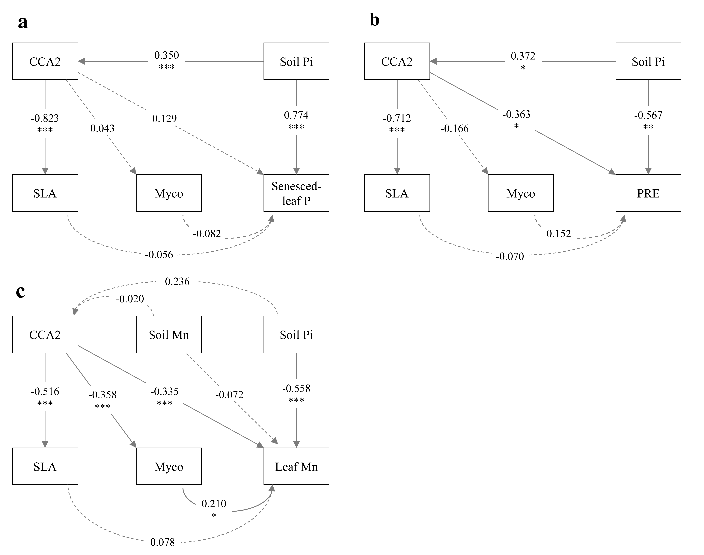
Figure S3. Structural equation models illustrating the paths and standardized path coefficients for (a) senesced-leaf P concentration, (b) P resorption efficiency, and (c) leaf Mn concentration. Solid and dashed arrows indicate statistically significant (p < 0.05) and non-significant (p ≥ 0.05) paths, respectively. *, p < 0.05; **, p < 0.01; ***, p < 0.001. Abbreviation: PRE, P resorption efficiency; Soil Pi, soil phosphorus availability (i.e. sum of the NaHCO₃-extracted and NaOH-extracted inorganic P concentration); Soil Mn, soil exchangeable calcium concentration; SLA, species mean specific leaf area; Myco, Mycorrhizal association type; CCA2, species CCA axis-2 score.

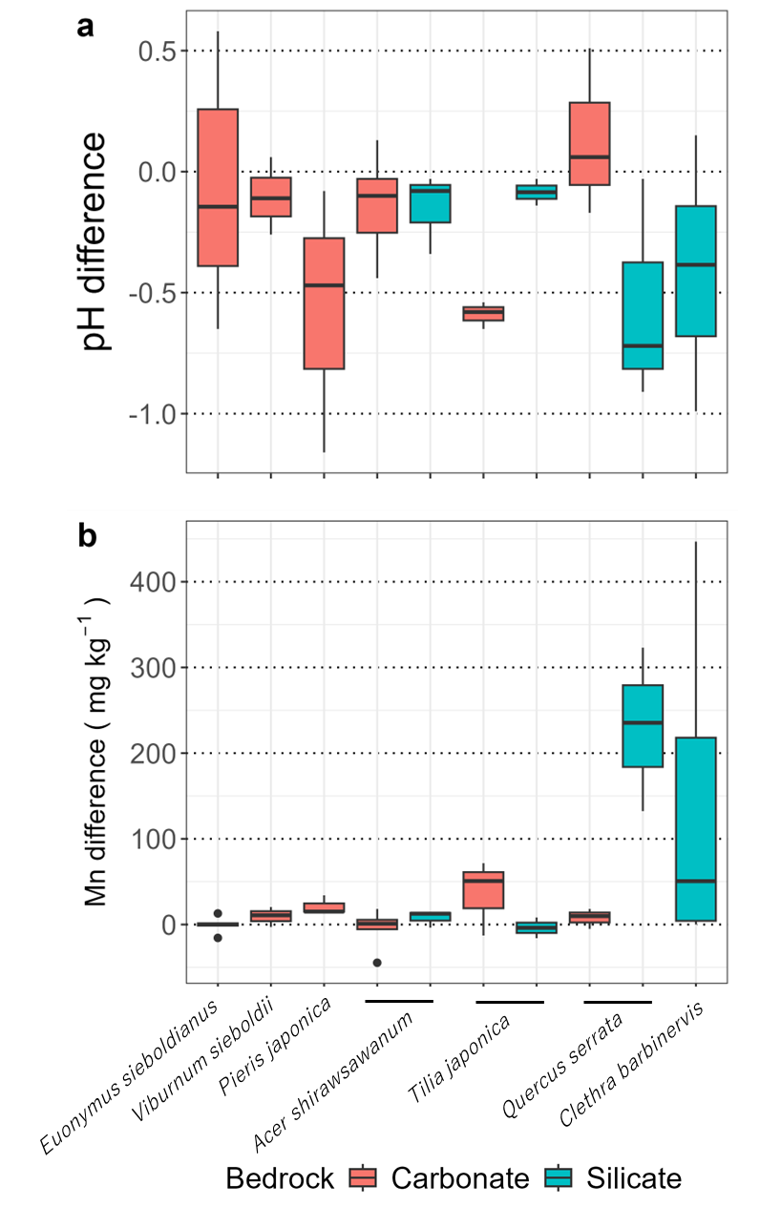
Figure S4. Difference of soil pH (a) and exchangeable manganese (Mn) concentration (b) between rhizosphere soil and bulk soil. Each pair of rhizosphere and bulk soils was collected from an individual (n = 6 for E.sieboldianus and V. sieboldii, n = 3 for other species).

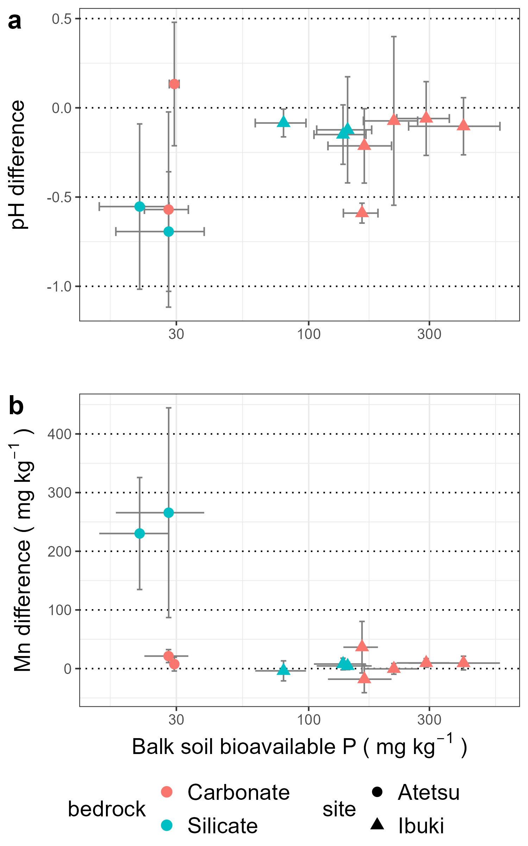
Figure S5. Correlation of NaOH-extracted inorganic phosphorus concentration of balk soil (Balk soil OH-Pi) and difference in pH (a) and exchangeable Mn (b) between rhizosphere and bulk soils. NaOH-extracted inorganic phosphorus were log-transformed. Each point represents a species mean in each plot. Grey bars indicate standard deviations.

