Supplementary Information for

"PNMA5 Promotes Radiotherapy Resistance in Colorectal Cancer by Regulating Angiogenic Factor Secretion and Apoptosis"

Yitao Chen¹, Juping Wang², Wanlu Zhang³, Runmei Wang^{4*}, and Xianggao Zhu⁵

¹ Inner Mongolia Medical University; The Second People's Hospital of Datong, Shanxi Province, China. (584911962@qq.com)
² Peking University Cancer Hospital, Inner Mongolia Branch, China; 15124705049@163.com
³ Inner Mongolia Medical University, China. maozaza2024@163.com
^{4,} Peking University Cancer Hospital, Inner Mongolia Branch, China; wangrunmei119@126.com
⁵ Peking University Cancer Hospital, China; 13811884504@163.com
* Corresponding author: wangrunmei119@126.com；13811884504@163.com

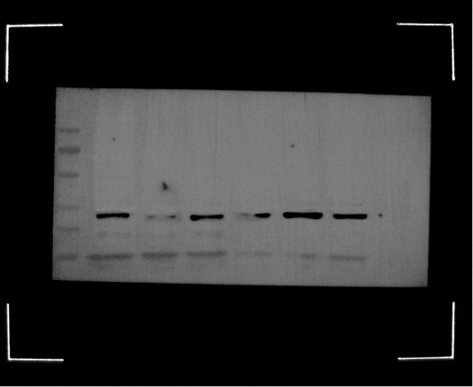
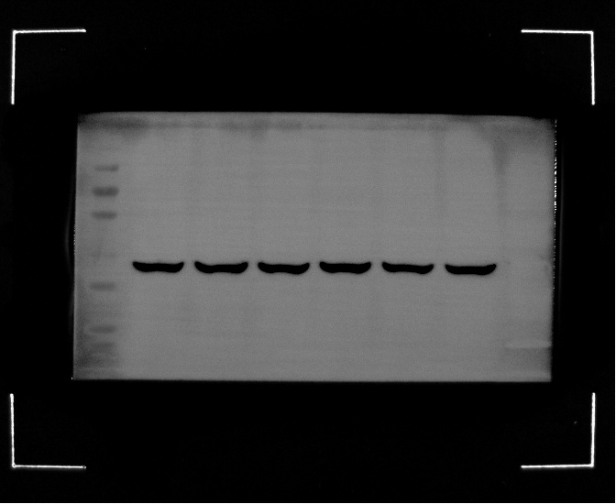
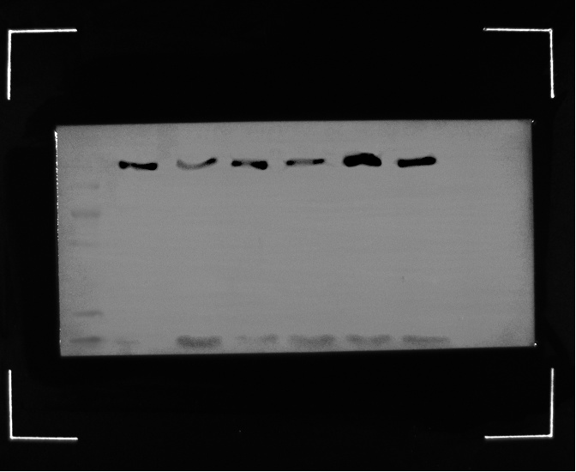
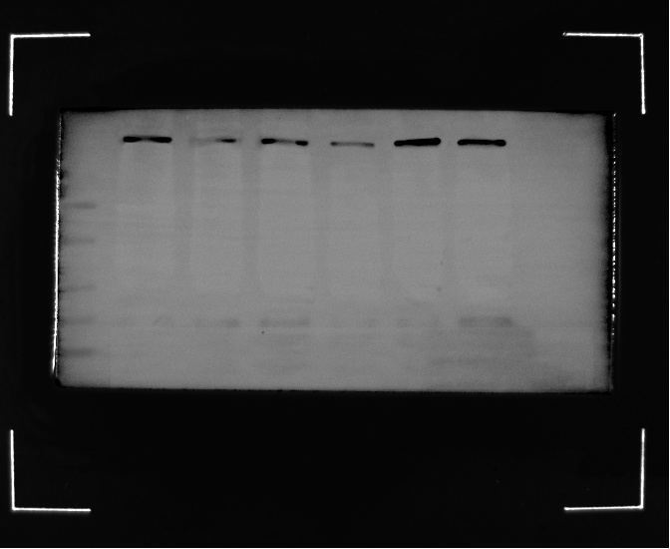
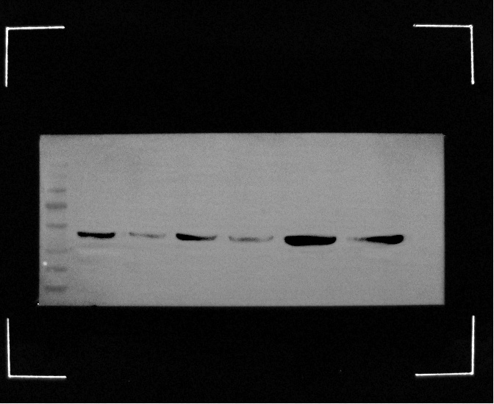
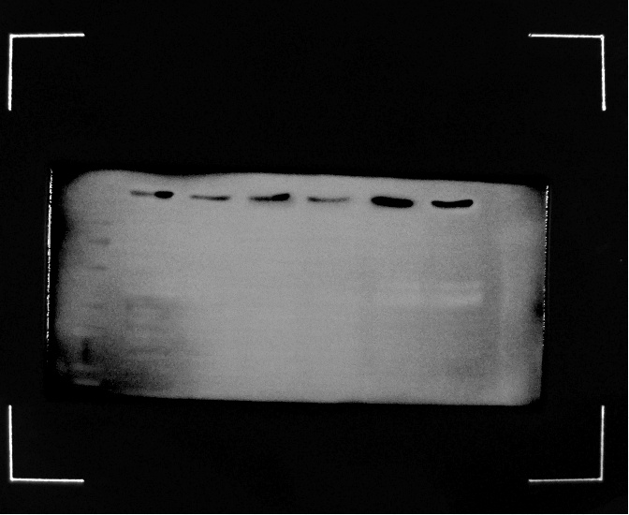
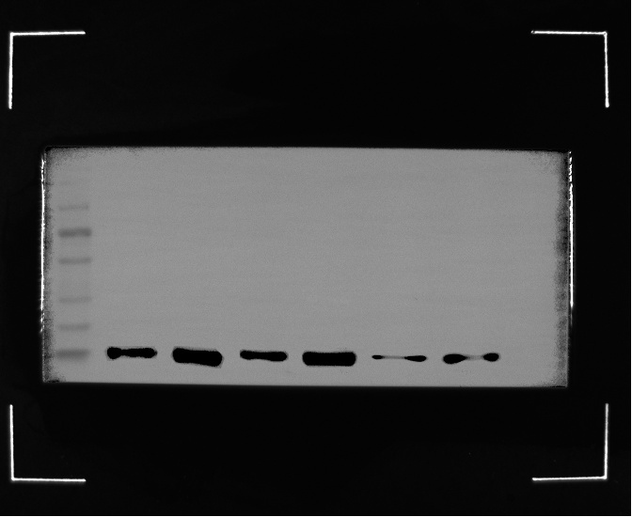
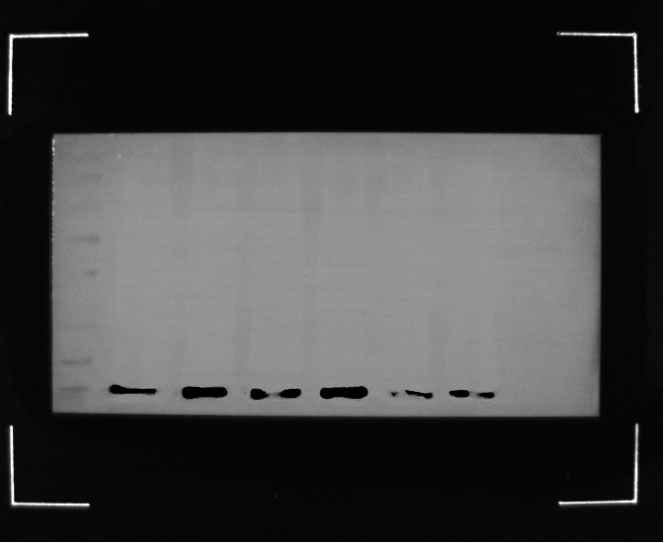
VEGF 130kDa
β-actin 45kDa
Ctrl RT NC si-PNMA5 OE OE+RT
HT-29 HT-29+RT HT-29 NC HT-29-SI-PNMA5 HT-29-OE-PNMA5 HT-29-OE+RT
Ctrl RT NC si-PNMA5 OE OE+RT
CD34 92kDa
Ctrl RT NC si-PNMA5 OE OE+RT
CD31 55kDa
Ctrl RT NC si-PNMA5 OE OE+RT
PNMA5 35kDa
Ctrl RT NC si-PNMA5 OE OE+RT
VEGFR 42kDa
Ctrl RT NC si-PNMA5 OE OE+RT
BCL-2 55kDa
Ctrl RT NC si-PNMA5 OE OE+RT
BAX 27kDa
Ctrl RT NC si-PNMA5 OE OE+RT
Figure S6. Full-length uncropped western blot images.
Full-length, uncropped blot images showing the protein expression levels presented in the manuscript, including the loading control β-actin, VEGF, CD31, CD34, VEGFR, PNMA5, BAX, and BCL-2.
Experimental groups (from left to right):
Ctrl (HT-29 control group)
RT (HT-29 + 6 Gy radiation)
NC (Negative control)
si-PNMA5 (PNMA5 knockdown)
OE (PNMA5 overexpression)
OE+RT (PNMA5 overexpression + 6 Gy radiation)
Red rectangles indicate the cropped regions displayed in the main manuscript figures. Molecular weight markers (in kDa) are indicated on the right of each blot.

