APPENDIX A- QUESTIONNAIRE
“Financial Attitudes, Literacy, Practices and Well-Being:
A Study of Indian College Students”
This questionnaire is part of an academic study on Financial Attitudes, Literacy, Practices, and Well-Being among Indian College Students. All responses will remain confidential and will be used for research purposes only.

SECTION A – DEMOGRAPHIC PROFILE
1. Name: ________________________________

2. Age
◯ Below 18
◯ 18–22
◯ 23 and above

3. Gender
◯ Male
◯ Female
◯ Prefer not to say
◯ Other

4. Course
◯ B.Com (Hons.)
◯ B.Com (Prog.)
◯ BBE
◯ Other
5. Year of Study
◯ 1
◯ 2
◯ 3
◯ 4

6. Sources of Study
◯ Parents
◯ Job
◯ Both
◯ Others

7. Living Arrangement
◯ Hostel
◯ With Family
◯ PG
◯ Rent

8. Do you have a part-time job?
◯ Yes
◯ No

SECTION B – FINANCIAL ATTITUDE
(☐ Strongly Disagree
☐ Disagree
☐ Neutral
☐ Agree
☐ Strongly Agree)

9. I believe it is important to save money regularly.
10. I feel confident in my ability to manage financial challenges.
11. I do not feel anxious when I think about my financial future.
12. Spending money on non-essential items makes me feel uncomfortable.
13. I prefer planning my finances rather than spending spontaneously.

SECTION C – FINANCIAL KNOWLEDGE
(☐ Strongly Disagree
☐ Disagree
☐ Neutral
☐ Agree
☐ Strongly Agree)
14. I understand how interest rates affect my loans or savings.
15. I know how to read and interpret a bank statement.
16. I am aware of the benefits and risks of different investment options.
17. I understand how EMIs and credit card payments work.

SECTION D – FINANCIAL BEHAVIOUR
(☐ Strongly Disagree
☐ Disagree
☐ Neutral
☐ Agree
☐ Strongly Agree)
18. I keep track of my expenses and income every month.
19. I prepare and follow a monthly budget.
20. I compare prices before buying costly items.
21. I avoid impulsive purchases.
22. I save a portion of my income regularly.
23. I keep an emergency fund for unexpected expenses.
24. I pay my bills/fees on time.

SECTION E – FINANCIAL PLANNING
(☐ Strongly Disagree
☐ Disagree
☐ Neutral
☐ Agree
☐ Strongly Agree)
25. I check my bank balance regularly to avoid overspending.
26. I have set short-term and long-term financial goals.
27. I feel financially prepared to handle unexpected expenses.
28. I feel in control of my financial future.

SECTION F – FINANCIAL SATISFACTION
(☐ Strongly Disagree
☐ Disagree
☐ Neutral
☐ Agree
☐ Strongly Agree)
29. Overall, I am satisfied with my current financial situation.
30. I feel financially secure in managing my monthly needs.
31. I am satisfied with my ability to save money.

SECTION G – STUDENT DEBT AND STRESS
32. My financial situation does not cause stress that affects my daily life.
☐ Strongly Disagree
☐ Disagree
☐ Neutral
☐ Agree
☐ Strongly Agree

33. Do you currently have student debt?
◯ Yes
◯ No

34. I feel stressed because of my debt.
☐ Strongly Disagree
☐ Disagree
☐ Neutral
☐ Agree
☐ Strongly Agree

SECTION H – ACADEMIC SATISFACTION
(☐ Strongly Disagree
☐ Disagree
☐ Neutral
☐ Agree
☐ Strongly Agree)
35. I am satisfied with my academic performance.
36. Financial concerns do not affect my academic concentration.

SECTION I – LIFE SATISFACTION
(☐ Strongly Disagree
☐ Disagree
☐ Slightly Disagree
☐ Neutral
☐ Slightly Agree
☐ Agree
☐ Strongly Agree)
37. In most ways my life is close to my ideal.
38. The conditions of my life are excellent.
39. I am satisfied with my life.
40. So far, I have gotten the important things I want in life.
41. If I could live my life over, I would change almost nothing.

FEEDBACK
42. In your opinion, how do financial habits influence your overall life satisfaction as a student?

__________________________________________

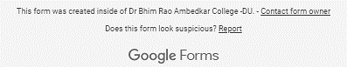

APPENDIX B- TABLES AND FIGURES (In addition to those already added in the main text)

- Reliability Statistics
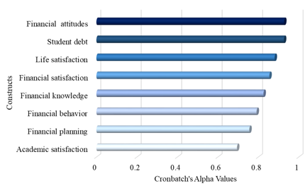

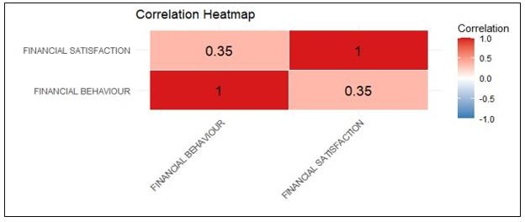
- Correlation Analysis between Financial behavior and Satisfaction

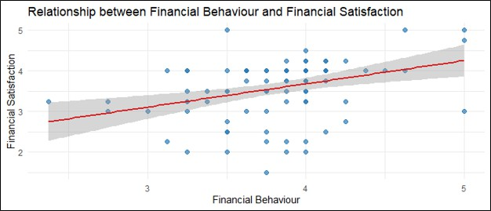
- Relationship between Financial behavior and Satisfaction

- Model Coefficients- Life Satisfaction
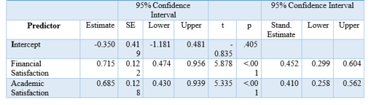

- Implications of the Study
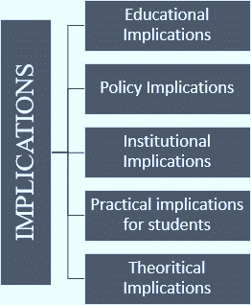

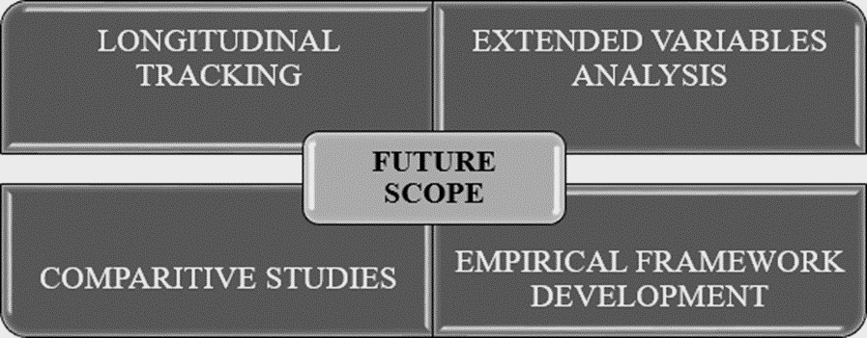
- Future Scope and Recommendations

