Supplemental Materials
Table S1: A list of registries included in data analysis, including the methods of projects within those registries, and a registry description.

Summary of forest-based project methodologies per registry
Registry | No. | Methods | Description
American Carbon Registry (ACR) | 9 | ACM0002 Grid-connected electricity generation from renewable sources (Version 15.0) - note: some projects under this methodology were relevant, those that were not were removed manually; ACR - Afforestation and Reforestation of Degraded Lands (Version 1.0); ACR - Improved Forest Management (IFM) on Canadian Forestlands (Version 1.0); ACR - Improved Forest Management (IFM) on Non-Federal U.S. Forestlands (Version 1.0); ACR - Improved Forest Management (IFM) on Non-Federal U.S. Forestlands (Version 1.1); ACR - Improved Forest Management (IFM) on Non-Federal U.S. Forestlands (Version 1.2); ACR - Improved Forest Management (IFM) on Non-Federal U.S. Forestlands (Version 1.3); ACR - Improved Forest Management (IFM) on Non-Federal U.S. Forestlands (Version 2.0); AMS-I.C. Thermal energy production with or without electricity (Version 19.0) | U.S.-based carbon crediting programme operating in global compliance and voluntary markets
Acorn | 2 | Smallscale Agroforestry (1.1); Smallscale Agroforestry (1) | A framework and methodology to increase the accessibility of the international voluntary carbon market for smallholder farmers in the developing world, particularly in the agroforestry sector
Architecture for REDD+ Transactions | 1 | The REDD+ Environmental Excellence Standard (TREES) (Version 2.0) | Global incentivisation initiative to encourage governments to reduce emissions from deforestation and forest degradation, and protect or restore existing forests
Australian Carbon Credit Unit (ACCU) Scheme (Australian ETS) | 24 | Carbon Credits (Carbon Farming Initiative-Avoided Clearing of Native Regrowth) Methodology Determination 2015; Carbon Credits (Carbon Farming Initiative-Avoided Clearing of Native Regrowth) Methodology Determination 2015 (Compilation No. 1); Carbon Credits (Carbon Farming Initiative-Avoided Deforestation 1.1) Methodology Determination 2015; Carbon Credits (Carbon Farming Initiative-Designated Verified Carbon Standard Projects) Methodology Determination 2015; Carbon Credits (Carbon Farming Initiative-Plantation Forestry) Methodology Determination 2017; Carbon Credits (Carbon Farming Initiative-Plantation Forestry) Methodology Determination 2017 (Compilation No. 1); Carbon Credits (Carbon Farming Initiative-Plantation Forestry) Methodology Determination 2022; Carbon Credits (Carbon Farming Initiative-Reforestation and Afforestation 2.0) Methodology Determination 2015; Carbon Credits (Carbon Farming Initiative) (Avoided Deforestation) Methodology Determination 2013; Carbon Credits (Carbon Farming Initiative) (Human-Induced Regeneration of a Permanent Even-Aged Native Forest-1.1) Methodology Determination 2013 (Compilation No. 1); Carbon Credits (Carbon Farming Initiative) (Human-Induced Regeneration of a Permanent Even-Aged Native Forest-1.1) Methodology Determination 2013 (Compilation No. 2); Carbon Credits (Carbon Farming Initiative) (Human-Induced Regeneration of a Permanent Even-Aged Native Forest-1.1) Methodology Determination 2013 (Compilation No. 3); Carbon Credits (Carbon Farming Initiative) (Measurement Based Methods for New Farm Forestry Plantations) Methodology Determination 2014 (Compilation No. 1); Carbon Credits (Carbon Farming Initiative) (Native Forest from Managed Regrowth) Methodology Determination 2013; Carbon Credits (Carbon Farming Initiative) (Native Forest from Managed Regrowth) Methodology Determination 2013 (Compilation No. 1); Carbon Credits (Carbon Farming Initiative) (Native Forest from Managed Regrowth) Methodology Determination 2013 (Compilation No. 2); Carbon Credits (Carbon Farming Initiative) (Quantifying Carbon Sequestration by Permanent Mallee Plantings using the Reforestation Modelling Tool) Methodology Determination 2013; Carbon Credits (Carbon Farming Initiative) (Reforestation and Afforestation-1.2) Methodology Determination 2013; Carbon Credits (Carbon Farming Initiative) (Reforestation and Afforestation) Methodology Determination 2013; Carbon Credits (Carbon Farming Initiative) (Reforestation by Environmental or Mallee Plantings-FullCAM) Methodology Determination 2014; Carbon Credits (Carbon Farming Initiative) (Reforestation by Environmental or Mallee Plantings-FullCAM) Methodology Determination 2014 (Compilation No. 1); Carbon Credits (Carbon Farming Initiative) (Reforestation by Environmental or Mallee Plantings-FullCAM) Methodology Determination 2014 (Compilation No. 2); Carbon Credits (Carbon Farming Initiative) (Reforestation by Environmental or Mallee Plantings-FullCAM) Methodology Determination 2024; Carbon Farming (Quantifying Carbon Sequestration by Permanent Environmental Plantings of Native Tree Species using the CFI Reforestation Modelling Tool) Methodology Determination 2012 | The Australian carbon crediting scheme for registering carbon reduction projects
BioCarbon Standard (BCR) | 3 | AR-ACM0003 Afforestation and reforestation of lands except wetlands; BCR0001_ARR Activities; BCR0002_Quantification of GHG Emission Reductions. REDD+ Projects | A global crediting programme for greenhouse gases projects and biodiversity conservation initiatives
Climate Action Reserve (CAR) | 18 | Avoided Conversion; Avoided Conversion - ARB Compliance; Conservation-Based Forest Management; Forestry - MX; Improved Forest Management; Improved Forest Management - ARB Compliance  Avoided Conversion (Version 3.1); Conservation-Based Forest Management (Version 2.1); Forestry - MX (Version 1.4); Forestry - MX (Version 1.5); Forestry - MX (Version 2.0); Forestry - MX (Version 3.0); Improved Forest Management (Version 3.1); Improved Forest Management (Version 3.2); Landfill Gas Capture/Combustion (Version 2.0); Livestock - ARB Compliance (ARB Compliance Offset Protocol Livestock Projects, November 14, 2014); Organic Waste Composting (Version 1.1); Organic Waste Digestion (Version 1.0) | An offset registry for global carbon markets with projects primarily in North and Central America, and China.
Canada Greenhouse Gas Offset Credit System Public Registry | 1 | Improved Forest Management on Private Land, Version 1.1 | A public registry for Canada’s credit and tracking system used to administer Canada’s Greenhouse Gas Offset Credit System, provides a current listing of registered projects and offset credits
Cercarbono | 12 | ACM0002 Grid-connected electricity generation from renewable sources; AMS-III.H. Methane recovery in wastewater treatment, AMS-III.F. Avoidance of methane emissions through composting, AMS-I.C. Thermal energy production with or without electricity; AR-ACM0003 Afforestation and reforestation of lands except wetlands; AR-ACM0003 Afforestation and reforestation of lands except wetlands, CCB - M/UT/F-A01: Methodology To Implement GHG Removal Projects Through Reforestation, M/UT/F-A01: Methodology for the Implementation of GHG Removal Projects Through Reforestation, Forest Regeneration and the Establishment of Woody Crops; CCA - M/LU-REDD+: Methodology for the Implementation of REDD+ Projects Consistent with National Reference Levels, CCB - M/LU-REDD; CCB - M/LU-REDD+: Methodology for the Implementation of REDD+ Projects Consistent with National Reference Levels; CCB - M/UT/F-A01: Methodology To Implement GHG Removal Projects Through Reforestation, M/UT/F-A01: Methodology for the Implementation of GHG Removal Projects Through Reforestation, Forest Regeneration and the Establishment of Woody Crops; CCB - M/UT/F-A01: Methodology To Implement GHG Removal Projects Through Reforestation, M/UT/F-A01: Methodology for the Implementation of GHG Removal Projects Through Reforestation, Forest Regeneration and the Establishment of Woody Crops, AR-ACM0003 Afforestation and reforestation of lands except wetlands; M/LU/F-W01: Modular Methodology for Climate Change Mitigation Activities on Forest Lands and Wetlands; M/UT/F-A01: Methodology for the Implementation of GHG Removal Projects Through Reforestation, Forest Regeneration and the Establishment of Woody Crops, CCB - M/UT/F-A01: Methodology To Implement GHG Removal Projects Through Reforestation; M/UT/F-A01: Methodology for the Implementation of GHG Removal Projects Through Reforestation, Forest Regeneration and the Establishment of Woody Crops, CCB - M/UT/F-A01: Methodology To Implement GHG Removal Projects Through Reforestation, AR-ACM0003 Afforestation and reforestation of lands except wetlands; NTC 6208 | A standard for voluntary carbon certification that registers climate mitigation projects, emissions certifications, and carbon credits
Clean Development Mechanism | 29 | AM0082 Use of charcoal from planted renewable biomass in a new iron ore reduction system (1.0); AMS-II.G. Energy efficiency measures in thermal applications of non-renewable biomass (2.0); AR-ACM0001 Afforestation and reforestation of degraded land (3.0); AR-ACM0001 Afforestation and reforestation of degraded land (4.0); AR-ACM0001 ver. 3; AR-ACM0003; AR-ACM0003 Afforestation and reforestation of lands except wetlands (1.0.0); AR-AM0001 Reforestation of degraded land (2.0); AR-AM0001 ver. 2; AR-AM0002 Restoration of degraded lands through afforestation/reforestation (1.0); AR-AM0002 Restoration of degraded lands through afforestation/reforestation (3.0); AR-AM0002 ver. 3; AR-AM0003 Afforestation and reforestation of degraded land through tree planting, assisted natural regeneration and control of animal grazing (4.0); AR-AM0003 ver. 4; AR-AM0004 Reforestation or afforestation of land currently under agricultural use (3.0); AR-AM0004 Reforestation or afforestation of land currently under agricultural use (4.0); AR-AM0004 ver. 3; AR-AM0004 ver. 4; AR-AM0005; AR-AM0005 Afforestation and reforestation project activities implemented for industrial and/or commercial uses (1.0); AR-AM0005 Afforestation and reforestation project activities implemented for industrial and/or commercial uses (3.0); AR-AM0005 ver. 3; AR-AM0009 ver. 4; AR-AM0010 Afforestation and reforestation project activities implemented on unmanaged grassland in reserve/protected areas (4.0); AR-AM0010 ver. 4; AR-AMS0001 Simplified baseline and monitoring methodologies for small-scale A/R CDM project activities implemented on grasslands or croplands with limited displacement of pre-project activities (5.0); AR-AMS0001 ver. 4; AR-AMS0001 ver. 5; AR-AMS0003 | An investment and credit scheme that allows a country with an emission-reduction or emission-limitation commitment under the Kyoto Protocol to develop emission-reduction projects in developing countries
Gold Standard Impact Registry | 24 | ACM0001 Flaring or use of landfill gas; ACM0010 GHG emission reductions from manure management systems; Afforestation/Reforestation GHG Emissions Reduction & Sequestration Methodology; AM0036 Use of biomass in heat generation equipment; AMS-I.A. Electricity generation by the user; AMS-I.C. Thermal energy production with or without electricity; AMS-I.D. Grid connected renewable electricity generation; AMS-I.E. Switch from non-renewable biomass for thermal applications by the user; AMS-I.I. Biogas/biomass thermal applications for households/small users; AMS-II.C. Demand-side energy efficiency activities for specific technologies; AMS-II.G. Energy efficiency measures in thermal applications of non-renewable biomass; AMS-III.Z. Fuel Switch, process improvement and energy efficiency in brick manufacture; GS Baseline and Monitoring Methodology Biodigester (1); GS Methodology for emission reductions from safe drinking water supply; GS Methodology for Improved Cook stoves and Kitchen Regimes (1); GS Methodology for Improved Cook stoves and Kitchen Regimes (2); GS MS Simplified Methodology for Efficient Cookstoves (1.1); GS MS Simplified Methodology for Efficient Cookstoves (1); GS TPDDTEC Reduced Emissions from Cooking and Heating – Technologies and Practices to Displace Decentralized Thermal Energy Consumption (1); GS TPDDTEC Reduced Emissions from Cooking and Heating – Technologies and Practices to Displace Decentralized Thermal Energy Consumption (2); GS TPDDTEC Reduced Emissions from Cooking and Heating – Technologies and Practices to Displace Decentralized Thermal Energy Consumption (3.1); GS TPDDTEC Reduced Emissions from Cooking and Heating – Technologies and Practices to Displace Decentralized Thermal Energy Consumption (3); GS TPDDTEC Reduced Emissions from Cooking and Heating – Technologies and Practices to Displace Decentralized Thermal Energy Consumption (4); Other | A carbon credit registry and status tracking system for projects utilising the Gold Standard certification process
Joint Crediting Mechanism (JCM) | 2 | KH_AM004; LA_AM004 | A Japan-based mechanism to facilitate reduction in greenhouse gas emissions in developing countries
Plan Vivo | 7 | Afforestation / Reforestation; Forest; Forest Conservation & Avoided Deforestation; Forest Restoration; Improved Forest Management; REDD; Reduced emissions from deforestation & degradation | A Scotland-based voluntary carbon market standard focused on community and smallholder land-use and marine projects
Puro.earth | 2 | PUR - Biochar; PUR - Wooden Building Elements | A voluntary market carbon certification based on the Puro Standard with an emphasis on durable carbon storage
Unregistered CDR | 3 | Bio-other; Biochar; NBS (CDR)
Verra | 44 | ACM0002 Grid-connected electricity generation from renewable sources; ACM0006 Electricity and heat generation from biomass; ACM0018 Electricity generation from biomass in power-only plants; AM0025 Alternative waste treatment processes; AMS-I.B. Mechanical energy for the user with or without electrical energy; AMS-I.C. Thermal energy production with or without electricity; AMS-I.C. Thermal energy production with or without electricity, AMS-III.E. Avoidance of methane production from decay of biomass through controlled combustion, gasification or mechanical/thermal treatment; AMS-I.D. Grid connected renewable electricity generation; AMS-I.D. Grid connected renewable electricity generation, ACM0002 Grid-connected electricity generation from renewable sources; AMS-I.E. Switch from non-renewable biomass for thermal applications by the user; AMS-I.E. Switch from non-renewable biomass for thermal applications by the user, AMS-III.AV. Low greenhouse gas emitting safe drinking water production systems; AMS-II.G. Energy efficiency measures in thermal applications of non-renewable biomass; AMS-III.B. Switching fossil fuels, ACM0001 Flaring or use of landfill gas; AR-ACM0001 Afforestation and reforestation of degraded land; AR-ACM0002 Afforestation or reforestation of degraded land without displacement of pre-project activities; AR-ACM0003 Afforestation and reforestation of lands except wetlands; AR-ACM0003 Afforestation and reforestation of lands except wetlands, AR-AM0005 Afforestation and reforestation project activities implemented for industrial and/or commercial uses; AR-ACM0003 Afforestation and reforestation of lands except wetlands, VM0005 Methodology for Conversion of Low-productive Forest to High-productive Forest; AR-AM0003 Afforestation and reforestation of degraded land through tree planting, assisted natural regeneration and control of animal grazing; AR-AM0005 Afforestation and reforestation project activities implemented for industrial and/or commercial uses; AR-AM0014 Afforestation and reforestation of degraded mangrove habitats; AR-AMS0001 Simplified baseline and monitoring methodologies for small-scale A/R CDM project activities implemented on grasslands or croplands with limited displacement of pre-project activities; AR-AMS0006 Simplified baseline and monitoring methodology for small-scale silvopastoral - afforestation and reforestation project activities under the clean development mechanism; AR-AMS0007 Afforestation and reforestation project activities implemented on lands other than wetlands; VM0003 Methodology for Improved Forest Management through Extension of Rotation Age; VM0004 Methodology for Avoided Planned Land Use Conversion in Peat Swamp Forests (1); VM0005 Methodology for Conversion of Low-productive Forest to High-productive Forest; VM0006 Methodology for Carbon Accounting for Mosaic and Landscape-scale REDD Projects; VM0007; VM0007 REDD+ Methodology Framework (REDD+MF); VM0007 REDD+ Methodology Framework (REDD+MF), VM0010 Methodology for Improved Forest Management: Conversion from Logged to Protected Forest; VM0009 Methodology for Avoided Ecosystem Conversion; VM0010 Methodology for Improved Forest Management: Conversion from Logged to Protected Forest; VM0012 Improved Forest Management in Temperate and Boreal Forests (LtPF); VM0015; VM0015 Methodology for Avoided Unplanned Deforestation; VM0017 Adoption of Sustainable Agricultural Land Management (1); VM0017 Adoption of Sustainable Agricultural Land Management (1), VM0015 Methodology for Avoided Unplanned Deforestation; VM0026 Methodology for Sustainable Grassland Management (SGM) (1); VM0033 Methodology for Tidal Wetland and Seagrass Restoration (1); VM0034 Canadian Forest Carbon Offset Methodology; VM0047; VM0048; VMR0006 Methodology for Installation of High Efficiency Firewood Cookstoves (1) | A certifier of carbon offsets based on the Verified Carbon Standard
Woodland Carbon Code | 9 | WCC - Continuous cover system; WCC - Mixed mainly clearfell; WCC - Mixed mainly continuous cover system; WCC - Mixed mainly no thin or clearfell; WCC - Mixed mainly thin and clearfell; WCC - Mixed mainly thinning; WCC - No thinning or clearfell; WCC - Thin and clearfell; WCC - Thin only | UK standard for validation and verification of afforestation projects, assuring the carbon sequestration levels from woodland creation projects

Table S2 - Inaccessible registries data which contain information on forest-based carbon projects that cross borders.
Summary of inaccessible registries
Registry | Reason for lack of access |  | Website
Ecosystem Restoration Standard | Some downloadable data is available across various datasheets, but carbon trade quantity or units not given |  | https://www.ers.org/
Carbon Assets Tracking System (CATS) | No purchaser details provided |  | https://cats.worldbank.org/  ProgramList?filter=TotalProg
Balkan Carbon Credit Registry (BCCR) | Some data available, but implementer and purchaser not clear, and methodology not included. Not downloadable. |  | https://bccregistry.org/registry

Supplementary Materials 1 - Governance metrics for implementer and purchaser countries of forest-based carbon units
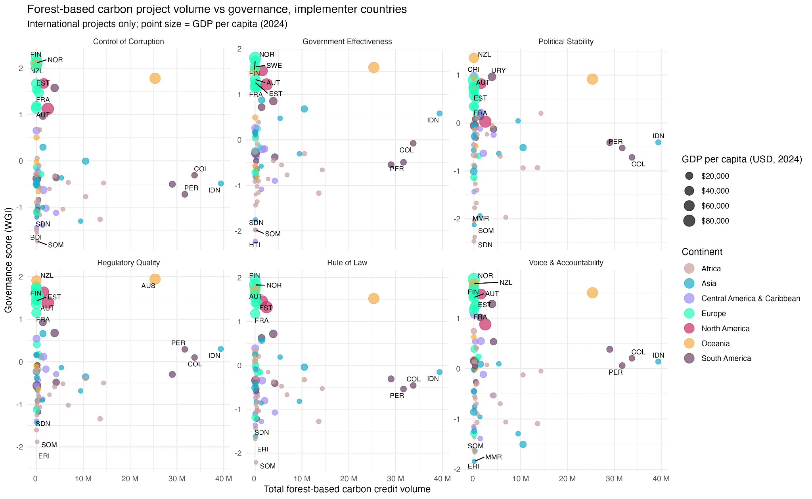
Figure SM1.1 - All governance metrics for implementer countries for forest-based carbon units.

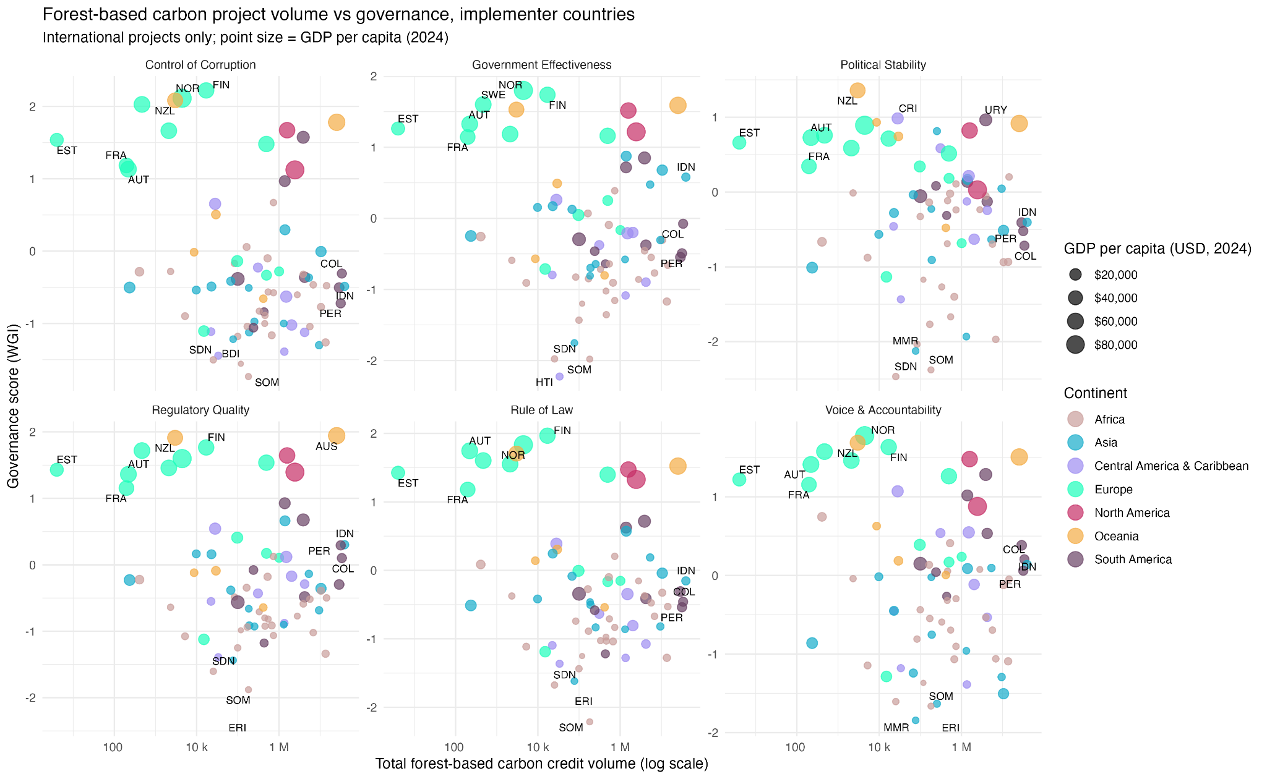
Figure SM1.2 - All governance metrics for implementer countries for forest-based carbon units (logged).
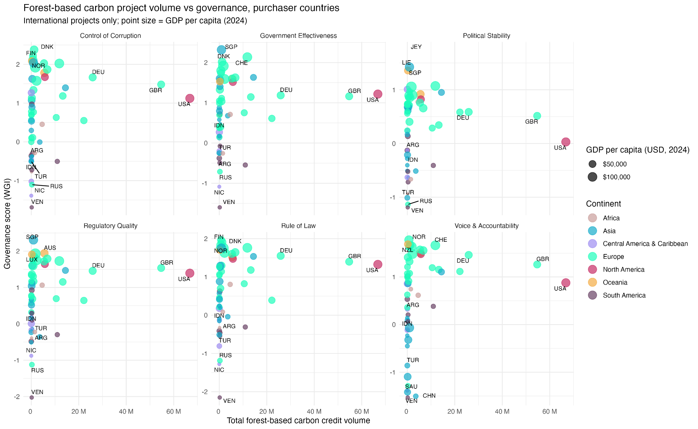
Figure SM1.3 - All governance metrics for purchaser countries for forest-based carbon units.

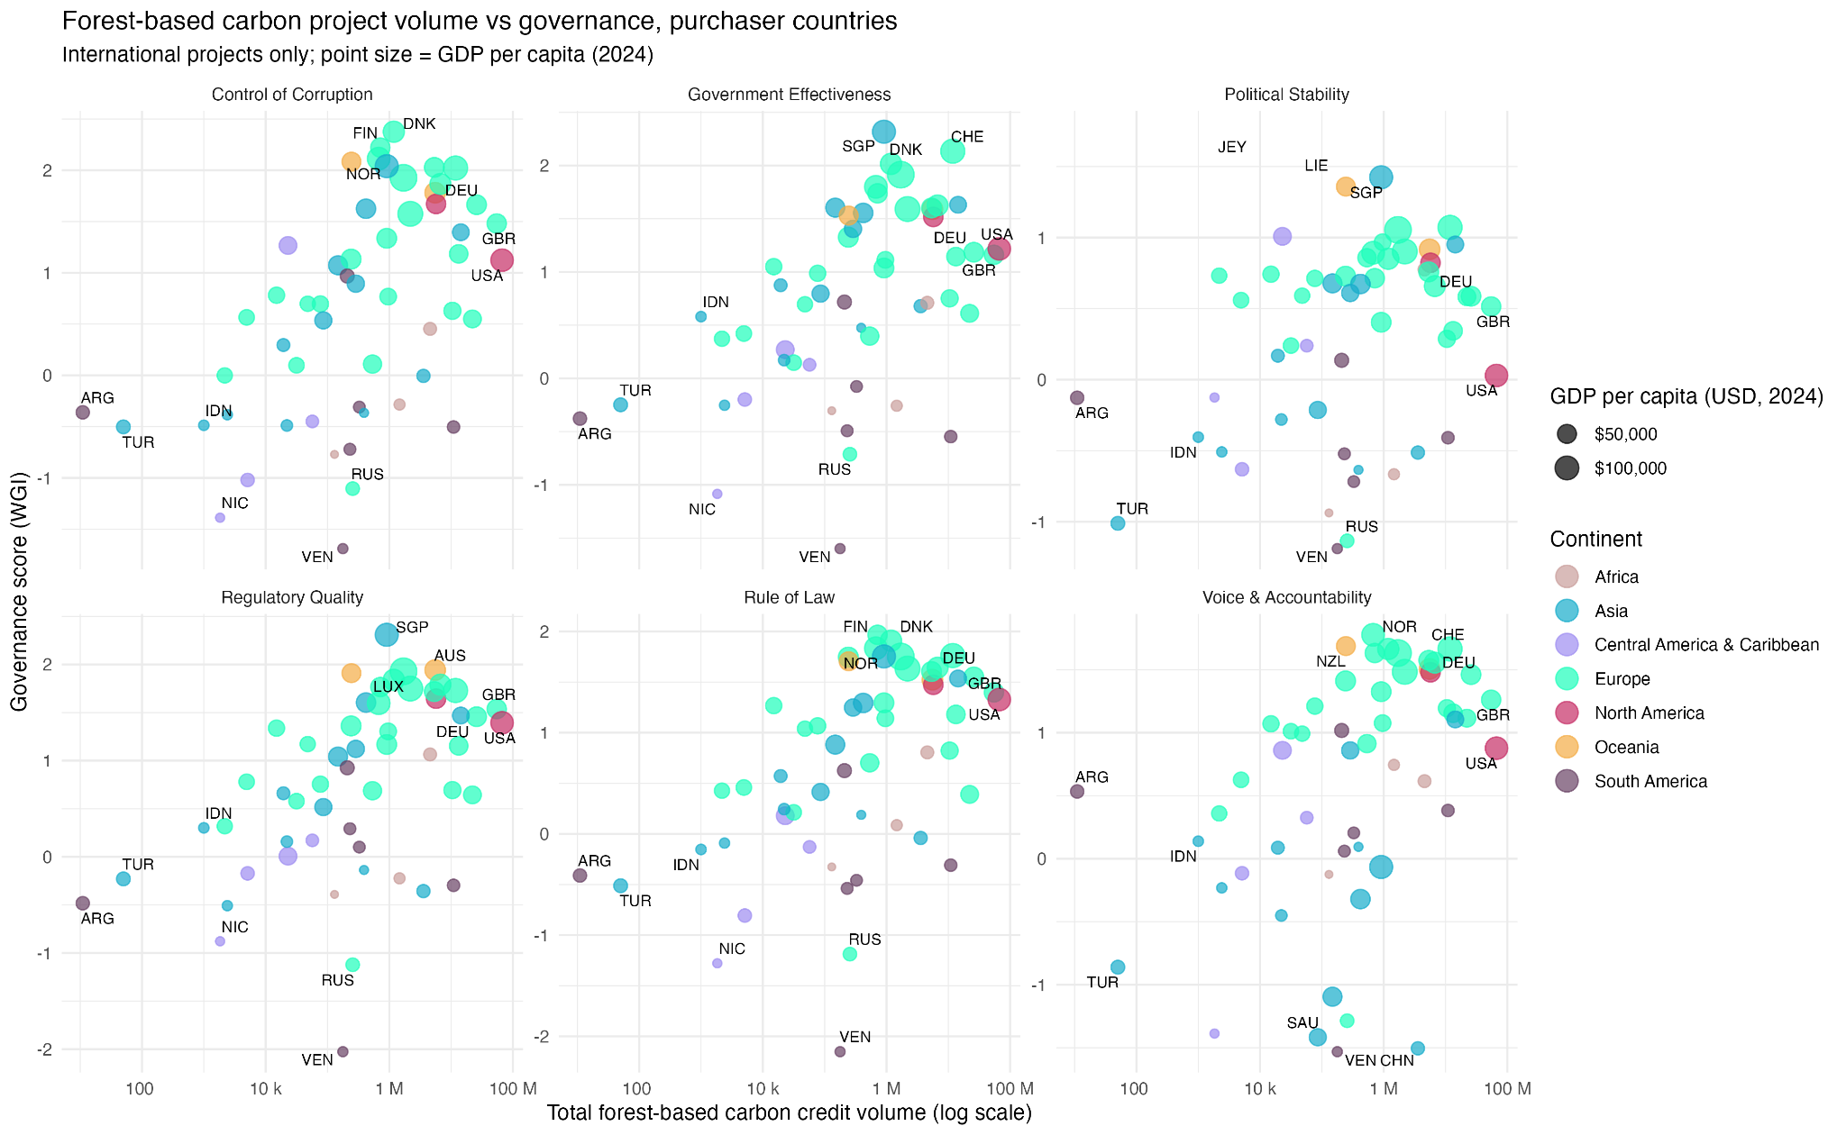
Figure SM1.4 - All governance metrics for purchaser countries for forest-based carbon units (logged).

