Supplementary Information

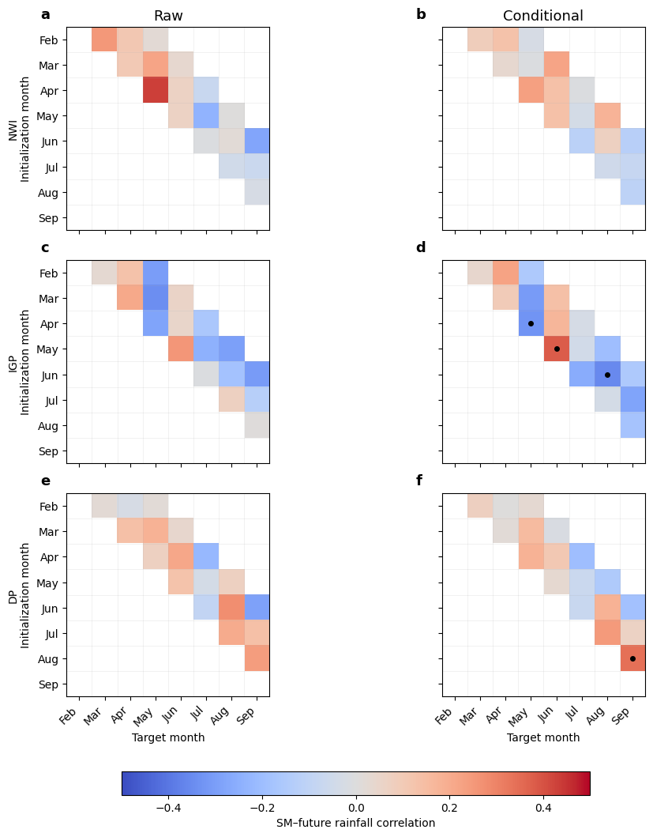

Supplementary Figure S1 | Seasonal structure of the predictive reach of soil-moisture memory. Correlations between monthly SM anomalies in each initialization month and rainfall anomalies in subsequent target months over NWI (a, b), the IGP (c, d), and the DP (e, f). Left panels show the raw SM-rainfall correlations. Right panels show conditional (partial) correlations between SM in the initialization month and rainfall in the target month after removing their linear associations with rainfall in the initialization month and the contemporaneous ENSO, Indian Ocean Basin Mode, and Indian Ocean Dipole indices. Thus, the conditional correlations quantify the remaining SM-subsequent-rainfall association after accounting for antecedent rainfall and major tropical ocean states that could contribute to covariance between the two variables. Only forward initialization-target combinations are shown; blank cells correspond to contemporaneous or earlier target months. Black dots denote conditional correlations significant at p < 0.05. The month-resolved relationships are heterogeneous in season and sign and do not form a coherent progression across successive leads, indicating limited predictive reach of persistent SM anomalies into subsequent rainfall.

