Catalytic dehydration of fructose to 5-HMF by a lignin-derived carbon solid acid catalyst modified by non-thermal plasma

Qing Qing*•Qidi Zhu• Siyu Yi• Mingyuan Gao• Zhaotian Ji• Shijun Lv • Liqun Wang • Jie Zhu

School of Biological and Food Engineering
Changzhou University
Changzhou 213164, Jiangsu, China
Corresponding to: Qing Qing, Telephone +86-519-86332327
Email: qqing@cczu.edu.cn

- Materials and methods
  - Solvent extraction of lignin for solid acid preparation
The lignin used for the catalyst preparation was extracted from corn stover (CS) by dilute acid catalyzed organic solvent extraction method. 14 g CS was weighed and put into a 250 mL high-pressure and high-temperature reactor (Zhenjiang Dantu Global Mechatronics, China), then mixed with 180 g THF/H₂O solvent mixture (weight ratio of 3:2). Concentrated sulfuric acid (98% H₂SO₄) was added into the system with the final concentration of 0.8% in the reaction liquor to promote the extraction of lignin. The reaction was conducted at 140 ℃ for 1 h. After the reaction finished, the reactor was quickly quenched in an iced water bath, and the reaction liquid were then separated from the solid residue by vacuum filtration. Fresh deionized water was added into the filtrate with a volume ratio of 4:1, and the dissolved lignin were precipitated out. The precipitated lignin solids were filtrated, washed, and then dried in a 45 °C oven overnight.
1.2 Carbonization of the solvent extracted lignin
Weigh 4 g solvent extracted lignin and grind it into powder. Then it was carbonized in a muffle furnace at 300 ℃ for 4 h to get approximately 2 g lignin-based solid activated carbon. After it was ground, the carbonized lignin was washed with deionized water and dried at 45 °C.
1.3 Preparing of LP-LDSA catalyst by nonthermal plasma for comparison
Preparing of the LP-LDSA catalyst by plasma method mainly includes two steps: (1) Pave the carbonized lignin evenly on a culture dish and put it into the plasma modification instrument (Zhongke Changtai Plasma Technology Co., Ltd.). The nonthermal plasma discharge treatment was carried out with O₂ as the gas source for 3 min and under the discharge power of 160 W and vacuum pressure of 20 Pa. The activation of O₂ will introduce a massive of free radicals and active sites on the lignin-derived carbonaceous material surface, which is conducive to the intervention of subsequent acidic groups. (2) Set the atmosphere gas to SO₂. The evaluated discharge time was varied from 2 to 8 min, the discharge power from 140 to 170 W, and the vacuum pressure from 20 to 50 Pa. After completion of the discharge treatment, the catalyst sample was taken out and stirred evenly. Then, the above two steps were repeated for 3 times to produce the carbonaceous solid acid catalyst (LP-LDSA).

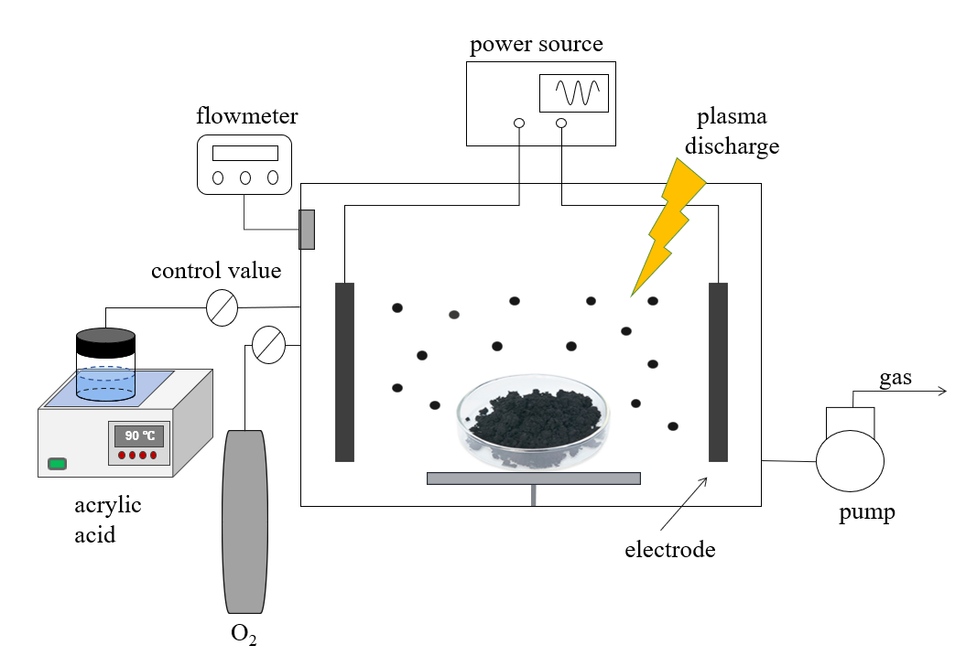
a
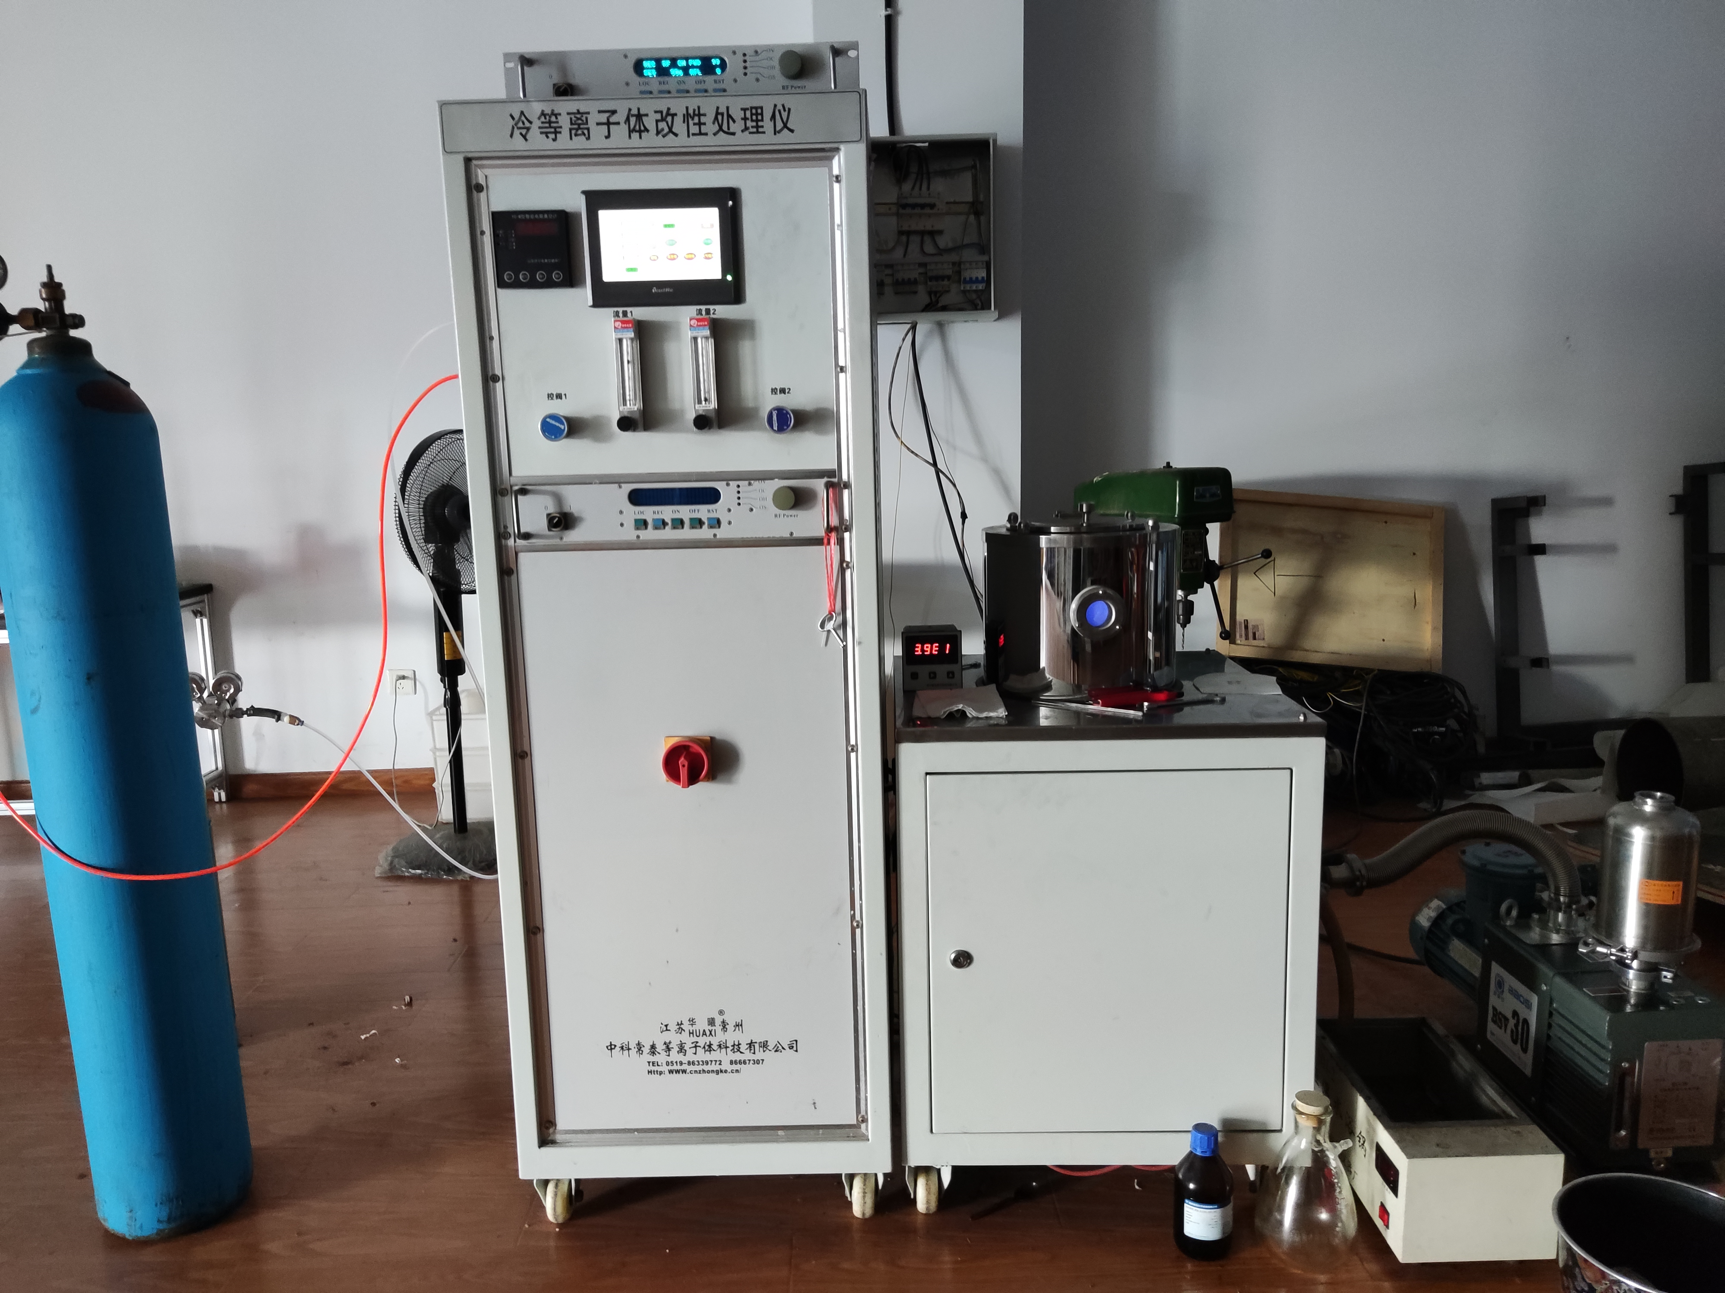
b
Fig. S1 Diagram (a) and photo (b) of the nonthermal plasma modification device.

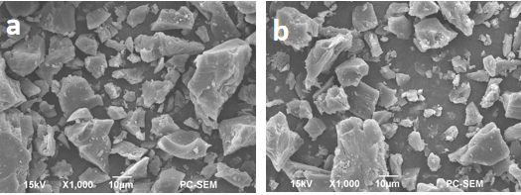
Fig. S2 SEM diagram of LDSA-COOH solid acid catalyst before (a) and after 5 times (b).

