Supplementary materials
for
Activation of hepatic USP5 as a novel strategy to ameliorate metabolic dysfunction-associated steatotic liver disease by deubiquitinating CPT-1A
Qinmei Sun^{1, 2, 3, 9}, Jiamei Chen^{1, 2, 9}, Guanghao Zhu^{4, 5, 9}, Siting Gao^{1, 2}, Yidan Shang³, Yaoshan Zhou^{1, 2}, Xin Xin^{1, 2}, Kai Huang^{1, 2}, Rutao Lin^{1, 2}, Fu Li⁶, Cheng Huang⁸, Yiyang Hu^{1, 2, *}, Hongshan Li^{7, *}, Guangbo Ge^{4, 5,*}, Ping Liu^{1, 2, 3, *}, Qin Feng^{1, 2, 4, 10, *}
¹ Institute of Liver Diseases, Shuguang Hospital Affiliated to Shanghai University of Traditional Chinese Medicine, Shanghai, China
² Key Laboratory of Liver and Kidney Diseases (Ministry of Education), Shuguang Hospital Affiliated to Shanghai University of Traditional Chinese Medicine, Shanghai, China
³ Institute of Interdisciplinary Integrative Medicine Research, Shanghai University of Traditional Chinese Medicine, Shanghai, China.
⁴ State Key Laboratory of Discovery and Utilization of Functional Components in Traditional Chinese Medicine, Shanghai University of Traditional Chinese Medicine
⁵ Shanghai Frontiers Science Center of TCM Chemical Biology, Institute of Interdisciplinary Integrative Medicine Research, Shanghai University of Traditional Chinese Medicine, Shanghai 201203, China.
⁶ Hepatobiliary and Pancreatic Surgery, Shuguang Hospital Affiliated to Shanghai University of Traditional Chinese Medicine, Shanghai, China.
⁷ Liver Disease Department of Integrative Medicine, Ningbo No. 2 Hospital, Ningbo, Zhejiang, China.
⁸ School of Pharmacy, Shanghai University of Traditional Chinese Medicine, Shanghai 201203, China.
⁹ These authors contributed equally to this work
¹⁰ Lead contact
This file contains six supplementary figures, one supplementary table, original WB images and Star Methods.

- Supplementary Figures and Figure legends
- Supplementary Tables
- Original WB images
- Star Methods

Supplementary Figures and Figure legends

Figure S1. Identification of USP5 as a key regulator of MASLD.
(A-C) Correlation of USP5 expression with clinical indices, including Lobular inflammation, ballooning degeneration and serum TC. (D) Representative oil red O staining in the primary hepatocyte cells; scale bar, 100 μm. (E-F) Immunoblots of USP5 expression. Data are mean ±SD. Unpaired Student’s test between two groups. One-way ANOVA between multiple groups. *P < 0.05, **P < 0.01, ***P < 0.001.
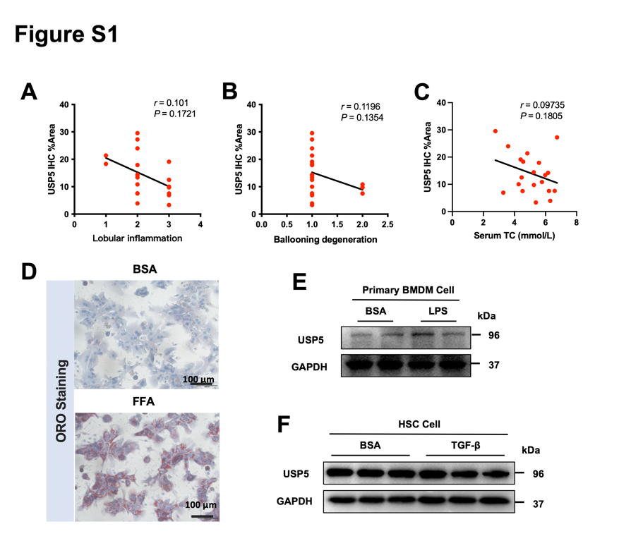

Figure S2. Hepatocyte-specific USP5 knockout exaggerates MASLD in mice.
(A) Immunoblots of hepatic USP5 expression in mice liver (n=5/group). (B) Body weights. (C) Liver weights. (D) Liver/Body weights. (E) Representative F4/80 IHC, and a-SMA IHC staining in the liver sections; scale bar, 25 μm. (F-G) Qualification of F4/80 IHC, and a-SMA IHC staining. (H) Relative mRNA levels of genes (n = 6/group). (I) immunofluorescence (IF) for GFP (Green) was performed in WT THLE2 cells, scale bar, 10 μm. (J) Immunoblots of hepatic USP5 expression (n=5/group). Data are mean ±SD. Unpaired Student’s test between two groups. One-way ANOVA between multiple groups. *P < 0.05, **P < 0.01, ***P < 0.001.
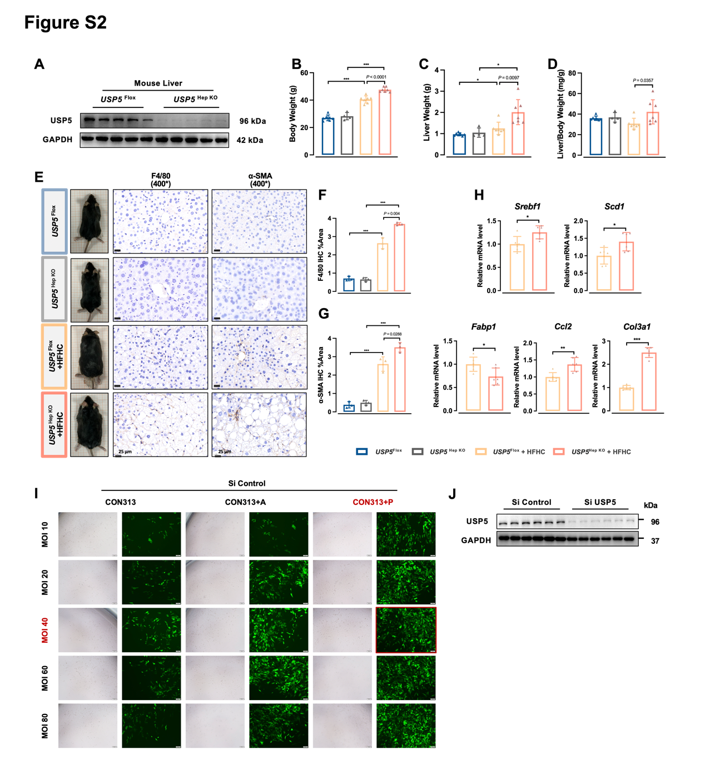

Figure S3. Hepatocyte-specific USP5 overexpression alleviates hepatic lipid accumulation and inflammation in MASLD mice.
(A) Immunoblots of hepatic USP5 expression in mice liver (n=5/group). (B-E) Serum TG, TC, LDL-C, and fasting serum insulin. (F) Representative F4/80 IHC and a-SMA IHC staining in the liver sections; scale bar, 25 μm. (G-H) Qualification of F4/80 IHC and a-SMA IHC staining. (I) Relative mRNA levels of genes (n = 6/group). (J) immunofluorescence (IF) for GFP (Green) was performed in WT THLE2 cells, scale bar, 10 μm. (K) Immunoblots of hepatic USP5 expression (n=5/group). Data are mean ±SD. Unpaired Student’s test between two groups. One-way ANOVA between multiple groups. *P < 0.05, **P < 0.01, ***P < 0.001.
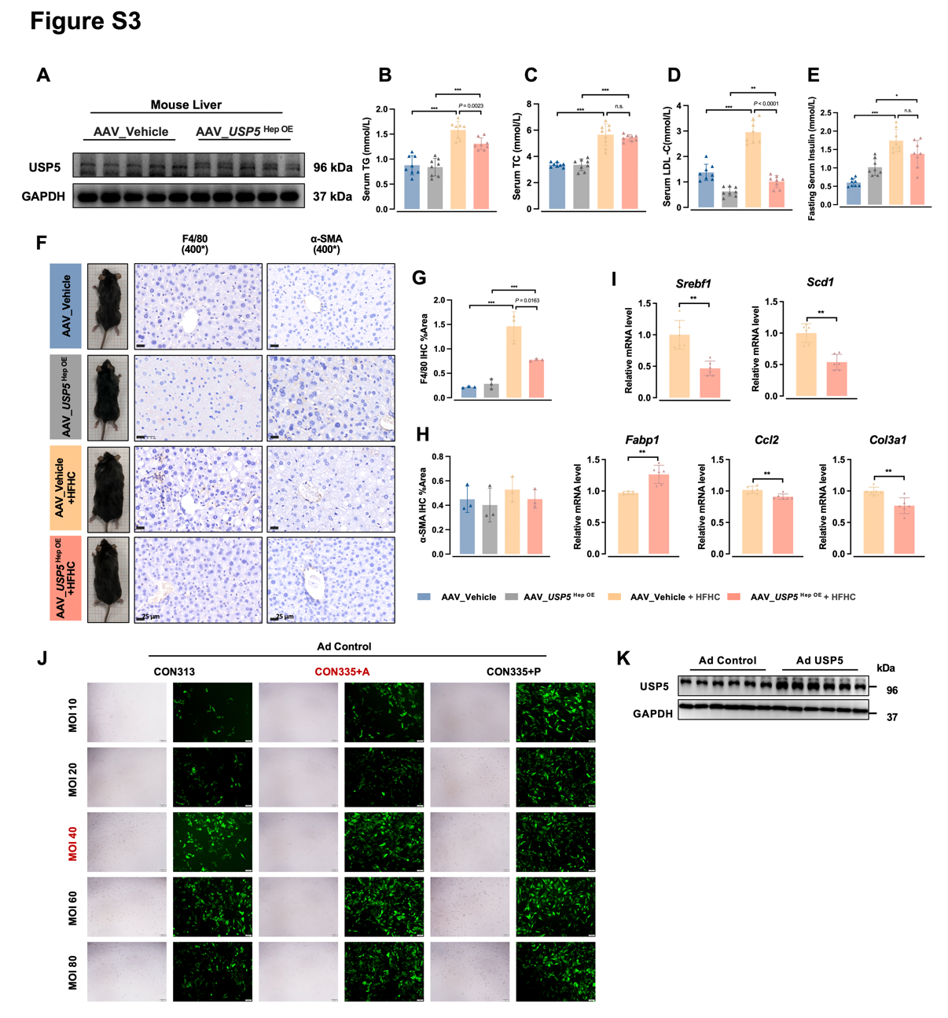

Figure S4. Identification of CPT-1A as a USP5 bonding partner.
(A) coIP assays were performed to examine the interaction of USP5 and IκBα in THLE2 cells. (B) IP-MS of CPT-1A. Data are mean ±SD. Unpaired Student’s test between two groups. One-way ANOVA between multiple groups. *P < 0.05, **P < 0.01, ***P < 0.001.
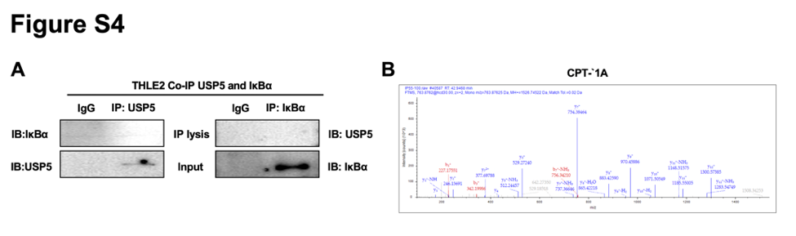

Figure S5. Rescue of CPT-1A could reverse the effect of USP5-ablation on lipid accumulation.
(A) OCR analysis of Si USP5 THLE2 cells treated with or without FFA (n = 5/group). (B) OCR analysis of Ad USP5 THLE2 cells treated with or without FFA (n = 5/group). (C) Illustration of mice. (D) Body weights and liver weights. Data are mean ±SD. Unpaired Student’s test between two groups. One-way ANOVA between multiple groups. *P < 0.05, **P < 0.01, ***P < 0.001.
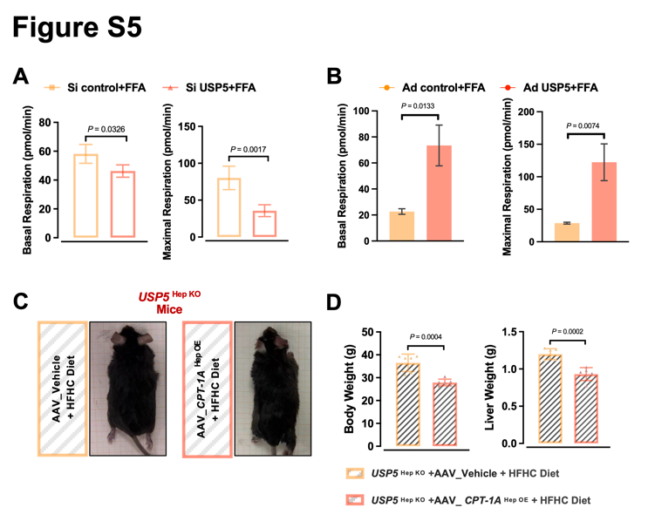

Figure S6. Ligustroflavone was identified as an activator of USP5 to alleviates MASLD.
(A) Schematic illustration of USP5 allosteric site. (B) Intracellular TG levels of 16 drugs (2 μM) were determined in FFA-induced AML-12 cells (n = 4/group). Data are mean ±SD. Unpaired Student’s test between two groups. One-way ANOVA between multiple groups. *P < 0.05, **P < 0.01, ***P < 0.001.
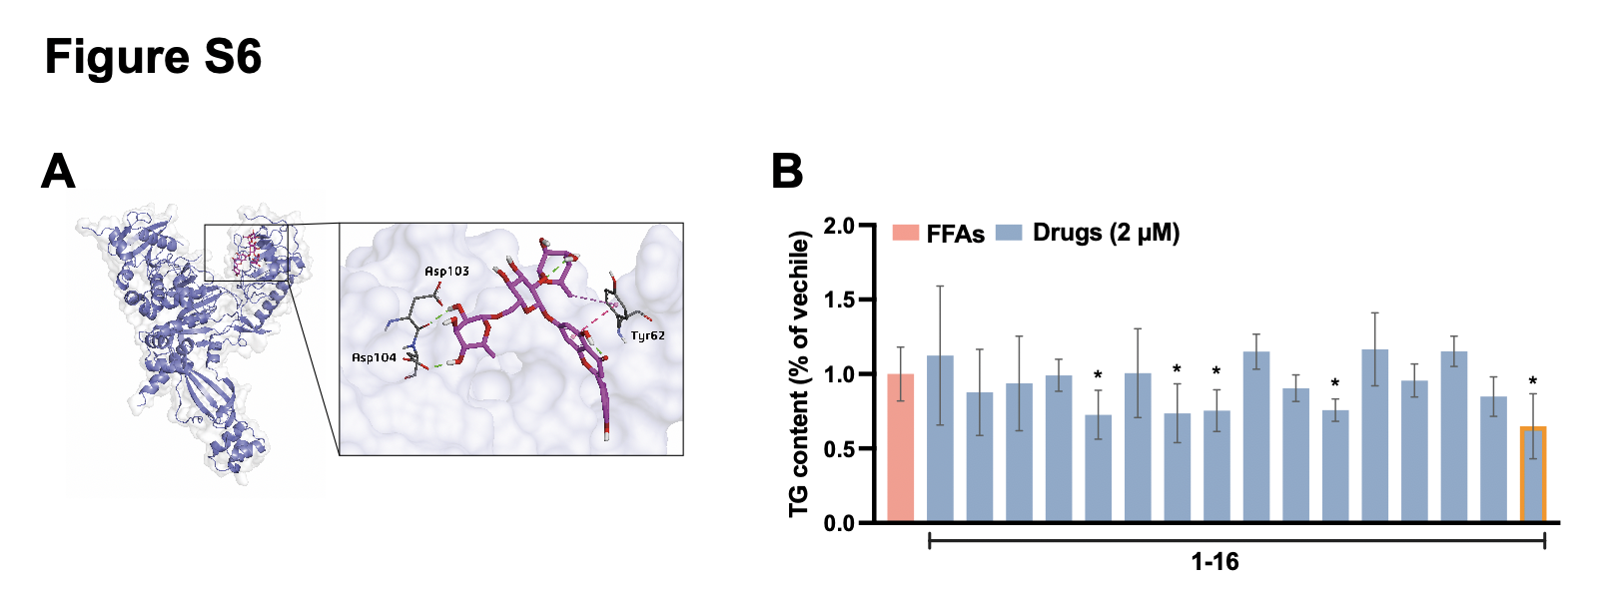

Supplementary Tables

Table S1. A list of primer sequences
Genes | Species | Forward Prime | Reverse primer
Srebf1 | mouse | 5'GGCTTGGTGATGCTATGTTGA3' | 5'GGCAAAGGAACAACTGAGACC3'
Scd-1 | mouse | 5′TGAGGGGCAGTGTCTGTAA3′ | 5′GGAAACTAAAGCAATGGATGG3′
Fabp-1 | mouse | 5'AAAGTCAAGGCAGTCGTCAAG3' | 5'TGGTGATTGTGTCTCCATTGA3'
Ccl2 | mouse | 5'ATCGGAACCAAATGAGATCAG3' | 5'GCTTCAGATTTACGGGTCAAC3'
Col3a1 | mouse | 5'CCTGGAGCCCCTGGACTAATA3' | 5'TCACCTGAAGGACCTCGTGTT3'

Original WB images

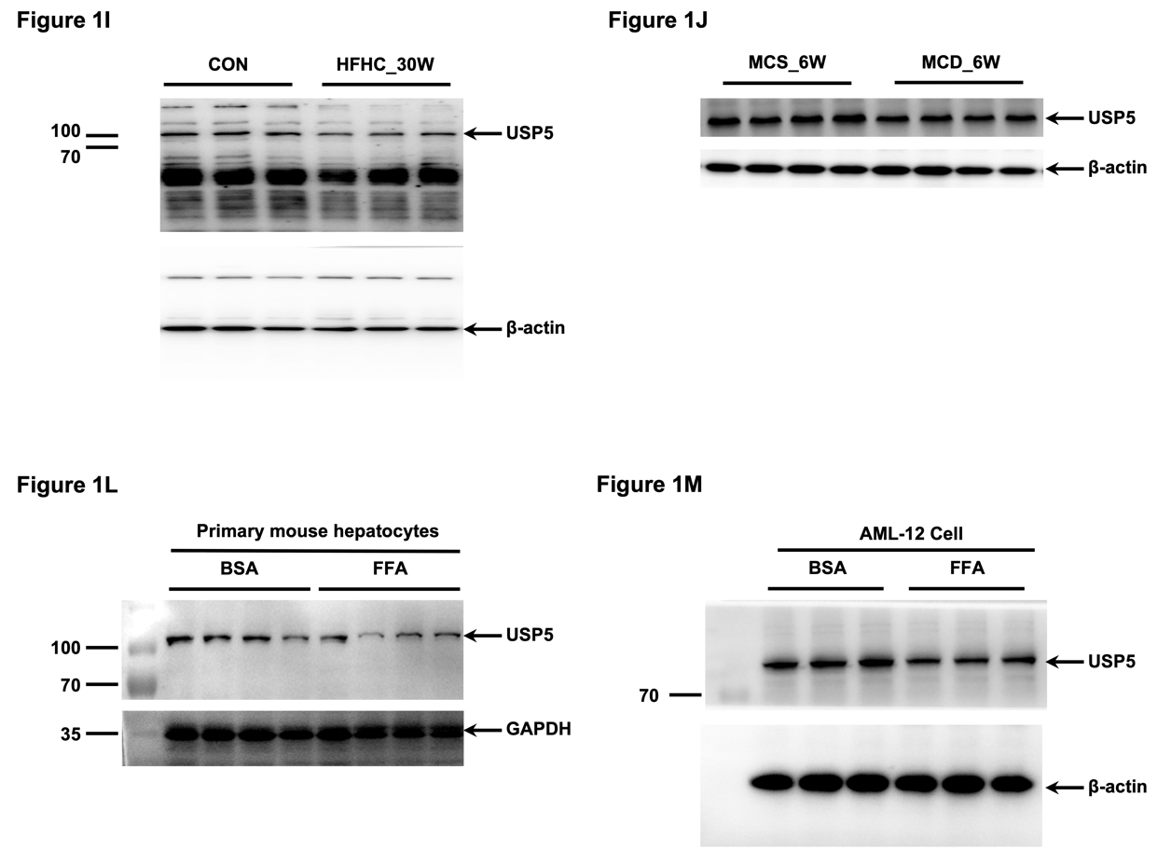
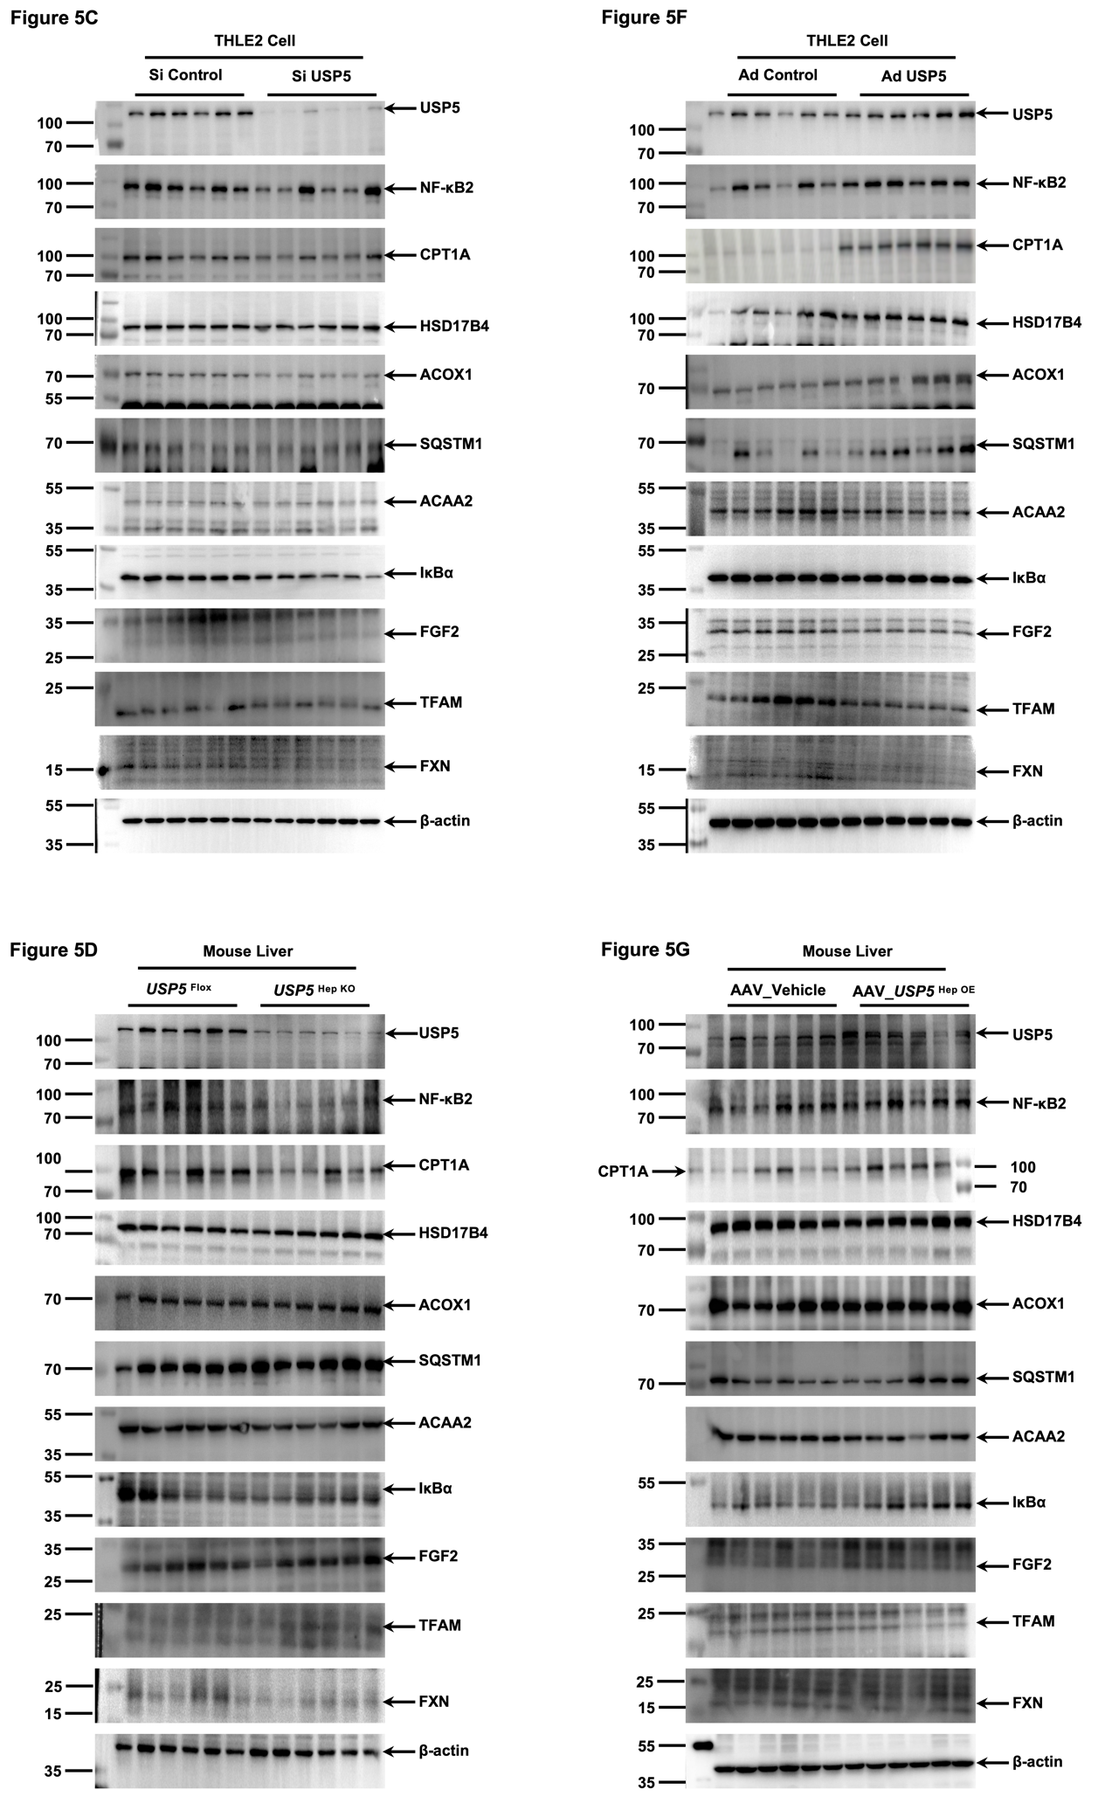
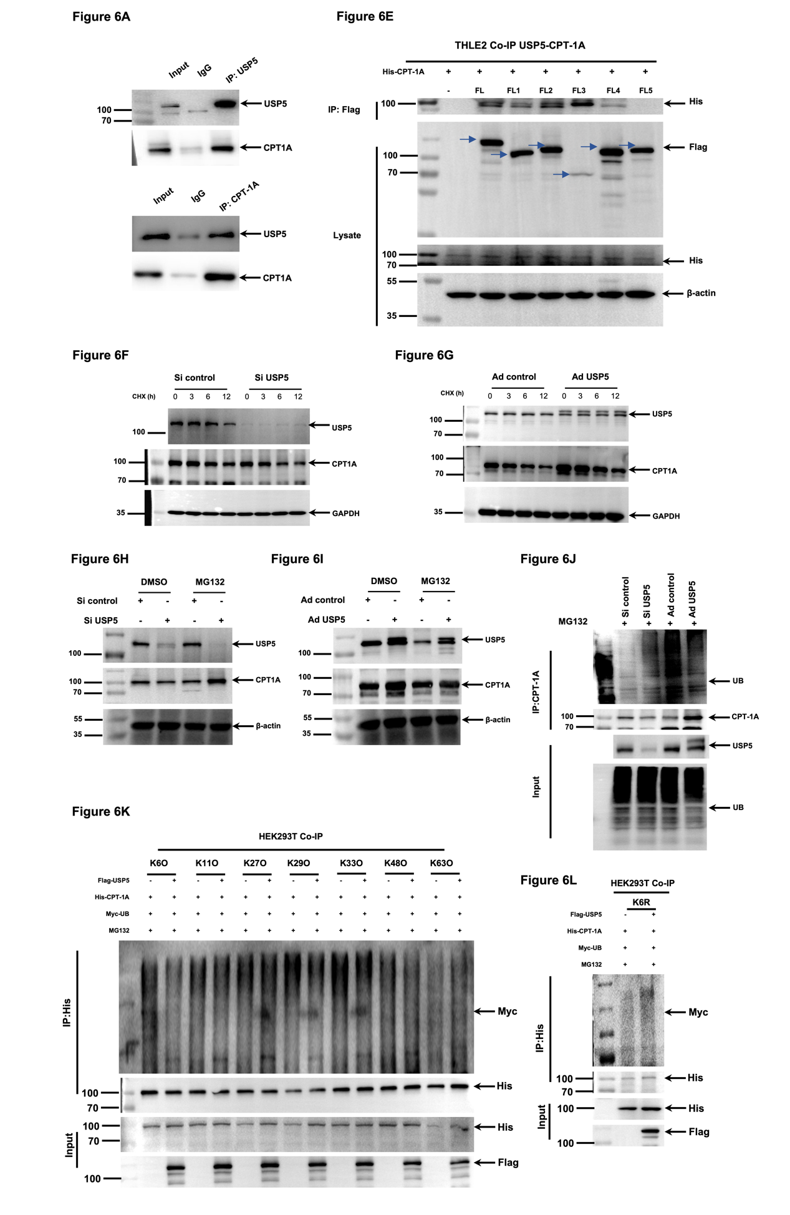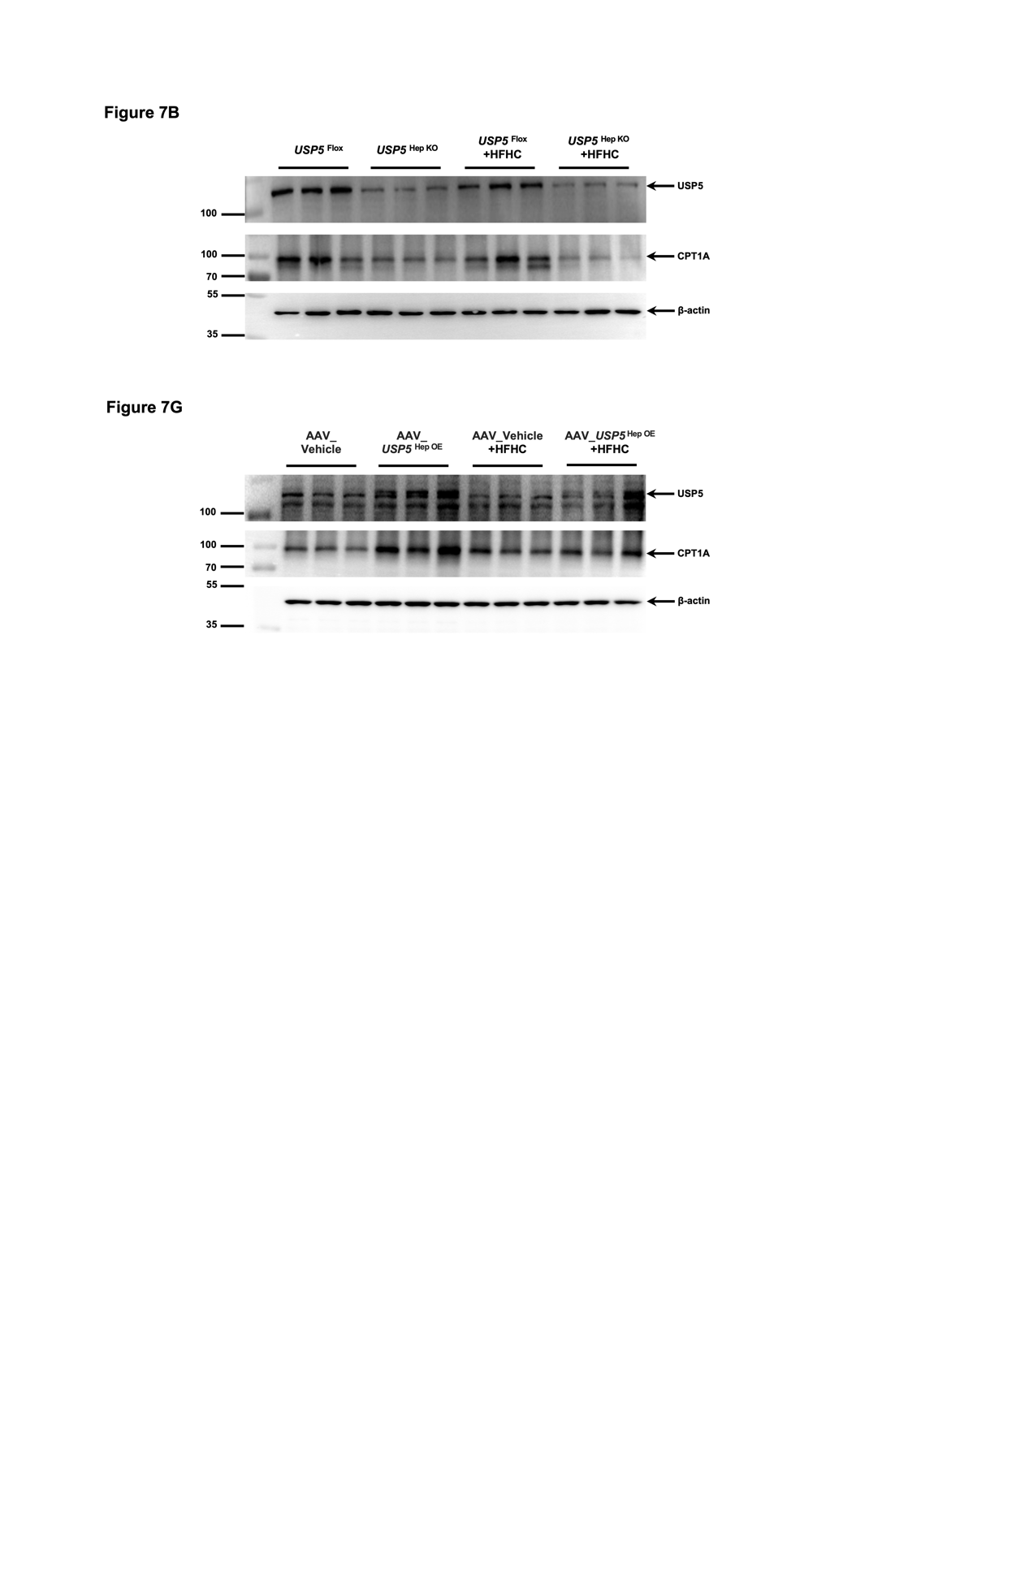

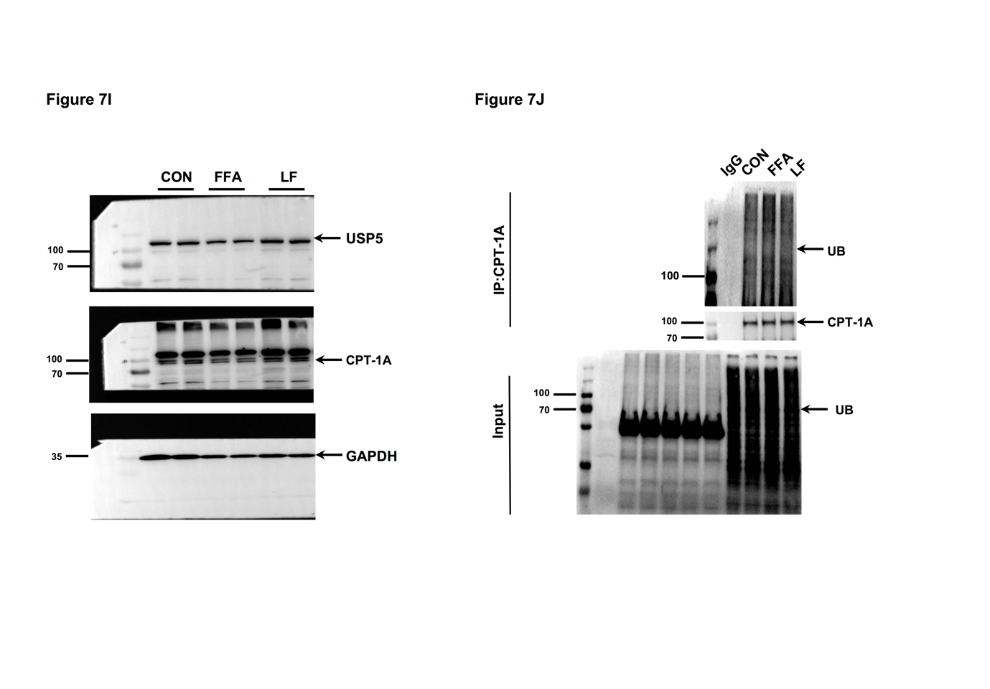

Star Methods
REAGEBT or RESOURCE | SOURCE | IDENTIFIER
Antibodies
Rabbit anti His-Tag pAb | ABclonal Technology | Cat: AE068
Recombinant Human IkB-alpha/NFKBIA Protein | ABclonal Technology | Cat: RP00032
CREB Rabbit mAb | ABclonal Technology | Cat: A10826
TEAD4 Rabbit pAb | ABclonal Technology | Cat: A4151
c-Jun Rabbit mAb | ABclonal Technology | Cat: A25329
C/EBPB Rabbit pAb | ABclonal Technology | Cat: A0711
SQSTM1/p62 Rabbit mAb | ABclonal Technology | Cat: A19700
FGF2 Rabbit mAb | ABclonal Technology | Cat: A22330
Frataxin/FXN Rabbit mAb | ABclonal Technology | Cat: A25507
NF-κB2 Rabbit pAb | ABclonal Technology | Cat: A5567
ACAA2 Rabbit mAb | ABclonal Technology | Cat: A0664
USP5 Rabbit pAb | Proteintech | Cat: 10473-1-AP
CPT-1a Rabbit mAb | Proteintech | Cat: 15184-1-AP
UB Rabbit mAb | Proteintech | Cat: 10201-2-AP
Bacterial and virus strains
CMV-MCS-3Flag-WPRE-BGH polyA/CMV-MCS-3Flag-WPRE-BGH polyA-USP5 | Genechem Biotechnology | N/A
Biological samples
Human liver biopsies see Data S1 | NingBo Secondary Hospital | https://data.mendeley.com/preview/yc9h9r5rsw
Chemicals, peptides, and recombinant proteins
Drugs 1-16 | Abphyto Biotechnology | N/A
Ligustroflavone | Abphyto Biotechnology | Cat: 260413-62-5
BSA, Fatty Acid Free | Beyotime | Cat: ST023
Protease inhibitor cocktail | Beyotime | Cat: P1005
PMSF (100mM) | Beyotime | Cat: ST506
RIPA Lysis Buffer | Beyotime | Cat: P0013B
Tween-20 | Beyotime | Cat: ST825
GMTrans liposomal transfection reagent | Genomeditech | Cat: TG-10015-2
Percoll | GE Healthcare Bio-Sciences AB | Cat: 17-0891-09
DMEM, High glucose, Pyruvate | Gibco | Cat: 11995073
DMEM/F-12, HEPES | Gibco | Cat: 11330032
Fetal Bovine Serum | Gibco | Cat: 10091148
opti-MEM | Gibco | Cat: 31985070
Oleic acid | MeilunBio | Cat: PWL220-2
Palmitic acid | MeilunBio | Cat: PWL222-2
penicillin | MeilunBio | SKU: PWL062-1
Hematoxylin-eosin | Nanjing Jiancheng Bioengineering Institute | Cat: D006-1-4
Oil Red O | Nanjing Jiancheng Bioengineering Institute | Cat: D027-1-4
Glycine | Shanghai Siding Biotechnology | Cat: SD6237
Methanol | Sinopharm Chemical Reagent | Cat: 100141190
Sodium dodecyl sulfate | Shanghai SiDing Biotechnology | Cat: SD6236
Trizma base | Shanghai Siding Biotechnology | Cat: SD6262
Critical commercial assays
Nonesterified Free fatty acids assay kit | Beyotime | Cat: S0215S
Alanine aminotransferase Assay Kit | Nanjing Jiancheng Bioengineering Institute | Cat: C009-3-1
Aspartate aminotransferase Assay Kit | Nanjing Jiancheng Bioengineering Institute | Cat: C010-3-1
Triglyceride assay kit | Nanjing Jiancheng Bioengineering Institute | Cat: A110-2-1
Total cholesterol assay kit | Nanjing Jiancheng Bioengineering Institute | Cat: A111-2-1
High-density lipoprotein cholesterol assay kit | Nanjing Jiancheng Bioengineering Institute | Cat: A112-2
Low-density lipoprotein cholesterol assay kit | Nanjing Jiancheng Bioengineering Institute | Cat: A113-2
Hydroxyproline assay kit | Nanjing Jiancheng Bioengineering Institute | Cat: A030-2-1
PAGE Gel Fast Preparation Kit (10%) | Shanghai Epizyme Biomedical Technology | Cat: PG112
BCA Protein Assay Kit | Thermo Fisher | Cat: 23227
Deposited data
The raw data of RNA-seq generated | This paper | GEO: GSE126848
Source data and Weatern blot, see Data S1 | This paper | DOI:10.17632/yc9h9r5rsw.1
Experimental models: Organisms/strains
Mouse: C57BL/6J, 6 weeks old for BMDM isolation | Sippr-Bikai | N/A
Mouse: C57BL/6J, 8 weeks old for NASH model and primary hepatocyte isolation | Sippr-Bikai | N/A
Mouse: Usp5^{Hep KO} | Cyagen Biosciences | N/A
Oligonucleotides
Primer list, see Table S1 | This paper | N/A
Recombinant DNA
pcDNA3.1-Flag-hUSP5 | Gene | N/A
pcDNA3.1-Flag-hUSP5-1 | Gene | N/A
pcDNA3.1-Flag-hUSP5-2 | Gene | N/A
pcDNA3.1-Flag-hUSP5-3 | Gene | N/A
pcDNA3.1-Flag-hUSP5-4 | Gene | N/A
pcDNA3.1-Flag-hUSP5-5 | Gene | N/A
pcDNA3.1-His-hCPT-1A | Gene | N/A
pcDNA3.1-Myc-hUB | Genomeditech | N/A
pcDNA3.1-Ha-hK6O | Genomeditech | N/A
pcDNA3.1-Ha-hK11O | Genomeditech | N/A
pcDNA3.1-Ha-hK27O | Genomeditech | N/A
pcDNA3.1-Ha-hK29O | Genomeditech | N/A
pcDNA3.1-Ha-hK33O | Genomeditech | N/A
pcDNA3.1-Ha-hK48O | Genomeditech | N/A
pcDNA3.1-Ha-hK63O | Genomeditech | N/A
pcDNA3.1-Ha-hK6R | Genomeditech | N/A
Software and algorithms
XF | Agilent | https://www.agilent.com.cn/
Prism 9 | GraphPad software | https://www.graphpad.com/
K-viewer | KFBIO | https://www.kfbio.cn
Excel | Microsoft | https://www.microsoft.com/zh-cn/microsoft-365/excel
Image J | National Institutes of Health | https://imagej.net/
Cell culture
Primary hepatocytes were isolated from 8-10 weeks male C57BL/6J mice by gentleMACSTM liver perfusion technique. In brief, mice were anaesthetized with 1% sodium pentobarbital. Then, liver was dissected and the perfusion tube was assembled. Perfusion the liver on the gentleMACS Octo Dissociator with Heaters, followed by releasing liver cells with tube C. The filtrate was washed twice with ice-cold DMEM and washed cell pellet was centrifuged at 200 g for 3 min. Isolated hepatocytes were cultured with DMEM supplemented with 10% FBS and 1% penicillin-streptomycin antibiotics at 37 °C in a humidified incubator with 5% CO₂.
The mouse liver cell line (AML-12) was kindly provided by Xin Xin. The human liver cell line THLE2 cells was purchased from Shanghai Institute of Life Sciences. L02 cells were provided by Siting Gao. HEK293T was kindly provided by Dr. Tiantian Chen (Nanjing Medical University, Nanjing, China). AML-12 cells were cultured in DMEM medium (Gibco, MA, USA) supplemented with 10% FBS and 1% penicillin. THLE2 was cultured in bronchial epithelial cell basal medium and additives (BEGM from Lonza/Clonetics Corporation, USA, BEGM Bullet Kit; CC3,170). L02, HEK293T cells were cultured in high glucose DMEM medium (Gibco, MA, USA) supplemented with 10% FBS and 1% penicillin. All the cell lines were incubated at 37℃ in 5% CO₂.
To detect the expression level of USP5 in steatosis, primary mouse hepatocytes and AML-12 cell line were cultured with BSA or FFAs (oleic (0.5 mM) and palmitic acid (0.25 mM) in a 2:1 ratio) for 24h.
To investigate the role of USP5 during steatosis development, THLE2 cells were infected with AdshRNA-USP5 (Ad USP5) or control lentivirus (Ad control) to establish the USP5 overexpression model, while SiRNA-USP5 (Si USP5) or control lentivirus (Si control) to establish the USP5 knockdown model. All lentiviral constructs were prepared by Shanghai Genechem Co., LTD. (Shanghai, China). In general, THLE2 cells were seeded in 6-well plate at the density of 30%-40%. Lentiviral were transfected into THLE-2 cells, and the virus was removed and replaced with fresh medium after 16h of culture. After 48-hour lentivirus USP5 knockdown or USP5 overexpression, the THLE2 cells were stimulated with BSA or FFAs for 24h.
To detect the binding site between USP5 and CPT-1A, THLE2 cells were transiently co-transfected with 1µg 6×His-CPT-1A and 1µg different domain of USP5 (Flag-USP5 ^{WT}, Flag-USP5^{𝛥1-169}, Flag-USP5^{𝛥169-289}, Flag-USP5^{𝛥289-625}, Flag-USP5^{𝛥625-749}, Flag-USP5^{𝛥749-835}) plasmids (Genomeditech, Shanghai, China). THLE2 was seeded in 6-well plate at the density of 30%-40% and replaced with opti-MEM, then plasmids were conducted into cells by GMTrans liposomal transfection reagent for 48h.
To explore the ubiquitin chain between USP5 and CPT-1A, HEK293T cells were transiently co-transfected with 1µg 6×His-CPT-1A, 1µg Flag-USP5 ^{WT}, 1µg Myc-UB and 1µg different domain of ubiquitin chain (K6O, K11O, K27O, K29O, K33O, K48O, K63O, K6R) plasmids. HEK293T was seeded in 6-well plate at the density of 30%-40% and replaced with opti-MEM, then plasmids were conducted into cells for 48h.
To study the rescue of CPT-1A, Si USP5 THLE2 cells were seeded to 6-well plate and transiently co-transfected with 1µg 6×His-CPT-1A plasmids for 48h. Then, the cells were treated with BSA or FFAs for 24h.
For screening the candidate compound for activator of USP5, AML-12 cells were seeded on 12-well plate at the density of 30%-40%, and incubated with BSA or FFAs or different compound for 24h after cell adhesion.
Specimen collection
All mice were fasted 12h before the end of the experiment and anesthetized by intraperitoneal injection of 2% sodium pentobarbital 3 ml/kg. 1 ml of blood was collected from each mouse. A portion of liver tissue was extracted from the same liver lobe, placed at the same location in each mouse, and fixed in a 10% neutral buffered formalin solution.
Biochemical analysis
Serum ALT and AST activities were measured by assay kits (Nanjing Jiancheng Bioengineering Institute, Jiangsu, China). Serum lipid metabolism was evaluated by TG, TC, LDL-C, and HDL-C with assay kits from Nanjing Jiancheng Bioengineering Institute (Jiangsu, China). To assess glucose metabolism, fasting blood glucose (FBG) was determined using a blood glucose meter (Roche Diagnostic GmbH, Germany). Fasting insulin (FINS) levels of mice were measured using an enzyme-linked immunosorbent assay (Ultra-Sensitive Mouse Insulin ELISA Kit, lot number: 90080, Crystal Chem, USA). The homeostatic model assessment-insulin resistance (HOMA-IR) index was calculated using the following formula: FBG(mM) × FINS (IU/L)/22.5.
Hepatic TG, NEFA and hydroxyproline (HYP) content were measured using assay kits (Nanjing Jiancheng Bioengineering Institute, Jiangsu, China), as previously described.
Histological analysis
Liver section (sectioned at 4μm by Leica RM2235) were embedded in paraffin and then stained with H&E staining kit (Nanjing Jiancheng Bioengineering Institute, Jiangsu, China). Lipid droplet accumulation was visualized using Oil Red O staining kit from Nanjing Jiancheng Bioengineering Institute of frozen liver sections (sectioned at 12μm) prepared in OCT compound. Liver fibrosis was evaluated by Sirius Red staining. The features of the liver sections were observed by the K-viewer and imaged. The MAS score consists of steatosis (scale 0-3), hepatocellular ballooning (scale 0-2), and lobular inflammation (scale 0-3).
Immunohistochemistry (IHC)
Human liver section (4μm) were incubated in anti-USP5 antibody at a dilution of 1:200 (proteintech) overnight at 4℃ and then reacted with secondary antibody (Gene tech, Shanghai, China). Mouse liver section (4μm) were incubated in anti-F4/80 antibody at a dilution of 1:150 and anti-alpha-SMA antibody at a dilution of 1:200 using the same method.
Western Blot analysis
Liver tissues or cells were homogenized in lysis with RIPA lysis buffer added PMSF and protease inhibitor cocktail (Beyotime, Shanghai, China). Total protein concentrations were quantified using a BCA protein assay kit from Thermo fisher. The samples were subjected to 7.5%-15% SDS-polyacrylamide gel electrophoresis (depending on the molecular weight of indicated protein), and transferred to 0.22μm PVDF membranes (IPVH00010; Millipore, Billerica, MA) by using Bio-rad. The membranes were blocked with 5% BSA in 1×TBST for 1h at room temperature and incubated with primary antibodies overnight at 4℃. Then, the blots were incubated with HRP-conjugated secondary antibodies. Protein signal was detected using an ECL kit (Beyotime, Shanghai, China) and visualized in a imaging system (Tianneng, China). The primary and secondary antibodies used information are listed in the table.
Quantitative real-time PCR
Total RNA was extracted using RNA extraction kit (B511321, Sangon Biotech Co., Ltd., Shanghai, China), and cDNA was synthesized from 1μg total RNA using RNA reverse transcription (1708890, BioRad, USA). Real-time PCR primer sequences are designed in BioTNT Biotech (Shanghai, China) and included in the Table S1. SYBR Green PCR Master Mix was used. Housekeeping genes Actin was used to normalize and fold change relative to controls was calculated using the 2^{-𝛥𝛥Ct} method.
RNA-seq library data analysis
For comparison of gene expression between human Normal-MASL samples, we utilized the publicly available dataset GSE126848, which includes high-throughput sequencing profiles of 29 snap-frozen liver biopsies: Normal (n = 14), and MAFL (n = 15).
To ensure robust normalization and minimize variability, we applied the limma relative log expression (RLE) normalization method to the expression profiles. Additionally, we removed outlier samples exhibiting abnormal expression levels and corrected for batch effects using the ‘‘svg’’ R package.
Immunoprecipitation (IP)
Cells were lysed with IP lysis buffer (BioTNT, Shanghai, China) and homogenized. The indicated antibody (1:200 dilution) was incubated with 25 μL of Protein A/G agarose beads (Beyotime, Shanghai, China) overnight at 4℃. Homogenates containing total 500μg were then incubated with Protein A/G agarose beads for 2-4 h at room temperature. Then, the beads were washed 3-4 times with cold IP lysis buffer, and collected in 80μL of 1×SDS loading buffer by boiling at 100℃ for 10min. Finally, western blotting was performed as mentioned above.
IP-MS of protein-USP5 interactions
For studying the USP5 protein-protein interactions, IP experiments were performed on L02 cells. In brief, the cell lysis were incubated with anti-USP5 or IgG antibody. Then, the samples were subjected to SDS-PAGE gel, and the gel were examined by LC-MS/MS. The rate of false positive protein identifications was controlled under 1%.
Surface plasmon resonance for affinity determination
To assess the binding kinetics or affinity of USP5 and CPT-1A, the Biacore T200 (GE Healthcare) was used to measure the KD values of protein‒protein and protein‒ligand interactions. All measuaments were performed at 25℃. Before coupling the protein, the CM7 chip (GE Healthcare) was first activated with 1-ethyl-3-(3-dimethylaminopropyl) carbodiimide (EDC, cytiva) and N-hydroxy succinimide (NHS, cytiva) at a flow rate of 10μL/min. Then, the CPT-1A protein was diluted to approximately 25 μg/mL and injected into the chip at a flow rate of 10μL/min. Finally, the channel was blocked with ethanolamine. For the affinity measurement of CPT-1A and USP5, we diluted the USP5 protein from 100 μg/mL to 3.13 μg/mL and flowed the protein from low to high concentrations through the chip channel with CPT-1A protein at a flow rate of 30 μL/min for 120 seconds. After each concentration point was flowed through, the chip was regenerated with NaOH at a flow rate of 30 μL/min for 120 seconds, and then real-time recording and data storage were performed.
Immunofluorescence staining
To visualize the location of USP5 and CPT-1A, THLE2 cells were seeded to 24-well plate containing glass circle coverslips at the density of 30-40%. After cell adhesion, cells were fixed with 4% PFA at room temperature for 30min after washing with PBS, blocking with 0.1% Triton X-100 for 30 min and 5% BSA for 1h at RT, incubated with primary antibodies (USP5, 1:400, Proteintech; CPT-1A, 1:400, Proteintech) at 4℃ overnight. Then, the cell were incubated with corresponding secondary antibodies (1:1000, abcam) for 1h at RT, and mounted with DAPI. Images were captured using a fluorescence confocal microscopy (LSM 900, Zeiss, Jena, Germany).
Cycloheximide (CHX) and MG132 analysis
THLE2 cells were treated with 50μM CHX for 0, 3, 6, 12h and 10μM MG132 for 8h.
Ubiquitination assay
Cells were transfected with specific plasmids at 80% density followed by drug exposure or indicated treatments. 10 μM MG132 was added to avoid proteasome-mediated protein degradation for 6 h before harvest. Cells were washed with ice-cold PBS, then whole cell lysate was collected and clarified by centrifugation. Cleared lysates was collected for IP using indicated antibodies coupled with protein A/G beads. Bound proteins were eluted with 1×SDS loading buffer, boiled and subject to western blot using indicated antibodies.
Transmission electron microscopy (TEM) analysis
The liver tissues of mice were fixed with 2.5% glutaraldehyde (PBS) and 1% osmium anhydride. After staining, the mitochondrial structural changes were observed by TEM.
Measurement of mitochondria respiration
Mitochondria respiration and glycolysis were measured with the Seahorse XF96e extracellular flux analysis system (Agilent). Ad USP5 and Si USP5 THLE2 cells were plated onto gelatin-coated, XF 96-well microplates at a density of 4×10³/well. The medium was replaced after 4-8 hours with XF assay medium (Seahorse Biosciences 103334-100, supplemented with 10mM glucose, 2mM pyruvate, 4mM glutamine) or minimal medium containing the same concentration of salt ions. The oxygen consumption rate (OCR) was measured by the XFe96 Extracellular Flux Analyzer (Seahorse Biosciences) according to the manufacturer's recommendations. Reagents were used at the following final concentrations: oligomycin (4μM), FCCP (0.5μM), rotenone (2μM), antimycin A (2μM). The measured values were normalized to the cell number of the THLE2 cells plated on parallel plates.
Natural compound database screening
Natural compounds screening with activating capacity on USP5 (PDB ID: 3IHP ) was performed based on a Natural Product Library Plus by using computer-aid molecular docking The Receptor Grid Generation module was used to create grid files, and grid files were generated centered on the allosteric site (Asp103/Asp104/Try62). The Virtual Screening Workflow module was used to perform virtual screening by importing the prepared compounds and using the Glide module to perform molecular docking, i.e., docking between receptor and ligand molecules by geometric and energy matching. The Traditional Chinese Medicine Active Compound Library (2.8 K compound) were first screened using the High Throughput Screening (HTVS) mode in the Glide module, and the scored small molecules were selected. The top 16 compounds screened (soces <-8.0). Finally, the cellular TG content was used to analyze in vitro.
QUANTIFICATION AND STATISTICAL ANALYSIS
Statistical analysis was performed using Prism software (GraphPad Software, CA, USA). Experimental data is presented as mean ±SD. Outliers were excluded from statistical analyses by the outlier analysis using the ROUT method (GraphPad Prism). Statistical significance between two groups was determined using two-tailed Student’s t-test. One-way ANOVA with Tukey’s post hoc correction was applied for multiple comparisons. A P-value less than 0.05 was considered statistically significant. Figures without P values or asterisks implied the data was not significantly different. The statistical details for each experiment are indicated in the figure legend.

