Supplementary Materials for
Title: Diffusion and flow matching for precipitation downscaling over India: a benchmark against statistical and deterministic methods
Authors:
Shailesh Kumar Jha¹, Priyank J. Sharma², Anurag Mishra³, Saksham Joshi⁴, and Vivek Gupta¹*
¹ School of Civil and Environmental Engineering, Indian Institute of Technology Mandi, Kamand, Himachal Pradesh, India
² Department of Civil Engineering, Indian Institute of Technology Indore, Indore, India
³ Regional Remote Sensing Centre–North, National Remote Sensing Centre (NRSC), New Delhi, India
⁴ Water Resources Group, National Remote Sensing Centre (NRSC), Hyderabad, India

Table S1. Spatial performance of the five downscaling methods for the eleven ETCCDI precipitation indices. Root-mean-square error (RMSE), fractional bias (%), and Kling–Gupta efficiency (KGE) are computed by comparing the spatial patterns of each ETCCDI index against the MSWX reference over the 2011–2014 evaluation period. Lower RMSE and smaller absolute bias indicate better agreement, whereas higher KGE indicates greater overall fidelity.
ETCCDI Index (Units; Obs Mean) | Flow Matching [RMSE (Bias %)] | DDPM [RMSE (Bias %)] | SRCNN [RMSE (Bias %)] | CA [RMSE (Bias %)] | WT [RMSE (Bias %)]
CDD: Dry Spells (days; Obs: 106.4) | 22.14 (+0.09%) | 21.20 (+0.03%) | 123.99 (+14.19%) | 47.40 (-29.15%) | 229.64 (+32.24%)
CWD: Wet Spells (days; Obs: 43.5) | 12.55 (-1.40%) | 12.86 (+2.40%) | 13.99 (+5.16%) | 34.99 (+48.78%) | 117.60 (+214.30%)
R1mm: Rainy Days (days; Obs: 520.7) | 31.05 (-0.39%) | 32.29 (+0.68%) | 55.97 (-1.37%) | 157.63 (+26.16%) | 287.61 (+46.51%)
R10mm: Moderate Precip (days; Obs: 136.8) | 13.21 (-0.47%) | 13.75 (-0.10%) | 19.66 (-4.36%) | 26.01 (+1.04%) | 56.33 (-11.68%)
R20mm: Heavy Precip (days; Obs: 52.1) | 8.72 (-1.04%) | 8.88 (-1.08%) | 12.29 (-7.32%) | 13.66 (-10.75%) | 38.93 (-48.82%)
Rx1day: Max 1-Day (mm; Obs: 91.2) | 30.31 (+0.46%) | 28.21 (-0.93%) | 29.17 (-11.43%) | 42.60 (-25.61%) | 92.02 (-74.76%)
Rx5day: Max 5-Day (mm; Obs: 190.8) | 40.59 (-0.07%) | 39.42 (-0.92%) | 44.55 (-7.21%) | 61.94 (-17.21%) | 150.11 (-58.78%)
SDII: Intensity Index (mm/d; Obs: 7.75) | 0.59 (+0.02%) | 0.60 (-0.59%) | 0.82 (-3.81%) | 1.65 (-17.60%) | 3.41 (-37.62%)
PRCPTOT: Annual Total (mm; Obs: 4498) | 404.64 (-0.13%) | 417.24 (+0.21%) | 646.03 (-4.47%) | 495.83 (+5.64%) | 548.08 (-3.10%)
R95pTOT: Very Heavy (mm; Obs: 1074) | 131.18 (+0.04%) | 132.94 (-0.13%) | 196.52 (-6.95%) | 158.12 (-4.07%) | 485.42 (-33.60%)
R99pTOT: Extremely Heavy (mm; Obs: 376.3) | 67.45 (+0.30%) | 65.87 (-0.25%) | 84.94 (-9.17%) | 88.81 (-7.68%) | 251.08 (-48.76%)
Domain Mean (All 11 Indices) | 69.31 (+0.40%) | 70.30 (+0.66%) | 111.63 (+6.86%) | 102.60 (+17.61%) | 205.48 (+55.47%)

Table S2. Mean precipitation bias (mm day⁻¹) during active and break monsoon phases across the 14 agro-climatic regions of India. Values are reported as Active / Break for each downscaling method relative to the MSWX reference over the 2011–2014 evaluation period. Positive values indicate wet bias and negative values indicate dry bias.
Agro-Climatic Region | DDPM (Active / Break) | Flow Matching (Active / Break) | SRCNN (Active / Break) | CA (Active / Break) | WT (Active / Break)
1. W. Dry (Rajasthan) | -0.006 / +0.005 | -0.029 / +0.020 | -0.194 / +0.124 | -1.238 / +0.493 | -2.875 / +1.236
2. W. Himalayan | -0.027 / +0.008 | -0.008 / +0.018 | -0.117 / +0.151 | -0.094 / +0.036 | -0.690 / +0.769
3. S. Plateau & Hills | +0.072 / -0.059 | +0.053 / -0.030 | +0.014 / -0.025 | +0.484 / +0.387 | +2.414 / +0.471
4. Upper Gangetic | +0.074 / -0.025 | +0.052 / -0.032 | -0.088 / +0.293 | -0.988 / +0.586 | -0.654 / +2.320
5. Gujarat Plains | -0.085 / +0.045 | +0.016 / +0.042 | -0.718 / +0.408 | -1.389 / +0.377 | -6.157 / +2.291
6. W. Plateau & Hills | -0.053 / +0.012 | -0.097 / +0.019 | -0.369 / +0.198 | +0.255 / -0.114 | -0.672 / +1.479
7. E. Himalayan | -0.074 / +0.063 | +0.018 / +0.068 | -0.050 / +0.035 | +0.660 / -0.154 | +2.541 / -3.785
8. Central Plateau | +0.021 / -0.027 | +0.014 / +0.012 | -0.225 / +0.279 | -0.559 / +0.657 | -1.501 / +3.069
9. W. Ghats & Coast | -0.011 / +0.087 | -0.073 / -0.034 | -2.330 / +1.375 | +0.122 / -1.944 | +5.553 / -0.965
10. E. Plateau & Hills | +0.063 / -0.101 | -0.009 / -0.013 | -0.265 / +0.181 | -0.771 / +0.745 | -1.553 / +2.069
11. Mid Gangetic | -0.073 / -0.022 | -0.079 / +0.093 | -0.139 / +0.341 | +0.683 / +0.431 | +1.747 / +1.696
12. Lower Gangetic | +0.016 / -0.077 | -0.061 / -0.016 | -0.077 / +0.071 | -0.922 / +0.782 | -3.436 / +1.239
13. E. Coast Plains | +0.063 / -0.047 | +0.118 / -0.027 | +0.035 / -0.034 | +0.340 / +0.450 | +0.878 / +0.949
14. Trans Gangetic | -0.012 / -0.014 | +0.019 / +0.004 | -0.114 / +0.127 | -1.010 / +0.267 | -1.331 / +1.034
Domain Mean | +0.003 / +0.013 | -0.001 / +0.002 | -0.072 / +0.079 | +0.037 / -0.201 | +0.106 / -0.094

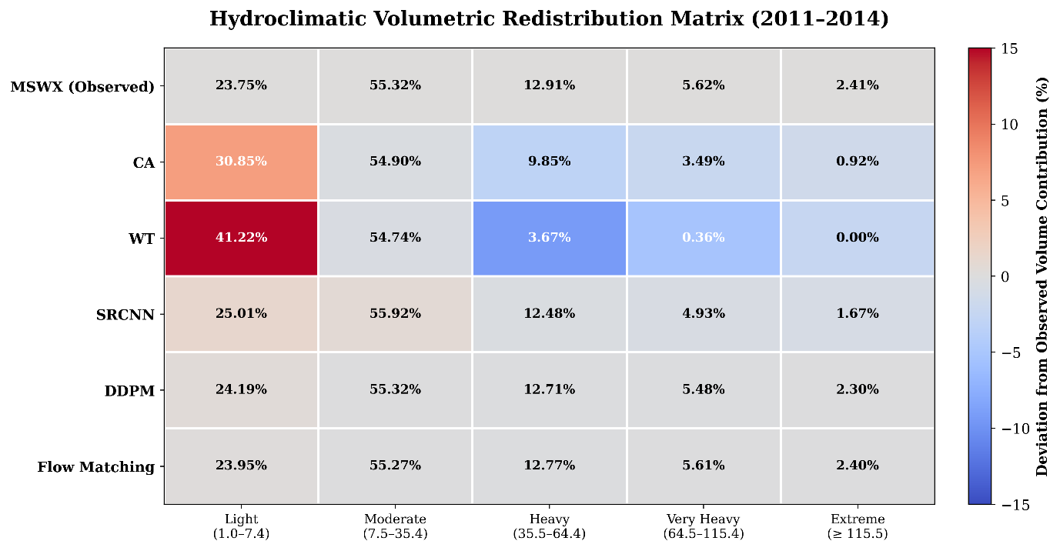
Figure S1: Distribution of wet-day rainfall volume across the five IMD precipitation intensity classes. Percentages denote the fraction of total wet-day rainfall volume contributed by each intensity class during 2011–2014. Cell colours indicate the deviation (percentage points) from the observed MSWX distribution, with warm colours indicating excess rainfall volume and cool colours indicating deficits relative to the observations.

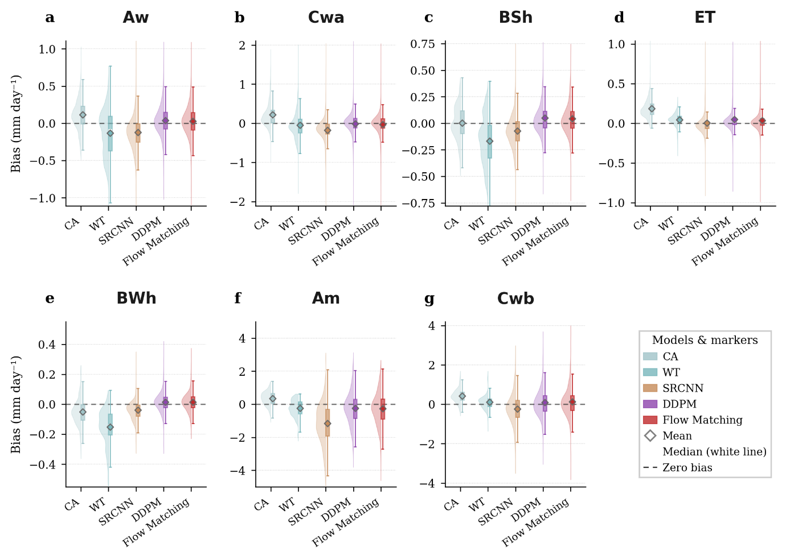
Figure S2: Distribution of climatological precipitation bias across Köppen–Geiger climate zones. Violin plots show the grid-cell bias (model − MSWX; mm day⁻¹) in the climatological mean precipitation for each downscaling method within the seven Köppen–Geiger climate zones. Diamonds denote the zonal mean, white horizontal lines indicate the median, and the dashed line marks zero bias.
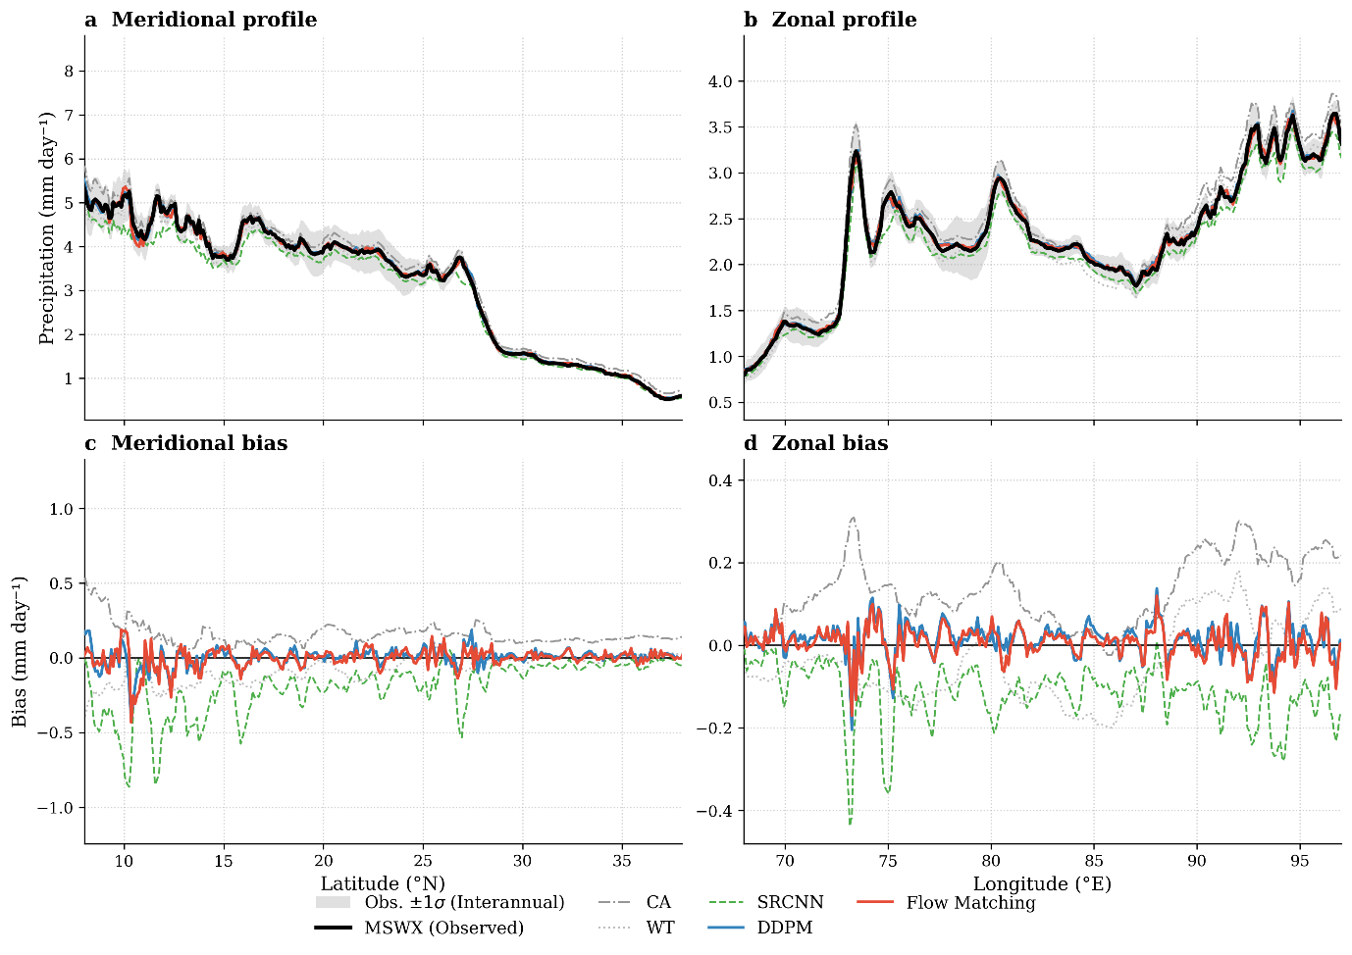
Figure S3: Meridional (latitude) and zonal (longitude) profiles of time-mean precipitation, 2011–2014, averaged over the Indian landmass. (a, b) Observed (MSWX) profiles with the interannual ±1σ envelope, and each method overlaid. (c, d) The corresponding model-minus-observed bias.
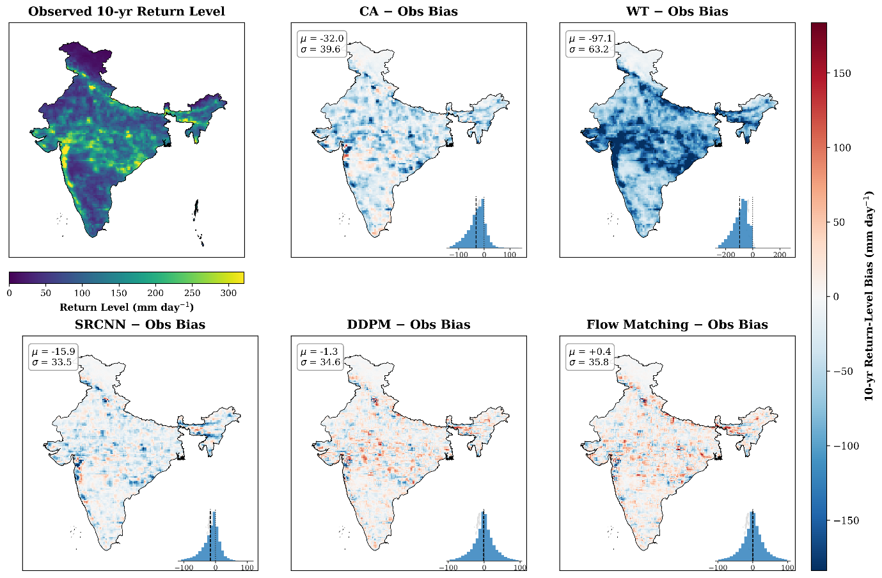
Figure S4: Extreme precipitation return-level fidelity and spatial error distributions. Comparison of 10-year return levels calculated from daily annual maximum precipitation (2011–2014) using pooled-shape Generalized Extreme Value (GEV) modeling. The reference MSWX observational field is shown with a sequential color scale (top-left). Model deviations (Model − Observed) for CA, WT, SRCNN, DDPM, and Flow Matching are mapped on a shared diverging scale, where red indicates overestimation and blue indicates underestimation of extreme return levels. Bottom-right insets depict normalized spatial bias histograms with the mean bias (μ) indicated by a black dashed line. Top-left statistics report global domain error metrics (μ and standard deviation σ, in mm day⁻¹) over continental India.
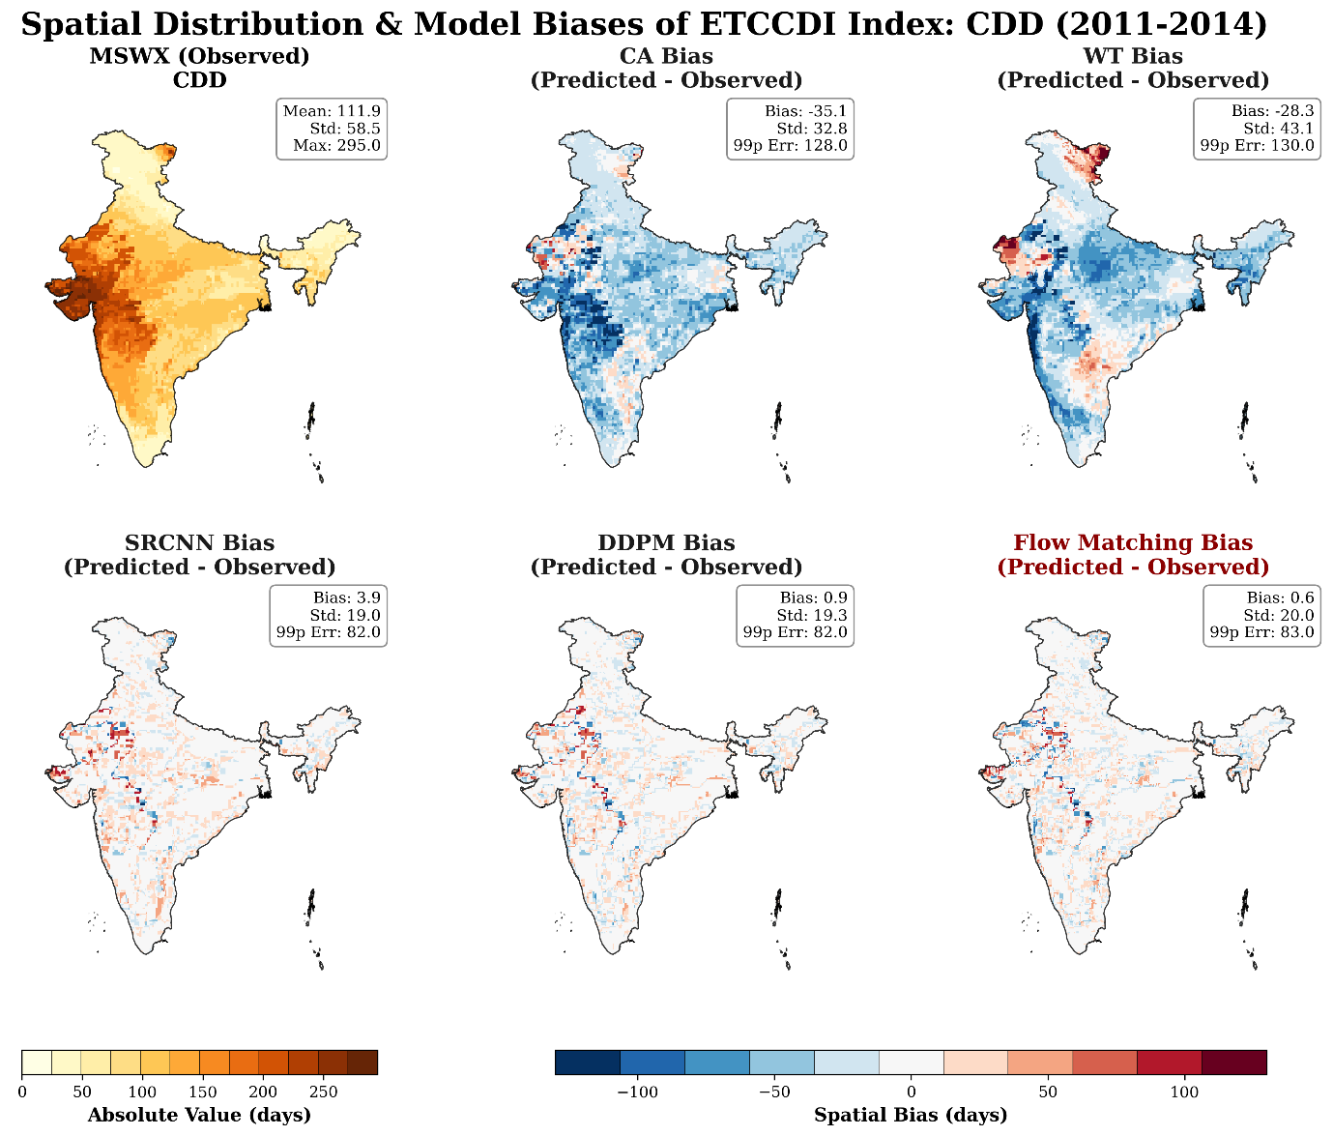
Figure S5: Spatial distribution of the annual maximum number of consecutive dry days (CDD). The first panel shows the MSWX reference, and the remaining panels show the spatial bias (model − observation) for Constructed Analogues (CA), Weather Typing (WT), SRCNN, DDPM, and Flow Matching over the 2011–2014 evaluation period. Positive biases indicate overestimation of dry-spell duration, whereas negative biases indicate underestimation
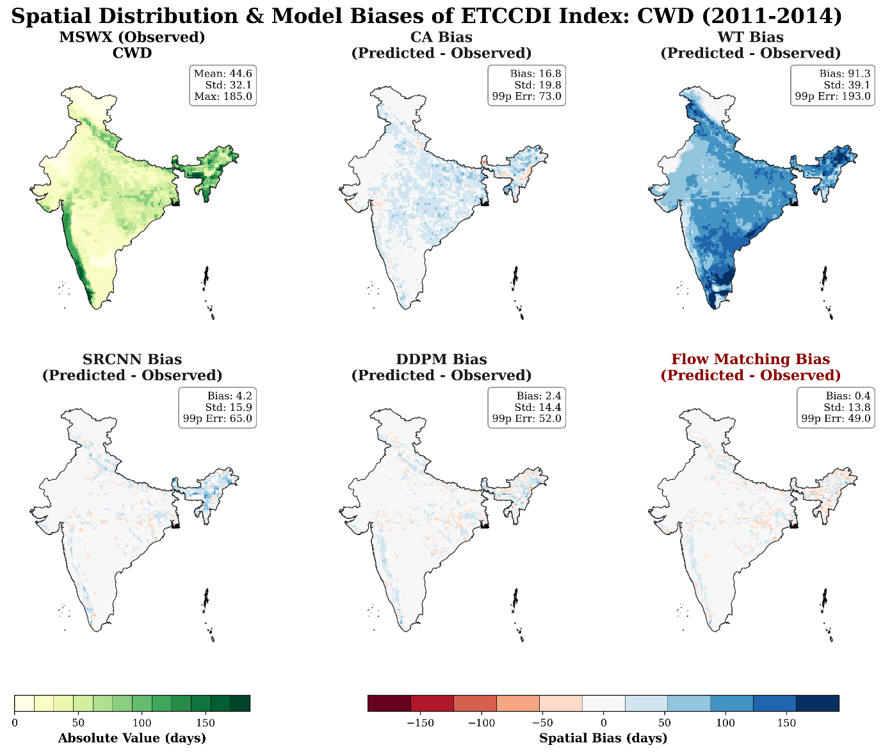
Figure S6: Spatial distribution of the annual maximum number of consecutive wet days (CWD). The first panel shows the MSWX reference, and the remaining panels show the spatial bias (model − observation) for each downscaling method during 2011–2014. Positive values denote overestimation of wet-spell duration and negative values denote underestimation.

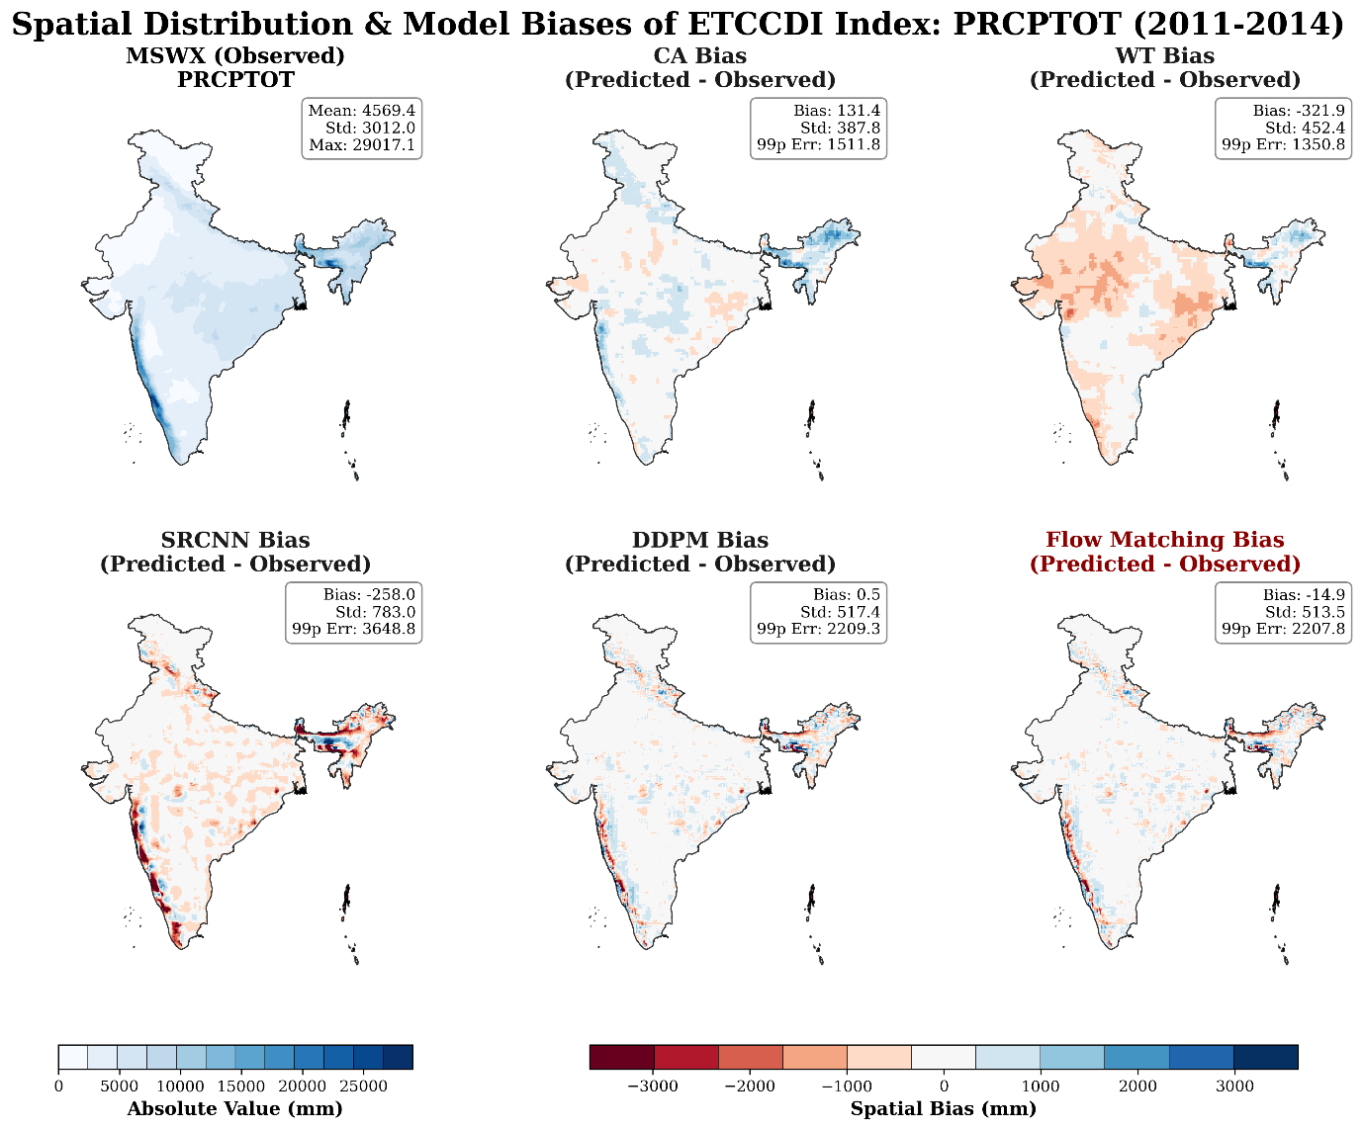
Figure S7: Spatial distribution of annual total wet-day precipitation (PRCPTOT). The first panel shows the MSWX reference, and the remaining panels display the spatial bias (model − observation) for each downscaling method during the 2011–2014 evaluation period.

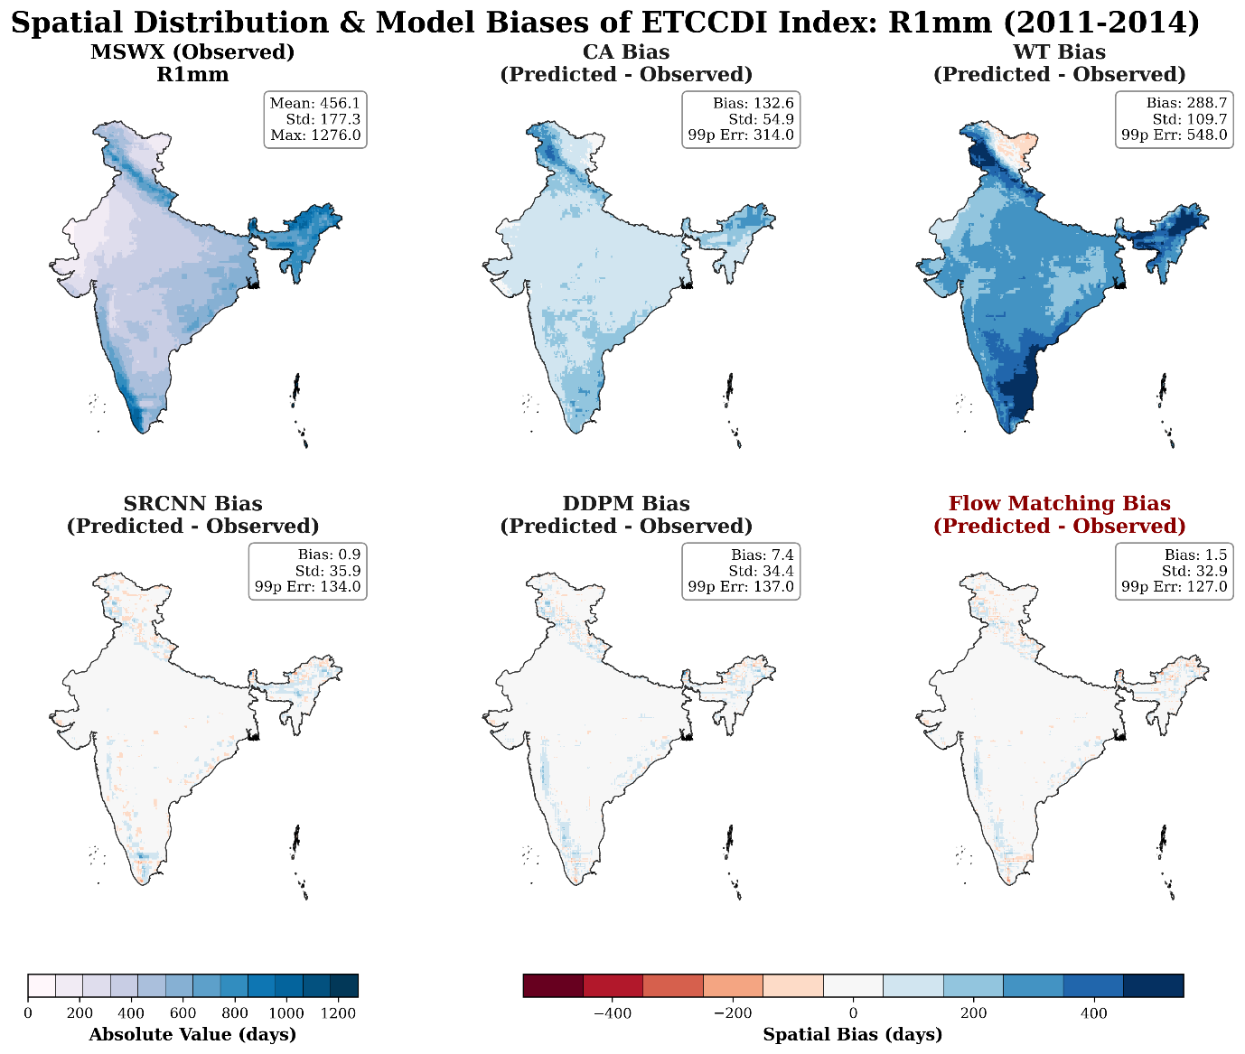
Figure S8: Spatial distribution of the annual number of wet days (R1mm). The first panel shows the MSWX reference, and the remaining panels display the spatial bias (model − observation) for each downscaling method during the 2011–2014 evaluation period.

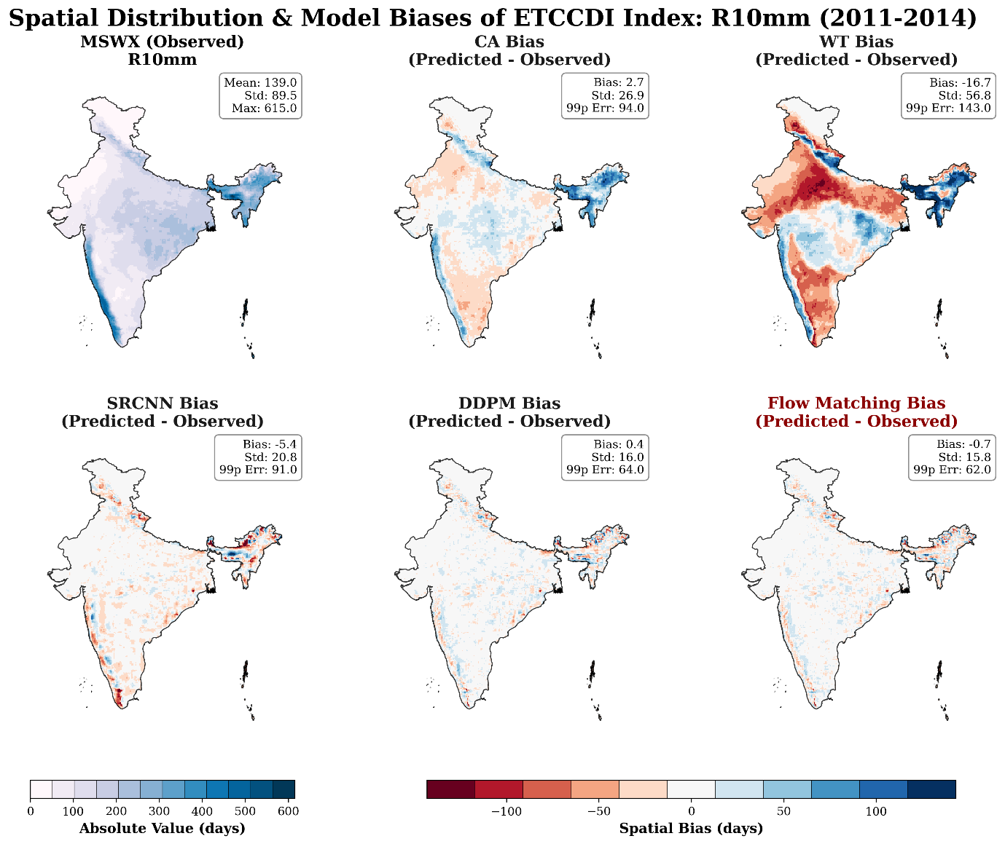
Figure S9: Spatial distribution of the annual number of moderate precipitation days (R10mm). The first panel shows the MSWX reference, and the remaining panels show the spatial bias (model − observation) for each downscaling method during 2011–2014.

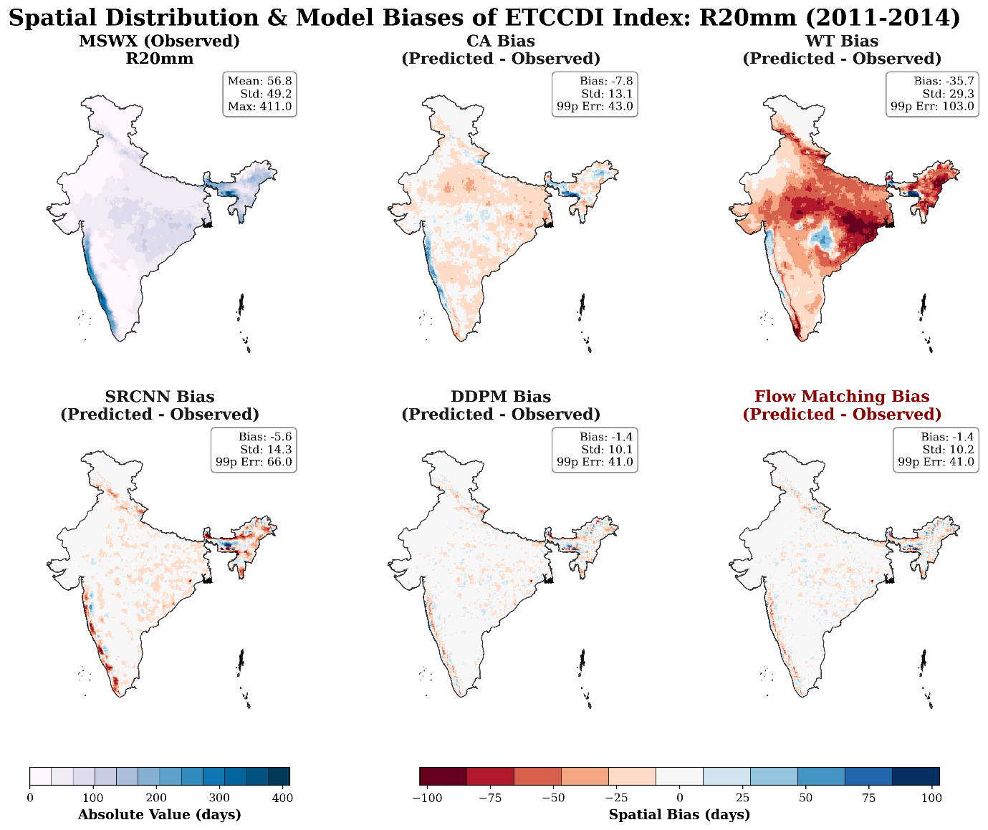
Figure S10: Spatial distribution of the annual number of heavy precipitation days (R20mm). The first panel shows the MSWX reference, and the remaining panels display the spatial bias (model − observation) for each downscaling method over the 2011–2014 evaluation period.

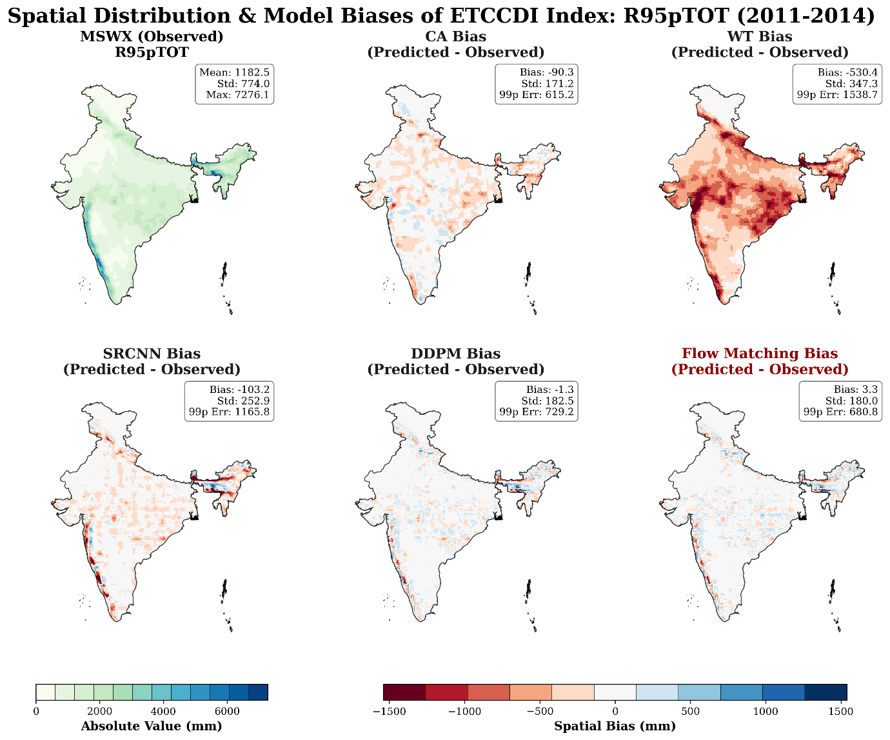
Figure S11: Spatial distribution of annual precipitation from very wet days (R95pTOT). The first panel shows the MSWX reference, and the remaining panels display the spatial bias (model − observation) for each downscaling method over the 2011–2014 evaluation period. R95pTOT represents the annual precipitation accumulated on days exceeding the climatological 95th percentile of wet-day precipitation.

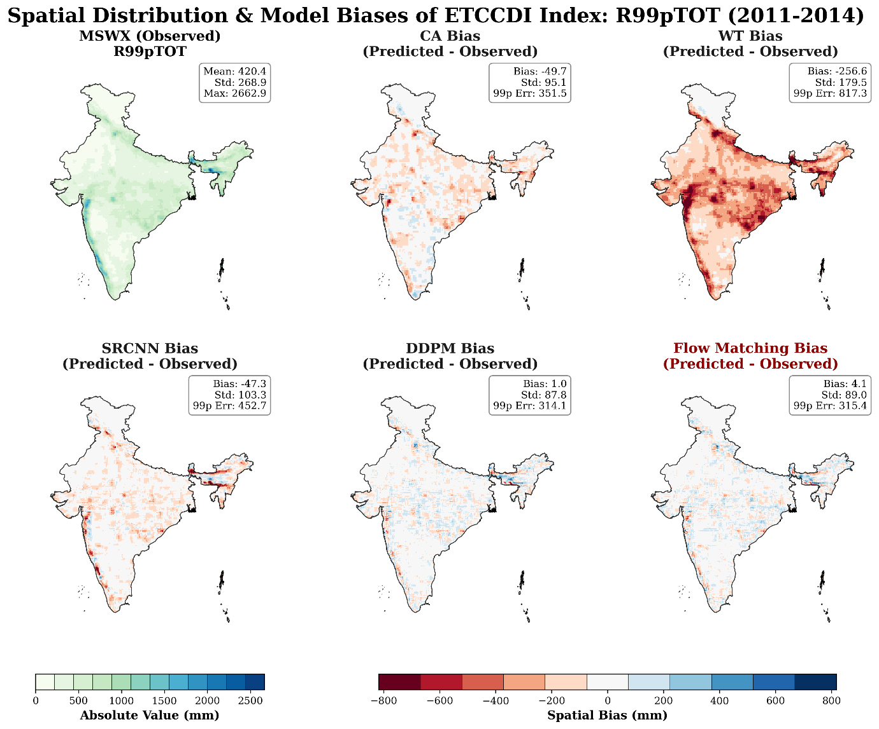
Figure 12: Spatial distribution of annual precipitation from extremely wet days (R99pTOT). The first panel shows the MSWX reference, and the remaining panels display the spatial bias (model − observation) for each downscaling method during the 2011–2014 evaluation period. R99pTOT represents the annual precipitation accumulated on days exceeding the climatological 99th percentile of wet-day precipitation.

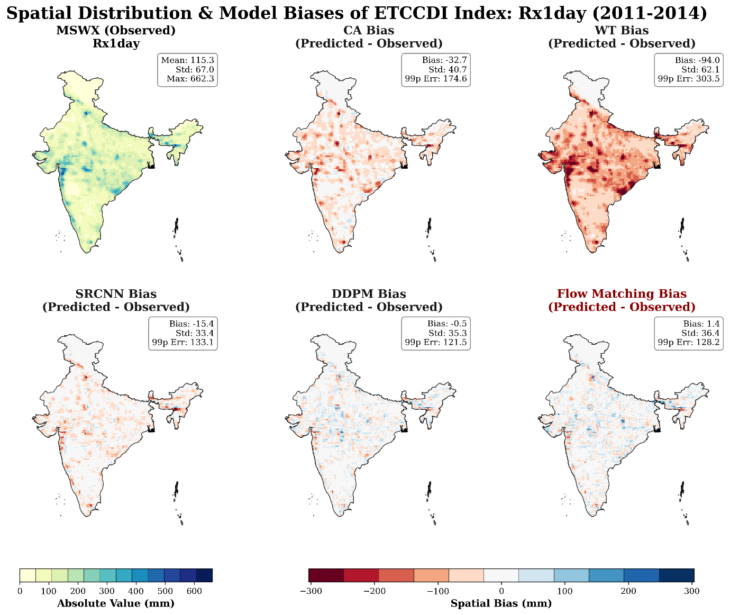

Figure S13: Spatial distribution of the annual maximum 1-day precipitation (Rx1day). The first panel shows the MSWX reference, and the remaining panels display the spatial bias (model − observation) for each downscaling method during 2011–2014. Positive biases indicate overestimation of annual daily precipitation extremes and negative biases indicate underestimation.

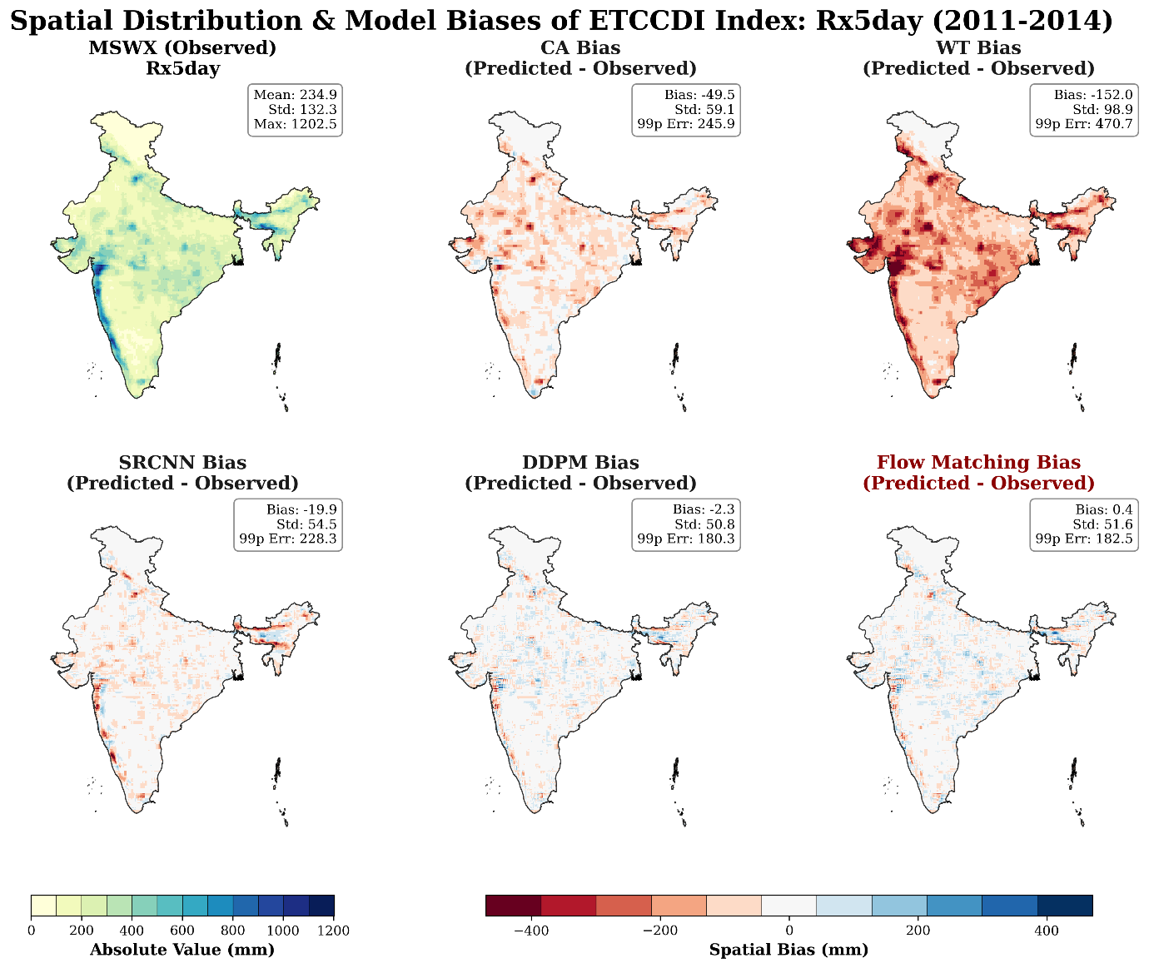
Figure S14: Spatial distribution of the annual maximum consecutive 5-day precipitation (Rx5day). The first panel shows the MSWX reference, and the remaining panels show the spatial bias (model − observation) for each downscaling method during the 2011–2014 evaluation period.

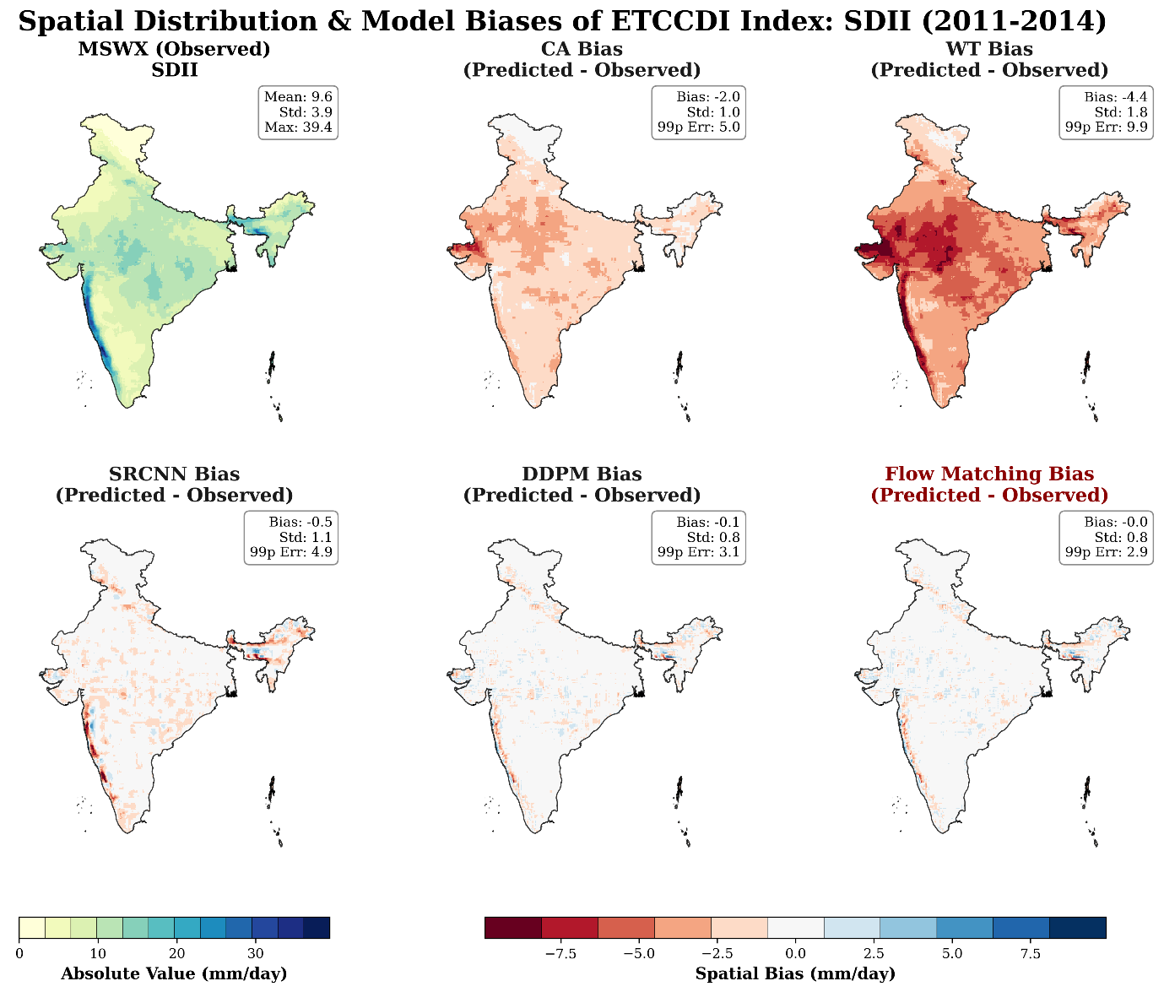

Figure S15: Spatial distribution of the Simple Daily Intensity Index (SDII). The first panel shows the MSWX reference, and the remaining panels display the spatial bias (model − observation) for each downscaling method over the 2011–2014 evaluation period. SDII is defined as the mean precipitation intensity on wet days.

