Supplementary Information

In-situ polymerized MXene@PDA nanocomposite for high-resolution simultaneous development of latent and blood fingerprints

Yaling Li · Zixuan Zhang · Xiangyang Hu · Ji Zhou · Yong Ye
Y. Li · X. Hu (corresponding author)
Criminal Justice School, Zhongnan University of Economics and Law, Wuhan 430000, Hubei, China
Innovation Base of Forensic Technology Application and Social Governance, Wuhan 430000, Hubei, China
e-mail: 709667234@qq.com

Z. Zhang · J. Zhou (corresponding author) · Y. Ye
Hubei Collaborative Innovation Center for Advanced Organic Chemical Materials & Ministry-of-Education Key Laboratory for the Synthesis and Application of Organic Functional Molecules & College of Chemistry and Chemical Engineering, Hubei University, Wuhan 430000, Hubei, China
e-mail: zhouji@hubu.edu.cn

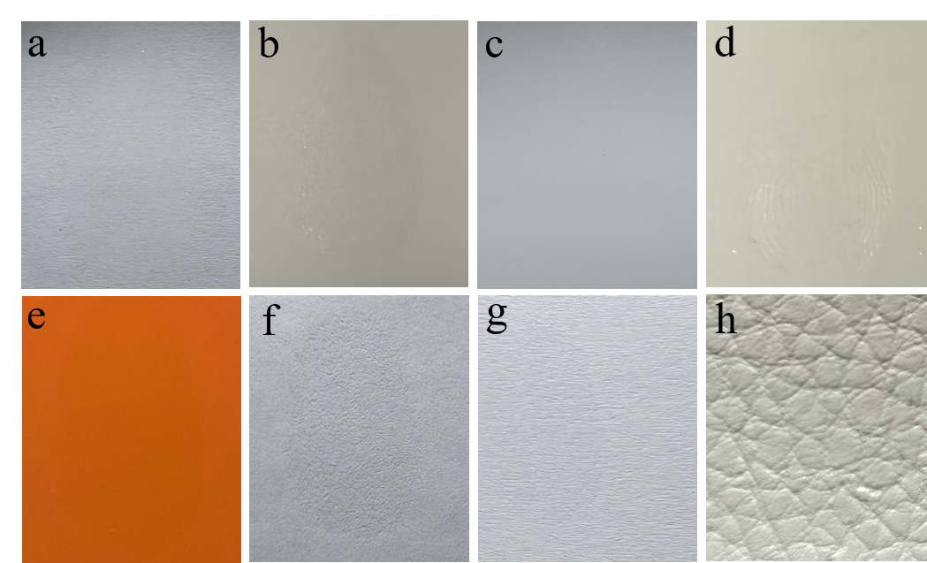
Fig. S1 (a-h) Latent fingerprints were collected on various substrates (a: glass slide, b: stainless steel, c: PVC sheet, d: ceramic cup, e: red plastic lid, f: weighing paper, g: typing paper, h: leather).
Fig. S2 Partial latent blood fingerprints on glass slides were developed using pure MXene powders (left) and MXene@PDA nanocomposite powders (right), respectively, and then imaged under white light.

Fig. S3 Latent blood fingerprint was collected on glass slide.

