A Rat Model of Ascending Uncomplicated Urinary Tract Infection for Anti-Infective Efficacy Studies
Songmin Yu¹, Sohinee Sarkar^{1, 2 #}

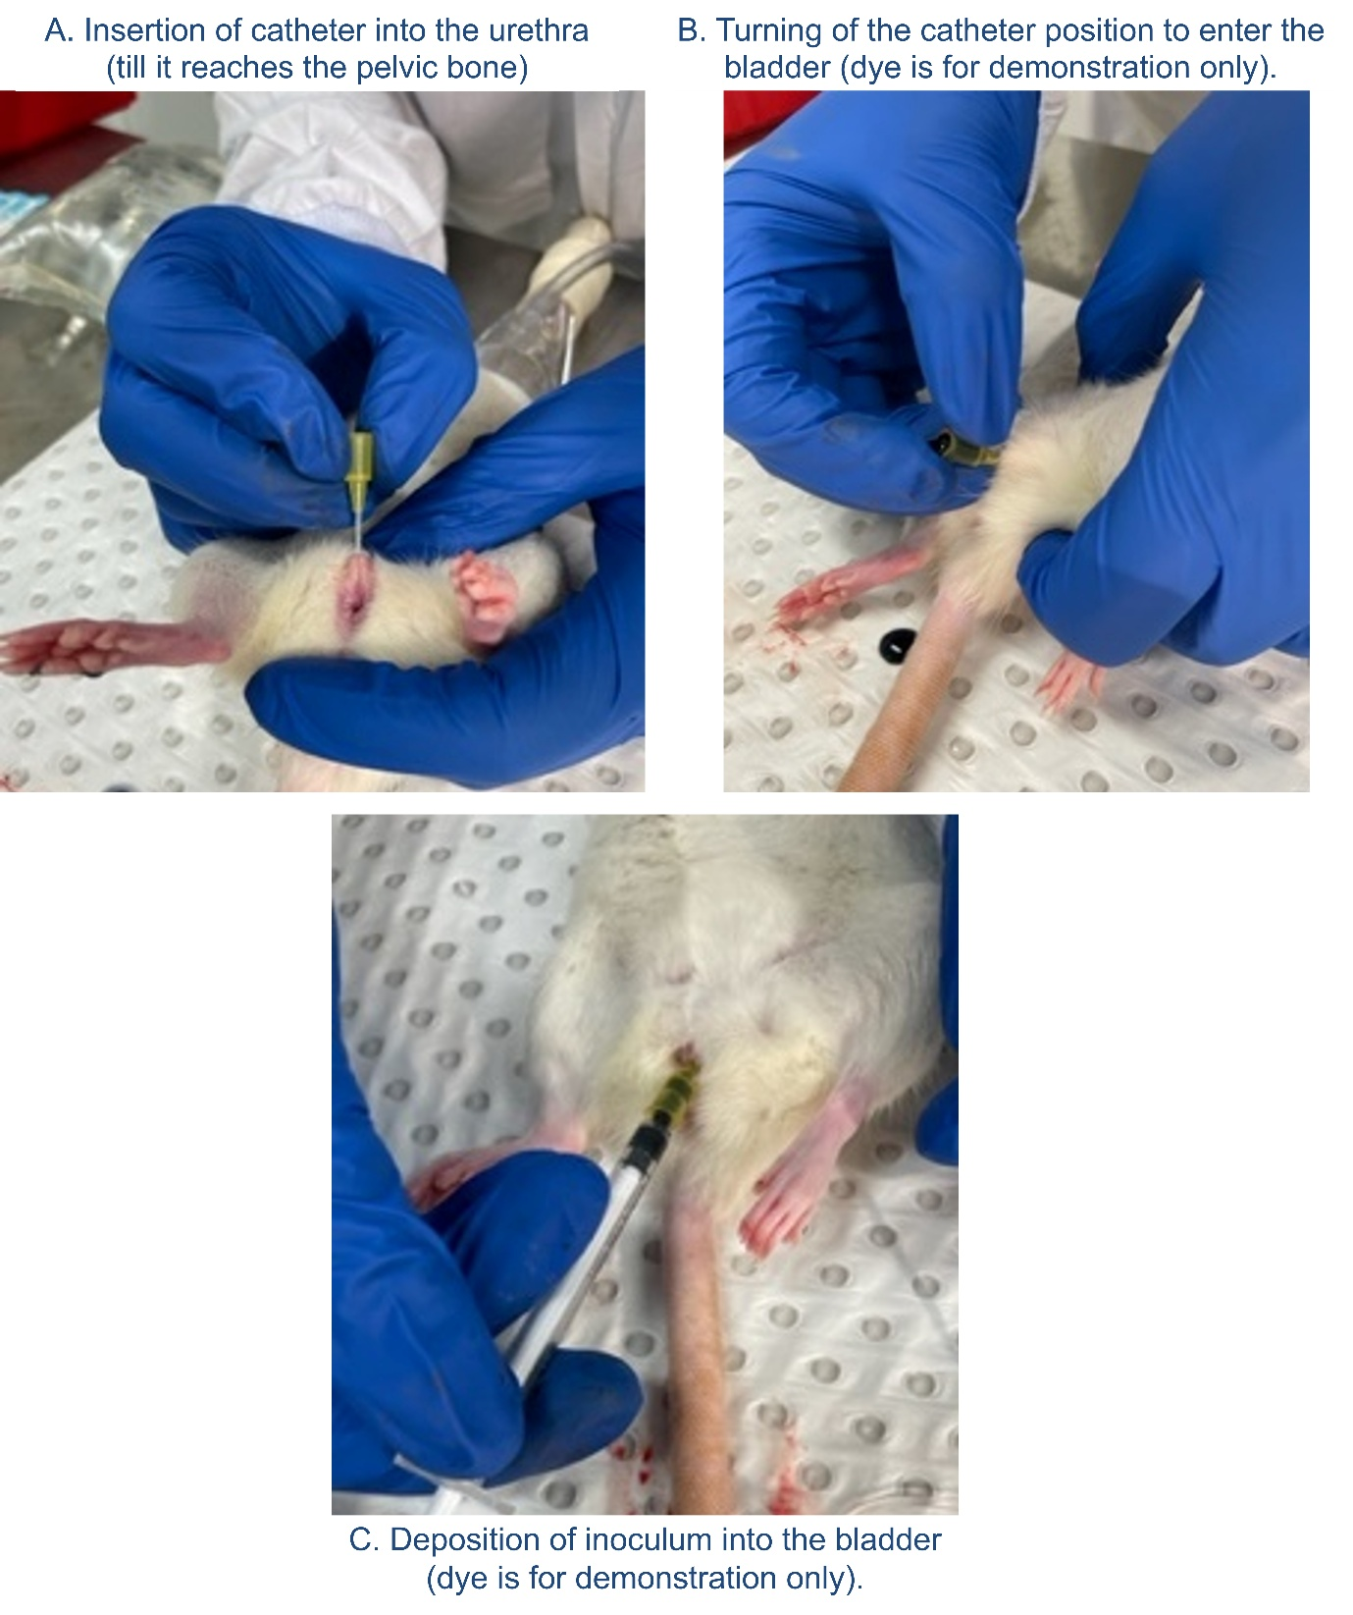
Figure S1: Example images of transurethral catheterization of Wistar female rat bladders. Adult rats are placed under isoflurane anesthesia. A) After local disinfection and application of lidocaine jelly, the lubricated catheter tip is inserted at a 45° angle. B) Once at the pelvic bone, the catheter position is turned till it is perpendicular to the abdomen, at which point it slides in (without any resistance) into the bladder. C) The catheter (with syringe attached for experimental inoculations), is then lowered on the opposite side and the plunger pressed gently to deposit the inoculum (or treatments) over 30-60 sec, directly into the bladder to avoid triggering any vesico-ureteral reflux (VUR).
Figure S2: Multiplex cytokine analysis of bladder homogenates. Levels of additional UTI-relevant bladder cytokines (as labelled) at 28hpi, normalized to total protein content in samples. Rat sera from age-matched infection-naïve animals are included as baseline controls. The samples included are from at least two separate experimental repeats. Each marker represents an individual animal. Bars show group means with standard errors. No significant differences were observed between the experimental groups (Mann-Whitney tests).
Figure S3: Multiplex cytokine analysis of bladder homogenates. Levels of additional UTI-relevant bladder cytokines (as labelled) at 28hpi, normalized to total protein content in samples. Rat sera from age-matched infection-naïve animals are included as baseline controls. The samples included are from at least two separate experimental repeats. Each marker represents an individual animal. Bars show group means with standard errors. No significant differences were observed between the experimental groups (Mann-Whitney tests).

