Targeting HMGB1 Conformation with a Novel Antagonist: An Innovative Therapeutic Strategy to Inhibit HMGB1-Initiated Neuroinflammation in Epilepsy
Liaoxi Tan^{1†}, Xuewa Jiang^{1†}, Junyi Ye¹, Weihang Yao¹, Pingping Shen⁴, Haixia Ge^{3**}, Jian Zhang^{1,2*}.
1, Department of Traditional Chinese Medicine Resources, China Pharmaceutical University, Nanjing 211198, China
2, Xizang University of Tibetan Medicine, Lhasa, 850000, China
3, School of Life Sciences, Huzhou Normal University, Huzhou 313000, China
4, School of Chemical Engineering, Xuzhou College of Industrial Technology, Xuzhou 221140, China
Content
Figure S1. Inhibitory Effects of Synthetic THPBs on HMGB1/LPS-Stimulated TNF-α Release in BV2 Cells--------------------------------------------------------------------------------------------------------------Page 2
Figure S2. Background of WB bands.-------------------------------------------------------------------Page 3-4

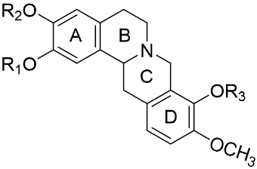
Fig. S1. Inhibitory Effects of Synthetic THPBs on HMGB1/LPS-Stimulated TNF-α Release in BV2 Cells.
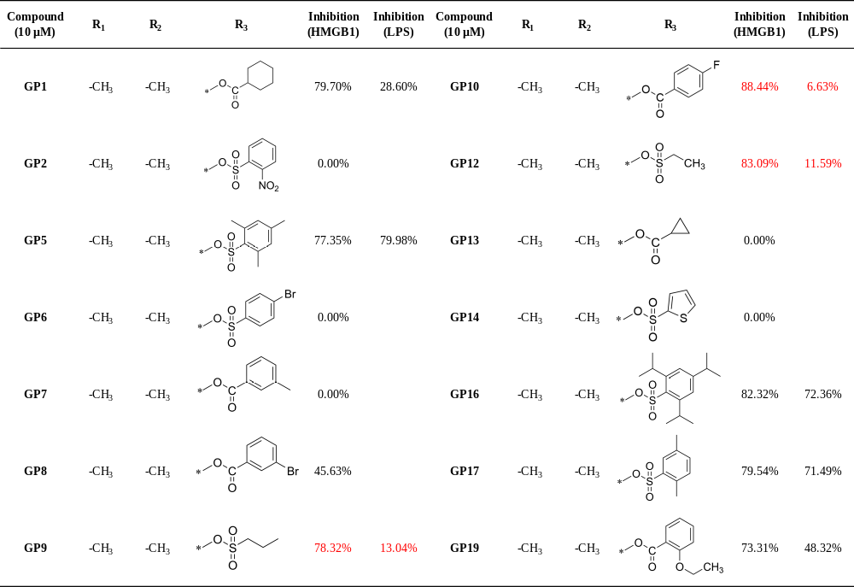
Table. S1 Structures of GPs and their inhibitory effects on HMGB1/LPS-induced TNF-α secretion in BV2 cells
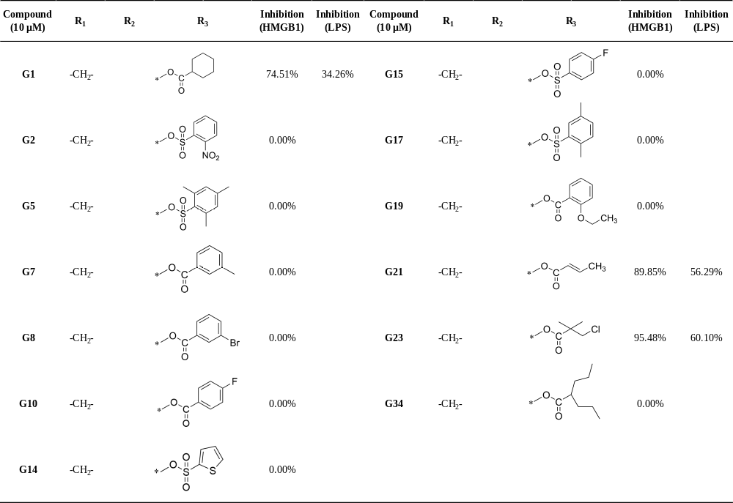
Table. S2 Structures of Gs and their inhibitory effects on HMGB1/LPS-induced TNF-α secretion in BV2 cells
Fig. S2. Background of WB bands.
Fig. 3a
Fig. 3f

Fig. 7f

