Appendix to: Rapid direct laser writing of microoptical components on a meltable biocompatible gel

- Dynamics of microlens fabrication - a theoretical model
Absorbed energy of the laser radiation is used both for material heating and its bleaching. This means that material can be locally melted only before it is completely bleached by the laser, when there is not enough absorption to heat it above the melting temperature. Here we briefly describe the dynamics of this process.
We should note that the absorption coefficient is not constant due to the bleaching of the sensitizer. We will assume that the absorption coefficient  decreases in proportion to the absorbed energy E_{abs} in a volume defined by the material thickness l and the laser beam cross-section S:
$E_{abs}=(α∙{l)∙(I}_{0}∙S)∙t$ (1)
where I₀ is laser radiation power density and t is a duration of irradiation. We may thus write that the differential change of coefficient of absorption d is proportional to total absorbed energy dE_{abs}:
$dα=-K∙dE_{abs}= -K∙α{∙I}_{0}∙S∙l∙dt$ (2)
where K is a proportionality constant defined by the properties of a sensitizer. This is a simple differential equation:
$\frac{dα}{α}=-A∙dt$ where $A= K∙I_{0}∙S∙l$ (3)
whose solution is:
$α=α_{0}exp⁡(-A∙t)$ (4)
where ₀ is initial value of the coefficient of absorption (before irradiation). However, there is a time independent component due to the intrinsic absorption of the base material, i.e.
$α=α_{0}(1+\exp\left(-A∙t\right))$ (5)
The whole process of laser induced material heating can be described by taking into account the absorbed energy E_{abs} (as in Eq. (1)) due to the irradiation and its loss E_{loss} due to conduction. We will assume that the heat is conducted only inside the material because the conductivity of air above the layer and substrate below is much lower. Also, radiative losses are small due to temperatures of the whole process are 30 -50 C above the room temperature. Thus:
$E_{loss}=β∙S_{0}∙\frac{dT}{dr}dt$ (6)
where  is a coefficient of conduction, S₀ cylindrical surface area through which thermal energy is conducted and T is a temperature difference. Heat is conducted in radial direction (see Fig. 1A) and we will assume that after distance r from the center of the laser beam, material is at constant temperature T₀. Thus:
$E_{loss}=β∙S_{0}∙\frac{T-T_{0}}{Δr}dt$ (7)
Difference between absorbed and conducted thermal energy is used to heat the material, i.e.:
$E_{abs}-E_{loss}=m∙c∙dT$ (8)
where m is a mass of laser irradiated material and c is a specific heat. We may write the previous equation in a differential form as:
$α∙{l∙I}_{0}∙S∙dt-$ $β∙S_{0}∙\frac{T-T_{0}}{Δr}dt= m∙c∙dT$ (9)
or:
$α_{0}exp⁡(-A∙t) ∙{l∙I}_{0}∙S∙dt-β∙S_{0}∙\frac{T-T_{0}}{Δr}dt= m∙c∙dT$ (10)
Or in a slightly shortened form:
$B\exp\left(-A∙t\right)-C∙T+D= \frac{dT}{dt}$ (11)
$B=\frac{α_{0}∙{l∙I}_{0}∙S}{mc}$ (12)
$C=\frac{β∙S_{0}}{mcΔr}$ (13)
$D=\frac{β∙S_{0}∙T_{0}}{mcΔr}+\frac{lI_{0}S}{mc}$ (14)
We will search for the solution of the following type:
$T=L∙exp\left(-At\right)+M∙exp\left(Nt\right)+Q$ (15)
By putting (15) into (11) we get:
$B\exp\left(-A∙t\right)-C∙\left(L∙exp\left(-At\right)+M∙exp\left(Nt\right)+Q\right)+D= -AL∙exp\left(-At\right)+NM∙exp\left(Nt\right)$ (16)
and after rearranging:
$\left(B-CL+AL\right)\exp\left(-A∙t\right)-M(C+N)∙exp\left(Nt\right)-CQ+D= 0$ (17)
The above equation can be fulfilled only if:
$B-CL+AL=0$ (18)
$C+N=0$ (19)
$-CQ+D=0$ (20)
Initial condition T = T₀ for t = 0 gives (using Eq. 15) additional equation:
$T_{0}=L+M+Q$ (21)
From (18) – (21), we can find parameters L, M, N and Q:
$L=\frac{B}{C-A}$ (22)
$N=-C$ (23)
$Q=\frac{D}{C}=T_{0}+\frac{A}{Kmc}$ (24)
$M=T_{0}-L-Q=-\frac{B}{C-A}-\frac{A}{Kmc}$ (25)
Finally, by putting (22) – (25) into (15), we find the equation which describes temperature as a function of time:
$T=T_{0}+\frac{A}{Kmc}+\frac{B}{C-A}∙exp\left(-At\right)-(\frac{B}{C-A}+\frac{A}{Kmc})exp\left(-Ct\right)$ (26)
_{Δr}
T
air
Meltable hydrogel
Glass
Laser heated zone
Heat conduction

Fig. A1: Laser heating of tothema thin layer
- Through focus imaging
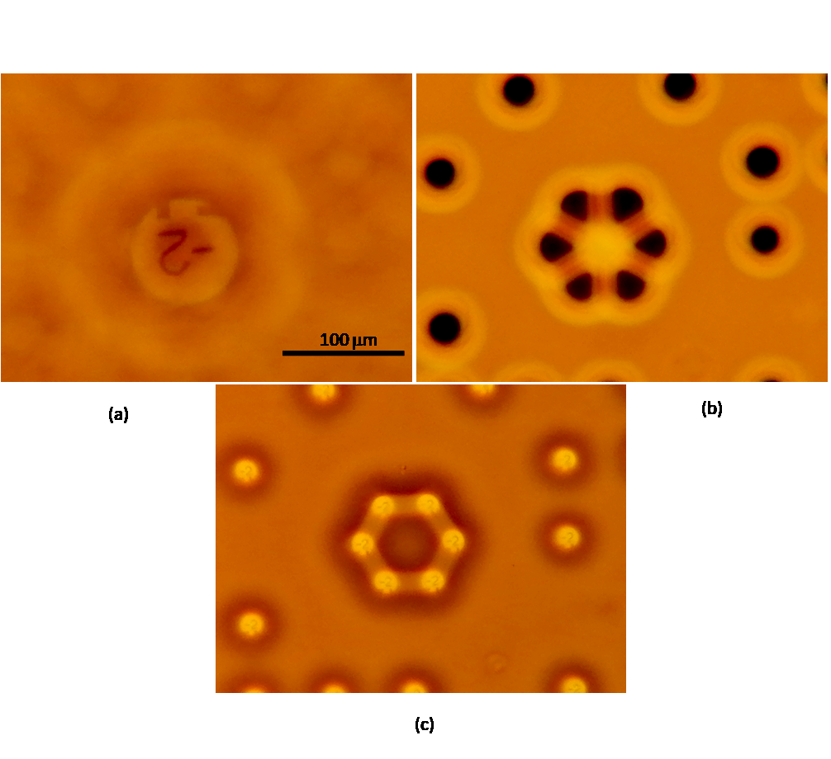
Individual microlenses and their arrays produce variable patterns when observed at different focal positions. Fig. A2 shows a specific arrangement of laser melted dips which are designed so to produce one positive microlens in the central part (see image of number -2 in the center of Fig. A2(a)). By changing the focal position, dips become visible as dark spots (Fig. 2(b)). If we go further through the focus, dips start acting as negative microlenses producing upright image of the number -2 (Fig.2 (c)). Through-focus Images produce patterns which strongly depend on laser-induced dips position, depth and size. These patterns may contain additional information encoded by the position, size and focal length of dips, and serve as a hard to copy security component.

Figure A2: Several consecutive focal positions of a microlens-based QR-code. As can be seen, a pattern is changeable, revealing a positive microlens, individual laser pits and negative lenses.

