Supplementary Information

Viral Lysis and Attenuated Microbial Degradation Synergistically Turn Eutrophic Reservoirs into Emerging RDOC Hotspots

Junhai Wu^{1, 3}, Jingfu Wang^{1, 2, 6*}, Yufeng Xiao^{1, 2}, Qiusheng Wu¹ , Qinglong Fu⁴, Qiuhua Li⁵, Xujiang Yu⁵, Yun He^{1, 2}, Jingan Chen^{1, 2}

¹ State Key Laboratory of Environmental Geochemistry, Institute of Geochemistry, Chinese Academy of Sciences, Guiyang, 550081, PR China.
² University of Chinese Academy of Sciences, Beijing, 100049, PR China.
³ School of Resources and Environmental Engineering, Guizhou University, Guiyang, 550025, PR China.
⁴ School of Environment, China University of Geosciences (Wuhan), Wuhan, 430074, PR China.
⁵ Guizhou Advanced Computing Provincial Key Laboratory, Guizhou Normal University, 550025, PR China.
⁶ Guizhou Province Field Scientific Observation and Research Station of Hongfeng Lake Reservoir Ecosystem, Guiyang, 551499, PR China

* Corresponding author: Prof. Jingfu Wang, wangjingfu@vip.skleg.cn
Appendix S1 TSI method
DOC concentration was measured using a total organic carbon analyzer (Elementar high TOC II). The samples were adjusted to pH 7.0 using 6 mol/L hydrochloric acid and sodium hydroxide solutions. Total nitrogen (TN) content in water samples was determined by alkaline potassium persulfate digestion–UV spectrophotometry (UV1200, China) according to the "National Environmental Protection Standard of the People's Republic of China" (HJ 636-2012). Total phosphorus (TP) content was determined by ammonium molybdate spectrophotometry (UV1200, China) according to the "National Standard of the People's Republic of China" (GB 11893-1989). Chlorophyll-a (Chla) was extracted with 90% ethanol and measured spectrophotometrically at 750 and 665 nm, with correction for Chla according to Jespersen and Christoffersen ¹. COD_{Mn} was measured by the colorimetric method specified in GB 11892-89. All measurements were performed in triplicate, and each analytical batch included procedural blanks and calibration standards.
The trophic state index (TSI) for each sample was calculated as a weighted average according to the formulas in the "Technical Regulations for Lake (Reservoir) Eutrophication Assessment and Classification" issued by the China National Environmental Monitoring Centre:
TSI (Chl-a) = 10 × (2.5 + 1.086 × ln(Chl-a)) (1)
TSI (TP) = 10 × (9.436 + 1.624 × ln(TP)) (2)
TSI (TN) = 10 × (5.453 + 1.694 × ln(TN)) (3)
TSI (SDD) = 10 × (5.118 - 1.94 × ln(SDD)) (4)
TSI (COD) = 10 × (0.109 + 2.66 × ln(COD)) (5)
TSI = Σ(W_{i} × TSI_{i}) (6)
where TSI(TN), TSI(TP), TSI(Chla), TSI(COD_{Mn}), and TSI(SDD) are the trophic state indices associated with TN, TP, Chla, COD_{Mn}, and SDD, respectively, and W represents the weight of each trophic state indicator. The units of TN, TP, Chla, COD_{Mn}, and SDD are mg/L, mg/L, µg/L, mg/L (determined by potassium permanganate method), and m, respectively. The weights for Chl-a, TP, TN, SDD, and COD_{Mn} are 0.2663, 0.1879, 0.1790, 0.1834, and 0.1834, respectively.

Appendix S2 Three-dimensional fluorescence spectroscopy
Filtered samples were stored in the dark at 4°C prior to measurement. Samples were placed in a 10-mm quartz cuvette and measured using an Aqualog fluorescence spectrophotometer (HORIBA, Japan) with ultrapure water as a blank. The scan speed was 1200 nm min⁻¹, and the photomultiplier tube voltage was 700 V. The excitation (Ex) wavelength ranged from 240 to 450 nm at 2-nm intervals, and the emission (Em) wavelength ranged from 300 to 600 nm at 5-nm intervals. Each sample was measured in triplicate. Parallel factor analysis (PARAFAC) was performed using the DOMFluor toolbox in MATLAB ². The HORIBA program automatically subtracted the blank and removed Rayleigh and Raman scattering. Non-negativity constraints were applied in the PARAFAC model to avoid negative values in the three identified components (i.e., excitation loadings, emission loadings, and concentration scores (fluorescence intensities) for each sample).
The Biological Index (BIX) is an indicator used to assess the freshness or recent biological activity contribution of dissolved organic matter (DOM). It is calculated as the ratio of fluorescence intensity at emission wavelength (Em) 380 nm to that at 430 nm with excitation wavelength (Ex) 310 nm. The general thresholds for BIX are as follows: BIX < 0.6 indicates that DOM has limited recent autochthonous characteristics; 0.6 < BIX < 1.0 indicates a moderate degree of recent autochthonous characteristics; and BIX > 1.0 indicates that DOM is predominantly composed of freshly produced microbial sources.
The Fluorescence Index (FI) is defined as the ratio of fluorescence intensity at emission 470 nm to that at 520 nm with excitation at 370 nm. This index is used to indicate the source of humic-like components in DOM. When FI < 1.2, DOM is mainly derived from allochthonous inputs, such as terrestrial organic matter or soil organic matter. When FI > 1.8, DOM is mainly derived from autochthonous processes, such as microbial degradation. When FI is between 1.2 and 1.8, DOM exhibits mixed allochthonous and autochthonous characteristics.
The Humification Index (HIX) is defined as the ratio of the integrated fluorescence intensity in the emission region of 435–480 nm to that in the combined region of 300–345 nm and 435–480 nm at excitation 254 nm. This index is used to characterize the degree of humification of DOM; higher HIX values indicate a greater proportion of complex, recalcitrant humic-like components and a longer residence time of organic matter in the environment ^{3, 4}.

Appendix S3 FT-ICR MS analysis
The solid-phase extraction (SPE) procedure was as follows: PPL cartridges were first rinsed with 200 mL methanol, then sequentially rinsed with 20 mL formic acid-acidified ultrapure water and 20 mL ultrapure water. A 500-mL water sample acidified with formic acid (pH = 2) was passed through the PPL cartridge for extraction. After the entire water sample had passed through the PPL cartridge, the cartridge was rinsed successively with 20 mL formic acid-acidified ultrapure water and 20 mL ultrapure water, and then completely dried with ultrapure nitrogen gas ⁵ Finally, the sample was eluted with 5 mL methanol. The eluate was stored in acid-washed and combusted glass vials at –18°C in the dark until subsequent FT-ICR MS analysis.
After SPE, the eluates were transported to the Hubei Key Laboratory of Environmental Water Science in the Yangtze River Basin, China University of Geosciences (Wuhan), for analysis at 4°C in the dark. DOM was analyzed using a Bruker apex-ultra Fourier transform ion cyclotron resonance mass spectrometer (Bruker FT-ICR MS) equipped with a 7.0 T superconducting magnet and coupled with an electrospray ionization (ESI) source in negative-ion mode, and calibrated with Suwannee River humic acid standard. Samples were continuously infused into the ESI source using a syringe pump at a flow rate of 150 μL h⁻¹. The capillary voltage and spray shield voltage were set at 4,000 V and –500 V, respectively. The drying gas flow rate was 5 L min⁻¹, and the source was operated at 200°C. The mass range was set to m/z 200–1,000. A total of 256 scan transient signals were accumulated to improve the signal-to-noise ratio and dynamic range, with a transient acquisition point number of 4M. After mass spectrometric data acquisition, internal calibration was performed using DataAnalysis 5.0, with a mass error of less than 0.5 ppm. Peak intensities of each molecular formula were normalized using ICBM-OCEAN, and DOM molecular formulas were assigned with elemental composition constraints of ¹²C₁₋₅₀, ¹H₁₋₁₀₀, ¹⁶O₁₋₅₀, ¹⁴N₀₋₃, ³²S₀₋₂, and ³¹P₀₋₁. Isotopic isomers were not considered in this study. The relative abundance of each DOM chemical component was calculated using the following formula:
(1)
where Xi (%) represents the relative abundance of a specific chemical component in dissolved organic matter, Ai denotes the sum of peak intensities for a particular chemical component, and As is the total sum of peak intensities for all chemical components in the sample.
The modified aromaticity index (AImod), nominal oxidation state of carbon (NOSC), and double bond equivalent (DBE) for each molecular formula were calculated using the following formulas:
(1)
(2)
(3)
where C, H, O, N, S, and P represent the stoichiometric numbers of carbon, hydrogen, oxygen, nitrogen, sulfur, and phosphorus atoms in each molecule, respectively. Intensity-weighted average values were used to obtain the above three parameters for each sample. The molecular lability boundary index (MLB_L) was calculated as the total intensity of molecular formulae with a H/C ratio greater than 1.5 divided by the total intensity of all molecular formulae. When H/C < 1.5, the dissolved organic matter components exhibit more recalcitrant characteristics.

Appendix S4 Metagenomic sequencing and sequence processing
Total DNA extracted from water samples was subjected to metagenomic sequencing on an Illumina NovaSeq platform(Guangdong Magigene Biotechnology Co.，Ltd. Guangzhou，China). Raw reads were processed using fastp v0.23.4 to obtain clean data ⁶. The clean reads were assembled into contigs with MEGAHIT v1.2.9 ⁷. Open reading frames (ORFs) were predicted using Prodigal with the -meta option ⁸. To construct a non-redundant gene catalog, ORFs were dereplicated across all samples using MMseqs2 with the parameters --min-seq-id 0.95 -c 0.9 --cov-mode 1 --cluster-mode 2 ⁹. Clean reads were aligned to the non-redundant gene catalog using BWA v0.7.18 ¹⁰, and the resulting alignments were processed with SAMtools v1.20 ¹¹ to generate ORF abundances. To correct for gene length and sequencing depth biases, abundance was normalized as transcripts per kilobase per million mapped reads (TPM). DOM degradation genes were identified by HMMER against the CAZy database (Table S8)., while carbon fixation genes were identified and quantified by KofamKOALA against the KEGG database ¹². Taxonomic assignment of the non-redundant gene catalog was conducted with Kraken2 ¹³ against the RefSeq database.

Appendix S5 Viral contig identification and abundance calculation
Contigs shorter than 2,000 bp were removed with SeqKit v2.6.1 ¹⁴. The remaining sequences were processed to identify viral information as follows: potential viral sequences were initially identified using geNomad v1.8.1, VirSorter2 v2.2.4, VirFinder v1.1 (P < 0.05), and CheckV v1.0.3 ^{15, 16, 17}. The retention criteria for contigs were as follows (i) : Contigs with “virus gene num ≥ 1” identified by CheckV were retained. (ii) : When “virus gene num == 0”, a contig was retained as a viral contig if it met any of the following conditions:(1) Any one of the following four criteria was satisfied: VirSorter2_score ≥ 0.95, geNomad_score ≥ 0.95, geNomad_n_hallmark ≥ 2, or VirSorter2_n_hallmarks ≥ 2. (2) When “host gene == 0”, a contig was retained if it was labeled as a viral contig by either geNomad or VirSorter2. (3) When “host gene == 0”, a contig with virus gene ≥ 2 was retained. The resulting set of viral contigs was then dereplicated at the species level to obtain non-redundant viral operational taxonomic units (vOTUs) using parameters of 95% average nucleotide identity (ANI) and 85% aligned fraction (AF) ¹⁸. Taxonomic assignments of vOTUs were performed with geNomad. Abundances of vOTUs were calculated using the contig module of CoverM ¹⁹.

Appendix S6 Viral host prediction and life‑cycle inference
Host prediction for the vOTUs was then performed using PHIST v1.2.1 against the GTDB, a tool known to provide a favorable balance of performance and accuracy for environmental metagenomic datasets ^{20, 21}. The life strategy (virulent vs temperate) of each vOTU was predicted with PhaTYP ²² and ProkBERT PhaStyle ²³. Specifically, vOTUs for which PhaTYP could not predict a lifestyle were subsequently analyzed using ProkBERT PhaStyle. To reduce false positives, sequences with a difference between the temperate score and the virulent score of less than 0.3 in the output were labeled as “Unpredicted”.

Appendix S7 Global estimation of DOC and RDOC storage in reservoirs
The global estimation of DOC and RDOC storage in reservoirs was based on reservoir storage capacity and DOC concentration data. Storage capacity data were obtained from the Global Dam Watch (GDW) v1.0 database (Scientific Data, 2024), which integrates 41,145 dam sites and 35,295 associated reservoir polygons worldwide, with a total cumulative storage capacity of 7,420 km³ ²⁴. In this study, reservoirs with valid storage capacity records in the GDW v1.0 database were summed, yielding a total storage capacity of approximately 6,403 km³. The average DOC concentration was set at 5.0 mg/L, derived from a systematic survey of 144 reservoirs in China by Song et al. (5.0 ± 4.5 mg/L), which represents the largest field-measured dataset of reservoir DOC concentrations globally to date; the volume-weighted mean DOC concentration of global lakes predicted by Toming et al. using machine learning models was 3.88 mg/L, which is of the same order of magnitude as 5.0 mg/L and indirectly supports the reasonableness of this value ^{25, 26}. The proportion of RDOC was set at 50%–70%, based on the CRAMs relative abundance data measured in this study (Table S5). Accordingly, the global reservoir DOC storage was estimated to be approximately 32 Tg C, and the RDOC storage approximately 16–22 Tg C. Major uncertainties include: (1) the GDW database does not fully cover numerous small reservoirs worldwide, potentially leading to an underestimation of total storage capacity; (2) the 5.0 mg/L value originates from Chinese reservoirs, and its global representativeness is limited. These factors all suggest that the storage estimates are likely conservative rather than overestimated.
The estimation of global autochthonous RDOC production in lakes and reservoirs was calculated as the product of global lake and reservoir net primary production (NPP) and the microbial carbon pump (MCP) conversion efficiency. Global lake and reservoir NPP was adopted as 1.0–1.3 Pg C·yr^{-1 27, 28}, and MCP conversion efficiency was adopted as 0.3%–0.4% ^{29, 30}. Based on these values, the global autochthonous RDOC production in lakes and reservoirs was estimated to be approximately 3.0–5.2 Tg C·yr⁻¹. Major uncertainties include: (1) the NPP data represent an integrated estimate for lakes and reservoirs as a whole, and no global reservoir-specific NPP dataset is currently available; (2) the MCP conversion efficiency is based on limited observations, and its spatiotemporal variability has not been fully constrained; (3) this estimate only accounts for the conversion of autochthonous primary production by the MCP, and does not include the conversion of allochthonous DOC within reservoirs or the direct release of RDOC by algae; (4) RDOC proportion was determined based on the relative abundance of CRAMs measured by FT-ICR MS. However, this approach has the following limitations: 1) solid-phase extraction typically recovers only 40%–70% of bulk DOM, with extraction efficiencies varying among different compound classes, and FT-ICR MS can only detect a subset of the extracted molecular pool; 2) electrospray ionization exhibits preferential ionization for certain compound classes, so these factors collectively may introduce systematic bias into the RDOC proportion estimate, suggesting that the actual RDOC storage could deviate from the current range. All the above estimates are based on the most reliable parameters currently available in the literature, and the results serve as scientifically valuable order-of-magnitude references; more precise quantification will require the establishment of a global reservoir-specific database in the future.
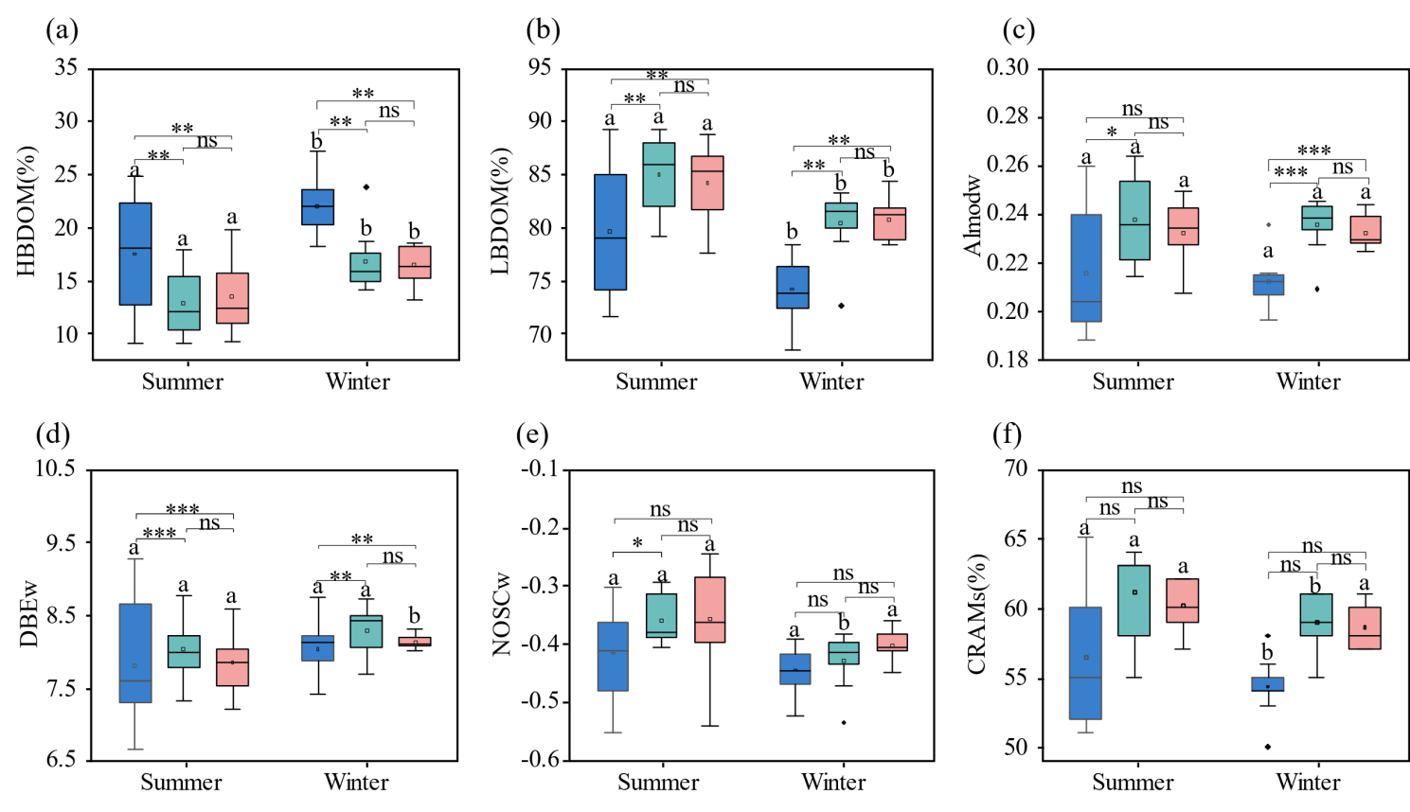
Figure S1: (a-f) Boxplots comparing the six indices across seasons (summer vs. winter) and trophic levels (oligotrophic, mesotrophic, and light eutrophic). Within the same trophic level, different lowercase letters (a, b) indicate significant differences between summer and winter (p < 0.05), whereas the same letter indicates no significant difference. Asterisks denote significant differences between trophic groups (*p < 0.05, **p < 0.01, ***p < 0.001); ns denotes not significant.
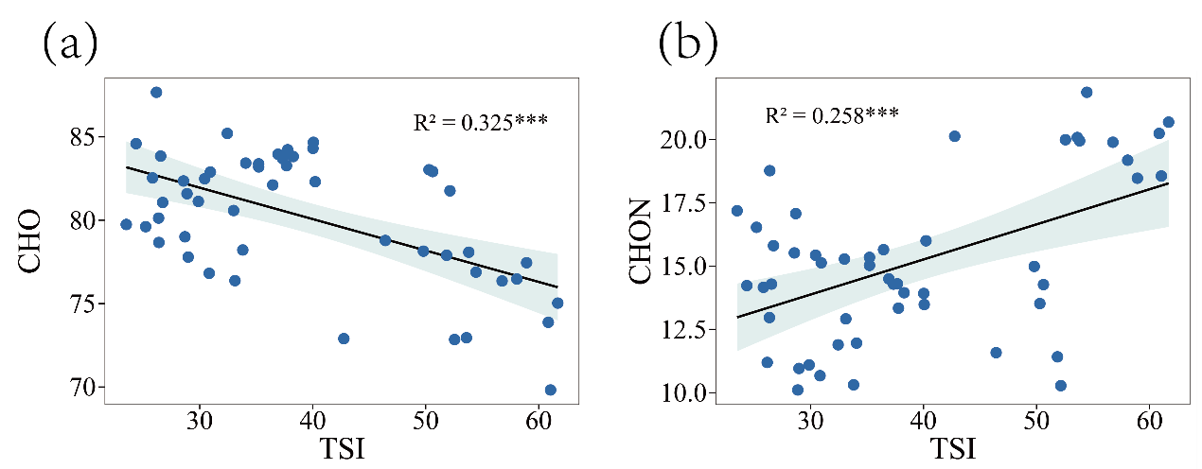
Figure S2: Linear regression analysis of DOM elemental composition (a: CHO, b: CHON) against TSI in the studied reservoirs
Figure S3: Contour plots and corresponding excitation–emission spectra of the three fluorescent components (C1, C2, and C3) identified by parallel factor analysis (PARAFAC) of three-dimensional fluorescence spectra
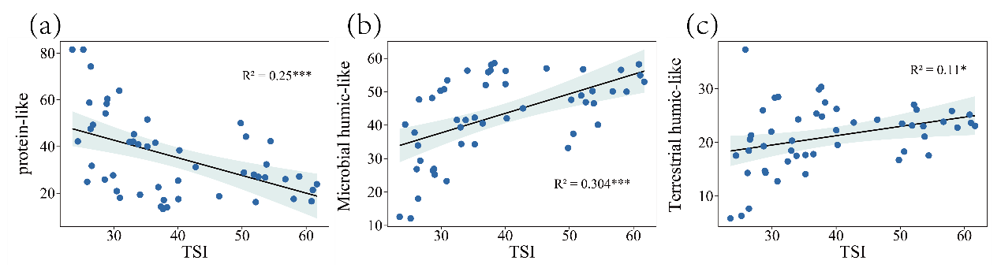
Figure S4: Linear regression analysis of the relative abundances of three fluorescent components (protein-like, microbial humic-like, terrestrial humic-like) of DOM against TSI in the studied reservoirs.
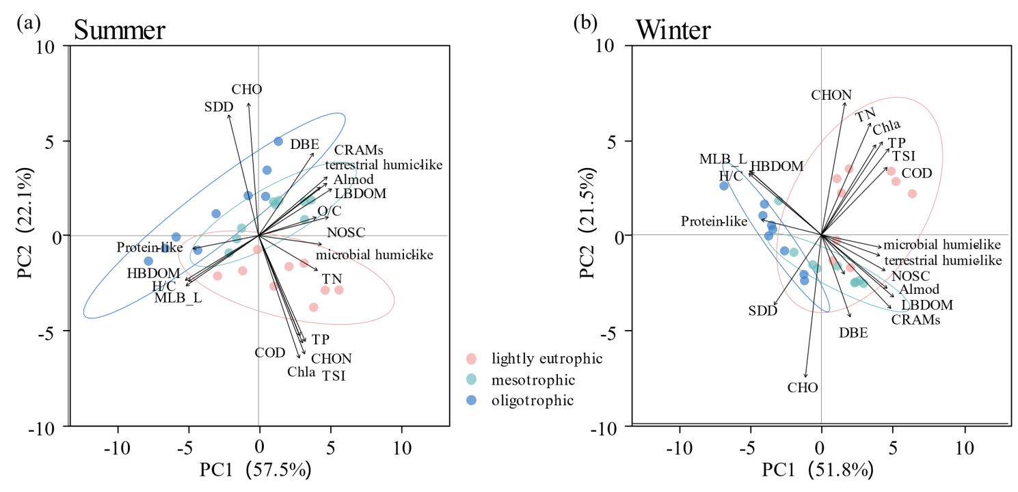
Figure S5: PCA ordination of DOM molecular characteristics and TSI parameters along the trophic gradient. Vectors indicate the loading directions and magnitudes of individual variables; dashed ellipses represent 95% confidence intervals for each trophic group.
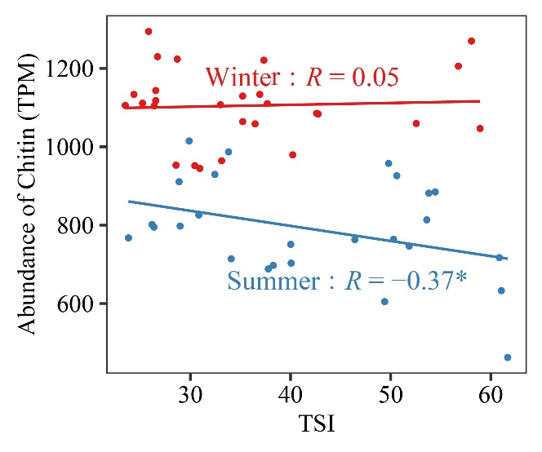
Figure S6: Relationships between the abundances of DOM degradation genes and TSI
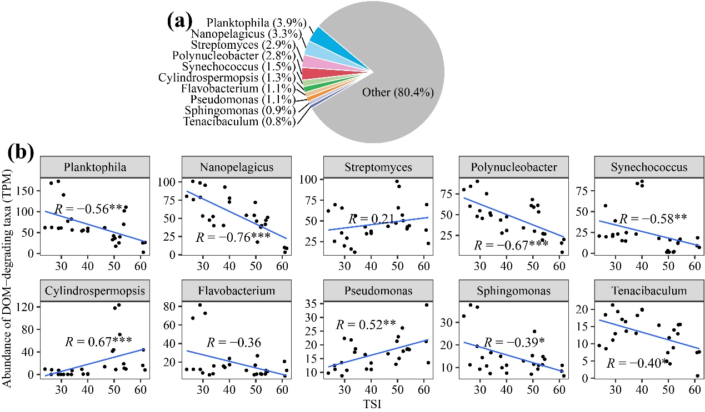
Figure S7: Relationships between the relative abundances of top 10 dominant genera hosting DOM degradation genes and TSI in summer
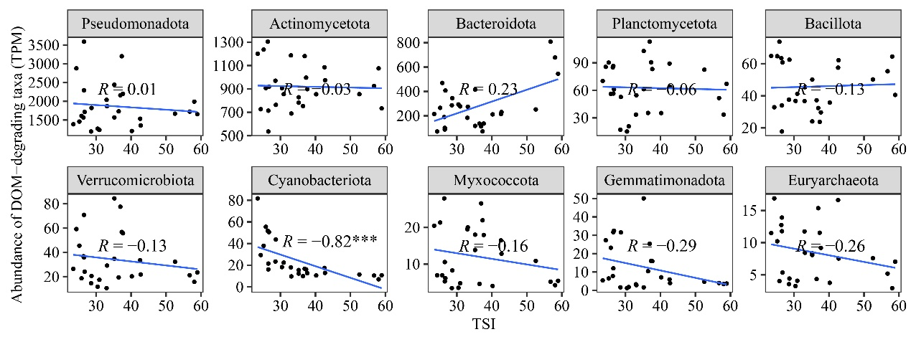
Figure S8: Relationships between the relative abundances of top 10 dominant phyla hosting DOM degradation genes and TSI in winter
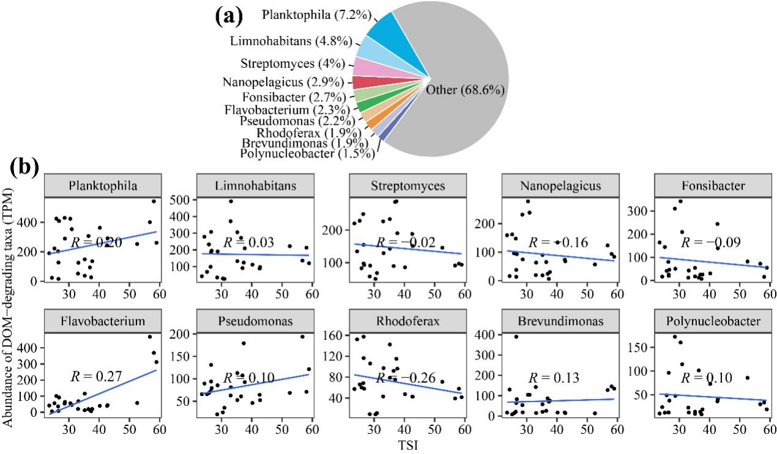
Figure S9: Relationships between the relative abundances of top 10 dominant genera hosting DOM degradation genes and TSI in winter
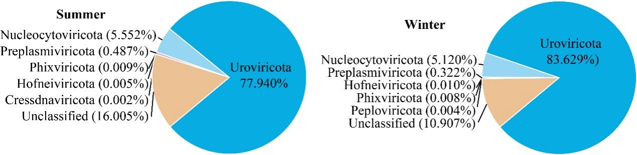
Figure S10: Taxonomic annotation results of viral communities in summer and winter

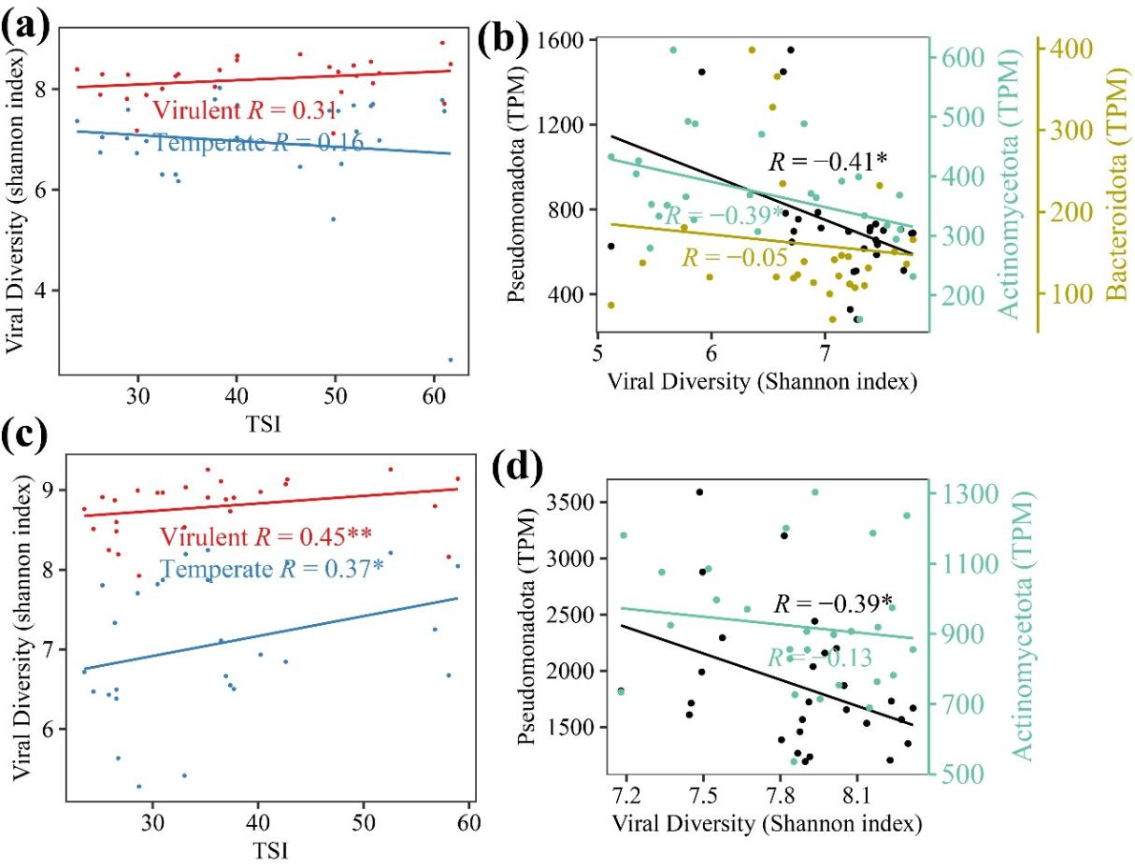
Figure S11: Relationships between viral diversity and TSI, and relationships between viruses and dominant hosts. Viral diversity vs. TSI (a: summer, c: winter). Diversity of viruses infecting dominant DOM-degrading species vs. host abundance (b: summer, d: winter)
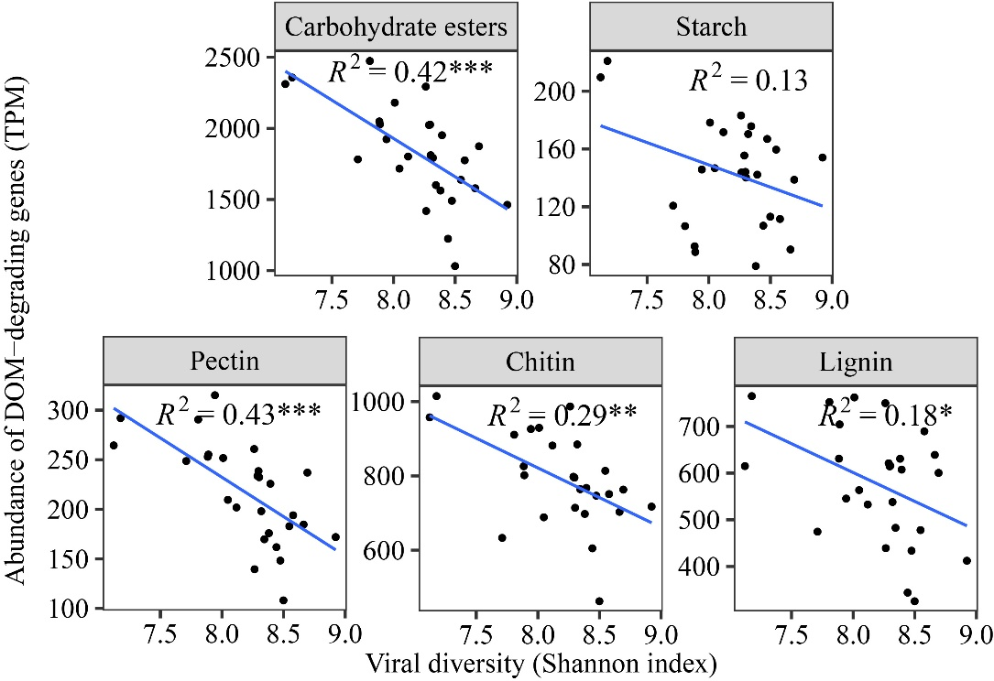
Figure S12: Relationship between lytic viral community diversity and abundances of DOM degradation genes in microbial communities in summer
Figure S13: Relationship between lytic viral abundance and abundances of DOM degradation genes in microbial communities in summer
Figure S14: Relationship between lytic viral abundance and abundances of DOM degradation genes in microbial communities in winter
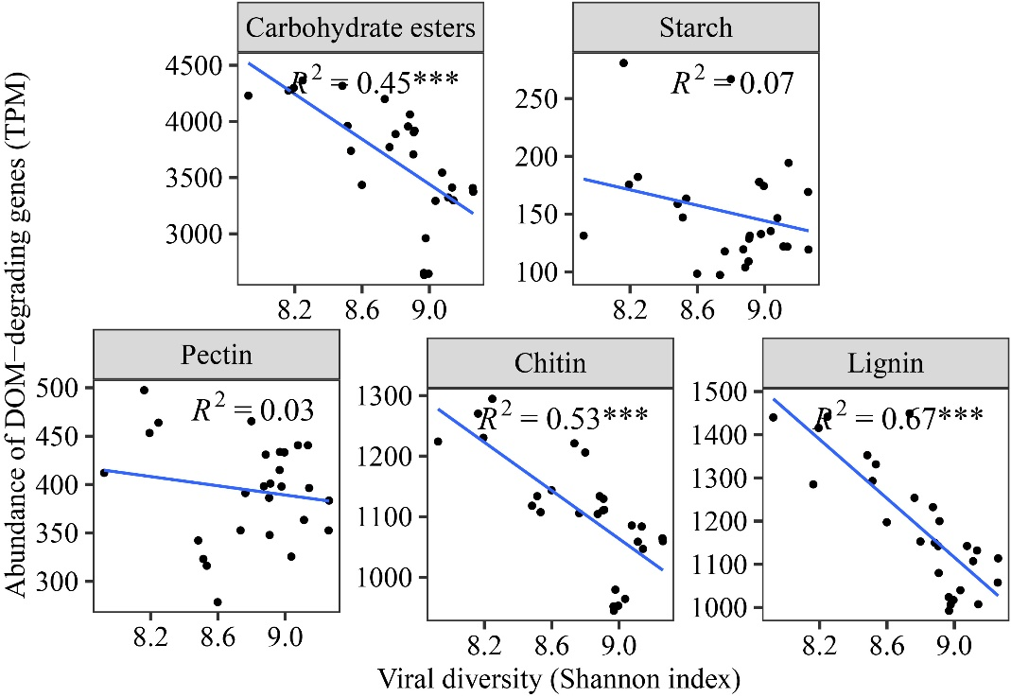
Figure S15: Relationship between lytic viral diversity and abundances of DOM degradation genes in microbial communities in winter
Figure S16: Relationship between abundances of carbon fixation genes in microbial communities and TSI.

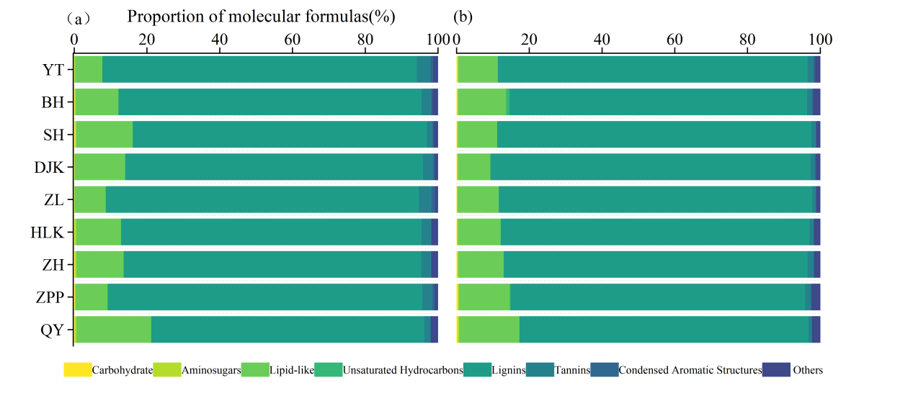
Figure S17: Relative abundance of molecular formulae belonging to seven biochemical classes of DOM in the studied reservoirs, (a) summer and (b) winter
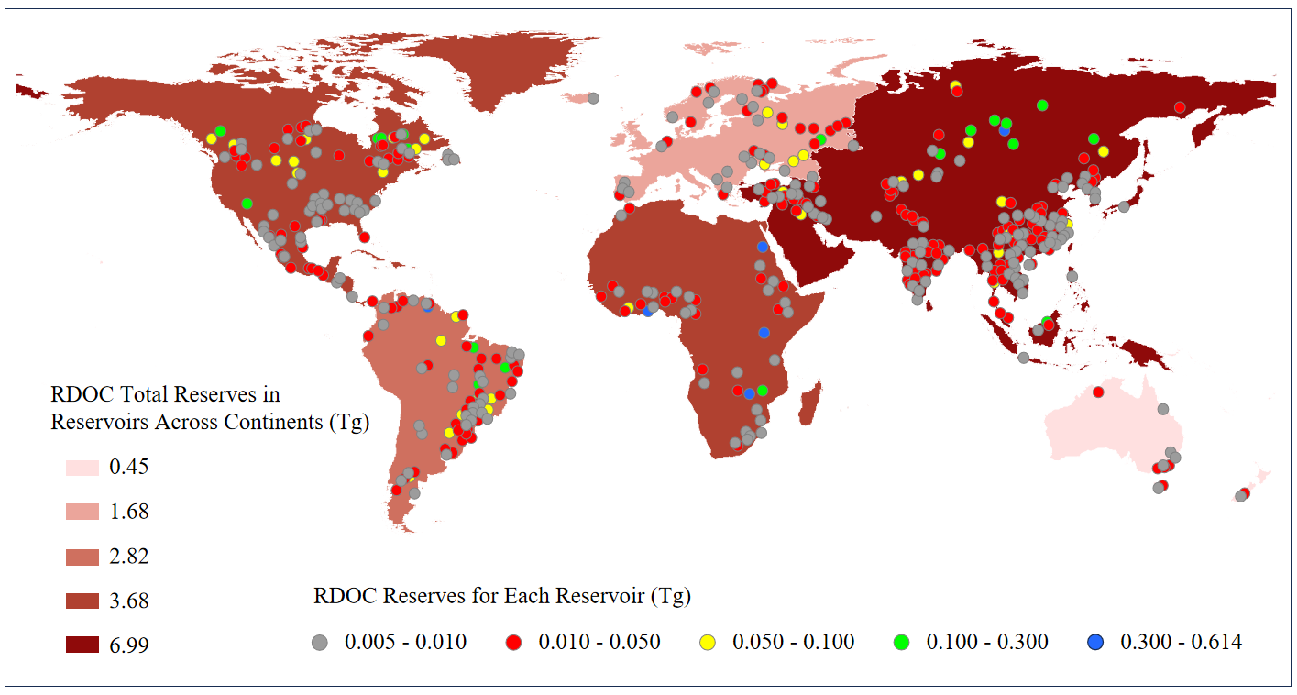
Figure S18: Estimated global reservoir RDOC storage by continent, and spatial distribution of reservoirs with estimated RDOC stocks > 0.005 Tg C.
Table S1 Location and basic information of the reservoir
Reservoir Locations | Latitude(°N) | Longitude  (°E) | Storage capacity(10⁸m³) | Reservoir age(year) | Trophic level
Qiyi(QY) | 28.83 | 118.27 | 1.15 | 65 | oligotrophic
Zipingpu(ZPP) | 31.03 | 103.56 | 11.12 | 19 | oligotrophic
Zhanghe(ZH) | 30.99 | 112.04 | 20.35 | 59 | oligotrophic
Hulukou(HLK) | 29.61 | 104.62 | 0.32 | 46 | mesotrophic
Zhelin(ZL) | 29.28 | 115.27 | 79.2 | 52 | mesotrophic
Danjiangkou(DJK) | 32.53 | 111.14 | 290.5 | 11 | mesotrophic
Shahe(SH) | 31.30 | 119.43 | 0.56 | 64 | Lightly eutrophic
Baihua(BH) | 26.67 | 106.54 | 1.1 | 59 | Lightly eutrophic
Yutan(YT) | 29.56 | 105.69 | 1.3 | 13 | Lightly eutrophic

Table S2 biochemical classes of DOM
Molecular class | Criteria
Carbohydrate | H/C:1.5-2.4; O/C:0.71-1.2
Amino sugars | H/C:1.5-2.2; O/C:0.52-0.71
Protein/Lipid-like | H/C:1.5-2.2; O/C:0-0.52
Tannins | H/C:0.5-1.5; O/C:0.67-1.2
Lignins | H/C:0.7-1.5; O/C:0.1-0.67
Unsaturated hydrocarbons | H/C:0.7-1.5; O/C:0-0.1
Condensed aromatic structures | H/C:0.2-0.7; O/C:0-0.67
Carboxyl-Rich Alicyclic Molecules(CRAMs) | DBE/C = 0.30 - 0.68; DBE/H = 0.20 - 0.95; DBE/O = 0.77 - 1.75

Table S3 The mean±SD of water chemistry parameters including total nitrogen (TN), total phosphorus (TP), chemical oxygen demand (COD_{Mn}), Chlorophyll (Chla), transparency (SDD), and trophic status index (TSI) of sampled reservoir.
Reservoir | TN(mg/L) | TP(mg/L) | COD_{Mn}(mg/L) | Chla(μg/L) | SDD(m) | TSI
QY-summer | 0.12±0.02 | 0.04±0.02 | 0.85±0.26 | 3.91±0.11 | 2.90±0.00 | 26.39±2.58
QY-winter | 0.38±0.04 | 0.02±0.01 | 1.07±0.05 | 1.52±0.09 | 3.43±0.23 | 25.04±1.45
ZPP-summer | 0.77±0.03 | 0.04±0.02 | 0.54±0.03 | 3.94±0.53 | 4.33±0.65 | 28.63±2.35
ZPP-winter | 0.87±0.04 | 0.02±0.01 | 0.80±0.07 | 2.55±0.52 | 4.20±0.44 | 27.08±1.46
ZH-summer | 0.70±0.10 | 0.04±0.02 | 1.67±0.09 | 1.22±0.18 | 3.20±1.59 | 32.04±1.99
ZH-winter | 0.25±0.03 | 0.03±0.01 | 1.44±0.00 | 1.15±0.13 | 4.26±1.89 | 25.81±1.26
HLK-summer | 1.37±0.08 | 0.11±0.01 | 2.72±0.12 | 17.18±1.94 | 1.40±0.10 | 39.43±6.34
HLK-winter | 0.41±0.06 | 0.02±0.01 | 1.80±0.08 | 2.98±0.81 | 4.77±0.21 | 29.98±1.25
ZL-summer | 0.61±0.01 | 0.04±0.02 | 1.79±0.50 | 9.97±7.25 | 1.53±0.85 | 49.94±0.62
ZL-winter | 0.68±0.17 | 0.03±0.01 | 1.60±0.08 | 2.56±0.88 | 2.46±1.01 | 33.78±1.25
DJK-summer | 1.05±0.04 | 0.06±0.02 | 2.32±0.12 | 3.84±0.14 | 2.90±0.26 | 39.45±1.01
DJK-winter | 0.84±0.09 | 0.03±0.01 | 1.95±0.05 | 3.51±0.60 | 1.93±0.12 | 37.32±0.38
SH-summer | 0.63±0.08 | 0.09±0.02 | 3.92±0.15 | 26.00±0.13 | 0.83±0.03 | 51.43±0.99
SH-winter | 0.49±0.05 | 0.03±0.01 | 2.37±0.05 | 3.94±1.65 | 1.73±0.31 | 37.30±2.60
BH-summer | 2.02±0.04 | 0.16±0.03 | 2.39±0.21 | 26.13±0.47 | 1.00±0.10 | 53.96±0.44
BH-winter | 2.83±0.17 | 0.06±0.02 | 2.21±0.09 | 8.94±6.35 | 2.01±1.13 | 45.97±5.72
YT-summer | 1.28±0.13 | 0.33±0.08 | 5.48±0.18 | 46.41±2.41 | 0.80±0.00 | 61.20±0.44
YT-winter | 2.57±0.09 | 0.11±0.02 | 4.85±0.09 | 50.93±7.58 | 1.30±0.22 | 57.92±1.09

Table S4 The average values ± standard deviations of the FT-ICR MS indicators of the sampled reservoirs
Reservoir | m/z | AImodw | H/Cw | O/Cw | NOSCw | DBEw | CRAMs(%)
QY-summer  QY-winter  ZPP-summer  ZPP-winter  ZH-summer  ZH-winter  HLK-summer  HLK-winter  ZL-summer  ZL-winter  DJK-summer  DJK-winter  SH-summer  SH-winter  BH-summer  BH-winter  YT-summer  YT-wintersummer | 389.88±16.78 | 0.20±0.01 | 1.38±0.02 | 0.42±0.01 | -0.51±0.04 | 7.22±0.49 | 51.63±0.44
QY-winter | 434.74±4.23 | 0.21±0.01 | 1.36±0.02 | 0.42±0.00 | -0.49±0.03 | 8.05±0.15 | 52.76±1.70
ZPP-summer | 409.84±6.89 | 0.25±0.01 | 1.27±0.02 | 0.45±0.01 | -0.35±0.04 | 8.87±0.34 | 62.55±2.41
ZPP-winter | 439.21±3.71 | 0.22±0.01 | 1.33±0.03 | 0.43±0.00 | -0.43±0.03 | 8.41±0.30 | 56.04±1.96
ZH-summer | 379.96±13.73 | 0.20±0.02 | 1.34±0.05 | 0.46±0.02 | -0.39±0.08 | 7.37±0.63 | 56.05±2.78
ZH-winter | 406.16±9.57 | 0.21±0.00 | 1.34±0.01 | 0.44±0.01 | -0.42±0.03 | 7.69±0.25 | 55.37±1.05
HLK-summer | 388.73±2.58 | 0.26±0.01 | 1.25±0.01 | 0.46±0.01 | -0.30±0.01 | 8.54±0.30 | 63.88±0.60
HLK-winter | 402.97±4.86 | 0.24±0.00 | 1.31±0.01 | 0.42±0.01 | -0.44±0.03 | 8.07±0.03 | 58.14±0.69
ZL-summer | 380.55±15.84 | 0.22±0.00 | 1.32±0.00 | 0.45±0.00 | -0.39±0.01 | 7.57±0.22 | 56.94±1.87
ZL-winter | 431.10±15.52 | 0.22±0.01 | 1.33±0.04 | 0.42±0.02 | -0.45±0.08 | 8.31±0.54 | 58.89±3.29
DJK-summer | 372.22±5.85 | 0.24±0.00 | 1.31±0.01 | 0.44±0.00 | -0.39±0.02 | 8.04±0.16 | 63.33±0.22
DJK-winter | 420.04±2.43 | 0.24±0.00 | 1.29±0.00 | 0.43±0.00 | -0.39±0.01 | 8.49±0.07 | 60.99±0.67
SH-summer | 377.83±4.55 | 0.22±0.01 | 1.34±0.04 | 0.43±0.02 | -0.46±0.07 | 7.51±0.33 | 58.73±1.37
SH-winter | 421.50±3.30 | 0.23±0.00 | 1.31±0.01 | 0.43±0.01 | -0.42±0.04 | 8.27±0.06 | 59.68±1.36
BH-summer | 373.23±7.00 | 0.23±0.01 | 1.30±0.02 | 0.45±0.01 | -0.35±0.04 | 7.74±0.25 | 60.94±1.55
BH-winter | 413.54±0.72 | 0.23±0.00 | 1.32±0.00 | 0.43±0.00 | -0.41±0.00 | 8.09±0.05 | 57.57±0.29
YT-summer | 396.70±4.95 | 0.24±0.01 | 1.26±0.01 | 0.47±0.00 | -0.26±0.02 | 8.31±0.27 | 61.79±0.73
YT-winter | 399.57±2.50 | 0.24±0.00 | 1.30±0.01 | 0.43±0.00 | -0.37±0.01 | 8.07±0.05 | 59.96±1.65

Table S5 The average value ± standard deviation of the FT-ICR MS components of the sampled reservoirs
Reservoir | CHO(%) | CHON(%) | CHOS(%) | HBDOM(%) | LBDOM(%) | MLB_L(%)
QY-summer  QY-winter  ZPP-summer  ZPP-winter  ZH-summer  ZH-winter  HLK-summer  HLK-winter  ZL-summer  ZL-winter  DJK-summer  DJK-winter  SH-summer  SH-winter  BH-summer  BH-winter  YT-summer  YT-wintersummer | 79.47±1.46 | 12.41±1.27 | 2.11±1.05 | 23.73±1.24 | 74.04±1.22 | 28.94±1.66
QY-winter | 79.34±0.59 | 17.49±1.15 | 1.34±0.25 | 24.49±2.40 | 72.89±2.59 | 29.61±2.55
ZPP-summer | 82.02±5.44 | 10.66±0.54 | 0.71±0.13 | 12.37±2.57 | 86.47±2.71 | 15.39±3.04
ZPP-winter | 80.87±1.77 | 15.68±1.46 | 1.50±0.31 | 21.36±2.66 | 75.87±3.07 | 25.93±3.14
ZH-summer | 81.52±3.51 | 11.10±0.79 | 2.09±1.02 | 17.10±4.21 | 80.85±4.65 | 22.25±5.22
ZH-winter | 84.22±0.37 | 14.26±0.03 | 0.86±0.26 | 20.47±1.72 | 77.30±1.95 | 25.53±1.95
HLK-summer | 82.14±2.94 | 12.29±0.92 | 1.89±0.73 | 10.02±0.67 | 88.97±0.62 | 13.01±0.80
HLK-winter | 82.58±0.28 | 15.36±0.21 | 1.18±0.10 | 17.31±1.49 | 81.09±1.40 | 21.36±1.27
ZL-summer | 80.53±2.39 | 14.63±0.36 | 0.65±0.03 | 16.85±1.22 | 81.35±1.29 | 21.47±1.16
ZL-winter | 80.05±3.44 | 14.41±1.30 | 1.47±0.74 | 18.75±4.82 | 79.47±5.13 | 23.09±5.42
DJK-summer | 84.27±0.43 | 13.78±0.26 | 1.55±0.34 | 12.59±0.83 | 86.33±0.59 | 15.65±0.64
DJK-winter | 83.64±0.35 | 14.36±0.12 | 0.79±0.11 | 15.15±0.13 | 83.05±0.26 | 19.02±0.21
SH-summer | 80.90±2.67 | 11.74±1.64 | 1.45±0.69 | 17.43±2.56 | 81.18±2.56 | 21.64±2.77
SH-winter | 82.60±0.68 | 15.66±0.33 | 0.91±0.21 | 16.90±1.74 | 81.67±1.78 | 20.91±1.79
BH-summer | 75.97±2.69 | 20.62±1.07 | 1.28±0.31 | 13.35±2.39 | 85.05±2.44 | 17.38±2.74
BH-winter | 72.87±0.03 | 20.05±0.07 | 3.89±0.51 | 18.44±0.17 | 79.50±0.24 | 22.92±0.36
YT-summer | 72.91±2.74 | 19.82±1.12 | 2.70±0.05 | 10.70±1.08 | 87.94±1.17 | 14.23±1.43
YT-winter | 76.76±0.60 | 19.18±0.71 | 2.40±0.23 | 15.04±1.39 | 83.21±1.53 | 19.18±1.60

Table S6 The average values ± standard deviations of the DOC and three-dimensional fluorescence indicators of the sampled reservoirs, including DOC concentration, fluorescence index (FI), Biological index (BIX), humification index (HIX), microbial humic-like, terrestrial humic-like, and protein-like.
Reservoir | DOC  (mg/L) | FI | BIX | HIX | microbial humic-like(%) | terrestrial humic-like(%) | protein-like(%)
QY-summer | 2.64±0.22 | 1.59±0.18 | 0.86±0.07 | 0.61±0.03 | 31.1±5.0 | 17.1±2.4 | 51.8±7.5
QY-winter | 1.98±0.09 | 1.94±0.06 | 1.33±0.13 | 0.43±0.04 | 14.2±3.3 | 6.6±1.0 | 79.2±4.2
ZPP-summer | 2.77±0.16 | 1.67±0.09 | 0.88±0.03 | 0.57±0.09 | 25.7±2.1 | 13.9±1.0 | 60.4±3.0
ZPP-winter | 1.77±0.26 | 1.58±0.03 | 0.64±0.07 | 0.68±0.14 | 31.2±5.9 | 26.0±9.9 | 42.8±15.8
ZH-summer | 6.29±0.37 | 1.61±0.03 | 0.96±0.06 | 0.74±0.08 | 44.5±5.0 | 18.7±2.9 | 36.8±7.9
ZH-winter | 5.79±0.44 | 1.68±0.03 | 0.94±0.02 | 0.64±0.04 | 48.8±1.6 | 25.0±4.1 | 26.2±5.7
HLK-summer | 7.85±0.47 | 1.68±0.03 | 0.89±0.04 | 0.83±0.01 | 57.2±0.9 | 24.4±0.3 | 18.4±1.2
HLK-winter | 11.68±0.63 | 1.65±0.02 | 0.81±0.03 | 0.77±0.02 | 52.3±1.8 | 28.5±0.3 | 19.2±1.6
ZL-summer | 5.54±0.11 | 1.66±0.03 | 0.93±0.01 | 0.67±0.02 | 33.8±3.3 | 16.8±1.5 | 49.4±4.8
ZL-winter | 2.24±0.32 | 1.72±0.06 | 0.93±0.21 | 0.69±0.06 | 36.0±3.0 | 17.6±3.2 | 46.3±4.0
DJK-summer | 6.39±0.06 | 1.60±0.05 | 0.88±0.02 | 0.81±0.05 | 55.7±3.2 | 25.3±2.7 | 19.0±5.8
DJK-winter | 4.00±0.34 | 1.64±0.03 | 0.87±0.05 | 0.80±0.04 | 54.7±1.7 | 29.5±0.8 | 15.8±1.8
SH-summer | 9.99±0.91 | 1.60±0.03 | 0.85±0.02 | 0.80±0.04 | 51.1±4.7 | 24.6±2.2 | 24.4±7.0
SH-winter | 3.44±0.21 | 1.68±0.01 | 1.02±0.10 | 0.69±0.02 | 41.6±1.0 | 18.3±1.0 | 40.0±1.4
BH-summer | 12.77±1.13 | 1.74±0.04 | 0.97±0.00 | 0.72±0.05 | 45.6±5.2 | 20.6±2.8 | 33.8±8.1
BH-winter | 5.02±0.36 | 1.89±0.04 | 0.88±0.01 | 0.75±0.01 | 45.1±1.9 | 25.0±1.2 | 29.9±2.4
YT-summer | 16.21±0.63 | 1.72±0.01 | 0.93±0.02 | 0.79±0.02 | 55.4±2.6 | 24.0±0.8 | 20.6±3.4
YT-winter | 11.05±0.14 | 1.72±0.03 | 0.90±0.02 | 0.75±0.02 | 52.2±3.6 | 24.2±1.6 | 23.6±5.3

Table S7 Estimates of water storage, dissolved organic carbon (DOC) storage, and refractory dissolved organic carbon (RDOC) storage in reservoirs across the globe and by continent.
Continent | storage capacity  (10⁶ m³) | DOC storage  (Tg) | Lower bound of RDOC storage (Tg) | Upper bound of RDOC storage  (Tg) | Median RDOC storage  (Tg)
Asia | 2,330,696 | 11.6535 | 5.8267 | 8.1574 | 6.9921
North America | 1,225,976 | 6.1299 | 3.0649 | 4.2909 | 3.6779
Europe | 559,054 | 2.7953 | 1.3976 | 1.9567 | 1.6772
Africa | 1,194,608 | 5.9730 | 2.9865 | 4.1811 | 3.5838
South America | 940,446 | 4.7022 | 2.3511 | 3.2916 | 2.8213
Oceania | 153082.5 | 0.7654 | 0.3827 | 0.5358 | 0.4592
Total | 6403862.5 | 32.0193 | 16.0097 | 22.4135 | 19.2116

References:
1. Jespersen, A.-M. & Christoffersen, K. Measurements of chlorophyll-a from phytoplankton using ethanol as extraction solvent. Archiv für Hydrobiologie 109, 445-454 (1987).
2. Stedmon, C. A., Markager, S. & Bro, R. Tracing dissolved organic matter in aquatic environments using a new approach to fluorescence spectroscopy. Marine chemistry 82, 239-254 (2003).
3. Huguet, A., et al. Properties of fluorescent dissolved organic matter in the Gironde Estuary. Organic Geochemistry 40, 706-719 (2009).
4. Ohno, T. Fluorescence inner-filtering correction for determining the humification index of dissolved organic matter. Environmental science & technology 36, 742-746 (2002).
5. Dittmar, T., Koch, B., Hertkorn, N. & Kattner, G. A simple and efficient method for the solid‐phase extraction of dissolved organic matter (SPE‐DOM) from seawater. Limnology and Oceanography: Methods 6, 230-235 (2008).
6. Chen, S., Zhou, Y., Chen, Y. & Gu, J. fastp: an ultra-fast all-in-one FASTQ preprocessor. Bioinformatics 34, i884-i890 (2018).
7. Li, D., Liu, C.-M., Luo, R., Sadakane, K. & Lam, T.-W. MEGAHIT: an ultra-fast single-node solution for large and complex metagenomics assembly via succinct de Bruijn graph. Bioinformatics 31, 1674-1676 (2015).
8. Hyatt, D., et al. Prodigal: prokaryotic gene recognition and translation initiation site identification. BMC Bioinformatics 11, 119 (2010).
9. Steinegger, M. & Söding, J. MMseqs2 enables sensitive protein sequence searching for the analysis of massive data sets. Nat Biotechnol 35, 1026-1028 (2017).
10. Li, H. & Durbin, R. Fast and accurate short read alignment with Burrows–Wheeler transform. Bioinformatics 25, 1754-1760 (2009).
11. Danecek, P., et al. Twelve years of SAMtools and BCFtools. GigaScience 10, giab008 (2021).
12. Aramaki, T., et al. KofamKOALA: KEGG Ortholog assignment based on profile HMM and adaptive score threshold. Bioinformatics 36, 2251-2252 (2020).
13. Wood, D. E., Lu, J. & Langmead, B. Improved metagenomic analysis with Kraken 2. Genome Biology 20, 257 (2019).
14. Shen, W., Sipos, B. & Zhao, L. SeqKit2: A Swiss army knife for sequence and alignment processing. iMeta 3, e191 (2024).
15. Guo, J., et al. VirSorter2: a multi-classifier, expert-guided approach to detect diverse DNA and RNA viruses. Microbiome 9, 37 (2021).
16. Ren, J., Ahlgren, N. A., Lu, Y. Y., Fuhrman, J. A. & Sun, F. VirFinder: a novel k-mer based tool for identifying viral sequences from assembled metagenomic data. Microbiome 5, 69 (2017).
17. Camargo, A. P., et al. Identification of mobile genetic elements with geNomad. Nat Biotechnol 42, 1303-1312 (2024).
18. Zielezinski, A., et al. Ultrafast and accurate sequence alignment and clustering of viral genomes. Nat Methods 22, 1191-1194 (2025).
19. Aroney, S. T. N., et al. CoverM: read alignment statistics for metagenomics. Bioinformatics 41, btaf147 (2025).
20. Zielezinski, A., Deorowicz, S. & Gudyś, A. PHIST: fast and accurate prediction of prokaryotic hosts from metagenomic viral sequences. Bioinformatics 38, 1447-1449 (2022).
21. Shang, J., et al. From genomic signals to prediction tools: a critical feature analysis and rigorous benchmark for phage–host prediction. Briefings in Bioinformatics 26, bbaf626 (2025).
22. Shang, J., Tang, X. & Sun, Y. PhaTYP: predicting the lifestyle for bacteriophages using BERT. Briefings in Bioinformatics 24, bbac487 (2023).
23. Juhász, J., et al. ProkBERT PhaStyle: accurate phage lifestyle prediction with pretrained genomic language models. Bioinformatics Advances 5, vbaf188 (2025).
24. Lehner, B., et al. High‐resolution mapping of the world's reservoirs and dams for sustainable river‐flow management. Frontiers in Ecology and the Environment 9, 494-502 (2011).
25. Song, K., et al. Quantification of dissolved organic carbon (DOC) storage in lakes and reservoirs of mainland China. Journal of environmental management 217, 391-402 (2018).
26. Toming, K., et al. Predicting lake dissolved organic carbon at a global scale. Scientific reports 10, 8471 (2020).
27. Jia, J., Dungait, J. A., Yu, G., Cui, T. & Gao, Y. Nutrient enrichment and climate warming drive carbon production of global lake ecosystems. Earth-Science Reviews 258, 104968 (2024).
28. Lewis Jr, W. M. Global primary production of lakes: 19th Baldi Memorial Lecture. Inland Waters 1, 1-28 (2011).
29. Osterholz, H., Niggemann, J., Giebel, H.-A., Simon, M. & Dittmar, T. Inefficient microbial production of refractory dissolved organic matter in the ocean. Nature Communications 6, 7422 (2015).
30. Zhang, M., et al. Carbon sequestration from refractory dissolved organic carbon produced by biodegradation of Saccharina japonica. Marine Environmental Research 183, 105803 (2023).

