Supplementary Data
Strain Deposition: Whole-genome sequence of T. halophilus EH3 has been deposited in the NCBI GenBank database under BioProject accession number PRJNA1482703 and BioSample accession number SAMN61132621.

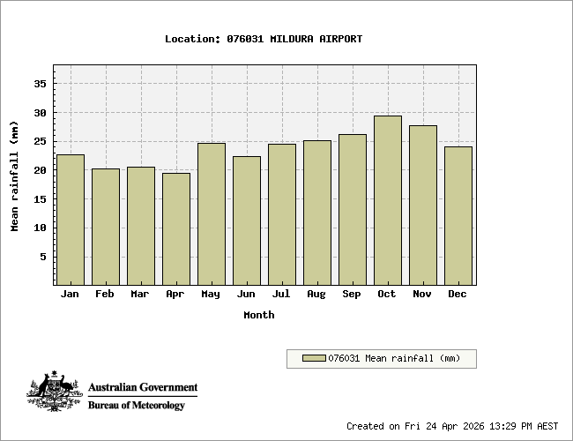

Supplementary Figure S1. Mean monthly rainfall at the soil sample collection site vicinity (Mildura, Victoria, Australia). Mean monthly rainfall (mm) recorded at Mildura Airport weather station (Station No. 076031, location: Mildura, Victoria, Australia). Climate data were obtained from the Australian Government Bureau of Meteorology (BOM) for station 076031 (Mildura Airport). Charts were generated on 24 April 2026 (AEST).

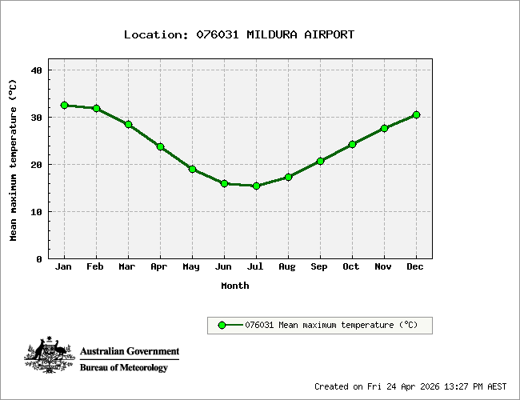
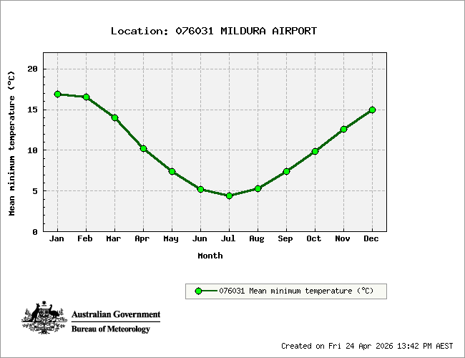

Supplementary Figure S2. Mean monthly maximum and minimum temperature at the soil sample collection site vicinity (Mildura, Victoria, Australia). Mean monthly maximum and minimum temperature (°C) recorded at Mildura Airport weather station (Station No. 076031, location: Mildura, Victoria, Australia). Climate data were obtained from the Australian Government Bureau of Meteorology (BOM) for station 076031 (Mildura Airport). Charts were generated on 24 April 2026 (AEST).

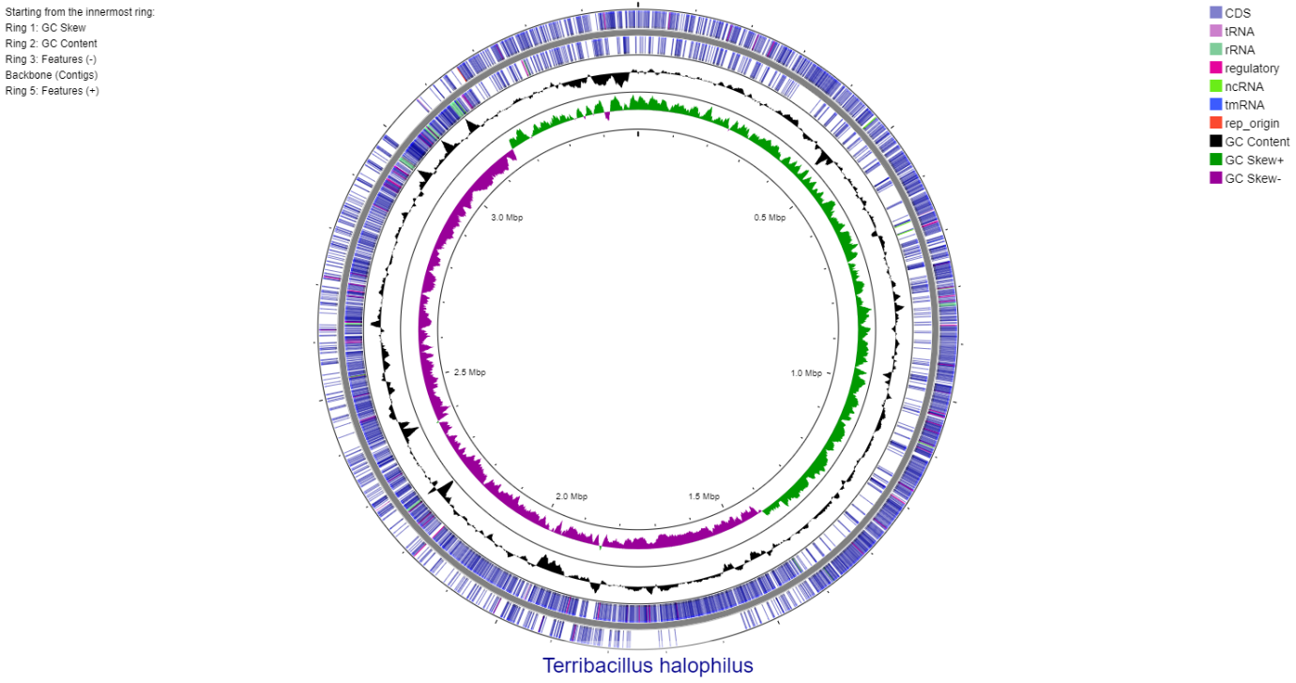

Supplementary Figure S3. Circular genome map of T. halophilus EH3.
The genome is displayed as concentric rings, progressing from the innermost to the outermost ring: Ring 1, GC skew (GC skew+, green; GC skew-, purple), indicating regions of asymmetric nucleotide composition associated with replication origin and terminus; Ring 2, GC content (black), with peaks above the mean indicating GC-rich regions; Ring 3, genomic features encoded on the reverse (-) strand; Ring 4, chromosome backbone showing contig boundaries; Ring 5, genomic features encoded on the forward (+) strand. Annotated genomic features are colour-coded as follows: coding sequences (CDS, purple), transfer RNA genes (tRNA, light purple), ribosomal RNA genes (rRNA, green), regulatory elements (pink), non-coding RNA (ncRNA, light green), and transfer-messenger RNA (tmRNA, blue).
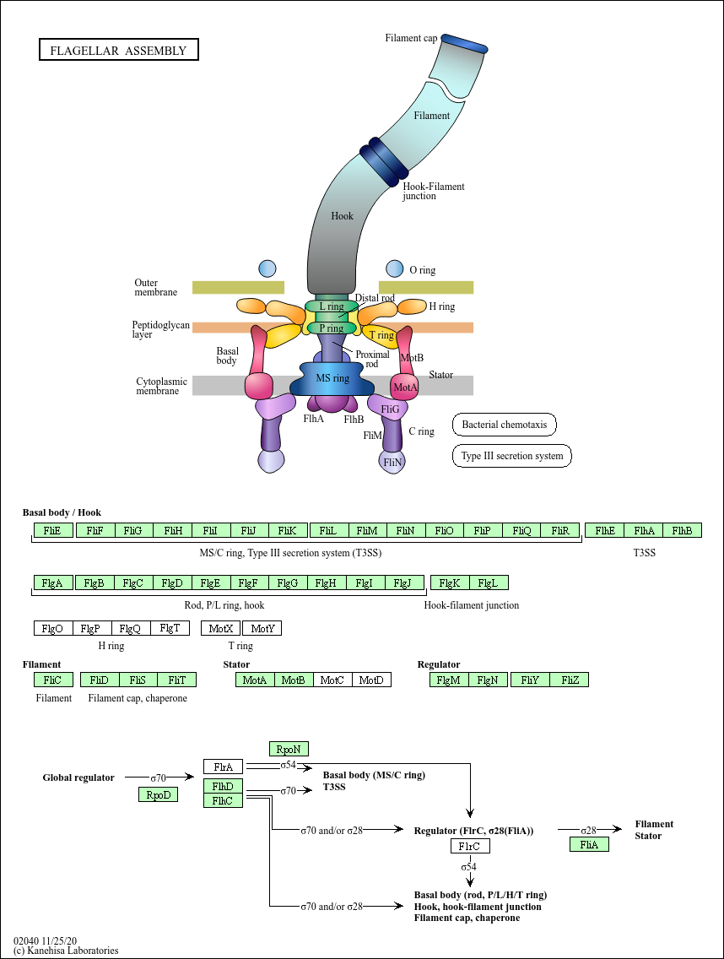

Supplementary Figure S4. KEGG pathway map of flagellar assembly in bacteria. This pathway map was retrieved from the Kyoto Encyclopedia of Genes and Genomes (KEGG) database (map02040; Kanehisa Laboratories, 2020). Green-highlighted genes indicate flagellar assembly components identified in the genome of T. halophilus EH3 based on KEGG orthology (KO) assignment through eggNOG-mapper annotation. White boxes represent components absent from the strain genome.

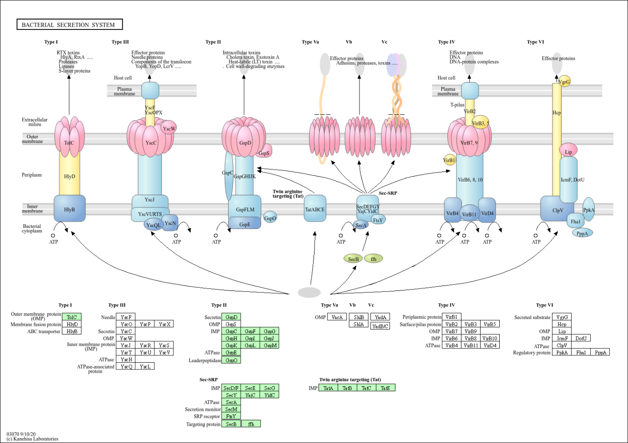
Supplementary Figure S5. KEGG pathway map of the bacterial secretion system in bacteria. This pathway map was retrieved from the Kyoto Encyclopedia of Genes and Genomes (KEGG) database (map03070; Kanehisa Laboratories, 2020). Green-highlighted genes indicate bacterial secretion system components identified in the genome of T. halophilus EH3 based on KEGG orthology (KO) assignment through eggNOG-mapper annotation. White boxes represent components absent from the strain genome.

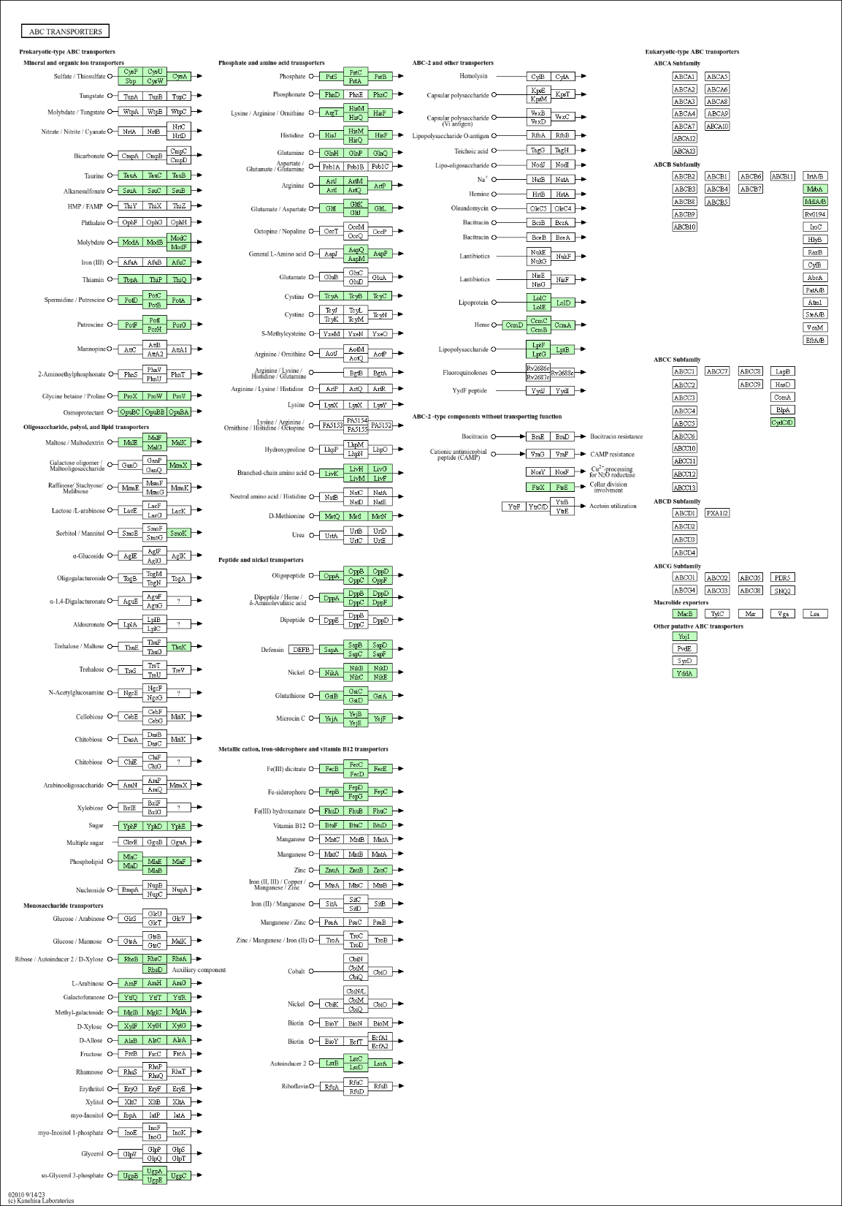

Supplementary Figure S6. KEGG pathway map of glyoxylate and dicarboxylate metabolism in bacteria. This pathway map was retrieved from the Kyoto Encyclopedia of Genes and Genomes (KEGG) database (map00630; Kanehisa Laboratories, 2020). Green-highlighted genes indicate glyoxylate and dicarboxylate metabolism enzymes identified in the genome of T. halophilus EH3 based on KEGG orthology (KO) assignment through eggNOG-mapper annotation. White boxes represent components absent from the strain genome.

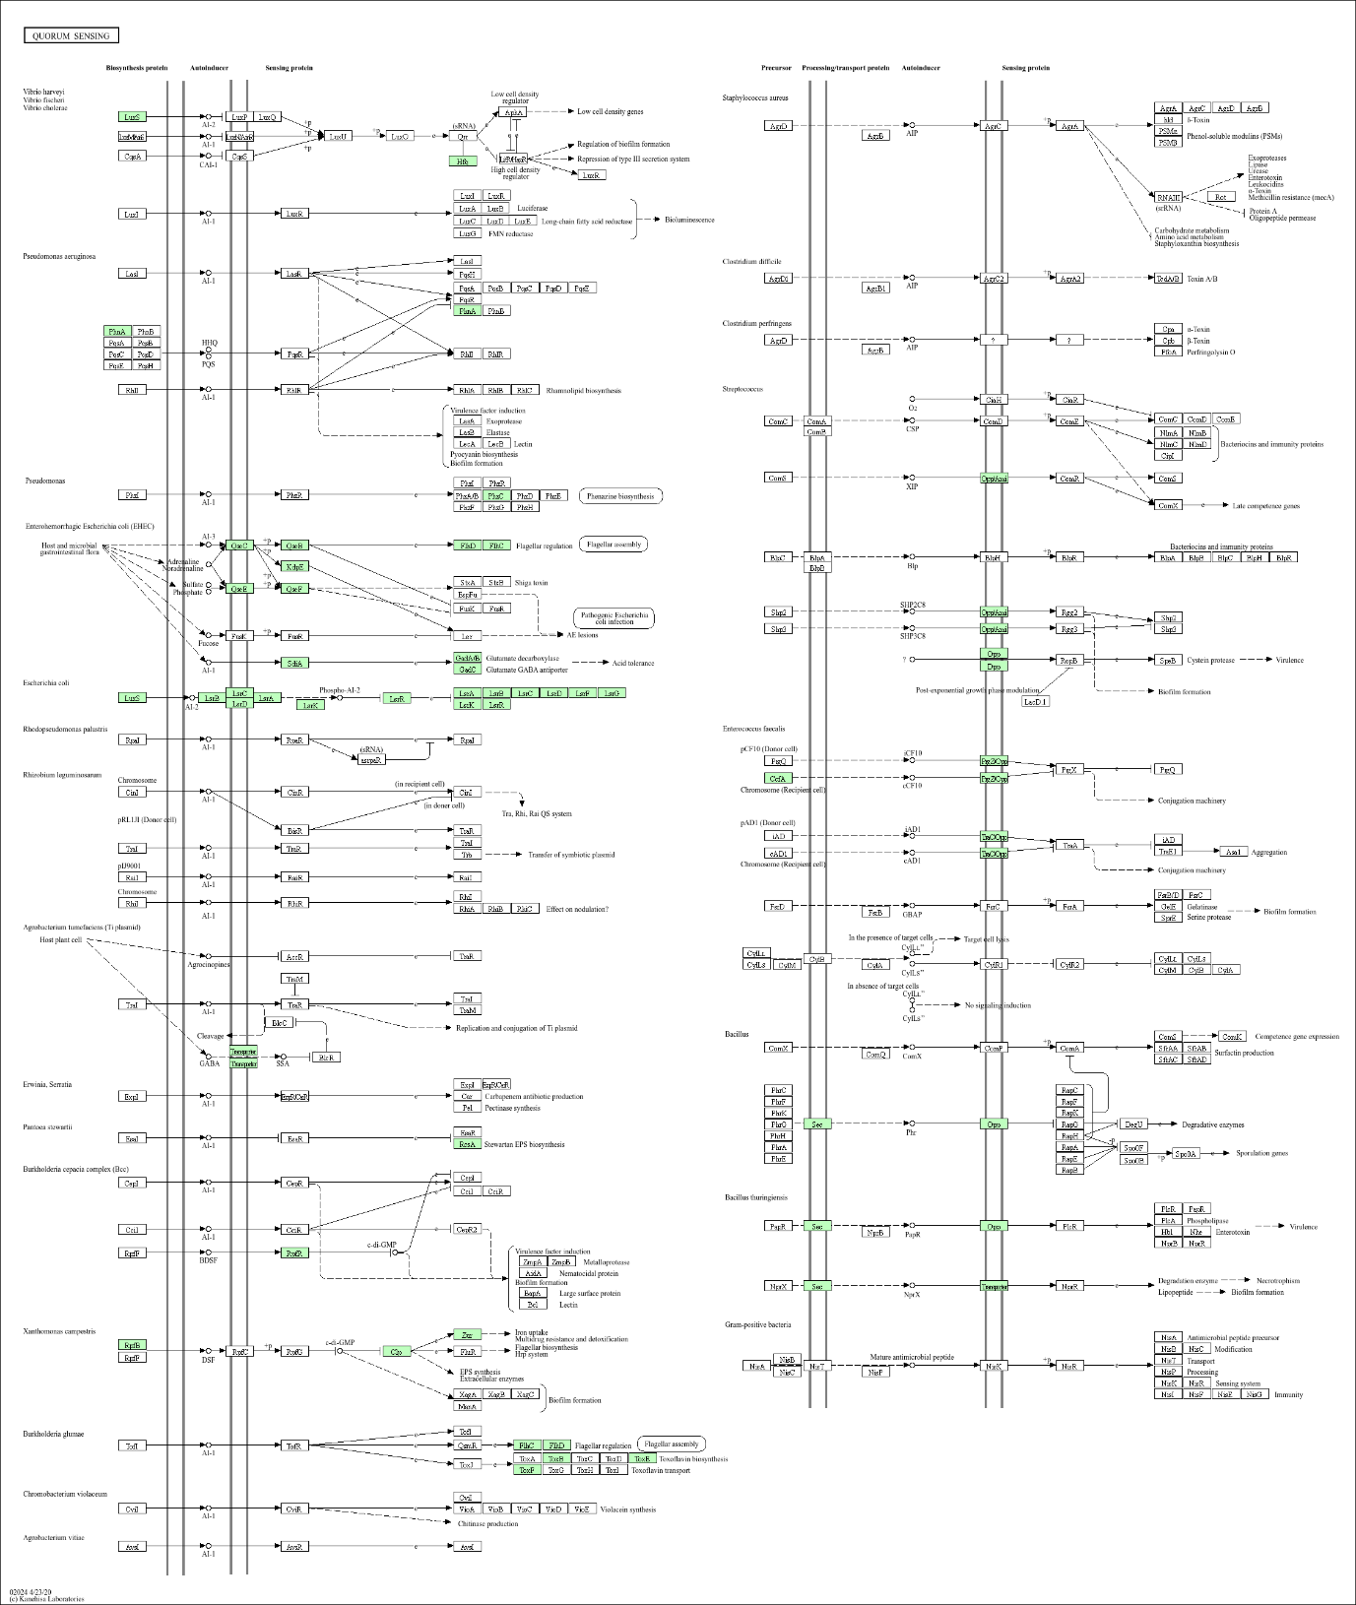

Supplementary Figure S7. KEGG pathway map of quorum sensing in bacteria. This pathway map was retrieved from the Kyoto Encyclopedia of Genes and Genomes (KEGG) database (map02024; Kanehisa Laboratories, 2020). Green-highlighted genes indicate quorum sensing components identified in the genome of T. halophilus EH3 based on KEGG orthology (KO) assignment through eggNOG-mapper annotation. White boxes represent components absent from the strain genome

Supplementary Figure S8. Circular pan-genome map of T. halophilus EH3 and related taxa constructed using T. halophilus EH3 (Th BE) as the reference genome.
Concentric rings are ordered from outermost to innermost as described in the Ring Guide. Ring 1 provides the genomic position scale with tick marks. Rings 2-6 represent strain presence/absence maps for each of the five genomes included in the analysis: T. halophilus EH3 ( Th BE - Ring 2, light blue), T. halophilus DSM21620 (Th DSM21620 - Ring 3, dark blue), T. saccharophilus MP602 (Ts MP602 - Ring 4, green), A. gibsonii KCCM41407 (Ag KCCM41407 - Ring 5, orange), and B. velezensis FZB42 (Bv FZB42 - Ring 6, pink); Coloured arcs indicate gene cluster presence in that strain; grey arcs indicate absence. Ring 7 gene cluster by pangenome partition: core genome (dark blue), soft-core (light blue), shell (green), and cloud (orange). Ring 8 assigns COG functional categories to each gene cluster. Ring 9 (innermost), chromosomal strand orientation showing forward (+, green) and reverse (-, orange) encoded genes.

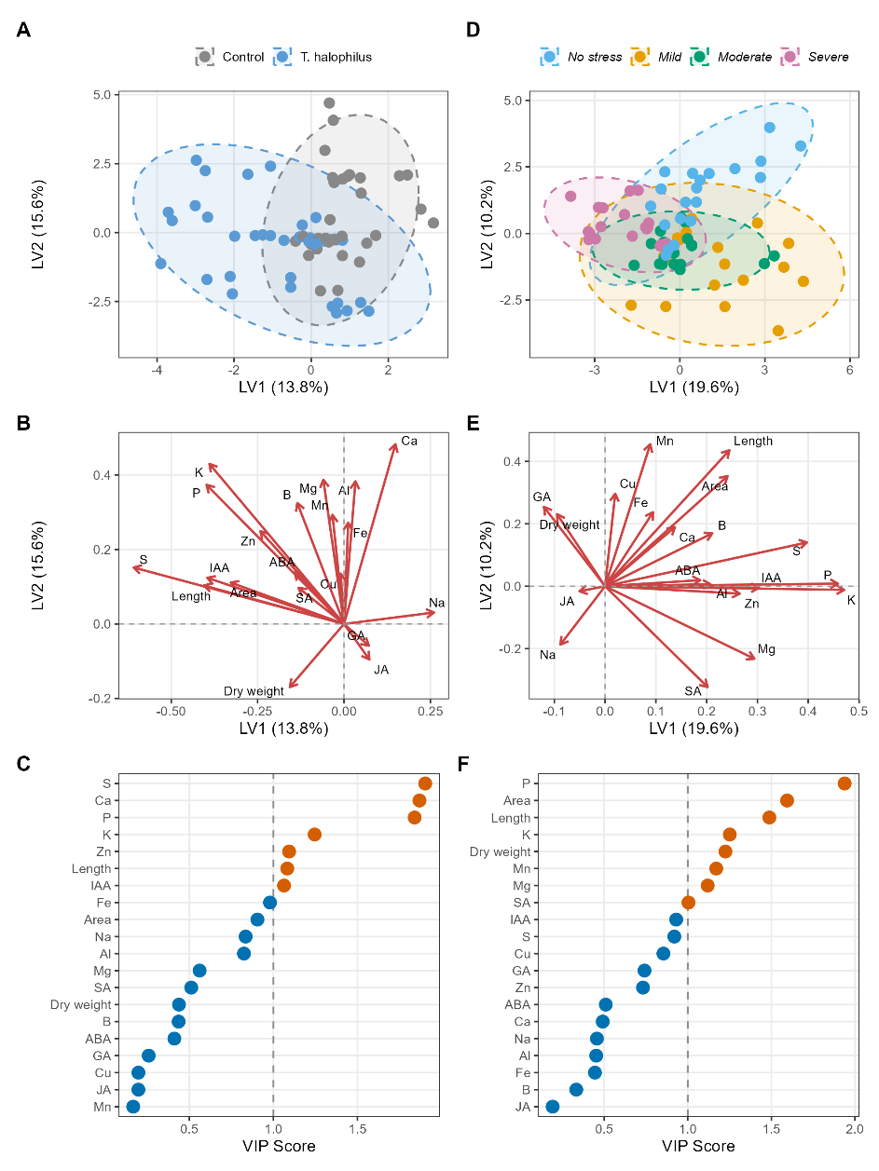
Supplementary Figure S9. Partial least squares discriminant analysis (PLS-DA) of physiological, hormonal, and elemental variables in hydroponically grown tomato (Solanum lycopersicum) plants at the vegetative stage, discriminated by bacterial inoculant treatment (A, B, C) and drought stress level (D, E, F).
Two independent PLS-DA models (treatment and drought) were constructed using standardised shoot morphological (shoot length, leaf area, dry weight), phytohormonal (ABA, GA, IAA, JA, SA), and elemental (Al, B, Ca, Cu, Fe, K, Mg, Mn, Na, P, S, Zn) variables measured in leaf tissue. For each model, score plots, loading plots, and Variable Importance in Projection (VIP) scores are presented. Dashed ellipses in score plots represent 95% confidence regions per group. Variables with VIP > 1.0 were considered significant discriminators of group membership and are highlighted in red.

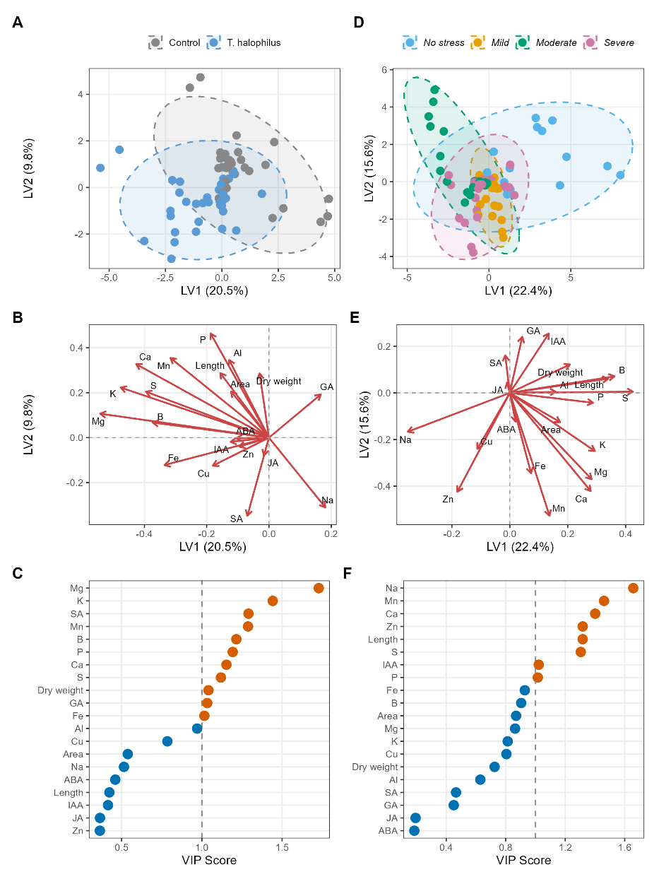
Supplementary Figure S10. Partial Least Squares Discriminant Analysis (PLS-DA) of physiological and elemental variables in hydroponically grown tomato (Solanum lycopersicum) plants at the vegetative stage, discriminated by bacterial inoculant treatment (A, B, C) and salinity stress level (D, E, F).
Two independent PLS-DA models (treatment and salinity) were constructed using standardised shoot morphological (shoot length, leaf area, dry weight), phytohormonal (ABA, GA, IAA, JA, SA), and elemental (Al, B, Ca, Cu, Fe, K, Mg, Mn, Na, P, S, Zn) variables measured in leaf tissue. For each model, score plots, loading plots, and Variable Importance in Projection (VIP) scores are presented. Dashed ellipses in score plots represent 95% confidence regions per group. Variables with VIP > 1.0 were considered significant discriminators of group membership and are highlighted in red.

